Table of Contents

SCHEDULE 14A

(Rule 14a-101)

INFORMATION REQUIRED IN PROXY STATEMENT

SCHEDULE 14A INFORMATION

Proxy Statement Pursuant to Section 14(a) of the Securities

Exchange Act of 1934 (Amendment No. )

Filed by the Registrant ☒

Filed by a Party other than the Registrant ☐

Check the appropriate box:

- Preliminary Proxy Statement

- Confidential, for Use of the Commission Only (as permitted by Rule 14a-6(e)(2)) ☒ Definitive Proxy Statement

- Definitive Additional Materials

- Soliciting Material pursuant to Rule 14a-12

Martin Marietta Materials, Inc.

(Name of Registrant as Specified In Its Charter)

(Name of Person(s) Filing Proxy Statement, if other than the Registrant)

Payment of Filing Fee (Check the appropriate box):

- No fee required.

- Fee computed on table below per Exchange Act Rules 14a-6(i)(1) and 0-11.

  - Title of each class of securities to which transaction applies:

  - Aggregate number of securities to which transaction applies:

  - Per unit price or other underlying value of transaction computed pursuant to Exchange Act Rule 0-11 (set forth the amount on which the filing fee is calculated and state how it was determined):

  - Proposed maximum aggregate value of transaction:

  - Total fee paid:

- Fee paid previously with preliminary materials.

- Check box if any part of the fee is offset as provided by Exchange Act Rule 0-11(a)(2) and identify the filing for which the offsetting fee was paid previously. Identify the previous filing by registration statement number, or the Form or Schedule and the date of its filing.

  - Amount Previously Paid:

  - Form, Schedule or Registration Statement No.:

  - Filing Party:

  - Date Filed:

Table of Contents


Table of Contents


April 16, 2020

Dear Fellow Shareholder:

On behalf of the Martin Marietta Board of Directors and executive officers, you are cordially invited to attend Martin Marietta’s 2020 Annual Meeting of Shareholders. I am providing some of the highlights of our key actions and important decisions in 2019, as well as information about our financial performance. Please review this Proxy Statement and the 2019 Annual Report for more information about these topics.

As we issue this Proxy Statement, COVID-19 continues to create challenges and hardships, both nationally and globally. While we remain open for business and ready to meet our communities’ product and service needs, we are also committed to safeguarding the health, safety and well-being of all who our business touches. The Company’s executive leadership and Board of Directors have been closely monitoring developments related to COVID-19 and its potential impacts to our employees, customers, supply chains, and others, and proactively taking actions to responsibly prepare so that our people, facilities and business remain safe.


Continued to Deliver Strong Financial Results

2019 was another outstanding year of achievement at Martin Marietta. We delivered top-line revenue growth and translated that growth into record profitability. We outperformed our peers, the S&P 500 and the S&P 500 Materials indices over the 1-, 5- and 10-year periods ended December 31, 2019. Our shareholders saw a total return of 64% over the 1-year period. We increased our quarterly dividend 15% in August 2019, following a 9% increase in August 2018, and have returned $1.6 billion to shareholders from dividends and share repurchases since announcing a 20 million share repurchase authorization in February 2015.

Shareholder Engagement, Enhanced Corporate Governance and Refreshed Board Membership

We remained engaged with shareholders and other key stakeholders during 2019. In response to valuable feedback from shareholders, we enhanced our disclosure regarding our activities, risks and opportunities regarding sustainability and other environmental, social and governance issues. Our investor outreach in 2019 extended to 82 meetings with 189 investor groups, and conversations with most of our top 30 shareholders. We visited with our shareholders across the United States and Canada, the United Kingdom, Sweden, Belgium, the Netherlands, and France.

Over the past four years, we have added six new independent directors. Most recently, Thomas H. Pike joined the Board in July 2019 and Dorothy M. Ables joined our Board in November 2018. In addition, we are nominating David C. Wajsgras to serve on our Board. We are committed to recruiting experienced directors who offer diverse perspectives, professional expertise, and unique skills that align with our long-term corporate strategy and business needs.

We are deeply grateful to Stephen P. Zelnak, Jr., who will retire from the Board at the 2020 Annual Meeting. Steve has served on our Board since November 1993, including as Chairman, and has made valuable contributions to both the Board and the Company from his previous service as CEO of Martin Marietta. Steve has been an important, thoughtful and knowledgeable voice. We will miss him.

World-Class Safety Performance

In 2019, we continued our impressive safety performance. Through the hard work and focus of our employees, safety awareness has been elevated across the Company. Our employees know world-class safety performance is possible; and, importantly, 2019’s results demonstrate this goal is attainable. Our company-wide Lost Time Incident Rate (LTIR) was 0.20, a world-class LTIR for the third year in a row.

Sustainability

We annually issue our Sustainability Report to share our story, and to provide information that we believe is responsive to requests from our shareholders and other stakeholders, on the efforts and advancements we are making in these important areas. Since our first report in 2015, we have enhanced our reporting with more comprehensive descriptions of our outstanding safety and regulatory programs and performance, targeted and intentional support of education and health, and strong community involvement. In our latest Sustainability Report, to be issued in April 2020, we have included additional disclosure about our activities, accomplishments and opportunities associated with key sustainability matters, including those related to the environment. This includes new disclosures of our direct greenhouse gas emissions across all our business lines, as well as our emissions reductions targets for 2030. Our activities reflect that these matters continue to be part of our core approach and strategy that brings value to our shareholders and other stakeholders.

Your Vote Matters

I urge you to cast your vote promptly—even if you plan to attend the Annual Meeting. We encourage you to vote so that your shares will be represented at the meeting.

Thank you for your investment in Martin Marietta. We look forward to continuing to deliver strong and responsible performance, innovation, and growth to our customers, our shareholders and our other stakeholders.

Sincerely,
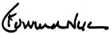

C. Howard Nye

Chairman of the Board, President and Chief Executive Officer

Table of Contents

MARTIN MARIETTA MATERIALS, INC.

2710 Wycliff Road, Raleigh, North Carolina 27607

Notice of Annual Meeting of Shareholders

To Be Held May 14, 2020

To Our Shareholders:

The Annual Meeting of Shareholders of Martin Marietta Materials, Inc. will be held on Thursday, May 14, 2020 at 11:30 a.m. EDT at our principal office located at 2710 Wycliff Road, Raleigh, North Carolina. At the meeting, the holders of our outstanding common stock will act on the following matters:

1

2

3

4

Election as Directors the ten (10) nominees named in the attached proxy statement, each to serve for a one-year term until 2021, and until their successors are duly elected and qualified;

Ratification of the appointment of PricewaterhouseCoopers LLP as independent auditors for 2020;

Advisory vote to approve the compensation of our named executive officers; and

Any other business that may properly come before the meeting.

All holders of record of Martin Marietta common stock (NYSE: MLM) at the close of business on March 6, 2020 are entitled to notice of and to vote at the Annual Meeting and any adjournments or postponements of the meeting.

The Board of Directors unanimously recommends that you vote FOR proposals 1, 2, and 3.


This notice and the accompanying proxy statement are being first mailed to shareholders on or about April 16, 2020. We have enclosed our 2019 Annual Report to Shareholders. The report is not part of the proxy soliciting materials for the Annual Meeting.

Whether or not you expect to attend the meeting, we hope you will date and sign the enclosed proxy card and mail it promptly in the enclosed stamped envelope. Submitting your proxy now will not prevent you from voting your shares at the meeting, as your proxy is revocable at your option.

Sincerely,
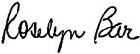

Roselyn R. Bar

Executive Vice President, General Counsel and Secretary

Raleigh, North Carolina

April 16, 2020

IMPORTANT NOTICE REGARDING THE AVAILABILITY OF PROXY MATERIALS FOR THE

ANNUAL SHAREHOLDER MEETING TO BE HELD ON MAY 14, 2020:

Martin Marietta’s proxy statement, form of proxy card and 2019 Annual Report to Shareholders are also available at ir.martinmarietta.com/reports-filings.

Table of Contents

Table of Contents

Proxy Summary |  |  | 1
The Board of Directors |  |  | 9
Board Committees |  |  | 13
Proposal 1 – Election of Directors |  |  | 17
Director Compensation |  |  | 22
Security Ownership of Certain Beneficial Owners and |  |  | 24
Management |  |  | 24
Delinquent Section 16(a) Reports |  |  | 25
Corporate Governance Matters |  |  | 26
Corporate Governance Philosophy |  |  | 26
Proposal 2 – Independent Auditors |  |  | 31
Summary of Fees |  |  | 31
Pre-Approval Policies and Procedures |  |  | 31
Audit Committee Review |  |  | 31

Performance-Based RSU Awards (45% of LTI Award) | 49
2019-2021 Performance Goals | 49
2017-2019 PSU Award Payouts | 51
Ongoing Corporate Governance Policies | 51
Compensation Decision Process | 51
Compensation Program Risk Assessment | 53
Stock-Based Awards Generally | 53
Stock Ownership Requirements | 53
Anti-Hedging and Pledging Policy | 54
Clawback Policy | 54
Our Use of Independent Compensation Consultants | 54
Practice Regarding Timing of Equity Grants | 55
Perquisites | 55
Retirement and Other Benefits | 55
Potential Payments upon Termination or Change of Control | 56
Tax and Accounting Implications | 56

Audit Committee Report

Management Development and Compensation Committee Report

Compensation Committee Interlocks and Insider Participation in Compensation Decisions

Compensation Discussion and Analysis

Introduction

Executive Summary

Shareholder Engagement and Feedback on 2019 Say On Pay

Our 2019 Performance

Safety, Environment and Sustainability

Components of Executive Compensation - Performance-Related Compensation

Pay Decisions and Compensation Governance Practices

2019 Chairman, President and CEO Compensation

CEO Target Opportunity Mix Determination of CEO Compensation
2019 Named Executive Officers’ Compensation - Our Compensation Strategy

Considerations Regarding 2019 Compensation 2019 Base Salary
2019 Annual Cash Incentive Goals and Results

2019 Long-Term Incentive Compensation Overview PSU Awards (55% of LTI Award) Selection of Relative TSR

32 | Executive Compensation | 57
 | Executive Officer Compensation | 57
33 | Summary Compensation Table | 57
33 | Grants of Plan-Based Awards | 59
33 | Outstanding Equity Awards at Fiscal Year-End | 60
33 | Option Exercises and Stock Vested | 61
34 | Pension Benefits | 63
34 | Potential Payments Upon Termination or Change of Control | 64
35 | CEO Pay Ratio Disclosure | 67

Proposal 3 – Advisory Vote on the Compensation of
³⁵ Our Named Executive Officers 68

36
- Securities Authorized for Issuance Under Equity
 | Compensation Plans |  | 69
40 | Description of the TXI Legacy Plan |  | 69
41 | Description of the Deferred Compensation Plan |  | 70
42 | Annual Meeting and Voting Information |  | 71
42 | Incorporation by Reference |  | 73
42 | Shareholders’ Proposals for 2021 Annual Meeting |  | 73
- Appendix A – Martin Marietta Guidelines for Potential
45 | New Board Members |  | A-1
45 | Appendix B – Non-GAAP Measures |  | B-1
46 |  |  | B-1
48
48
49

2020 PROXY STATEMENT

Table of Contents


Proxy Summary

This Proxy Summary highlights information about Martin Marietta Materials, Inc. (Martin Marietta or the Company) that can be found elsewhere in this proxy statement. It does not contain all of the information you should consider in voting your shares. We encourage you to read the entire proxy statement for more detailed information on each topic prior to casting your vote. This proxy statement, the proxy card, and the notice of meeting are being sent commencing on approximately April 16, 2020 to shareholders of record on March 6, 2020.

2020 Annual Meeting of Shareholders

Meeting Date: May 14, 2020 Place: 2710 Wycliff Road, Raleigh, NC

Time: 11:30 am ET Record Date: March 6, 2020

Your vote is important. You may vote in person at the 2020 Annual Meeting of Shareholders (Annual Meeting) or submit a proxy over the internet. If you have received a paper copy of the proxy card (or if you request a paper copy of the materials), you may submit a proxy by telephone or by mail.

Via the Internet In Person

www.voteproxy.com Attend the Annual Meeting and vote by ballot.

By Telephone By Mail

1-800-PROXIES (1-800-776-9437)

in the United States or 1-718-921-8500 from outside the United States.

Sign, date and mail your proxy card in the envelope provided.

If you submit your proxy by telephone or over the internet, you do not need to return your proxy card by mail.

PROPOSALS AND VOTING RECOMMENDATIONS

Proposal |  | Description |  |  |  | Board Voting Recommendation | Page
1 |  | Election of ten director nominees |  |  |  | FOR EACH DIRECTOR NOMINEE | 17
2 |  | Ratification of the appointment of |  |  |  | FOR | 31
2 |  | PricewaterhouseCoopers LLP as independent auditors |  |  |  | FOR | 31
3 |  | Advisory vote on the Company’s named executive officer
 |  | compensation |  |  |  | FOR | 68

2020 PROXY STATEMENT | 1

Table of Contents
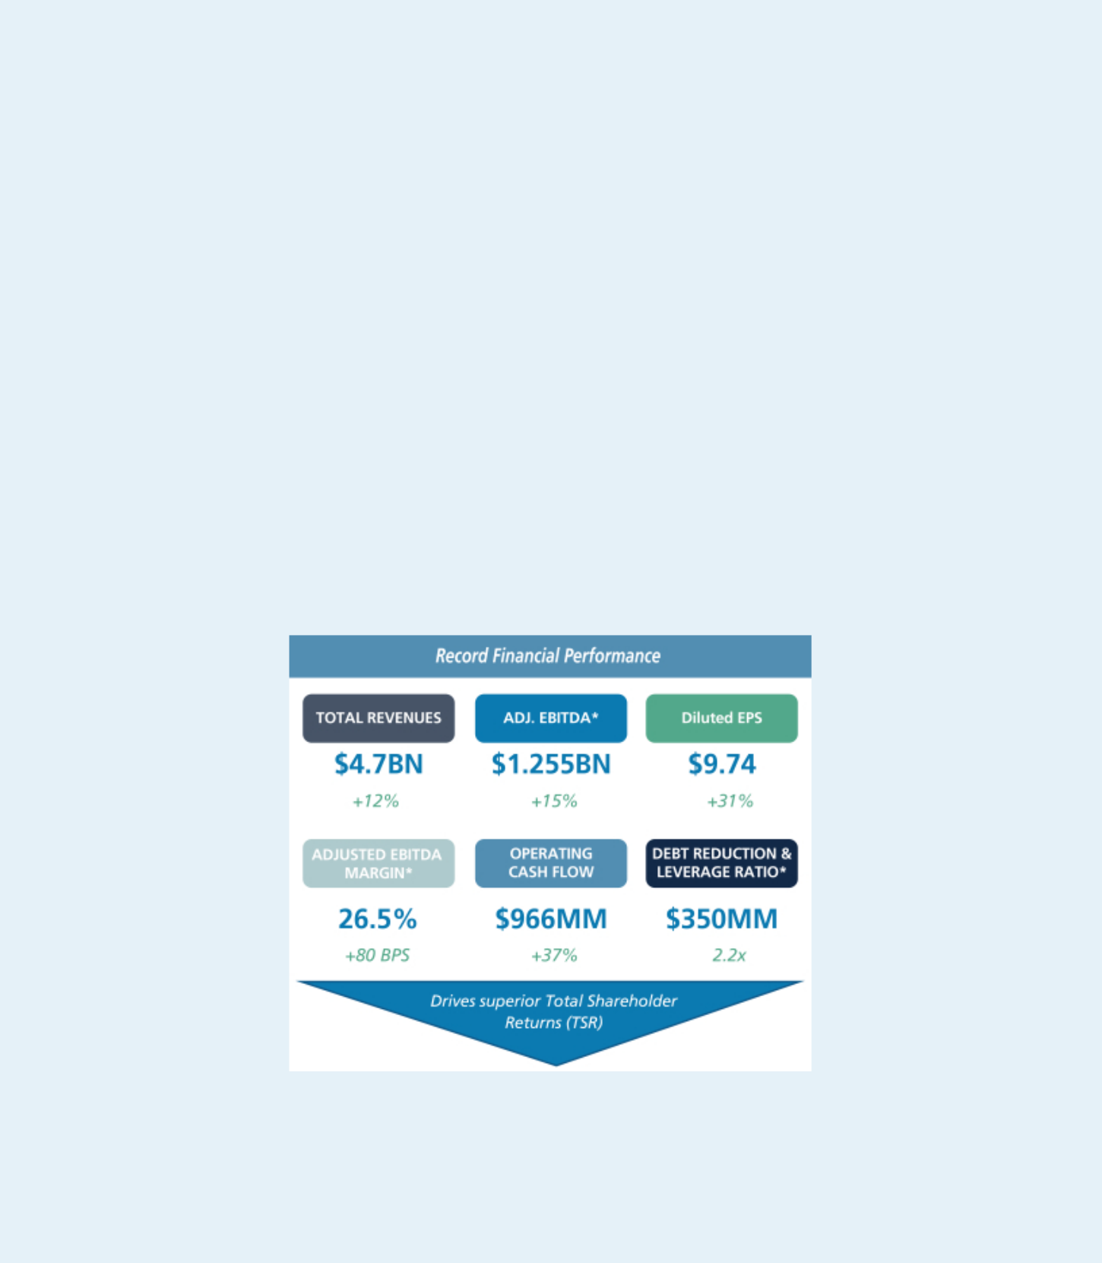

2020 BUSINESS HIGHLIGHTS

Shareholders Benefit from Martin Marietta’s Record 2019 Performance

The past year was one of improved financial performance, disciplined capital allocation and continued emphasis on safety, health and our other tenets of sustainability. We continued to see the full-year benefits from our 2018 acquisition and quick-paced integration of Bluegrass Materials Company (Bluegrass), strengthening our foundation for long-term financial success. Our record 2019 financial performance is a continuation of the growth in total revenues, gross profit, adjusted EBITDA and earnings diluted per share (EPS) since 2011. These trends, along with our record safety results, validate both our strategic plan and our ability to logically and successfully execute against that plan. Disciplined execution against our capital allocation priorities was also reflected in 2019 as we continued our share repurchase program and meaningfully increased our dividend again.

These are highlights of our financial performance in 2019:

- Record consolidated revenues of $4.7 billion, a 12% year-on-year increase, driven by double-digit aggregates and cement shipment growth and steady pricing gains across the Building Materials business, with net earnings attributable to Martin Marietta of $612 million

- Achieved 8th consecutive year of revenue, gross profit, adjusted EBITDA and EPS growth

- Record-setting results yielded a 64 percent Total Shareholder Return (TSR), more than double the S&P 500

- $50 million contributed to the Company’s ~100% funded qualified pension plan

- Repurchased 416,000 shares for $98.2 million ($236.04 per share); 13.7 million shares remaining on our February 2015 authorization

- Our Board of Directors (Board) approved a 15% dividend increase ($2.20 per share on an annualized basis) in August, one of the largest increases in Company history

- Maintained our investment grade credit rating, exiting the year at 2.2x debt-to-EBITDA leverage ratio, within our target ratio of 2.0x – 2.5x

* Please see Appendix B for a reconciliation of non-GAAP measures to GAAP measures.

- 2020 PROXY STATEMENT

Table of Contents
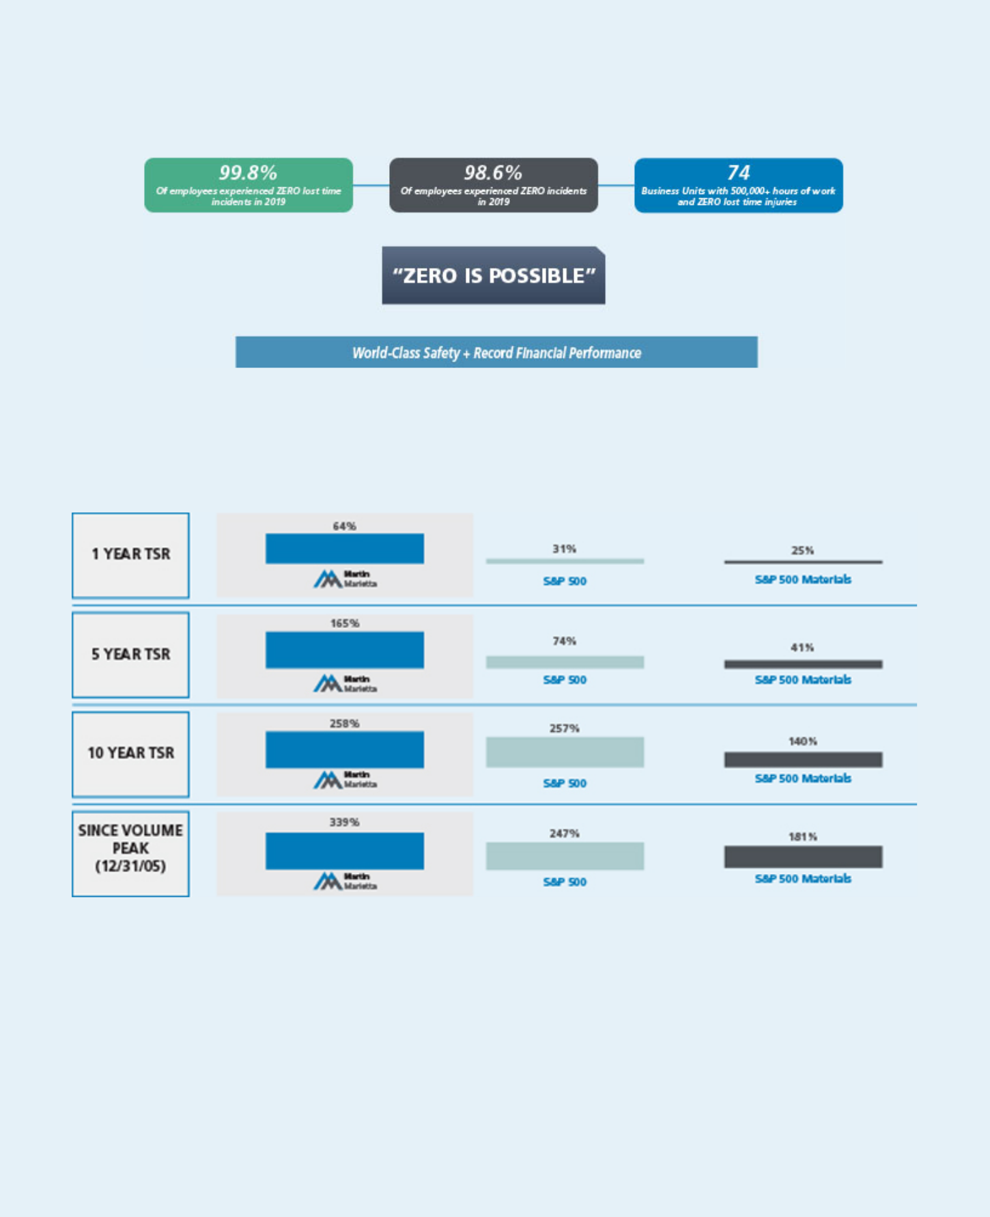

Our Commitment to our Guardian Angel Safety Culture

- World-class LTIR for the 3rd consecutive year

- Safety performance sets the foundation for long-term financial strength and successful strategic plan (SOAR) execution

- We outperformed our peers in 2019, and also outperformed the S&P 500 and S&P 500 Materials on TSR

- Our short- and long-term performance, reflected in our TSR over the 1-, 5- and 10-year periods ended December 31, 2019, show the strength of our strategic plan.

- Our shareholders received a total return of 64% over the 1-year period.

2020 PROXY STATEMENT | 3

Table of Contents


Corporate Governance Highlights:

Creating Sustainable Long-Term Shareholder Value

Recent Updates

• Directors elected annually to serve one-year terms

- Elimination of excise tax gross-up, walk-right and value of perquisites in the severance calculation in Employment Protection Agreements

• Elimination of single-trigger vesting in equity award agreements for grants beginning in 2019

- Adoption of Stock Ownership Guidelines

• Adoption of Hedging and Pledging Policy

- Adoption of Clawback Policy

- Our shareholders have the ability to nominate director candidates and have those nominees included in our proxy statement, subject to meeting the requirements in our Bylaws, a shareholder right known as proxy access

Board of Directors

- Lead Independent Director who is a former public company CEO

• 10 current Directors; 9 or 90% are independent

- Key committee Chairs are independent, consisting of independent Chairs of the Audit Committee, Management Development and Compensation Committee, and Nominating and Corporate Governance Committee

• Executive sessions of non-management Directors at each regularly-scheduled meeting

- All Directors attended 100% of all Board and committee meetings during their term of service in 2019

• 90% of our Board has experience on other public company boards and 60% are current or former public company CEOs

- Code of Ethical Business Conduct and ethics program reports to a Board Committee

• Annual Board and individual performance evaluations are conducted, including Director peer review

- Risk oversight by full Board and Committees

• Chair/CEO is the only Board member who is currently also management

- Only one member of our 10-member Board of Directors standing for reelection is currently or formerly management of the Company

Shareholder Interest

- Majority voting standard for uncontested Director elections

• No shareholder rights plan

- Annual advisory vote to ratify independent auditor

• Annual advisory vote to approve executive compensation

- Longstanding active shareholder engagement

- We publish annually a Sustainability Report that discusses our commitment to our shareholders, employees and the communities that we serve.
  - We also created a new position to better focus on these important issues

  - Our Board committees review the Company’s accomplishments with regard to sustainability

- No shares with enhanced voting rights

- 2020 PROXY STATEMENT

Table of Contents
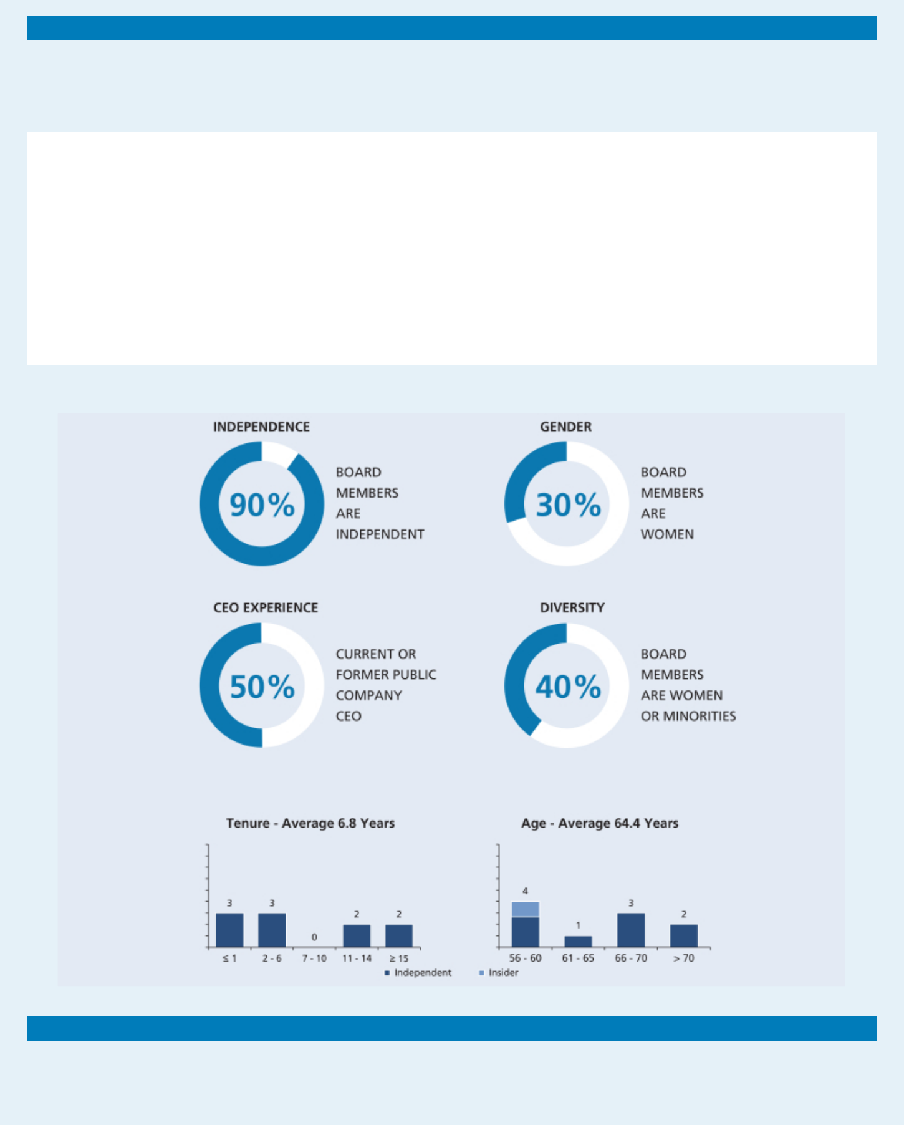

Board Composition

We seek to include a diverse group of Directors on our Board to provide different perspectives to the Board’s oversight responsibilities. Our Board nominees demonstrate diversity in the form of experience, geography, gender, ethnicity, age and tenure. We were recognized in 2019, 2017 and 2015 at the Women’s Forum of New York at its Biennial Breakfast of Corporate Champions for our Board diversity. We were also recognized by 2020 Women on Boards as a Winning ‘W’ Company for eight consecutive years for championing board diversity.

30%

40%

<7 years

Women represent 30% of our Board nominees

40% of our Board nominees bring diversity in gender or ethnicity

The average tenure of our Board nominees is less than 7 years

Our Board refreshment has resulted in a decrease of the Board’s average tenure, with a greater mix of Directors with long-term knowledge of the Company, its strategy, opportunities and challenges and those with new perspectives

DIRECTOR NOMINEES

Board Attendance

In 2019, during their terms of service, all directors attended 100% of the total Board and committee meetings to which they were assigned. All directors then in office attended the May 2019 Annual Meeting, and all directors expect to attend the 2020 Annual Meeting.

2020 PROXY STATEMENT | 5

Table of Contents
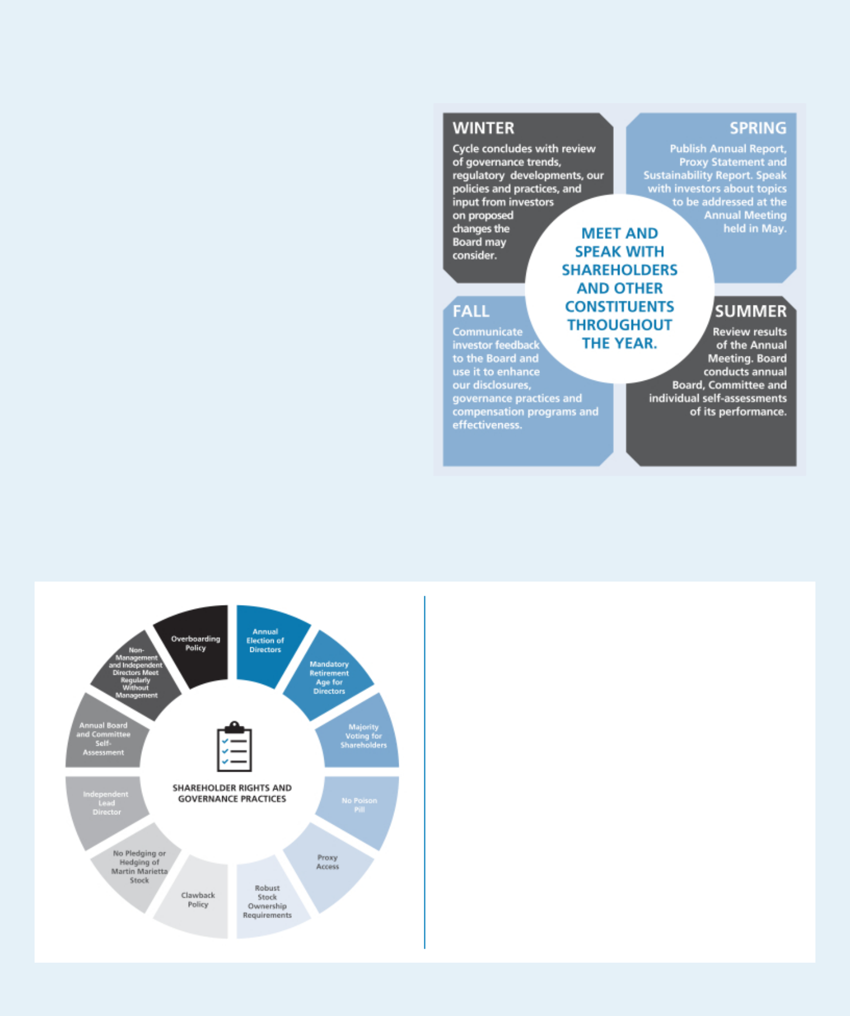

Effective Shareholder Engagement

Accountability to our shareholders is an important component of the Company’s success. We recognize the value of building informed relationships with our investors that promote further transparency and accountability. While proxy voting is one direct way to influence corporate behavior, proactive engagement with our investors can be effective and impactful. Investor views are communicated to the Board and are instrumental in the development of our governance, compensation and sustainability policies and inform our business strategy.

During 2019, we engaged in person, by telephone and/or written correspondence with our largest institutional investors and other significant shareholders on an array of governance topics, including our executive compensation programs.

At our 2019 Annual Meeting of Shareholders, 92% of the shares cast voted in favor of the advisory vote on executive compensation, or Say On Pay. We made meaningful changes in 2018 to our compensation program based on feedback from shareholders consisting of:

- The elimination of the excise tax gross-up in executive officers’ Employment Protection Agreements

- The elimination of the walk-right and value of perks in the severance calculation in executive officers’ Employment Protection Agreements

- The decision to not include these provisions in future Employment Protection Agreements

- The elimination of the single-trigger vesting for equity awards beginning in 2019

Proactively Engaging and Responding to Shareholders

CORPORATE GOVERNANCE HIGHLIGHTS

✓ Directors elected for 1-year terms

✓ Eliminated gross-up, walk-right on Change of Control

✓ Eliminated single-trigger vesting for equity awards beginning in 2019

✓ Established robust stock ownership guidelines for officers and directors

✓ Implemented hedging and pledging policy ✓ Adopted clawback policy

✓ Implemented majority voting standard ✓ Eliminated shareholder rights plan ✓ Adopted proxy access

✓ Added 6 new Board members since 2016 (assuming the election of Mr. Wajsgras)

✓ Published Annual Sustainability Report

- 2020 PROXY STATEMENT

Table of Contents
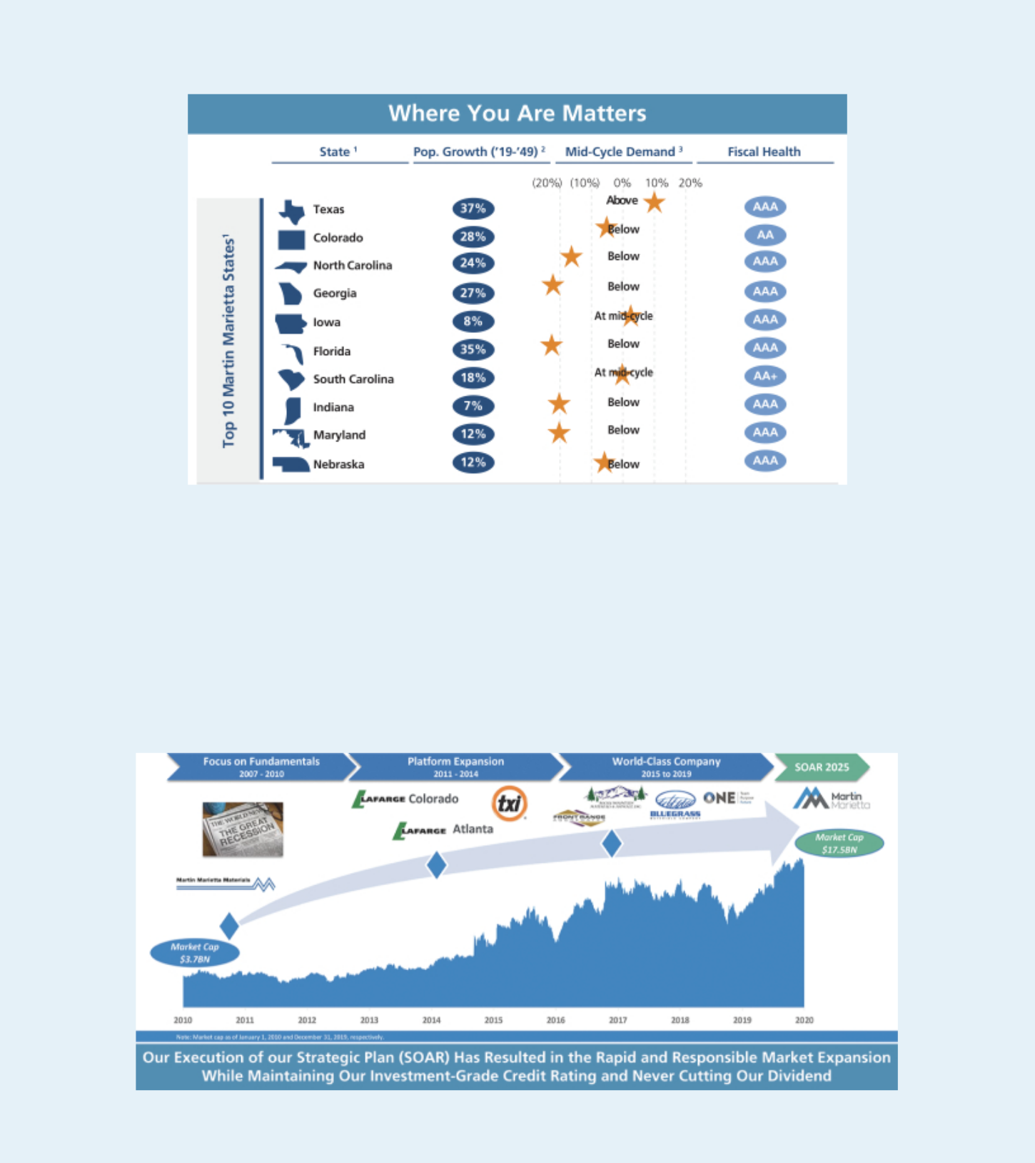

Our Commitment to Excellence, Safety, Corporate Governance, Shareholder Engagement and Sustainability Is Integral to Our Strategic Plan

Sources: (1) Company materials, Wall Street Research, IHS Markit, S&P Global and U.S. State Ratings and Outlooks. (2) Based on top 10 revenue generating states based on 2019 Building Materials product revenues by state of destination. (3) Management calculation based on aggregates consumption per capita multiplied by estimated state population. Based on latest information available as of December 31, 2019.

Over the last decade, Martin Marietta has been a disciplined and well-run heavy construction materials company

- Grew total revenues by 3.0x (11% compounded annual growth rate (CAGR)) and Adjusted EBITDA by 3.4x (13% CAGR) over this period

- Completed creative asset swap in Colorado, and acquisitions of Texas Industries, Inc. (Texas aggregates, strategic cement) and Bluegrass Materials (strong margins, significantly below mid-cycle demand states)

- After maintaining dividends through the financial crisis, consistently increased dividends through the decade

- Maintained a strong investment grade rating, with a leverage ratio now within target range of 2.0x to 2.5x

- Delivered superior shareholder value (2010-2019 TSR CAGR of 14%)

2020 PROXY STATEMENT | 7

Table of Contents
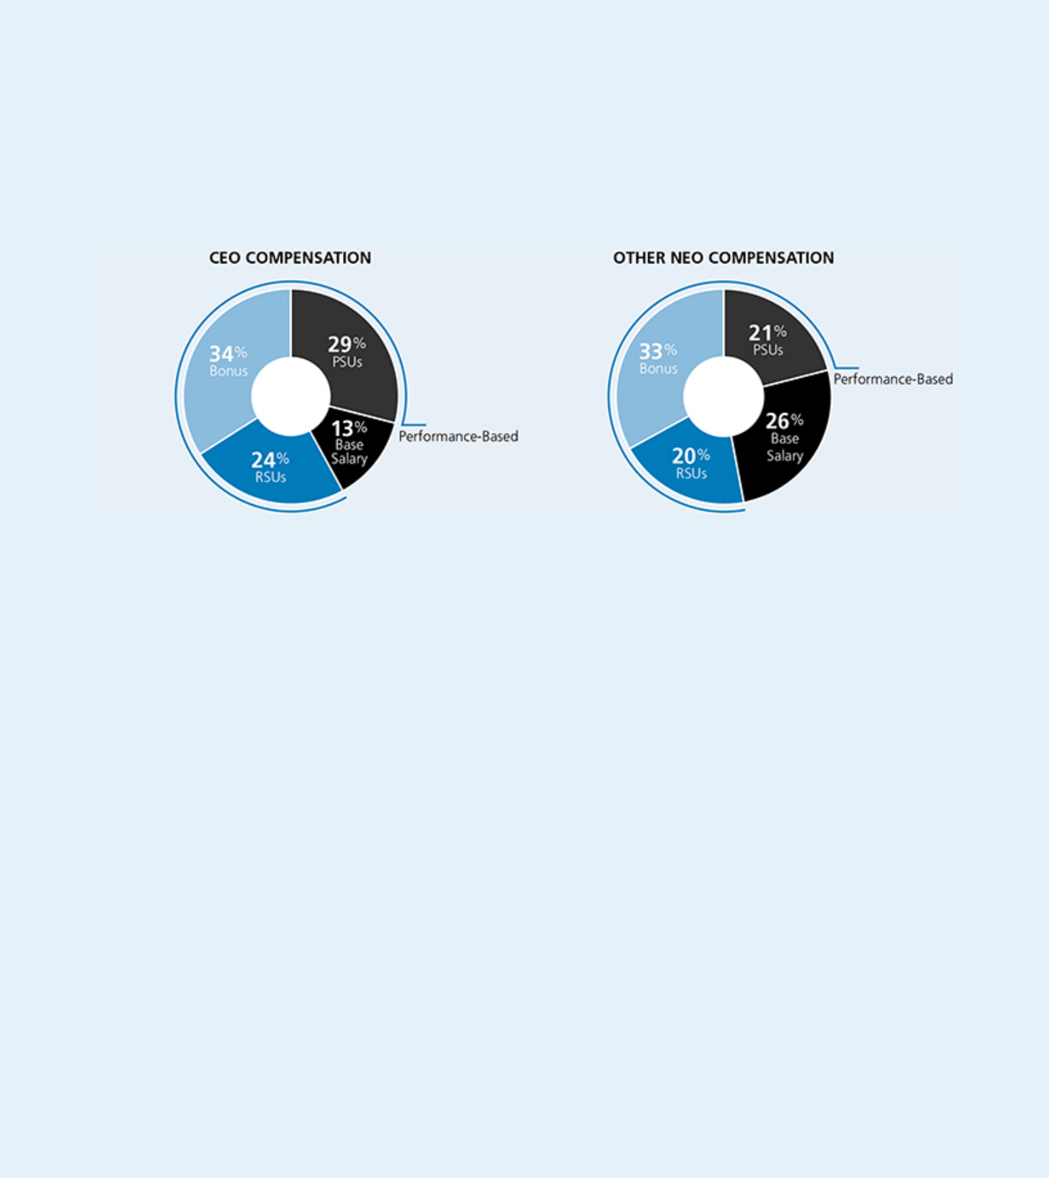

Our Compensation Approach

A substantial portion of compensation paid to our named executive officers (NEOs) is variable and performance-based. We use the 50th percentile of our peer group as a reference point when determining target compensation, but target pay is set based on a variety of factors and actual pay realized by our NEOs is dependent on our financial, operational and other related performance. Based on our record levels of performance in 2019, variable compensation payable under both our short-term and long-term incentive plans exceeded the target amounts established for each NEO, which is consistent with our pay-for-performance philosophy. All compensation paid to our CEO and other

NEOs in 2019 was performance-based other than base salary: approximately 87% of our CEO’s compensation was performance-based and 74% of our other NEOs’ compensation was performance based.*

- Based on grant date value of Performance Share Units (PSUs) and Restricted Stock Units (RSUs).

Will any other matters be presented at the Annual Meeting?

At the time this proxy statement was filed with the Securities and Exchange Commission (SEC), the Board of Directors was not aware that any matters not referred to herein would be presented for action at the Annual Meeting. If any other matters properly come before the meeting, it is intended that the persons named in the enclosed proxy will vote the shares represented by proxies on such matters in accordance with the recommendation of the Board, or, if no recommendation is given, in their own discretion. It is also intended that discretionary authority will be exercised with respect to the vote on any matters incident to the conduct of the meeting.

What are the Board’s recommendations?

Unless you give other instructions on your proxy card, the persons named as proxy holders on the proxy card will vote in accordance with the recommendations of the Board. The Board’s recommendation, as well as a description of each proposal, is set forth in this proxy statement. The Board recommends a vote:

- FOR the election of each of the Director Nominees;

- FOR the ratification of the selection of PricewaterhouseCoopers LLP as independent auditors; and

- FOR the approval, on a non-binding advisory basis, of the compensation of our NEOs as described in this proxy statement.

CAUTIONARY NOTE REGARDING FORWARD-LOOKING STATEMENTS

This proxy statement contains forward-looking statements as defined in the Securities Exchange Act of 1934 and is subject to the safe harbors created therein. The forward-looking statements contained herein are generally identified by the words “believe,” “project,” “expect,” “anticipate,” “estimate,” “intend,” “strategy,” “future,” “opportunity,” “plan,” “may,” “should,” “will,” “would,” “will be,” “will continue,” “will likely result,” and similar expressions. Forward-looking statements are based on the beliefs and assumptions of our management and on currently available information. A detailed discussion of risks and uncertainties that could cause actual results and events to differ materially from such forward-looking statements is included in our annual report on Form 10-K for the fiscal year ended December 31, 2019. We undertake no responsibility to publicly update or revise any forward-looking statement other than as required by law.

- 2020 PROXY STATEMENT

Table of Contents

The Board of Directors

The Board of Directors currently consists of ten members, nine of whom are non-employee Directors. Under our Bylaws, nominations of persons for election to the Board may be made at an Annual Meeting of Shareholders by the Board and by any shareholder who complies with the notice procedures set forth in the Bylaws. As described in the proxy statement for our 2019 Annual Meeting, for a nomination to be properly made by a shareholder at the 2020 Annual Meeting, the shareholder’s notice must have been sent to, and received by, our Secretary at our principal executive offices between January 11, 2020 and February 10, 2020. No such notice was received during this period.

The Bylaws of the Corporation provide that a Director will retire at the Annual Meeting of Shareholders following the Director’s 75th birthday. One of our current Directors, Stephen P. Zelnak, Jr., reached this mandatory retirement age this year and is not eligible for election at the Annual Meeting for a new term. Mr. Zelnak has stated that he intends to serve as a Director through the commencement of the 2020 Annual Meeting of Shareholders, after which he will retire from the Board. The Board extends its sincere appreciation to Mr. Zelnak for his years of service and thoughtful Board leadership. Mr. Zelnak gave generously of his time and consistently provided the Board with independent insight and advice, which have been invaluable to the Board and to Martin Marietta.

The Board has nominated Thomas H. Pike and David C. Wajsgras to stand for election by shareholders at the 2020 Annual Meeting. Mr. Pike was first elected as a Director by the Board in July 2019 and Mr. Wajsgras is being nominated to fill the vacancy resulting from Mr. Zelnak’s retirement. Both Mr. Pike and Mr. Wajsgras were initially identified by the Chairman, President and CEO and were recommended as a director nominee by the Nominating and Corporate Governance Committee. The Nominating and Corporate Governance Committee from time to time retains a search firm to help identify director prospects, perform candidate outreach, assist in reference checks, and provide other related services. The recruiting process typically involves either the Chairman, President and CEO, the search firm or a member of the Nominating and Corporate Governance Committee contacting a prospect to gauge his or her interest and availability. A candidate will then meet with several members of the Nominating and Corporate Governance Committee and sometimes the Board. At the same time, the Nominating and Corporate Governance Committee and the search firm will contact references for the prospect. A background check is completed before a final recommendation is made to the Board to appoint a candidate to the Board.

The Board has nominated ten persons for election as Directors to serve a one-year term expiring in 2021. Unless otherwise directed, proxies will be voted in favor of these nominees. Each nominee has agreed to serve if elected. Each of the nominees, other than Mr. Wajsgras, is currently serving as a Director. Should any nominee become unable to serve as a Director, the persons named in the enclosed form of proxy will, unless otherwise directed, vote for the election of such other person for such position as the present Board of Directors may recommend in place of such nominee. Proxies cannot be voted for a greater number of persons than the number of nominees named. Should any of the following nominees be unavailable for election by reason of death or other unexpected occurrence, the proxy, to the extent permitted by applicable law, may be voted with discretionary authority in connection with the nomination by the Board and the election of any substitute nominee.

BOARD EFFECTIVENESS AND REFRESHMENT

Board composition is one of the most critical areas of focus for the Board of Directors. Having the right mix of people who bring diverse perspectives, business and professional experiences, and skills provides a foundation for robust dialogue, informed advice and collaboration in the boardroom. The Nominating and Corporate Governance Committee develops criteria for open Board positions, taking into account a variety of factors, which may include current Board member skills, composition, age, tenure, other diversity factors, the range of talents and experience that would best complement those already represented on the Board, the need for specialized expertise, and anticipated retirements to define gaps that may need to be filled through the board refreshment process. The Board strives to ensure an environment that encourages diverse critical thinking and values innovative, strategic discussions to achieve a higher level of success for the Company.

The Nominating and Corporate Governance Committee screens and recommends candidates for nomination by the full Board. It uses a variety of methods to help identify potential Board candidates with the desired skills and background needed for the Company’s business, including from time to time informal networks, third party search firms and other channels. When the Committee is assisted from time to time with its recruitment efforts by an outside search firm, the firm recommends candidates that satisfy the criteria defined by the Board, and provides background research and pertinent information regarding prospective candidates.

2020 PROXY STATEMENT | 9

Table of Contents

- The Board of Directors

Once the Committee has identified a prospective nominee, it makes an initial determination as to whether to conduct a full evaluation. In making this determination, the Committee takes into account various information, including information provided at the time of the candidate recommendation, the Committee’s own knowledge, and information obtained through inquiries to third parties to the extent the Committee deems appropriate. The preliminary determination is based primarily on the need for additional Board members and the likelihood that the prospective nominee can satisfy the criteria that the Committee has established. If the Committee determines, in consultation with the Chairman, President and CEO and other Directors as appropriate, that additional consideration is warranted, it may request management or a third-party search firm to gather additional information about the prospective nominee’s background and experience and to report its findings to the Committee. The Committee then evaluates the prospective nominee against the specific criteria that it has established for the position, as well as the standards and qualifications set out in the Company’s Corporate Governance Guidelines, including:

- the ability of the prospective nominee to represent the interests of the shareholders of the Company;

- the prospective nominee’s standards of integrity, commitment and independence of thought and judgment;

- the prospective nominee’s ability to dedicate sufficient time, energy and attention to the diligent performance of his or her duties, including the prospective nominee’s service on other public company boards, as specifically set out in the Company’s Corporate Governance Guidelines;

- 2020 PROXY STATEMENT

- the extent to which the prospective nominee contributes to the range of talent, skill and expertise appropriate for the Board; and

- the extent to which the prospective nominee helps the Board reflect the diversity of the Company’s shareholders, employees, customers and the communities in which it operates.

If the Committee decides, on the basis of its preliminary review, to proceed with further consideration, members of the Committee, the Chairman, President and CEO, as well as other members of the Board as appropriate, interview the nominee. After completing this evaluation and interview, the Committee makes a recommendation to the full Board, which makes the final determination whether to nominate or appoint the new Director after considering the Committee’s report. A background check is completed before a final recommendation is made to the Board to appoint a candidate to the Board.

In selecting nominees for the Board, the Board seeks to achieve a mix of members who together bring experience and personal backgrounds relevant to the Company’s strategic priorities and the scope and complexity of the Company’s business. The Board also seeks a demonstrated ability to manage complex issues that involve a balance of risk and reward. The background information on current nominees beginning on page 17 and the skills matrix on page 11 set out how each of the current nominees contributes to the mix of experience and qualifications the Board seeks. In making its recommendations with respect to the nomination for re-election of existing Directors at the annual shareholders meeting, the Committee assesses the composition of the Board at the time and considers the extent to which the Board continues to reflect the criteria set forth above.

Table of Contents

The Board of Directors ◆

The following sets forth certain information for each nominee for election regarding age, gender, diversity, tenure and skills that are important to the Board of Directors.

Demographics

and Background

Age |  |  |  |  |  |  |  | 62 | 69 | 72 | 69 | 57 |  | 66 | 60 |  | 71 | 58 |  | 60
Gender |  |  |  |  |  |  |  | F | F | M | M | M |  | F | M |  | M | M |  | M
Ethnic Diversity |  |  |  |  |  |  |  |  |  | • |  |  |  | •
Tenure |  |  |  |  |  |  |  | 1 | 18 | 2 | 4 | 10 |  | 16 | <1 |  | 12 | 4 |  | <1
Qualifications |  |  |  |  |  |  |  |  |  |  | Why is this important to Martin Marietta?
and Experience
Corporate | • | • | • | • | • | • | • | • | • | • | Ensures background and knowledge necessary to provide
Governance/Legal |  |  |  |  |  |  |  |  |  |  | effective oversight and governance
Current or Former |  |  |  |  |  |  |  |  |  |  | Strong leadership skills and critical experience with demands
CEO of Public |  |  |  | • | • |  | • | • | •
CEO of Public |  |  |  | • | • |  | • | • | • |  | and challenges with managing a large public organization
Company
Financial or |  |  |  |  |  |  |  |  |  |  | Enables in-depth analysis of our financial statements, capital
Financial or | • | • |  | • | • | • | • | • | • | • | structure, | financial |  | transactions, and |  |  |  | financial | reporting
Accounting | • | •
Accounting |  |  |  |  |  |  |  |  |  |  | process
Government |  |  |  |  |  |  |  |  |  |  | Critical | for | understanding |  |  | complex |  | regulatory |  | and
Relations/
Relations/ | • | • | • | • | • | • | • | • | • | • | governmental |  | environment that |  |  |  | impacts | our business and
Regulatory/
Regulatory/ |  |  |  |  |  |  |  |  |  |  | our strategic goals relating to sustainability
Sustainability
Logistics/ |  |  |  | • | • |  | • | • | • | • | Necessary in overseeing a sustainable company that relies
Operations |  |  |  | • | • |  |  |  |  |  | heavily on logistics
Other Public | • | • |  | • | • | • | • | • | • |  | Adds perspective |  |  | important |  | to | shareholders and |  |  | public
Boards | • | • |  |  |  |  |  |  |  |  | company governance
Risk Management | • | • | • | • | • | • | • | • | • | • | Facilitates understanding |  |  |  | of | the | risks facing the |  | Company
 |  |  |  |  |  |  |  |  |  |  | and appropriate process and procedures for managing them
 |  |  |  |  |  |  |  |  |  |  | Supports | setting of long-term corporate |  |  |  |  |  | vision, | disciplined
Strategy/M&A | • | • | • | • | • | • | • | • | • | • | strategic development and integration to facilitate company’s
 |  |  |  |  |  |  |  |  |  |  | growth
Technology | • |  |  | • |  |  | • |  |  | • | Important | to | facilitate business |  |  |  | objectives and security of
Technology | • |  |  | • |  |  | • |  |  | • | Company’s proprietary and confidential data


The Board has implemented a number of processes to assist it in refreshing the Board in an appropriate manner that helps create shareholder value.

2020 PROXY STATEMENT | 11

Table of Contents

- The Board of Directors

Board Refreshment Elements

Review of Board Candidates | The Board seeks a diverse group of candidates who, at a minimum, possess the background, skills, expertise and time to make a
 | significant contribution to the Board, the Company and its shareholders. The Corporate Governance Guidelines list criteria against
 | which candidates may be judged. In addition, the Nominating and Corporate Governance Committee considers, among other things:
 | • input from the Board’s self-assessment process to prioritize areas of expertise that were identified;
 | • investor feedback and perceptions;
 | • the candidates’ skills and competencies to ensure they are aligned with the Company’s future strategic challenges and
 | opportunities; and
 | • the needs of the Board in light of recent and anticipated Board vacancies.
 | During the process of identifying and selecting director nominees, the Nominating and Corporate Governance Committee screens and
 | recommends candidates for nomination by the full Board. The Bylaws provide that the size of the Board may range from 9 to 11
 | members.
 | Director candidates also may be identified by shareholders and will be evaluated under the same criteria applied to other director
 | nominees and considered by the Nominating and Corporate Governance Committee. Information on the process and requirements for
 | shareholder nominees may be found in our Bylaws on the Corporation’s website at ir.martinmarietta.com/corporate-governance.
Board Assignments | In February, the Nominating and Corporate Governance Committee reviews the membership, tenure, leadership and commitments of
 | each of the Committees and considers possible changes given the qualifications and skill sets of members on the Board or a desire
 | for committee rotation or refreshment. The Nominating and Corporate Governance Committee also takes into consideration the
 | membership requirements and responsibilities set forth in each of the respective Committee charters and the Corporate Governance
 | Guidelines as well as any upcoming vacancies on the Board due to our mandatory retirement age. The Nominating and Corporate
 | Governance Committee recommends to the Board any proposed changes to Committee assignments and leadership to be made
 | effective at the next Annual Meeting of Shareholders. The Nominating and Corporate Governance Committee also reviews the
 | operation of the Board generally.
Refreshment | The Board has added six new directors in the past four years. Mr. Zelnak will retire at the 2020 Annual Meeting, with Mr. Wajsgras
 | being nominated to succeed him and further refreshing the Board. At the same time, obtaining a detailed understanding of the
 | Corporation’s business takes time. We believe that implementing term limitations may prevent the Board from taking advantage of
 | insight that longer tenure brings.
Annual Performance | The Board conducts a self-assessment of its performance and effectiveness as well as that of its Committees on an annual basis. The
Assessment | self-assessment helps the Nominating and Corporate Governance Committee track progress in certain areas targeted for
 | improvement from year-to-year and to identify ways to enhance the Board’s and its Committees’ effectiveness. For 2019, each
 | director completed a written questionnaire. The questions were open-ended to solicit candid feedback. The collective ratings and
 | comments are compiled and summarized and then discussed by the Nominating and Corporate Governance Committee and the full
 | Board.
Onboarding and | New directors are provided with an orientation about the Company, including our business operations, strategy and governance.
Continuing Education | Directors also are provided continuing education by subject matter experts and/or continuing education programs sponsored by
 | educational and other institutions to assist them in staying abreast of developments in corporate governance and critical issues
 | relating to the operation of public company boards. Members of our senior management regularly review with the Board the operating
 | plan of each of our business segments and the Company as a whole. The Board also conducts periodic visits to our facilities as part
 | of its regularly scheduled Board meetings.
Tenure Guidelines
Mandatory Retirement Age | Directors must retire at the annual meeting following his or her 75th birthday.
Employment Change | Directors must report to the Chairman of the Board and Chairman of the Nominating and Corporate Governance Committee
 | regarding any significant change in principal employment or responsibilities to assure he/she can commit the appropriate time to
 | Board service.

- 2020 PROXY STATEMENT

Table of Contents

The Board of Directors ◆

BOARD, COMMITTEE AND INDIVIDUAL

DIRECTOR EVALUATIONS
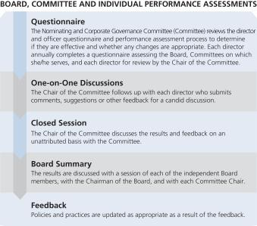

As a part of our continuous improvement process intended to enhance the Board’s overall effectiveness, the Board regularly evaluates its performance through self-assessments, corporate governance reviews and periodic charter reviews. Those evaluations, changes in our business strategy or operating environment, and the future needs of the Board in light of anticipated director retirements are used to identify desired backgrounds and skill sets for future Board members. The feedback solicited from Board members regarding the Board, each Committee on which they serve, and individual Board members is one of the tools used to assist the Nominating and Corporate Governance Committee in its responsibility to evaluate Board and Committee performance annually. For 2019, each director completed a written questionnaire. The questions were intended to solicit candid feedback by asking for comments. The collective ratings and comments were compiled, summarized and presented to the Nominating and Corporate Governance Committee, the Chair of which then followed-up as appropriate and shared the feedback with the full Board and the Chair of each Board Committee.

Board Committees

Martin Marietta’s Board of Directors has six standing Committees: the Audit Committee; the Ethics, Environment, Safety and Health Committee; the Executive Committee; the Finance Committee; the Management Development and Compensation Committee; and the Nominating and Corporate Governance Committee. Each Committee has a written charter

that describes its purposes, membership, meeting structure, authority and responsibilities. These charters are reviewed by the respective Committee on an annual basis with any recommended changes adopted upon approval by our Board. The charters of our six standing Committees are posted on our website.

Below is a summary of our current Committee structure and membership information.

 |  |  | Ethics, |  |  | Management
 |  |  | Environment, |  |  | Development | Nominating
 |  |  | Safety and |  |  | and | and Corporate
 | Independent | Audit | Health | Executive | Finance | Compensation | Governance
Director | Director | Committee | Committee | Committee | Committee | Committee | Committee

 | Dorothy M. Ables
 | Financial Expert
 | Sue W. Cole
 | Smith W. Davis |  |  | Chair
 | John J. Koraleski |  |  |  |  |  | Chair
 | Financial Expert |  |  |  |  |  | Chair
 | C. Howard Nye* |  |  |  | Chair
 | Laree E. Perez |  | Chair
 | Financial Expert |  | Chair
 | Thomas H. Pike
 | Michael J. Quillen
 | Lead Independent Director
 | Donald W. Slager |  |  |  |  |  |  | Chair
 | Stephen P. Zelnak, Jr. |  |  |  |  | Chair
 | Number of Meetings |  | 7 | 2 | 0 | 4 | 4 | 5
 | in 2020
* Mr. Nye is the only member of management who sits on the Board.
 |  |  |  |  |  |  | 2020 PROXY STATEMENT |  | 13

Table of Contents

The Board of Directors ◆ Board Committees

The Executive Committee held no meetings during 2019. It has the authority to act during the intervals between the meetings of the Board of Directors and may exercise the powers of the Board in the management of the business and affairs of Martin Marietta as may be authorized by the Board of Directors,

except to the extent such powers are by statute, our Articles of Incorporation or Bylaws reserved to the full Board. The Executive Committee’s current members are Directors Nye (Chair), Koraleski, and Quillen.

The primary responsibilities, membership and meeting information for our other standing Committees are summarized below.
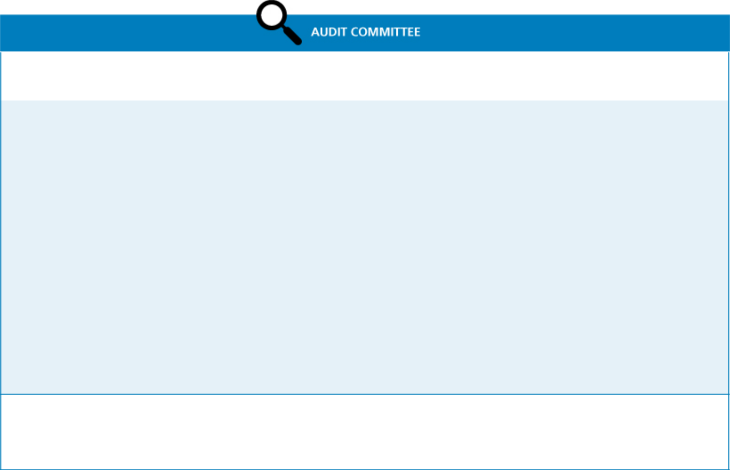

Current Members: | Meetings in 2019: | Average Attendance in 2019:
Laree E. Perez (Chair) | Meetings in 2019: | Average Attendance in 2019:
Dorothy M. Ables | 7 | 100%
John J. Koraleski
Primary Responsibilities:

- Reviews our significant accounting principles, policies and practices in reporting our financial results under generally accepted accounting principles.

- Reviews our annual audited financial statements and related disclosures.

- Reviews management letters or internal control reports, and reviews our system of internal control over financial reporting.

- Appoints, retains and oversees the work of the independent auditors.

- Reviews the effectiveness of the independent audit effort.

- Pre-approves audit and permissible non-audit services provided by the independent registered public accounting firm.

- Reviews our interim financial results for each fiscal quarter.

- Reviews the qualifications and the plan and scope of work of the corporate internal audit function.

- Reviews and discusses the reports of our internal audit group.

- Reviews and discusses management’s assessment of the effectiveness of Martin Marietta’s system of internal control over financial reporting.

- Discusses Martin Marietta’s earnings press releases, as well as financial information and earnings guidance provided to analysts, investors and rating agencies.

- Discusses matters related to risk assessment and risk management and how the process is handled by management.

- Reviews and oversees related party transactions.

- Reviews complaints regarding accounting, internal controls or auditing matters.

- Considers allegations of possible financial fraud or other financial improprieties.

- Reviews annually the adequacy of the Committee charter and recommends proposed changes to the Board.

- Prepares the annual Audit Committee Report to be included in the proxy statement.

Other Governance Matters:

All members of the Audit Committee, including the Chair, are audit committee financial experts under applicable SEC regulations.

The Chair of the Audit Committee is an independent Director.

The Chair of the Audit Committee has experience serving as a Chair and member of other public company audit committees.

All members satisfy the audit committee experience and independence standards required by the New York Stock Exchange (NYSE).

- 2020 PROXY STATEMENT

Table of Contents

Board Committees ◆ The Board of Directors
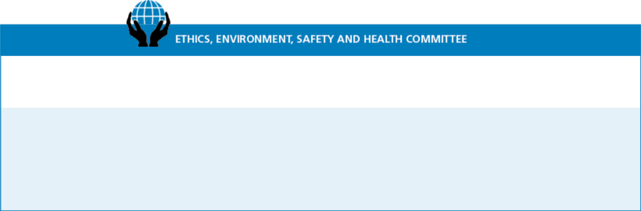

Current Members:
Smith W. Davis (Chair) | Meetings in 2019: | Average Attendance in 2019:
Sue W. Cole | 2 | 100%
Laree E. Perez
Stephen P. Zelnak, Jr.
Primary Responsibilities:

- Monitors compliance with our Code of Ethical Business Conduct and reviews all matters presented to it by the Corporate Ethics Officer concerning the ethical practices of Martin Marietta and its Directors, officers, and employees, including conflicts or potential conflicts of interest between Martin Marietta and any of its Directors, officers, and employees.

- Reviews and discusses our sustainability efforts, goals and risks, and our annual Sustainability Report.

- Reviews and monitors the adequacy of our policies and procedures and organizational structure for ensuring compliance with environmental laws and regulations.

- Reviews matters relating to our health and safety programs and performance.

- Reviews annually the adequacy of the Committee charter and recommends proposed changes to the Board.


Current Members:

Stephen P. Zelnak, Jr. (Chair)

Michael J. Quillen
Donald W. Slager

Meetings in 2019:

4

Average Attendance in 2019:

100%

Primary Responsibilities:

- Provides general oversight relating to the management of our financial affairs.

- Reviews and approves establishment of lines of credit or other short-term borrowing arrangements and investing excess working capital funds on a short-term basis.

- Reviews and makes recommendations to the Board concerning changes to capital structure, including the incurrence of long-term debt, issuance of equity securities, share repurchases, and the payment of dividends, as well as capital expenditures.

- Approves our charitable contributions budget.

- Reviews annually the adequacy of the Committee charter and recommends proposed changes to the Board.

2020 PROXY STATEMENT | 15

Table of Contents

The Board of Directors ◆ Board Committees
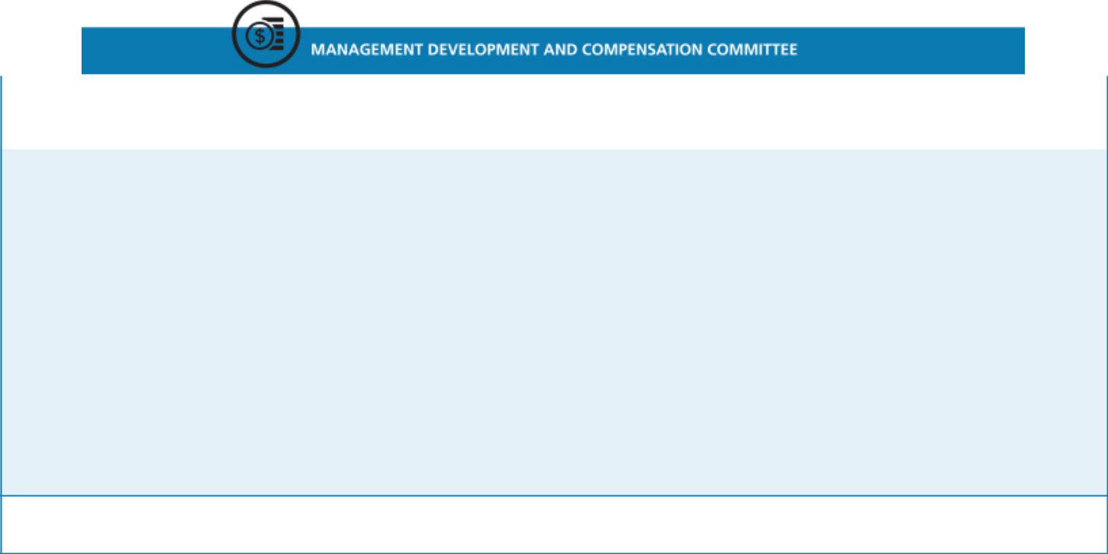

Current Members: | Meetings in 2019: | Average Attendance in 2019:
John J. Koraleski (Chair) | Meetings in 2019: | Average Attendance in 2019:
Thomas H. Pike | 4 | 100%
Michael J. Quillen
Primary Responsibilities:

- Establishes an overall strategy with respect to compensation for officers and management to enable Martin Marietta to attract and retain qualified employees.

- Reviews and oversees executive succession and management development plans.

- Reviews and approves management’s assessment of the performance of executive officers, and reviews and approves the salary, incentive compensation, and other compensation of such officers.

- Approves and administers our equity and other plans relating to compensation of Martin Marietta’s directors and executive officers.

- Reviews and discusses the Compensation Discussion and Analysis and produces a compensation committee report as required by the SEC to be included in this proxy statement.

- Provides oversight of our Benefit Plan Committee, which administers Martin Marietta’s defined benefit and contribution plans.

- Reviews and approves the goals and objectives for the CEO’s compensation, evaluates the CEO’s performance in light of those goals and objectives, and determines and approves the CEO’s compensation.

- Makes recommendations to the Board on changes in the compensation of non-employee directors.

- Reviews annually the adequacy of the Committee charter and recommends proposed changes to the Board.

- Has the authority, in its sole discretion, to retain, pay, and terminate any consulting firm, if any, used to assist in evaluating director, CEO, or senior executive compensation.

Other Governance Matters:

All members are non-employee, independent Directors, as required by the rules of the NYSE, the Martin Marietta Guidelines for Director’s Independence, applicable rules of the SEC, and the Committee’s charter.
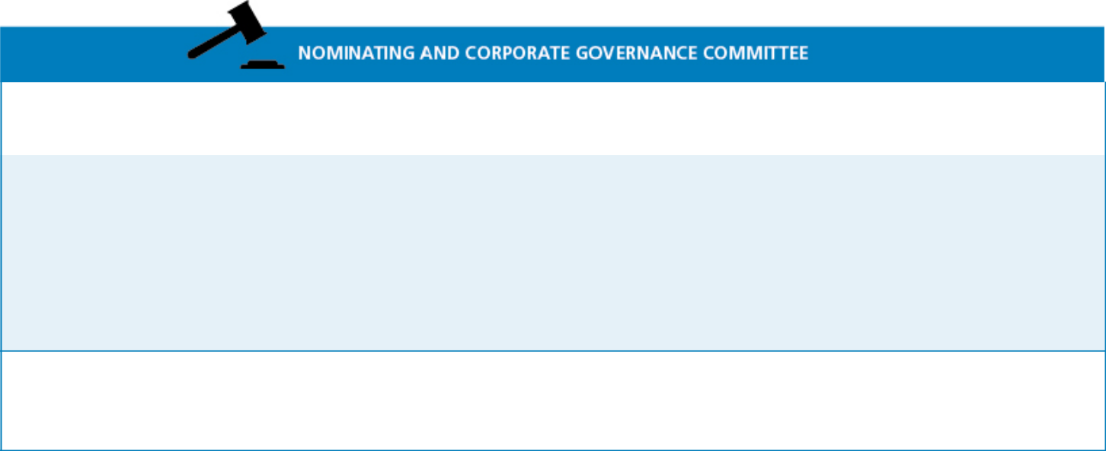

Current Members: | Meetings in 2019: | Average Attendance in 2019:
Donald W. Slager (Chair) | Meetings in 2019: | Average Attendance in 2019:
Sue W. Cole | 5 | 100%
Smith W. Davis
Primary Responsibilities:

- Develops criteria for nominating and appointing directors, including Board size and composition, corporate governance policies, and individual director expertise, attributes and skills.

- Recommends to the Board the individuals to be nominated as directors.

- Recommends to the Board the appointees to be selected for service on the Board Committees.

- Oversees an annual review of the performance of the Board and each Committee.

- Reviews annually the adequacy of the Committee charter and recommends proposed changes to the Board.

- Oversees the development and implementation of a set of corporate governance principles applicable to Martin Marietta.

Other Governance Matters:

All members are non-employee, independent Directors, as required by the rules of the NYSE.

Upon recommendation of this Committee, the Board of Directors has adopted a set of Corporate Governance Guidelines for Martin Marietta. The Guidelines are posted and available for public viewing on our website at https://ir.martinmarietta.com/corporate-governance. A copy may also be obtained upon request from Martin Marietta’s Corporate Secretary.

- 2020 PROXY STATEMENT

Table of Contents

Proposal 1

Election of Directors

The following sets forth the age, experience, key attributes and other biographical information for each nominee for election as a director for a one-year term until 2021.

◆DOROTHY M.


ABLES

Director Since: 2018

Age: 62

Committees:


Ms. Ables joined the Martin Marietta Board in November 2018. Ms. Ables held a number of executive positions with Spectra Energy and predecessor companies, including serving from 2008 to 2017 as the Chief Administrative Officer of Spectra Energy Corp., a North American energy infrastructure company, where she was responsible for human resources, information technology, support services, community relations and audit services. Prior to that, she served as Vice President of Audit Services and Chief Ethics and Compliance Officer for Spectra Energy, Vice President and Chief Compliance Officer for Duke Energy Corporation, an American electric power holding company, and Senior Vice President and Chief Financial Officer for Duke Energy Gas Transmission. Spectra Energy was a Fortune 500 Company and one of North America’s leading pipeline and midstream companies prior to its acquisition by Enbridge Inc. in 2017. Ms. Ables started her career in the audit department of Peat, Marwick, Mitchell & Co.

Ms. Ables serves as an Independent Director of Cabot Oil & Gas Corporation, an independent oil and gas company, where she is Chair of the audit committee and a member of the compensation committee. She served as a Director of Spectra Energy Partners, an affiliate of Spectra Energy Corp., from 2013 to 2017. Ms. Ables attended the University of Texas at Austin where she earned a Bachelor of Business Administration degree in Accounting.

Key attributes, experience and skills:

- More than 8 years of C-Suite experience

- Financial expertise acquired through serving as CFO of Duke Energy Gas Transmission and as Vice President of Audit Services and Chief Compliance Officer of Spectra Energy Corp. and Duke Energy Corporation

- Valuable business leadership in human resources, information technology, community relations, finance and financial statements

- Strong leadership skills and familiarity with Texas, an important state for the Company

◆SUE W. COLE


Director Since: 2002

Age: 69

Committees:


Ms. Cole is the managing partner of SAGE Leadership & Strategy, LLC, an advisory firm for businesses, organizations and individuals relating to strategy, governance and leadership development. Ms. Cole was previously a principal of Granville Capital Inc., a registered investment advisory firm, from 2006 to 2011, and before that she was the Regional CEO, Mid-Atlantic Region, of U.S. Trust Company, N.A., where she was responsible for the overall strategic direction, growth, and leadership of its North Carolina, Philadelphia and Washington, D.C. offices. Ms. Cole previously held various positions in the U.S. Trust Company, N.A. and its predecessors. Ms. Cole serves as Chair of the compensation committee of Biscuitville, Inc., where she was previously Chairman of the Board. Ms. Cole has previously served on the public-company board of UNIFI, Inc. She has also been active in community and charitable organizations, including previously serving as Chairman of the North Carolina Chamber of Commerce, on the investment committee of the University of North Carolina at Greensboro and as a member on the North Carolina Economic Development Board. Ms. Cole attended the University of North Carolina at Greensboro where she earned a Bachelor of Science degree in Business Administration and a Masters in Business Administration in Finance.

Key attributes, experience and skills:

- Valuable experience in executive compensation, corporate governance, human resources, finance and financial statements, and customer service

- Chief executive officer of several financial services businesses as well as several non-profit organizations

- Strong leadership skills and familiarity with North Carolina, an important state for the Company

2020 PROXY STATEMENT | 17

Table of Contents

Proposal 1: Election of Directors ◆


◆SMITH W. DAVIS

Director Since: 2018

Age: 72

Committees:

Director Nominees

Mr. Davis is a shareholder at Greenberg Traurig, LLP, an international law firm, where he focuses his practice on both legal reform (litigation-related policy matters) across a broad range of industries and issues related to natural gas pipelines. His work with respect to pipelines has centered on multiemployer pension policy and environmental issues. Previously, Mr. Davis served as senior partner at Akin Gump Strauss Hauer & Feld LLP, an international law firm focused on lobbying, where he provided counsel on a wide variety of legislative and regulatory matters, including those before a variety of congressional committees. Mr. Davis joined Akin Gump in 1979, and his practice included advising on legal matters relating to environmental issues, financial institutions, mergers and acquisitions, and pension reform. Mr. Davis also served on Akin Gump’s compensation and management committees. Prior to joining Akin Gump, Mr. Davis served as a counsel to the House Judiciary Committee. Mr. Davis attended Yale University where he received a Bachelors of Arts degree, magna cum laude, and Yale Law School where he received his Juris Doctor degree.

Key attributes, experience and skills:

- Extensive experience in legal, compliance, and corporate governance

- Strong leadership skills and expertise in governmental and regulatory issues, safety, health and environmental matters, mergers and acquisitions, executive compensation, financial affairs, and risk assessment

- Brings additional perspective to the Board on diversity and corporate citizenship

Chair

◆JOHN J.


KORALESKI

Director Since: 2016

Age: 69

Committees:


Chair

Mr. Koraleski joined the Martin Marietta Board in 2016. Mr. Koraleski served from February 2015 through his retirement in September 2015 as executive Chairman of the Board of the Union Pacific Corporation (UP), which through its subsidiaries operates North America’s premier railroad franchise, covering 23 states across the western two-thirds of the United States. Prior to that, he was named President and Chief Executive Officer of the UP in March 2012, elected as a Director of the UP in July 2012 and appointed Chairman of the Board in 2014. Since joining the Union Pacific (Railroad) in 1972, Mr. Koraleski held a number of executive positions in the UP and the Railroad, including, Executive Vice President – Marketing and Sales from 1999 to 2012, Executive Vice President – Finance and Information Technology, Chief Financial Officer and Controller. Mr. Koraleski served as the Chairman of The Bridges Investment Fund, Inc., a general equity fund whose primary investment objective is to seek long-term capital appreciation, from 2005 through March 2012 and is a past Chairman of the Association of American Railroads. Mr. Koraleski earned a Bachelor’s and Master’s degree in business administration from the University of Nebraska at Omaha.

Key attributes, experience and skills:

- Experience with the demands and challenges associated with managing a large publicly-traded organization from his experience as Chairman and CEO of Union Pacific

- Extensive knowledge of financial system management, public company accounting, disclosure requirements and financial markets

- Valuable expertise in talent management, compensation, governance and succession planning

- Understanding of complex logistic operations, safety and rail operations

- Broad strategic analysis and experience with acquisitions, integration, marketing and information technologies

- 2020 PROXY STATEMENT

Table of Contents

Director Nominees ◆ Proposal 1: Election of Directors

◆C. HOWARD NYE


Director Since: 2010

Age: 57

Chairman of the Board

Committees:


Chair

Mr. Nye has served as Chairman of the Board since 2014, as President of Martin Marietta since 2006 and as Chief Executive Officer and a Director since 2010. Mr. Nye previously served as Chief Operating Officer from 2006 to 2009. Prior to joining Martin Marietta in 2006, Mr. Nye spent nearly 13 years in a series of increasingly responsible positions with Hanson PLC, an international building materials company, including as Executive Vice President of its North American building materials business. Mr. Nye received a Bachelor’s degree from Duke University and a Juris Doctor degree from Wake Forest University. In addition to his educational, professional, executive and related roles, Mr. Nye is a past Chairman of the Board of the National Stone, Sand & Gravel Association (NSSGA); he presently serves as Chairman of the North Carolina Chamber and as Vice Chairman of the American Road & Transportation Builders Association (ARTBA). Mr. Nye is also a member of the Board of Directors of the United States Chamber of Commerce, the world’s largest business organization. Since 2018, Mr. Nye has been a member of the Board of Directors of General Dynamics Corporation (NYSE: GD), a global aerospace and defense company. From 2015 to 2018, Mr. Nye was also an independent director for Cree, Inc. (NASDAQ: CREE), an American manufacturer and marketer of lighting-class lighting products. In 2019, Forbes magazine recognized Mr. Nye as one of America’s Most Innovative Leaders; he was previously recognized by both Aggregates Manager and Pit & Quarry magazines, as Aggman of the Year and a Hall of Fame inductee, respectively. Mr. Nye has also served on numerous other state, local and/or philanthropic organizations including the North Carolina Business Council of Management and Development, Inc., Co-Chair of the NC FIRST Commission (evaluating North Carolina’s current and future transportation investment needs), and as a gubernatorial appointee to the North Carolina Mining Commission. He has also served on the Alumni Boards at Duke University and Wake Forest University School of Law.

Key attributes, experience and skills:

- Extensive knowledge of the construction aggregates industry

- Extensive leadership, business, operating, marketing, mergers and acquisitions, legal, customer-relations, and safety and environmental experience

- Understands the competitive nature of the business and has strong management skills, broad executive experience, and corporate governance expertise

- Broad strategic vision for the future growth of Martin Marietta

◆LAREE E. PEREZ


Director Since: 2004

Age: 66

Committees:


Ms. Perez is an investment consultant with DeRoy & Devereaux, an independent investment adviser, where she has provided client consulting services since 2015. She was previously Owner and Managing Partner of The Medallion Company, LLC, a consulting firm, from 2003 to 2015. Ms. Perez was previously a Director of GenOn Energy, Inc., one of the largest power producers in the United States, from 2002 to 2012, and served as the Chairman of the audit committee of GenOn Energy, Inc. from 2002 to 2007 and a member of its audit and risk and finance oversight committees from 2008 to 2012. Previously, she was Vice President of Loomis, Sayles & Company, L.P. and co-founder, President and Chief Executive Officer of Medallion Investment Company, Inc. In addition to civic and charitable organizations, Ms. Perez served as Vice Chairman of the Board of Regents at Baylor University and previously served on the Board of Trustees of New Mexico State University, where she was also Chairman of the Board. Ms. Perez earned a Bachelor’s degree from Baylor University in Finance and Economics.

Key attributes, experience and skills:

- Significant business, financial and private investment experience

- Significant expertise with respect to financial statements, corporate finance, accounting and capital markets, mergers and acquisitions, and strategic analysis

- Insight into auditing best practices

- Familiarity with the southwestern United States

Chair

2020 PROXY STATEMENT | 19

Table of Contents

Proposal 1: Election of Directors


◆THOMAS H.

PIKE

Director Since: 2019

Age: 60

Committees:


- Director Nominees

Mr. Pike joined the Martin Marietta Board in July 2019. Mr. Pike served as Chief Executive Officer and a member of the Board of Directors of Quintiles Transnational Holdings, Inc. (Quintiles) from April 2012 until its merger with IMS Health in December 2016 to create IQVIA (NYSE:IQV). Before its merger with IMS, Quintiles had a network of more than 35,000 employees conducting business in approximately 100 countries. Mr. Pike led Quintiles through a successful public offering and helped it grow into a Fortune 500 company. Under Mr. Pike’s leadership, Quintiles was named one of the world’s Most Ethical Companies in 2016. Prior to Quintiles, Mr. Pike spent 22 years at Accenture (NYSE: ACN), a leading global professional services company, providing a broad range of services and solutions in strategy, consulting, digital, technology and operations, until December 2009. At Accenture, Mr. Pike’s roles included serving as Chief Risk Officer and Managing Director of the North America Health and Products business areas. He previously served as the global Chief Operating Officer for Accenture’s Resources operating group and had also served as Accenture’s Chief Strategy Officer. Since leaving Accenture in December 2009 and until joining Quintiles in April 2012, Mr. Pike was involved with a number of start-ups in the technology and healthcare sectors. Early in his career Mr. Pike was a consultant with McKinsey & Company. Mr. Pike earned his Bachelor’s degree in accounting from the University of Delaware.

Key attributes, experience and skills:

- More than 14 years of C-Suite experience

- Broad strategic and financial experience

- Extensive experience in mergers and acquisitions, integration, and strategic development and analysis

- Significant mentorship, business and operating experience in a public company

- Valuable knowledge of financial system management, public company accounting, disclosure requirements and financial markets

◆MICHAEL J.
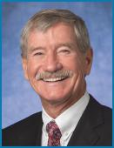

QUILLEN

Director Since: 2008

Age: 71

Lead Independent Director

Committees:


Mr. Quillen was the founder and served as Chief Executive Officer of Alpha Natural Resources, Inc. (NYSE: ANR), a leading eastern United States coal supplier, since its formation in 2004 until its merger with Foundation Coal Holdings, Inc. in July 2009, and served as President and Chairman of ANR from 2006 to 2009, and non-Executive Chairman until May 2012. Mr. Quillen held senior executive positions in the coal industry throughout his career at Pittston/Pittston Coal Sales Corp., AMVEST Corporation, NERCO Coal Corporation, Addington, Inc. and Mid-Vol Leasing, Inc. He has also served as Chairman (Rector) of the Board of Visitors of Virginia Polytechnic Institute and State University from July 2012 to June 2018. He was Chairman of the audit and finance committee of Virginia Polytechnic Institute and State University from July 2010 to June 2012. He also served on the Virginia Port Authority from 2003 to 2012 and as Chairman from July 2011 to December 2012. Mr. Quillen attended Virginia Polytechnic Institute and State University, earning both Bachelor’s and Master’s degrees in Civil Engineering.

Key attributes, experience and skills:

- Valuable business, leadership, management, financial, and mergers and acquisitions experience

- Extensive experience related to mining companies, governmental and regulatory issues, safety, health and environmental matters

- Tremendous insight and expertise with respect to strategic analysis, the natural resources industry, and energy

- Wealth of knowledge related to transportation

- 2020 PROXY STATEMENT

Table of Contents

Director Nominees ◆ Proposal 1: Election of Directors

◆DONALD W.


SLAGER

Director Since: 2016

Age: 58

Committees:


Chair

Mr. Slager serves as President and Chief Executive Officer of Republic Services, Inc. (Republic), a service provider in the non-hazardous solid waste industry, holding this position since January 2011. Prior to this, he served as President and Chief Operating Officer of Republic from December 2008 until his promotion to CEO. Prior to that, Mr. Slager served in the same capacity for Allied Waste Industries, Inc. (Allied Waste), from 2005 to 2008, prior to its merger with Republic. Mr. Slager was Executive Vice President and Chief Operating Officer of Allied Waste between 2003 and 2004. Prior to that, Mr. Slager held varying positions of increasing responsibility with Allied Waste. Mr. Slager also has served as a Director of Republic since 2010. Mr. Slager previously served as an independent Director of UTi Worldwide Inc. (UTi) from 2009 to January 2016, where he served as Chairman of the nominating and corporate governance committee and as a member of both the compensation and risk committees. UTi, a former NYSE listed company, was an international, non-asset-based supply chain services and solutions company providing air and ocean freight forwarding, contract logistics, customs brokerage, distribution, inbound logistics, truckload brokerage and other supply chain management services until it was acquired by DSV A/S, a third-party logistics services provider, in January 2016. Mr. Slager has completed the Northwestern University Kellogg School Advanced Executive Program and holds a certificate from the Stanford University Board Consortium Development Program.

Key attributes, experience and skills:

- More than 15 years of C-Suite experience

- More than 28 years of general management experience in a complex, capital intensive and logistics business

- Extensive experience in mergers and acquisitions, integration, and strategic development and analysis

- Valuable experience from his membership on two publicly-traded board of directors

◆DAVID C.


WAJSGRAS

Director Since: N/A

Age: 60

Mr. Wajsgras served as Raytheon Company (NYSE: RTN) vice president and president of the Intelligence, lnformation and Services (IIS) business from March 2015 to April 2020. Raytheon is a major U.S. defense contractor and industrial corporation. IIS provides a full range of technical and professional services to intelligence, defense, federal and commercial customers worldwide. The business specializes in global Intelligence, Surveillance and Reconnaissance; navigation; Department of Defense space and weather solutions; cybersecurity; analytics; training; logistics; mission support; engineering; automation and sustainment solutions; and international and domestic Air Traffic Management systems. Prior to this role, he was senior vice president and chief financial officer (CFO) of Raytheon from March 2006 to March 2015. Before joining Raytheon, Mr. Wajsgras was executive vice president and CFO of Lear Corporation, an American automotive manufacturing company. Prior to joining Lear, Mr. Wajsgras was corporate controller for Engelhard Corporation, a former American Fortune 500 company that supplied catalysts. He also held numerous financial management positions with Honeywell International, Inc., an American multinational conglomerate company. Mr. Wajsgras served as the chair of the board for Raytheon Australia and was on the board for Forcepoint. He serves on the Center for a New American Security Advisory Board; the Intelligence and National Security Alliance Board of Directors; and is a member of the Massachusetts Cybersecurity Strategy Council. In 2019, Washington Exec named Mr. Wajsgras to its top 25 list of executives and recognized him as its Intelligence Industry Executive of the Year. Mr. Wajsgras has appeared on Executive Mosaic’s annual Wash 100 list of influential leaders in the government contracting arena for the last five years. He was named Federal Computer Week’s prestigious Industry Eagle Award winner in 2018 for his pivotal role in the U.S. government Information Technology community. In 2012, Mr. Wajsgras was named one of the Wall Street Journal’s 25 Best CFOs among the larger companies in the Standard

- Poor’s 500 Index. Mr. Wajsgras earned his Bachelor’s degree in accounting from the University of Maryland. He has a Masters in Business Administration from American University.

Key attributes, experience and skills:

- Extensive financial and operating experience

- Knowledge of corporate finance, strategic planning and risk management processes

- Experience as a public company CFO, as well as expansive knowledge of accounting principles and practices, auditing, internal control over financial reporting, and risk management processes

- Expertise in cybersecurity products and services

The Board Unanimously Recommends a Vote “FOR” All Nominees for Election to the Board of Directors on this Proposal 1

2020 PROXY STATEMENT | 21

Table of Contents

Proposal 1: Election of Directors ◆ Director Compensation

Director Compensation

Martin Marietta uses a combination of cash and stock-based compensation to attract and retain qualified candidates to serve on the Board of Directors. In setting Director compensation, Martin Marietta considers the significant amount of time that Directors expend in fulfilling their duties to Martin Marietta as well as the skill level required by Martin Marietta of members of the Board. The Board determines reasonable compensation for Directors upon recommendation of the Management Development and Compensation Committee of the Board, which retains an independent compensation consultant to assist it in making each recommendation.

Cash Compensation Paid to Board Members

The cash-based elements of annual Director compensation for fiscal year 2019 paid in quarterly installments, measured from the end of the month during which the 2019 Annual Meeting of Shareholders was held, were as follows.


Cash Component Amount
Annual Board cash retainer | $ | 120,000
Annual Audit Committee chair retainer¹ | $ | 20,000
Annual Management Development and
Compensation Committee chair retainer² | $ | 17,500
Annual Finance Committee chair retainer² | $ | 15,000
Annual Nominating and Corporate Governance
Committee chair retainer² | $ | 15,000
Annual Ethics, Environmental, Health & Safety
Committee chair retainer² | $ | 8,000
Annual Audit Committee member retainer² | $ | 5,000
Annual Lead Independent Director retainer³ | $ | 30,250

- This is in addition to the annual retainer and the annual Audit Committee member retainer
- This is in addition to the annual retainer in view of increased responsibilities

- This is in addition to the annual retainer and the annual Committee chair retainers in view of increased responsibilities

The Company reimburses Directors for the travel expenses of, or provides transportation on Company aircraft for, Board and Committee meetings, meetings with management or independent consultants or advisors, and other Company-related events, such as Investor Day and meetings with potential Board candidates. Martin Marietta’s plane was used to transport some Directors to and from Board and Committee meetings, but no Directors received personal use of Martin Marietta’s plane or other perquisites or personal benefits in 2019.

Equity Compensation Paid to Board Members

Non-employee Directors received an award of restricted stock units (RSUs) with a value of $130,000 (rounded up to the nearest RSU) based on the closing price as of the date of grant,

- 2020 PROXY STATEMENT

which was generally immediately following the 2019 Annual Meeting of Shareholders in May 2019. In May 2019, this award was 600 RSUs. Mr. Pike received his RSU award of 578 RSUs when he joined the Board. The RSUs granted to the Directors in 2019 were fully vested upon award. Directors are required to defer at least 50% of the RSUs until retirement from the Board. Directors may choose to voluntarily defer an additional portion of their RSUs, and any RSUs that are not so deferred are settled in shares of common stock of Martin Marietta as soon as practicable following the grant date. The RSUs were awarded under the Martin Marietta Amended and Restated Stock-Based Award Plan (the Stock Plan), which was approved by shareholders on May 19, 2016. The Stock Plan provides that, during any calendar year, no non-employee Director may be granted
- restricted shares and other full-value stock-based awards, including RSUs, in respect of more than 7,000 shares of common stock of Martin Marietta or (ii) options or stock appreciation rights in respect of more than 20,000 shares of common stock of Martin Marietta.

The Directors do not have voting or investment power for their respective RSUs.

Deferred Compensation Program for Board Members

The Common Stock Purchase Plan for Directors provides that non-employee Directors may elect to receive all or a portion of their fees earned in 2019 in the form of Martin Marietta common stock units. If deferral is elected, there is a mandatory deferral minimum time of three years with, subject to certain restrictions, redeferrals at each Director’s election up to the date the person ceases to be a Director or the date that is one year and one month following the date that the person ceases to be a Director. Directors may elect to receive payment of the deferred amount in a single lump sum or in equal annual installments for a period of up to ten years. By resolution adopted by Martin Marietta’s Board of Directors on May 17, 2018, amounts deferred under the plan in common stock are credited toward units of common stock at 100% of the fair market value of the common stock (the closing price of the common stock as reported in The Wall Street Journal) on the date the Director fees would otherwise be paid. Prior to that, amounts deferred under the plan in common stock were credited toward units of common stock at a 20% discount from the fair market value of the common stock (the closing price of the common stock as reported in The Wall Street Journal) on the date the Director fees would otherwise be paid. There are no matching contributions made by Martin Marietta. Dividend equivalents are paid on the units at the same rate as dividends are paid to all shareholders. The Directors do not have voting or investment power for their respective common stock units. Directors may also elect to defer their fees into a cash-based account on the same basis. Amounts deferred under the plan in cash are credited with interest at the prime rate as of January 1 of that year.

Table of Contents

Director Compensation ◆ Proposal 1: Election of Directors

Director Compensation Table

The table below summarizes the compensation paid by Martin Marietta to each person who served as a non-employee Director during the fiscal year ended December 31, 2019.

 |  |  | Change in Pension
 |  |  | Value and
 |  |  | Nonqualified
 | Fees |  | Deferred
 | Earned or | Stock | Compensation | All Other
 | Paid in Cash | Awards | Earnings | Compensation | Total
Name¹ | ($)² | ($)³ | ($)⁴ | ($)⁵ | ($)
(a) | (b) | (c) | (f) | (g) | (h)
Dorothy M. Ables | 125,000 | 130,164 | 64 | 2,481 | 257,709
Sue W. Cole | 123,750 | 130,164 | 25,429 | 53,947 | 333,290
Smith W. Davis | 126,000 | 130,164 | 141 | 4,625 | 260,930
John J. Koraleski | 138,125 | 130,164 | 416 | 6,765 | 275,470
Laree E. Perez | 145,000 | 130,164 | 12,194 | 30,049 | 317,407
Thomas H. Pike | 60,000 | 130,044 | 5 | 636 | 190,685
Michael J. Quillen | 155,064 | 130,164 | 12,135 | 34,821 | 332,184
Dennis L. Rediker⁶ | 33,250 | 0 | 6,576 | 9,497 | 49,323
Donald W. Slager | 131,250 | 130,164 | 362 | 4,217 | 265,993
Stephen P. Zelnak, Jr. | 135,000 | 130,164 | 9,733 | 32,024 | 306,921

- Mr. Nye, who is the Chief Executive Officer of Martin Marietta and a member of the Board of Directors, is not included in this table because he is not compensated separately for his service as a Director. The compensation received by Mr. Nye as an employee of Martin Marietta is shown in the Summary Compensation Table on page 57.

- The amounts in column (b) reflect fees earned in 2019. Some of these fees were deferred pursuant to the Common Stock Purchase Plan for Directors in the form of common stock units. The number of units of common stock credited in 2019 to each of the Directors under the Common Stock Purchase Plan for Directors and the grant date fair value for these awards determined in accordance with FASB ASC Topic 718, are as follows: Ms. Ables, 0; Ms. Cole, 554 units and $124,165 value, respectively; Mr. Davis, 560 units and $126,691 value, respectively; Mr. Koraleski, 611 units and $138,626 value, respectively; Ms. Perez, 0; Mr. Pike, 0; Mr. Quillen, 694 units and $155,510 value, respectively; Mr. Rediker, 36 units and $6,761 value, respectively; Mr. Slager, 0; and Mr. Zelnak, 301 units and $67,864 value, respectively. The number of units credited to each of the Directors as of December 31, 2019, including units accumulated under the plan for all years of service as a Director, is as follows: Ms. Ables, 0; Ms. Cole, 15,716; Mr. Davis, 1,023; Mr. Koraleski, 1,235; Ms. Perez, 5,258; Mr. Pike, 0; Mr. Quillen, 7,048; Mr. Slager, 0; and Mr. Zelnak, 6,831. Mr. Pike joined the Board in July 2019 and his fees were prorated.

- Each Director who was serving immediately following the 2019 Annual Meeting of Shareholder received 600 RSUs in May 2019. Mr. Pike received 578 RSUs upon joining the Board in July 2019. The amounts in column (c) reflect the grant date fair value for these awards determined in accordance with FASB ASC Topic 718. The RSUs fully vested upon award and will be distributed to the Director upon retirement, except Ms. Perez and Mr. Quillen each received a distribution of 300 unrestricted shares of common stock and deferred the distribution of 300 RSUs until retirement. As of December 31, 2019, each Director held RSUs in the amounts as follows: Ms. Ables, 1,344; Ms. Cole, 10,153; Mr. Davis, 1,209; Mr. Koraleski, 2,148; Ms. Perez, 9,329; Mr. Pike, 578; Mr. Quillen, 9,329; Mr. Slager, 2,187; and Mr. Zelnak, 8,774. As of December 31, 2019, none of the Directors held options for common stock. Mr. Rediker’s RSUs were distributed upon his retirement.
- The amounts in column (f) reflect interest paid on fees deferred in cash under the Common Stock Purchase Plan for Directors.

- The amounts in column (g) reflect for each Director the dollar value of dividend equivalents paid in 2019 on common stock units held under the plan. The Directors did not receive perquisites or other personal benefits in 2019.

- Mr. Rediker retired at the 2019 Annual Meeting of Shareholders in accordance with the Bylaws that provide for retirement following the Director’s 75th birthday.

2020 PROXY STATEMENT | 23

Table of Contents

Security Ownership of Certain

Beneficial Owners and Management

How much stock do Martin Marietta’s Directors and executive officers own?

The following table sets forth information as of March 6, 2020 with respect to the shares of common stock that are beneficially owned by the Directors, the Director nominee, the Chief Executive Officer, the Chief Financial Officer, and the three other named executive officers who are listed in the Summary Compensation Table on page 57 of this proxy statement, individually, and by all Directors and executive officers of Martin Marietta as a group. The address of each beneficial owner below is Martin Marietta’s principal executive office.

 | Amount and Nature of | Deferred and
Name of Beneficial Owner | Beneficial Ownership¹ | Restricted Units⁵ | Total
Dorothy M. Ables | 1,344² | — | 1,344
Roselyn R. Bar | 56,074³ | 8,464 | 64,538
Sue W. Cole | 31,882^{2,4} | — | 31,882
Smith W. Davis | 2,373² | — | 2,373
Daniel L. Grant | 16,161³ | 4,132 | 20,293
John J. Koraleski | 8,440² | — | 8,440
Craig M. LaTorre | 499³ | 9,112 | 9,611
James A. J. Nickolas | 2,841³ | 9,160 | 12,001
C. Howard Nye | 134,308³ | 43,509 | 177,817
Laree E. Perez | 14,587² | — | 14,587
Thomas H. Pike | 578² | — | 578
Michael J. Quillen | 19,972² | — | 19,972
Donald W. Slager | 2,187² | — | 2,187
David C. Wajsgras | — | — | —
Stephen P. Zelnak, Jr. | 23,030² | — | 23,030
All Directors and executive officers as
a group
(17 individuals including those named | 316,128^{3,4}
above) | 316,128^{3,4} | 87,902 | 404,030

- As to the shares reported, unless indicated otherwise, (i) beneficial ownership is direct, and (ii) the person indicated has sole voting and investment power. None of the Directors or named executive officers individually own in excess of one percent of the shares of common stock outstanding. All Directors and executive officers as a group own 0.0058% of the shares of common stock outstanding as of March 6, 2020. None of the shares reported are pledged as security.

- Amounts reported include (1) compensation paid on an annual basis that Directors have received in common stock units that are deferred pursuant to the Amended and Restated Martin Marietta Materials, Inc. Common Stock Purchase Plan for Directors and (2) RSUs that each Director received in 2019 as part of their compensation. The Directors do not have voting or investment power for their respective common stock units and RSUs. The number of common stock units credited to each of the Directors pursuant to the Common Stock Purchase Plan as of March 6, 2020 is as follows: Ms. Ables, 0; Ms. Cole, 15,848; Mr. Davis, 1,164; Mr. Koraleski, 1,392; Ms. Perez, 5,258; Mr. Pike, 0; Mr. Quillen, 7,214; Mr. Slager, 0; and Mr. Zelnak, 6,906.

- The number of shares owned for each of Mr. Nye, Ms. Bar, Mr. LaTorre, Mr. Grant, Mr. Nickolas and all Directors and executive officers as a group assumes that options held by each of them covering shares of common stock in the amounts indicated, which are currently exercisable within 60 days of March 6, 2020, have been exercised: Mr. Nye, 10,000; Ms. Bar, 8,517; Mr. Grant, 1,892; Mr. LaTorre, 0; Mr. Nickolas, 0; and all Directors and executive officers as a group, 20,409.
- Includes an approximation of the number of shares in an IRA account.

- The amounts reported include common stock units credited to each of the NEOs in connection with (i) their deferral of a portion of their cash bonus under the Martin Marietta Materials, Inc. Incentive Stock Plan, and (ii) RSUs (not including any performance-based share units (PSUs) granted under the Stock Plan that are subject to forfeiture in accordance with the terms of the plan and are scheduled to vest within 60 days of March 6, 2020), each in the following amounts: Mr. Nye, 19,727 and 23,782, respectively; Ms. Bar, 3,534 and 4,930, respectively; Mr. Nickolas, 1,375 and 7,785, respectively; Mr. Grant, 1,432 and 2,700, respectively; Mr. LaTorre, 507 and 8,605, respectively; and all Directors and executive officers as a group, 17,247 and 54,491, respectively. There are no voting rights associated with the stock units or RSUs.

- 2020 PROXY STATEMENT

Table of Contents

Section 16(a) Beneficial Ownership Reporting Compliance ◆ Security Ownership of Certain Beneficial Owners and Management

Who are the largest owners of Martin Marietta’s stock?

The following table sets forth information with respect to the shares of common stock which are held by persons known to Martin Marietta to be the beneficial owners of more than 5% of such stock as of March 6, 2020. To the best of Martin Marietta’s knowledge, based on filings with the Securities and Exchange Commission as noted below, no person beneficially owned more than 5% of any class of Martin Marietta’s outstanding voting securities at the close of business on March 6, 2020, except for those shown below.

 |  | Percent
Name and Address | Amount and Nature | of Class
of Beneficial Owner | of Beneficial Ownership
The Vanguard Group¹
100 Vanguard Boulevard V26
Malvern, PA 19355 | 6,898,654 | 11.03%
BlackRock, Inc.²
55 East 52nd Street
New York, NY 10055 | 4,105,223 | 6.6%

- As reported in Schedule 13G/A reporting beneficial ownership as of December 31, 2019 filed with the Securities and Exchange Commission on February 12, 2020, indicating sole power to vote 93,240 shares, shared power to vote 16,298 shares, sole power to dispose of 6,794,063 shares, and shared power to dispose of 104,591 shares.

- As reported in Schedule 13G/A reporting beneficial ownership as of December 31, 2019 filed with the Securities and Exchange Commission on February 5, 2020, indicating sole power to vote 3,626,476 shares and sole power to dispose of 4,105,223 shares.

Delinquent Section 16(a) Reports

Section 16(a) of the Exchange Act requires Directors and officers of Martin Marietta and persons who own more than 10% of the common stock to file with the SEC initial reports of ownership and reports in changes in ownership of the common stock. Directors, officers and more than 10% shareholders are required by SEC regulations to furnish to Martin Marietta copies of all Section 16(a) reports filed. Based solely on its review of copies of reports furnished to Martin Marietta, the Company believes that during fiscal year 2019, such filing requirements were timely satisfied except for 6 quarterly dividend reinvestments in 2017 and 2018 that should have been previously reported on two Form 5s were inadvertently reported late by John P. Mohr, Senior Vice President and Chief Information Officer. Such reinvestments related to approximately 3.9 shares in the aggregate.

2020 PROXY STATEMENT | 25

Table of Contents

Corporate Governance Matters

Corporate Governance Philosophy

Martin Marietta has a culture dedicated to ethical business behavior and responsible corporate activity, which we believe promotes the long-term interests of shareholders. This commitment is reflected in our Corporate Governance Guidelines, posted and available for public viewing on Martin Marietta’s website at https://ir.martinmarietta.com/corporate-governance, which set forth a flexible framework within which the Board, assisted by its Committees, directs the affairs of Martin Marietta. The Guidelines address, among other things, the composition and functions of the Board of Directors, director qualifications and independence, Chief Executive Officer performance evaluation and management succession, Board Committees and the selection of new Directors.

Martin Marietta’s Code of Ethical Business Conduct has been in place since the 1980s and is regularly updated. It applies to all Board members, officers, and employees, providing our policies and expectations on a number of topics, including our commitment to good citizenship, promoting a positive and safe

work environment, avoiding conflicts of interest, honoring the confidentiality of sensitive information, preservation and use of Company assets, compliance with all laws, and operating with integrity in all that we do. To implement the Code of Ethical Business Conduct, Board members, officers, and employees participate regularly in ethics training. There have been no waivers from any provisions of our Code of Ethical Business Conduct to any Board member or executive officer.

In addition, the Board believes that accountability to shareholders is a hallmark of good governance and critical to Martin Marietta’s success. To that end, management regularly engages with shareholders on a variety of topics throughout the year, including sustainability and governance, to ensure we are addressing their questions, thoughts and concerns, to seek input and to provide perspective on Company policies and practices. Feedback received during these discussions is shared with the Board and directly impacts deliberations on material topics. See discussion of our shareholder outreach on pages 6 and 35.

The chart below provides a snapshot of Martin Marietta’s governance highlights.
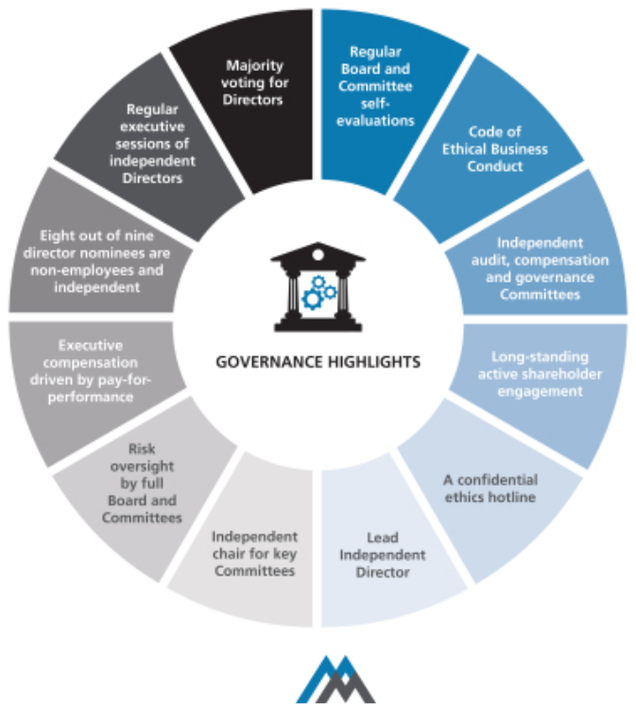

- 2020 PROXY STATEMENT

Table of Contents

Who are Martin Marietta’s Independent Directors?

All of Martin Marietta’s Directors are non-employee Directors except Mr. Nye. Mr. Nye neither sits in the executive sessions of the independent Directors (unless invited to attend for a specific discussion) nor does he participate in any action of the Board relating to any executive compensation which he may receive.

In assessing the independence of its members and nominees, the Board has adopted for Martin Marietta a set of Guidelines for Director’s Independence (Guidelines). The Guidelines are posted and available for

public viewing on Martin Marietta’s website at https://ir.martinmarietta.com/corporate-governance. These Guidelines reflect the rules of the NYSE, applicable requirements of the SEC, and other standards determined by the Board to be important in assessing the independence of Board members. The Board has determined that, other than Mr. Nye, all members of the Board and Mr. Wajsgras are “independent” under these Guidelines, resulting in 90% of the Board being independent. The Board of Directors has determined that no Director (except Mr. Nye), or nominee, or any person or organization with which the Director or nominee has any affiliation, has a relationship with Martin Marietta that may interfere with his or her independence from Martin Marietta and its management. In making this “independence” determination, the Board considered other entities with which the Directors and Mr. Wajsgras were affiliated and any business Martin Marietta had done with such entities.

Do the independent Directors ever meet without management? Martin Marietta’s Corporate Governance Guidelines adopted by the Board provide that at least two Board meetings each year will include an executive session of the non-employee Directors to discuss such topics as they may choose, including a discussion of the performance of Martin Marietta’s Chairman and Chief Executive Officer. In 2019, Martin Marietta’s independent Directors met at each regularly scheduled Board meeting, consisting of four times in executive session without management, in addition to executive sessions held by Committees of the Board. In 2019, all the independent Directors were non-employees.

What is the Board’s leadership structure?

Our Corporate Governance Guidelines provide that the Board’s policy as to whether the Chairman and CEO positions should be separate is to adopt the practice that best serves the Company’s needs at any particular time. The Nominating and Corporate Governance Committee and the Board discussed board leadership alternatives in connection with combining the Chairman and CEO roles.

The Board believes that, at the present time, the Company is best served by allocating governance responsibilities between a combined Chairman and CEO and a Lead Independent Director with robust responsibilities. This structure allows the Company to present a single face to our constituencies through the

Corporate Governance Philosophy ◆ Corporate Governance Matters

combined Chairman and CEO position while at the same time providing an active role and voice for the independent directors through the Lead Independent Director.


REASONS FOR COMBINED CHAIR AND CEO

Key highlights:

- The independent Board members believe that Mr. Nye has extensive experience in all facets of the construction materials industry, in both the U.S. and with global competitors.

- Mr. Nye has been effective in creating shareholder value through strategic acquisitions and divestitures, with achievement of expected synergies.

- Mr. Nye has in-depth knowledge of safety, operational, environmental, and regulatory considerations that impact the business and oversight of management.

- Mr. Nye has demonstrated his leadership and vision to guide the Board in its oversight of management with the development of two five-year strategic plans, with the current Strategic Operating Analysis and Review (SOAR 2020) discussed with and approved by the Board in August 2015.

- Mr. Nye has engaged in an active investor relations program, including the Company’s Investor Day presentations, and leads the Board in understanding the perspective of the Company’s shareholders.

- Mr. Nye is the only member of management who sits on the Board.

- Strong independent directors comprise 90% of the current Board, and open communications exist between Mr. Nye and the independent directors.

As a result of Mr. Nye’s tenure at Martin Marietta and strong performance as a leader since his election as CEO, the Board believes he is uniquely qualified through his experience, education and expertise to be the person who promotes strong and visionary leadership for our Board as well as important recognition as the leader of Martin Marietta by our customers, employees and other constituencies. The Board also believes that Mr. Nye’s serving as both Chairman and CEO is appropriate taking into consideration the size and nature of our business, Mr. Nye’s effective and careful formulation and execution of our strategic plan, his established working relationship and open communication with our other Directors, both during meetings and in the intervals between meetings, the significant board-level experience of our independent Directors as a whole, the strong independent leadership and accountability to shareholders provided by 90% of our Directors being independent, the independent leadership provided by our Committee chairs, and our Board culture in which Mr. Nye and the other Directors are able to thoughtfully debate different points of view and reach consensus in an efficient manner.

2020 PROXY STATEMENT | 27

Table of Contents

Corporate Governance Matters ◆ Corporate Governance Philosophy

Does the Board have a Lead Independent Director?

In deciding that a combined Chairman and Chief Executive Officer position is the appropriate leadership structure for the Company at this time, the Nominating and Corporate Governance Committee and Board also recognized the benefit of independent leadership to enhance the effectiveness of the Board’s oversight role and communications between the Board and Mr. Nye. Accordingly, in November 2014, our Corporate Governance Guidelines were revised to provide that in the event the Chairman and Chief Executive Officer positions are held by one person, our independent Directors may designate a Lead Independent Director from among the independent Directors. The designation of the Lead Independent Director is to be made annually, although with the expectation of the Board that the Lead Independent Director will be re-appointed for multiple, consecutive one-year terms. Michael J. Quillen currently serves as the Lead Independent Director.

The responsibilities of the Lead Independent Director include:

- Presiding at Board meetings when the Chairman is not present.

- Presiding at executive sessions of the independent Directors, with or without the attendance of the Chairman, and meeting separately with the Chairman after executive sessions to review the matters discussed during the executive sessions.

- Acting as a liaison between the Chairman and the independent Directors.

- Suggesting to the Chairman agenda items for Board meetings and consulting with the Chairman regarding Board meeting schedules.

- Calling, where necessary, meetings of independent Directors and executive sessions.

- Being available to meet with shareholders and other key constituents.

- Acting as a resource for, and counsel to, the Chairman.

In addition, the Lead Independent Director attends and meets with shareholders at Company-sponsored Investor Days.

What is the Board’s role in risk oversight?

Our Board currently has nine independent members and only one non-independent member, Mr. Nye. A number of our independent Board members are serving or have served as members of senior management of other public companies, have served as directors of other public companies, and otherwise have experience and/or educational backgrounds that we believe qualify them to effectively assess risk. Each of our Board Committees, including our key Committees of Audit, Management Development and Compensation, and Nominating and Corporate Governance Committees, are comprised solely of independent Directors, each with a different independent Director serving as Chair of the Committee (other than the Executive Committee, which does not meet on a regular basis).

- 2020 PROXY STATEMENT

The Board has overall responsibility for oversight of risk management. The Board believes that an effective risk management system will (1) timely identify the material risks that Martin Marietta faces, (2) communicate necessary information with respect to material risks to senior executives and, as appropriate, to the Board or relevant Board Committee,
- determine whether the risk is excessive or appropriate under the circumstances and designed to achieve a legitimate corporate goal,
- implement risk management responses consistent with Martin Marietta’s risk profile, and (5) integrate risk management into Martin Marietta’s decision-making.

The Board delegates certain responsibilities to Board Committees to assist in fulfilling its risk oversight responsibilities. Each of the Committees reports regularly to the full Board of Directors as to actions taken and topics discussed. In addition, the Board regularly reviews with management the most significant risks facing Martin Marietta, the probabilities of those risks occurring, the steps taken to mitigate any impact of risks, and management’s general risk management strategy. In addition, the Board encourages management to promote a corporate culture that incorporates risk management into Martin Marietta’s day-to-day operations.

The Board has designated the Audit Committee to take the lead in overseeing risks related to financial reporting, financial statements, internal control environment, internal audit, independent audit, cybersecurity, and accounting processes. The Finance Committee evaluates risks associated with Martin Marietta’s capital structure, including credit and liquidity risks. The Management Development and Compensation Committee oversees aspects of risk related to the annual performance evaluation of our Chief Executive Officer, succession planning and ensuring that executive compensation is appropriate to meet Martin Marietta’s objectives. That Committee’s assessment of the design features of our executive compensation program that reduce the risk of excessive risk-taking are discussed in the Compensation Discussion and Analysis on page 53. The Nominating and Corporate Governance Committee oversees aspects of risk related to the composition of the Board and its Committees, Board performance and best practices in corporate governance. The Ethics, Environment, Safety and Health Committee monitors risks for the Company in key areas of Martin Marietta’s sustainability program, including health, safety, and the environment as well as the Company’s ethics program.

While the Board oversees Martin Marietta’s risk management, the executive officers are responsible for the day-to-day risk management processes. We believe this division of responsibilities is the most effective approach for addressing the risks facing our Company and is appropriate whether the positions of Chairman and Chief Executive Officer are separate or held by the same individual.

Table of Contents

Corporate Governance Philosophy ◆ Corporate Governance Matters

How would interested parties make their concerns known to the independent Directors?
The Board of Directors provides a process for shareholders and other interested parties to send communications to the Board. Shareholders and other interested parties may communicate anonymously and confidentially with the Board through Martin Marietta’s Ethics Hotline at +1 (800) 209-4508. The Board has also designated the Corporate Secretary to facilitate communications to the Board. Shareholders and other interested parties may communicate directly with the Board of Directors, or directly with the independent Directors, or an individual Director, including the Lead Independent Director, by writing to Martin Marietta, Attn: Corporate Secretary, 2710 Wycliff Road, Raleigh, North Carolina 27607-3033.

All communications by shareholders or other interested parties addressed to the Board will be sent directly to Board members. While Martin Marietta’s Ethics Office and the Corporate Secretary may review, sort, and summarize these communications, all direct communications will be presented to the independent Directors unless there is instruction from them to filter such communications (and in such event, any communication that has been filtered out will be made available to any independent Director who wishes to review it).

Martin Marietta and its Board of Directors will continue to review and evaluate the process by which shareholders or other interested persons communicate with Martin Marietta and the Board and may adopt other or further processes and procedures in this regard. If so, Martin Marietta will identify those policies and procedures on our website at www.martinmarietta.com.

How often did the Board meet during 2019?

Martin Marietta’s Board of Directors held four regularly scheduled meetings during 2019. There were also a total of 24 Committee meetings in 2019. In addition, management confers frequently with its Directors on an informal basis to discuss Company affairs.

How many times did Directors attend meetings of the Board and its Committees?
In 2019, all Directors attended 100% of the meetings of the Board of Directors during their term of service on the Board. All Directors attended 100% of the meetings of the Committees of the Board on which they served (during the periods that they served).

Will the Directors attend the Annual Meeting?

Martin Marietta’s Directors are expected to attend Martin Marietta’s Annual Meeting of Shareholders although frequently no Shareholders other than Directors and Officers attend these meetings. In 2019, all then-current Directors attended the Annual Meeting in May.

Will the Nominating and Corporate Governance Committee consider any Director candidates recommended by shareholders?
The Nominating and Corporate Governance Committee will consider nominees recommended by shareholders for election as

a Director at an Annual Meeting of Shareholders of Martin Marietta, if the shareholder making such recommendation complies with the advance notice provisions and other criteria specified in the Bylaws of Martin Marietta. The Bylaws of Martin Marietta require advance notice for any proposal for the nomination for election as a Director at an Annual Meeting of Shareholders that is not included in Martin Marietta’s notice of meeting or made by or at the direction of the Board of Directors. In general, nominations must be delivered to the Secretary of Martin Marietta at its principal executive offices, 2710 Wycliff Road, Raleigh, North Carolina 27607, not less than 60 days nor more than 90 days prior to the first anniversary of the mailing of the proxy statement in connection with the preceding year’s Annual Meeting of Shareholders and must contain specified information concerning the nominee and the shareholder proposing the nomination. Any shareholder desiring a copy of the Bylaws of Martin Marietta will be furnished a copy without charge upon written request to the Secretary of Martin Marietta. Since the 2019 Annual Meeting, Martin Marietta has not made any material changes to the procedures by which shareholders may recommend nominees to Martin Marietta’s Board of Directors. Additional information is contained in the section entitled Shareholders’ Proposals For 2021 Annual Meeting below.

How does the Board select nominees for the Board?

The Nominating and Corporate Governance Committee will consider candidates for Board membership suggested by its members and other Board members, as well as management and shareholders. The Committee may also retain a third-party executive search firm to identify potential candidates for its consideration from time to time. The Committee makes an initial determination as to whether to conduct a full evaluation of the candidate, and reviews all information provided to the Committee, including the recommendations for the prospective candidate and the Committee’s own knowledge of the prospective candidate. If the Committee determines that additional consideration is warranted, interviews are conducted by the members of the Committee, as well as the Chief Executive Officer of Martin Marietta; appropriate inquiries are conducted into the background and qualifications of potential candidates; the Committee meets to discuss its evaluation and feedback from the Chief Executive Officer; and, if the Committee determines to do so, it makes a recommendation to the full Board as to the persons who should be nominated by the Board. The Board of Directors determines the nominees after considering the recommendation and report of the Committee.

In evaluating any potential candidate, the Nominating and Corporate Governance Committee considers the extent to which the candidate has the personal characteristics and core competencies outlined in the Guidelines for Potential New Board Members adopted by the Committee, and takes into account all other factors it considers appropriate. A copy of these Guidelines is attached to this proxy statement as Appendix A.

2020 PROXY STATEMENT | 29

Table of Contents

Corporate Governance Matters ◆ Corporate Governance Philosophy

Do the Board Committees have charters? How can shareholders obtain them?
Martin Marietta’s Board of Directors has adopted written charters meeting the requirements of the NYSE for the Audit Committee, Management Development and Compensation Committee, and Nominating and Corporate Governance Committee. These charters address the purposes and responsibilities of each Committee, as described above, and provide for an annual performance evaluation of each Committee. Copies of these charters, and the charters of the other Committees of the Board, are posted on Martin Marietta’s website at ir.martinmarietta.com/investor-relations/corporate-governance, along with copies of Martin Marietta’s Corporate Governance Guidelines, Code of Ethical Business Conduct, and Guidelines for Director’s Independence.

How are transactions with persons related to Martin Marietta reviewed?
The SEC requires Martin Marietta to disclose in this proxy statement certain transactions in which Martin Marietta participates and in which certain persons considered “related persons” of Martin Marietta have a direct or indirect material interest. These “related persons” would include the Directors and executive officers of Martin Marietta, nominees for Director, certain control persons, and their immediate family members. Since January 1, 2019, there have been no such transactions.

Each Director, executive officer, and nominee for Director of Martin Marietta receives and agrees to abide by Martin

- 2020 PROXY STATEMENT

Marietta’s Code of Ethical Business Conduct. Martin Marietta considers that any transaction in which Martin Marietta participates and in which any related person of Martin Marietta has a direct or indirect material interest will be subject to review, approval or ratification, as appropriate under the circumstances, by Martin Marietta under the standards enumerated in Martin Marietta’s Code of Ethical Business Conduct. If a proposed transaction is one in which a Director of Martin Marietta has an actual or potential conflict of interest, it will be subject to review by the Chairman of the Board of Directors and the Chairman of the Nominating and Corporate Governance Committee.

Any waivers of the Code of Ethical Business Conduct for Directors and executive officers may be made only by Martin Marietta’s Board of Directors or any Committee to which it delegates that authority. Any waivers for Directors and executive officers and any amendments to the Code of Ethical Business Conduct will be promptly disclosed on our website, www.martinmarietta.com.

In assessing the independence of its members, the Board considers any interests a director may have in any transactions in which Martin Marietta participates. The Board also considers other entities with which the Directors are affiliated and any business Martin Marietta has done with such entities.

Table of Contents

Proposal 2

Independent Auditors

(Item 2 on Proxy Card)

The Audit Committee has appointed PricewaterhouseCoopers LLP (PwC), an independent registered public accounting firm, to audit the consolidated financial statements of Martin Marietta and the effectiveness of Martin Marietta’s internal control over financial reporting for the 2020 fiscal year and the Board of Directors recommends that the shareholders ratify this appointment. The ratification of the appointment of PwC is being submitted to the shareholders because the Board of Directors believes this to be good corporate practice. Should the shareholders fail to ratify this appointment, the Audit Committee will review the matter and determine, in its sole discretion, whether PwC or another independent registered public accounting firm should be retained.

PwC served as Martin Marietta’s independent auditors for 2019 and audited the consolidated financial statements of Martin Marietta for the year ended December 31, 2019 and the effectiveness of Martin Marietta’s internal control over financial reporting as of December 31, 2019. In connection with the audit of Martin Marietta’s 2019 consolidated financial statements, Martin Marietta entered into an engagement letter with PwC that sets forth the terms by which PwC would perform audit services for Martin Marietta.

The Audit Committee is solely responsible for retaining or terminating Martin Marietta’s independent auditors. Representatives of PwC are expected to attend the Annual Meeting, will have the opportunity to make a statement if they so desire, and will be available to respond to questions from shareholders.

The Board Unanimously Recommends a Vote “FOR” on this Proposal 2


Summary of Fees

The following table summarizes the aggregate fees billed for professional services rendered to Martin Marietta by PwC in 2019 and 2018.

 | 2019 | 2018
Audit Fees¹ | $2,819,000 | $2,883,000
Audit-Related Fees² | 100,000 | 100,000
Tax Fees³ | — | 22,000
All Other Fees⁴ | 3,000 | 3,000
TOTAL | $2,922,000 | $3,008,000
Percentage of Audit & Audit-Related Fees to Total Fees | 99.9% | 99.2%

- Services in connection with the annual consolidated financial statement audit, the annual internal controls audit, and reviews of the consolidated financial statements included in the quarterly reports.
- Services in connection with audit-related services, including agreed-upon procedures reports and subsidiary audits.
- Services in connection with tax advice related to transfer pricing matters.
- Other fees include license fees for technical accounting software.

Pre-Approval Policies and Procedures

The Audit Committee has adopted a policy that requires advance approval of all audit, audit-related, tax services, and other services performed by its independent auditor. The policy provides for pre-approval by the Audit Committee of specifically defined audit and non-audit services. Unless the specific service has been previously pre-approved with respect to that year, the Audit Committee must approve the permitted service before the independent auditor is engaged to perform it. The Audit Committee has delegated to the Chair of the Audit Committee authority to approve permitted services, provided that the Chair reports any decision to the Committee at its next scheduled meeting.

Audit Committee Review

In connection with the Audit Committee’s review of services rendered and fees billed by the independent auditor, the Audit Committee has considered whether the provision of the non-audit related services described above is compatible with maintaining the independent auditors’ independence and has concluded that the provision of these services did not compromise such independence.

2020 PROXY STATEMENT | 31

Table of Contents

Audit Committee Report

The Audit Committee operates under a written charter adopted by the Board of Directors, which is reassessed at least annually for adequacy by the Audit Committee. The Directors who serve on the Audit Committee have no financial or personal ties to Martin Marietta (other than Director compensation and equity ownership as described in this proxy statement) and are all “independent” for purposes of the SEC’s regulations, the NYSE listing standards, and the Guidelines for Director’s Independence adopted by the Board of Directors. The Board of Directors has determined that none of the Audit Committee members has a relationship with Martin Marietta that may interfere with the Director’s independence from Martin Marietta and its management. Copies of the Audit Committee’s charter and Martin Marietta’s Guidelines for Director’s Independence can be viewed on Martin Marietta’s website at https://ir.martinmarietta.com/corporate-governance.

The Board of Directors has charged the Audit Committee with a number of responsibilities, including review of the adequacy of Martin Marietta’s financial reporting, accounting systems, and internal controls. Martin Marietta’s independent auditors and the vice president of the internal audit function report directly and are ultimately accountable to the Audit Committee.

In the discharge of its responsibilities, the Audit Committee has reviewed and discussed with management and the independent auditors Martin Marietta’s audited consolidated financial statements for fiscal year 2019. In addition, the Committee has discussed with the independent auditors matters such as the quality (in addition to acceptability), clarity, consistency, and completeness of Martin Marietta’s financial reporting, as required by Auditing Standard No. 1301, Communications with Audit Committees, as adopted by the Public Company Accounting Oversight Board.

The Audit Committee has received from the independent auditors written disclosures and a letter concerning the independent auditors’ independence from Martin Marietta, as required by the Public Company Accounting Oversight Board (PCAOB) in Rule 3526, Communication with Audit Committees Concerning Independence, and has discussed with the independent auditors the independent auditors’ independence. These disclosures have been reviewed by the Committee and discussed with the independent auditors.

Based on these reviews and discussions, the Audit Committee has recommended to the Board of Directors that the audited financial statements be included in Martin Marietta’s 2019 Annual Report on Form 10-K for filing with the Securities and Exchange Commission.

February 20, 2020

AUDIT COMMITTEE

Laree E. Perez, Chair
Dorothy M. Ables
John J. Koraleski

- 2020 PROXY STATEMENT

Table of Contents

Management Development and

Compensation Committee Report

The Management Development and Compensation Committee has reviewed and discussed with management the Compensation Discussion and Analysis beginning on page 34 of this Proxy Statement. Based on this review and discussion, the Management Development and Compensation Committee recommended to the Board of Directors that the Compensation Discussion and Analysis be included in Martin Marietta’s 2019 Annual Report on Form 10-K and this Proxy Statement.

February 19, 2020

MANAGEMENT DEVELOPMENT AND

COMPENSATION COMMITTEE

John J. Koraleski, Chair
Thomas H. Pike
Michael J. Quillen

Compensation Committee Interlocks and Insider Participation in Compensation Decisions

The members of Martin Marietta’s Management Development and Compensation Committee are Directors Koraleski, Pike, and Quillen, none of whom has ever been an officer or employee of Martin Marietta or any of its subsidiaries, or had any relationship requiring disclosure by Martin Marietta under Item 404 of Regulation S-K of the SEC. There are no executive officer-Director interlocks where an executive of Martin Marietta serves on the compensation committee of another corporation that has an executive officer serving on Martin Marietta’s Board of Directors.

2020 PROXY STATEMENT | 33

Table of Contents

Compensation Discussion and Analysis

 | Introduction |  |  |  |  |  |  |  | 34
 | Executive Summary |  |  |  |  |  |  |  | 35
 | Shareholder Engagement and Feedback on 2019 Say on
 | Pay |  |  |  |  |  |  |  | 35
 | Our 2019 Performance |  |  |  |  |  |  |  | 36
 | Safety, Environment and Sustainability |  |  |  |  |  |  |  | 37
 | Components of Executive Compensation - Performance-
 | Related Compensation |  |  |  |  |  |  |  | 40
 | Pay Decisions and Compensation Governance Practices |  |  |  |  |  |  |  | 41
 | 2019 Chairman, President and CEO
 | Compensation |  |  |  |  |  |  |  | 42
 | CEO Target Opportunity Mix |  |  |  |  |  |  |  | 42
 | Determination of CEO Compensation |  |  |  |  |  |  |  | 42
 | 2019 Named Executive Officers’ Compensation - Our
 | Compensation Strategy |  |  |  |  |  |  |  | 42
 | Considerations Regarding 2019 Compensation |  |  |  |  |  |  |  | 45
 | 2019 Base Salary |  |  |  |  |  |  |  | 45
 | 2019 Annual Cash Incentive Goals and Results |  |  |  |  |  |  |  | 46
 | 2019 Long-Term Incentive Compensation Overview |  |  |  |  |  |  |  | 48
 | PSU Awards (55% of LTI Award) |  |  |  |  |  |  |  | 48
 | Selection of Relative TSR |  |  |  |  |  |  |  | 49
 | Performance-Based RSU Awards (45% of LTI Award) |  |  |  |  |  |  |  | 49
 | 2019-2021 Performance Goals |  |  |  |  |  |  |  | 49
 | 2017-2019 PSU Award Payouts |  |  |  |  |  |  |  | 51
 | Ongoing Corporate Governance Policies |  |  |  |  |  |  |  | 51
 | Compensation Decision Process |  |  |  |  |  |  |  | 51
 | Compensation Program Risk Assessment |  |  |  |  |  |  |  | 53
 | Stock-Based Awards Generally |  |  |  |  |  |  |  | 53
 | Stock Ownership Requirements |  |  |  |  |  |  |  | 53
 | Anti-Hedging and Pledging Policy |  |  |  |  |  |  |  | 54
 | Clawback Policy |  |  |  |  |  |  |  | 54

Our Use of Independent
Compensation Consultants | 54
Practice Regarding Timing of
Equity Grants | 55
Perquisites | 55
Retirement and Other Benefits | 55
Potential Payments upon Termination
or Change of Control | 56
Tax and Accounting Implications | 56

Introduction

This Compensation Discussion and Analysis, or CD&A, describes our 2019 executive compensation program and the attendant oversight provided by the Management Development and Compensation Committee of the Board of Directors (the Committee). It also summarizes our executive compensation structure and discusses the compensation earned by Martin Marietta’s named executive officers, or NEOs (the CEO, the CFO, and the three other most highly compensated executive officers in 2019) as presented below in the tables under “Executive Compensation” following this CD&A, which contain detailed compensation information quantifying and further explaining our NEOs’ compensation.

For 2019, our NEOs were:
NEO | Title
C. Howard Nye | Chairman of the Board, President and
 | Chief Executive Officer
James A. J. Nickolas | Senior Vice President and Chief
 | Financial Officer
Roselyn R. Bar | Executive Vice President, General
 | Counsel and Corporate Secretary
Daniel L. Grant | Senior Vice President – Strategy and
 | Development
Craig M. LaTorre | Senior Vice President and Chief Human
 | Resources Officer

- 2020 PROXY STATEMENT

Table of Contents

Executive Summary ◆ Compensation Discussion and Analysis

Executive Summary

We are committed to maintaining strong pay and governance practices in which compensation is tied to performance. The Committee hired Mercer, a leading independent consulting firm to help in this regard.

The Committee feels strongly that our executive compensation programs should evolve and be adjusted over time to support the achievement of our business goals, to reflect our challenges, and to promote both the near- and long-term profitable growth of Martin Marietta. During 2019, the Committee reviewed and evaluated market trends and best practices in designing and implementing elements of our compensation program. The Committee continues to believe that the goals for our executive

compensation programs are to incentivize and reward achievements that create value for our shareholders.

Our annual incentives are based on the achievement of various performance metrics, including overall financial performance, shareholder returns, safety performance, sustainability, environmental and regulatory compliance results, management of working capital, and organic and inorganic growth. Our long-term incentives are designed to align executives with shareholder interests and to tie incentives with long-term goals. To ensure our plans achieve these goals, we conduct an annual assessment of compensation practices, which are more fully described below.

Shareholder Engagement and Feedback on 2019 Say On Pay

We regularly engage with our shareholders to understand the topics that matter most to them as they relate to executive compensation. We view a continuing, constructive dialogue with our long-term shareholders as critically important to ensuring that we remain aligned with their interests. We regularly talk to long-term shareholders and appreciate the opportunity to gain further insight and understanding into their views. Typically, we speak with our top 25 shareholders, representing 70% of our outstanding shares, at least annually. In 2019 our investor relations outreach extended to 82 meetings with 189 investment groups in the United States, Canada, the United Kingdom, Sweden, Belgium, the Netherlands, and France.

Avenues of engagement | Discussion highlights
We hold in-person meetings with investor groups across the globe | › | Financial and operating performance of the Company
We conduct quarterly conference calls with analysts | › | Executive compensation, pay-for-performance
We engage with investors continually through meetings, calls and | › | Safety, environment and sustainability
emails
We report investor feedback to the Committee and the Board to assist in | › | Ongoing company strategy
aligning pay and performance

We also have a history of being responsive to our shareholders. At our 2017 Annual Meeting, a nonbinding advisory shareholder proposal to adopt a proxy access Bylaw was supported by a majority of the shares that voted on the proposal. Martin Marietta engaged in discussion with some of our largest shareholders regarding proxy access and, while not unanimous in their view, they generally supported the concept of proxy access. Based on the vote, these discussions, and additional dialogue with the proposal’s proponent, the Board amended our Bylaws in February 2018 to implement proxy access.

In April 2018, we received a favorable 78.9% Say On Pay vote. The 78.9% vote was lower than we had typically experienced and it related to a concern regarding the inclusion of an excise tax gross-up and walk-right in our legacy change in control agreements. We spoke to many of our shareholders in 2018, including most of our top 30 shareholders, and listened to their feedback. Based on that, we made meaningful changes to our

compensation arrangements intended to be responsive to the concerns raised. We believe that as a result of these changes and our responsiveness, we received a favorable Say On Pay vote of 92% at our 2019 Annual Meeting of Shareholders.

As a reflection of our commitment to shareholders, Institutional Investor named Martin Marietta to its All-America Executive Team 2020. Martin Marietta ranked in the top three for Best CEO, Best CFO and Best IR Professional in the Homebuilders & Building Products category. Factors contributing to the Company’s high marks include accessibility of senior executives, timely and appropriate disclosures, quick and thorough responses to questions, and a well-informed and empowered investor relations team.

We consider the input of our shareholders, along with emerging best practices, to ensure alignment with our executive pay programs.

2020 PROXY STATEMENT | 35

Table of Contents

Compensation Discussion and Analysis ◆ Our 2019 Performance

Our 2019 Performance

Building on prior year success, 2019 proved to be another year of outstanding performance. As we marked our 25th year as a public company, we also achieved our eighth consecutive year of growth for revenues, adjusted gross profit, adjusted EBITDA and adjusted earnings per diluted share (after adjusting for one-time earnings per diluted share benefit in 2017, resulting from the Tax Cuts and Jobs Act of 2017). With continued focus on operational excellence and world-class safety, the Company delivered excellent results in 2019, and increased shareholder value.


Net Earnings attributable to Martin Marietta of $612 million and Adjusted EBITDA* of $1.255 BILLION, an increase of 15%



Continuous commitment to SUSTAINABILITY, which is included in our strategy and compensation decisions

TOTAL SHAREHOLDER RETURN of 64%, more than double the S&P 500


Third consecutive year of WORLD-CLASS SAFETY performance

- See Appendix B for reconciliation to reported net earnings attributable to Martin Marietta. Adjusted EBITDA is a metric used for executive performance targets.

Our five-year strategic planning process, or Strategic Operating Analysis and Review (SOAR), supplemented by our annual plan, has guided us since 2010 as we have grown the business in an intentional, contemplative, and disciplined manner. Our performance since 2010 reflects the power of our SOAR process:

2019 Highlights |  | Disciplined Capital Allocation
✓ | Record consolidated revenues of $4.7 billion, a 12% year-over-year | ✓ | $50 million contributed to the Company’s nearly 100% funded
 | increase, driven by double-digit aggregates and cement shipment |  | qualified pension plan
 | growth and steady pricing gains across our Building Materials
 | business
✓ | Achieved 8th consecutive year of revenue, gross profit, adjusted | ✓ | Repurchased 416,000 shares for $98.2 million ($236.04 per share);
 | EBITDA and adjusted earnings per diluted share growth |  | 13.7 million shares remaining on our February 2015 authorization
✓ | Record-setting results yielded a 64 percent TSR, more than double | ✓ | Board approved a 15% quarterly dividend increase ($2.20/share on
 | the S&P 500 |  | an annualized basis) in August, one of the largest increases in
 |  |  | Company history
 |  | ✓ | Maintained our investment grade credit rating, exiting the year with
 |  |  | a 2.2x leverage ratio, within our target ratio of 2.0x – 2.5x

As a result of our commitment to SOAR, 2019 was a year of significant growth for Martin Marietta. Record consolidated total revenues of $4.7 billion, reflecting a 12% increase over the prior year, was driven by the double-digit aggregates and cement shipment growth and industry-leading pricing gains. For the eighth-consecutive year, the Company achieved annual revenue, gross profit, adjusted EBITDA and adjusted EPS growth.
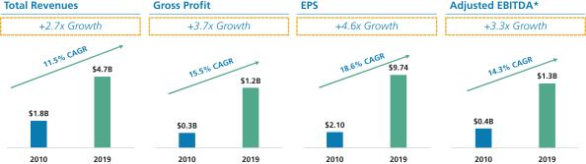

- Adjusted EBITDA is one of the metrics used for executive performance targets and is shown here for an understanding of this metric as compared to other measures of the Company’s performance. See Appendix B for reconciliation to net earnings attributable to Martin Marietta.

- 2020 PROXY STATEMENT

Table of Contents

Our 2019 Performance ◆ Compensation Discussion and Analysis

Martin Marietta’s ability to consistently translate revenue growth into increased profitability has also given us the ability to protect our balance sheet in order to make prudent acquisitions and capital investments in our business, while achieving a debt-to-EBITDA leverage ratio of 2.2x at year-end. As a result, we have been able to position our business as an aggregates leader in 90% of the geographies in which we operate and align our product offerings to leverage strategic cement and targeted downstream opportunities. This led to our significant outperformance of our peers in 2019, during which time we delivered a 64 percent total shareholder return.
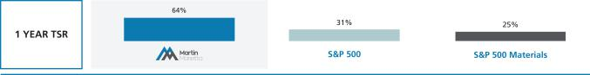

Safety, Environment and Sustainability

Sustainability Reporting

Our commitment to sustainability is part of our core strategy and we have a long track record of building solid foundations, caring about our employees, our communities and the environment, while responsibly growing our company. One of our commitments to our shareholders and other stakeholders is to improve each year on these metrics. In addition, we have endeavored to tell our story better each year, informing our shareholders and other stakeholders about our efforts, costs, risks, goals, and the relationship between our goals and management compensation.

In this regard, we have made the following enhancements to our

Sustainability activities:

- We reported in our 2018 Sustainability Report Scope 1 green house gas (GHG) emissions data relating to our aggregates group.

- Our most recent Sustainability Report, which will be issued in April 2020, includes enhanced disclosures relating to key

sustainability matters, including reporting Scope 1 GHG emissions data across all of our business lines (both in terms of absolute emissions and emissions intensity). In that report, we also disclose Scope 1 GHG emissions reduction targets across both our cement and magnesia specialties operations, which are the sources of most of our Scope 1 GHG emissions, for 2030 over a 2010 baseline year.

- We created a new position dedicated to sustainability and communications.

- Our Chairman and CEO, joined by other senior managers, engaged with 13 shareholders specifically on sustainability issues, and discussed sustainability issues with almost all of the 189 investor groups we met with in 2019.

- In 2019, we hosted 7 investors and other stakeholders who visited and toured our cement facilities and met with our cement management team.
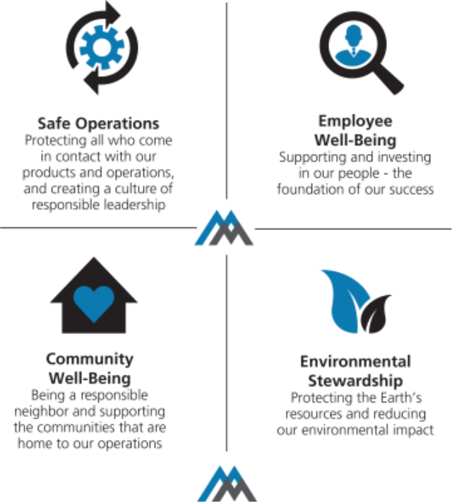

2020 PROXY STATEMENT | 37

Table of Contents

Compensation Discussion and Analysis ◆ Safety, Environment and Sustainability

Our approach to Sustainability is embedded in four vital pillars of Safety, Environment, Employees, and Community. We continued to achieve improvements in each of these areas in 2019.

Track records such as ours are not built by accident; they are the result of a deliberate focus on fulfilling our responsibilities to our shareholders, our employees and other stakeholders. These responsibilities include:

- Demanding and facilitating a safe, ethical workplace for our employees

- Creating a positive, lasting impact on our communities and the environment

- Growing our business and responsibly investing our capital for maximum return


Our Board and management oversight and engagement reflects the importance of these critical matters to Martin Marietta. Sustainability is a key component of our strategy and business plan at Martin Marietta. Sustainability excellence is not only the right thing to do and a key driver of shareholder value, it is a vital component of both our strategic planning process, SOAR, and our annual planning process. SOAR, supplemented by our annual plan, has guided us since 2010 as we have grown our business, driven our safety incidents to record low levels, achieved record financial performance and created positive impacts on our communities and the environment. Key managers from across our business and our senior leadership

- 2020 PROXY STATEMENT

In furtherance of these continuing commitments, we have:

- Included performance relating to Environment, Health, Safety and Sustainability (collectively, EHS) in our management strategy

- Considered achievement of individual and company-wide goals in regard to EHS in management compensation decisions

- Developed a task force relating to Sustainability with a view towards assessing and improving Company performance and disclosure as against world-class achievements

- Regularly report, at least twice annually, our progress on EHS issues to our Ethics, Environment, Health and Safety Committee (EESHC), an independent Committee of the Board of Directors

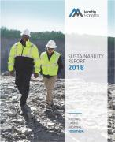

team engage throughout the year on material topics, including safety, employee well-being, community well-being and the environment.

Both SOAR and our annual plan are reviewed and endorsed by our Board of Directors. Our EESHC is an experienced, diverse and knowledgeable group and has for decades overseen our ongoing efforts to hone truly sustainable business practices. Our full Board visits our operations frequently to hear firsthand from our team and see the positive impact we have on our communities.

Table of Contents

Safety, Environment and Sustainability ◆ Compensation Discussion and Analysis

Safety Performance

We have adopted a safety culture built on Guardian Angel, a safety program we first introduced in 2000 to encourage our employees to look out for each other to make sure everyone goes home safely each day. This program has propelled us to new heights in terms of safety performance, and we continue to search for ways to improve our safety performance. In 2019, we rolled out a comprehensive safety mentoring process to pair new employees with committed safety champions.

We believe that Zero is Possible. This means operating our business without any safety incidents. Our goal is zero. We look to world-class companies and safety incident rates for guidance as to how we achieve this. We have continued to make headway in 2019 towards this important goal.

Several of our facilities were recognized by the National Stone, Sand and Gravel Association (NSSGA) as Safety Excellence Award winners. These awards recognize operations that have gone the longest duration without a reportable incident in their size category, based on data provided by the U.S. Department of Labor’s Mine Safety and Health Administration. In 2019, our Onslow Quarry in North Carolina won gold-level honors, while our Iowa Grading 2 plant in Iowa and Charlotte Quarry in North Carolina received bronze awards.

The National Ready Mixed Concrete Association also recognized our Valmont, Colorado operations with a gold award for Excellence in Safety as a result of achieving zero safety incidents in 2019.
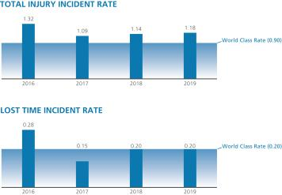

For Martin Marietta, safety performance sets our foundation for long-term financial strength and successful SOAR execution. Simply said, a safe operation is a profitable one. All awards are meaningful, but it is particularly satisfying when we are recognized for achievement against our core values.

Employee Well-being

Martin Marietta marked 25 years of success as a public company in 2019. | employee communication across the enterprise, focused employee
To celebrate, Chairman and CEO C. Howard Nye hosted an Employee | development by designing career paths and development plans, and
Town Hall for our nearly 9,000 employees. His message was that Martin | provision of a competitive offering of employee benefits including: health
Marietta is safer, more inclusive, and more profitable than ever, | and welfare, Company sponsored pension plan and 401(k) plan with
underscored by the creation and evolution of the Guardian Angel safety | company match.
program, improved
Also new in 2019, Martin Marietta developed and | and attractiveness of Martin Marietta as an
implemented an Employer Brand, ONE, supported by a | employer of choice to strengthen our talent
strong Employee Value Proposition. This initiative is | pipeline, and increase employee talent
designed to build a more compelling connection with current | pipeline, | and | increase | employee
and potential employees, increase the visibility | engagement, morale and retention.


In May 2019, Martin Marietta was named to the Denver Post’s list | news outlet’s Large Company | category. | Both rankings |  | were
of Top Workplaces. The company appeared at #21 in the annual | determined solely by extensive | employee | surveys | focused on
ranking’s Large Company category. Six months later, Martin | various elements of workplace culture. In addition, |  |  | Zippia | hand-

Marietta was selected for inclusion on The Dallas Morning News’ curated a list of the best companies to work for headquartered

Top 100 Places to Work list, a ranking that highlights the best in and around Raleigh, North Carolina using data on salaries,

employers in the 10 counties surrounding Dallas-Fort Worth. company financial health, and employee diversity, and Martin

Martin Marietta claimed the #25 spot in the Marietta earned the #2 spot out of 100 entrants.

2020 PROXY STATEMENT 39

Table of Contents

Compensation Discussion and Analysis ◆ Safety, Environment and Sustainability

Community Relations

Another core value for which we are recognized by NSSGA is community. The NSSGA Community Relations Awards program recognizes aggregates producers whose community involvement and support activities enhance the public perception of the aggregates industry in general and the public image of the

Environmental Stewardship

Environmental stewardship is another of our core values and our operations were well-represented among the NSSGA Environmental Excellence Award winners. These awards provide national recognition for operations actively contributing to the maintenance of the environment in and around their operations as evidenced by a commitment to the exemplary use of environmental controls and systems. This award is based, in part, on the extent to which an operation meets and exceeds technical

Ethical Business Conduct

We strive to continually enhance our high standards and controls for ethical business conduct, compliance and transparency. Our Code of Ethical Business Conduct (our Code of Conduct) applies to all of our employees, Board members, consultants, contract laborers and other agents when they represent or act on behalf of the Company. It describes our expectations and policies on a number of topics, including our commitments to compliance with laws, protection of human rights, maintenance of accurate business records, transparency in our public disclosures, protection of sensitive information, promotion of a positive and safe work environment, zero tolerance for corruption and general avoidance of even the appearance of impropriety in all that we do. Our Code of Conduct also emphasizes employees’ responsibility to report any violation or suspected violation of the Code of Conduct and emphasizes the Company’s non-retaliation policy. In 2019, we provided ethics training to all salaried employees. There were no waivers from any provisions of our Code of Conduct or

individual producer’s aggregates operations in particular. In 2019, our Texas Quarry (MD) won gold, while St. Cloud Quarry (MN) and Berkeley Quarry (SC) took home silver, while fifteen. Fifteen Martin Marietta sites received bronze.

environmental and regulatory requirements. In addition, in order to be eligible for the award, the operation must certify its compliance with all applicable governmental environmental regulatory requirements and that it does not have a pattern of violations during the time period of two full years prior to the date of application. Benson Quarry (NC) won gold, while Bonds Quarry (NC), Midlothian Quarry (VA), Medford Quarry (MD), Bridgeport Stone (TX) and Tin Top Sand & Gravel (TX) received silver.

amendments applicable to any Board member or executive officer in 2019.


Components of Executive Compensation – Performance-Related Compensation

Each NEO is eligible for a mix of fixed and variable components of compensation. A substantial portion of our CEO’s and other executive officers’ compensation is at risk and will vary depending upon our performance. All of the opportunities to achieve long-term equity incentives (LTI) granted to our CEO and other executive officers in 2019 were performance-related consisting of performance share unit awards (PSUs) that comprised 55% of the long-term equity awards and performance-related restricted stock unit awards (RSUs) that comprised 45% of the awards. The following charts summarize the various forms of compensation and demonstrate that in 2019 87% of the CEO’s compensation and approximately 80% of other NEO compensation is variable and tied to company performance.
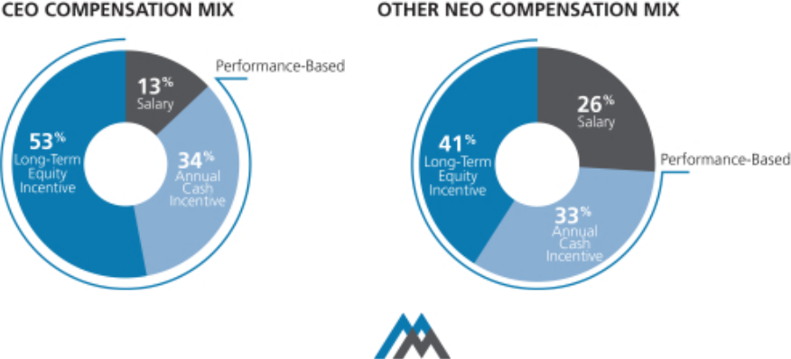

- 2020 PROXY STATEMENT

Table of Contents

Pay Decisions and Compensation Governance Practices ◆ Compensation Discussion and Analysis

Pay Decisions and Compensation Governance Practices

WHAT WE DO

Pay for performance. Tie pay to performance by ensuring that a significant portion of NEO compensation is performance-based and at-risk.

Median compensation targets. We generally aim to align all compensation elements for our executives with the median of our peer group companies.

PSUs are a substantial portion of LTI. PSU grants, tied to our achievement of specified performance measures, comprised approximately 55% of the total value of annual long-term incentive grants made to our NEOs in 2019. Performance-based RSUs comprised the remaining 45%.

Independent compensation consultant. The Committee retains an independent compensation consultant.

Robust share ownership requirements. We have robust stock ownership guidelines of 7 times base salary for the CEO, 5 times base salary for our other NEOs, and 5 times annual retainer for Directors. We also have an equity retention requirement of 50% of net shares paid as incentive compensation until ownership guidelines are met.

Clawback policy. We have a compensation recovery (clawback) policy that requires officers to forfeit certain cash-based incentive compensation and/or equity-based incentive compensation if the company restates its financial statements due to the officer’s misconduct.

Regular engagement with shareholders. We engage with shareholders to hear their views on compensation and other issues.

Annual elections. We no longer have a classified Board of Directors and all of our Directors stand for election each year.

WHAT WE DON’T DO

No employment contracts. None of our NEOs or other executive officers have employment contracts that guarantee continued employment.

No dividends on unvested awards. Our 2019 RSU and PSU awards require three years to fully vest and dividends paid on shares of common stock of Martin Marietta during the vesting period are only paid to award holders if and when an award vests.

No pledging of shares. Our directors and executive officers are not permitted to pledge Martin Marietta shares as collateral for loans or any other purpose.

No hedging. We prohibit directors and executive officers from engaging in short sales of Martin Marietta stock or similar transactions intended to hedge or offset the market value of Martin Marietta stock owned by them.

No 280G gross-ups. We do not provide Section 280G excise tax gross-ups.

Minimal executive perquisites. We do not provide NEOs with country club reimbursements, personal use of the Company aircraft unrelated to business travel, or other excessive perks.

A number of key 2019 compensation-related decisions resulted from our achievements, which are discussed more fully below. The Committee believes that our executive compensation program continues to reflect a strong pay-for-performance philosophy and is well aligned with the interests of shareholders

2020 PROXY STATEMENT | 41

Table of Contents

Compensation Discussion and Analysis ◆ 2019 Chairman, President and CEO Compensation

2019 Chairman, President and CEO Compensation

Base Salary. For 2019, Mr. Nye’s base salary was set at $1,150,000 (effective March 1, 2019).

2019 Annual Incentive. Mr. Nye’s target annual incentive amount for 2019 was $1,484,167 (130% of salary received for the year). His actual annual incentive for 2019 was $2,900,000, or 195% of target.

2019-2021 Long-Term Incentives. In 2019, Mr. Nye’s target LTI award was 400% of base salary. He was granted an LTI award of approximately $4.60 million, which was allocated 55%, or $2.53 million, in PSUs and 45%, or $2.07 million, in performance-based RSUs. RSUs will vest pro rata over three years if the performance measure is satisfied, while the vesting of PSUs will be based upon our results relative to the three-year performance goals that were established in the beginning of 2019.

Benefit and Retirement Plans. Mr. Nye is eligible for benefit and retirement programs similar to other employees. None of our executives received additional years of service credits or other forms of formula enhancements under our benefit or retirement plans. Our pension formula is based on years of service and pension eligible compensation, which is a similar formula offered by other companies with defined benefit plans. Mr. Nye is not eligible for retiree health benefits.

Perquisites. Mr. Nye received limited executive perquisites. We provide company-leased cars to the NEOs for their use. Additionally, we pay for the insurance, maintenance and fuel for such vehicles. The value of personal mileage is charged to the NEO as imputed income. We make the company-owned aircraft available to the CEO and other senior executives for business travel only. We do not provide other perquisites, such as country club memberships, to the NEOs. The Committee reviews our policies and determines whether and to what extent perquisites should be modified or continued.

2019 Target Pay Mix. We believe that most of the compensation opportunities of our CEO should be variable and the variable elements of the compensation package should tie to the Company’s long-term success and the achievement of sustainable long-term total return to our shareholders. As shown in the chart below, a significant portion of our CEO’s target compensation is variable and in the form of LTI, and more than half of total target pay is in the form of equity incentives.

CEO Target Opportunity Mix*
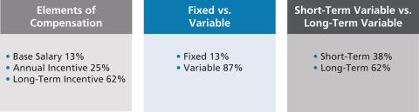

- We consider base salary and annual incentives as short-term pay and PSUs and RSUs as long-term pay. We do not include retirement or other compensation components in the chart.

Determination of CEO Compensation

At each February Committee meeting, without the CEO present, the Committee reviews and evaluates CEO performance, and determines achievement levels for the prior year. At this meeting, the Committee also discusses an evaluation of the CEO’s performance, competitive compensation data, and salary and annual incentive pay recommendations with the independent members of the Board. In addition, the Committee reviews and discusses an award of RSUs and the target PSU grant size for the CEO at that meeting, which is also discussed with the independent members of the Board.

2019 Named Executive Officers’ Compensation – Our Compensation Strategy

Our executive compensation program is specifically designed to:

- Attract and retain top-caliber, knowledgeable and experienced senior executives.

- Motivate our executives to achieve superior results and build long-term value for shareholders.

- 2020 PROXY STATEMENT

Table of Contents

2019 Named Executive Officers’ Compensation – Our Compensation Strategy ◆ Compensation Discussion and Analysis

- Reward performance that meets or exceeds established goals consistent with our strategic aims and upholding integrity.

- Align individual objectives with the Company’s objectives without fostering excessive or inappropriate risk-taking.

- Encourage an ownership mentality and align the long-term financial interests of our executives with those of our shareholders.

- Be market competitive with our peers with whom we compete for talent.

- Provide reward systems that are measurable and easily understood by our managers and shareholders.

- Reinforce the succession planning process undertaken on a company-wide basis by building bench strength and by identifying and retaining senior leadership, both capable of achieving the Company’s long-term growth, profitability and other objectives.

In 2019, our executive compensation structure consisted of three primary components: base salary, annual incentives, and long-term incentives. Within the long-term incentive component, we utilized a balanced portfolio of PSUs and performance-based RSUs.
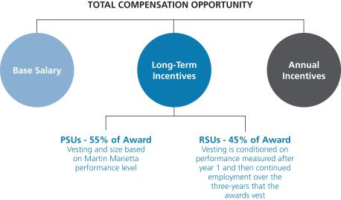

Martin Marietta has a long-standing commitment to pay for performance. We fulfill that aim by providing a majority of compensation through programs in which the amounts

ultimately received vary in order to best reflect our financial, operational and strategic performance.

2020 PROXY STATEMENT | 43

Table of Contents

Compensation Discussion and Analysis ◆ 2019 Named Executive Officers’ Compensation – Our Compensation Strategy

The following table summarizes the key elements of our 2019 executive compensation program:

Element | Primary Purpose | Key Characteristics
Base Salary | To compensate the executive fairly and competitively for | Fixed compensation that is reviewed annually.
 | the responsibility level of the position.
Annual Performance- Based | To motivate and reward organizational and individual | Variable compensation component; based on
Incentive Awards | achievement of annual, Company and individual | pre-established Company and individual performance
 | objectives. | goals.
Incentive Stock Plan | To ensure executives invest certain levels of their annual | To promote sustainable performance results, a portion of
Incentive Stock Plan | incentive compensation into Martin Marietta stock units. | each NEO’s annual cash incentive compensation (35%
 |  | for the CEO and 20% for the other NEOs) is
 |  | automatically converted into common stock units. NEOs
 |  | may elect to convert up to 50% of their annual cash
 |  | incentive compensation into common stock units.
Long-Term | To align executives with shareholder interests, to reinforce | Variable compensation component. Reviewed and
Incentive Awards | long-term value creation, and to provide a balanced | granted annually. Program splits long-term incentives for
 | portfolio of long-term incentive opportunities. | NEOs at 55% PSUs and 45% RSUs.
Performance Share Units | To motivate executives by tying incentives to our multi- | Grants based on three-year adjusted EBITDA and Sales
(PSUs) | year financial goals and relative TSR reinforcing the link | Growth goals, with a modifier based on TSR
 | between our executive officers and our shareholders. | performance relative to peers.
Performance-Based Restricted | To motivate the appropriate behaviors delivering superior | Stock price growth. Awards are subject to achievement
Stock Units | long-term total shareholder return. | of one-year adjusted EBITDA goals.
(RSUs)
Health/Welfare Plan and | To provide competitive benefits promoting employee | Fixed compensation component.
Retirement Benefits | health and productivity and support financial security.
Perquisites and Other Benefits | To provide limited business-related benefits, where | Fixed compensation component.
 | appropriate, and to assist in attracting and retaining
 | executive officers.
Change-in-Control Protection | To provide continuity of management and bridge future | Fixed compensation component; only paid in the event
 | employment if terminated following a change in control. | the executive’s employment is terminated other than for
 |  | “cause” or for “good reason”, in either case, in
 |  | connection with a change in control.

- 2020 PROXY STATEMENT

Table of Contents

Considerations Regarding 2019 Compensation ◆ Compensation Discussion and Analysis

Considerations Regarding 2019 Compensation

The following chart summarizes the target compensation in our 2019 executive compensation program:

Pay Component | Summary
Base Salary | • | At the February 2019 meeting, the Committee reviewed competitive market data and individual performance
 |  | evaluations. Increases were effective March 1, 2019 for all NEOs.
Target Annual | • | Our CEO’s target incentive for 2019 was 130% of base earnings. For other NEOs’ target incentives for 2019 were
Cash Incentives |  | 70% to 80% of base earnings.
- Our shareholders in 2016 approved a new Executive Cash Incentive Plan that fixed the bonus amounts based on certain objective criteria and allowed the Committee to reduce the award based on enumerated factors in the plan.
- Our CEO is required to invest a minimum of 35% of his annual cash bonus into stock units, which are required to be held generally for a period of three years.
- Other NEOs are required to invest a minimum of 20% of their annual cash bonus into stock units, which are held generally for a period of three years.

Long-Term | • Our LTI structure consists of PSUs and performance-based RSUs.
Incentives | • The LTI awards for NEOs in 2019 were weighted 55% PSUs and 45% RSUs. The LTI grant size is based on
 | competitive market data.
 | • PSU awards in 2019 are earned based on achievement of performance levels, with 33% based on three-year
 | cumulative Sales Growth and 67% based on three-year cumulative adjusted EBITDA performance. The Company’s
 | relative TSR ranking compared to the S&P 500 provides a modifier to the award up to 20%.
 | • RSU awards to NEOs in 2019 are subject to the achievement of one-year adjusted EBITDA performance.

Total Compensation The Committee uses the size-adjusted 50th percentile of our Compensation Peer Group as a guide in setting the target for the total compensation opportunity, but considers a variety of factors in setting compensation, including the short-term and longer-term performance and leadership characteristics of the executive, and may vary materially. Overall, the Committee believes targeted compensation should be more heavily weighted on variable “at-risk” compensation and longer-term components.

The Committee approved the following actual compensation items in February 2019:

2019 Base Salary

The Committee determines base salaries for the NEOs and other executives based on a number of factors, including but not limited to, market data, individual performance, the Company’s performance, internal pay equity, the advice of the Committee’s independent compensation consultant, management recommendations (except for the CEO), and, for the CEO, the Committee’s assessment of Mr. Nye’s performance. Based on these factors, the Committee approved the following increases in base salary.

- Mr. Nye: 4.5% increase, based on his excellent achievements during his CEO tenure, and specifically his performance in 2019.

- Other NEOs: approximately 3.3% to 7.4% increases, based on a review of competitive market data and individual performance evaluations; Mr. LaTorre received an 18.8% increase in connection with his promotion to Senior Vice President.

 |  | 2019 |  | 2018
NEO | Base Salary |  | Base Salary
C. Howard Nye | $1,150,000 |  | $1,100,000
James A. J. Nickolas | $ | 525,000 | $ | 488,800
Roselyn R. Bar | $ | 570,000 | $ | 542,500
Craig M. LaTorre* | $ | 475,000 | $ | 400,000
Daniel L. Grant | $ | 396,500 | $ | 384,000

- NEO base salaries were increased effective March 1, 2019 with the exception of Mr. LaTorre whose base salary was effective as of April 1, 2019.

2020 PROXY STATEMENT | 45

Table of Contents

Compensation Discussion and Analysis ◆ 2019 Annual Cash Incentive Goals and Results

2019 Annual Cash Incentive Goals and Results

NEOs and other executives are eligible to earn annual incentive compensation under our Executive Cash Incentive Plan based on the achievement of various performance metrics. Individual NEO targets (as a percent of base salary) are approved by the Committee at the beginning of the year based on a review of competitive market data, the advice of the Committee’s independent compensation consultant, and internal pay equity.

The Committee awards actual annual cash incentive compensation based on achievement against corporate performance objectives and individualized targeted goals. This furthers Martin Marietta’s compensation philosophy to encourage superior performance and reward the achievement of Martin Marietta’s annual goals. The Committee determined the 2019 incentive awards in February 2020. In 2019, all of the executive officers participated in the plan. The annual incentive compensation level paid for 2019 for the NEOs other than Mr. Nye was 160% to 185% of target. The annual incentive compensation level paid for 2019 for Mr. Nye was 195%.

In determining the incentive payment for the CEO, the Committee first reviews the achievements of Martin Marietta for the past year as compared to its targeted goals set at the end of the previous year. Our financial goals are established at the completion of our annual planning process, which for 2019 were determined in November 2018. The annual planning process includes reviews of the assumptions used by the business segments in generating their financial projections, such as industry trends and competitive assessments, current and future projected performance levels, and the risks and opportunities surrounding these baseline assumptions. The annual plan on which our financial goals are based is tied to the business environment in which we operate and can vary year-over-year.

The objective financial metrics in our annual plan that were measured for purposes of the 2019 Annual Cash Incentive were Pre-Tax Earnings and EBITDA, which are viewed as indicative of the Company’s profitability, and Days Sales Outstanding (DSO), which is viewed as indicative of the Company’s cash flow. All of these are important measures reflecting our performance and the creation of value for shareholders. In addition, the Committee considered the following:

- A detailed assessment of Martin Marietta’s overall financial performance and each segment’s financial performance, including the highlights and the challenges.

- Shareholder returns, including the consistent delivery of value to Martin Marietta’s shareholders.

- Our safety performance, which continues to be industry leading even though we increased hourly headcount and continued to train new employees hired through new acquisitions.

- Outstanding environmental and regulatory compliance results, sustainability initiatives, and cybersecurity protections.

- Continuing achievement of excellent management of working capital.

- The successful organic and inorganic growth of Martin Marietta.

Key individual performance criteria are established for each NEO, which are intended to drive strategic focus and support operational results in the Company and the functional groups. For the NEOs other than Mr. Nye, 50% of the determination is made with respect to Martin Marietta’s performance against the same goals as for Mr. Nye and 50% is based on the individual’s performance against established objectives.

The individualized target goals are tailored for each executive, based on his or her specific areas of responsibility and the then-current and longer-term goals of Martin Marietta. In addition, achievement of the goals typically is in part dependent on conditions outside the control of each of the NEOs. For example, our business may be adversely affected by hurricanes or other weather-related conditions, which could have the result of impeding the achievement of certain performance-based goals. Similar to the Committee’s assessment of financial goals, the Committee’s assessment of individual performance goals generally excludes non-recurring or extraordinary items.

The Committee also reviewed and considered management’s furtherance of its strategic plan, including a primary objective of value-enhancing growth, and the adoption of Mission, Vision, and Values of the Company to unify management with the same objectives.

The Committee conducted a comparative review of the individual contributions of each of the executive officers towards achieving these goals. The Committee also considered qualitative measures of performance for the executive officers, such as adherence to and implementation of Martin Marietta’s Code of Ethical Business Conduct, customer satisfaction, and product quality.

The maximum incentive compensation is fixed based on objective criteria as described in the Executive Cash Incentive Plan, and the Committee then determines an appropriate award payout beneath the maximum amount based on the factors described above. We set challenging, but attainable, targets and our NEOs have a reasonable expectation of receiving cash incentive awards that reflect the achievement of our short-and long-term objectives as well as their individual performances.

- 2020 PROXY STATEMENT

Table of Contents

2019 Annual Cash Incentive Goals and Results ◆ Compensation Discussion and Analysis

2019 Actual Incentive Cash Earned

In 2019, the Committee determined that Company and individual performance warranted the annual incentive payments in the chart below based on a review of financial metrics and other important achievements. The Committee reviews the NEOs’ performance based on continuous improvement from the preceding year. As described above, the Committee considered the following financial metrics in making this determination:

- Pre-Tax Earnings (profitability) as against prior year and current year plan

- EBITDA (profitability) as against prior year and current year plan

- DSO (cash flow) as against prior year and current year plan

The table below summarizes the targets for 2019, individual achievements and annual incentive award earned by each NEO:

 |  |  |  | Target Annual | 2019 Target |  | 2019 Actual
 |  |  |  | Incentive Bonus |  | Annual |  | Annual
 | NEO |  | 2019 Performance Metrics | (% of Salary) | Incentive* |  | Incentive
 | C. Howard Nye | • | Continue to drive a world-class safety culture through leadership alignment on | 130% | $ | 1,484,167 | $ | 2,900,000
 |  |  | safety initiatives
 |  | • Generate long-term value for shareholders through strategic growth and profitability
 |  | • Effective development of succession plans and professional development of top
 |  |  | leaders
 | James A. J. Nickolas | • | Continue to develop the finance team | 75% | $ | 389,225 | $ | 661,683
 |  | • Effective development and oversight of financial filings, audits and accounting
 |  | • Simplify and standardize financial processes and reporting methods to improve
 |  |  | accuracy and knowledge sharing and to enable informed and timely business
 |  |  | decisions
 | Roselyn R. Bar | • | Effective management of the legal department, including appropriate handling for | 80% | $ | 452,333 | $ | 836,817
 |  |  | securities law compliance, annual and periodic reporting, and robust case
 |  |  | assessment
 |  | • Provide oversight of ethics program as Chief Ethics Officer
 |  | • Continue to improve of processes and management of Corporate Secretary function
 | Craig M. LaTorre | • | Define and develop the safety strategy and gain business alignment on long-term | 70% | $ | 319,375 | $ | 523,812
 |  |  | safety initiatives
 |  | • | Develop and implement key Human Resources priorities, which include talent
 |  |  | acquisition, employee development, performance management and succession
 |  |  | planning
 | Daniel L. Grant | • | Continue to lead strategic merger and acquisition and asset disposition projects and | 70% | $ | 276,092 | $ | 441,747
 |  |  | initiatives that align with our business objectives
 |  | • Development of Strategy and Development personnel
 |  | • Continue progress on world-class organization initiative
* Based on actual base salary earnings in 2019.
 |  |  |  |  | 2020 PROXY STATEMENT |  |  |  | 47

Table of Contents

Compensation Discussion and Analysis ◆ 2019 Annual Cash Incentive Goals and Results

Annual Incentive Feature: Performance-Based Stock Purchase Plan
The Incentive Stock Plan further promotes the alignment of executive compensation levels with our investors’ financial interests by requiring that a portion of the annual bonus award be deferred into Company stock units that vest based on continued service. Executive officers can also elect to defer amounts above the mandatory deferral amount. The voluntary election allows executives to invest up to 50% of their annual cash incentive compensation to purchase units that are subsequently converted into shares of common stock pursuant to the terms of the plan at a 20% discount from the market price of Martin Marietta’s common stock on the date the amount of the incentive compensation is determined. The discount is used to account for the risk of trading current cash compensation for “at-risk” shares which may decline in value.

The mandatory portion requires executives to invest a minimum of 20% of their cash incentive compensation towards the crediting of units under the plan. The CEO is required to invest a minimum of 35% of his cash incentive compensation towards the crediting of such units.

The units generally vest in three years from the date of the award and are distributed in shares of common stock. If an executive officer voluntarily terminates employment before the units vest, the stock units are forfeited and the executive officer receives a cash payment equal to the lesser of the cash that was invested or the fair value of the share units on the day of termination. Mr. Nye deferred the maximum of 50% of his 2019 cash bonus in stock units.

The mandatory contribution requirement directly links a portion of executive officer compensation to shareholder returns. The vesting aspect, combined with the yearly stock purchase requirement, creates continuous overlapping three-year cycles, which encourage executive officer retention and provide a continuous link of a significant portion of executive officer compensation with shareholder return over the long-term to reward these executive officers in line with our shareholders when our stock price increases.

2019 Long-Term Incentive Compensation Overview

Our LTI plan’s design reflects the objectives of our compensation program and is in-line with current market approaches, based on the advice of the Committee’s independent compensation consultant. Our plan design objectives are a simplified LTI program, that is transparent and enhances the line of sight between our performance and compensation.

The award in 2019 for all NEOs was determined as a fixed percentage of base salary with some variation for position and grade, which amount was converted into common stock units based on the average Martin Marietta stock price for the 20-day period ending on February 20, 2019, the day the Martin

Marietta Board of Directors confirmed the award, or $182.895. This award value was then divided into PSUs and performance-based RSUs, with 55% of the total award for NEOs consisting of the PSUs at target level and 45% of the total award for NEOs consisting of performance-based RSUs. The Committee believes that the incentive mix (PSUs and performance-based RSUs) constitutes an appropriate pay process and streamlined plan, which more fully reflects the performance of the Company and is better aligned with each NEO’s role within Martin Marietta. See a further description under Outstanding Equity Awards at Fiscal Year-End and corresponding footnotes on pages 60 to 61.

The following table provides a notional example of the LTI plan design.

 |  | LTI
 | LTI | Target |  | PSU |  | RSU
Salary | Target | Value | PSU | Value | RSU | Value
$ | % | $ | % | $ | % | $
150,000 | 140% | 210,000 | 55% | 115,500 | 45% | 94,500

PSU Awards (55% of LTI Award)

One of our compensation objectives is to align the potential rewards to senior management with increases in shareholder value. In that regard, the PSUs give the recipient the opportunity to receive Martin Marietta common stock if specific performance goals are achieved, consisting of:

- Earnings before Interest, Income Taxes, Depreciation and Amortization (EBITDA), measuring profitability and comprising 67% of the total target award, and

- Sales Growth, measuring growth and comprising 33% of the total target award.

- In addition, relative Total Shareholder Return (rTSR) will act as a modifier for the performance such that Martin Marietta’s performance will be measured against the S&P 500, and will modify the total award by a range of -20% to +20%.

The following table summarizes the weighting of our PSU performance measures:

Cumulative | Cumulative | Relative TSR
EBITDA | Sales Growth | Modifier
67% | 33% | +/- 20%

EBITDA and Sales Growth are two of the drivers of our performance and metrics of significance to our investors. The total payout opportunity for PSUs in 2019 was 0% to 240%: 50% of target if the threshold level is satisfied, 100% of target if the target level is satisfied, and 200% of target if the maximum level is satisfied. The rTSR modifier over the three-year measurement period is then applied to the final award to adjust it up or down by up to 20%. The threshold must be satisfied to receive PSUs for each performance metric. If the threshold is not met, none of the PSUs relating to that metric will vest.

- 2020 PROXY STATEMENT

Table of Contents

PSU Awards (55% of LTI Award) ◆ Compensation Discussion and Analysis

Performance for each metric is measured independently, so PSUs can be earned as long as the threshold is satisfied for at least one metric. The “Target” level is generally viewed as achievable although it has not been achieved every year. The “Maximum” level is a stretch that is attainable if we outperform in the area measured. PSU payments are capped at the target level if three-year TSR is negative.

The performance will be measured in February 2022 for the three-year period beginning January 2019 through December 2021 to determine

- the three-year cumulative EBITDA for Martin Marietta against the target identified in the PSU Award Agreement, and (2) the three-year cumulative Sales Growth against the target identified in the PSU Award Agreement. The payment amount will be further modified by the rTSR for the three-year period as against the S&P 500, as set forth in the PSU Award Agreement. The Committee in its discretion may adjust the final award values only as set forth in the Agreement, either collectively or on an individual basis, in recognition of factors that are unusual or nonrecurring.

Over the three-year performance period, up to one-third of the target PSUs may be earned each year based on one-third of the three-year cumulative EBITDA and Sales Growth goals. Each year, any earned PSUs are not distributed until the end of the three-year measurement period when the cumulative three-year performance is determined. The actual PSUs will equal the greater of the total PSUs earned for each of the annual periods (capped at 100% of the annual target, that is, one-third of the cumulative target) or the amount earned for cumulative three-year performance (capped at 200% of target). The final amount of earned PSUs to be distributed are then subject to the three-year rTSR modifier.

The PSUs will convert to unrestricted common stock and be distributed conditioned upon and to the extent that the performance goals have been met, which will be determined in February 2022. These awards are also generally subject to continued employment through the date the PSUs vest. The actual financial performance targets and achievement against those targets will be disclosed at the end of the three-year performance period.

Selection of Relative TSR

We selected rTSR for the PSUs to measure our performance against the companies in the S&P 500 index. We recognize that every industry faces different challenges and opportunities, and that the S&P 500 index does not perfectly correlate to the environment in which Martin Marietta operates. However, we believe that the majority of our closest competitors are not publicly-held companies or are not U.S. companies, and therefore accurate information to potentially use as comparisons is not readily available. As a result, we believe that comparing

our TSR against the S&P 500 index is appropriate because (1) it measures the interest of investors for whom we compete, (2) there is no consensus of a significantly better peer group with readily available comparable financial information; and (3) by using rTSR as a modifier rather than a primary measurement, we give our other performance measures more weight and their focus on profitability and growth both provide long-term value creation.

We believe that EBITDA, Sales Growth and rTSR metrics drive the behaviors of our management team in ways that are intended to create the most value for our shareholders.

Performance-Based RSU Awards (45% of LTI Award)

RSUs vest in three equal portions, each on the anniversary of the grant date (February 20, 2019) over a period of three years, subject to satisfaction of the performance measure and generally to continued employment through each one of those anniversaries. Once the restricted period ends (each anniversary for one third of the total RSU award), the recipient will be issued unrestricted shares of common stock (minus applicable taxes). The 2019 RSUs awarded to executive officers are also subject to a performance measure that a stated level of EBITDA be achieved during the first year. If the performance measure is satisfied, then the RSUs will continue to vest. If the performance measure is not satisfied, then the RSUs will be forfeited. For the 2019 grants, the performance measure was satisfied.

2019-2021 Performance Goals

In setting minimum and maximum levels of payment, we reviewed historical levels of performance against our long-range plan commitments and conducted sensitivity analyses on alternative outcomes focused on identifying likely minimum and maximum boundary performance levels. Levels between 100% and the minimum and maximum levels were derived using linear interpolation between the performance hurdles.

The specific EBITDA and Sales Growth target values for the 2019-2021 PSUs are not publicly disclosed at the time of grant due to the proprietary nature and competitive sensitivity of the information. However, the method used to calculate the awards will be based on actual performance compared to our 2019-2021 targets, with straight-line interpolation between points. The individual award agreements require the adjustment of goals to ensure that the ultimate payouts are not impacted to the benefit or detriment of management by specified events, such as unplanned pension contributions, changes in accounting (GAAP) standards or impact of an acquisition or divestiture. The Committee may exercise its discretion to reduce the final vesting percentage to no more than target if the Company’s three-year TSR is less than zero.

2020 PROXY STATEMENT | 49

Table of Contents

Compensation Discussion and Analysis ◆ 2019-2021 Performance Goals
The following table provides a summary of the long-term incentives that each of the NEOs received in 2019.
 |  | RSUs
 |  | (3 year annual | PSUs – Target
 |  | installment vesting | (3 year cliff vesting
 |  | subject to achievement | subject to achievement
 |  | of performance | of performance
 |  | measure) | measures)
 | NEO | (# of shares) | (# of shares)
 | C. Howard Nye | 11,318 | 13,175
 | James A. J. Nickolas | 2,261 | 2,632
 | Roselyn R. Bar | 2,455 | 2,857
 | Craig M. LaTorre | 2,188 | 1,042
 | Daniel L. Grant | 1,269 | 1,477

In setting performance goals for the three-year PSUs awarded in 2019, the Committee considered various factors in choosing the metrics and establishing the goals, including:

- The metrics reflect drivers of our performance and we believe are important to our investors.

- The goals are consistent with our business plan and positive over prior year.

- We have a history of setting challenging target and maximum goals.

In addition, we have looked at the alignment of our payouts with the Company’s performance, including TSR, and found that pay and performance are aligned.

2019 Performance Goals and Metrics


Relative TSR (Modifier +/- 20%)* TSR
Percentile Payout
Achievement Factor

EBITDA (67%)***

EBITDA Payout

Achievement Factor**

Sales Growth (33%)

Sales

Growth Payout
Achievement Factor**

³ 75th | +20% (Maximum)
50th | 0% adjustment (Target)
£ 25th | -20% (Threshold)

Plan + ³ $.36B

Plan EBITDA

Plan - $.36B

Plan - < $.36B

200% (Maximum)

100% (Target)

50% (Threshold)

0%

Plan + ³ 4.5%

Plan Growth

Plan - 1.5%

Plan - < 1.5%

200% (Maximum)

100% (Target)

50% (Threshold)

0%

- rTSR is calculated as (i) the average of our closing stock price over the final 20 trading days of the measurement period, minus the average of our closing stock price over the first 20 trading days of the measurement period, plus the value of reinvested dividends divided by (ii) the average of our closing stock price over the first 20 trading days of the measurement period, and is measured against each of the companies in the S&P 500 index (excluding any Companies acquired during the measurement period.
- Threshold and maximum are a percentage of the target.
- EBITDA is calculated from Martin Marietta’s audited financial statements in the same manner as set forth in the reconciliations as provided in Appendix B, with the exception that adjustments are taken for certain nonrecurring items in accordance with the award agreements.

- 2020 PROXY STATEMENT

Table of Contents

2017-2019 PSU Award Payouts ◆ Compensation Discussion and Analysis

2017-2019 PSU Award Payouts

PSUs that were granted in 2017 vested on December 31, 2019, because the applicable performance criteria were satisfied. These PSUs were certified and paid out in February 2020. The PSU payouts for the three-year performance period ended December 31, 2019 were calculated by comparing actual corporate performance for each metric for the period January 1, 2017 through December 31, 2019, against a table of payment levels from 0% to 200% (with the 100% payout level being considered target) established at the beginning of the performance period.

For the three-year performance period ended December 31, 2019, actual results were 186% of target. The results were

above targeted level for each metric. EBITDA (weighted 67%) was $3.43 billion compared to our pre-established target of $2.85 billion and generated a 134% payout factor and Sales Growth (weighted 33%) was 17.7% compared to our pre-established target of 4.5% and generated a 66% payout factor. The rTSR modifier, which provides for an adjustment up or down of up to 20%, resulted in a 93% adjustment as our TSR over the three year measurement period was at the 41st percentile of S&P 500 companies over the same period. The awards are calculated pursuant to the provisions provided in the award agreements. The Committee cannot make any adjustments to the final payout factor beyond the adjustments specified in the award agreements.

Measure

EBITDA

Sales Growth

Relative TSR

Performance

Target

- 2.85B

4.5%

50th percentile

Performance

Result

- 3.43B

17.7%

41st percentile

Weighting

67%

33%

+/-20%

Weighted

Payout Factor

134%

66%

93% of total award

Based on a weighted payout factor of 186%, the following table shows the payouts under the 2017-2019 PSU made in February 2020.

Payment Calculation for PSUs Granted in 2017

Certified on February 20, 2020

 | Target Units Granted | Payout
NEO | in 2017 (shares) | (shares)
C. Howard Nye | 11,355 | 21,112
James A. J. Nickolas*
Roselyn R. Bar | 3,267 | 6,075
Craig M. LaTorre*
Daniel L. Grant | 2,210 | 4,109

- Mr. Nickolas commenced employment with the Company in August 2017. Mr. LaTorre commenced employment in July 2018.

Ongoing Corporate Governance Policies

We endeavor to maintain good corporate governance standards relating to our executive compensation policies and practices, including the following that were in effect during 2019 that directly impacted compensation:

- The Committee is comprised solely of independent Directors who regularly schedule and meet in executive sessions without management present.

- The Committee’s independent compensation consultant is retained directly by the Committee.

- The Committee conducts an annual review and approval of our compensation strategy, including a review of our compensation-related risk profile, to ensure that our compensation-related risks are not reasonably likely to have a material adverse effect on the Company.

- We pay for performance, with approximately 87% of our CEO’s total target pay opportunity being performance-based “at-risk” compensation.

- We cap PSU payments at target if three-year TSR is negative, regardless of our ranking.

- We limit perquisites and other benefits.

Compensation Decision Process

Role of Management and the Committee

The Committee is responsible for carrying out the philosophy and objectives of the Board of Directors related to executive compensation in addition to its responsibilities of overseeing the development and succession of executive management of Martin Marietta. The Committee has the authority to determine compensation and benefits for Martin Marietta’s executive officers. The Committee members are each non-employee, independent Board members pursuant to the NYSE rules, and the Committee

2020 PROXY STATEMENT | 51

Table of Contents

Compensation Discussion and Analysis ◆ Compensation Decision Process

operates pursuant to a written charter, a copy of which can be viewed on Martin Marietta’s website at ir.martinmarietta.com/corporate-governance.

The performance of the CEO and each other executive officer is reviewed regularly by the Committee. Based on this review, the Committee sets compensation for all executive officers. Compensation decisions with respect to the executive officers other than the CEO are based in part on recommendations by the CEO, with input from the Senior Vice President and Chief Human Resources Officer, with respect to salary adjustments and annual cash and equity awards. The Committee can accept, reject or modify any recommended adjustments or awards to executive officers. For the CEO, the Committee sets the levels of annual adjustments and awards based on the criteria it deems to be appropriate under the circumstances with input from the independent compensation consultant. There are no employment agreements between Martin Marietta and any executive officer of Martin Marietta, including the CEO.

Role of the Independent Compensation Consultant

The Committee retained Mercer, an independent compensation consultant, in accordance with the Committee’s charter. The consultant reports directly to the Committee. The Committee retains sole authority to hire or terminate the consultant, approve its compensation, determine the nature and scope of services, and evaluate performance. The compensation consultant attends Committee meetings, either in person or by telephone, as requested, and communicates with the Committee Chair between meetings. The Committee makes all final decisions.

The compensation consultant’s specific roles include, but are not limited to, the following:

- Advise the Committee on executive compensation trends and regulatory developments and other factors affecting executive officer compensation, as well as any other areas of concern or risk.

- Provide a total compensation assessment for executives compared to peer companies and recommendations for executive pay.

- Serve as a resource to the Committee Chair for meeting agendas and supporting materials in advance of each meeting.

- Review and comment on proxy disclosure items, including this CD&A.

- Advise the Committee on management’s pay recommendations.

Based on these activities, the compensation consultant makes recommendations regarding, and proposes adjustments to, our executive officer compensation program as it deems appropriate. While the consultant works closely with the appropriate members of our executive management team in performing these activities, the consultant reports directly to and is retained by the Committee on all executive compensation matters, and speaks to the Committee and the Chair of the Committee on a regular basis without management present.

Role of Peer Companies and Competitive Market Data

The Committee considered peer groups for two elements of the executive compensation program in 2019: the Compensation Peer Group, consisting of 15 companies that the Committee believes compete with us for talent, and the TSR Peer Group, consisting of the S&P 500, which the Committee believes compete with us for investors and is used to assess the achievement of rTSR measured for the PSU awards.

Annually, the Committee studies competitive total compensation market data provided by its independent compensation consultant. To assess competitive pay levels, the Committee reviews and approves the composition of our Compensation Peer Group. The following peer group criteria are considered:

- Company size (approximately 0.4 times to 2.5 times Martin Marietta’s annual revenues);

- Company market cap;

- Companies in similar industries based on GICS code classifications;

- Direct competitors for business and management talent that are publicly-traded in the United States;

- Companies covered by the investment analysts that track Martin Marietta; and

- Companies that include Martin Marietta in their compensation peer group.

The following companies comprised our Compensation Peer Group for 2019 base salary and long-term incentive pay decisions:

Albemarle Corporation | Louisiana-Pacific Corporation | Owens Corning | Vulcan Materials Company
Eagle Materials, Inc. | Masco Corporation | Stanley Black & Decker, Inc. | Westlake Chemical Corporation
FMC Corporation | The Mosaic Company | Summit Materials, Inc. | Weyerhauser
Fortune Brands Home & Security | Nucor Corporation | USG Corp.

The Committee studies competitive total compensation data from various sources, including proxy statements of the peer group. Since proxy statements do not provide precise comparisons by position to our executive officers, in 2019 the

Committee also took into consideration published independent compensation surveys of companies with revenue in the range of $2.5 billion to $8.0 billion as to median levels for each executive officer as well as private compensation survey

- 2020 PROXY STATEMENT

Table of Contents

data. Where available, size-adjusted market values were developed using regression analysis. This statistical technique accounts for revenue size differences within the peer group and develops an estimated market value for a similar-size company as Martin Marietta. The size-adjusted 50th percentile for total compensation is a key reference point for the Committee. On average, the target for our NEO total compensation opportunities is competitively positioned within a reasonable range of the size-adjusted 50th percentile.

Although the Committee uses the size-adjusted 50th percentile as its starting point in setting compensation levels, the compensation packages for executive officers may vary materially from it based on several factors. Market data, position, tenure, individual and organization performance, retention needs and internal pay equity have been the primary factors considered in decisions to increase or decrease compensation opportunities. Specifically, the Committee typically sets compensation levels below the size-adjusted 50th percentile for executive officers with relatively less relevant experience, less responsibility, less tenure with Martin Marietta and/or lower performance ratings. Conversely, if an officer consistently receives favorable performance ratings, accumulates years of service and expertise in relevant areas, has more responsibility and/or has significant other achievements, his or her compensation will typically be above the size-adjusted 50th percentile.

Compensation Program Risk Assessment

We perform a thorough annual review of our compensation program structure and all compensation programs, which are also reviewed in detail with the Committee. We believe our executive pay is appropriate and provides necessary incentives to our executives to achieve our financial and strategic goals without encouraging them to take excessive risks in their business decisions. Our compensation structure does not include features that are reasonably likely to have a material adverse effect on the Company. Compensation program features that mitigate against risks include the following:

- Our annual incentive compensation plan does not provide payment for poor individual or corporate performance, regardless of whether the failure to achieve target was outside management’s control.

- There are caps on the long-term equity awards, even if the required performance-related criteria are exceeded.

- A majority of the NEOs’ compensation is long-term, with equity grants vesting over three to five years, depending on the award.

- Our compensation is not based on highly-leveraged short-term incentives that encourage high risk investments at the expense of long-term value.

Compensation Decision Process ◆ Compensation Discussion and Analysis

- Long-term compensation to executive officers is based on specific performance measures that balance long-term growth and returns.

- The Committee uses benchmarking data and the advice of its independent compensation consultant to keep compensation in line with typical market practices and appropriate to Martin Marietta’s needs.

- We use a balanced portfolio of long-term incentive programs.

- The Committee’s governance process requires review and approval of all compensation over a certain amount.

Stock-Based Awards Generally

All of Martin Marietta’s active equity-based award plans have been approved by shareholders. Our Stock Plan requires a minimum vesting period of 12 months for restricted stock or RSUs and a minimum vesting period of 36 months for stock options or stock appreciation rights (SARs). The Company has not issued SARs and has not issued options since 2015.

Stock Ownership Requirements

In 2018, the Board adopted robust formal Stock Ownership Guidelines for executive officers and members of the Board of Directors. These require the following ownership levels as a multiple of base salary or annual cash retainer, as applicable:

 | Annual Base
Title | Salary Multiple
Chairman, President and CEO | 7 times
Other Executive Officers | 5 times
Other Members of the Board of Directors | 5 times

The following types of equity instruments count in determining stock ownership for purposes of these guidelines:

- Shares owned separately by the covered person or owned either jointly with, or separately by, his or her immediate family members residing in the same household;

- Shares held in trust for the benefit of the covered person or his or her immediate family members;

- Shares purchased on the open market;

- Shares obtained through stock option exercise (and not thereafter sold);

- Vested shares pursuant to RSUs;

- Unvested RSUs;

- Shares held pursuant to deferred stock unit plans for Directors or executive officers; and

- Shares acquired under the Company’s Savings and Investment Plan and similar plans or arrangements

2020 PROXY STATEMENT | 53

Table of Contents

Compensation Discussion and Analysis ◆ Stock Ownership Requirements

Covered persons who are employees are expected to meet these requirements within five years of the later of becoming a covered person and the date of adoption of the policy. Until such time as such covered person has met these requirements, he or she is expected to retain 50% of any shares of common stock received upon vesting of RSUs, deferred stock unit awards, PSUs, the exercise of stock options, and other similar equity awards, net of amounts withheld to pay taxes and the exercise price of stock options until the applicable Guideline level is met.

Stock ownership does not include vested or unvested stock options, unvested PSUs and vested or unvested stock appreciation rights.

All of the Company’s executive officers and members of the Board of Directors are in compliance with the Stock Ownership Guidelines.

We also require a holding period of annual cash incentive compensation converted to Martin Marietta share equivalents as described below, with vesting generally in three years. There is no additional holding period beyond the vesting date, however a significant portion of the executive compensation program is in the form of equity awards that vest over three years generally.

Our CEO must invest a minimum of 35% of each year’s cash bonus award in common stock units of Martin Marietta. Executive officers must invest a minimum of 20% of their annual bonus. Stock is purchased at a 20% discount to the price on the grant date to account for the additional risk of taking a common stock unit payment in lieu of a risk-free cash payment. In 2019, Mr. Nye deferred the maximum of 50% of his cash bonus in common stock units.

Anti-Hedging and Pledging Policy

Our policies prohibit hedging and pledging of Martin Marietta stock by all directors and executive officers. Under our policies, directors and executive officers may not engage in any hedging or monetization transactions, such as puts, calls, options, other derivative securities, prepaid variable forward contracts, equity swaps, collars, exchange funds and short sales with respect to Company stock, the purpose of which is to hedge or offset any decrease in the market value of such stock. This policy also prohibits directors and executive officers from purchasing Company stock on margin, borrowing against Company stock on margin, or pledging Company stock as collateral for any loan.

Clawback Policy

We also have a clawback policy. If the Board determines that an officer’s intentional misconduct, gross negligence or failure to report such acts by another person was a contributing factor in requiring us to restate any of our financial statements or constituted fraud, bribery or another illegal act (or contributed to another person’s fraud, bribery or other illegal act) which

- 2020 PROXY STATEMENT

adversely impacted our financial position or reputation, then the Board shall take such action as it deems in the best interest of the Corporation and necessary to remedy the misconduct and prevent its recurrence. Among other actions, the Board may seek to recover or require reimbursement of any amount awarded to the officer in the form of an annual incentive bonus or LTI award. There were no events requiring Board consideration of a clawback action during 2019.

Our Use of Independent Compensation Consultants

The independent compensation consultant provides important information about market practices, the types and amounts of compensation offered to executives generally and the role of corporate governance considerations in making compensation decisions. The Committee’s charter authorizes it to retain outside advisors that it believes are appropriate to assist in evaluating executive compensation.

For 2019, the Committee continued to retain Mercer as an independent compensation consultant. In connection with its retention of Mercer, the Committee considered the following factors in assessing Mercer’s independence:

- The provision of services provided by Mercer to Martin Marietta in addition to compensation advisory services.

- The compensation paid to Mercer is less than 1% of Mercer’s revenues.

- Mercer has business ethics and insider trading and stock ownership policies, which are designed to avoid conflicts of interest.

- Mercer employees supporting the engagement do not own Martin Marietta securities.

- Mercer employees supporting the engagement have no business or personal relationships with members of the Compensation Committee or with any Martin Marietta executive officer.

At its February 2019 meeting, the Committee renewed the engagement of Mercer. At that time, Mercer confirmed the continuing validity of each of the factors described above.

The nature and scope of Mercer’s engagement was determined by the Committee and not limited in any way by management. Mercer was paid $141,978 for its compensation advisory services in 2019. During 2019, Mercer and its Marsh & McLennan affiliates were also retained by management to provide services unrelated to executive compensation, including property/casualty insurance brokerage services and administration of a risk management information system. The aggregate fees paid for those other services for 2019 were $355,230. These represent less than .003% of Marsh & McLennan’s global revenue. The Committee and the Board did not review or approve the other services provided to us by

Table of Contents

Our Use of Independent Compensation Consultants ◆ Compensation Discussion and Analysis

Mercer and its Marsh & McLennan affiliates as those services are approved by management in the normal course of business.

We have been advised by Mercer that the reporting relationship and compensation of the individual Mercer consultants who perform executive compensation consulting services for our Committee is separate from, and is not determined by reference to, Mercer’s or Marsh & McLennan’s other lines of business or their other work for us. The Committee considered these separate reporting relationships and compensation structures, the provision of other services to the Company by Mercer and Marsh & McLennan, and the absence of any business or personal relationship between our officers and Directors and the specific Mercer consultants advising the Company (other than the consulting relationship with the Committee). The Committee also considered Mercer’s Global Business Standards intended to address potential conflicts of interests with respect to their executive compensation consulting services and the other factors required to be considered by applicable SEC and NYSE rules in approving the Committee’s engagement of Mercer for 2019. Based on this review, the Committee did not identify that Mercer had any conflicts of interest that would prevent Mercer from independently advising the Committee.

The Committee has considered and assessed all relevant factors, including but not limited to those set forth in Rule 10C-1(b)(4)(i) through

- under the Securities Exchange Act of 1934, that could give rise to a potential conflict of interest with respect to the individual independent compensation consultants that provided services in 2019. Based on this review, there are no conflicts of interest raised by the work performed by Mercer.

Practice Regarding Timing of Equity Grants

The stock purchase awards under our Incentive Stock Plan and the PSUs and RSUs awarded under our LTI program, each as described above, were granted in 2019 at the Committee’s regularly scheduled meetings in February following the availability of financial results for the prior year. Newly hired executive officers may, subject to the discretion of the Committee, receive an award of RSUs as of the date of their hire. The number of such RSUs is based on the NYSE closing price of Martin Marietta’s common stock on the date of the grant or the first date of employment, whichever is later. The Committee’s schedule is determined several months in advance and the proximity of any awards to earnings announcements or other market events is coincidental.

Our practice with regard to the timing of equity grants is:

- No equity award may be backdated. A future date may be used if, among other reasons, the Committee’s action occurs in connection with a new employee who has not yet commenced employment.

- Proposed equity awards are presented to the Committee in February of each year. Off-cycle awards may be considered

in the Committee’s discretion in special circumstances, which may include hiring, retention or acquisition transactions.

In addition, our existing stock award plan prohibits repricing of stock options or paying cash for underwater stock options.

Perquisites

Martin Marietta provides executives with perquisites that the Committee believes are appropriate, reasonable and consistent with its overall compensation program to better enable Martin Marietta to attract and retain superior employees for key positions. The Committee periodically reviews the types and levels of perquisites provided to the NEOs. The value of each of the NEO’s perquisites, determined in accordance with SEC rules, is included in the annual compensation set forth in the Summary Compensation Table.

In 2019, we provided personal use of leased automobiles to NEOs. We pay for the insurance, maintenance and fuel for such vehicles, and the value of personal mileage and use is charged to the NEO as imputed income. We make the company-owned aircraft available to the CEO and other senior executives for business travel. If the NEO is accompanied by his or her spouse on such trips, that use is included in the NEO’s taxable income for the year and the incremental cost, if any, is included as “All Other Compensation” in the Summary Compensation Table required to be included in our proxy statement for that year.

Martin Marietta also provides to executive officers, as well as most other salaried employees, certain other fringe benefits such as tuition reimbursement, airline club dues, professional society dues, and food and recreational fees incidental to official company functions. We do not provide other perquisites, such as country club memberships or financial planning services, to the NEOs or other employees.

Retirement and Other Benefits

In order to maintain market competitive levels of compensation, we provide retirement and other benefits to the NEOs and other employees, including:

- Medical and dental benefits

- Life, accidental death and disability insurance

- Pension and savings plans

The benefits under the defined benefit pension plan are more valuable for employees who remain with Martin Marietta for longer periods, thereby furthering our objectives of retaining individuals with more expertise in relevant areas and who can also participate in management development for purposes of executive succession planning. All of Martin Marietta’s salaried employees in the United States are eligible to participate in our retirement and other plans, and the NEOs participate in the plans on the same terms as Martin Marietta’s other salaried employees.

2020 PROXY STATEMENT | 55

Table of Contents

Compensation Discussion and Analysis ◆ Potential Payments upon Termination or Change of Control

Additional information regarding these benefits is under the heading Pension Benefits Table on page 63 and the accompanying narrative.

Potential Payments upon Termination or Change of Control

We do not have written employment agreements with executives. Instead, each of our NEOs has a change of control severance agreement (an Employment Protection Agreement) that provides for retention and continuity in order to minimize disruptions during a pending or anticipated change of control. The agreements are triggered only by a qualifying termination of employment in connection with a change of control. Martin Marietta’s equity-based award plans and retirement plans also provide for certain post-termination payments and benefits, as well as, for equity awards granted prior to 2019, the acceleration of time periods for purposes of vesting in, or realizing gain from, such equity award in the event of a change of control. The Committee believes these payments and benefits are also important to align the interests of the executive officers with the interests of the shareholders because the agreements will reduce or eliminate the reluctance to pursue potential

change of control transactions that may ultimately lead to termination of their employment but would otherwise be in the best interests of our shareholders. The Employment Protection Agreements are described on pages 64 and 65 of this Proxy Statement.

Tax and Accounting Implications

In administering the compensation program for NEOs, for awards made in 2019 the Committee considered tax consequences, including the limit on deductibility on compensation in excess of $1 million to certain executive officers under Section 162(m) of the Internal Revenue Code and the consequences under financial accounting standards.

While the Committee considers the tax deductibility as one factor in determining executive compensation, the Committee also looks at other factors in making its decisions, as noted above, and retains the flexibility to award compensation that it determines to be consistent with the goals of our executive compensation program to attract talent, promote retention, or recognize and reward desired performance even if the awards are not deductible for income tax purposes.

- 2020 PROXY STATEMENT

Table of Contents

Executive Compensation

Executive Officer Compensation

The following tables show annual and long-term compensation, for services in all capacities to Martin Marietta, earned by the Chief Executive Officer, the Chief Financial Officer, and the three other most highly compensated executive officers in 2019, which we refer to collectively in this section of this proxy statement as the “named executive officers” or “NEOs.” These tables and the accompanying narratives should be read in conjunction with the Compensation Discussion and Analysis section of this proxy statement, which provides a detailed overview of the methods used by Martin Marietta to compensate its officers, including the named executive officers.

Summary Compensation Table

The table below summarizes the total compensation paid to or earned by each of the named executive officers for the fiscal years set forth below. Martin Marietta has not entered into any employment agreements with any of the named executive officers.

SUMMARY COMPENSATION TABLE

 |  |  |  |  |  |  |  | Change in
 |  |  |  |  |  |  |  | Pension Value
 |  |  |  |  |  |  |  | and Non-
 |  |  |  |  |  |  |  | Qualified
 |  |  |  |  |  |  | Non-Equity | Deferred
 |  |  |  |  | Stock | Option Incentive Plan Compensation |  |  | All Other
Name and |  |  | Salary | Bonus | Awards | Awards Compensation |  | Earnings | Compensation | Total
Principal Position |  | Year | ($)¹ | ($) | ($)² | ($)³ | ($)⁴ | ($)⁵ | ($)⁶ | ($)
(a) |  | (b) | (c) | (d) | (e) | (f) | (g) | (h) | (i) | (j)
C. Howard Nye | 2019 |  | 1,141,667 |  | 6,294,708 |  | 1,450,000 | 3,073,183 | 238,800 | 12,198,358
Chairman, President |  | 2018 | 1,090,833 |  | 5,046,900 |  | 1,050,000 | 1,235,634 | 110,091 | 8,533,458
and CEO |  | 2018 | 1,090,833 |  | 5,046,900
and CEO |  | 2017 | 1,039,167 |  | 5,431,412 |  | 1,000,000 | 1,414,782 | 103,804 | 8,989,165
James A. J. Nickolas | 2019 |  | 518,967 |  | 1,100,171 |  | 529,346 | 240,591 | 32,587 | 2,421,662
Senior Vice | 2018 |  | 485,667 |  | 899,577 |  | 451,670 | 91,960 | 84,393 | 2,013,267
President and CFO |  |  | 485,667 |  | 899,577
President and CFO | 2017 |  | 172,936 |  | 1,320,232 |  | 162,127 | 25,995 | 8,534 | 1,689,824
Roselyn R. Bar | 2019 |  | 565,417 |  | 1,301,753 |  | 585,772 | 2,153,409 | 79,931 | 4,686,282
Executive Vice President, |  | 2018 | 537,783 |  | 1,073,594 |  | 496,912 | 940,466 | 52,958 | 3,101,713
General Counsel and |  | 2018 | 537,783 |  | 1,073,594
Corporate Secretary |  | 2017 | 511,383 |  | 1,433,583 |  | 475,586 | 1,039,249 | 52,062 | 3,511,863
Craig M. LaTorre⁷ | 2019 |  | 456,250 |  | 736,506 |  | 419,050 | 142,339 | 21,305 | 1,775,450
Senior Vice President,
Chief Human Resources
Officer
Daniel L. Grant | 2019 |  | 394,417 |  | 631,506 |  | 353,398 | 317,458 | 56,555 | 1,753,334
Senior Vice President, |  | 2018 | 380,383 |  | 527,756 |  | 308,871 | 163,952 | 41,967 | 1,422,929
Strategy & Development |  | 2018 | 380,383 |  | 527,756
Strategy & Development |  | 2017 | 360,433 |  | 947,503 |  | 255,457 | 193,221 | 38,825 | 1,795,439
- The amounts in column (c) reflect the base salary actually paid.

- No amounts that qualify as bonuses were payable during the last three years. The amounts in column (e) reflect the aggregate grant date fair value of awards made in the year reported, determined in accordance with FASB ASC Topic 718 (without any assumption for early forfeiture), of awards of RSUs and awards of PSUs, which are described in more detail on pages 48 to 50 under the heading “2019 Long-Term Incentive Compensation.” The amounts included in the table reflects the value of the units granted, which are subject to forfeiture if the executive does not remain in the employment of Martin Marietta for the requisite time period (generally three years) or if Martin Marietta does not achieve the performance criteria, where applicable. The amounts reported include the amounts of cash bonuses deferred in common stock units by each named executive officer pursuant to Martin Marietta’s Incentive Stock Plan, which is discussed in further detail on page 48 under the heading “Annual Incentive Feature: Performance-Based Stock Purchase Plan”. The amount in column (e) includes PSUs based on the target level of performance. Assuming the maximum payout under the PSUs granted in 2019, whose payout will be determined in February 2022 based on the Company’s performance in 2019-2021, the amounts reported above for

2019 would be as follows:
Mr. Nye, $6,404,631; Mr. Nickolas, $1,279,468; Ms. Bar, $1,388,845; Mr. LaTorre, $506,537; and Mr. Grant, $717,999. Assumptions used in the calculation of these amounts are included in Note A to Martin Marietta’s audited financial statements for the fiscal year ended December 31, 2019,

2020 PROXY STATEMENT | 57

Table of Contents

Executive Compensation ◆ Summary Compensation Table

included in Martin Marietta’s Annual Report on Form 10-K filed with the SEC on February 21, 2020. The amounts of cash bonus deferred in 2019 for each named executive officer are included in column (e) as follows: Mr. Nye, $1,450,000; Mr. Nickolas, $132,337; Ms. Bar, $251,045; Mr. LaTorre, $104,762; and Mr. Grant, $88,349.
- The Company does not issue SARs and has not granted any options since 2015. The Stock Plan prohibits share recycling for options or SARs.

- The amounts in column (g) for 2019 reflect the cash paid to the named individuals earned in 2019 and paid in 2020 under annual incentive arrangements discussed in further detail on pages 46 to 48 under the heading “2019 Annual Cash Incentive Goals and Results” and not deferred pursuant to Martin Marietta’s Incentive Stock Plan, which is discussed in further detail on page 48 under the heading “Annual Incentive Feature: Performance-Based Stock Purchase Plan.”

- The amounts in column (h) reflect the aggregate increase in the actuarial present value of the named executive officer’s accumulated benefits during 2019, 2018 and 2017, respectively, under all defined benefit retirement plans established by Martin Marietta determined using interest rate and mortality rate assumptions consistent with those used in Martin Marietta’s financial statements and include amounts which the named executive officer may not currently be entitled to receive because such amounts are not vested.

- The amount shown in column (i) for 2019 reflects for each named executive officer: matching contributions allocated by Martin Marietta to each of the named executive officers pursuant to the Savings and Investment Plan, which is more fully described on page 62 under the heading “Retirement and Other Benefits” in the following amounts: Mr. Nye, $9,800; Mr. Nickolas, $9,800; Ms. Bar, $9,800; Mr. LaTorre, $6,661; and Mr. Grant, $8,437; the value attributable to life insurance benefits provided to the named executive officers, which is more fully described on page 62 under the heading “Retirement and Other Benefits” in the following amounts: Mr. Nye, $10,062; Mr. Nickolas, $2,240; Ms. Bar, $6,308; Mr. LaTorre, $1,739; and Mr. Grant, $14,254; the value attributable to personal use of leased automobiles provided by Martin Marietta in the following amounts: Mr. Nye, $11,389; Mr. Nickolas, $13,905; Ms. Bar, $15,476; Mr. LaTorre, $12,905; and Mr. Grant, $6,442; dividend equivalents on RSUs in the following amounts: Mr. Nye, $205,422; Mr. Nickolas, $6,643; Ms. Bar, $48,347; Mr. LaTorre, $0; and Mr. Grant, $27,422. These values are included as compensation on the W-2 of named executive officers who receive such benefits. Each such named executive officer is responsible for paying income tax on such amount. The amounts in column (i) also reflect the dollar value of dividend equivalents on units credited under the equity awards as computed for financial statement reporting purposes for each fiscal year ended December 31, 2019, 2018 and 2017 in accordance with FASB ASC Topic 718.
- Mr. LaTorre was not a named executive officer for purposes of the Summary Compensation Table in 2017 and 2018.

- 2020 PROXY STATEMENT

Table of Contents

Grants of Plan-Based Awards ◆ Executive Compensation

Grants of Plan-Based Awards

The table below shows each grant of an award made to a named executive officer in the fiscal year ended December 31, 2019. This includes equity awards made to the named executive officers under the Stock Plan and the Incentive Stock Plan.

GRANTS OF PLAN-BASED AWARDS TABLE

 |  |  |  |  |  |  |  |  |  | All Other
 |  |  |  |  |  |  |  |  |  | Stock
 |  | Estimated Future Payouts |  |  |  |  | Estimated Future Payouts |  |  | Awards: | Grant Date
 |  |  |  |  |  |  |  |  |  | Number | Fair Value
 |  | Under Non-Equity Incentive |  |  |  |  | Under Equity Incentive |  |  | of Shares | of Stock
 |  |  | Plan Awards |  |  |  | Plan Awards |  |  | of Stock | and
 | Grant | Threshold |  | Target |  | Maximum | Threshold | Target | Maximum | or Units | Option
Name | Date | ($) | ($) |  |  | ($) | (#) | (#) | (#) | (#) | Awards4
(a) | (b) | (c) |  | (d) |  | (e) | (f) | (g) | (h) | (i) | (l)
C. Howard Nye | 2/19/20¹ |  |  | 742,084 |  | 3,750,000 |  | 3,586 | 18,122 |  | 927,591
 | 2/20/19² |  |  |  |  |  | 5,270 | 13,175 | 31,620 |  | 2,668,596
 | 2/20/19³ |  |  |  |  |  |  |  |  | 11,318 | 2,176,112
James A. J. Nickolas | 2/19/20¹ |  |  | 311,380 |  | 6,000,000 |  | 377 | 7,249 |  | 97,519
 | 2/20/19² |  |  |  |  |  | 1,053 | 2,632 | 6,317 |  | 533,112
 | 2/20/19³ |  |  |  |  |  |  |  |  | 2,261 | 434,722
Roselyn R. Bar | 2/19/20¹ |  |  | 316,634 |  | 5,250,000 |  | 656 | 10,873 |  | 169,688
 | 2/20/19² |  |  |  |  |  | 1,143 | 2,857 | 6,857 |  | 578,685
 | 2/20/19³ |  |  |  |  |  |  |  |  | 2,455 | 472,023
Craig M. LaTorre | 2/19/20¹ |  |  | 255,500 |  | 6,000,000 |  | 309 | 7,249 |  | 79,929
 | 2/20/19² |  |  |  |  |  | 417 | 1,042 | 2,501 |  | 211,057
 | 2/20/19³ |  |  |  |  |  |  |  |  | 2,188 | 420,687
Daniel L. Grant | 2/19/20¹ |  |  | 220,874 |  | 6,000,000 |  | 267 | 7,249 |  | 69,065
 | 2/20/19² |  |  |  |  |  | 591 | 1,477 | 3,545 |  | 299,166
 | 2/20/19³ |  |  |  |  |  |  |  |  | 1,269 | 243,991

- The amounts shown in this row reflect the annual bonus that could have been earned in 2019, payable in 2020, pursuant to the Executive Cash Incentive Plan. For each named executive officer, the amounts shown in columns (d) and (e) reflect the portion of the annual bonus that would have been paid in cash if, respectively, target and maximum performance was achieved for the year (i.e., after reduction for the total portion that would be deferred pursuant to the Incentive Stock Plan pursuant to both mandatory and voluntary deferrals). The amounts shown in columns (g) and (h) reflect the portion of the annual bonus that would have been deferred pursuant to the Incentive Stock Plan if, respectively, target and maximum performance was achieved for the year, inclusive of the 20% discount. Participants in the Incentive Stock Plan for 2019 were approved on May 9, 2019. These awards are discussed under the heading “Annual Incentive Feature: Performance-Based Stock Purchase Plan” on page 48. The actual amounts paid are reflected in the Summary Compensation Table on page 57.

- The amounts shown in columns (f), (g) and (h) reflect the threshold, target and maximum, respectively, levels of PSUs payable if the performance measurements are satisfied in the period 2019-2021. These awards are discussed under the heading “2019 Long-Term Incentive Compensation” on pages 48 to 50.

- The amounts shown in column (i) reflect the number of RSUs granted in 2019 to each of the named executive officers pursuant to the Stock Plan. These awards are discussed under the heading “2019 Long-Term Incentive Compensation” on pages 48 to 50. These awards are also included in column (e) of the Summary Compensation Table on page 57.

- The amounts shown in column (l) reflect the grant date fair value of each equity award computed in accordance with FASB ASC Topic 718. No options to purchase shares of Martin Marietta’s common stock were granted in 2019.

Stock-based incentive awards have been a significant component of Martin Marietta’s management compensation. In 1998, the Board of Directors adopted and Martin Marietta’s shareholders approved the Stock Plan. In 2016, the Board of Directors and the shareholders approved amendments to the plan increasing the number of shares of Martin Marietta’s common stock available for equity awards. They also approved

amendments to the plan designed to more directly tie long-term compensation incentives to Martin Marietta’s performance and enhance flexibility in structuring long-term incentive compensation packages by providing a mix of different types of long-term stock-based incentives. In addition, dividend equivalents that would have been paid in cash during the vesting period will be paid only if and when an award vests.

2020 PROXY STATEMENT | 59

Table of Contents

Executive Compensation ◆ Grants of Plan-Based Awards

As amended, the Stock Plan authorizes the Management Development and Compensation Committee to award stock options, restricted stock and other stock-based incentive awards to employees of Martin Marietta for the purpose of attracting, motivating, retaining and rewarding talented and experienced employees. Since 2016, Martin Marietta’s long-term compensation program consists of a mix of RSUs and PSUs for senior level employees and other select employees.

Vesting of the awards granted in 2019 is based on the achievement by Martin Marietta of performance measures described under “2019 Long-Term Incentive Compensation” on pages 48 to 50.

A maximum of 5,800,000 shares of Martin Marietta’s common stock are authorized under the plan for grants to key employees. Each award under the plan is evidenced by an award agreement setting forth the number and type of stock-based incentives subject to the award and such other terms and conditions applicable to the award as determined by the Committee. No employee may receive annual grants for more than 300,000 shares of common stock with respect to (i) full-value awards or (ii) stock options or stock appreciation rights.

Outstanding Equity Awards at Fiscal Year-End

The table below shows for each of the named executive officers information with respect to the unexercised stock options (columns (b), (c), (e), and (f)), stock unit awards (columns (g) and (h)) that have not vested, and equity incentive plan awards (columns (i) and (j)) outstanding on December 31, 2019.

OUTSTANDING EQUITY AWARDS AT FISCAL YEAR-END TABLE

 | OPTION AWARDS |  |  |  |  | STOCK AWARDS |  | Equity
 |  |  |  |  |  |  |  | Incentive
 |  |  |  |  |  |  |  | Plan
 |  |  |  |  |  |  |  | Awards:
 |  |  |  |  |  |  |  | Market or
 |  |  |  |  |  |  | Equity | Payout
 |  |  |  |  |  |  | Incentive Plan | Value or
 |  |  |  |  |  |  | Awards: | Unearned
 |  |  |  |  |  | Market | Number of | Shares,
 | Number of | Number of |  |  | Number | Value of | Unearned | Units or
 | Securities | Securities |  |  | of Shares | Shares or | Shares, Units | Other
 | Underlying | Underlying |  |  | or Units of | Units of | or Other | Rights
 | Unexercised | Unexercised | Option |  | Stock | Stock | Rights That | That
 | Options | Options | Exercise | Option | That Have | That Have | Have | Have Not
 | (#) | (#) | Price | Expiration | Not Vested | Not Vested1 | Not Vested | Vested1
Name | Exercisable | Unexercisable | ($) | Date | (#) | ($) | (#) | ($)
(a) | (b) | (c) | (e) | (f) | (g) | (h) | (i) | (j)
C. Howard Nye | 10,000 | 0 | 69.12 | 5/24/2020 | 3,251² | 909,110 | 11,355⁷ | 3,175,312
 |  |  |  |  | 5,692³ | 1,591,711 | 9,940⁸ | 2,779,622
 |  |  |  |  | 11,318⁴ | 3,164,966 | 13,175⁹ | 3,684,257
 |  |  |  |  | 5,893⁵ | 1,647,919
 |  |  |  |  | 6,827⁶ | 1,909,102
James A. J. Nickolas |  |  |  |  | 4,047¹⁰ | 1,131,703 | 1,956⁸ | 546,976
 |  |  |  |  | 1,120³ | 313,197 | 2,632⁹ | 736,012
 |  |  |  |  | 2,261⁴ | 632,266
 |  |  |  |  | 735⁶ | 205,535
Roselyn R. Bar | 4,513 | 0 | 69.12 | 5/24/2020 | 935² | 261,463 | 3,267⁷ | 913,584
 | 4,004 | 0 | 108.24 | 5/23/2023 | 1,226³ | 342,839 | 2,140⁸ | 598,430
 |  |  |  |  | 2,455⁴ | 686,516 | 2,857⁹ | 798,931
 |  |  |  |  | 935⁵ | 261,463
 |  |  |  |  | 1,385⁶ | 387,301
Craig M. LaTorre |  |  |  |  | 5,892¹¹ | 1,647,639 | 1,042⁹ | 291,385
 |  |  |  |  | 2,188⁴ | 611,852
Daniel L. Grant | 816 | 0 | 121.00 | 5/22/2024 | 632² | 176,732 | 2,210⁷ | 618,004
 | 1,076 | 0 | 154.58 | 5/21/2025 | 642³ | 179,529 | 1,120⁸ | 313,197
 |  |  |  |  | 1,217⁴ | 340,322 | 1,477⁹ | 413,028
 |  |  |  |  | 502⁵ | 140,379
 |  |  |  |  | 503⁶ | 140,659
- Based on the closing price of our common stock as of December 31, 2019 ($279.64).

- 2020 PROXY STATEMENT

Table of Contents

Outstanding Equity Awards at Fiscal Year-End ◆ Executive Compensation

- RSU restrictions lapsed on March 28, 2020.
- RSU restrictions lapse ratably in installments on February 22, 2020 and February 22, 2021.
- RSU restrictions lapse ratable in installments on February 20, 2020, February 20, 2021 and February 20, 2022.
- Incentive Stock Plan units restrictions lapse on December 1, 2020.
- Incentive Stock Plan units restrictions lapse on December 1, 2021.
- The amount for these outstanding awards of PSUs are presented at the target performance levels. The awards generally vested at December 31, 2019.
- The amount for these outstanding awards of PSUs are presented at the target performance levels. The awards generally vest at December 31, 2020.
- The amount for these outstanding awards of PSUs are presented at the target performance levels. The awards generally vest at December 31, 2021.

- RSUs fully vest on August 21, 2022 subject to continued employment. If Mr. Nickolas’ employment terminates prior to August 21, 2022 as a result of his voluntary termination or the Company’s termination of Mr. Nickolas for cause, all outstanding RSUs expire and he is required to return to the Company the value of any vested shares of common stock that vested in connection with this award.

- RSUs vest as follows subject to continued employment on the dates of vesting: 1,964 units vest on August 23, 2021; 1,964 units vest on August 23, 2022; and 1,964 units vest on August 23, 2023.

Option Exercises and Stock Vested

The table below shows on an aggregated basis for each of the named executive officers information on (1) the exercise of options for the purchase of Martin Marietta’s common stock and (2) the vesting of stock, including RSUs, PSUs and Incentive Stock Plan units, during the last completed fiscal year. There are no awards of stock appreciation rights for Martin Marietta’s common stock or other similar instruments.

OPTION EXERCISES AND STOCK VESTED TABLE

 | OPTION AWARDS |  | STOCK AWARDS
 | Number |  | Number of
 | of Shares | Value | Shares | Value
 | Acquired | Realized | Acquired | Realized
 | on Exercise | on Exercise | on Vesting | on Vesting¹
Name | (#) | ($) | (#) | ($)
(a) | (b) | (c) | (d) | (e)
C. Howard Nye | 49,703 | 6,651,783 | 58,809 | 13,538,636
James A. J. Nickolas | 0 | 0 | 1,644 | 409,440
Roselyn R. Bar | 3,528 | 391,733 | 19,434 | 4,652,801
Craig M. LaTorre | 0 | 0 | 0 | 0
Daniel L. Grant | 0 | 0 | 13,691 | 3,331,811

- The amounts in column (e) include the value of RSUs and PSUs at the time of vesting and the appreciation of both mandatory and voluntary contributions under the Incentive Stock Plan.

2020 PROXY STATEMENT | 61

Table of Contents

Executive Compensation ◆ Option Exercises and Stock Vested

Retirement and Other Benefits

In order to maintain market competitive levels of compensation, we provide retirement and other benefits to the named executive officers and other employees. The benefits under the defined benefit pension plan are more valuable for employees who remain with Martin Marietta for longer periods, thereby furthering Martin Marietta’s objectives of retaining individuals with more expertise in relevant areas and who can participate in management development for purposes of executive succession planning. All of Martin Marietta’s salaried employees in the United States are eligible to participate in the following retirement and other plans. The named executive officers participate in the plans on the same terms as Martin Marietta’s other salaried employees.

Pension Plan. We have a tax qualified defined benefit pension plan (Pension Plan) under which eligible full-time salaried employees of Martin Marietta who have completed five continuous years of employment with Martin Marietta, including the named executive officers, earn the right to receive certain benefits upon retirement on a reduced basis at or after age 55 and on an unreduced basis at or after age 62. Retirement benefits are monthly payments for life based on a multiple of the years of service and the final average eligible pay for the five highest consecutive years in the last ten years before retirement, less an offset for social security. The amount is equal to the sum of (A), (B) and (C) below:

- 1.165% of the participant’s final average eligible pay up to social security covered compensation, multiplied by the participant’s credited years of service up to 35 years;

- 1.50% of the participant’s final average eligible pay in excess of social security covered compensation, multiplied by the participant’s credited years of service up to 35 years; and

- 1.50% of the participant’s final average eligible pay multiplied by the participant’s credited years of service in excess of 35 years.

Supplemental Excess Retirement Plan (SERP). We also have a non-qualified restoration plan that covers any employee in the defined benefit pension plan, including the named executive officers, who are highly compensated and whose qualified plan benefit is reduced by Internal Revenue Code benefit or pay limits in Sections 415(b) and 401(a)(17). The plan is based on the same formula as the qualified Pension Plan described above. Benefits under our nonqualified plan are paid from our general assets.

Savings and Investment Plan. The Savings and Investment Plan is a tax-qualified defined contribution retirement savings plan pursuant to which all employees in the United States, including the named executive officers, are eligible to contribute up to 25% or the limit prescribed by the Internal Revenue

- 2020 PROXY STATEMENT

Service on a ROTH individual retirement account on a before-tax basis and up to an additional 17% of pay on an after-tax basis not to exceed a total of 25% of pay. We match 100% of the first 1% of pay and 50% of the next 5% of pay that is contributed by employees to the Savings and Investment Plan up to Internal Revenue Service limitations. All contributions as well as any matching contributions are fully vested upon contribution. Prior to 2015, the Company sponsored two defined contribution savings plans, the Performance Sharing Plan for salaried employees and the Savings and Investment Plan for hourly employees generally. The two plans were merged in 2014.

Retiree Medical. Eligible salaried employees who commenced employment with Martin Marietta prior to December 1, 1999 and who retire with at least 5 years of service are currently eligible for retiree medical benefits for life. Eligible salaried employees who commenced employment with Martin Marietta between December 1, 1999 and December 31, 2001 and who retire with at least 15 years of service are currently eligible for retiree medical benefits until age 65. Eligible employees share the cost of retiree medical based on their years of service and a predetermined cap on total payments by Martin Marietta. Employees who commenced employment with Martin Marietta on or after January 1, 2002 are not eligible for retiree medical benefits. Mr. Nye, Mr. Nickolas, Mr. LaTorre and Mr. Grant are not eligible for retiree medical benefits as each commenced employment with Martin Marietta after 2002.

Medical Insurance. Martin Marietta provides an opportunity to all of its salaried employees in the United States and the employees’ immediate family members to select health, dental and vision insurance coverage. Martin Marietta pays a portion of the premiums for this insurance for all employees. All employees in the United States, including the named executive officers, pay a portion of the premiums depending on the coverage they choose.

Life and Disability Insurance. Martin Marietta provides to all of its salaried employees in the United States, including the named executive officers, long-term disability and life insurance that provides up to 1.5 times base salary at no cost to the employee. All of our employees in the United States, including the named executive officers, can choose additional coverage and pay a portion of the premiums depending on the coverage they choose. In addition, Martin Marietta pays an amount equal to one year of base salary in the event of death of any active salaried employee.

Housing Allowance and Relocation Costs. Martin Marietta provides relocation benefits, including a housing allowance, to certain employees upon their employment with Martin Marietta or in conjunction with a job relocation or promotion.

Table of Contents

Pension Benefits ◆ Executive Compensation

Pension Benefits

The table below shows the present value of accumulated benefits payable to each of the named executive officers, including the number of years of service credited to each such named executive officer, under our Pension Plan and SERP, determined using interest rate and mortality rate assumptions consistent with those used in Martin Marietta’s financial statements.

PENSION BENEFITS TABLE

 |  | Numbers of Years | Present Value of | Payments During
 |  | Credited Service | Accumulated Benefit | Last Fiscal Year
Name | Plan Name | (#) | ($)¹ | ($)
(a) | (b) | (c) | (d) | (e)
C. Howard Nye | Pension Plan | 13.417 | 624,446
 | SERP | 13.417 | 8,264,290
James A. J. Nickolas | Pension Plan | 2.417 | 85,515
 | SERP | 2.417 | 273,031
Roselyn R. Bar | Pension Plan | 25.5 | 1,491,045
 | SERP | 25.5 | 5,771,902
Craig M. LaTorre | Pension Plan | 1.500 | 61,296
 | SERP | 1.500 | 108,486
Daniel L. Grant | Pension Plan | 6.333 | 325,153
 | SERP | 6.333 | 686,042

- Amounts in column (d) reflect the valuation method and use the assumptions that are included in Notes A and K to Martin Marietta’s audited financial statements for the fiscal year ended December 31, 2019, included in Martin Marietta’s Annual Report on Form 10-K filed with the Securities and Exchange Commission on February 21, 2020.

The Pension Plan is a defined benefit plan sponsored by Martin Marietta and covers all of Martin Marietta’s executive officers, including the named executive officers, and substantially all of the salaried employees of Martin Marietta on a non-contributing basis. Compensation covered by the Pension Plan generally includes, but is not limited to, base salary, executive incentive compensation awards, lump sum payments in lieu of a salary increase, and overtime. The normal retirement age under the Pension Plan is 65, but unreduced early retirement benefits are available at age 62 and reduced benefits are available as early as age 55. The calculation of benefits under the Pension Plan is generally based on an annual accrual rate, average compensation for the highest consecutive five years of the ten years preceding retirement, and the participant’s number of years of credited service (1.165% of average compensation up to social security covered compensation for service up to 35 years and 1.50% of average compensation over social security covered compensation for service up to 35 years and 1.50% of average compensation for service over 35 years.) Benefits payable under the Pension Plan are subject to current Internal Revenue Code limitations, including a limitation on the amount of annual compensation for purposes of calculating eligible remuneration for a participant under a qualified retirement plan ($280,000 in 2019). Martin Marietta’s SERP is a restoration plan that generally provides for the payment of benefits in excess of the Internal Revenue Code limits, which benefits vest in the same manner that benefits vest under the Pension Plan. The SERP provides for a lump sum payment of the vested benefits

provided by the SERP subject to the provisions of Section 409A of the Internal Revenue Code. Of the named executive officers, Mr. Nye, Ms. Bar and Mr. Grant are each eligible for early retirement, which allows for payment to employees who are age 55 or older with at least five years of service at a reduced benefit based on the number of years of service and the number of years prior to age 62 at which the benefits began. Mr. Nickolas is not yet eligible for early retirement, but would be eligible for payments at age 55 at a reduced benefit based on the number of years of service and the number of years prior to age 65 at which the benefits began. Mr. LaTorre is not yet eligible for early retirement, but would be eligible for payments after 5 years of service at a reduced benefit based on the number of years of service and the number of years prior to age 65 at which the benefits began. The present value of the Pension Plan and SERP benefit, respectively, for Mr. Nye, Mr. Nickolas, Ms. Bar, Mr. LaTorre, and Mr. Grant, if they had terminated on December 31, 2019 and began collecting benefits at age 55 or current age if older would be as follows: Mr. Nye, $656,882 and $9,057,478, respectively; Mr. Nickolas, $0 and $0, respectively, since he has less than five years of service with Martin Marietta and therefore is not vested in the plans; Ms. Bar, $1,507,292 and $5,844,815, respectively; Mr. LaTorre, $0 and $0, respectively, since he has less than five years of service with Martin Marietta and therefore is not vested in the plans; and Mr. Grant, $325,153 and $686,042, respectively. The amounts listed in the foregoing table are not subject to any deduction for Social Security benefits or other offset amounts.

2020 PROXY STATEMENT | 63

Table of Contents

Executive Compensation ◆ Potential Payments Upon Termination or Change of Control

Potential Payments Upon Termination or Change of Control

The discussion and tables below reflect the amount of potential payments and benefits to each of the named executive officers at, following, or in connection with any termination of such executive’s employment, including voluntary termination, involuntary not-for-cause termination, for-cause termination, normal retirement, early retirement, in the event of disability or death of the executive, and termination following a change of control. The amounts assume that such termination was effective as of December 31, 2019 and thus includes amounts earned through such time and are estimates of the amounts that would have been paid out to the executives upon their termination at such time. The actual amounts to be paid out can only be determined at the time of such executive’s actual separation from Martin Marietta.

Payments Upon Any Termination. Regardless of the manner in which the employment of a named executive officer terminates, he or she is entitled to receive the amounts earned during the term of employment, including cash compensation earned during the fiscal year, amounts contributed by the employee and Martin Marietta’s matching contributions to the Savings and Investment Plan, unused earned vacation pay and amounts accrued and vested through Martin Marietta’s Pension Plan and SERP.

Payments Upon Voluntary Termination. In addition to the amounts described under the heading Payments Upon Any Termination, upon a voluntary termination of employment, the named executive officer would be entitled to receive the lower of the amount of cash contributed to the Incentive Stock Plan or the current market value of the common stock units credited to the employee measured by the NYSE closing price of Martin Marietta’s common stock on the date of termination.

Payments Upon Involuntary Not-For-Cause Termination. In addition to the amounts described under the heading Payments Upon Any Termination , upon an involuntary termination of employment not for cause, the named executive officer would be entitled to receive a prorated share of the common stock units credited to him or her under the Incentive Stock Plan paid out as shares of common stock and the remaining cash contribution invested by the employee in the plan.

Payments Upon Involuntary For-Cause Termination. In the event of involuntary termination for cause, which is defined in the Employment Protection Agreement and the Stock Plan, the named executive officer would be entitled to receive the payments and benefits described under the heading Payments Upon Voluntary Termination.

Payments Upon Retirement. In the event of the retirement at age 62 or above of a named executive officer, in addition to the items described under the heading Payments Upon Any Termination, the executive will receive a portion of the cash incentive bonus based upon performance and payable under the

Executive Cash Incentive Plan that correlates to the percentage of the year in which the employee worked for the Company; will continue to hold all outstanding options unaffected by the retirement and retain such options for the remainder of the outstanding term; will continue to hold all awards of RSUs and PSUs for the remainder of the outstanding term unaffected by the retirement; will vest in all outstanding awards of common stock units under the Incentive Stock Plan; in the case of Ms. Bar, will be eligible to receive health and welfare benefits as described under the heading Retiree Medical on page 62; and will continue to receive life insurance coverage until his or her death.

Payments Made Upon Early Retirement. In the event of retirement prior to reaching age 62 but on or after reaching age 55, the named executive officer will receive benefits as described under the heading Payments Upon Voluntary Termination. In addition, the named executive officer will receive reduced benefits of the type described under Pension Benefits on page 63 and may be eligible for benefits described under the heading Retiree Medical beginning on page 62 at a higher cost.

Payments Upon Death or Disability. In the event of the death or disability of a named executive officer, in addition to the payments and benefits under the heading Payments Upon Any Termination, the named executive officer or his or her estate will receive benefits under Martin Marietta’s long-term disability plan or life insurance plan, as applicable, and a death benefit payment, as applicable, equal to the then-current base salary of such employee paid under the Pension Plan plus one month base salary. In addition, in the event of death, all options will vest and the executor of their estate will have one year to exercise the options. In the event of disability, the executive will receive a portion of the cash incentive compensation based upon performance and payable under the Executive Cash Incentive Plan that correlates to the percentage of the year in which the employee worked for the Company; will continue to hold all outstanding options unaffected by the disability and will retain such options for the remainder of the outstanding term; will continue to hold all awards of PSUs and RSUs for the remainder of the outstanding term unaffected by the disability; and will vest in all outstanding awards of common stock units under the Incentive Stock Plan.

Payments Upon or in Connection With a Change of Control. Martin Marietta has entered into Employment Protection Agreements, as amended from time to time, with each of the named executive officers. The purpose of these agreements is to provide Martin Marietta’s key executives with payments and benefits upon certain types of terminations within two years following a “Change of Control.” For purposes of the agreements, a Change of Control is generally defined as (i) the acquisition by any person, or related group of persons, of 40% or more of either the outstanding common stock of Martin Marietta or the combined voting power of Martin Marietta’s

- 2020 PROXY STATEMENT

Table of Contents

Potential Payments Upon Termination or Change of Control ◆ Executive Compensation

outstanding securities, (ii) consummation of a reorganization, merger or consolidation or sale or other disposition of all or substantially all of Martin Marietta’s assets following which Martin Marietta’s shareholders before such event fail to own more than 50% of the resulting entity, (iii) a change in the majority membership of the Board, or (iv) a liquidation or dissolution of Martin Marietta.

The agreements provide that if, within the two-year period following a Change of Control, an executive is terminated without “Cause” (as defined in the agreements) or terminates his or her employment with “Good Reason” (as defined in the agreements), Martin Marietta is obligated to pay the executive, in a lump sum, an amount equal to three times the sum of the executive’s base salary, annual bonus, and Martin Marietta’s match to the defined contribution plan; the payment of a pro-rata annual target bonus in the year of termination as determined under the Executive Cash Incentive Plan (for Mr. Nye such target bonus is 130% for purposes of the Employment Protection Agreement) and to provide continuation of health, medical and other insurance benefits for a period of three years following termination. The rationale for selecting these triggers is to encourage the named executive officers to remain focused on Martin Marietta, its performance and matters that are in the best interests of its shareholders rather than be distracted by the personal impact to their employment that the Change of Control may have. For purposes of the agreements, “base salary” means the highest annual rate of base salary that the executive received within the twelve-month period ending on the date of the Change of Control, and “annual bonus” means the executive’s highest annual bonus paid during the period beginning five years prior to the Change of Control and ending on the date of the executive’s termination of employment. Executives also are credited with an additional three years of service under the Pension Plan and are eligible to retire after age 55 without reduction in benefits and with a lump sum payment based on a 0% discount rate. Martin Marietta must also continue to provide the executive all benefits provided under Martin Marietta’s defined benefit and defined contribution retirement plans and provide the executive with the same retiree medical benefits that were in effect for retirees immediately prior to the Change of Control. The agreements also have

confidentiality requirements to ensure that the executives do not disclose any confidential information relating to Martin Marietta.

The agreements were amended in December 2018 in response to the 2018 Say On Pay vote that was supported by 78.9% of the shareholders that voted. The amendments eliminated (1) the “gross up” payments that compensate the executives for any golden parachute excise taxes imposed under the Internal Revenue Code; (2) the “walk-right” if the executive voluntarily terminates his or her employment for any reason during the thirty-day period following the second anniversary of the Change of Control; and (3) the inclusion of the value of perquisites in the severance payment provided for in the agreements.

The term of the agreements is one year following their effective dates. On each anniversary date of the effective date, the agreements are renewed for one additional year, unless either party gives notice of its intent to cancel the automatic extension. If, prior to termination, a Change of Control occurs or the Board becomes aware of circumstances which in the ordinary course could result in a Change of Control, then under no circumstances will the agreements terminate prior to the second anniversary of the Change of Control.

In addition, the Stock Plan, pursuant to which equity-based awards are made to the executive officers, provides that upon the occurrence of a Change of Control of Martin Marietta as provided in the Employment Protection Agreements, all time periods for purposes of vesting in, or realizing gain from, any outstanding award under the plan will automatically accelerate. For purposes of such vesting, any performance criteria will be deemed achieved at the greater of target performance and actual performance, as measured through the date of the Change of Control. In December 2018, in response to the 2018 Say On Pay vote, the Company’s form of RSU award agreement and PSU award agreement were changed such that future grants of RSUs and PSUs will require termination of the executive’s employment in connection with a Change of Control in order for accelerated vesting to occur.

2020 PROXY STATEMENT | 65

Table of Contents

Executive Compensation ◆ Potential Payments Upon Termination or Change of Control

Value of Payments Upon Termination. The following table shows the potential incremental value of payments to each of our named executive officers upon termination, including in the event of a Change of Control of Martin Marietta, assuming a December 31, 2019 termination date and, where applicable, using the NYSE closing price of our common stock of $279.64 on December 31, 2019 (the last trading day of 2019).

POTENTIAL INCREMENTAL VALUE OF PAYMENTS UPON TERMINATION

OR CHANGE OF CONTROL AT DECEMBER 31, 2019


 |  |  | Involuntary
 |  |  | Not-for-
 |  |  | Cause |  |  | Change-
Name | Benefit or Payment¹ | Retirement | Termination | Disability | Death | of-
 | Benefit or Payment¹ | ($) | ($) | ($) | ($) | Control
 | Cash Severance² |  |  |  |  | 11,700,000
 | Unvested RSUs³ | 5,665,786 | — | 5,665,786 | 5,665,786 | 5,665,786
 | Unexercisable Options
C. Howard Nye | Unvested Incentive Stock Plan Units⁴ | 1,182,021 | 576,330 | 1,182,021 | 1,182,021 | 1,182,021
C. Howard Nye | PSUs⁵ | 6,463,879 |  | 6,463,879 | 6,463,879 | 6,463,879
 | Retirement Plans⁶ |  |  | 1,573,228 | — | 11,927,671
 | Health and Welfare Benefits⁷ |  |  |  |  | 78,027
 | Cash Severance² |  |  |  |  | 3,268,764
 | Unvested RSUs³ | 2,077,166 | — | 2,077,166 | 2,077,166 | 2,077,166
 | Unexercisable Options |  |  |  |  | —
James A. J. Nickolas | Unvested Incentive Stock Plan Units⁴ | 92,617 | 27,240 | 92,617 |  | —
James A. J. Nickolas | PSUs⁵ | 1,282,988 |  | 1,282,988 | 1,282,988 | 1,282,988
 | Retirement Plans⁶ |  |  | 1,666,690 | — | 1,945,812
 | Health and Welfare Benefits⁷ |  |  |  |  | 75,977
 | Cash Severance² |  |  |  |  | 3,839,622
 | Unvested RSUs³ | 1,290,818 | — | 1,290,818 | 1,290,818 | 1,290,818
 | Unexercisable Options |  |  |  |  | —
Roselyn R. Bar | Unvested Incentive Stock Plan Units⁴ | 277,274 | 117,881 | 277,274 | 277,274 | 277,274
Roselyn R. Bar | PSUs⁵ | 1,397,361 |  | 1,397,361 | 1,397,361 | 1,397,361
 | Retirement Plans⁶ |  |  | — | — | 4,697,590
 | Health and Welfare Benefits⁷ |  |  |  |  | 49,959
 | Cash Severance² |  |  |  |  | 2,347,767
 | Unvested RSUs³ | 705,252 | — | 705,252 | 705,252 | 705,252
 | Unexercisable Options |  |  |  |  | —
Daniel L. Grant | Unvested Incentive Stock Plan Units⁴ | 118,668 | 54,394 | 118,668 | 118,668 | 118,668
Daniel L. Grant | PSUs⁵ | 726,225 |  | 726,225 | 726,225 | 726,225
 | Retirement Plans⁶ |  |  | 18,951 | — | 999,496
 | Health and Welfare Benefits⁷ |  |  |  |  | 33,183
 | Cash Severance² |  |  |  |  | 1,425,000
 | Unvested RSUs³ | 2,259,491 | — | 2,259,491 | 2,259,491 | 2,259,491
 | Unexercisable Options |  |  |  |  | —
Craig M. LaTorre | Unvested Incentive Stock Plan Units⁴ |  |  |  | — | —
Craig M. LaTorre | PSUs⁵ | 291,385 |  | 291,385 | 291,385 | 291,385
 | Retirement Plans⁶ |  |  | 802,785 | — | 945,816
 | Health and Welfare Benefits⁷ |  |  |  |  | 78,092

- The table does not include information with respect to plans or arrangements that are available generally to all salaried employees and that do not discriminate in favor of executive officers. The table reflects the incremental value over the amounts to which the named executive officer would have been entitled on a voluntary resignation on December 31, 2019.
- Assumes all earned base salary has been paid.
- Reflects the estimated lump-sum intrinsic value of all unvested RSUs.

- Reflects the difference between the value of the unvested Incentive Stock Plan share units at year-end and the amount of cash invested by the executive officer in the share units.
- Reflects the estimated lump-sum intrinsic value of all unvested PSUs.

- The table does not include information related to the form and amount of payments or benefits that are not enhanced or accelerated in connection with any termination that would be provided by Martin Marietta’s retirement plans, which is disclosed in the Pension Benefits Table and the accompanying narrative on page 63. Change of Control values include the incremental value of the benefit (including three times Martin Marietta’s match to the defined contribution plan) payable upon a qualifying termination of employment following a Change of Control.

- Reflects the estimated incremental lump-sum present value of all future premiums that would be paid on behalf of the named executive officer under Martin Marietta’s health and welfare plans, including long-term disability and life insurance plans.

- 2020 PROXY STATEMENT

Table of Contents

CEO Pay Ratio Disclosure

The Company is required to disclose in its proxy statement the annual total compensation of the median-compensated employee of, generally, all Company employees (excluding the CEO), the annual total compensation of its CEO, and the ratio of the CEO compensation to the median employee’s compensation.

The Company in 2019 employed approximately 8,700 employees that were located primarily in the United States, but also with employees in Canada and The Bahamas.

The methodology described in this section was used to identify the median employee in 2017 and 2018. For 2019, we used the rule allowing us to use the same median employee as last year. The median employee compensation was identified using a consistently applied compensation measure, encompassing base salary, overtime, incentive compensation with a performance period of one year or less (such as annual incentives and sales or other bonuses), and allowances (such as personal use of company-provided vehicles). As allowed under the SEC rules, base pay was annualized for employees hired during the year to reflect a full year of service.

We determined the required ratio by:

- calculating the compensation based on a consistently applied measure as described above of all employees except the CEO, and then sorting those employees from highest to lowest;

- determining the median employee from that list, including evaluating employees situated slightly above and below the calculated median to ensure the selected employee reflects our population as a whole; and

CEO Pay Ratio Disclosure ◆ Executive Compensation

- calculating the total annual compensation of our CEO and of the median employee using the same methodology required for the Summary Compensation Table.

The total annual compensation for our CEO for fiscal year 2019 was $12,198,358. The total annual compensation in 2019 for the median employee (other than our CEO) was $67,956. The resulting ratio of CEO pay to the pay of our median employee for fiscal year 2019 is 180 to one.

This pay ratio is a reasonable estimate calculated in a manner consistent with SEC rules based on our payroll and employment records and the methodology described above. Because the SEC rules for identifying the median-compensated employee and calculating the pay ratio based on that employee’s annual total compensation allow companies to adopt a variety of methodologies, to apply certain exclusions, and to make reasonable estimates and assumptions that reflect their compensation practices, the amount of compensation of the median-compensated employee and the pay ratio reported by other companies may not be comparable to our estimates reported above, as other companies may have different employment and compensation practices and may utilize different methodologies, exclusions, estimates and assumptions in calculating their own pay ratios. As permitted by the SEC rules, we used the same median employee as in 2017 and 2018, as there were no changes to our median employee’s status, our employee population or our compensation programs in 2019 that we would reasonably believe would result in a significant change in our pay ratio disclosure.

2020 PROXY STATEMENT | 67

Table of Contents

Proposal 3

Advisory Vote on the Compensation of Our Named Executive Officers

(Item 3 on Proxy Card)

Public companies are required to provide their shareholders with a periodic opportunity to endorse or not endorse their executive officer pay program and policies. The Board of Directors has elected to do so annually and intends to present the following non-binding resolution for approval by shareholders at the Annual Meeting:

“RESOLVED, that the shareholders approve, on an advisory basis, the overall compensation paid to Martin Marietta’s named executive officers, as disclosed pursuant to Item 402 of Regulation S-K in this Proxy Statement in the Compensation Discussion and Analysis and in the narrative and tabular disclosure under the heading “Executive Compensation.”

Shareholders are urged to read the Compensation Discussion and Analysis and consider the various factors regarding compensation that are discussed. We believe that our executive compensation program is reasonable, competitive and strongly focused on pay-for-performance principles. Our executive compensation policies have enabled us to implement our compensation philosophy and achieve its goals. We believe that compensation awarded to our named executive officers in 2019 was appropriate and aligned with 2019 performance and positions us for growth in future years. The results of the vote on this resolution are advisory and will not be binding upon the Board of Directors. However, the Board values our shareholders’ opinions, and consistent with our record of shareholder engagement, will consider the outcome of the vote in making future executive compensation decisions. The next such vote will occur at the 2021 Annual Meeting.

The Board Unanimously Recommends a Vote “FOR” This Proposal 3

- 2020 PROXY STATEMENT

Table of Contents

Securities Authorized for Issuance

Under Equity Compensation Plans

The following table shows information as of December 31, 2019 regarding Martin Marietta’s compensation plans that allow Martin Marietta to issue its equity securities. Martin Marietta’s equity compensation plans consist of the Amended and Restated Martin Marietta Materials, Inc. Common Stock Purchase Plan for Directors (the Directors’ Plan), the Stock Plan, the Martin Marietta Materials, Inc. Amended and Restated Stock-Based Award Plan (the Stock-Based Award Plan), under which the Incentive Stock Plan was adopted, the Martin Marietta Materials, Inc. Amended Omnibus Securities Award Plan (the Omnibus Securities Award Plan), and the Martin Marietta Materials, Inc. Shareholder Value Achievement Plan (the Achievement Plan). Martin Marietta’s shareholders have approved all of these plans. Martin Marietta has not entered into any individual compensation arrangements that would allow it to issue its equity securities to employees or non-employees in exchange for goods or services.

EQUITY COMPENSATION PLAN INFORMATION

Plan Category

Equity compensation plans approved by shareholders

Equity compensation plans not approved by shareholders
TOTAL

 |  |  | Number of securities
 |  |  | remaining available
Number of securities |  |  | for future issuance
to be issued upon | Weighted-average |  | under equity
exercise of | exercise price of |  | compensation plans
outstanding | outstanding |  | (excluding securities
options, warrants, | options, warrants, reflected in column
and rights | and rights |  | (a))
(a) |  | (b)³ | (c)
403,076¹ | $ | 132.12 | 1,090,688⁴
3,508² | $ | 47.22 | 0⁵
406,584 | $ | 129.10 | 1,090,688


- Includes 55,332 stock options that have a weighted-average exercise price of $112.84; 308,160 restricted stock units that have a $0 exercise price; and 39,584 stock units granted in accordance with the Incentive Stock Plan that are credited to participants at an average weighted cost of $159.07. The restricted stock units and stock units granted in accordance with the Incentive Stock Plan represent Martin Marietta’s obligation to issue shares in the future subject to certain conditions in accordance with the Stock-Based Award Plan.

- Represents stock options granted to legacy Texas Industries, Inc. (“TXI”) employees and employees hired after July 1, 2014.

- The weighted-average exercise price does not take into account the restricted stock units and stock units for which there is no exercise price.

- Includes shares of Martin Marietta’s common stock available for issuance (other than those reported in column (a)) under Martin Marietta’s equity compensation plans as of December 31, 2019 in the following amounts: Directors’ Plan (140,727 shares), Stock-Based Award Plan (741,986 shares), and Achievement Plan (207,975 shares). Also excludes Texas Industries Inc. stock-based award plans (1,893,311 shares). The Directors’ Plan provides that nonemployee directors may elect to receive all or a portion of their fees in the form of common stock. Under the Achievement Plan, awards can be granted to key senior employees based on certain common stock performance over a long-term period. No awards have been granted under this plan since 2000.

- There are 1,893,311 shares of Martin Marietta’s common stock available for issuance to legacy TXI employees. These shares will be used to settle currently outstanding awards but no further awards will be granted for these shares, as indicated by management in connection with the approval by shareholders of the Stock-Based Award Plan on May 19, 2017.

On July 1, 2014, in conjunction with the merger of TXI into a wholly-owned subsidiary of Martin Marietta, the Company assumed the TXI 2004 Omnibus Equity Compensation Plan (TXI Legacy Plan) and TXI’s Management Deferred Compensation Plan (the TXI DC Plan) and shares available for future issuance under the TXI Legacy Plan and the TXI DC Plan following the merger.

Description of the TXI Legacy Plan

The TXI Legacy Plan became effective as of July 11, 2012 and will terminate on July 11, 2022 unless sooner terminated. All legacy employees of TXI and its affiliates and subsidiaries are eligible to receive awards. However, no further awards will be granted under the TXI Legacy Plan, as indicated by management

in connection with the approval by shareholders of the Amended and Restated Stock-Based Award Plan on May 19, 2017.

If Martin Marietta is dissolved or liquidated, or if substantially all of its assets are sold or there is a merger or consolidation and the acquiring or surviving entity does not substitute equivalent awards for the awards then outstanding, each award granted under the TXI Legacy Plan will become fully vested and exercisable and all restrictions on it will lapse. All options and stock appreciation rights not exercised upon the occurrence of such a corporate event will terminate, and the Company may, in its discretion cancel all other awards then outstanding and pay the award holder its then current value as determined by the Committee.

2020 PROXY STATEMENT | 69

Table of Contents

Securities Authorized for Issuance Under Equity Compensation Plans ◆ Description of the Deferred Compensation Plan

Description of the Deferred Compensation Plan

The TXI DC Plan became effective as of July 11, 2012 and will terminate on July 11, 2022 unless sooner terminated. Key management legacy employees of TXI, its subsidiaries and its affiliates are eligible to participate in the TXI DC Plan. Under the terms of the TXI DC Plan, participants may elect each year to defer all or a portion of their eligible compensation received during that year. However, no further awards will be granted

under the TXI DC Plan, as indicated by management in connection with the approval by shareholders of the Stock-Based Award Plan on May 19, 2017.

If Martin Marietta is dissolved or liquidated, or if substantially all of its assets are sold (or there is a merger or consolidation) and the acquiring or surviving entity does not substitute equivalent awards for the awards then outstanding, each award granted under the TXI DC Plan will become fully vested and all restrictions on it will lapse.

- 2020 PROXY STATEMENT

Table of Contents

Annual Meeting and Voting Information

What is the purpose of the Annual Meeting?

At our Annual Meeting, shareholders will act on the matters outlined in the accompanying Notice of Annual Meeting of Shareholders. This statement is furnished in connection with the solicitation by Martin Marietta’s Board of Directors of proxies to be used at the meeting and at any and all adjournments or postponements of the meeting.

Whether or not you plan to attend the meeting, we encourage you to date, sign, and return your proxy in the enclosed envelope.

Who is entitled to vote at the meeting?

Only shareholders of record at the close of business on March 6, 2020 are entitled to notice of and to participate in the Annual Meeting. If you were a shareholder of record on that date, you will be entitled to vote all the shares that you held on that date at the meeting, or any adjournments or postponements of the meeting.

What are the voting rights of the holders of Martin Marietta common stock?
Each share of Martin Marietta common stock is entitled to one vote on each matter considered at the meeting.

Who can attend the meeting?

All shareholders as of the record date, or their duly appointed proxies, beneficial owners presenting satisfactory evidence of ownership as of the record date, and invited guests of Martin Marietta may attend the meeting.

What constitutes a quorum?

The presence at the meeting, in person or by proxy, of the holders of a majority of the common stock outstanding on the record date constitutes a quorum, permitting shareholders to take action at the meeting. On March 6, 2020, there were 62,143,706 shares outstanding of Martin Marietta’s common stock, $.01 par value per share.

Who will oversee the voting results?

Votes cast by proxy or in person at the Annual Meeting will be tabulated by an independent inspector of election appointed by Martin Marietta’s Board of Directors for the Annual Meeting from American Stock Transfer & Trust Company, Martin Marietta’s transfer agent, or such other person as appointed by the Chairman of the Board if a representative of American Stock Transfer & Trust Company is unable to attend the Annual Meeting. The inspector of election will determine whether a quorum is present. For purposes of determining the presence of a quorum, abstentions and broker non-votes (which are described below) will be counted as shares that are present and entitled to vote.

How do I vote?

Registered shareholders: Registered shareholders have four voting options:

- over the Internet at the internet address shown on the enclosed proxy card;

- by telephone through the number shown on the enclosed proxy card;

- by completing, signing, dating and returning the enclosed proxy card by mail; or

- in person at the meeting.

Even if you plan to attend the meeting, we encourage you to vote your shares by submitting your proxy. If you choose to vote your shares at the meeting, please bring proof of stock ownership and proof of your identity for entrance to the meeting.

Beneficial shareholders: If you hold your Martin Marietta shares in street name, your ability to vote by internet or telephone depends on the voting process of the bank, broker or other nominee through which you hold the shares. Please follow their directions carefully. If you want to vote at the meeting, you must request a legal proxy from your bank, broker or other nominee and present that proxy, together with proof of your identity, for entrance to the meeting.

If you complete and properly sign the accompanying proxy card and return it to Martin Marietta, it will be voted as you direct. If you are a registered shareholder and attend the meeting, you may deliver your completed proxy card or vote in person. Shareholders whose shares are held by brokers, banks, or other nominees who wish to vote at the meeting will need to obtain a proxy form from the institution that holds its shares.

What can I do if I change my mind after I vote my shares?

Even if you have submitted your vote, you may revoke your proxy and change your vote at any time before voting begins at the Annual Meeting.

Registered shareholders: Registered shareholders may change their votes in one of two ways:

- by voting on a later date by telephone or over the Internet (only your last dated proxy card or telephone or Internet vote is counted); or

- by delivering a later dated proxy card to our Secretary, either prior to or at the meeting; or by voting your shares in person at the meeting. In order to vote your shares at the meeting, you must specifically revoke a previously submitted proxy.

2020 PROXY STATEMENT | 71

Table of Contents

- Annual Meeting and Voting Information

Beneficial shareholders: If you hold your shares in street name, you should contact your bank, broker or other nominee to find out how to revoke your proxy.

How do I vote my 401(k) shares?

Each participant in Martin Marietta’s Savings and Investment Plan may direct the trustee as to the manner in which shares of common stock allocated to the plan participant’s account are to be voted. If the plan participant does not return a signed voting instruction card to the trustee in a timely manner or returns a card without indicating any voting instructions, the trustee will vote the shares in the same proportion as shares for which the trustee receives voting instructions for that plan.

Will my broker vote my shares for me if I do not give voting instructions? What are “broker non-votes”?
Brokers holding shares for beneficial owners must vote those shares according to the specific instructions they receive from the beneficial owners. If specific instructions are not received, brokers may generally vote these shares at their discretion. However, the NYSE rules preclude brokers from exercising their voting discretion on certain proposals, such as the election of Directors and executive compensation matters. In such cases, absent specific instructions from the beneficial owner, the broker may not vote on those proposals. This results in what is known as a “broker non-vote.” The approval of the ratification of the appointment of independent auditors is not a proposal subject to this rule. Accordingly, if you want your broker to vote your shares on the election of Directors or, the approval on an advisory basis of the compensation of our named executive officers, you must provide specific voting instructions to your broker. Conversely, any broker holding shares for you may vote your shares at their discretion with respect to the ratification of the appointment of independent auditors unless you give them specific instructions on how you wish for them to vote.

What vote is required to approve each item?

Martin Marietta amended its Articles of Incorporation following the 2013 Annual Meeting of Shareholders to provide for majority voting in the election of Directors. As a result, in an uncontested Director election (i.e., an election where the only nominees are those proposed by our Board of Directors, such as at the 2020 Annual Meeting), Directors are elected by a majority of the votes cast by holders of our common stock present in person or by proxy at the meeting. For purposes of uncontested Director elections, a majority of votes cast means that the number of votes cast “for” a nominee’s election exceeds the number of votes cast “against” that nominee’s election. Abstentions and broker non-votes will not be counted as votes cast in the election of Directors and will have no effect on the outcome of the election of Directors.

Under North Carolina law, if an incumbent director is not re-elected at an Annual Meeting, then, even though his or her term has expired, the incumbent director continues to serve in office as a holdover director until his or her successor is elected or until there is a decrease in the number of directors.

North Carolina law further provides that if the shareholders fail to elect the full authorized number of directors, a board of directors

- 2020 PROXY STATEMENT

may fill the vacancy by electing a successor. Accordingly, Martin Marietta’s Articles of Incorporation provide that if a nominee is not elected by a vote of the majority of the votes cast with respect to that nominee’s election, the Board of Directors may decrease the number of Directors, fill any vacancy or take other appropriate action.

The ratification of the selection of independent auditors, the advisory vote to approve the compensation of the named executive officers, and any other proposal presented at the meeting, will be approved if more votes are cast by proxy or in person in favor of the proposal than are cast against it.

Abstentions and broker non-votes, if any, will not be counted “for” or “against” any of these proposals.

What is required to attend the meeting?

Attendance at the Annual Meeting will be limited to our shareholders as of the record date of March 6, 2020 and their proxies. If you are a shareholder and plan to attend the Annual Meeting and your shares are held in street name (for example, if your shares are held through an account maintained by a bank or securities broker), you must present evidence of your stock ownership as of March 6, 2020 in order to be admitted to the Annual Meeting. You can obtain this evidence from your bank or brokerage firm. If your shares are held in street name as of March 6, 2020 and you intend to vote your shares at the Annual Meeting, you must also request a legal proxy appointment from your bank, broker or other nominee and present that proxy appointment at the Annual Meeting’s registration desk. Whether you are a registered shareholder, your shares are held in street name, or you are a duly authorized proxy for a shareholder, a government-issued identification will be required to obtain admittance to the Annual Meeting.

We speak to almost all of our largest shareholders each year and we rarely have any shareholders in attendance at our shareholders’ meetings. In addition, the proposals to be considered at the 2020 Annual Meeting are routine. For these reasons, we currently intend to hold the Annual Meeting in person. We are actively monitoring developments regarding COVID-19 and are sensitive to public health concerns and the protocols that federal, state, and local governments may impose. In the event that alternative arrangements for the Annual Meeting are required, we intend to promptly advise our shareholders. Please monitor our website, https://ir.martinmarietta.com/events-presentations, for updated information if you are planning to attend the Annual Meeting. To assist with logistical planning for the Annual Meeting, we request that shareholders planning on attending the Annual Meeting notify us by email at corporatesecretary@martinmarietta.com. Providing such notice is not required for attendance at the Annual Meeting and is requested solely to assist in our planning.

Where can I find voting results for the Annual Meeting?

We will announce preliminary voting results at the conclusion of the meeting and publish final results in a Current Report on Form 8-K filed with the Securities and Exchange Commission within four business days after the Annual Meeting.

Table of Contents

Annual Meeting and Voting Information ◆

Where can I find out more information about Martin Marietta?

We maintain a website at www.martinmarietta.com where you can find additional information about Martin Marietta. Visitors to the website can view and print copies of Martin Marietta’s SEC filings, including periodic and current reports on Forms 10-K, 10-Q and 8-K, as soon as reasonably practicable after those filings are made with the SEC. Copies of the charters for each of our Audit Committee, Management Development and Compensation Committee, and Nominating and Corporate Governance Committee, Corporate Governance Guidelines, as well as our Code of Ethical Business Conduct are all available through the website. Alternatively, our shareholders and other interested parties may obtain, without charge, copies of all of these documents by writing to the Corporate Secretary, Martin Marietta, 2710 Wycliff Road, Raleigh, NC 27607. Please note that the information contained on Martin Marietta’s website is not incorporated by reference in, or considered to be a part of, this document.

Who is paying for this proxy statement?

The entire cost of preparing, assembling, printing, and mailing the Notice of Meeting, this proxy statement, and proxies, and the cost of soliciting proxies relating to the meeting, if any, has been or will be paid by Martin Marietta. In addition to use of the mail, proxies may be solicited by Directors, officers, and other regular employees of Martin Marietta by telephone, facsimile, or personal solicitation, and no additional compensation will be paid to such individuals. Martin Marietta will use the services of Morrow Sodali LLC, 470 West Avenue, Stamford, CT 06902, a professional soliciting organization, to assist in obtaining in person or by proxy shareholder votes. Martin Marietta estimates its expenses for solicitation services will not exceed $10,000. Martin Marietta will, if requested, reimburse banks, brokerage houses and other custodians, nominees and certain fiduciaries for their reasonable expenses incurred in mailing proxy materials to their principals.

Incorporation by Reference

The Audit Committee Report beginning on page 32 and the Management Development and Compensation Committee Report beginning on page 33 do not constitute soliciting material and should not be deemed filed or incorporated by reference into any other filing by Martin Marietta under the

Securities Act of 1933 or the Securities Exchange Act of 1934, or subject to Regulation 14A or to the liabilities of Section 18 of the Exchange Act, except to the extent that Martin Marietta specifically requests that the information be treated as soliciting material or specifically incorporates such information by reference.

Shareholders’ Proposals for 2021 Annual Meeting

Proposals by shareholders intended to be presented at the 2021 Annual Meeting of Shareholders of Martin Marietta must be received by the Secretary of Martin Marietta no later than December 18, 2020 in order to be included in the proxy statement and on the proxy card that will be solicited by the Board of Directors in connection with that meeting. The inclusion of any proposal will be subject to applicable rules of the SEC. In addition, the Bylaws of Martin Marietta establish an advance notice requirement for any proposal of business to be considered at an Annual Meeting, including the nomination of any person for election as Director. In general, written notice must be received by the Secretary of Martin Marietta at its principal executive office, 2710 Wycliff Road, Raleigh, North Carolina 27607, not less than 60 days nor more than 90 days prior to the first anniversary of the mailing of the preceding year’s proxy statement in connection with the Annual Meeting and must contain specified information concerning the matter to be brought before such meeting and concerning the shareholder proposing such a matter. Accordingly, to be considered at the 2021 Annual Meeting, proposals must be received by the Secretary of Martin Marietta no earlier than January 16, 2021 and no later than February 15, 2021. Any waiver by Martin Marietta of these requirements with respect to the submission of a particular shareholder proposal shall not constitute a waiver

with respect to the submission of any other shareholder proposal nor shall it obligate Martin Marietta to waive these requirements with respect to future submissions of the shareholder proposal or any other shareholder proposal. Our Bylaws provide a proxy access right to permit a shareholder, or a group of up to 20 shareholders, owning at least 3% of our outstanding common stock continuously for at least three years, to nominate and include in our proxy materials director nominees constituting up to 25% of the Board of Directors or two Directors, whichever is greater, provided that the shareholder(s) and the nominee(s) satisfy the requirements specified in our Bylaws. Under our Bylaws, compliant notice of proxy access Director nominations for the 2020 Annual Meeting must be submitted to the Secretary no earlier than November 17, 2020 and no later than December 17, 2020. The notice must contain the information required by the Bylaws. Any shareholder desiring a copy of the Bylaws of Martin Marietta will be furnished one without charge upon written request to the Secretary of Martin Marietta at its principal executive office, 2710 Wycliff Road, Raleigh, North Carolina 27607.

MARTIN MARIETTA MATERIALS, INC.

April 16, 2020

2020 PROXY STATEMENT | 73

Table of Contents

Appendix A

MARTIN MARIETTA

GUIDELINES FOR POTENTIAL NEW BOARD MEMBERS

Preamble: The following considerations are one of the tools used to assist the Nominating and Corporate Governance Committee in the exercise of its responsibility to evaluate the suitability of new potential candidates for the Board of Directors, consistent with any criteria set out in Martin Marietta’s Corporate Governance Guidelines. In evaluating a new potential candidate who is not an employee or former employee of Martin Marietta, the Nominating and Corporate Governance Committee would take into consideration the extent to which the candidate has the personal characteristics and core competencies outlined in one or more of the guidelines set out below, and would take into account all other factors it considers appropriate, including the overall composition of the Board. These guidelines are in addition to and are not intended to change or interpret any law or regulation, or Martin Marietta’s Articles of Incorporation or Bylaws. The guidelines are subject to modification from time to time by the Nominating and Corporate Governance Committee.

- Candidates should have a long-term history of the highest integrity and should ascribe fully to the ethics program of Martin Marietta.

- Candidates should be experienced, seasoned and have mature business judgment. It would be desirable if they are still active in their careers.

- Consideration should be given to matching the geographic base of the candidate with the geographic coverage of Martin Marietta.

- Consideration should be given to diversity on the Board. Such diversity may include type of experience, education, skill sets, ethnic origin, gender and other items that will enable the Board to have a broad knowledge base and diverse viewpoints.

- Generally, candidates should not come from firms or companies that are significant sellers or buyers of goods and services to or from Martin Marietta.

- Candidates who would serve on Martin Marietta’s Audit Committee, Nominating and Corporate Governance Committee, or Management Development and Compensation Committee should be “independent” as defined by the Securities and Exchange Commission, the New York Stock Exchange and Martin Marietta’s Corporate Governance Guidelines.

- Given the nature of Board governance, the background and expertise of candidates should reflect the skill needs of the Board and Martin Marietta. With the Securities and Exchange Commission requirements with respect to audit committees and the financial nature of much of what the Board is responsible for, a significant number of Board members need to have strong financial knowledge.

- Candidates should have significant professional experience to make a significant contribution to the Board such that the overall composition of the Board includes expertise in the following areas: audit committee financial experts, legal, human resources, business strategy, marketing, the primary businesses in which Martin Marietta operates, and other areas of importance to Martin Marietta.

- Public company experience is highly desirable.

- Candidates from education or nonprofit organizations will be considered where there is a specific priority need identified by the Board and where such a candidate can add value.

- Board candidates ideally would serve on no more than three for-profit boards inclusive of Martin Marietta Materials to assure adequate time to discharge the duties of a Board member.

2020 PROXY STATEMENT A-1

Table of Contents

Appendix B

NON-GAAP MEASURES

Non-GAAP financial measures disclosed by management are provided as additional information to investors in order to provide them with an alternative method for assessing our financial condition and operating results, and are often requested by investors. These measures are not in accordance with, or a substitute for, GAAP and may be different from or inconsistent with non-GAAP financial measures used by other companies. Adjusted EBITDA is an indicator used by the Company and investors to evaluate the Company’s operating performance period to period.

EBITDA is a widely accepted financial indicator of a company’s ability to service and/or incur indebtedness. EBITDA is not defined by GAAP and, as such, should not be construed as an alternative to earnings from operations, net earnings or operating cash flow. Consolidated adjusted EBITDA excludes the impact of selling acquired inventory after its markup to fair value as part of acquisition accounting; acquisition-related expenses, net; and asset and portfolio rationalization charge.

The following presents a reconciliation of net earnings attributable to Martin Marietta to consolidated adjusted EBITDA for the years ended December 31, 2019, 2018, and 2010.

Consolidated adjusted EBITDA for year ended December 31:

(dollars in millions) |  |  | 2019 |  |  |  | 2018 |  | 2010
Net Earnings Attributable to Martin Marietta | $ |  | 611.9 |  | $ |  | 470.0 |  | $ |  | 97.0
Add back (deduct):
Interest expense |  |  | 128.9 |  |  |  | 137.1 |  |  |  | 68.5
Income tax expense (benefit) for controlling interests |  |  | 136.3 |  |  |  | 105.6 |  |  |  | 29.3
Depreciation, depletion and amortization expense and earnings/loss from nonconsolidated equity affiliates |  |  | 377.4 |  |  |  | 328.4 |  |  |  | 182.3
Impact of selling acquired inventory after markup to fair value |  |  | — |  |  |  | 18.7 |  |  |  | —
Acquisition-related expenses, net |  |  | — |  |  |  | 13.5 |  |  |  | —
Asset and portfolio rationalization charges |  |  | — |  |  |  | 18.8 |  |  |  | —
Consolidated Adjusted EBITDA | $ |  | 1,254.5 |  | $ |  | 1,092.1 |  | $ |  | 377.1
Consolidated Total Revenues | $ |  | 4,739.1 |  | $ |  | 4,244.3
Adjusted EBITDA Margin |  |  | 26.5% |  |  |  | 25.7%

2020 PROXY STATEMENT B-1

Table of Contents

Appendix B ◆ Non-GAAP Measures

The leverage ratio is our consolidated debt to consolidated EBITDA for the trailing twelve months as defined by the Company’s credit agreement. The following is the calculation of the leverage ratio as of December 31, 2019:

(dollars in millions)
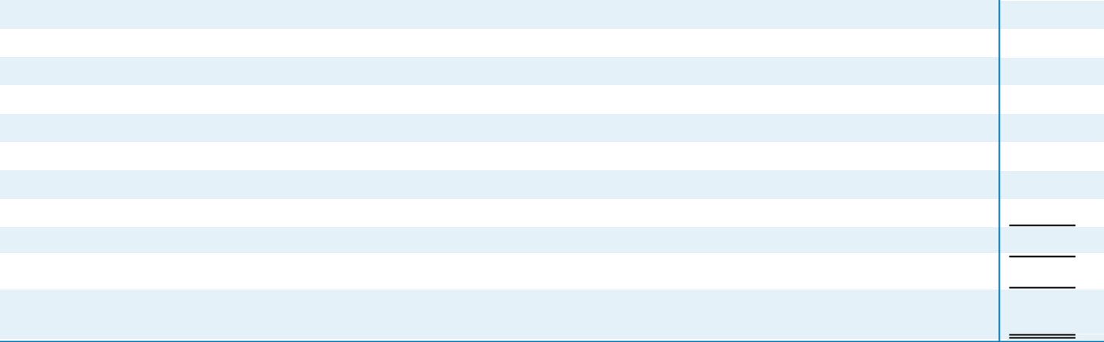

Net Earnings Attributable to Martin Marietta

Add back:

Interest expense

Income tax expense

Depreciation, depletion and amortization expense and nonconsolidated equity affiliate adjustment

Stock-based compensation expense

Deduct:

Interest income

Consolidated EBITDA, as defined by the Company’s Credit Agreement

Consolidated debt, as defined and including debt for which the Company is a co-borrower, at December 31, 2019

Consolidated debt-to-consolidated EBITDA, as defined by the Company’s Credit Agreement, at December 31, 2019 for trailing-twelve month EBITDA

$ | 611.9

129.3

136.3

383.4

34.1

(0.4)

- 1,294.6

- 2,793.8

2.2x

B-2 2020 PROXY STATEMENT

Table of Contents


Table of Contents
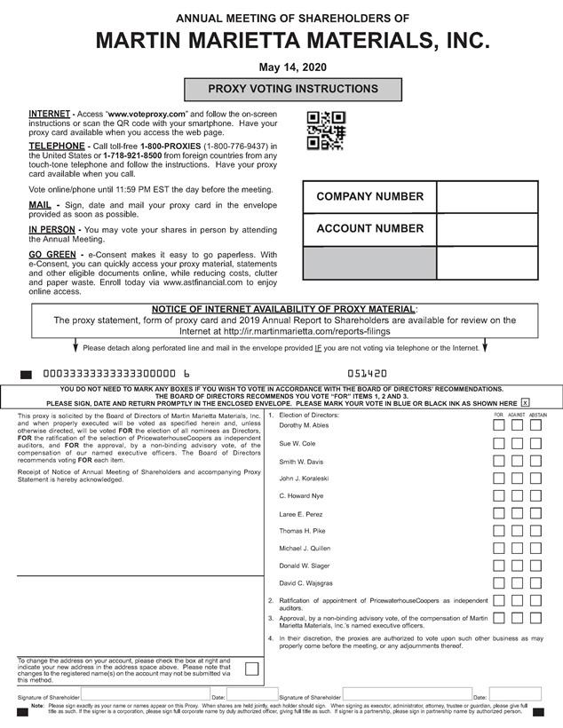

Table of Contents
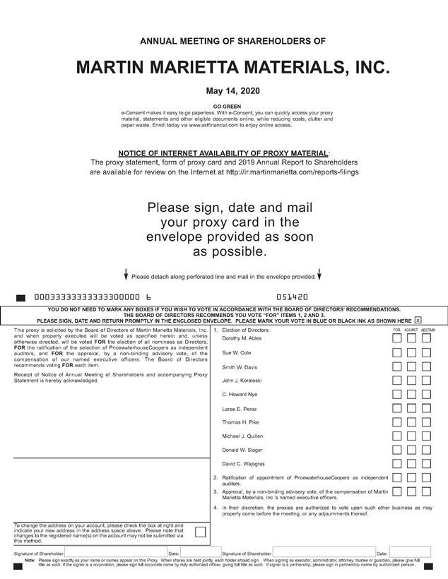

Table of Contents


