UNITED STATES

SECURITIES AND EXCHANGE COMMISSION
Washington, D.C. 20549

SCHEDULE 14A INFORMATION

Proxy Statement Pursuant to Section 14(a) of the

Securities Exchange Act of 1934
(Amendment No. )

Filed by the Registrant ☐ Filed by a Party other than the Registrant ☒

Check the appropriate box:

- Preliminary Proxy Statement

- Confidential, for Use of the Commission Only (as permitted by Rule 14a-6(e)(2))

- Definitive Proxy Statement

- Definitive Additional Materials

- Soliciting Material Pursuant to §240.14a-12

VULCAN MATERIALS COMPANY

(Name of Registrant as Specified in its Charter)

MARTIN MARIETTA MATERIALS, INC.

(Name of Person(s) Filing Proxy Statement, if other than the Registrant)

Payment of Filing Fee (Check the appropriate box):

- No fee required.

- Fee computed on table below per Exchange Act Rules 14a-6(i)(1) and 0-11.

  - Title of each class of securities to which transaction applies:

  - Aggregate number of securities to which transaction applies:

  - Per unit price or other underlying value of transaction computed pursuant to Exchange Act Rule 0-11 (set forth the amount on which the filing fee is calculated and state how it was determined):

  - Proposed maximum aggregate value of transaction:

  - Total fee paid:

- Fee paid previously with preliminary materials.

- Check box if any part of the fee is offset as provided by Exchange Act Rule 0-11(a)(2) and identify the filing for which the offsetting fee was paid previously. Identify the previous filing by registration statement number, or the Form or Schedule and the date of its filing.

  - Amount Previously Paid:

  - Form, Schedule or Registration Statement No.:

  - Filing Party:

  - Date Filed:



Update on Martin Marietta

Materials’ Proposed

Combination with Vulcan

Materials

May 1, 2012

Rock Solid Fundamentals.

Positioned for the Long Term.

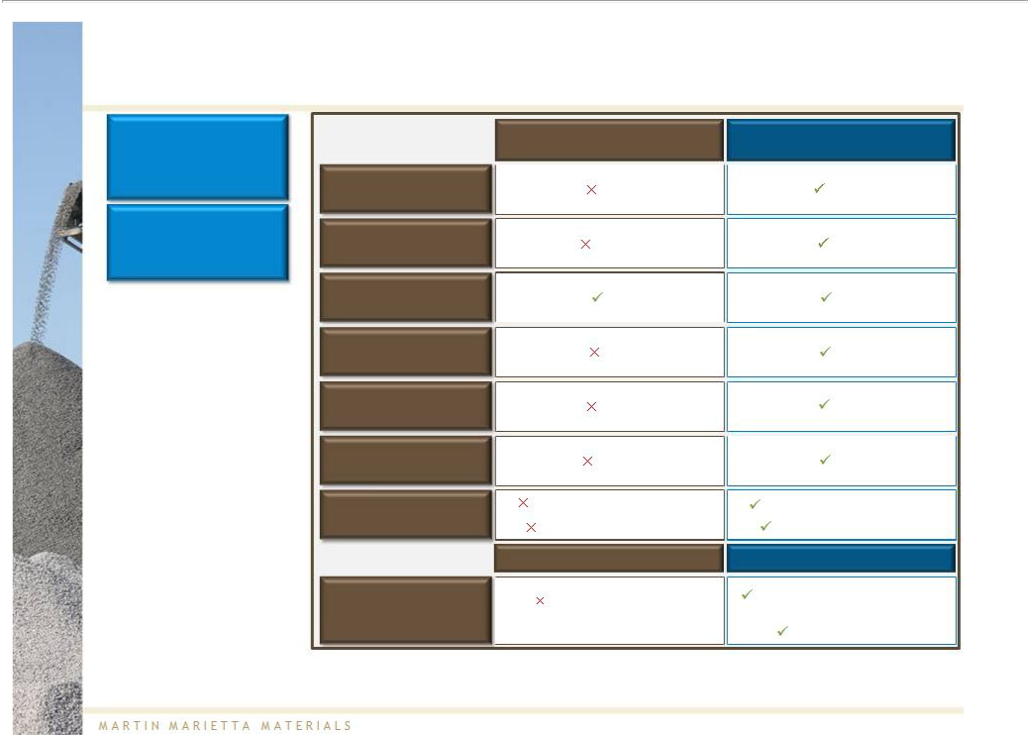
Introduction: Martin Marietta Continues to Outperform Vulcan

Martin Marietta’s net sales is growing at a faster rate than Vulcan’s…

…and generating stronger margins

• Vulcan's earnings

announcement focused on

promises for future performance but did not
provide a substantive
update on their recently
announced Profit Enhancement Plan and Planned Asset Sales

• When asked, Vulcan did

not quantify savings in
Q1 associated with their

YoY Net Sales Growth

Aggregates YoY Price

Growth

Aggregates YoY Shipments Growth

Gross Margin

Adj. EBITDA Margin 2

SG&A % of Net Sales 3

Vulcan | Martin Marietta
Q1 2012 Results | Q1 2012 Results
9.5% | 12.5%¹
(0.8%) | 2.8%
10% | 10%
4.4% | 6.8%
8.5% | 10.0%
13.0% | 9.4%

recently announced Profit Enhancement Plan
• Vulcan still did not

provide detail on which

assets are included in
their Planned Asset Sales
and expected timing

2012 Aggregates

Outlook

Other Results

Volume growth: 2% - 4%

Price growth: 1% - 3%

Non-aggregates4

Negative gross margin

Volume growth: 4% - 5%

Price growth: 2% - 4%

Specialty Products4

Quarterly record for net sales and earnings from operations

37.5% gross margin

Note 1: YoY Net Sales growth reflects Heritage Aggregates business. Inclusive of acquisitions, the YoY Net Sales growth is 20.6%.

Note 2: Please see EBITDA reconciliation in appendix.

Note 3: SG&A not adjusted for R&D expense, as item not disclosed in Vulcan's Q1 2012 press release.

Note 4: Vulcan’s non-aggregates segment includes concrete, asphalt and cement. Martin Marietta’s Specialty Products segment includes the magnesia-based chemicals and dolomitic lime businesses.

Source: Company filings

2



Summary

3


Vulcan Shareholders Should Show Their Support for Martin Marietta's Compelling Offer

Martin Marietta believes that:

- There is undeniable strategic logic in the combination of Martin Marietta and Vulcan

- Vulcan’s claims of undervaluation ignore the fact that Vulcan shareholders are not cashing out, but rather maintaining ~58% ownership in a stronger entity

- Vulcan continues to mask underperformance and value destruction while refusing to accept Martin Marietta’s invitation to engage in discussions

- Vulcan shareholders have an opportunity to send a strong messageto their Board

– Elect Martin Marietta’s independent nominees to the Vulcan Board

– Communicate support for the transaction to fellow shareholders

4

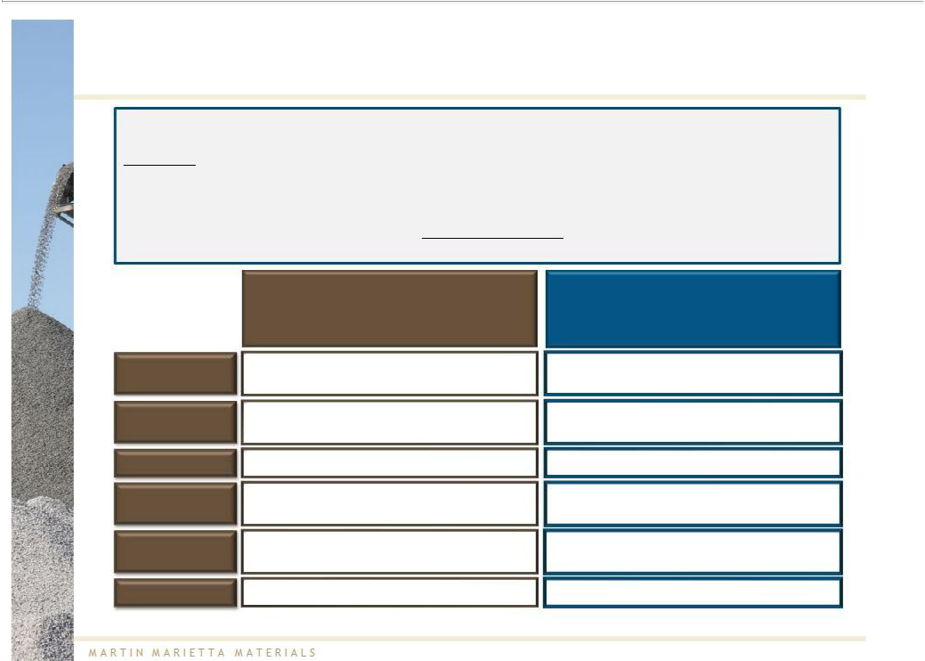
Martin Marietta’s Proposal is a 100% Stock-for-Stock Combination, With Vulcan Shareholders Retaining ~58% Ownership

Vulcan’s statements about value for its shareholders fundamentally mischaracterize Martin Marietta’s proposal, ignoring the shared upside of a stock-for-stock combination

The offer:

– Doesnot undervalue Vulcan; it provides an immediate premium to the unaffected price and values Vulcan at a 2012 EBITDAmultiple of 16.7x while Martin Marietta is trading at 12.7x ¹

– Does not exploit cyclical lows; Vulcan’s share price already reflects expected recovery given current trading multiple and offer at a fixed exchange ratio

– EnhancesVulcan shareholder value through synergies and shared upside in a tax-free combination

Martin Marietta’s

Cash Acquisition Proposed Stock-for-Stock

Combination

Consideration

Leverage

Synergies

Timing

Premium

Future Upside

Cash

Burden increases for buyer

Accrue to buyer only

Opportunistic timing is critical

Typically higher than transactions with stock or mixed consideration

Seller does not participate in future upside

Stock

No incremental leverage related to financing of transaction

Realized and shared

Less important as parties ride economic cycle together

Meaningful premium to the unaffected price

Shared by both parties

Note 1: Vulcan implied TEV/2012E EBITDA based on 0.50 of a Martin Marietta share of common stock for each Vulcan share of common stock (as of 4/27/2012). EBITDA projections based on Thomson median consensus estimates as of 4/27/2012.

5

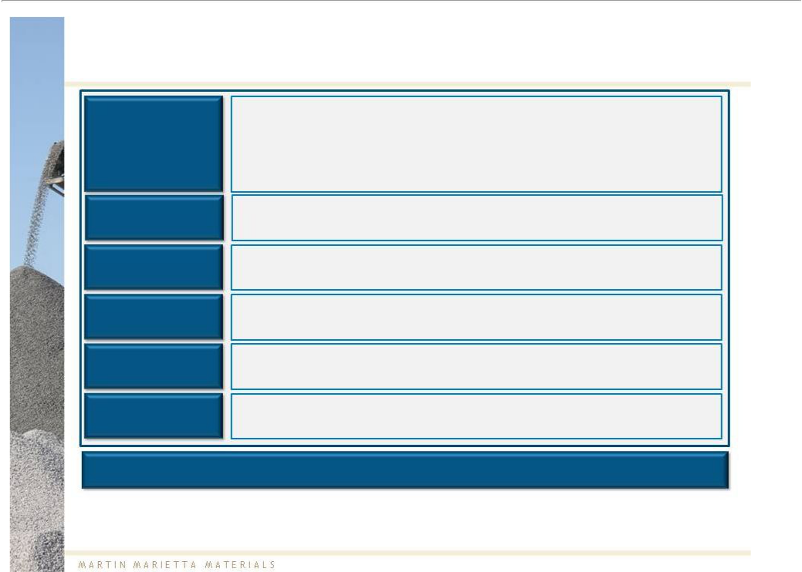
We Agree With Vulcan’s Assertion that “It All Comes Down to Value” ¹…

• Combination creates a “world-class” U.S.-based aggregates leader

Aggregates Leader | • | Significantly increased scale
Aggregates Leader | • | Complementary geographic footprint
 | • | Outstanding combined asset base, including 28 billion tons of mineral reserves

Participation in

the Recovery

Synergies

Meaningful

Dividend

Strong Balance

Sheet

Best-in-Class Management

  - Participation in the eventual cyclical recovery through ~58% continuing ownership in the combined company

- $200 –250 million expected annual cost synergies²

- Immediate meaningful dividend restoration (20x improvement over the current Vulcan dividend)

- Immediately “de-risked” balance sheet and improved access to and credibility with capital markets

- Continued focus on operational excellence

Shareholders stand to benefit immediately from the powerful combination

Note 1: Source: Vulcan’s “The Vulcan Value Proposition”, March 2012.

Note 2: Martin Marietta continues to believe that it can achieve $200 to $250 million of annual cost synergies as a result of the combination. With respect to the purported savings programs announced by Vulcan since December 12, 2011, Martin Marietta believes that Vulcan’s programs will be far from fully effective, at best, for several years, and not necessarily sustainable, although they may
result in some level of cost reductions during this period. Martin Marietta’s belief is based on Martin Marietta’s understanding of the design and attempted implementation to date of Vulcan’s programs and Martin Marietta’s experience in implementing its own fully operational management reporting system. Moreover, Martin Marietta believes that Vulcan’s senior management lacks

demonstrated capability and discipline to be credible to deliver Vulcan’s “hope plan” on a standalone basis, leaving Vulcan shareholders exposed to substantial execution risk. Actual synergies will be based on future performance, as to which there can be no assurance.

6


…But Management Credibility is Essential

Martin Marietta believes that:

Vulcan has masked underperformance and value destruction:

- Relied on flawed operating comparisons

- Mischaracterized the historical performance of its businesses

Vulcan continues to use “smokescreen” tactics to impede a transaction:

- Ignored its own elevated trading multiple, which Martin Marietta believes already reflects the potential benefits of an eventual economic recovery

- Set unrealistic expectations for the relative timing and extent of Vulcan's recovery

- Created vague “hope plans” as a response to Martin Marietta’s proposal

- Disregarded Vulcan’s 26% stock price increase (approximately $1.1 billion in equity value) since 12/9/2011, which appears to have been driven by Martin Marietta’s proposal ¹

Note 1: Equity value reflects change from 12/9/2011 to 4/27/2012.

Source: Company filings, Capital IQ

7

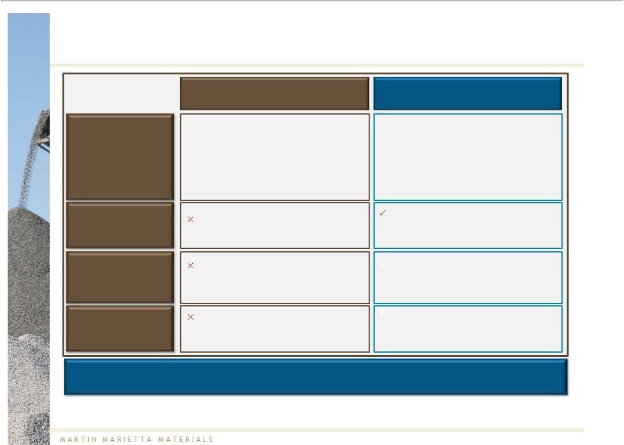
Can You Trust Today’s Vulcan to Make the Right Transaction Decision?

Vulcan’s View

Value Impact

Transaction

Structure

Leverage

Acquisition of Florida Rock in 2007

“The combined company will have enhanced earnings growth and a strong cash flow profile to reduce debt while maintaining Vulcan Materials' historical dividend practices ...”

(Vulcan Press Release, 2/19/2007)

Destroyed $4.3B of the combined company’s shareholder value ¹

Essentially a cash out transaction (~70% cash) with minimal interest in ongoing entity

$3.2B of additional debt that ultimately led to near elimination of the dividend

Martin Marietta’s Proposal

“We do not believe that Martin Marietta’s offer reflects the intrinsic value of Vulcan’s assets or would create value for our shareholders”

(Vulcan Q1 2012 Earnings Conference Call)

Expected to create ~$1.8B-$2.2B of incremental value for the combined company ²

Continuing participation in market recovery (~58% ownership) through all-stock merger

Immediate deleveraging for Vulcan from 7.4x to 4.0x-4.3x with immediate restoration of meaningful dividend ³

Vulcan shareholders deserve the opportunity to participate in Martin Marietta’s value-enhancing proposal

Note 1: Reflects change in market capitalization of Vulcan between 12/31/2007 and 12/9/2011.

Note 2: Assumes $200 - $250M annual synergies at estimated cycle-average EBITDA multiple of 10x, less one-time costs to achieve synergies equal to one times fully achieved annual synergies. Excludes divestitures.
Note 3: Assumes annual synergies of $200 - $250M, attributable to cost savings related to SG&A, duplicative operating functions, and purchasing economies of scale. Excludes divestitures. Please refer to note 2 on page 6.

Source: Company filings
8

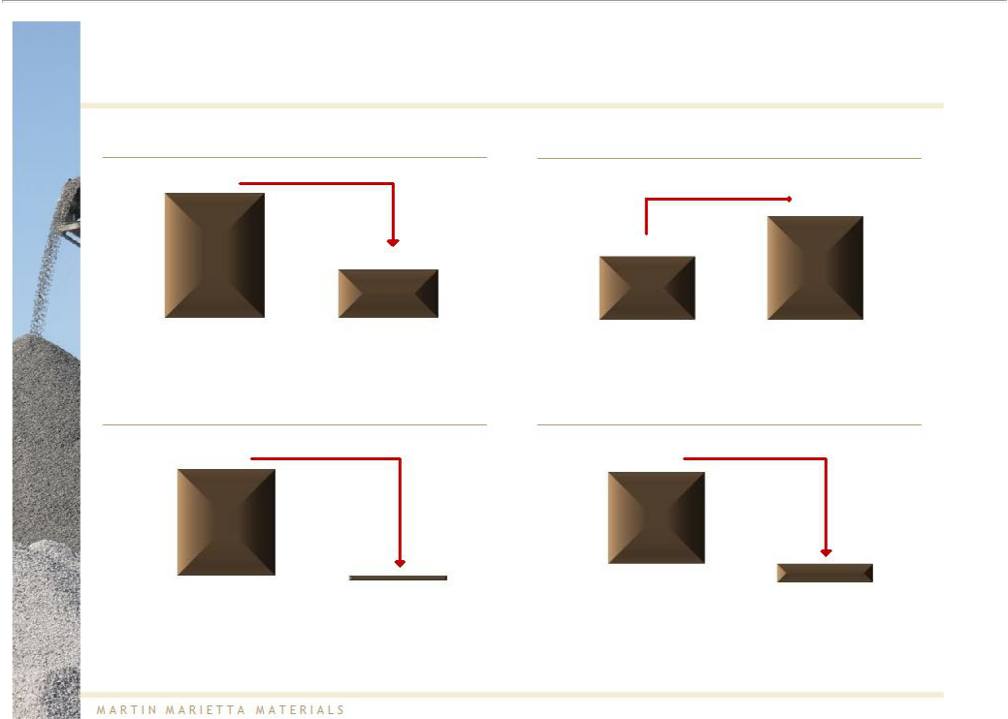
Vulcan’s Underperformance Provides Little Evidence that Vulcan Management Can Deliver on its “Hope Plans”

Vulcan Gross Profit (% of Net Sales) |  |  | 1
 |  | Vulcan Adj. SG&A (% of Net Sales)
 | (1,900 bps) |  | +270 bps
30.8% |  |  | +270 bps
 |  |  | 12.0%
 |  | 9.3%
 | 11.8%
2007 | 2011 | 2007 | 2011

Vulcan Adj. EBIT (% of Net Sales)²

(2,200 bps)

21.0%

(1.0%)

2007 2011

Note 1: Vulcan’s SG&A excludes R&D for comparative purposes. Please see SG&A reconciliation in the appendix.

Note 2: Please see EBIT reconciliation in the appendix.

Note 3: Reflects net income from continuing operations.

Source: Company filings

Vulcan Net Income (% of Net Sales)³

(1,810 bps)

15.0%

(3.1%)

2007 2011

9

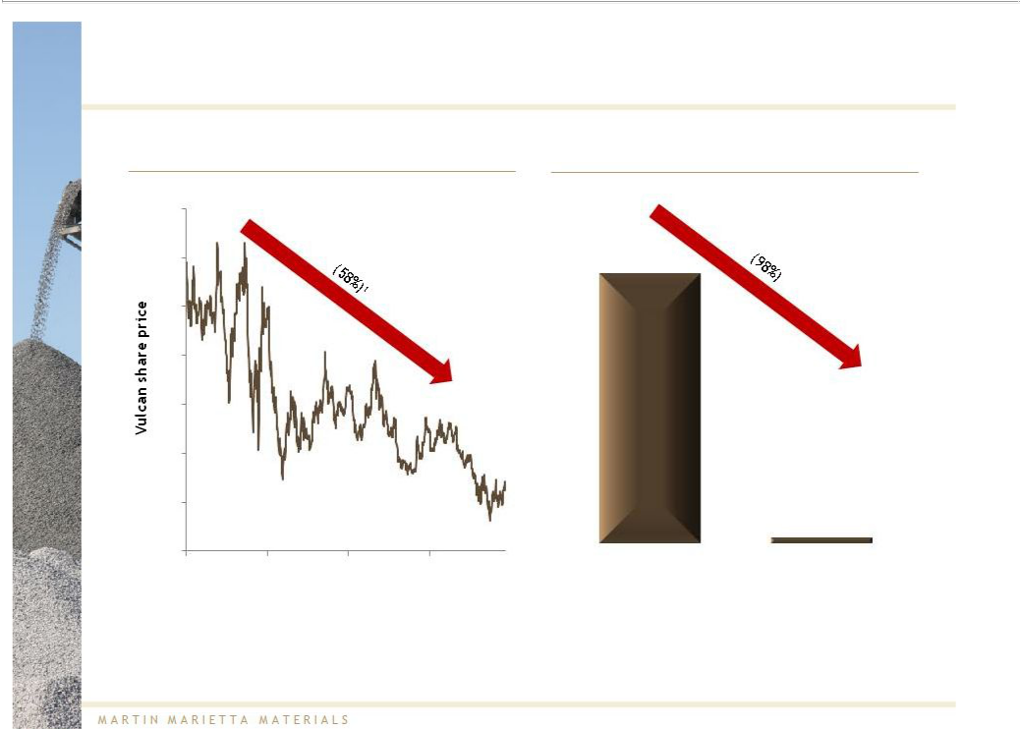
Vulcan’s Underperformance Has Destroyed Significant Shareholder Value

Vulcan Share Price Performance¹

$90
$80
$70
$60
$50
$40
$30
$20
2008 | 2009 | 2010 | 2011

Note 1: Vulcan’s share price performance for the period 12/31/2007 – 12/9/2011.

Source: Company filings, Capital IQ

Vulcan Dividend Level ($/share)

$1.84

$0.04

2007 Q1 2012 annualized

10

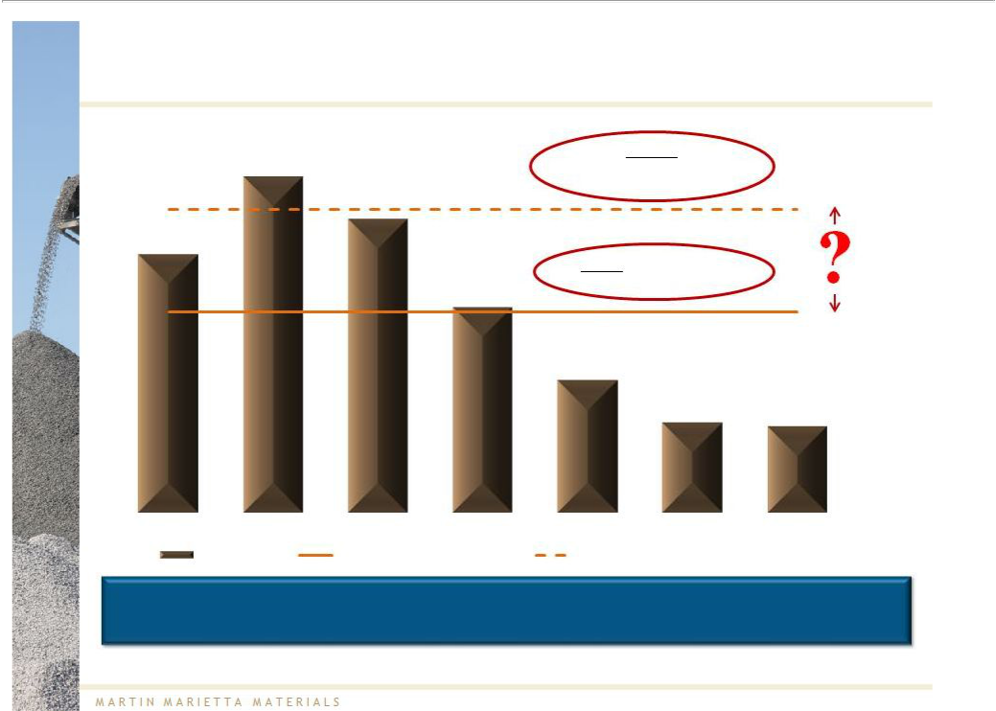
Vulcan’s Valuation Analysis Appears to be Based on Flawed Assumptions Regarding its Recovery

($M) |  | Vulcan Claimed“Profit-
$1,306 |  | Enhanced”Mid-CycleEBITDA:¹
 | $1,143 | $1,179
$1,006
 |  | Actual Vulcan Average
 |  | EBITDA (’05-’11): $780
 |  | $800
 |  | $516
 |  | $352 | $338

PF2005 | PF2006 | PF2007 | 2008 | 2009 | 2010 | 2011
 | Vulcan EBITDA | Average Vulcan EBITDA ('05-'11) |  | Vulcan Profit-Enhanced Mid-Cycle EBITDA

Vulcan cited a mid-cycle EBITDA 50% higher than Vulcan’s historical average

Note: Please see EBITDAreconciliation in appendix. 2005 – 2007 pro forma for the acquisition of Florida Rock.

Note 1: Source: Vulcan’s “The Vulcan Value Proposition”, March 2012.

Source: Company filings

11

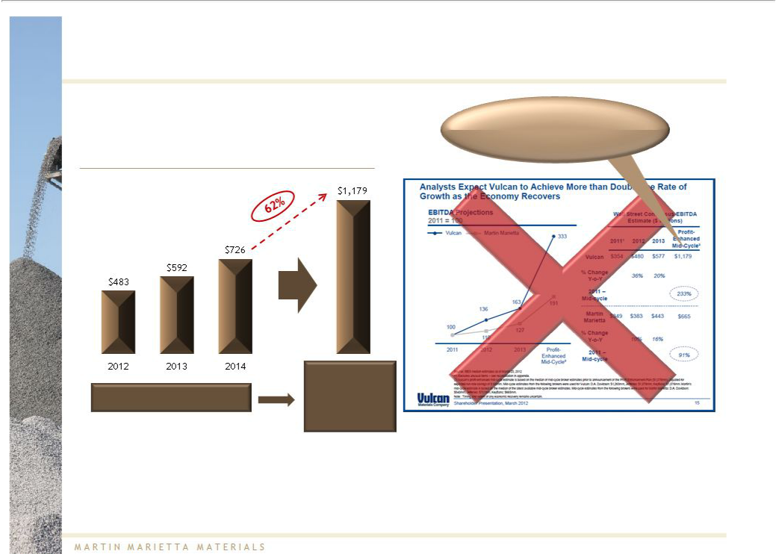
Timing of Vulcan’s Recovery Remains Highly Uncertain

Vulcan EBITDA¹

To calculate its “Profit-Enhanced

Mid-Cycle” EBITDA, Vulcan added

$100 million to an estimate that

already appeared aggressive

($M)

How long to

achieve
Analyst consensus estimates ^{Vulcan’s “Profit}
Enhanced” mid-
cycle EBITDA?²

Note 1: 2012-2014 based on Thomson median consensus estimates as of 4/27/2012.

Note 2: Based on Vulcan’s “The Vulcan Value Proposition”, March 2012.

Source: Company filings, Vulcan’s “The Vulcan Value Proposition”, March 2012

12

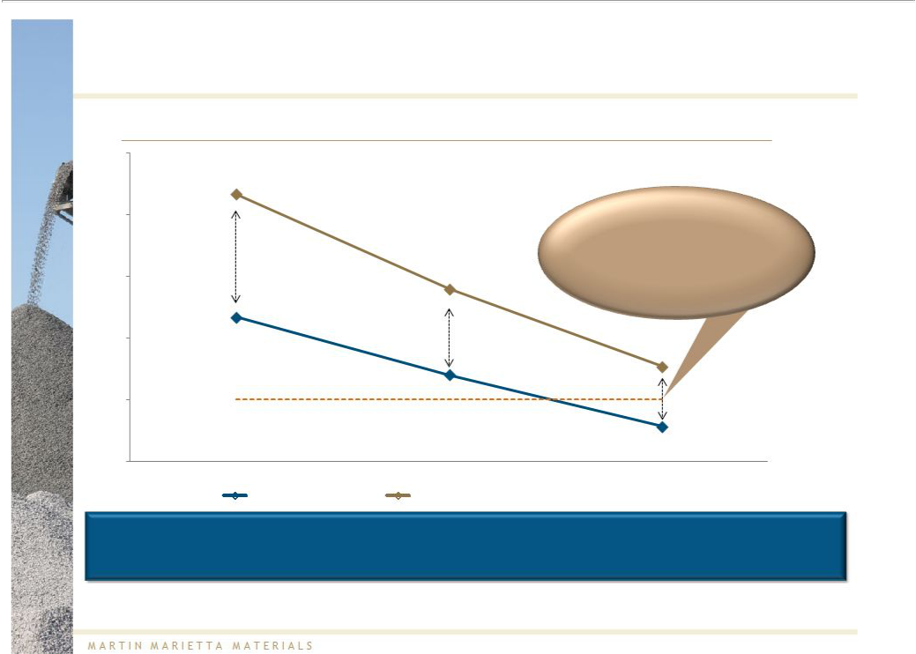
Martin Marietta's Proposal, as Reflected in Vulcan's TEV/EBITDA Multiple, Already Incorporates Analysts' Views of the Eventual Cyclical Recovery And Future Performance

Total EnterpriseValue / EBITDAMultiple ¹

18.0x

16.7x

16.0x |  |  | At the proposed exchange
16.0x |  |  | ratio, Vulcan is valued at a
 |  |  | premium to Martin Marietta,
 |  |  | even using current 2014 analyst
14.0x |  | 13.6x | EBITDA estimates that
 |  |  | incorporate significant recovery
 |  |  | assumptions
12.0x | 12.7x |  | 11.1x
10.0x |  | 10.8x
10.0x | Estimated cycle-average
 | EBITDA multiple of 10.0x
8.0x |  |  | 9.1x
 | 2012 | 2013 | 2014
 | Martin Marietta | Vulcan (at Martin Marietta's Proposal)¹

Martin Marietta’s proposal provides a significant, real premium to Vulcan shareholders; Vulcan’s contrary claim is demonstrably wrong

Note: Market data as of 4/27/2012.

Note 1: Vulcan TEV implied based on current proposed exchange ratio of 0.50 of a Martin Marietta share of common stock for each Vulcan share of common stock.

EBITDA projections based on Thomson median consensus estimates as of 4/27/2012.

Source: Company filings, ThomsonOne

13

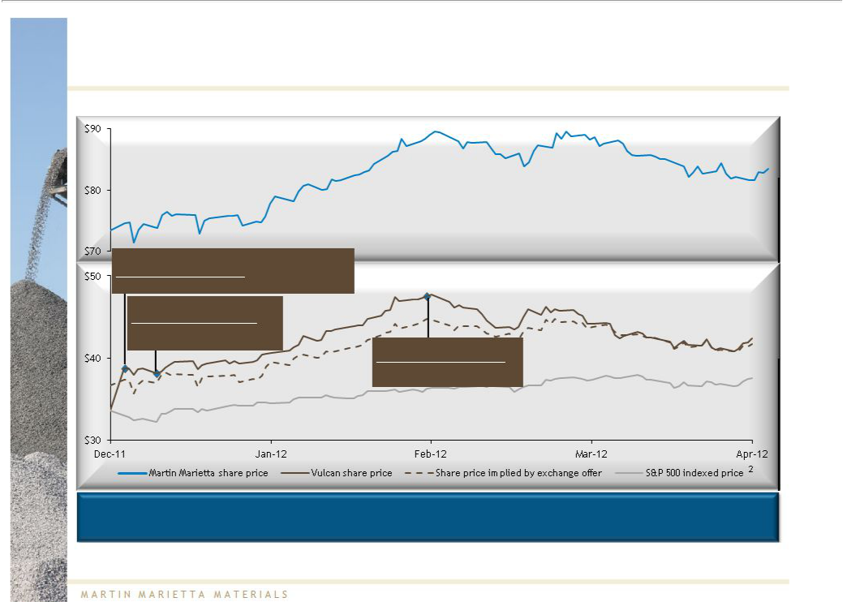
Martin Marietta’s Proposal, and Not the Profit Enhancement Plan, Appears to Have Driven Up Vulcan’s Stock Price

Stock Price Performance Since 12/9/2011

12/12/2011:
Changevs. S&P500: +16.8%¹

Positive price reaction to Martin Marietta proposal

Martin

Marietta

12/19/2011:
Change vs. S&P 500: (2.5%)¹

Vulcan announcement of

“ongoing” restructuring efforts

2/16/2012:
Change vs. S&P 500 : (0.6%)¹
Announcement of Vulcan’s

“hope plans”

Vulcan

S&P500 ²

Following an increase of ~17% upon announcement of the proposal, Vulcan’s share price has traded in line with Martin Marietta’s ¹

Note: Market data as of 4/27/2012.

Note 1: Vulcan share price performance equals Vulcan 1-day change less S&P 500 1-day change.

Note 2: S&P price indexed to Vulcan share price as of 12/9/2011.

Source: Company filings, Capital IQ

14

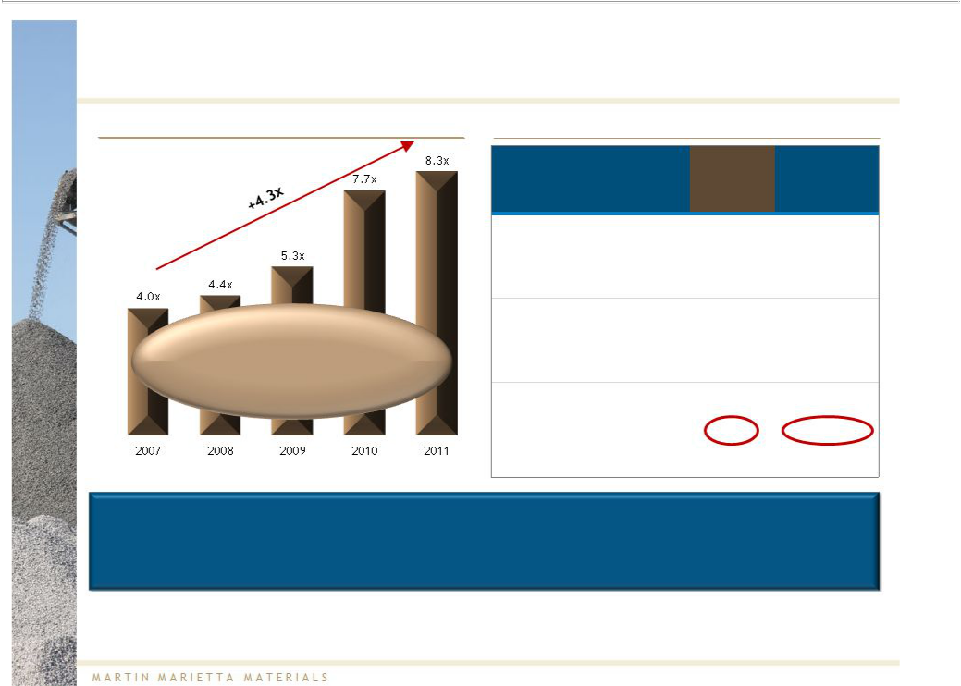
Through a Combination, Vulcan Shareholders Would Realize Immediate Balance Sheet Improvement…

Vulcan StandaloneLeverage¹

“In the absence of a combination, we expect credit measures to remain weak for the rating in the near term, despite some improvement in 2012 as aggregates volumes and pricing rise.”

(Standard & Poor’s, 4/27/2012)

Credit | A3/A- | Baa2/BBB+ | Baa2/BBB | Baa3 / BBB- Ba2/BB
Rating

Combined Financials

3/31/2012 | MARTIN | VULCAN | Combined ²
3/31/2012 | MARIETTA | VULCAN | Combined ²
($M) | MARIETTA
Debt | $1,135 | $2,814 | $3,949
LTM Adj. | $349 | $379 | $928-$9784
EBITDA³ | $349 | $379 | $928-$9784
Total Debt/
LTM Adj. | 3.3x | 7.4x | 4.3x – 4.0x 4
EBITDA³

Vulcan claimsthat it will de-risk its balance sheet “as EBITDAgrows”but ignoresthe time needed for Vulcan to achieve a reasonableleverage ratio on a standalonebasis and the opportunity cost and risk of an extended achievement period

Note 1: Leverage defined as total debt / LTM adjusted EBITDA. Please see EBITDA reconciliation in the appendix.

Note 2: Combined financials exclude fees and expenses associated with the proposed combination.
Note 3: Please see EBITDA reconciliation in the appendix.

Note 4: Assumes annual synergies of $200 - $250 million, attributable to cost savings related to SG&A, duplicative operating functions, and purchasing economies of scale. Excludes divestitures.

Please refer to note 2 on page 6.

Source: Company filings

15

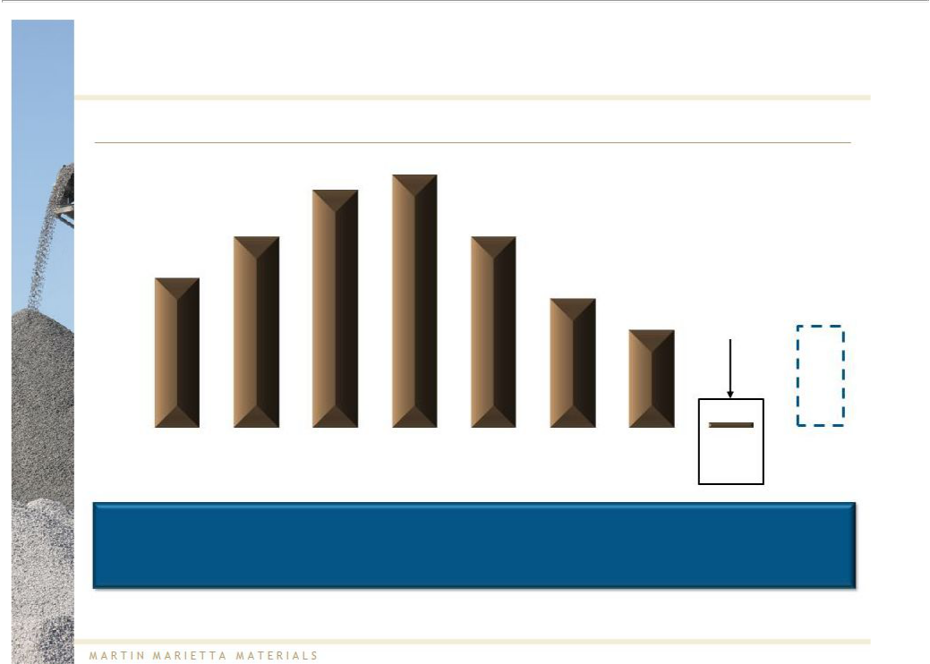
…And an Immediate Return to a Meaningful Dividend

 | Vulcan Dividend Per Share ($)
 | 1.96
 | 1.84
1.48 | 1.48
1.16 |  | Vulcan
1.16 |  | recently cut
 | 1.00 | recently cut
 | 1.00 | its quarterly
 | 0.76¹ | dividend to | 0.80
 | 0.76¹ | $0.01 | 0.80
per share

 |  |  |  |  |  |  | 0.04
2005 | 2006 | 2007 | 2008 | 2009 | 2010 | 2011 | Q1 2012 | Implied annual
 |  |  |  |  |  |  |  | dividend after
 |  |  |  |  |  |  | Annualized | dividend after
combination

The dramatic 3-year decline in Vulcan’s dividend does not inspire confidence in its stated “commitment to restore a competitive dividend when prudent to do so”²

Note 1: Reflects Vulcan’s October 14, 2011 announcement to cut its quarterly dividend to $0.01.

Note 2: Source: Vulcan’s “The Vulcan Value Proposition”, March 2012.

Source: Company filings

16

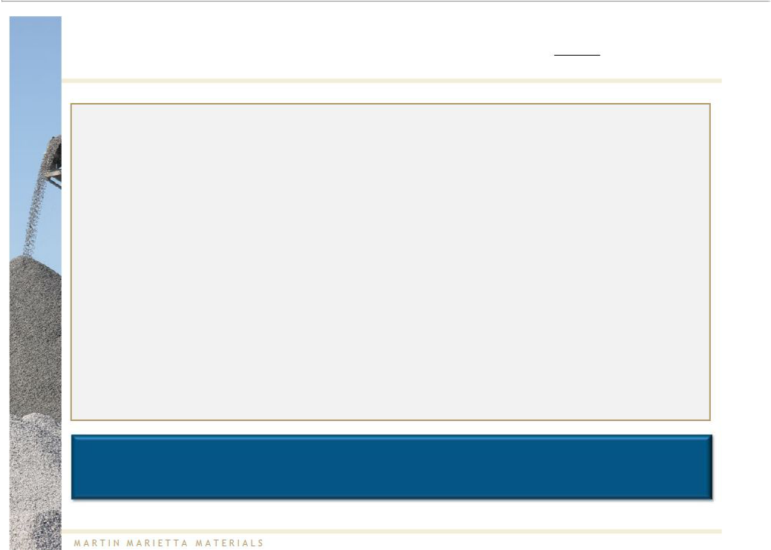
Vulcan ShareholdersShouldSenda StrongMessageto Their Board

- Elect Martin Marietta’s independent nominees to the Vulcan Board

– Martin Marietta has nominated four highly qualified independent director nominees to replace the four incumbent Vulcan directors seeking re-election

– Nominees are independent and have no affiliation with Martin Marietta or Vulcan

– Nominees will bring a fresh perspective - including an open mind - to the Vulcan Boardroom on whether Vulcan should engage with Martin Marietta on its business combination

- Don’t wait – promptly and publicly communicate support for the transaction to:

– The Vulcan Board

– Your fellow shareholders

Vulcan shareholders should support the transaction by voting for the four independent director candidates nominated by Martin Marietta

17



Addressing Vulcan's Most Recent Mischaracterizations

18


Vulcan’s Tactics Are a Smokescreen to Impede the Proposed Transaction

In its March 2012 presentation, “The Vulcan Value Proposition,” Vulcan appears to have:

- Asked its shareholders to believe in the Profit Enhancement Plan, and overlook the unfulfilled promises following the acquisition of Florida Rock

- Refused to acknowledge that the divestiture plan that may be required as part of Martin Marietta’s proposed business combination builds a stronger enterprise as opposed to Vulcan’s asset sale plan which at best will reduce excessive leverage resulting from its Florida Rock transaction

- Cherry-picked metrics for flawed performance comparisons

- Ignored relevant profitability and operating metric comparisons

19

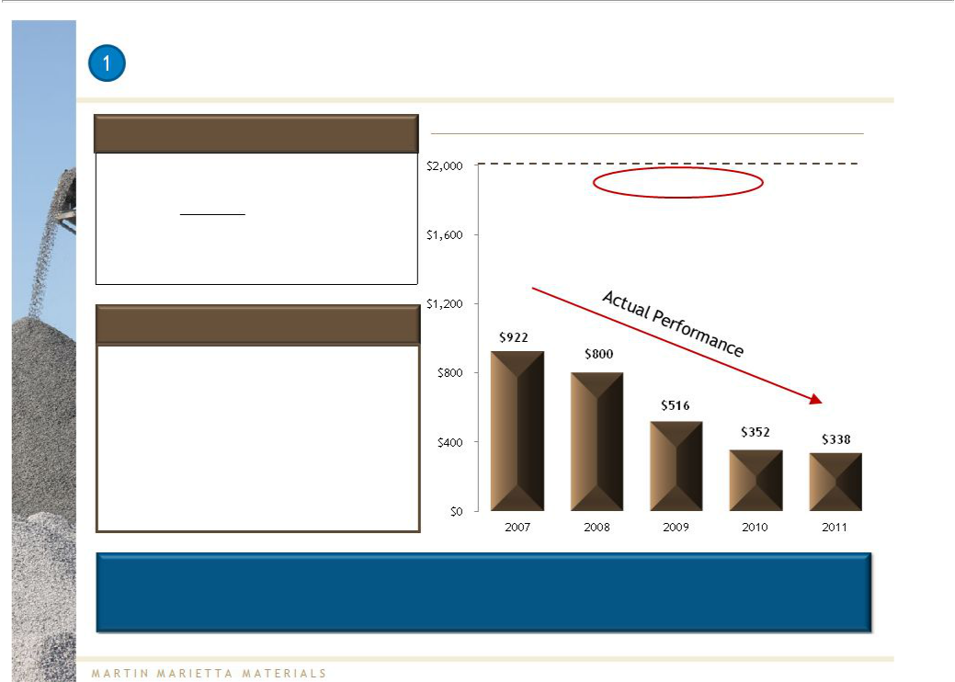
Vulcan Overpromised and Underdelivered Following the Florida Rock Acquisition

What Vulcan Said in 2007: | Adjusted EBITDA and % EBITDA Margin
What Vulcan Said in 2007: | ($M)
“Anticipated average annual EBITDA of | $2B targeted EBITDA
more than $2 billion over the next 3 years,
enabling rapid debt reduction.”
(Vulcan Investor Presentation, February 20, 2007)

What Vulcan Delivered Since 2007:

- EBITDAhas fallen by 63%¹ and is currently 17% of the $2B goal

- Stated focus on cost reduction has yielded only a 9%reduction in SG&Acosts¹ (excluding $50M Florida Rock synergies)

- Failed to accomplish stated goals of de-levering the balance sheet and maintaining an investment grade rating

30%

margin
23%

margin

20%
margin
15% _{14%}
margin _{margin}

Given Vulcan’s lack of credibility, Martin Marietta believes shareholders should not trust Vulcan to deliver significant cost savings over its projected three year time horizon

Note 1: Compares Vulcan’s EBITDA and SG&A for 2007 and 2011.

Source: Company filings

20

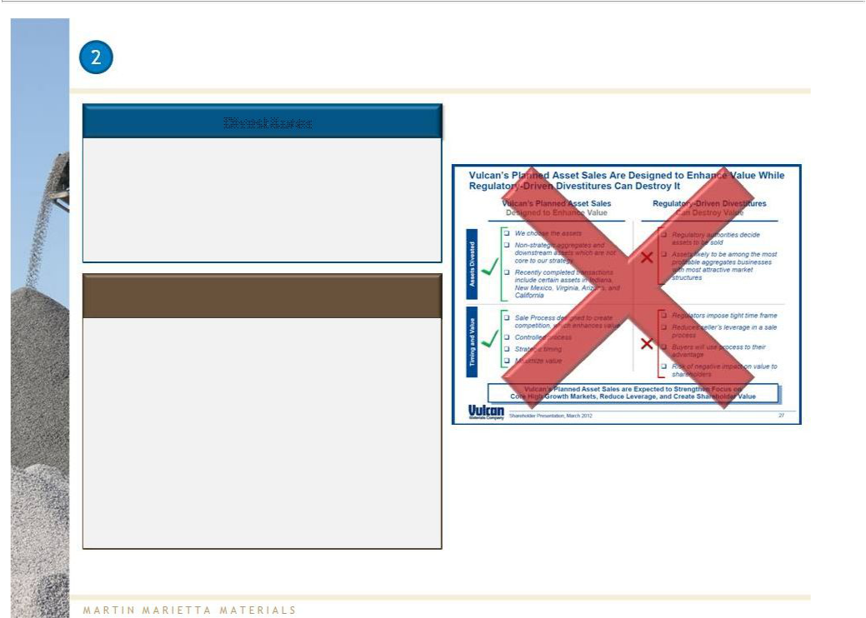
Potential Divestitures in the Business Combination Build a Stronger

Enterprise, Versus Vulcan’s Planned Asset Sales to Reduce Excessive leverage

Divestitures

- Discussions with the DOJ continue; optimistic that outstanding issues will be resolved in the next several weeks

- Numerous buyers have expressed interest in assets that may be divested

Vulcan’s Planned Asset Sales

- Not the optimal strategy to reduce the excessive leverage from Vulcan’s acquisition of Florida Rock

  - In order to achieve $500M of asset sales, meaningful EBITDA generating assets may need to be divested, further extending the time required to reduce leverage

  - Vulcan is ignoring an opportunity to strengthen its balance sheet immediately and restore its dividend through a combination with Martin Marietta

Source: Vulcan’s “The Vulcan Value Proposition”, March 2012

21

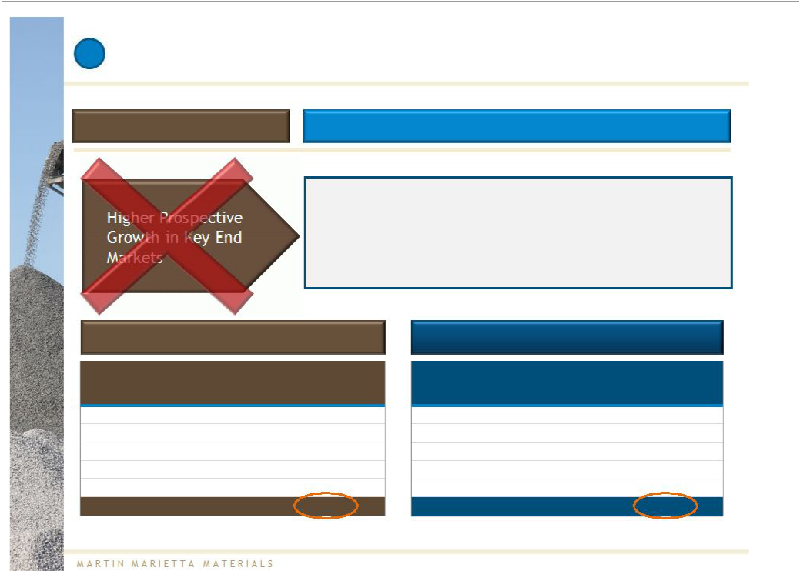
- Flawed Comparisons

VULCAN CLAIM MARTIN MARIETTA’S POSITION

- Both companies well positioned to benefit from estimated long term demographic growth

- Weighted average estimated population growth of 16.3% for Martin Marietta and 14.8% for Vulcan ¹

 | VULCAN |  |  |  | MARTIN MARIETTA
 | % of 2011 Net |  | 2010 – 2020 |  | % of 2011 Net | 2010 – 2020
Top States |  |  | Estimated | Top States | % of 2011 Net | Estimated
Top States | Sales |  | Estimated | Top States | Sales | Estimated
 | Sales |  | Population Growth |  | Sales | Population Growth
California | 21% |  | 11.6% | Texas | 19% | 19.2%
Virginia | 13% |  | 9.9% | North Carolina | 17% | 19.1%
Texas | 9% |  | 19.2% | Iowa | 8% | 3.3%
Florida | 9% |  | 22.4% | Georgia | 8% | 18.1%
Georgia | 7% |  | 18.1% | South Carolina | 5% | 13.3%
Top 5 total ¹ | 59% |  | 14.8% | Top 5 total ¹ | 57% | 16.3%
Note 1: Top 5 states’ | population growth weighted by 2011 sales.
Source: Company filings, Moody’s 2010 – 2020 population |  | projections (April 2012)

22

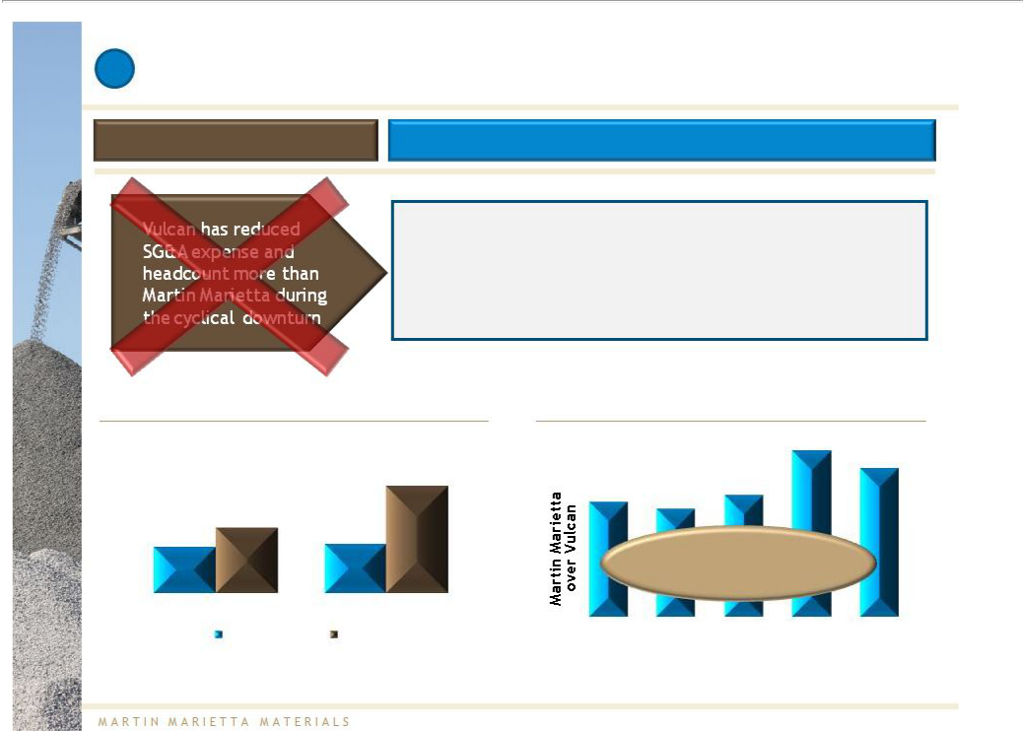
- Flawed Comparisons (continued)

VULCAN CLAIM MARTIN MARIETTA’S POSITION

- For a meaningful comparison, SG&A should be evaluated as a percentage of sales rather than on an absolute basis

- Vulcan’s EBITDA per employee has been significantly below Martin Marietta’s

Adj. SG&A(%of Net Sales)¹ |  |  |  |  |  | 2
 |  | EBITDA Per Employee Comparison
 |  |  |  |  | 183%
 |  |  |  |  |  | 163%
 | 12.0% |  |  | 134%
 |  | 126% | 119% | 134%
9.3%
8.0% | 8.2% |  | Over the last 5 years, Martin
 |  |  | Marietta has generated on
 |  |  | average 45% more EBITDA per
 |  |  | employee than Vulcan
2007 | 2011
Martin Marietta | Vulcan | 2007 | 2008 | 2009 | 2010 | 2011³

Note 1: Vulcan’s SG&A excludes R&D for comparative purposes. Please see SG&A reconciliation in the appendix.

Note 2: Martin Marietta EBITDA per employee divided by Vulcan EBITDA per employee.
Note 3: 2011 headcount for Martin Marietta adjusted to exclude impact of asset swap transaction closed in December 2011, with a net impact of approximately 450 employees.
Source: Company filings

23

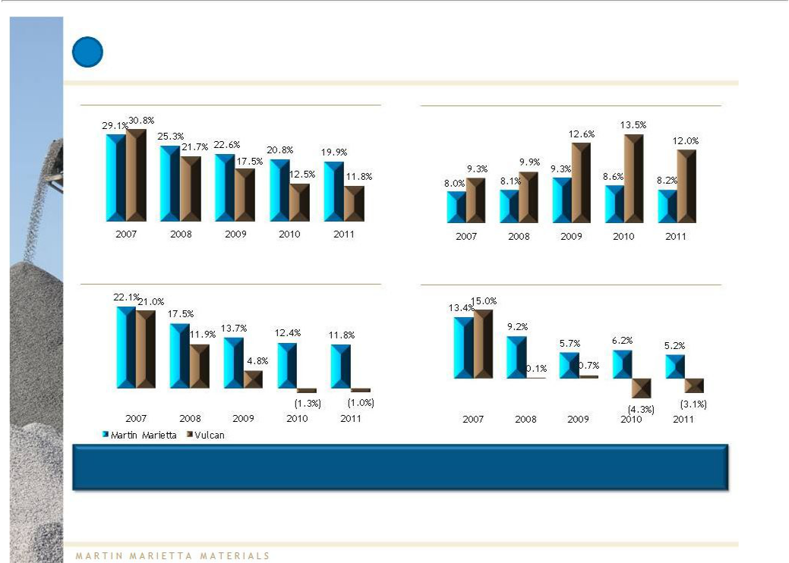
Relevant Metrics Show Martin Marietta has Clearly Outperformed
- Vulcan

Gross Profit (% of Net Sales) Adj. SG&A (% of Net Sales) ¹

Adj. EBIT (% of Net Sales) ² Net Income (% of Net Sales) ³

Confronted with the same downturn in the construction market,

Martin Marietta has outperformed Vulcan

Note 1: Vulcan’s SG&A excludes R&D for comparative purposes. Please see SG&A reconciliation in the appendix.

Note 2: Please see EBIT reconciliation in the appendix.

Note 3: Reflects net income from continuing operations.

Source: Company filings

24



Revisiting the Compelling Nature of the Proposal

25

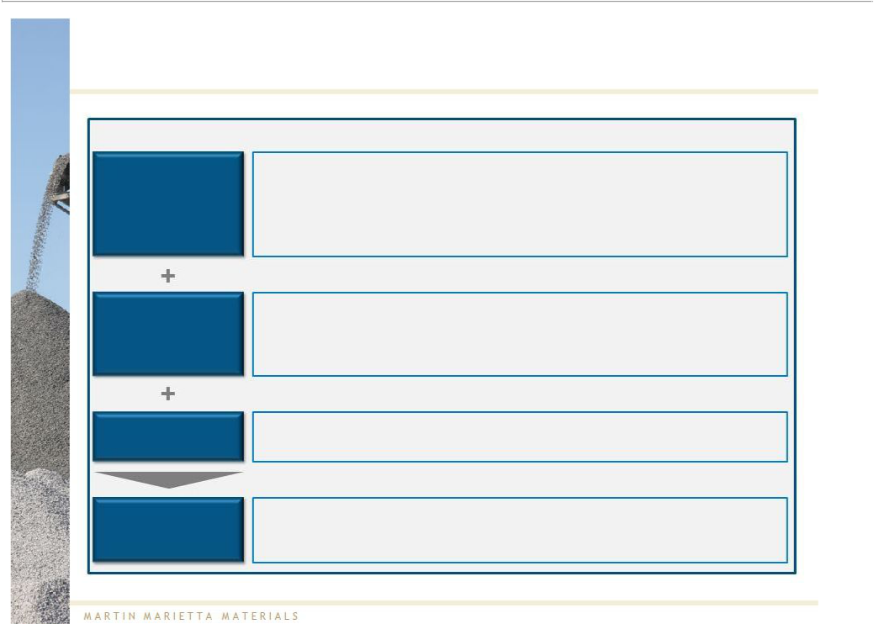
Undeniable Strategic Logic for a Combination

Aggregates

Leader

Synergies

Positioned for

Growth

Value Creation

Martin Marietta believes that a combination:

- Creates a “world-class” U.S.-based aggregates leader

  - Significantly increased scale

  - Complementary geographic footprint

  - Outstanding combined asset base, including 28 billion tons of mineral reserves

- Generatessignificantly greater cost reduction through synergiesthan Vulcan is likely to achieve on its own

  - $200 –250M annual cost synergies vs. Vulcan’s unsubstantiated “hope plan” 1

- Presents greater growth opportunities than either company on a standalone basis

- Creates significant value for both companies’ shareholders

Note 1: Please refer to note 2 on page 6.

26

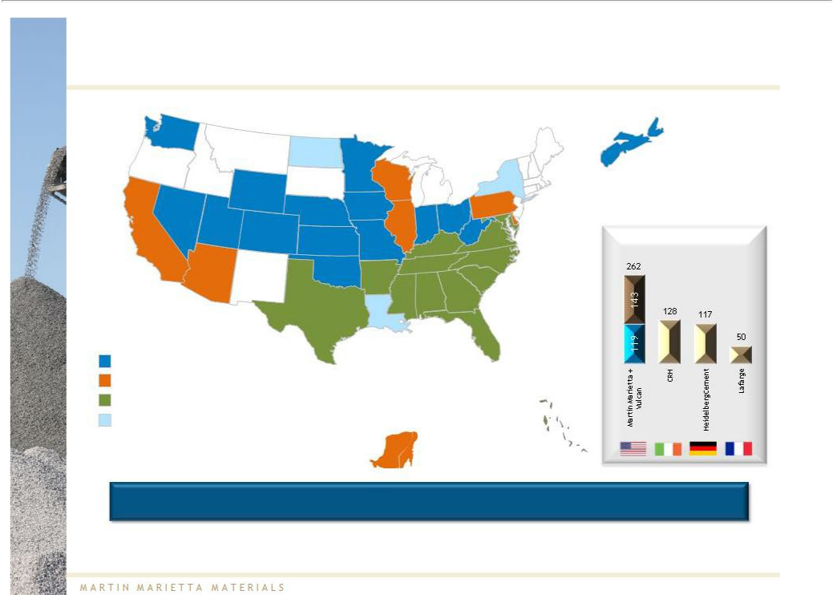
Combined Company Will Have the Most Extensive Aggregates Footprint

WA

 |  | MT
OR
ID
 |  | WY
NV
CA | UT | CO
AZ |  | NM

States with Martin Marietta locations States with Vulcan locations
States with both companies’ locations Locations served by Martin Marietta

ND |  |  |  | ME
 | MN |  |  | VT
SD | WI |  |  | NH
SD | WI |  | NY | MA
 |  | MI |  | CT _{RI}
NE | IA |  | PA | NJ
NE |  |  | OH | DE
 | IL | IN | OH | DE
 | IL | IN | WV | MD
KS |  |  | WV
KS | MO | KY | VA
 |  | KY | NC
 |  | TN | NC
OK |  | TN
OK | AR |  | SC
 | MS | AL | GA
TX | LA
 |  |  | FL

Bahamas

Yucatán

Peninsula

Nova Scotia

U.S. aggregates producers

(by shipments) ¹

2,3

4

Combined company has extensive geographic coverage and diversity

Note 1: Fiscal year 2011 annual shipments measured in millions of short tons and based on publicly available information. Excludes divestitures.

Note 2: Martin Marietta includes shipments from Nova Scotia and the Bahamas which are primarily used to service the U.S.

Note 3: Vulcan includes shipments from the Yucatán Peninsula and the Bahamas.

Note 4: Heidelberg reports North American aggregates volumes, which includes production sites in western Canada.

Source: Company filings

27

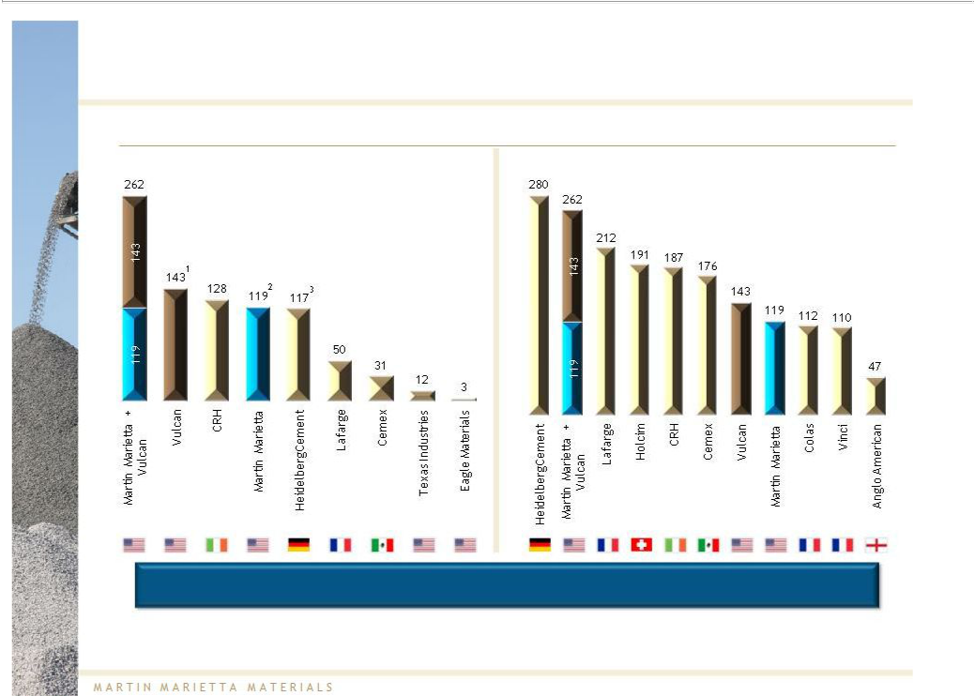
Creates a “World-Class” U.S.-Based Aggregates Leader

Aggregates Shipments by Tonnage

U.S. Global

Combinationcreates the “must own” U.S. heavy building materials stock

Note:

Note 1:

Note 2:

Note 3:

Source:

Fiscal year 2011 annual shipments measured in millions of short tons and based on publicly available information. Excludes divestitures.

Vulcan includes shipments from the Yucatán Peninsula and the Bahamas.

Martin Marietta includes shipments from Nova Scotia and the Bahamas which are primarily used to service the U.S.

Heidelberg reports North American aggregates volumes, which includes production sites in Western Canada.

Company filings

28

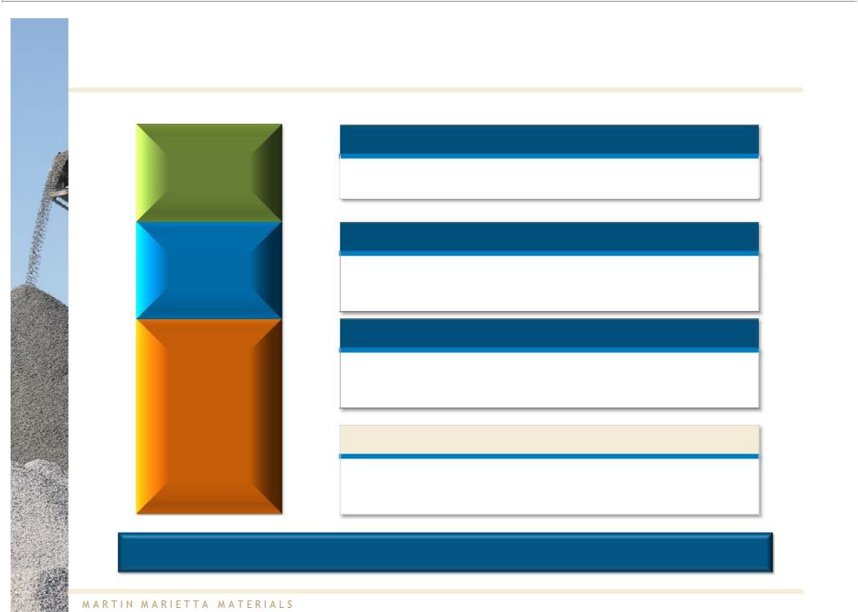
Realization of $200 - 250M in Annual Cost Synergies

$50 – 60M

$50 – 60M

Improved Purchasing Efficiencies from Greater Scale

- Goods and services

- Distribution network

Duplicative Operating Functions

- Realigned organizational structure

- Management, facility, sales force and production overhead integration

Duplicative SG&A Functions

• Management, facility, corporate overhead and information

technology integration
• Public company costs

$100 – 130M

Realization and Cost to Achieve

- Synergies expected to be realized over two to three years

- One-time costs to achieve synergies expected to be equal to one times fully achieved annual synergies

Realization of cost synergies creates significant shareholder value

Note: Please refer to note 2 on page 6.

29

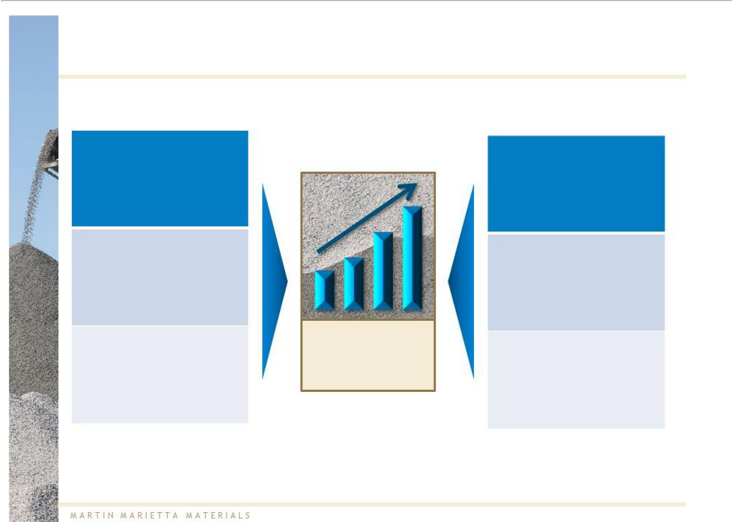
Significant Shareholder Value Creation

Estimated

$200 - $250 million
in annual synergies¹

Meaningful dividend

Balance sheet well-positioned for cyclical recovery and growth

Significant

shareholder

value creation

Efficiencies gained from size and scale

Continued focus on operational excellence

Stronger platform for long term growth

Note 1: Please refer to note 2 on page 6.

30

Martin Marietta is Committed to Making This Combination a Reality

31

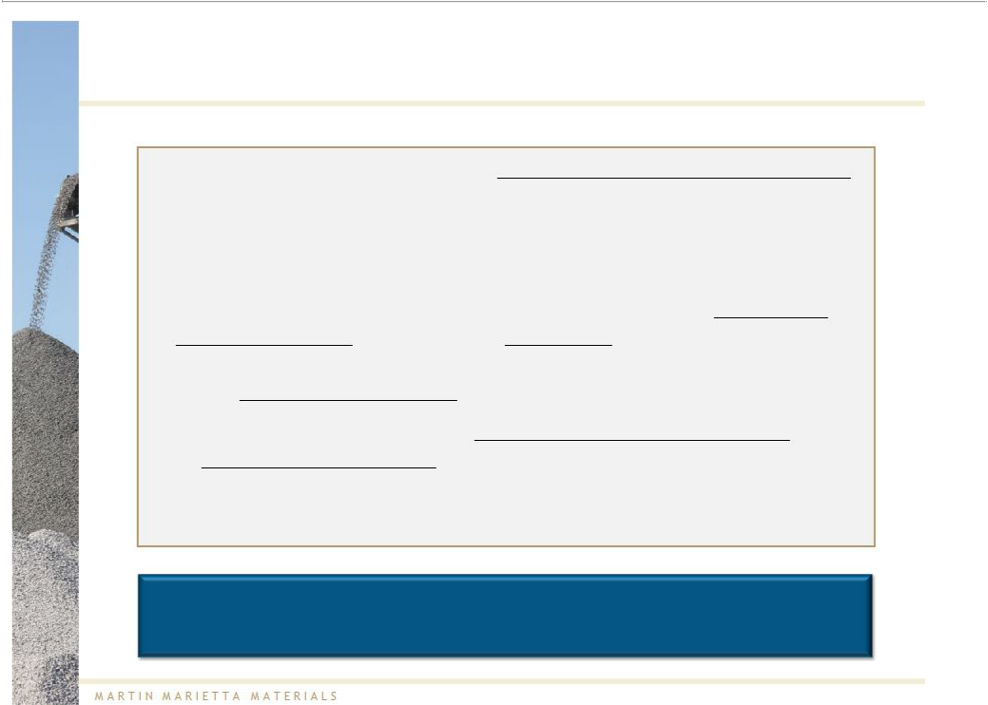
The Election of Martin Marietta’s Independent Director Nominees is The Important Next Step for a Successful Transaction

- Martin Marietta has nominated 4 independent director candidates to the Vulcan Board who would replace the 4 incumbent Vulcan directors seeking re-election

- Election of Martin Marietta’s independent nominees will bring a fresh perspective – including an open mind – to the Vulcan Boardroom on whether Vulcan should engage with Martin Marietta on its business combination

  - In contrast, a vote for the incumbent Board members is a vote for the status quo, encouraging the current Vulcan Board to continue to ignore value creating opportunities for shareholders

This election provides a critical opportunity to the Vulcan shareholders to show support for a combination of the two companies

32

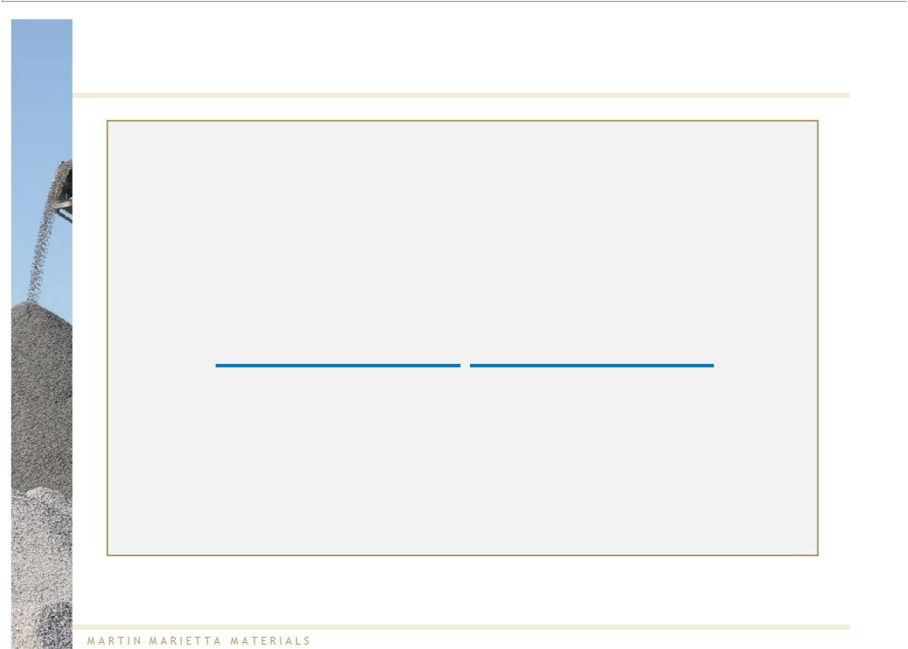
Qualified and Independent Board Nominees

- Martin Marietta has proposed qualified, independent Board nominees

- Each nominee has been carefully screened to ensure independence

– No affiliation with Martin Marietta, Vulcan or any of their subsidiaries

- Board nominees have a broad set of skills and experience required to ensure the Board functions efficiently and provides appropriate oversight

Skills

– Corporate governance

– Securities and disclosure

– Executive compensation

– Finance and accounting

– Operations

Experience

– Current and former directors of public companies

– Financial and operating experience

– Major corporate M&A transaction experience

33


Now is the Time for Vulcan Shareholders to Act

Vote the blue proxy card or blue voting instruction form today and communicate your support for the proposal to the Vulcan Board

34



Appendix

35

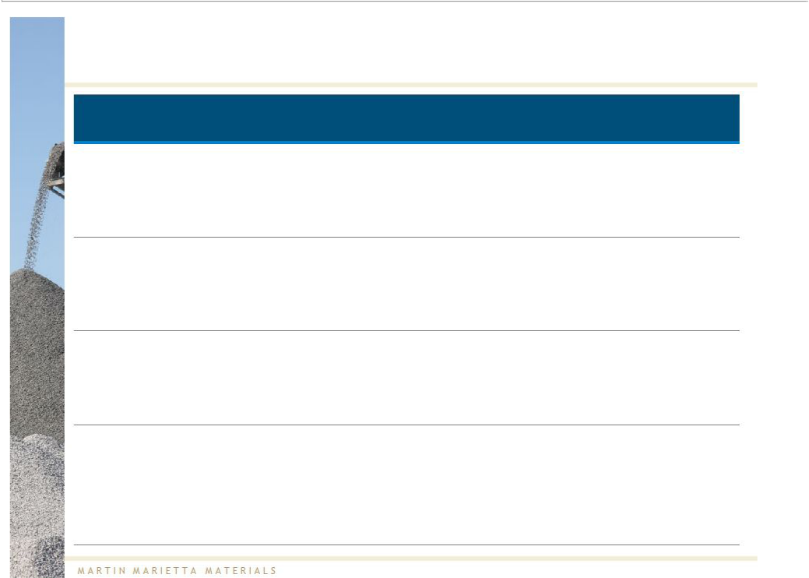
Qualified Independent Board Nominees

Board Nominees Selected Qualifications Expertise

- Senior VP and Chief Administrative Officer of Time Warner, Inc. (1991-1998)
Philip R. Lochner, Jr. - Commissioner of the SEC (1990-1991)

- Currently serves as director on four publicly traded U.S. corporations

- Senior VP of Finance and CFO of 7-ELEVEN, Inc. (2002-2006)

- Executive VP of Finance and CFO of Covanta Energy

Edward W. Moneypenny Corporation (2001)

- Previously CFO at two former Fortune 500 companies in the energy industry

- Executive VP and CFO of Chemtura Corporation (2004-2007)

- Senior VP and CFO of Westvaco Corporation and

Karen R. Osar MeadWestvaco Corporation (1999-2003)

- Previously Managing Director, investment banking, of JPMorgan Chase & Co.

- Chairman of the Board of Capstone Infrastructure Corp.

- Significant prior experience as former director or trustee of

V. James Sardo multiple institutions

- Interim CEO of Royal Group Technologies Limited (2005-2006)

Corporate Governance

Securities and

Disclosure

Finance and Accounting

Executive Compensation Corporate Governance Finance and Accounting

Corporate Governance Operations

36

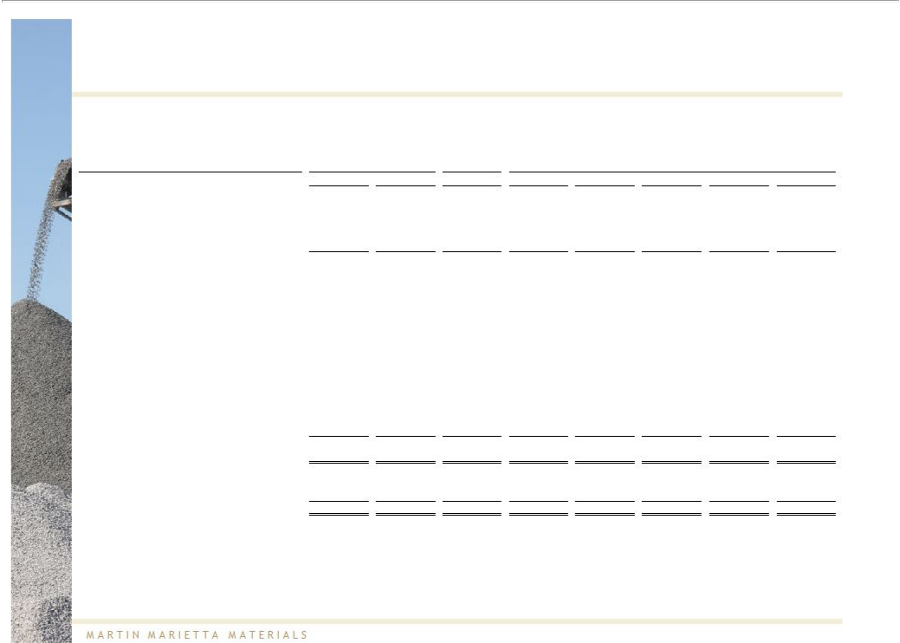
Martin Marietta EBITDA & EBIT Reconciliation

 | For the Quarter Ended
(dollars in millions) |  | March 31, |  |  |  | LTM |  |  |  | For the Year Ended December 31,
 |  | 2012 |  | 2011 |  | 3/31/2012 |  | 2011 |  | 2010 |  | 2009 |  | 2008 |  | 2007
Net earnings attributable to entity | $ | (36.7) | $ | (17.4) | $ | 63.1 | $ | 82.4 | $ | 97.0 | $ | 85.5 | $ | 176.3 | $ | 262.7
Add back:
Interest expense |  | 13.5 |  | 18.2 |  | 53.9 |  | 58.6 |  | 68.5 |  | 73.5 |  | 74.3 |  | 60.9
Income tax expense for controlling interests |  | (10.0) |  | (6.4) |  | 19.6 |  | 23.2 |  | 29.3 |  | 27.4 |  | 77.3 |  | 116.6
Depreciation, depletion and amortization expense |  | 43.8 |  | 42.9 |  | 172.7 |  | 171.8 |  | 179.9 |  | 177.7 |  | 169.8 |  | 150.4
EBITDA | $ | 10.6 | $ | 37.3 | $ | 309.3 | $ | 336.0 | $ | 374.7 | $ | 364.1 | $ | 497.7 | $ | 590.6
Adjusted for:
Legal settlement |  | - |  | - |  | - |  | - |  | - |  | 11.9 |  | - |  | -
Reversal of excess legal reserve |  | - |  | - |  | - |  | - |  | (5.0) |  | - |  | - |  | -
Nonrecurring reduction in workforce charge |  | - |  | - |  | - |  | - |  | - |  | - |  | 5.4 |  | -
Charge for early retirement benefit |  | - |  | - |  | 4.4 |  | 4.4 |  | - |  | - |  | - |  | -
Loss (gain) on sales of assets |  | 0.5 |  | (3.0) |  | (2.0) |  | (5.5) |  | (4.5) |  | 3.0 |  | (12.8) |  | -
Transaction costs |  | 25.9 |  | 1.0 |  | 43.5 |  | 18.6 |  | 1.2 |  | 2.2 |  | 3.6 |  | -
Settlement expense for pension plan |  | - |  | - |  | 0.4 |  | 0.4 |  | 3.5 |  | - |  | 2.8 |  | 0.7
Asset write-offs |  | - |  | - |  | - |  | - |  | - |  | - |  | 3.3 |  | -
Other nonoperating (income) expense |  | (1.8) |  | (0.2) |  | 0.2 |  | 1.8 |  | 0.2 |  | (1.1) |  | 2.0 |  | (7.3)
Pretax loss (gain) on discontinued operations |  | 0.7 |  | 1.8 |  | (7.3) |  | (6.2) |  | (0.3) |  | (0.5) |  | (10.1) |  | (3.7)
Income attributable to noncontrolling interests |  | (1.0) |  | (0.3) |  | 0.5 |  | 1.2 |  | 1.7 |  | 2.8 |  | 3.7 |  | 0.9
Adjusted EBITDA | $ | 34.9 | $ | 36.6 | $ | 349.0 | $ | 350.7 | $ | 371.5 | $ | 382.4 | $ | 495.6 | $ | 581.2
Less:
Depreciation, depletion and amortization expense |  | 43.8 |  | 42.9 |  | 172.7 |  | 171.8 |  | 179.9 |  | 177.7 |  | 169.8 |  | 150.4
Adjusted EBIT | $ | (8.9) | $ | (6.3) | $ | 176.3 | $ | 178.9 | $ | 191.6 | $ | 204.7 | $ | 325.8 | $ | 430.8

Note: Adjusted Q1 2012 and LTM EBITDA is preliminary and amounts may change upon finalization of Martin Marietta’s Q1 2012 earnings as reported on Form 10-Q.

Source: Company filings

37

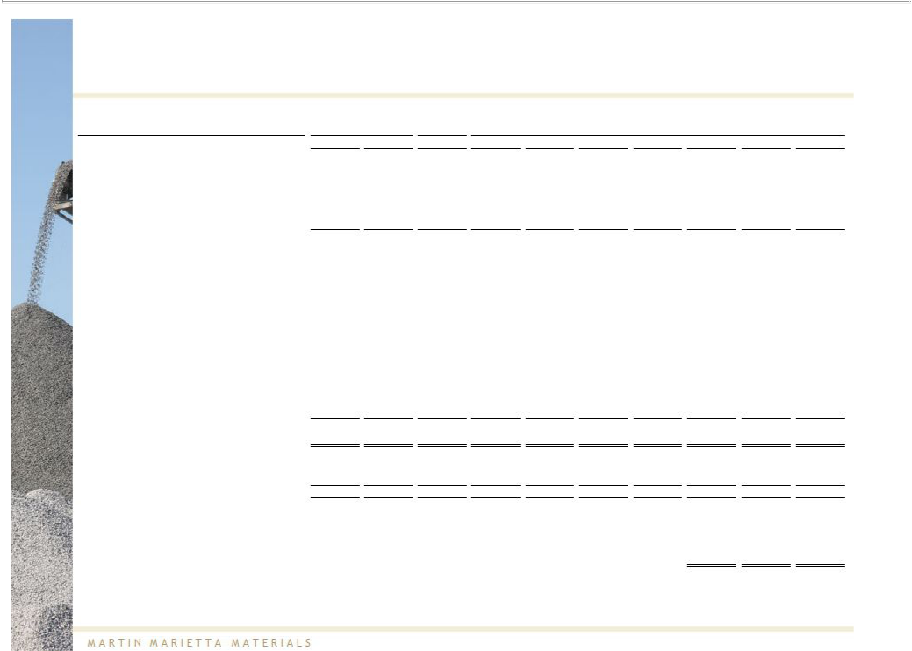
Vulcan EBITDA & EBIT Reconciliation

 | For the Quarter Ended
(dollars in millions) | March 31, |  |  | LTM |  |  | For the Year Ended December 31,
 | 2012 |  | 2011 | 3/31/2012 | 2011 | 2010 |  | 2009 |  | 2008 |  | 2007 |  | 2006 |  | 2005
Net (loss) earnings | $ (52.1) | $ | (54.7) | $ (68.1) | $ (70.8) | $ (96.5) | $ | 30.3 | $ | 0.9 | $ | 450.9 | $ | 470.2 | $ | 470.2
Add back:
Interest expense | 52.3 |  | 42.3 | 227.2 | 217.2 | 180.7 |  | 173.0 |  | 169.7 |  | 41.6 |  | 20.1 |  | 20.5
Income tax (benefit) expense | (38.4) |  | (31.0) | (83.0) | (75.6) | (85.7) |  | (30.1) |  | 70.1 |  | 197.2 |  | 216.7 |  | 164.1
Depreciation, depletion and amortization expense | 85.2 |  | 90.6 | 356.3 | 361.7 | 382.1 |  | 394.6 |  | 389.1 |  | 271.5 |  | 226.4 |  | 222.9
Goodwill impairment | - |  | - | - | - | - |  | - |  | 252.7 |  | - |  | - |  | -
EBITDA | 47.0 |  | 47.1 | 432.4 | 432.5 | 380.6 |  | 567.8 |  | 882.5 |  | 961.2 |  | 933.4 |  | 796.5
Adjusted for:
Legal settlement | - |  | - | - | - | 40.0 |  | - |  | - |  | - |  | - |  | -
Recovery for legal settlement | - |  | (25.5) | (20.9) | (46.4) | - |  | - |  | - |  | - |  | - |  | -
Legal expense | - |  | - | - | - | 3.0 |  | - |  | - |  | - |  | - |  | -
Transaction expenses | 10.1 |  | - | 10.1 | (0.0) | - |  | - |  | - |  | - |  | - |  | -
Restructuring charges | - |  | - | 15.2 | 15.2 | - |  | - |  | - |  | - |  | - |  | -
Gain on sales of assets | (6.5) |  | (0.5) | (53.8) | (47.8) | (59.3) |  | (27.1) |  | (94.2) |  | (58.7) |  | (5.6) |  | (8.3)
Asset write-offs | - |  | - | - | - | 9.2 |  | 8.5 |  | 10.5 |  | - |  | - |  | -
Accretion expense for asset retirement obligations | - |  | (2.2) | (6.0) | (8.2) | (8.6) |  | (8.8) |  | (7.1) |  | (5.9) |  | (5.5) |  | (4.8)
Other nonoperating (income) expense | (3.1) |  | (1.4) | (1.7) | (0.0) | (3.1) |  | (5.3) |  | 4.4 |  | 5.3 |  | (28.5) |  | (24.4)
(Earnings) loss on discontinued operations, net of tax | (5.0) |  | (16.4) | (4.0) | (7.4) | (10.0) |  | (19.5) |  | 4.1 |  | 19.3 |  | 16.6 |  | (83.7)
Income attributable to noncontrolling interests | - |  | - | - | - | - |  | - |  | - |  | 0.2 |  | - |  | 11.2

Adjusted EBITDA | $ | 42.4 | $ | 1.2 | $ | 379.2 | $ | 337.9 | $ | 351.8 | $ | 515.6 | $ | 800.1 | $ | 921.5 | $ | 910.4 | $ | 686.6
Less:
Depreciation, depletion and amortization expense |  | 85.2 |  | 90.6 |  | 356.3 |  | 361.7 |  | 382.1 |  | 394.6 |  | 389.1 |  | 271.5 |  | 226.4 |  | 222.9
Adjusted EBIT | $ | (42.7) | $ | (89.4) | $ | 22.9 | $ | (23.8) | $ | (30.3) | $ | 121.0 | $ | 411.0 | $ | 650.0 | $ | 684.0 | $ | 463.7
Plus:
Florida Rock adjusted EBITDA ¹ |  |  |  |  |  |  |  |  |  |  |  |  |  |  |  | 221.1 |  | 395.2 |  | 319.0
Adjusted pro forma EBITDA |  |  |  |  |  |  |  |  |  |  |  |  |  |  | $ | 1,142.6 | $ | 1,305.6 | $ | 1,005.6

Note: Adjusted Q1 2012 and LTM EBITDA is preliminary and amounts may change upon finalization of Vulcan’s Q1 2012 earnings as reported on Form 10-Q.
Note 1: Florida Rock financials calendarized to December 31 year-end. 2007 period represents financials for the first 9 months of 2007.
Source: Company filings

38

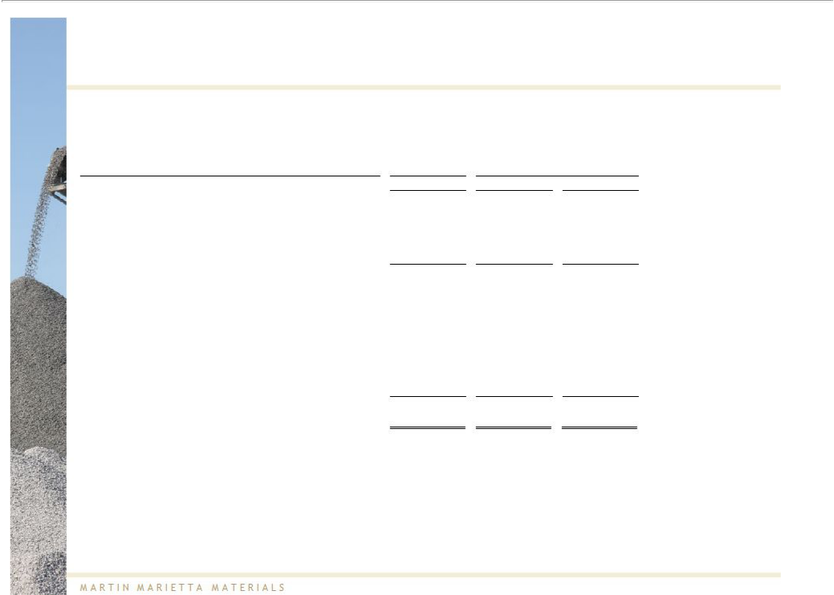
Florida Rock EBITDA Reconciliation

 | For the 9 months
(dollars in millions) | ended Sept. 30, |  | For the Year Ended December 31,
 |  | 2007 |  | 2006 |  | 2005
Net (loss) earnings | $ | 96.7 | $ | 213.7 | $ | 169.6
Add back:
Interest expense (income) |  | (1.1) |  | (3.6) |  | (0.5)
Income tax (benefit) expense |  | 52.2 |  | 119.2 |  | 104.7
Depreciation, depletion and amortization expense |  | 63.7 |  | 76.9 |  | 65.5
EBITDA |  | 211.5 |  | 406.2 |  | 339.2
Adjusted for:
Recovery for legal expenses |  | - |  | - |  | (0.6)
Transaction expenses |  | 10.1 |  | - |  | -
Gain on sales of assets |  | 0.0 |  | (6.3) |  | (7.5)
Life insurance proceeds |  | - |  | - |  | (0.6)
Insurance settlement |  | - |  | - |  | (2.1)
Other nonoperating (income) expense |  | (0.6) |  | (4.6) |  | (9.5)
Adjusted EBITDA | $ | 221.1 | $ | 395.2 | $ | 319.0

Note: Florida Rock financials calendarized to December 31 year-end. 2007 period represents financials for the first 9 months of 2007.
Source: Company filings

39

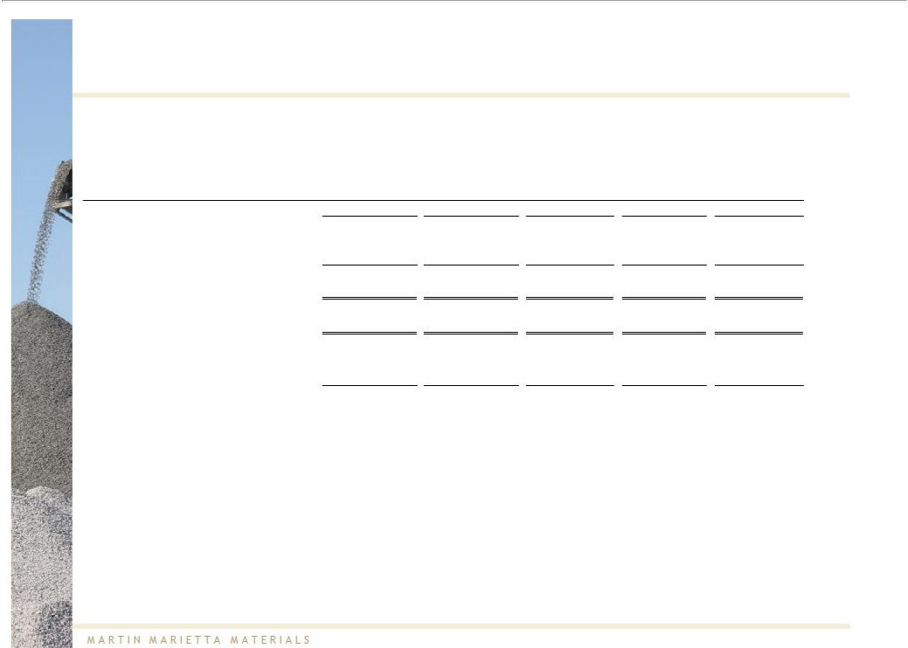
Vulcan SG&A Reconciliation

(dollars in millions) |  |  |  |  | For the Year Ended December 31,
 |  | 2011 |  | 2010 |  | 2009 |  | 2008 |  | 2007
SG&A, as reported | $ | 290.0 | $ | 327.5 | $ | 321.6 | $ | 342.6 | $ | 289.6
R&D expense, as disclosed in notes to financials |  | 1.1 |  | 1.6 |  | 1.5 |  | 1.5 |  | 1.6
Adjusted SG&A | $ | 288.9 | $ | 326.0 | $ | 320.1 | $ | 341.0 | $ | 288.0
Net Sales | $ | 2,406.9 | $ | 2,405.9 | $ | 2,543.7 | $ | 3,453.1 | $ | 3,090.1
Adjusted SG&A as Percentage of Net Sales |  | 12.0% |  | 13.5% |  | 12.6% |  | 9.9% |  | 9.3%

Source: Company filings

40

Cautionary Note Regarding Forward-Looking Statements

This presentation may include "forward-looking statements." Statements that include words such as "anticipate," "expect," "should be," "believe," "will," and other words of similar meaning in connection with future events or future operating or financial performance are often used to identify forward-looking statements. All statements in this presentation, other than those relating to historical information or current conditions, are forward-looking statements. These forward-looking statements are subject to a number of risks and uncertainties, many of which are beyond Martin Marietta's control, which could cause actual results to differ materially from such statements. Risks and uncertainties relating to the proposed transaction with Vulcan include, but are not limited to: Vulcan's willingness to accept Martin Marietta's proposal and enter into a definitive transaction agreement reasonably satisfactory to the parties; Martin Marietta's ability to obtain shareholder, antitrust and other approvals on the proposed terms and schedule; uncertainty as to the actual premium that will be realized by Vulcan shareholders in connection with the proposed transaction; uncertainty of the expected financial performance of the combined company following completion of the proposed transaction; Martin Marietta's ability to achieve the cost-savings and synergies contemplated by the proposed transaction within the expected time frame; Martin Marietta's ability to promptly and effectively integrate the businesses of Vulcan and Martin Marietta; the combined company’s ability to pay dividends in the amounts anticipated; a downgrade of the credit rating of Vulcan's indebtedness, which could give rise to an obligation to redeem Vulcan's existing indebtedness; the potential implications of alternative transaction structures with respect to Vulcan, Martin Marietta and/or the combined company, including potentially requiring an offer to repurchase certain of Martin Marietta's existing

debt; the implications of the proposed transaction on certain of Martin Marietta’s and Vulcan’s employee benefit plans; and disruption from the proposed transaction making it more difficult to maintain relationships with customers, employees or suppliers. Additional risks and uncertainties include, but are not limited to: the performance of the United States economy; decline in aggregates pricing; the inability of the U.S. Congress to pass a successor federal highway bill; the discontinuance of the federal gasoline tax or other revenue related to infrastructure construction; the level and timing of federal and state transportation funding, including federal stimulus projects; the ability of states and/or other entities to finance approved projects either with tax revenues or alternative financing structures; levels of construction spending in the markets that Martin Marietta and Vulcan serve; a decline in the commercial component of the nonresidential construction market, notably office and retail space; a slowdown in residential construction recovery; unfavorable weather conditions, particularly Atlantic Ocean hurricane activity, the late start to spring or the early onset of winter and the impact of a drought or excessive rainfall in the markets served by Martin Marietta and Vulcan; the volatility of fuel costs, particularly diesel fuel, and the impact on the cost of other consumables, namely steel, explosives, tires and conveyor belts; continued increases in the cost of other repair and supply parts; transportation availability, notably barge availability on the Mississippi River system and the availability of railcars and locomotive power to move trains to supply Martin Marietta's and Vulcan's long haul distribution markets; increased transportation costs, including increases from higher passed-through energy and other costs to comply with tightening regulations as well as higher volumes of rail and water shipments; availability and cost of construction equipment in the United States; weakening in the steel industry markets served by Martin Marietta's dolomitic lime products; inflation and its effect on both production and interest costs; Martin Marietta’s ability to successfully integrate acquisitions and business combinations quickly and in a cost-effective manner and achieve anticipated profitability to maintain compliance with Martin Marietta's leverage ratio debt covenants; changes in tax laws, the interpretation of such laws and/or administrative practices that would increase Martin Marietta's and/or Vulcan's tax rate; violation of Martin Marietta's debt covenant if price and/or volumes return to previous levels of instability; a potential downgrade in the rating of Martin Marietta's or Vulcan’s indebtedness; downward pressure on Martin Marietta's or Vulcan's common stock price and its impact on goodwill impairment evaluations; the highly competitive nature of the construction materials industry; the impact of future regulatory or legislative actions; the outcome of pending legal proceedings; healthcare costs; the amount of long-term debt and interest expense; changes in interest rates; volatility in pension plan asset values which may require cash contributions to pension plans; the impact of environmental clean-up costs and liabilities relating to previously divested businesses; the ability to secure and permit aggregates reserves in strategically located areas; exposure to residential construction markets; and the impact on the combined company (after giving effect to the proposed transaction with Vulcan) of any of the foregoing risks, as well as other risk factors listed from time to time in Martin Marietta's and Vulcan's filings with the SEC.

The foregoing review of important factors should not be construed as exhaustive and should be read in conjunction with the other cautionary statements that are included elsewhere, including the Risk Factors section of the Registration Statement and our most recent report on Form 10-K, and any other documents of Martin Marietta and Vulcan filed with the SEC. Any forward-looking statements made in this presentation are qualified in their entirety by these cautionary statements, and there can be no assurance that the actual results or developments anticipated by us will be realized or, even if substantially realized, that they will have the expected consequences to, or effects on, us or our business or operations. Except to the extent required by applicable law, we undertake no obligation to update publicly or revise any forward-looking statement, whether as a result of new information, future developments or otherwise.

41

Important Additional Information

This presentation relates to the Exchange Offer by Martin Marietta to exchange each issued and outstanding share of common stock of Vulcan for 0.50 shares of Martin Marietta common stock. This presentation is for informational purposes only and does not constitute an offer to exchange, or a solicitation of an offer to exchange, shares of Vulcan common stock, nor is it a substitute for the Tender Offer Statement on Schedule TO or the preliminary prospectus/offer to exchange included in the Registration Statement on Form S-4 (the "Registration Statement") (including the letter of transmittal and related documents and as amended and supplemented from time to time, the "Exchange Offer Documents") initially filed by Martin Marietta on December 12, 2011 with the SEC. The Registration Statement has not yet become

effective. The Exchange Offer will be made only through the Exchange Offer Documents. INVESTORS AND SECURITY HOLDERS ARE URGED TO READ THE EXCHANGE OFFER DOCUMENTS AND ALL OTHER RELEVANT DOCUMENTS THAT MARTIN MARIETTA HAS FILED OR MAY FILE WITH THE SEC WHEN THEY BECOME AVAILABLE BECAUSE THEY CONTAIN OR WILL CONTAIN IMPORTANT INFORMATION.

In connection with the solicitation of proxies for Vulcan's 2012 annual meeting of shareholders (the "Vulcan Meeting"), Martin Marietta filed a definitive proxy statement on April 25, 2012 (the "Vulcan Meeting Definitive Proxy Statement") with the SEC. The Vulcan Meeting Definitive Proxy Statement and accompanying proxy card will be mailed to the shareholders of Vulcan. Martin Marietta also intends to file a proxy statement on Schedule 14A and other relevant documents with the SEC in connection with its solicitation of proxies for a meeting of Martin Marietta shareholders (the "Martin Marietta Meeting") to approve, among other things, the issuance of shares of

Martin Marietta common stock pursuant to the Exchange Offer (the "Martin Marietta Meeting Proxy Statement"). INVESTORS AND SECURITY HOLDERS ARE URGED TO READ

THE VULCAN MEETING DEFINITIVE PROXY STATEMENT, THE MARTIN MARIETTA MEETING PROXY STATEMENT AND OTHER RELEVANT MATERIALS AS THEY BECOME AVAILABLE BECAUSE THEY WILL CONTAIN IMPORTANT INFORMATION.

All documents referred to above, if filed, will be available free of charge at the SEC's website (www.sec.gov) or by directing a request to Morrow & Co., LLC at (877) 757-5404 (banks and brokers may call (203) 658-9400).

Martin Marietta, its directors and executive officers and the individuals nominated by Martin Marietta for election to Vulcan's Board of Directors are participants in any solicitation of proxies from Vulcan shareholders for the Vulcan Meeting or any adjournment or postponement thereof. Martin Marietta, its directors and executive officers are participants in any solicitation of proxies from Martin Marietta shareholders for the Martin Marietta Meeting or any adjournment or postponement thereof. Information about the participants, including a description of their direct and indirect interests, by security holdings or otherwise, is available in the Registration Statement, the proxy statement for Martin Marietta's 2012 annual meeting of shareholders, filed with the SEC on April 18, 2012, and the Vulcan Meeting Definitive Proxy Statement, or will be available in the Martin Marietta Meeting Proxy Statement, as applicable.

Martin Marietta anticipates that some divestitures may be required in connection with the regulatory approval process. Certain information in this presentation reflects the combined operations of Martin Marietta and Vulcan, but does not reflect the impact of any divestitures that may be necessary.

42

