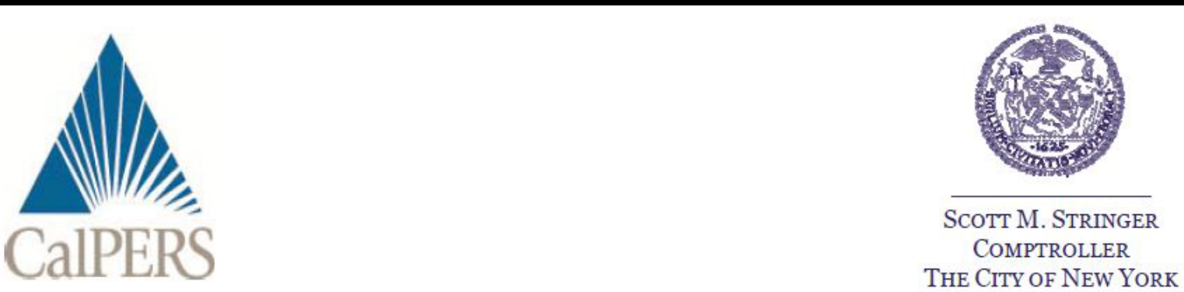

April 20, 2017

Dear Fellow Martin Marietta Materials, Inc. Shareowner:

Support Shareowner Proposal #5 Requesting Proxy Access

The California Public Employees’ Retirement System (CalPERS) and the New York City Pension Funds request shareowners vote “FOR” proposal #5 – a non-binding proposal to give shareowners effective access to the director nomination process – at the Martin Marietta Materials, Inc. annual meeting on May 18, 2017. Together, our funds have $480 billion in assets and are substantial long-term shareowners of Martin Marietta Materials, Inc. with approximately 340,000 shares.

Proxy Access is a Fundamental Shareowner Right – Provides Accountability in the Boardroom

We believe providing access to a company’s proxy by giving shareowners the ability to nominate directors to the board is one of the most important rights for owners of a company. Without effective proxy access, the director election process simply offers little more than a ratification of management’s slate of nominees. Therefore, we believe long-term shareowners should have meaningful access to this process on the terms specified in the proposal #5. The proposed thresholds include:

- Beneficial ownership of at least 3 percent of the outstanding stock;

- Three years of continuous ownership; and

- Ability to nominate up to 25 percent of the board.

Proposed Terms Based on SEC Proxy Access Rulemaking in 2010

Before adopting its now vacated proxy access rule in 2010, the SEC undertook a detailed analysis, both internally and through the public comment process. The SEC determined that a 3 percent ownership threshold was appropriate, stating, “The ownership threshold we are establishing should not expose issuers to excessively frequent and costly election contests conducted through use of Rule 14a-11, but it is also not so high as to make use of the rule unduly inaccessible as a practical matter.” The proposed holding period and slate size limitation in proposal #5 are also consistent with the former SEC rule.

Trends Show U.S. Companies and Shareowners Are Embracing Proxy Access

Prior to 2015 only 10 U.S. companies had a 3 percent proxy access bylaw in place – that number has sharply increased to more than 400 companies (representing over 57% of the S&P 500) as of March 10, 2017. The growing number of companies spans across various industries and size ranges – examples include Apple, Microsoft, Johnson & Johnson, General Electric, Amazon, Wells Fargo, AT&T, Coca-Cola, Pfizer, Exxon Mobil and Chevron. These companies are adopting the governance best practice, thereby rejecting the assertion that proxy access is costly, distracting, and favored mainly by special interest groups.

The rapid uptake in proxy access reflects widespread support among investors. From January 1, 2015 through December 31, 2016, 174 proxy access shareowner proposals have gone to a shareowner vote and have received an average voting support level of 52%. Further, these trends have led many companies to adopt proxy access without the need for a shareowner vote. Due to this increased adoption of proxy access, the Council of Institutional Investors has developed a “Proxy Access: Best Practices”¹ guide to provide a framework for companies to adopt a shareowner-supportable proxy access bylaw provision and recently released “Proxy Access by Private Ordering”² to provide a summary of prevailing practices.

CFA Institute Concludes Proxy Access Would Benefit the Markets and Boardroom

A report published by the CFA Institute found that giving investors access to the proxy to nominate directors would benefit shareowners and the capital markets.³ The specific report findings include:

- Proxy access has the potential to enhance board performance and raise US market capitalization.

- Proxy access reform will not hinder board performance.

- Proxy access is used infrequently and with little disruption in other markets around the world.

Support Proxy Access and Director Accountability – Vote “FOR” Shareowner Proposal #5

We believe proxy access is fundamental to a sustainable system of governance that fosters director accountability and long-term value creation. Fully accountable governance structures should be in place to offer shareowners effective access to the director nomination process. Please vote “FOR” proxy access proposal #5.

Should you have any questions please feel free to contact Todd Mattley, CalPERS Investment Officer at INVO_GE_Corporate_Governance_Engagements@calpers.ca.gov or 916-795-0565.

Thank you for your support.

Sincerely,


Simiso Nzima
Investment Manager, CalPERS


Scott M. Stringer
New York City Comptroller

- http://www.cii.org/files/publications/misc/08_05_15_Best%20Practices%20-%20Proxy%20Access.pdf
² http://www.cii.org/files/publications/misc/02_02_17_proxy_access_private_ordering_final.pdf ³ http://www.cfapubs.org/doi/pdf/10.2469/ccb.v2014.n9.1

PLEASE NOTE: The cost of this solicitation is being borne entirely by CalPERS and is being done through the use of the mail and telephone communication. CalPERS is not asking for your proxy card. Please do not send us your proxy card. For additional information, please contact Garland Associates, Inc. at (561) 366-1165.

CalPERS Public Employees’ Retirement System Shareowner Alert

