Table of Contents

SCHEDULE 14A

(Rule 14a-101)

INFORMATION REQUIRED IN PROXY STATEMENT

SCHEDULE 14A INFORMATION

Proxy Statement Pursuant to Section 14(a) of the Securities
Exchange Act of 1934 (Amendment No. )

Filed by the Registrant ☒

Filed by a Party other than the Registrant ☐

Check the appropriate box:

- Preliminary Proxy Statement

- Confidential, for Use of the Commission Only (as permitted by Rule 14a-6(e)(2)) ☒ Definitive Proxy Statement
- Definitive Additional Materials

- Soliciting Material pursuant to Rule 14a-12

Martin Marietta Materials, Inc.

(Name of Registrant as Specified In Its Charter)

(Name of Person(s) Filing Proxy Statement, if other than the Registrant)

Payment of Filing Fee (Check the appropriate box):

- No fee required.

- Fee computed on table below per Exchange Act Rules 14a-6(i)(1) and 0-11.

  - Title of each class of securities to which transaction applies:

  - Aggregate number of securities to which transaction applies:

  - Per unit price or other underlying value of transaction computed pursuant to Exchange Act Rule 0-11 (set forth the amount on which the filing fee is calculated and state how it was determined):

  - Proposed maximum aggregate value of transaction:

  - Total fee paid:

- Fee paid previously with preliminary materials.

- Check box if any part of the fee is offset as provided by Exchange Act Rule 0-11(a)(2) and identify the filing for which the offsetting fee was paid previously. Identify the previous filing by registration statement number, or the Form or Schedule and the date of its filing.

  - Amount Previously Paid:

  - Form, Schedule or Registration Statement No.:

  - Filing Party:

  - Date Filed:

Table of Contents
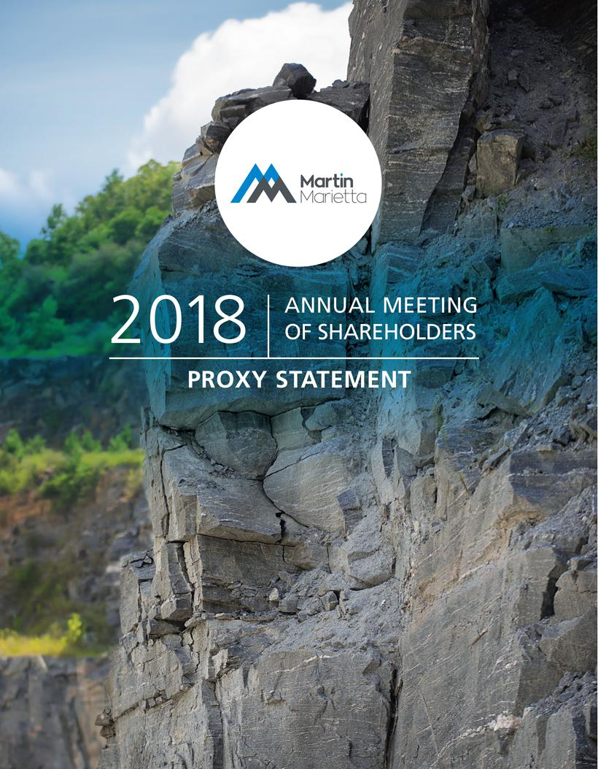

Table of Contents


April 18, 2018

Dear Fellow Shareholder:


On behalf of the Martin Marietta Board of Directors and executive officers, it is my pleasure to invite you to our 2018 Annual Meeting of Shareholders.

Strong Financial Performance

2017 was an exceptional year for Martin Marietta. We established several new financial records and demonstrated the earnings power of our strategically-positioned assets, driven by a more durable, construction-centric recovery. We delivered record revenues, profitability and earnings per diluted share for both the fourth quarter and full year 2017, building on the momentum created by record performance in prior years. And, as always, we achieved these results while remaining committed to the safety, ethics, integrity and values that are the hallmark of Martin Marietta.

World-Class Safety Performance

Our 2017 safety performance was the best in Martin Marietta’s history. Through the hard work and focus of our employees, safety awareness has been elevated across the Company, yielding impressive results. Our employees know world-class safety performance is possible; and, importantly, 2017’s results demonstrate this goal is attainable. Specifically, half of our operating divisions exceeded the

world-class Total Injury Incident Rate (TIIR) (i.e., a TIIR of 0.90 or lower), and company-wide, with a Lost Time Incident Rate (LTIR) of 0.13, we bested the world-class LTIR of 0.20 or lower.

Shareholder Engagement and Governance

Our investor outreach in 2017 extended to 86 meetings with 296 investor groups, and conversations with most of our top 20 shareholders. We visited with our shareholders across the United States and in Toronto, Amsterdam, Brussels, The Hague, London, Edinburgh and Paris. We also issued our third Sustainability Report in 2017 - Building. Caring. Growing. - in response to our shareholders’ request that we share our story on the efforts and improvements we are making in this important aspect. From our world-class safety programs and performance, to our targeted and intentional support of education and health, and environmental programs that ensure operational excellence, we have a solid foundation and an exciting opportunity to build upon.

We also have a commitment to sound corporate governance and independent leadership in our boardroom. In this regard, we made several important changes to our corporate governance. First, our Board adopted a proxy access bylaw in response to the favorable advisory vote of a majority of our shareholders at our 2017 annual meeting of shareholders. Second, our Board adopted formal guidelines and policies relating to Stock Ownership for Board members and executive officers, Hedging and Pledging of Stock for Board members and executive officers, and Clawbacks for executive officers, which you can read more about in the attached proxy statement. Our Board continues to review our governance policies to ensure we are able to create appropriate value for our shareholders.

Board Member Changes

We also are nominating for election a new Board member in 2018, namely Smith W. Davis, a partner with the law firm of Akin Gump Strauss Hauer & Feld LLP in Washington DC. Mr. Davis is an expert in legal and regulatory matters, as well as governance, environmental and compensation matters. We are delighted to nominate Mr. Davis to our Board, who brings a strong background and adds a new and diverse perspective to our Board mix.

Proxy Voting

Because your proxy vote matters, I urge you to cast it promptly - even if you plan to attend the Annual Meeting. We encourage you to vote so that your shares will be represented and voted at the meeting.

Thank you for your continued support of Martin Marietta.

Sincerely,
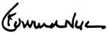

C. Howard Nye

Chairman of the Board, President and Chief Executive Officer

Table of Contents

MARTIN MARIETTA MATERIALS, INC.

2710 Wycliff Road, Raleigh, North Carolina 27607

Notice of Annual Meeting of Shareholders

To Be Held May 17, 2018

To Our Shareholders:

The Annual Meeting of Shareholders of Martin Marietta Materials, Inc. will be held on Thursday, May 17, 2018, at 11:30 a.m. at our principal office located at 2710 Wycliff Road, Raleigh, North Carolina. At the meeting, the holders of our outstanding common stock will act on the following matters:

- Election as Directors the seven (7) nominees named in the attached proxy statement, each to serve their respective term as described in the attached proxy statement, and until their successors are duly elected and qualified;

- Ratification of the appointment of PricewaterhouseCoopers LLP as independent auditors for 2018;

- Advisory vote to approve the compensation of our named executive officers; and

- Any other business that may properly come before the meeting.

All holders of record of Martin Marietta common stock (NYSE: MLM) at the close of business on March 9, 2018 are entitled to notice of and to vote at the Annual Meeting and any adjournments or postponements of the meeting.

The Board of Directors unanimously recommends that you vote FOR proposals 1, 2, and 3.

This notice and the accompanying proxy statement are being first mailed to shareholders on or about April 18, 2018. We have enclosed our 2017 Annual Report to Shareholders. The report is not part of the proxy soliciting materials for the Annual Meeting.

Whether or not you expect to attend the meeting, we hope you will date and sign the enclosed proxy card and mail it promptly in the enclosed stamped envelope. Submitting your proxy now will not prevent you from voting your shares at the meeting, as your proxy is revocable at your option.

Sincerely,
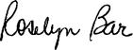

Roselyn R. Bar

Executive Vice President, General

Counsel and Secretary

Raleigh, North Carolina

April 18, 2018

IMPORTANT NOTICE REGARDING THE AVAILABILITY OF PROXY MATERIALS FOR THE

ANNUAL SHAREHOLDER MEETING TO BE HELD ON MAY 17, 2018:

Martin Marietta’s proxy statement, form of proxy card and 2017 Annual Report to Shareholders are also available at ir.martinmarietta.com/investor-relations/reports-filings.

Table of Contents

Table of Contents

Proxy Summary |  |  |  |  |  |  |  |  | 1
The Board of Directors |  |  |  |  |  |  |  |  | 6
Proposal 1 – Election of Directors |  |  |  |  |  |  |  |  | 8
 | Director Compensation |  |  |  |  |  |  |  | 13
Security Ownership of Certain Beneficial Owners and |  |  |  |  |  |  |  |  | 15
Management |  |  |  |  |  |  |  |  | 15
 | Section 16(a) Beneficial Ownership Reporting Compliance |  |  |  |  |  |  |  | 16

Executive Compensation |  |  |  |  |  |  |  |  |  | 51
 | Executive Officer Compensation |  |  |  |  |  |  |  |  | 51
 | Summary Compensation Table |  |  |  |  |  |  |  |  | 51
 | Grants of Plan-Based Awards |  |  |  |  |  |  |  |  | 53
 | Outstanding Equity Awards at Fiscal Year-End |  |  |  |  |  |  |  |  | 55
 | Option Exercises and Stock Vested |  |  |  |  |  |  |  |  | 56
 | Pension Benefits |  |  |  |  |  |  |  |  | 58
 | Potential Payments Upon Termination or Change of Control |  |  |  |  |  |  |  |  | 59
 | CEO Pay Ratio Disclosure |  |  |  |  |  |  |  |  | 62

 |  | Proposal 3 – Advisory Vote on the Compensation of |  |  | 63
Corporate Governance Matters | 17 | Our Named Executive Officers |  |  | 63

Corporate Governance Philosophy

Board Committees

Proposal 2 – Independent Auditors

Summary of Fees

Audit Fees

Audit-Related Fees

Tax Fees

All Other Fees

Pre-Approval Policies and Procedures

Audit Committee Review

Audit Committee Report

Management Development and Compensation Committee Report

Compensation Committee Interlocks and Insider Participation in Compensation Decisions

Compensation Discussion and Analysis

17 | Securities Authorized for Issuance Under Equity
21
21 | Compensation Plans |  |  |  |  |  |  |  |  |  |  |  |  | 64
27 |  |  | Description of the TXI Legacy Plan |  |  |  |  |  |  |  |  |  |  | 64
27 |  |  | Description of the Deferred Compensation Plan |  |  |  |  |  |  |  |  |  |  | 65
28 |  |  |  |  |  |  |  |  |  |  |  |  |  | 65
28 | General Information |  |  |  |  |  |  |  |  |  |  |  |  | 66
28 |  |  |  |  |  |  |  |  |  |  |  |  |  | 66
28 | Incorporation by Reference |  |  |  |  |  |  |  |  |  |  |  |  | 68
28 |  |  |  |  |  |  |  |  |  |  |  |  |  | 68
28 | Shareholders’ Proposals for 2019 Annual Meeting |  |  |  |  |  |  |  |  |  |  |  |  | 68
28 |  |  |  |  |  |  |  |  |  |  |  |  |  | 68
28 | Appendix A – Martin Marietta Guidelines for Potential |  |  |  |  |  |  |  |  |  |  |  |  | 68
29
29 | New Board Members |  |  |  |  |  |  |  |  |  |  |  |  | A-1
30 |  | Appendix B – Non-GAAP Measures |  |  |  |  |  |  |  |  |  |  |  | B-1
30
31

Introduction |  |  |  |  |  |  |  |  |  |  |  |  |  |  |  | 31
Executive Summary |  |  |  |  |  |  |  |  |  |  |  |  |  |  |  | 31
2017 Say-On-Pay Vote and Shareholder Outreach |  |  |  |  |  |  |  |  |  |  |  |  |  |  |  | 34
Performance-Related Compensation |  |  |  |  |  |  |  |  |  |  |  |  |  |  |  | 35
Pay Decisions in 2017 Made in Light of Performance |  |  |  |  |  |  |  |  |  |  |  |  |  |  |  | 36
Our Compensation Strategy |  |  |  |  |  |  |  |  |  |  |  |  |  |  |  | 38
Ongoing Corporate Governance Policies |  |  |  |  |  |  |  |  |  |  |  |  |  |  |  | 39
Compensation Decisions Process |  |  |  |  |  |  |  |  |  |  |  |  |  |  |  | 40
Determination of CEO Compensation |  |  |  |  |  |  |  |  |  |  |  |  |  |  |  | 41
Compensation Program Risk Assessment |  |  |  |  |  |  |  |  |  |  |  |  |  |  |  | 42
Considerations Regarding 2017 Compensation |  |  |  |  |  |  |  |  |  |  |  |  |  |  |  | 43
Stock-Based Awards Generally |  |  |  |  |  |  |  |  |  |  |  |  |  |  |  | 48
Stock Ownership Guidelines |  |  |  |  |  |  |  |  |  |  |  |  |  |  |  | 48
Perquisites |  |  |  |  |  |  |  |  |  |  |  |  |  |  |  | 49
Retirement and Other Benefits |  |  |  |  |  |  |  |  |  |  |  |  |  |  |  | 49
Potential Payments upon Termination or Change of Control |  |  |  |  |  |  |  |  |  |  |  |  |  |  |  | 50
Tax and Accounting Implications |  |  |  |  |  |  |  |  |  |  |  |  |  |  |  | 50

Table of Contents


Proxy Summary

This Proxy Summary highlights information about Martin Marietta that can be found elsewhere in this proxy statement. It does not contain all of the information you should consider in voting your shares. We encourage you to read the entire proxy statement for more detailed information on each topic prior to casting your vote. This proxy statement, the proxy card, and the notice of meeting are being sent commencing on approximately April 18, 2018 to shareholders of record on March 9, 2018.

2018 Annual Meeting of Shareholders

Meeting Date: May 17, 2018 ^{Place:} 2710 Wycliff Road, Raleigh, NC

Time: 11:30 am ET Record Date: March 9, 2018

Your vote is important. You may vote in person at the Annual Meeting or submit a proxy over the internet. If you have received a paper copy of the proxy card (or if you request a paper copy of the materials), you may submit a proxy by telephone or by mail.

Via the Internet

www.voteproxy.com.

By Telephone

1-800-PROXIES (1-800-776-9437)

in the United States or 1-718-921-8500 from outside the United States.

In Person

Attend the Annual Meeting and vote by ballot.

By Mail

Sign, date and mail your proxy card in the envelope provided.

If you submit your proxy by telephone or over the internet, you do not need to return your proxy card by mail.

PROPOSALS AND VOTING RECOMMENDATIONS

Proposal | Description | Board Voting Recommendation | Page
1 | Election of Seven Director Nominees | FOR ALL DIRECTOR NOMINEES | 8
2 | Ratification of the appointment of | FOR | 27
2 | PricewaterhouseCoopers LLP as independent auditors | FOR | 27
3 | Advisory Vote on Company’s Executive Compensation | FOR | 63

2018 PROXY STATEMENT | 1

Table of Contents
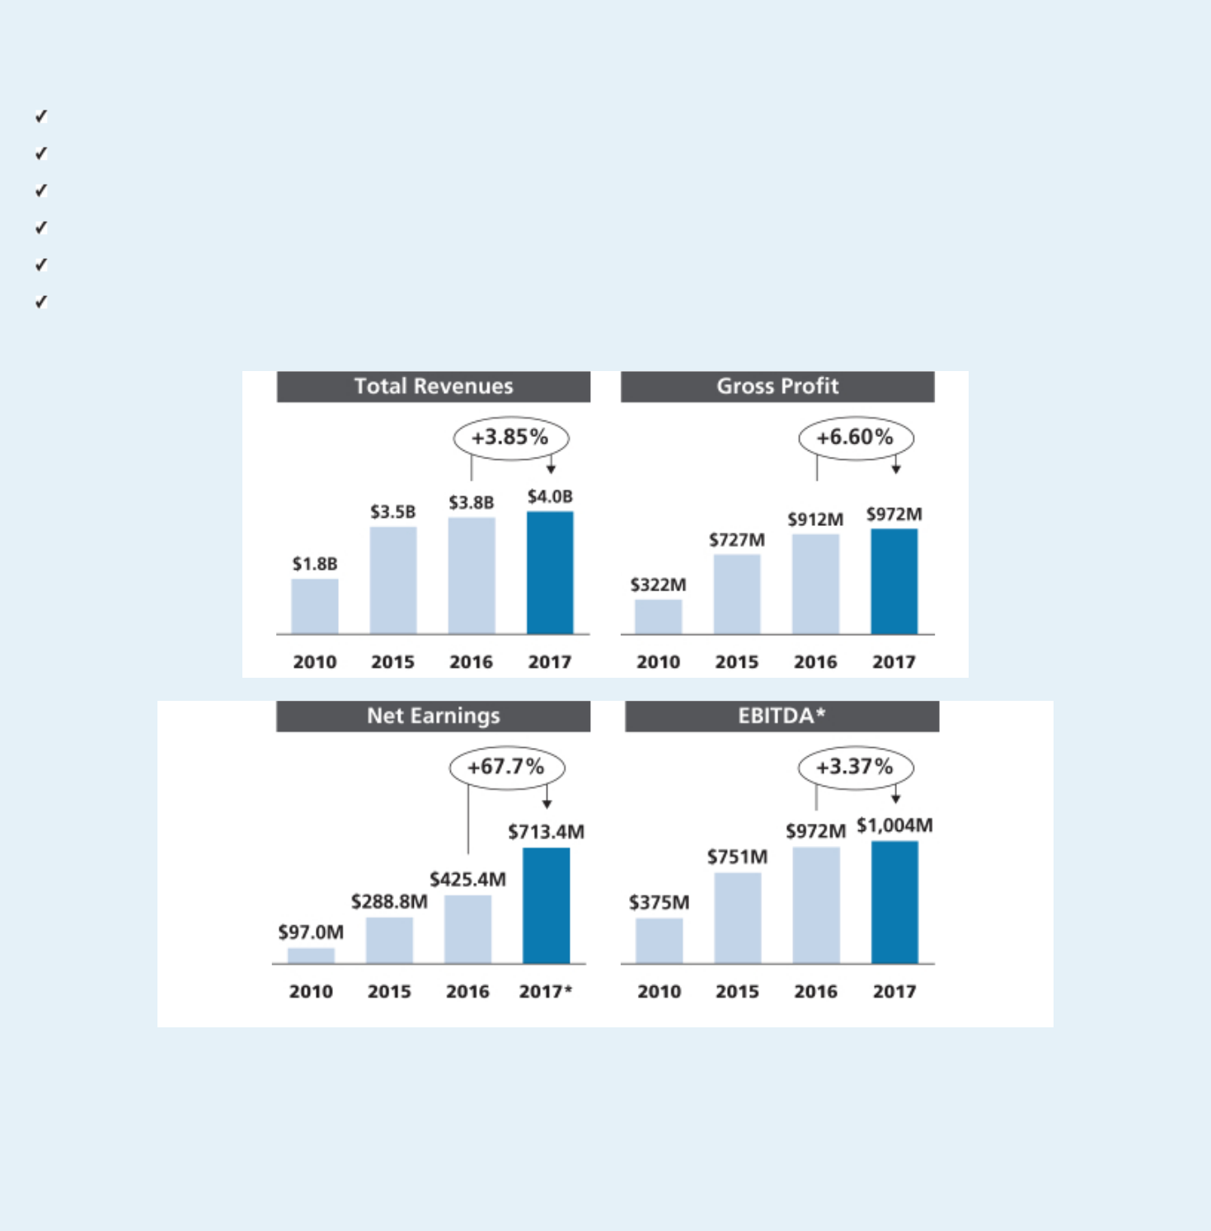

Shareholders Benefit from Martin Marietta’s Record 2017 Performance

Record total revenues of almost $4.0 billion up 3.9% from 2016

Record gross profit of $972 million up 6.6%, and a 24.5% gross margin Record operating earnings of $700 million up 3.4%

Record net earnings attributable to Martin Marietta of $713.4 million, an increase of 68% over 2016

Record earnings before interest, taxes, depreciation and amortization (EBITDA) of $1.004 billion, up 3% from 2016 Record earnings attributable to common shareholders per diluted share of $11.25.

* Reconciliation of Net Earnings Attributable to Martin Marietta to EBITDA is included in Appendix B.

- 2018 PROXY STATEMENT

Table of Contents
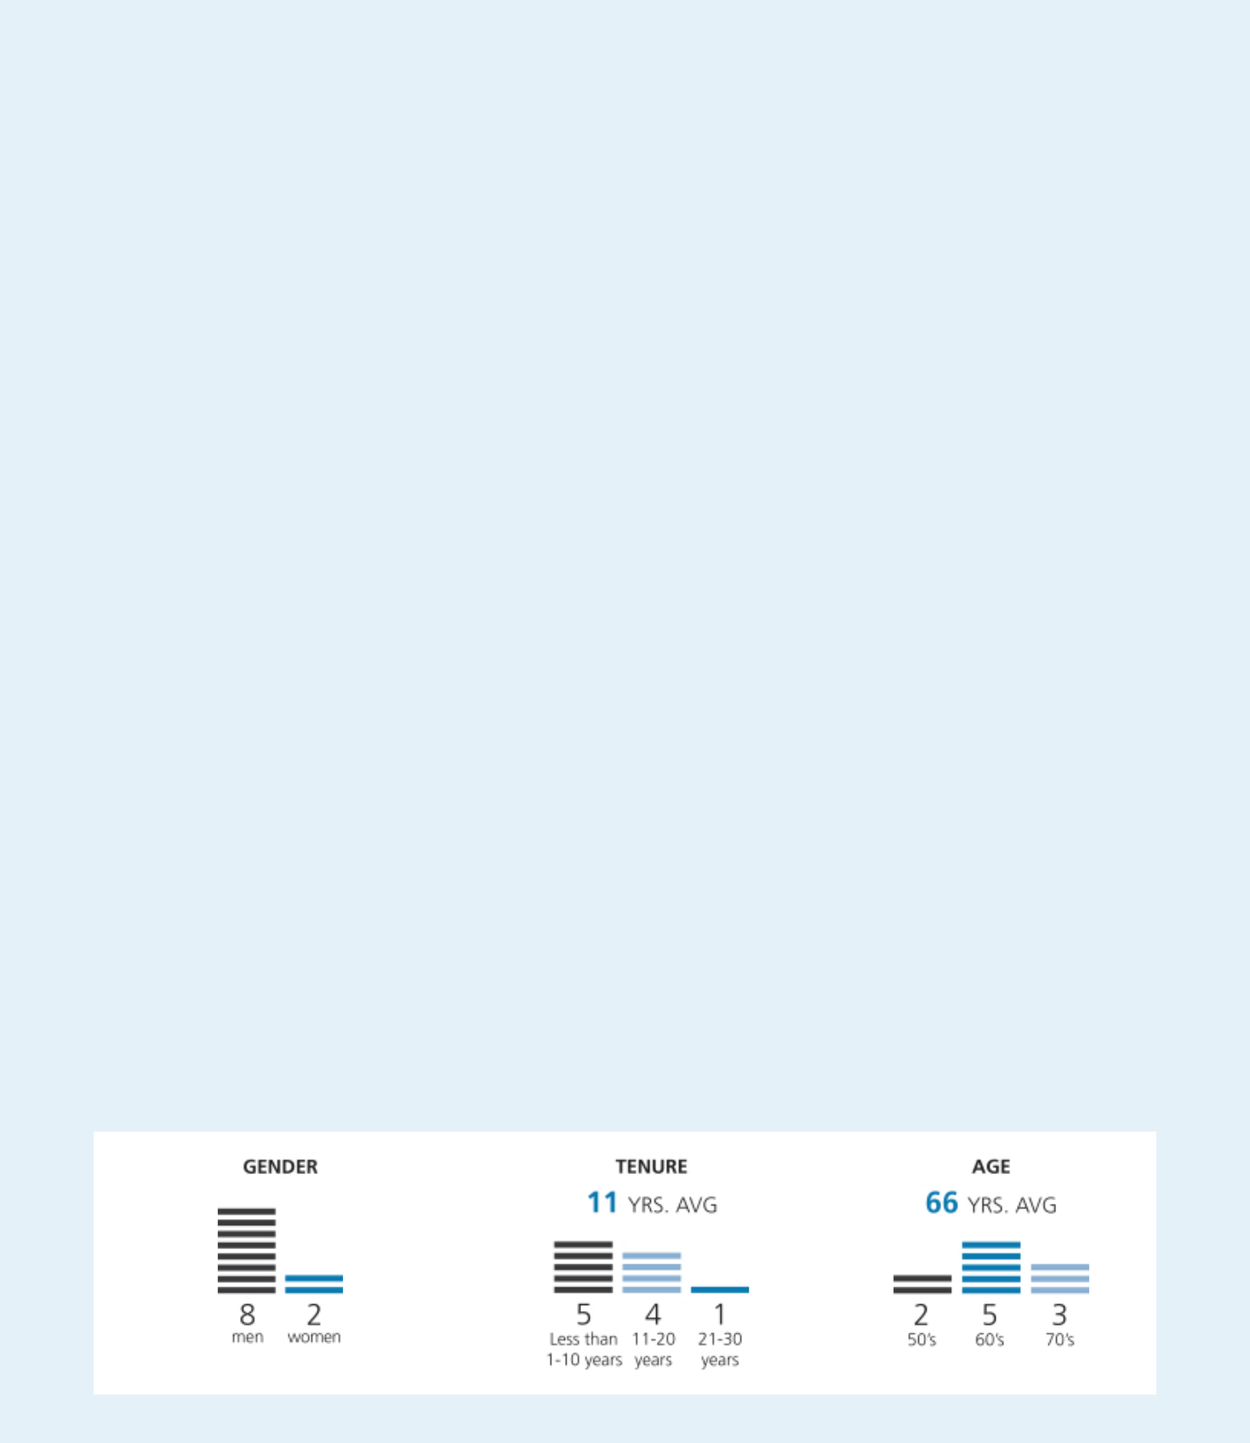

Corporate Governance Highlights: Creating Sustainable Long-Term Shareholder Value

Recent Updates

- Our shareholders have the ability to nominate director candidates and have those nominees included in our proxy statement, subject to meeting the requirements in our Bylaws, a shareholder right known as proxy access

- Declassified Board phase-in continues—Directors elected annually in 2017 and 2018 to serve one-year terms

- Adoption of Stock Ownership Guidelines

- Adoption of Hedging and Pledging Policy

- Adoption of Clawback Policy

Board of Directors

- Lead Independent Director

- 10 Directors/Nominees; 9 are non-employees; 9 are independent

- Key committee Chairs are independent

- Executive sessions of non-management Directors at each regularly-scheduled meeting

- All Directors attended 100% of all Board and committee meetings in 2017

- Limited membership on other public company boards

- Code of Ethical Business Conduct and ethics program that reports to a Board Committee

- Regular Board self-assessments and Director peer review

- Risk oversight by full Board and Committees

Shareholder Interest

- Majority voting standard for uncontested Director elections

- No shareholder rights plan

- Annual advisory vote to ratify independent auditor

- Annual advisory vote to approve executive compensation

- Longstanding active shareholder engagement

- We publish annually a Sustainability Report that discusses our commitment to our shareholders, employees and the communities that we serve

Board Composition

We nominated for election at our 2018 annual meeting of shareholders a new Director to the Board who has extensive experience in regulatory and legal matters. We were recognized in 2017 and 2015 at the Women’s Forum of New York at its Biennial Breakfast of Corporate Champions for our Board diversity. We were also recognized by 2020 Women on Boards as a Winning ‘W’ Company for seven consecutive years for championing board diversity.

These charts assume that Smith W. Davis is elected at the annual meeting of shareholders.

2018 PROXY STATEMENT | 3

Table of Contents
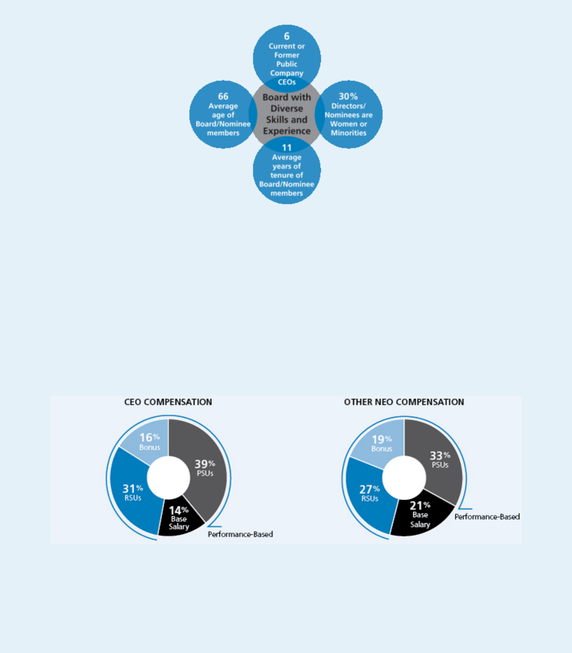

Board Attendance

In 2017, all directors attended 100% of the total Board and committee meetings to which they were assigned. All directors attended the May 2017 Annual Meeting.

Our Compensation Approach

A substantial portion of compensation paid to our named executive officers (NEOs) is variable and performance-based. We use the 50th percentile of our comparator group as a reference point when determining target compensation, but target pay is set based on a variety of factors and actual pay realized by our NEOs is dependent on our financial, operational and other related performance. Based on our record levels of performance in 2017, variable compensation payable under both our short-term and long-term incentive plans exceeded the target amounts established for each NEO, which is consistent with our pay-for-performance philosophy. All compensation paid to our CEO and other NEOs in 2017 was performance-based other than base salary: 86% of our CEO’s compensation was performance-based and approximately 80% of our NEOs compensation was performance based.*

- Based on grant date value of PSUs and RSUs. Other NEO Compensation includes Mr. Nickolas, who commenced employment with the Company in August 2017.

- 2018 PROXY STATEMENT

Table of Contents
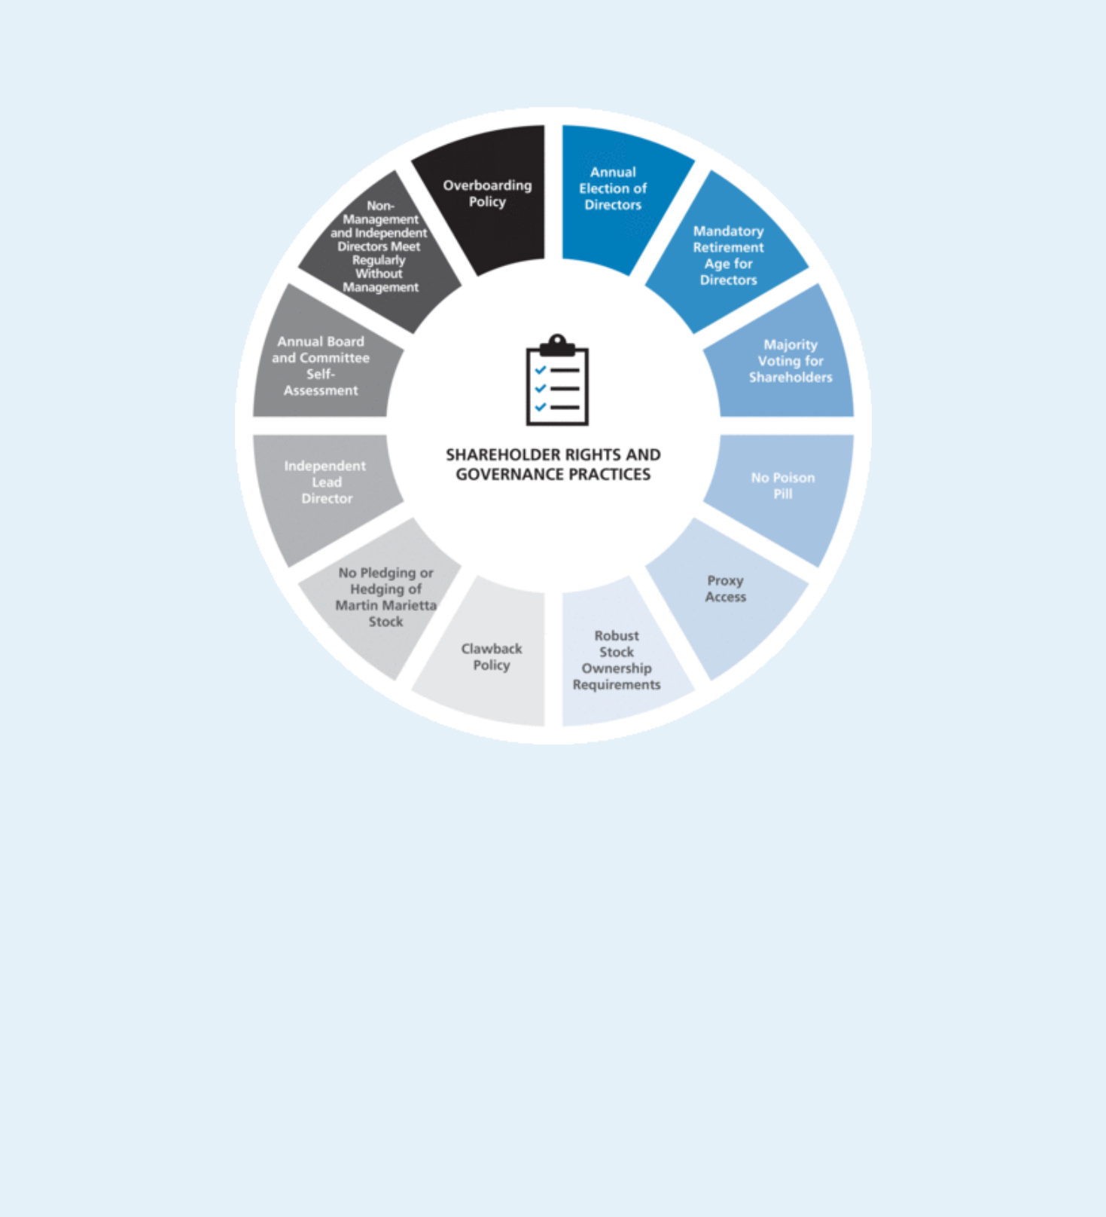

Shareholder Rights and Governance Practices

Will any other matters be presented at the Annual Meeting?

At the time this proxy statement was filed with the Securities and Exchange Commission, the Board of Directors was not aware that any matters not referred to herein would be presented for action at the Annual Meeting. If any other matters properly come before the meeting, it is intended that the persons named in the enclosed proxy will vote the shares represented by proxies on such matters in accordance with the recommendation of the Board of Directors, or, if no recommendation is given, in their own discretion. It is also intended that discretionary authority will be exercised with respect to the vote on any matters incident to the conduct of the meeting.

What are the Board’s recommendations?

Unless you give other instructions on your proxy card, the persons named as proxy holders on the proxy card will vote in accordance with the recommendations of the Board of Directors. The Board’s recommendation, as well as a description of each proposal, is set forth in this proxy statement. The Board recommends a vote:

- FOR the election of the nominated slate of Directors;

- FOR the ratification of the selection of PricewaterhouseCoopers LLP as independent auditors; and

- FOR the approval, on a non-binding advisory basis, of the compensation of our NEOs as described in this proxy statement.

2018 PROXY STATEMENT | 5

Table of Contents


CAUTIONARY NOTE REGARDING FORWARD-LOOKING STATEMENTS

This proxy statement contains forward-looking statements as defined in the Securities Exchange Act of 1934 and is subject to the safe harbors created therein. The forward-looking statements contained herein are generally identified by the words “believe,” “project,” “expect,” “anticipate,” “estimate,” “intend,” “strategy,” “future,” “opportunity,” “plan,” “may,” “should,” “will,” “would,” “will be,” “will continue,” “will likely result,” and similar expressions. Forward-looking statements are based on the beliefs and assumptions of our management and on currently available information. A detailed discussion of risks and uncertainties that could cause actual results and events to differ materially from such forward-looking statements is included in our annual report on Form 10-K for the fiscal year ended December 31, 2017. We undertake no responsibility to publicly update or revise any forward-looking statement.

The Board of Directors

The Board of Directors currently consists of nine members, eight of whom are non-employee Directors. At the 2016 Annual Meeting, shareholders approved the Board of Directors’ proposal to amend our Articles of Incorporation to phase out the classification of the terms of our Directors and to provide instead for the annual election of our Directors. Prior to the charter amendment, our Board of Directors was divided into three classes, with each class serving three-year terms. Commencing with the 2017 Annual Meeting of Shareholders, our Directors are elected to one-year terms of office after the current terms of the Directors of each class expire at this 2018 Annual Meeting of Shareholders and the 2019 Annual Meeting.

The Board of Directors has nominated seven persons for election as Directors to serve a one-year term expiring in 2019. Unless otherwise directed, proxies will be voted in favor of these nominees. Each nominee has agreed to serve if elected. Each of the nominees, except Mr. Davis, is currently serving as a Director. Should any nominee become unable to serve as a Director, the persons named in the enclosed form of proxy will, unless otherwise directed, vote for the election of such other person for such position as the present Board of Directors may recommend in place of such nominee. Proxies cannot be voted for a greater number of persons than the number of nominees named.

Under our Bylaws, nominations of persons for election to the Board of Directors may be made at an Annual Meeting of Shareholders by the Board of Directors and by any shareholder who complies with the notice procedures set forth in the Bylaws. As described in the proxy statement for our 2017 Annual Meeting, for a nomination to be properly made by a shareholder at the 2018 Annual Meeting, the shareholder’s notice must have been sent to, and received by, our Secretary at our principal executive offices between January 17, 2018 and February 16, 2018. No such notice was received during this period. Should any of the following nominees be unavailable for election by reason of death or other unexpected occurrence, the proxy, to the extent permitted by applicable law, may be voted with discretionary authority in connection with the nomination by the Board of Directors and the election of any substitute nominee.

Working closely with the full Board, the Nominating and Corporate Governance Committee develops criteria for open Board positions. In developing these criteria, the Committee takes into account a variety of factors, which may include: the current composition of the Board and expected retirements from the Board; the range of talents, experiences and skills that would best complement those already represented on the Board; and the need for financial or other specialized expertise. Applying these criteria, the Committee considers candidates for Board membership suggested by Committee members, other Board members, and management. The Committee has also retained a third-party executive search firm to identify and review candidates from time to time.

Once the Committee has identified a prospective nominee, it makes an initial determination as to whether to conduct a full evaluation. In making this determination, the Committee takes into account various information, including information provided at the time of the candidate recommendation, the Committee’s own knowledge, and information obtained through inquiries to third parties to the extent the Committee deems appropriate. The preliminary determination is based primarily on the need for additional Board members and the likelihood that the prospective nominee can satisfy the criteria that the Committee has established. If the Committee determines, in consultation with the Chairman, President and CEO and other Directors as appropriate, that additional consideration is warranted, it may request management or a third-party search firm to gather additional information about the prospective nominee’s background and experience and to report its findings to the Committee. The Committee then evaluates the prospective nominee against the specific criteria that it has established for the position, as well as the standards and qualifications set out in the Company’s Corporate Governance Guidelines, including:

- the ability of the prospective nominee to represent the interests of the shareholders of the Company;

- the prospective nominee’s standards of integrity, commitment and independence of thought and judgment;

- 2018 PROXY STATEMENT

Table of Contents

- the prospective nominee’s ability to dedicate sufficient time, energy and attention to the diligent performance of his or her duties, including the prospective nominee’s service on other public company boards, as specifically set out in the Company’s Corporate Governance Guidelines;

- the extent to which the prospective nominee contributes to the range of talent, skill and expertise appropriate for the Board; and

- the extent to which the prospective nominee helps the Board reflect the diversity of the Company’s shareholders, employees, customers and the communities in which it operates.

If the Committee decides, on the basis of its preliminary review, to proceed with further consideration, members of the Committee, the Chairman, President and CEO, as well as other members of the Board as appropriate, interview the nominee. After completing this evaluation and interview, the Committee makes a recommendation to the full Board, which makes the final determination whether to nominate or appoint the new Director after considering the Committee’s report. A background check is completed before a final recommendation is made to the Board to appoint a candidate to the Board.

In selecting nominees for Director, the Board seeks to achieve a mix of members who together bring experience and personal backgrounds relevant to the Company’s strategic priorities and the scope and complexity of the Company’s business. The Board also seeks demonstrated ability to manage complex issues that involve a balance of risk and reward. The background information on current nominees beginning on page 8 sets out how each of the current nominees contributes to the mix of experience and qualifications the Board seeks. In making its recommendations with respect to the nomination for re-election of existing Directors at the annual shareholders meeting, the Committee assesses the composition of the Board at the time and considers the extent to which the Board continues to reflect the criteria set forth above.

The following sets forth the age and certain other biographical information for each of the nominees for election and for each of the other members of the Board of Directors as of the date of this proxy statement.

2018 PROXY STATEMENT | 7

Table of Contents

Proposal No. 1

Election of Directors

Nominees for Election to the Board of Directors for a Term Continuing Until 2019:


◆SUE W. COLE

Director Since: 2002

Age: 67

Chair of the Nominating and Corporate Governance Committee and member of the Management Development and Compensation Committee.
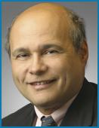

Ms. Cole is the managing partner of SAGE Leadership & Strategy, LLC, an advisory firm for businesses, organizations and individuals relating to strategy, governance and leadership development. Ms. Cole was previously a principal of Granville Capital Inc., a registered investment advisor, from 2006 to 2011, and before that she was the Regional CEO, Mid-Atlantic Region, of U.S. Trust Company, N.A., where she was responsible for the overall strategic direction, growth, and leadership of its North Carolina, Philadelphia and Washington, D.C. offices. Ms. Cole previously held various positions in the U.S. Trust Company, N.A. and its predecessors. Ms. Cole has previously served on the public-company board of UNIFI, Inc. She has also been active in community and charitable organizations, including previously serving as Chairman of the North Carolina Chamber, on the Investment Committee of the University of North Carolina at Greensboro and as a member on the North Carolina Economic Development Board. Ms. Cole attended the University of North Carolina at Greensboro where she earned a Bachelor of Science degree in Business Administration and a Masters in Business Administration in Finance.

Key attributes, experience and skills:

- Valuable experience in executive compensation, corporate governance, human resources, finance and financial statements, and customer service

- Chief executive officer of several financial services businesses as well as several non-profit organizations

- Strong leadership skills and familiarity with North Carolina, an important state for the Company

◆SMITH W. DAVIS

Age: 70

Mr. Davis is a senior partner at Akin Gump Strauss Hauer & Feld LLP, an international law firm, where he provides counsel on a wide variety of legislative and regulatory matters, including those before a variety of congressional committees. Mr. Davis joined Akin Gump in 1979 and his practice has included advising on legal matters relating to environmental issues, financial institutions, mergers and acquisitions, and pension reform. Mr. Davis also has served on the law firm’s compensation and management committees. Prior to joining Akin Gump, Mr. Davis served as a counsel to the House Judiciary Committee. Mr. Davis attended Yale University where he received a Bachelors of Arts degree, magna cum laude and Yale Law School where he received his Juris Doctor degree.

Key attributes, experience and skills:

- Extensive experience in legal, compliance, and corporate governance

- Strong leadership skills and expertise in governmental and regulatory issues, safety, health and environmental matters, mergers and acquisitions, executive compensation, financial affairs, and risk assessment.

- Brings new perspective to the Board on diversity and corporate citizenship

- 2018 PROXY STATEMENT

Table of Contents


◆JOHN J.

KORALESKI

Director Since: 2016

Age: 67

Member of the Audit Committee, Executive Committee and Management Development and Compensation Committee.


Director Nominees ◆ Proposal 1: Election of Directors

Mr. Koraleski joined the Martin Marietta Board in 2016. Mr. Koraleski served | Key attributes,
from February 2015 through his retirement in September 2015 as executive | experience and skills:
Chairman of the Board of the Union Pacific Corporation (UP), which through its | • Experience with the demands
subsidiaries operates North America’s premier railroad franchise, covering 23
 |  | and challenges associated with
states across the western two-thirds of the United States. Prior to that, he was |  | and challenges associated with
 |  | managing a large publicly-
named President and Chief Executive Officer of the UP in March 2012, elected |  | managing a large publicly-
 |  | traded organization from his
as a Director of the UP in July 2012 and appointed Chairman of the Board in |  | traded organization from his
 |  | experience as Chairman and
2014. Since joining the Union Pacific (Railroad) in 1972, Mr. Koraleski held a |  | experience as Chairman and
 |  | CEO of Union Pacific
number of executive positions in the UP and the Railroad, including, Executive |  | CEO of Union Pacific
 | • | Extensive knowledge of
Vice President – Marketing and Sales from 1999 to 2012, Executive Vice | • | Extensive knowledge of
President – Finance and Information Technology, Chief Financial Officer and |  | financial system management,
Controller. Mr. Koraleski served as the Chairman of The Bridges Investment |  | public company accounting,
Fund, Inc., a general equity fund whose primary investment objective is to seek |  | disclosure requirements and
long-term capital appreciation, from 2005 through March 2012 and is a past |  | financial markets
Chairman of the Association of American Railroads. Mr. Koraleski earned a | • | Valuable expertise in talent
Bachelor’s and Master’s degree in business administration from the University |  | management, compensation,
of Nebraska at Omaha. |  | governance and succession
 |  | planning
 | • | Understanding of complex
 |  | logistic operations, safety and
 |  | rail operations
 | • | Broad strategic analysis and
 |  | experience with acquisitions,
 |  | integration, marketing and
 |  | information technologies

◆DAVID G.

MAFFUCCI

Director Since: 2005

Age: 67

Chair of the Audit Committee and member of the Ethics, Environment, Safety and Health Committee.

Mr. Maffucci is a Director of Domtar Corporation, which designs, manufactures, markets and distributes a wide variety of fiber-based products, including communication papers, specialty and packaging papers, market pulp and absorbent hygiene products. He is currently the Chair of its Audit Committee and a member of its Finance Committee and Nominating and Corporate Governance Committee. Mr. Maffucci previously served as Executive Vice President and Chief Financial Officer of Xerium Technologies, Inc., a manufacturer and supplier of consumable products used in paper production, from 2009 to 2010, as well as on its Board of Directors from 2008 until 2010, serving on its Audit and Compensation Committees from 2008 to 2009. On March 30, 2010, Xerium Technologies, Inc. filed a voluntary petition for relief under Chapter 11 of the Federal bankruptcy laws as part of a “pre-arranged” restructuring plan with the support of its lenders. On May 25, 2010, Xerium Technologies, Inc. emerged from Chapter 11 protection. Mr. Maffucci also served as Executive Vice President and Chief Financial Officer of Bowater Incorporated. Mr. Maffucci previously worked at KPMG and is a Certified Public Accountant. He received his Bachelor’s degree from Sacred Heart University.

Key attributes, experience and skills:

- Extensive financial experience with a large public accounting firm

- Accounting principles and practices, auditing, internal control over financial reporting, and risk management processes

2018 PROXY STATEMENT | 9

Table of Contents

Proposal 1: Election of Directors ◆ Director Nominees
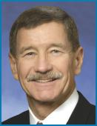

◆MICHAEL J.

QUILLEN
Director Since: 2008

Age: 69

Lead Independent Director, Chair

of the Management Development

and Compensation Committee,

Member of the Executive

Committee and the Nominating

and Corporate Governance

Committee.


Mr. Quillen was the founder and served as Chief Executive Officer of Alpha Natural Resources, Inc. (ANR), a leading Appalachian coal supplier, since its formation in 2004 until its merger with Foundation Coal Holdings, Inc. in July 2009, and served as President and Chairman of ANR from 2006 to 2009, and non-Executive Chairman until May 2012. Mr. Quillen held senior executive positions in the coal industry throughout his career at Pittston/Pittston Coal Sales Corp., AMVEST Corporation, NERCO Coal Corporation, Addington, Inc. and Mid-Vol Leasing, Inc. He has also served as Chairman (Rector) of the Board of Visitors of Virginia Polytechnic Institute and State University from July 2012 to June 2014 and was reappointed to an additional four-year term on the Board of Governors in July 2014. He was Chairman of the Audit and Finance Committee of Virginia Polytechnic Institute and State University from July 2010 to June 2012. He also served on the Virginia Port Authority from 2003 to 2012 and as Chairman from July 2011 to December 2012. Mr. Quillen attended Virginia Polytechnic Institute and State University, earning both Bachelor’s and Master’s degrees in Civil Engineering.

Key attributes, experience and skills:

- Valuable business, leadership, management, financial, and mergers and acquisitions experience

- Extensive experience related to mining companies, governmental and regulatory issues, safety, health and environmental matters

- Tremendous insight and expertise with respect to strategic analysis, the natural resources industry, and energy

- Wealth of knowledge related to transportation

◆DONALD W.

SLAGER

Director Since: 2016

Age: 56

Member of the Finance Committee and the Nominating and Corporate Governance Committee.

Mr. Slager serves as President and Chief Executive Officer of Republic Services, Inc., a service provider in the non-hazardous solid waste industry, holding this position since January 2011. Prior to this, he served as President and Chief Operating Officer of Republic from December 2008 until his promotion to CEO. Prior to that, Mr. Slager served in the same capacity for Allied Waste Industries, Inc. (“Allied Waste”), from 2005 to 2008, prior to its merger with Republic Services. Mr. Slager was Executive Vice President and Chief Operating Officer of Allied Waste between 2003 and 2004. Prior to that, Mr. Slager held varying positions of increasing responsibility with Allied Waste. Mr. Slager also has served as a Director of Republic since 2010. Mr. Slager previously served as an independent Director of UTi Worldwide Inc. (UTi) from 2009 to January 2016, where he served as Chairman of the Nominating and Corporate Governance Committee and as a member of both the Compensation and Risk Committees. UTi, a former NYSE listed company, was an international, non-asset-based supply chain services and solutions company providing air and ocean freight forwarding, contract logistics, customs brokerage, distribution, inbound logistics, truckload brokerage and other supply chain management services until it was acquired by DSV A/S a third-party logistics services provider, in January 2016. Mr. Slager has completed the Northwestern University Kellogg School Advanced Executive Program and holds a certificate from the Stanford University Board Consortium Development Program.

Key attributes, experience and skills:

- More than 13 years of C-Suite experience

- More than 26 years of general management experience in a complex, capital intensive and logistics business

- Extensive experience in mergers and acquisitions, integration, and strategic development and analysis

- Valuable experience from his membership on two publicly-traded board of directors

- 2018 PROXY STATEMENT

Table of Contents


◆STEPHEN P.

ZELNAK, JR.
Director Since: 1993

Age: 73

Chair of the Finance Committee and Member of the Ethics, Environment, Safety and Health Committee.

Director Nominees ◆ Proposal 1: Election of Directors

Mr. Zelnak currently serves as Chairman of the Board of Beazer Homes USA, | Key attributes, experience and
Inc., a geographically diversified homebuilder with active operations in 13 states | skills:
within three geographic regions in the United States. He previously served as | • Former Chairman and CEO of
Chief Executive Officer of Martin Marietta from 1993 to 2009, President from
 |  | Martin Marietta
1993 to 2006, Chairman of the Board from 1997 through 2009, Executive |  | Martin Marietta
 | • Extensive mentorship, business
Chairman from January 2010 to May 2010, and non-Executive Chairman from
May 2010 until May 2014. Mr. Zelnak joined Martin Marietta Corporation in |  | and operating experience
1981 and was responsible for the aggregates operations since 1982. Mr. Zelnak | • | Knowledge of all aspects of
is also Chairman and majority owner of ZP Enterprises, LLC, a private |  | Martin Marietta and the
investment firm. In addition to community and charitable organizations, Mr. |  | construction aggregates
Zelnak has served as Chairman of the North Carolina Chamber and the |  | industry
National Stone, Sand and Gravel Association. He currently serves on the | • | Broad strategic and financial
Advisory Board of the College of Management at North Carolina State | • | Broad strategic and financial
University and is a Trustee Emeritus of the Georgia Tech Foundation Board. Mr. |  | experience
Zelnak received a Bachelor’s degree from Georgia Institute of Technology and | • | Knowledge of the homebuilding
Master’s degrees in Administrative Science and Business Administration from |  | industry and factors that impact
the University of Alabama system. |  | construction

The Board Unanimously


Recommends a Vote “FOR”

All Nominees for Election to the

Board of Directors

on this Proposal 1

2018 PROXY STATEMENT | 11

Table of Contents

Proposal 1: Election of Directors ◆ Director Nominees

Other Directors Whose Terms Continue Until 2019:


◆C. HOWARD NYE

Director Since: 2010

Age: 55

Chairman of the Board and Chair of the Executive Committee


Mr. Nye has served as Chairman of the Board since 2014 and as President and Chief Executive Officer of Martin Marietta since January 1, 2010. He previously served as President and Chief Operating Officer of Martin Marietta from August 2006 to 2009. From 2003 to 2006, Mr. Nye served as Executive Vice President of Hanson Aggregates North America, a producer of aggregates for the construction industry, and in other managerial roles since 1993. Mr. Nye is also currently an independent Director of CREE, Inc., a multi-national manufacturer and market-leading innovator of lighting-class LEDs, LED lighting, and semiconductor solutions for wireless and power applications, where he serves as a member on the Compensation Committee and Chair of the Governance and Nominations Committee. Mr. Nye has also been active in a number of various business, civic, and education organizations, including serving as Chairman of the Steering Committee, as a member of the Executive Committee and Nominating & Leadership Development Committee and past Chairman of the Board of Directors of the National Stone, Sand & Gravel Association, Vice Chairman of the Board of Directors of the American Road & Transportation Builders Association (ARTBA), and a member of the Board of Directors of the United States Chamber of Commerce. Mr. Nye has also been a gubernatorial appointee to the North Carolina Mining Commission. Mr. Nye received a Bachelor’s degree from Duke University and a Juris Doctor degree from Wake Forest University.

Key attributes, experience and skills:

- Extensive knowledge of the construction aggregates industry

- Extensive leadership, business, operating, marketing, mergers and acquisitions, legal, customer-relations, and safety and environmental experience

- Understands the competitive nature of the business and has strong management skills and broad executive experience

- Broad strategic vision for the future growth of Martin Marietta

◆LAREE E. PEREZ

Director Since: 2004

Age: 64

Chair of the Ethics, Environment, Safety and

Health Committee and member of the Audit Committee

Ms. Perez is an investment consultant with DeRoy & Devereaux, an independent investment adviser, where she has provided client consulting services since 2015. She was previously Owner and Managing Partner of The Medallion Company, LLC, a consulting firm, from 2003 to 2015. Ms. Perez was previously a Director of GenOn Energy, Inc., one of the largest power producers in the United States, from 2002 to 2012, and served as the Chairman of the Audit Committee of GenOn Energy, Inc. from 2002 to 2007 and a member of its Audit and Risk and Finance Oversight Committees from 2008 to 2012. Previously, she was Vice President of Loomis, Sayles & Company, L.P. and co-founder, President and Chief Executive Officer of Medallion Investment Company, Inc. In addition to civic and charitable organizations, Ms. Perez recently served as Vice Chairman of the Board of Regents at Baylor University and previously served on the Board of Trustees of New Mexico State University, where she was also Chairman of the Board. Ms. Perez earned a Bachelor’s degree from Baylor University in Finance and Economics.

Key attributes, experience and skills:

- Significant business, financial and private investment experience

- Significant expertise with respect to financial statements, corporate finance, accounting and capital markets, mergers and acquisitions, and strategic analysis

- Insight into auditing best practices

- Familiarity with the southwestern United States

- 2018 PROXY STATEMENT

Table of Contents

Director Nominees ◆ Proposal 1: Election of Directors
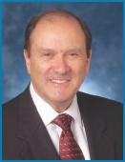

Mr. Rediker served as the President and Chief Operating Officer of Utility | Key attributes,
Composite Solutions International, a developer and maker of composite materials | experience and skills:
for utility and municipal lighting applications, from 2011 until its sale to Highland | • | Significant operating, financial,
Industries in 2016. He is currently providing consulting and transition services to | • | Significant operating, financial,
 |  | leadership, strategic, audit, and
Highland Industries. From 2009 to 2011, Mr. Rediker served as the President and |  | leadership, strategic, audit, and
 |  | marketing experience
Chief Operating Officer of B4C, LLC, a developer and maker of ceramic materials |  | marketing experience
 | • | Extensive experience in
for defense and aerospace applications. He previously served as President and | • | Extensive experience in
Chief Executive Officer and Director of The Standard Register Company, and as |  | mergers and acquisitions,
the Chief Executive Officer and a Director of English China Clays, plc. Mr. Rediker |  | environmental and safety, and
received a Bachelor’s degree from the University of California at Santa Barbara in |  | customer service
electrical engineering. | • | Expertise in corporate strategy

◆DENNIS L.

REDIKER

Director Since: 2003

Age: 74

Member of the Audit

Committee and the

Finance Committee

Director Compensation

Martin Marietta uses a combination of cash and stock-based compensation to attract and retain qualified candidates to serve on the Board of Directors. In setting Director compensation, Martin Marietta considers the significant amount of time that Directors expend in fulfilling their duties to Martin Marietta as well as the skill level required by Martin Marietta of members of the Board. The Board determines reasonable compensation for Directors upon recommendation of the Management Development and Compensation Committee of the Board, which retains an independent compensation consultant to assist it in making each recommendation.

Cash Compensation Paid to Board Members

The cash-based elements of annual Director compensation for fiscal year 2017 paid in quarterly installments, measured from the end of the month during which the Annual Meeting of Shareholders is held. were as follows.

Annual Board cash retainer | $ |  | 100,000
Annual committee chair retainer¹ |  | $ | 8,000
Annual Audit Committee chair retainer² | $ |  | 15,000
Annual Audit Committee member retainer¹ | $ |  | 5,000
Annual Lead Director retainer³ | $ |  | 25,000

- This is in addition to the annual retainer in view of increased responsibilities
- This is in addition to the annual retainer and the annual Audit Committee member retainer, but in lieu of the annual committee chair retainer in view of increased responsibilities
- This is in addition to the annual retainer and the annual committee chair retainers in view of increased responsibilities

The Company reimburses Directors for the travel expenses of, or provides transportation on Company aircraft for, Board and Committee meetings, meetings with management or independent consultants or advisors, and other Company-related events, such as Investor Day and meetings with potential Board candidates. Martin Marietta’s plane was used to transport some Directors to and from Board and committee meetings, but no Directors received personal use of Martin Marietta’s plane or other perquisites and personal benefits in 2017.

Equity Compensation Paid to Board Members

Non-employee Directors received an award of restricted stock units (RSUs) with a value of $100,000 (rounded up to the nearest RSU) based on the closing price as of the date of grant, which was generally immediately following the 2017 Annual Meeting of Shareholders in May 2017. In 2017, this award was 437 RSUs. The RSUs granted to the Directors in 2017 were fully vested upon award. Directors are required to defer at least 50% of the RSUs until retirement from the Board. Directors may choose to voluntarily defer an additional portion of their RSUs, and any RSUs that are not so deferred are settled in shares of common stock of Martin Marietta as soon as practicable following the grant date. The RSUs were awarded under the Martin Marietta Amended and Restated Stock-Based Award Plan (the “Stock Plan”), which was approved by shareholders on May 19, 2016. The Stock Plan provides that, during any calendar year, no non-employee Director may be granted (i) restricted shares and other full-value stock-based awards, including RSUs, in respect of more than 7,000 shares of common stock of Martin Marietta or (ii) options or stock appreciation rights in respect of more than 20,000 shares of common stock of Martin Marietta.

2018 PROXY STATEMENT | 13

Table of Contents

Proposal 1: Election of Directors ◆ Director Compensation

The Directors do not have voting or investment power for their respective RSUs.

Deferred Compensation Program for Board Members

The Common Stock Purchase Plan for Directors provides that non-employee Directors may elect to receive all or a portion of their fees earned in 2017 in the form of Martin Marietta’s common stock units. If deferral is elected, there is a mandatory deferral minimum time of three years with, subject to certain restrictions, redeferrals at each Director’s election up to the date the person ceases to be a Director or the date that is one year and one month following the date that the person ceases to be a Director. Directors may elect to receive payment of the

Director Compensation Table

deferred amount in a single lump sum or in equal annual installments for a period up to ten years. Amounts deferred under the plan in common stock are credited toward units of common stock at a 20% discount from the fair market value of the common stock (the closing price of the common stock as reported in the Wall Street Journal) on the date the Director fees would otherwise be paid. There are no matching contributions made by Martin Marietta. Dividend equivalents are paid on the units at the same rate as dividends are paid to all shareholders. The Directors do not have voting or investment power for their respective common stock units. Directors may also elect to defer their fees into a cash-based account on the same basis. Amounts deferred under the plan in cash are credited with interest at the prime rate as of January 1 of that year.

The table below summarizes the compensation paid by Martin Marietta to each person who served as a non-employee Director during the fiscal year ended December 31, 2017.

 |  |  | Change in Pension
 |  |  | Value and
 |  |  | Nonqualified
 | Fees |  | Deferred
 | Earned or | Stock | Compensation | All Other
Name¹ | Paid in Cash | Awards | Earnings | Compensation | Total
Name¹ | ($)² | ($)³ | ($)⁵ | ($)⁶ | ($)
(a) | (b) | (c) | (f) | (g) | (h)
Sue W. Cole | 108,000 | 100,195 | 12,565 | 68,449 | 289,209
John J. Koraleski | 105,000 | 100,195 | 34 | 1,432 | 206,661
David G. Maffucci | 120,000 | 100,195 | 7,403 | 34,872 | 262,470
William E. McDonald⁷ | 25,000 | — | 6,279 | 33,774 | 65,053
Laree E. Perez | 113,000 | 100,195 | 5,721 | 23,959 | 242,875
Michael J. Quillen | 133,000 | 100,195 | 5,387 | 61,748 | 300,330
Dennis L. Rediker | 105,000 | 100,195 | 9,683 | 37,691 | 252,569
Donald W. Slager | 100,000 | 100,195 | 44 | 1,499 | 201,738
Stephen P. Zelnak, Jr. | 108,000 | 100,195 | 4,178 | 37,215 | 249,588

- Mr. Nye, who is the Chief Executive Officer of Martin Marietta and a member of the Board of Directors, is not included in this table because he is not compensated separately for his service as a Director. The compensation received by Mr. Nye as an employee of Martin Marietta is shown in the Summary Compensation Table on page 51.

- The amounts in column (b) reflect fees earned in 2017. Some of these fees were deferred pursuant to the Common Stock Purchase Plan for Directors in the form of common stock units. The number of units of common stock credited in 2017 to each of the Directors under the Common Stock Purchase Plan for Directors and the grant date fair value for these awards determined in accordance with FASB ASC Topic 718, which includes the 20% discount, are as follows: Ms. Cole, 630 units and $108,337 value, respectively; Mr. Koraleski, 0; Mr. Maffucci, 141 units and $24,249 value, respectively; Mr. McDonald, 145 units and $25,050 value, respectively; Ms. Perez, 0; Mr. Quillen, 776 units and $133,441 value, respectively; Mr. Rediker, 124 units and $21,326 value, respectively; Mr. Slager, 0; and Mr. Zelnak, 316 units and $54,344 value, respectively. The number of units credited to each of the Directors as of December 31, 2017, including units accumulated under the plan for all years of service as a Director, is as follows: Ms. Cole, 15,252; Mr. Koraleski, 0; Mr. Maffucci, 9,036; Mr. McDonald, 6,507; Ms. Perez, 5,258; Mr. Quillen, 7,593; Mr. Rediker, 9,833; and Mr. Zelnak, 6,197. The 20% discount from the market price of Martin Marietta’s common stock used in converting to common stock is reported in column (g).

- Each Director who was serving immediately following the 2017 Annual Meeting of Shareholder received 437 RSUs in 2017. The amounts in column (c) reflect the grant date fair value for these awards determined in accordance with FASB ASC Topic 718. The RSUs fully vested upon award and will be distributed to the Director upon retirement, except Mr. Maffucci, Ms. Perez and Mr. Quillen each received a distribution of 219 unrestricted shares of common stock and deferred the distribution of 218 RSUs until retirement. As of December 31, 2017, each Director held RSUs in the amounts as follows: Ms. Cole, 8,944; Mr. Koraleski, 939; Mr. Maffucci, 7,675; Ms. Perez, 8,725; Mr. Quillen, 8,725; Mr. Rediker, 8,944; Mr. Slager, 978; and Mr. Zelnak, 7,565. As of December 31, 2017, each Director held options for common stock in the amounts as follows: Ms. Cole, 3,000; Mr. Koraleski, 0; Mr. Maffucci, 0; Ms. Perez, 3,000; Mr. Quillen, 3,000; Mr. Rediker, 0; Mr. Slager, 0; and Mr. Zelnak, 0.
- The amounts in column (f) reflect interest paid on fees deferred in cash under the Common Stock Purchase Plan for Directors.

- The amounts in column (g) reflect for each Director: (i) an amount equal to the 20% discount from the market price of Martin Marietta’s common stock used in converting fees deferred in 2017 into common stock units pursuant to the Common Stock Purchase Plan for Directors, and (ii) the dollar value of dividend equivalents paid in 2017 on common stock units held under the plan. The Directors did not receive perquisites or other personal benefits in 2017.

- Mr. McDonald retired at the 2017 Annual Meeting of Shareholders in accordance with the Bylaws that provide for retirement following the Director’s 75th birthday.

- 2018 PROXY STATEMENT

Table of Contents

Security Ownership of Certain

Beneficial Owners and Management

How much stock do Martin Marietta’s Directors and executive officers own?

The following table sets forth information as of March 9, 2018 with respect to the shares of common stock that are beneficially owned by the Directors, the Chief Executive Officer, the Chief Financial Officer, and the three other named executive officers who are listed in the Summary Compensation Table on page 51 of this proxy statement, individually, and by all Directors and executive officers of Martin Marietta as a group.

 |  | Deferred and
 | Amount and Nature of | Restricted
Name of Beneficial Owner | Beneficial Ownership¹ | Units⁵ | Total
Roselyn R. Bar | 48,096² | 19,808 | 67,904
Sue W. Cole | 33,988^{3,4} | — | 33,988
Daniel L. Grant | 3,905² | 13,308 | 17,213
John J. Koraleski | 1,600³ | — | 1,600
Anne H. Lloyd⁶ | 58,780² | 21,673 | 80,453
David G. Maffucci | 17,238³ | — | 17,238
Donald A. McCunniff | 13,695² | 14,689 | 28,384
James A. J. Nickolas | — | 8,317 | 8,317
C. Howard Nye | 131,597² | 66,810 | 198,407
Laree E. Perez | 14,202³ | — | 14,202
Michael J. Quillen | 20,283³ | — | 20,283
Dennis L. Rediker | 18,810³ | — | 18,810
Donald W. Slager | 978³ | — | 978
Stephen P. Zelnak, Jr. | 13,845³ | — | 13,845
All Directors and executive officers
as a group
(15 individuals including those
named above) | 392,341^{3,4} | 158,785 | 551,126

- As to the shares reported, unless indicated otherwise, (i) beneficial ownership is direct, and (ii) the person indicated has sole voting and investment power. None of the Directors or named executive officers individually own in excess of one percent of the shares of common stock outstanding. All Directors and executive officers as a group own 0.75% of the shares of common stock outstanding as of March 9, 2018. None of the shares reported are pledged as security.

- The number of shares owned for each of Mr. Nye, Ms. Bar, Mr. McCunniff, Mr. Grant, Ms. Lloyd and all Directors and executive officers as a group assumes that options held by each of them covering shares of common stock in the amounts indicated, which are currently exercisable within 60 days of March 9, 2018, have been exercised: Mr. Nye, 61,163; Ms. Bar, 16,865; Mr. McCunniff, 8,647; Mr. Grant, 767; Ms. Lloyd, 20,667 and all Directors and executive officers as a group, 97,112.

- Amounts reported include (1) compensation paid on an annual basis that Directors have received in common stock units that are deferred pursuant to the Amended and Restated Martin Marietta Materials, Inc. Common Stock Purchase Plan for Directors and (2) RSUs that each Director received in 2017 as part of their compensation. The Directors do not have voting or investment power for their respective common stock units and RSUs. The number of common stock units credited to each of the Directors pursuant to the Common Stock Purchase Plan as of March 9, 2018 is as follows: Ms. Cole, 15,418; Mr. Koraleski, 161; Mr. Maffucci, 9,073; Ms. Perez, 5,258; Mr. Quillen, 7,457; Mr. Rediker, 9,866; Mr. Slager, 0; and Mr. Zelnak, 6,280. Amounts reported also include 3,000 options for common stock held by each of Ms. Cole and Mr. Quillen.
- Includes an approximation of the number of shares in IRA account.

- The amounts reported include common stock units credited to each of the NEOs in connection with (i) their deferral of a portion of their cash bonus under the Martin Marietta Materials, Inc. Incentive Stock Plan, and (ii) RSUs (not including any performance-based share units (PSUs) granted under the Stock Plan that are subject to forfeiture in accordance with the terms of the plan, each in the following amounts: Mr. Nye, 16,550 and 50,260, respectively; Ms. Bar, 2,813 and 16,995, respectively; Mr. Nickolas, 0 and 8,317, respectively; Mr. McCunniff, 1,440 and 13,249, respectively; Mr. Grant, 1,750 and 11,558, respectively; Ms. Lloyd, 3,119 and 18,554, respectively; and all Directors and executive officers as a group, 23,875 and 113,237 respectively. There are no voting rights associated with the stock units.

- Ms. Lloyd retired as Executive Vice President – Chief Financial Officer as of December 31, 2017. The amounts reported reflect ownership as of May 24, 2017 and includes restricted stock awards that vested and were distributed before March 9, 2018.

2018 PROXY STATEMENT | 15

Table of Contents

Security Ownership of Certain Beneficial Ownership and Management ◆ Section 16(a) Beneficial Ownership Reporting Compliance

Section 16(a) Beneficial Ownership Reporting Compliance

Section 16(a) of the Exchange Act requires Directors and officers of Martin Marietta and persons who own more than 10% of the common stock to file with the Securities and Exchange Commission initial reports of ownership and reports in changes in ownership of the common stock. Directors, officers and more than 10% shareholders are required by Securities and Exchange Commission regulations to furnish to Martin Marietta copies of all Section 16(a) reports filed. Based solely on its review of copies of reports furnished to Martin Marietta and written representations of Directors and officers, the company believes that during fiscal year 2017, such filing requirements were satisfied.

Who are the largest owners of Martin Marietta’s stock?

The following table sets forth information with respect to the shares of common stock which are held by persons known to Martin Marietta to be the beneficial owners of more than 5% of such stock as of March 9, 2018. To the best of Martin Marietta’s knowledge, based on filings with the Securities and Exchange Commission as noted below, no person beneficially owned more than 5% of any class of Martin Marietta’s outstanding voting securities at the close of business on March 9, 2018, except for those shown below.

Name and Address | Amount and Nature | Percent
of Beneficial Owner | of Beneficial Ownership | of Class
The Vanguard Group¹
100 Vanguard Boulevard V26
Malvern, PA 19355 | 6,510,846 | 10.35%
BlackRock, Inc.²
55 East 52nd Street
New York, NY 10055 | 3,861,669 | 6.1%

- As reported in Schedule 13G/A reporting beneficial ownership as of December 31, 2017 filed with the Securities and Exchange Commission on February 9, 2018, indicating sole power to vote 88,098 shares, shared power to vote 12,310 shares, sole power to dispose of 6,410,973 shares, and shared power to dispose of 99,873 shares.

- As reported in Schedule 13G/A reporting beneficial ownership as of December 31, 2017 filed with the Securities and Exchange Commission on January 25, 2018, indicating sole power to vote 3,337,349 shares and sole power to dispose of 3,861,669 shares.

- 2018 PROXY STATEMENT

Table of Contents

Corporate Governance Matters

Corporate Governance Philosophy

Martin Marietta has a culture dedicated to ethical business behavior and responsible corporate activity, which we believe promotes the long-term interests of shareholders. This commitment is reflected in our Corporate Governance Guidelines, posted and available for public viewing on Martin Marietta’s website at www.martinmarietta.com, which set forth a flexible framework within which the Board, assisted by its Committees, directs the affairs of Martin Marietta. The Guidelines address, among other things, the composition and functions of the Board of Directors, director qualifications and independence, Chief Executive Officer performance evaluation and management succession, Board Committees and the selection of new Directors.

Martin Marietta’s Code of Ethical Business Conduct has been in place since the 1980s and is regularly updated. It and applies to all Board members, officers, and employees, providing our policies and expectations on a number of topics, including our commitment to good citizenship, promoting a positive and safe work environment,

avoiding conflicts of interest, honoring the confidentiality of sensitive information, preservation and use of Company assets, compliance with all laws, and operating with integrity in all that we do. To implement the Code of Ethical Business Conduct, Board members, officers, and employees participate regularly in ethics training. There have been no waivers from any provisions of our Code of Ethical Business Conduct to any Board member or executive officer.

In addition, the Board believes that accountability to shareholders is a mark of good governance and critical to Martin Marietta’s success. To that end, management regularly engages with shareholders on a variety of topics throughout the year, including sustainability and governance, to ensure we are addressing their questions and concerns, to seek input and to provide perspective on Company policies and practices. Feedback received during these discussions is shared with the Board and directly impacts deliberations on material topics. See discussion of our shareholder outreach on page 34.

The chart below provides a snapshot of Martin Marietta’s governance highlights.
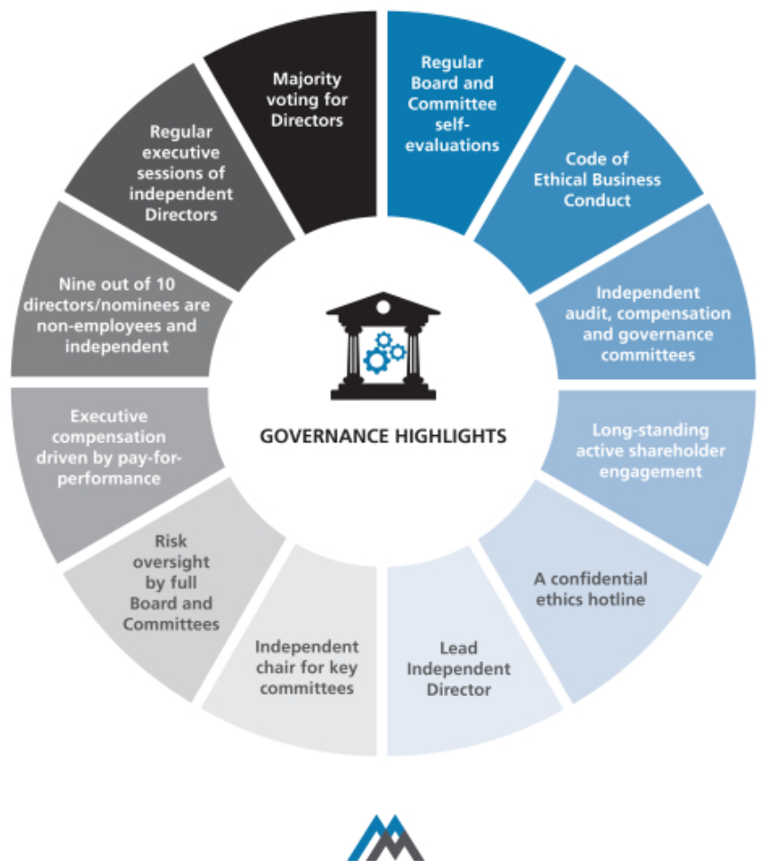

2018 PROXY STATEMENT | 17

Table of Contents

Corporate Governance Matters ◆ Corporate Governance Philosophy

Who are Martin Marietta’s Independent Directors?

All of Martin Marietta’s Directors and nominee are non-employee Directors except Mr. Nye. Mr. Nye does not sit in the executive sessions of the independent Directors unless invited to attend for a specific discussion nor does he participate in any action of the Board relating to any executive compensation which he may receive.

In assessing the independence of its members and nominee, the Board has adopted for Martin Marietta a set of Guidelines for Director’s Independence. The Guidelines are posted and available for public viewing on Martin Marietta’s website at www.martinmarietta.com. These Guidelines reflect the rules of the New York Stock Exchange, applicable requirements of the SEC, and other standards determined by the Board to be important in assessing the independence of Board members. The Board has determined that, other than Mr. Nye, all members of the Board and Mr. Davis are “independent” under these Guidelines, resulting in more than two-thirds of the Board being independent. The Board of Directors has determined that no Director or nominee (except Mr. Nye), or any person or organization with which the Director or nominee has any affiliation, has a relationship with Martin Marietta that may interfere with his or her independence from Martin Marietta and its management. In making this “independence” determination, the Board considered other entities with which the Directors and Mr. Davis were affiliated and any business Martin Marietta had done with such entities.

Do the independent Directors ever meet without management? Martin Marietta’s Corporate Governance Guidelines adopted by the Board provide that at least two Board meetings each year will include an executive session of the non-employee Directors to discuss such topics as they may choose, including a discussion of the performance of Martin Marietta’s Chairman and Chief Executive Officer. In 2017, Martin Marietta’s non-employee Directors met at each regularly scheduled Board meeting, consisting of four times in executive session without management, in addition to executive sessions held by committees of the Board. In addition, at least once a year the independent Directors meet in executive session.

What is the Board’s leadership structure?

Our Corporate Governance Guidelines provide that the Board’s policy as to whether the Chairman and CEO positions should be separate is to adopt the practice that best serves the Company’s needs at any particular time. The Nominating and Corporate Governance Committee and the Board discussed board leadership alternatives in connection with combining the Chairman and CEO roles.

The Board believes that, at the present time, the Company is best served by allocating governance responsibilities between a combined Chairman and CEO and a Lead Independent Director

- 2018 PROXY STATEMENT

with robust responsibilities. This structure allows the Company to present a single face to our constituencies through the combined Chairman and CEO position while at the same time providing an active role and voice for the independent directors through the Lead Independent Director.

REASONS FOR COMBINED CHAIR AND CEO


Key highlights:

- The independent Board members believe that Mr. Nye has extensive experience in all facets of the construction materials industry, in both the U.S. and with global competitors.

- Mr. Nye has been effective in creating shareholder value through strategic acquisitions and divestitures, with achievement of expected synergies.

- Mr. Nye has in-depth knowledge of safety, environmental, and regulatory considerations that impact the business and oversight of management.

- Mr. Nye has demonstrated his leadership and vision to guide the Board in its oversight of management with the development of two five-year strategic plans, with the current Strategic Operating Analysis and Review (SOAR 2020) discussed with and approved by the Board in August 2015.

- Mr. Nye has engaged in an active investor relations program, including the Company’s Investor Day presentations, and leads the Board in understanding the perspective of the Company’s shareholders.

- Strong independent directors and nominee comprise 90% of the Board, and open communications exist between Mr. Nye and the independent directors.

As a result of Mr. Nye’s tenure at Martin Marietta and strong performance as a leader since his election as CEO, the Board believes he is uniquely qualified through his experience, education and expertise to be the person who promotes strong and visionary leadership for our Board as well as important recognition as the leader of Martin Marietta by our customers, employees and other constituencies. The Board also believes that Mr. Nye’s serving as both Chairman and CEO is appropriate taking into consideration the size and nature of our business, Mr. Nye’s effective and careful formulation and execution of our strategic plan, his established working relationship and open communication with our other Directors, both during meetings and in the intervals between meetings, the significant board-level experience of our independent Directors as a whole, the strong independent leadership and accountability to shareholders provided by 90% of our Directors (including the Board’s nominee for Director, Mr. Davis) being independent, the independent leadership provided by our Committee chairs, and our Board culture in which Mr. Nye and the other Directors are able to thoughtfully debate different points of view and reach consensus in an efficient manner.

Table of Contents

Corporate Governance Philosophy ◆ Corporate Governance Matters

Does the Board have a Lead Independent Director?

In deciding that a combined Chairman and Chief Executive Officer position is the appropriate leadership structure for the Company at this time, the Nominating and Corporate Governance Committee and Board also recognized the benefit of independent leadership to enhance the effectiveness of the Board’s oversight role and communications between the Board and Mr. Nye. Accordingly, in November 2014, our Corporate Governance Guidelines were revised to provide that in the event the Chairman and Chief Executive Officer positions are held by one person, our independent Directors may designate a Lead Independent Director from among the independent Directors. The designation of the Lead Independent Director is to be made annually, although with the expectation of the Board that the Lead Independent Director will be re-appointed for multiple, consecutive one-year terms. Michael J. Quillen currently serves as the Lead Independent Director.

The responsibilities of the Lead Independent Director include:

- Presiding at Board meetings when the Chairman is not present.

- Presiding at executive sessions of the non-management Directors and the independent Directors, with or without the attendance of the Chairman, and meeting separately with the Chairman after executive sessions to review the matters discussed during the executive sessions.

- Acting as a liaison between the Chairman and the independent Directors.

- Suggesting to the Chairman agenda items for Board meetings and consulting with the Chairman regarding Board meeting schedules.

- Calling, where necessary, meetings of independent Directors and executive sessions.

- Being available to meet with shareholders and other key constituents.

- Acting as a resource for, and counsel to, the Chairman.

In addition, the Lead Independent Director attended and met with shareholders at the Company-sponsored Investor Days.

What is the Board’s role in risk oversight?

Our Board currently has eight independent members and only one non-independent member, Mr. Nye. In addition, Mr. Davis, who is nominated for election, is independent. A number of our independent Board members are serving or have served as members of senior management of other public companies, have served as directors of other public companies, and otherwise have experience and/or educational backgrounds that we believe qualify them to effectively assess risk. Each of our Board Committees, including our key committees of Audit, Management Development and Compensation, and Nominating and Corporate Governance Committees, are comprised solely of independent Directors, each with a different independent

Director serving as Chair of the Committee (other than the Executive Committee, which does not meet on a regular basis).

The Board has overall responsibility for oversight of risk management. The Board believes that an effective risk management system will (1) timely identify the material risks that Martin Marietta faces, (2) communicate necessary information with respect to material risks to senior executives and, as appropriate, to the Board or relevant Board Committee,

- determine whether the risk is excessive or appropriate under the circumstances and designed to achieve a legitimate corporate goal,
- implement risk management responses consistent with Martin Marietta’s risk profile, and (5) integrate risk management into Martin Marietta’s decision-making.

The Board delegates certain responsibilities to Board Committees to assist in fulfilling its risk oversight responsibilities. Each of the Committees reports regularly to the full Board of Directors as to actions taken and topics discussed. In addition, the Board regularly reviews with management the most significant risks facing Martin Marietta, the probabilities of those risks occurring, the steps taken to mitigate any impact of risks, and management’s general risk management strategy. In addition, the Board encourages management to promote a corporate culture that incorporates risk management into Martin Marietta’s day-to-day operations.

The Board has designated the Audit Committee to take the lead in overseeing risks related to financial reporting, financial statements, internal control environment, internal audit, independent audit, cybersecurity, and accounting processes. The Finance Committee evaluates risks associated with Martin Marietta’s capital structure, including credit and liquidity risks. The Management Development and Compensation Committee oversees aspects of risk related to the annual performance evaluation of our Chief Executive Officer, succession planning and ensuring that executive compensation is appropriate to meet Martin Marietta’s objectives. That Committee’s assessment of the design features of our executive compensation program that reduce the risk of excessive risk-taking are discussed in the Compensation Discussion and Analysis on page 31. The Nominating and Corporate Governance Committee oversees aspects of risk related to the composition of the Board and its Committees, Board performance and best practices in corporate governance. The Ethics, Environment, Safety and Health Committee monitors risks in key areas of Martin Marietta’s sustainability program, including health, safety, and the environment as well as the Company’s ethics program.

While the Board oversees Martin Marietta’s risk management, the executive officers are responsible for the day-to-day risk management processes. We believe this division of responsibilities is the most effective approach for addressing the risks facing our Company and is appropriate whether the positions of Chairman and Chief Executive Officer are separate or held by the same individual.

2018 PROXY STATEMENT | 19

Table of Contents

Corporate Governance Matters ◆ Corporate Governance Philosophy

How would interested parties make their concerns known to the independent Directors?

The Board of Directors provides a process for shareholders and other interested parties to send communications to the Board. Shareholders and other interested parties may communicate anonymously and confidentially with the Board through Martin Marietta’s Ethics Hotline at 1-800-209-4508. The Board has also designated the Corporate Secretary to facilitate communications to the Board. Shareholders and other interested parties may communicate directly with the Board of Directors, or directly with non-management Directors, or an individual Director, including the Lead Independent Director, by writing to Martin Marietta, Attn: Corporate Secretary, 2710 Wycliff Road, Raleigh, North Carolina 27607-3033.

All communications by shareholders or other interested parties addressed to the Board will be sent directly to Board members. While Martin Marietta’s Ethics Office and the Corporate Secretary may review, sort, and summarize these communications, all direct communications will be presented to the non-management Directors unless there is instruction from them to filter such communications (and in such event, any communication that has been filtered out will be made available to any non-employee Director who wishes to review it).

Martin Marietta and its Board of Directors will continue to review and evaluate the process by which shareholders or other

- 2018 PROXY STATEMENT

interested persons communicate with Martin Marietta and the Board and may adopt other or further processes and procedures in this regard. If so, Martin Marietta will identify those policies and procedures on our website at www.martinmarietta.com.

How often did the Board meet during 2017?

Martin Marietta’s Board of Directors held five meetings during 2017, four of which were regularly scheduled meetings and one of which was a special meeting. There were also a total of 24 committee meetings in 2017. In addition, management confers frequently with its Directors on an informal basis to discuss Company affairs.

How many times did Directors attend meetings of the Board and its Committees?

In 2017, all Directors attended 100% of the meetings of the Board of Directors. All Directors attended 100% of the meetings of the committees of the Board on which they served (during the periods that they served).

Will the Directors attend the Annual Meeting?

Martin Marietta’s Directors are expected to attend Martin Marietta’s Annual Meeting of Shareholders. In 2017, all Directors attended the Annual Meeting in May.

Table of Contents

Board Committees ◆ Corporate Governance Matters

Board Committees

Martin Marietta’s Board of Directors has six standing committees: the Audit Committee, the Ethics, Environment, Safety and Health Committee, the Executive Committee, the Finance Committee, the Management Development and Compensation Committee, and the Nominating and Corporate Governance Committee. Each committee has a written charter

that describes its purposes, membership, meeting structure, authority and responsibilities. These charters are reviewed by the respective committee on an annual basis with any recommended changes adopted upon approval by our Board. The charters of our six standing committees are posted on our website.

Below is a summary of our current committee structure and membership information.

 |  | Ethics,
 |  | Environment,
 |  | Safety and
 | Audit | Health
Director | Committee | Committee
Sue W. Cole
John J. Koraleski
Financial Expert
David G. Maffucci | Chair
Financial Expert | Chair
C. Howard Nye
Laree E. Perez |  | Chair
Financial Expert |  | Chair
Michael J. Quillen
Lead Independent Director
Dennis L. Rediker
Financial Expert
Donald W. Slager
Stephen P. Zelnak, Jr.
Number of Meetings | 8 | 2
in 2017 | 8 | 2
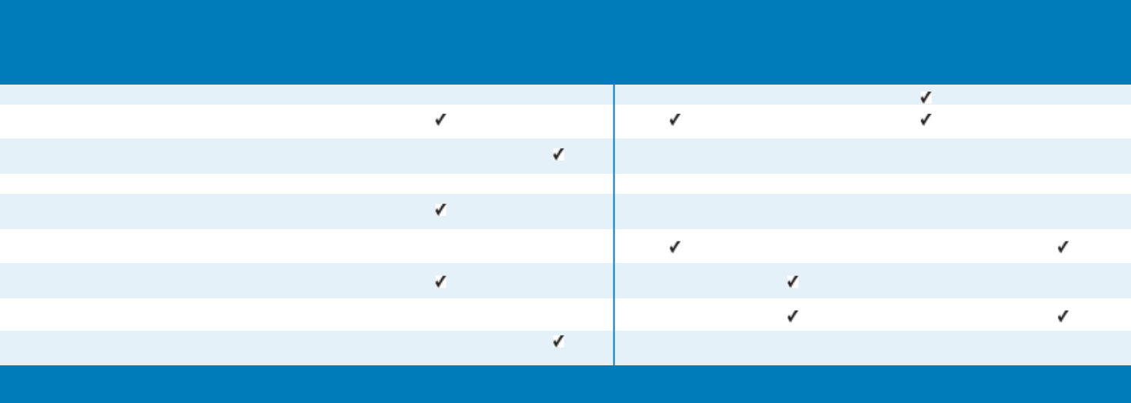

 |  | Management
 |  | Development | Nominating
 |  | and | and Corporate
Executive | Finance | Compensation | Governance
Committee | Committee | Committee | Committee
Chair |  |  | Chair
 |  | Chair
 | Chair
0 | 5 | 6 | 3

The Executive Committee held no meetings during 2017. It has the authority to act during the intervals between the meetings of the Board of Directors and may exercise the powers of the Board in the management of the business and affairs of Martin Marietta as may be authorized by the Board of Directors,

except to the extent such powers are by statute, the Articles of Incorporation or Bylaws reserved to the full Board. The Committee’s current members are Directors Nye (Chair), Koraleski, and Quillen.

2018 PROXY STATEMENT | 21

Table of Contents

Corporate Governance Matters ◆ Board Committees

The primary responsibilities, membership and meeting information for our other standing committees are summarized below.
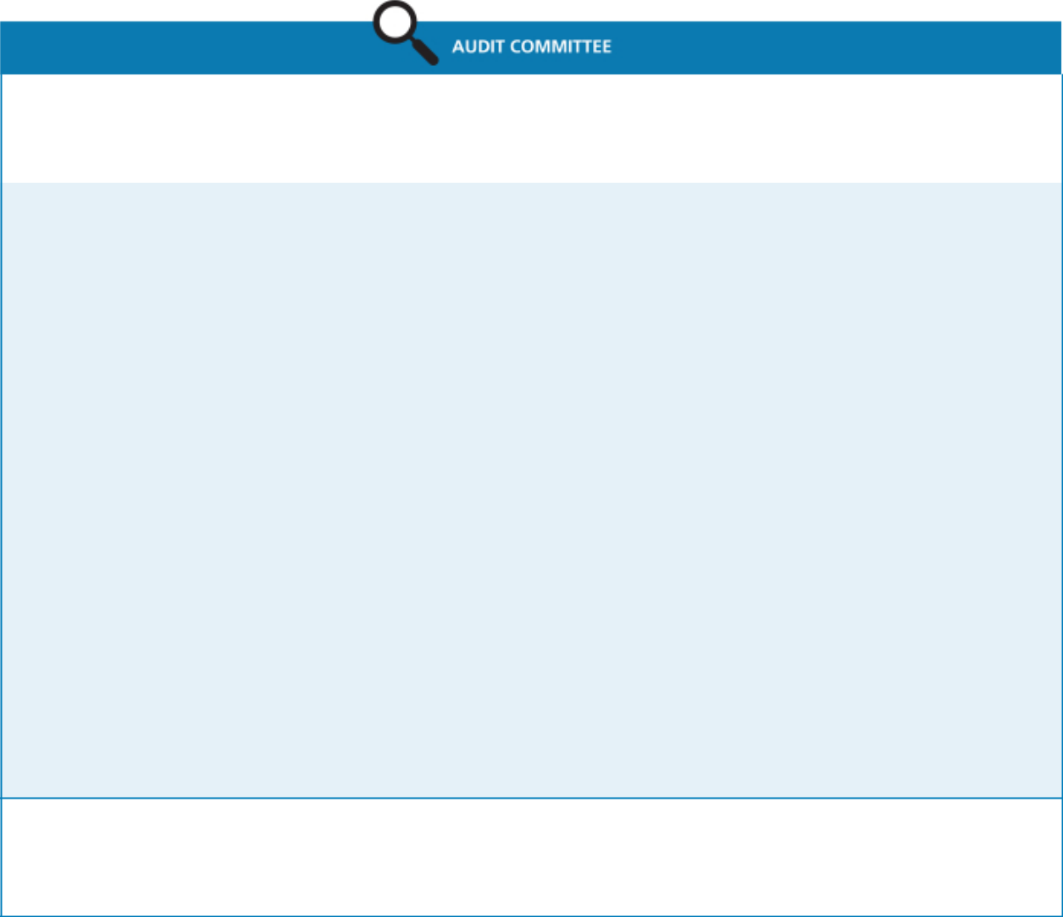

Current Members:
David G. Maffucci (Chair) | Meetings in 2017: | Average Attendance in 2017:
John J. Koraleski | Meetings in 2017: | Average Attendance in 2017:
John J. Koraleski | 8 | 100%
Laree E. Perez | 8 | 100%
Dennis L. Rediker
Primary Responsibilities:

- reviews our significant accounting principles, policies and practices in reporting our financial results under generally accepted accounting principles;

- reviews our annual audited financial statements and related disclosures;

- reviews management letters or internal control reports, and reviews our system of internal control over financial reporting;

- appoints, retains and oversees the work of the independent accountants;

- reviews the effectiveness of the independent audit effort;

- pre-approves audit and permissible non-audit services provided by the independent registered public accounting firm;

- reviews our interim financial results for each fiscal quarters;

- reviews the qualifications and the plan and scope of work of the corporate internal audit function;

- reviews and discusses the reports of our internal audit group;

- reviews and discusses management’s assessment of the effectiveness of Martin Marietta’s system of internal control over financial reporting;

- discusses Martin Marietta’s earnings press releases, as well as financial information and earnings guidance provided to analysts, investors and rating agencies;

- discusses matters related to risk assessment and risk management and how the process is handled by management;

- reviews and oversees related party transactions;

- reviews complaints regarding accounting, internal controls or auditing matters;

- considers allegations of possible financial fraud or other financial improprieties;

- reviews annually the adequacy of the committee charter and recommends proposed changes to the Board; and

- prepares the annual Audit Committee Report to be included in the proxy statement.

Other Governance Matters:

All members satisfy the audit committee experience and independence standards required by NYSE, and have been determined to be financially literate.

Each member of the Audit Committee has been determined to be an ‘‘audit committee financial expert’’ under applicable SEC regulations.

- 2018 PROXY STATEMENT

Table of Contents

Board Committees ◆ Corporate Governance Matters
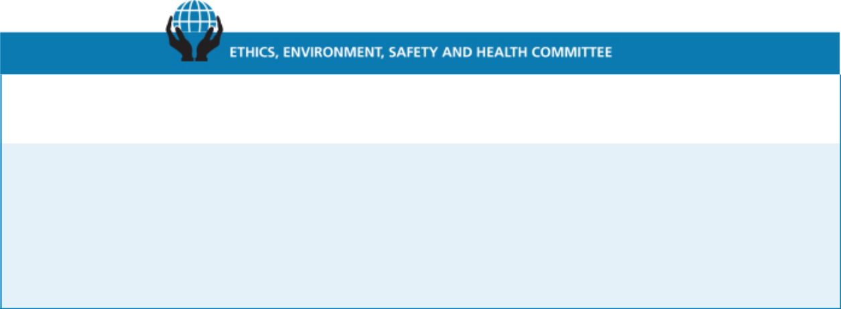

Current Members:
Laree E. Perez (Chair) | Meetings in 2017: | Average Attendance in 2017:
David G. Maffucci | 2 | 100%
Stephen P. Zelnak, Jr.
Primary Responsibilities:

- monitors compliance with our Code of Ethical Business Conduct and reviews all matters presented to it by the Corporate Ethics Officer concerning the ethical practices of Martin Marietta and its Directors, officers, and employees, including conflicts or potential conflicts of interest between Martin Marietta and any of its Directors, officers, and employees;

- reviews and monitors the adequacy of our policies and procedures and organizational structure for ensuring compliance with environmental laws and regulations;

- reviews matters relating to our health and safety programs and performance; and

- reviews annually the adequacy of the committee charter and recommends proposed changes to the Board.

Current Members:
Stephen P. Zelnak, Jr. (Chair) | Meetings in 2017: | Average Attendance in 2017:
Dennis L. Rediker | 5 | 100%
Donald W. Slager

Primary Responsibilities:

- provides general oversight relating to the management of our financial affairs;

- reviews and approves establishment of lines of credit or other short-term borrowing arrangements and investing excess working capital funds on a short-term basis;

- reviews and makes recommendations to the Board concerning changes to capital structure, including the incurrence of long-term debt, issuance of equity securities, share repurchases, and the payment of dividends, as well as capital expenditures;

- approves our contributions budget; and

- reviews annually the adequacy of the committee charter and recommends proposed changes to the Board.

2018 PROXY STATEMENT | 23

Table of Contents

Corporate Governance Matters ◆ Board Committees
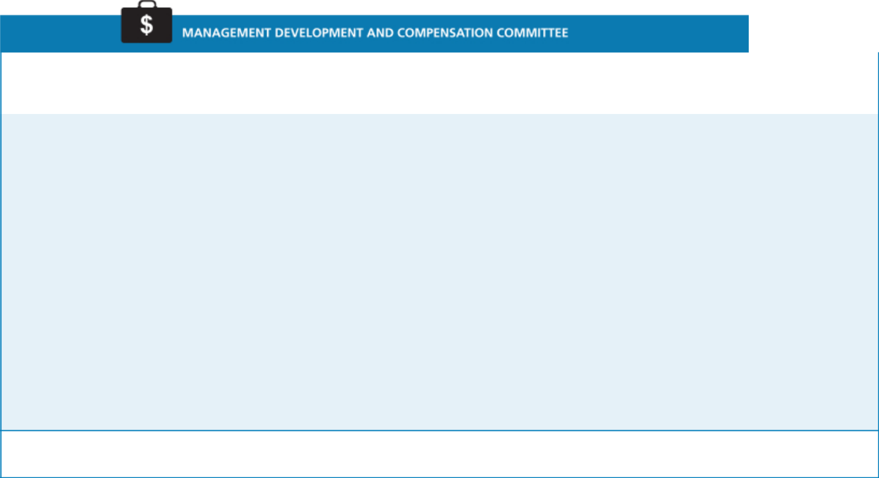

Current Members: |  | Average
Michael J. Quillen (Chair) | Meetings in 2017: | Attendance in
Sue W. Cole | 6 | 2017:
John J. Koraleski |  | 100%
Primary Responsibilities:

- establishes an overall strategy with respect to compensation for officers and management to enable Martin Marietta to attract and retain qualified employees;

- reviews and oversees executive succession and management development plans;

- reviews and approves management’s assessment of the performance of executive officers, and reviews and approves the salary, incentive compensation, and other compensation of such officers;

- approves and administers our equity and other plans relating to compensation of Martin Marietta’s directors and elected officers;

- reviews and discusses the Compensation Discussion and Analysis and produces a compensation committee report as required by the SEC to be included in this proxy statement;

- provides oversight of our Benefit Plan Committee, which administers Martin Marietta’s defined benefit and contribution plans;

- reviews and approves the goals and objectives for the CEO’s compensation, evaluates the CEO’s performance in light of those goals and objectives, and determines and approves the CEO’s compensation;

- makes recommendations to the Board on changes in the compensation of non-employee directors;

- reviews annually the adequacy of the committee charter and recommends proposed changes to the Board; and

- has the authority, in its sole discretion, to retain, pay, and terminate any consulting firm, if any, used to assist in evaluating director, chief executive officer, or senior executive compensation.

Other Governance Matters:

All members are non-employee, independent Directors, as required by the rules of the NYSE, the Martin Marietta Guidelines for Director’s Independence and the Committee’s charter.
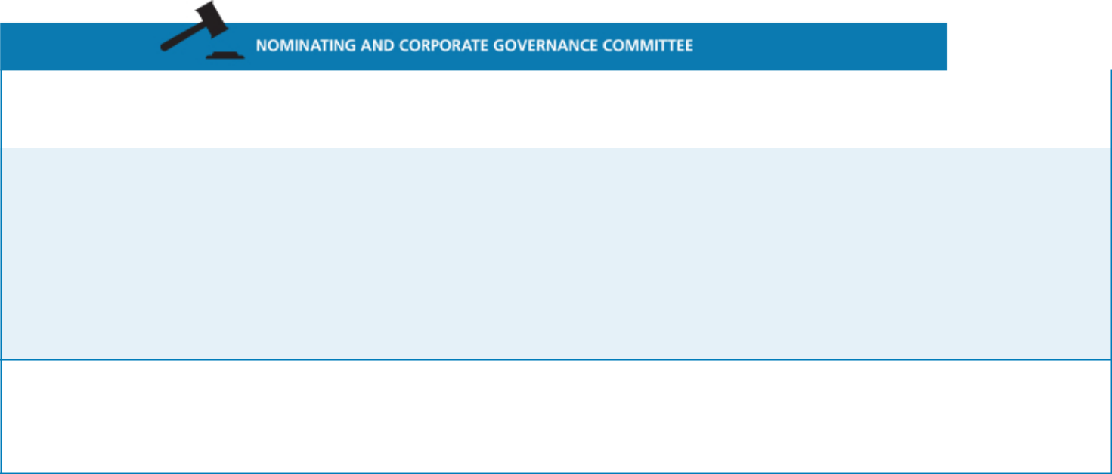

Current Members: |  | Average
Sue W. Cole (Chair) | Meetings in 2017: | Attendance in
Michael J. Quillen | 3 | 2017:
Donald W. Slager |  | 100%
Primary Responsibilities:

- develops criteria for nominating and appointing directors, including Board size and composition, corporate governance policies, and individual director expertise, attributes and skills;

- recommends to the Board the individuals to be nominated as directors;

- recommends to the Board the appointees to be selected for service on the Board committees;

- oversees an annual review of the performance of the Board and each committee;

- reviews annually the adequacy of the committee charter and recommends proposed changes to the Board; and

- oversees the development and implementation of a set of corporate governance principles applicable to Martin Marietta.

Other Governance Matters:

All members are non-employee, independent Directors, as required by the rules of the NYSE.

Upon recommendation of this Committee, the Board of Directors has adopted a set of Corporate Governance Guidelines for Martin Marietta. The Guidelines are posted and available for public viewing on our website at www.martinmarietta.com. A copy may also be obtained upon request from Martin Marietta’s Corporate Secretary.

- 2018 PROXY STATEMENT

Table of Contents

Board Committees ◆ Corporate Governance Matters

Will the Nominating and Corporate Governance Committee consider any Director candidates recommended by shareholders?

The Nominating and Corporate Governance Committee will consider nominees recommended by shareholders for election as a Director at an Annual Meeting of Shareholders of Martin Marietta, if the shareholder making such recommendation complies with the advance notice provisions of the Bylaws of Martin Marietta. The Bylaws of Martin Marietta require advance notice for any proposal for the nomination for election as a Director at an Annual Meeting of Shareholders that is not included in Martin Marietta’s notice of meeting or made by or at the direction of the Board of Directors. In general, nominations must be delivered to the Secretary of Martin Marietta at its principal executive offices, 2710 Wycliff Road, Raleigh, North Carolina 27607, not less than 60 days nor more than 90 days prior to the first anniversary of the mailing of the proxy statement in connection with the preceding year’s Annual Meeting of Shareholders and must contain specified information concerning the nominee and the shareholder proposing the nomination. Any shareholder desiring a copy of the Bylaws of Martin Marietta will be furnished a copy without charge upon written request to the Secretary of Martin Marietta. Since the 2017 Annual Meeting, Martin Marietta has not made any material changes to the procedures by which shareholders may recommend nominees to Martin Marietta’s Board of Directors. Additional information is contained in the section entitled “Shareholders’ Proposals For 2019 Annual Meeting” below.

How does the Board select nominees for the Board?

The Nominating and Corporate Governance Committee will consider candidates for Board membership suggested by its members and other Board members, as well as management and shareholders. The Committee has also retained a third-party executive search firm to identify potential candidates for its consideration from time to time. The Committee makes an initial determination as to whether to conduct a full evaluation of the candidate, and reviews all information provided to the Committee, including the recommendations for the prospective candidate and the Committee’s own knowledge of the prospective candidate. If the Committee determines that additional consideration is warranted, interviews are conducted by the members of the Committee, as well as the Chief Executive Officer of Martin Marietta; appropriate inquiries are conducted into the background and qualifications of potential candidates; the Committee meets to discuss its evaluation and feedback from the Chief Executive Officer; and, if the Committee determines to do so, it makes a recommendation to the full Board as to the persons who should be nominated by the Board. The Board of Directors determines the nominees after considering the recommendation and report of the Committee.

In evaluating any potential candidate, the Nominating and Corporate Governance Committee considers the extent to which the candidate has the personal characteristics and core competencies outlined in the Guidelines for Potential New Board

Members adopted by the Committee, and takes into account all other factors it considers appropriate. A copy of these Guidelines is attached to this proxy statement as Appendix A.

Our Articles of Incorporation provide that the size of the Board shall be not less than nine nor more than 11, with the number of Directors to serve on the Board being set within that range by the Board. The Board has set the size of the Board to ten, effective upon commencement of the 2018 Annual Meeting. The Board has nominated Smith W. Davis to stand for election by shareholders at the 2018 Annual Meeting of Shareholders for a one-year term to fill the vacancy created by the increase in the size of the Board to ten. The Nominating and Corporate Governance Committee did not retain a search firm in 2018 to help identify director prospects and other tasks relating to potential new Board members. Mr. Davis was initially identified by the Chairman, President and CEO and was recommended as a Director nominee by the Nominating and Corporate Governance Committee.

Do the Board Committees have charters? How can shareholders obtain them?

Martin Marietta’s Board of Directors has adopted written charters meeting the requirements of the NYSE for the Audit Committee, Management Development and Compensation Committee, and Nominating and Corporate Governance Committee. These charters address the purposes and responsibilities of each committee, as described above, and provide for an annual performance evaluation of each committee. Copies of these charters, and the charters of the other committees of the Board, are posted on Martin Marietta’s website at www.martinmarietta.com, along with copies of Martin Marietta’s Corporate Governance Guidelines, Code of Ethical Business Conduct, and Guidelines for Director’s Independence.

How are transactions with persons related to Martin Marietta reviewed?

The SEC requires Martin Marietta to disclose in this proxy statement certain transactions in which Martin Marietta participates and in which certain persons considered “related persons” of Martin Marietta have a direct or indirect material interest. These “related persons” would include the Directors and executive officers of Martin Marietta, nominees for Director, certain control persons, and their immediate family members. Since January 1, 2017, there have been no such transactions.

Each Director, executive officer, and nominee for Director of Martin Marietta receives and agrees to abide by Martin Marietta’s Code of Ethical Business Conduct. Martin Marietta considers that any transaction in which Martin Marietta participates and in which any related person of Martin Marietta has a direct or indirect material interest will be subject to review, approval or ratification, as appropriate under the circumstances, by Martin Marietta under the standards enumerated in Martin Marietta’s Code of Ethical Business Conduct. If a proposed transaction is one in which a Director of Martin Marietta has an actual or potential conflict of interest, it will be subject to review

2018 PROXY STATEMENT | 25

Table of Contents

Corporate Governance Matters ◆ Board Committees

by the Chairman of the Board of Directors and the Chairman of the Nominating and Corporate Governance Committee.

Any waivers of the Code of Ethical Business Conduct for Directors and executive officers may be made only by Martin Marietta’s Board of Directors or any committee to which it delegates that authority. Any waivers for Directors and executive officers and any amendments to the Code of Ethical Business Conduct will be

- 2018 PROXY STATEMENT

promptly disclosed to Martin Marietta’s shareholders by posting on our website, www.martinmarietta.com.

In assessing the independence of its members, the Board considers any interests a director may have in any transactions in which Martin Marietta participates. The Board also considers other entities with which the Directors are affiliated and any business Martin Marietta has done with such entities.

Table of Contents

Proposal 2

Independent Auditors

(Item 2 on Proxy Card)

The Board of Directors recommends that the shareholders ratify the appointment of PricewaterhouseCoopers LLP (“PwC”), an independent registered public accounting firm, to audit the consolidated financial statements of Martin Marietta and the effectiveness of Martin Marietta’s internal control over financial reporting for the 2018 fiscal year. The ratification of the appointment of PwC is being submitted to the shareholders because the Board of Directors believes this to be good corporate practice. Should the shareholders fail to ratify this appointment, the Audit Committee will review the matter and determine, in its sole discretion, whether PwC or another independent registered public accounting firm should be retained.

PwC served as Martin Marietta’s independent auditors for 2017 and audited the consolidated financial statements of Martin Marietta for the year ended December 31, 2017 and the effectiveness of Martin Marietta’s internal control over financial reporting as of December 31, 2017. In connection with the audit of Martin Marietta’s 2017 consolidated financial statements, Martin Marietta entered into an engagement letter with PwC that sets forth the terms by which PwC would perform audit services for Martin Marietta in 2017.

The Audit Committee conducted a competitive process with multiple firms to determine the Company’s independent registered public accounting firm for the fiscal year ending December 31, 2016. The Audit Committee invited several firms to participate in this process, including its then-incumbent independent auditor, Ernst & Young LLP (EY). As a result of this process, on March 14, 2016, the Audit Committee dismissed EY as its independent registered public accounting firm for the fiscal year ending December 31, 2016. During the fiscal year ended December 31, 2015 and in the subsequent interim period through March 14, 2016, there were no “disagreements” (as that term is described in Item 304(a)(1)(iv) of Regulation S-K of the rules and regulations of the SEC and the related instructions) with EY on any matters of accounting principles or practices, financial statement disclosure, or auditing scope or procedure which, if not resolved to the satisfaction of EY, would have caused EY to make reference to the subject matter of such disagreements in their reports on the consolidated financial statements.

The audit reports of EY on the Company’s consolidated financial statements as of and for the fiscal year ended December 31, 2015 did not contain an adverse opinion or a disclaimer of opinion, and were not qualified or modified as to uncertainty, audit scope or accounting principles. During the fiscal year ended December 31, 2015 and in the subsequent interim period through March 14, 2016 there were no “reportable events” as that term is described in Item 304(a)(1)(v) of Regulation S-K of the rules and regulations of the SEC.

On March 14, 2016, the Audit Committee approved the appointment of PwC as the Company’s new independent registered public accounting firm for the year ending December 31, 2016. During the fiscal years ended December 31, 2015 and 2014 and in the subsequent interim period through March 14, 2016, neither the Company nor anyone acting on its behalf consulted with PwC regarding (i) the application of accounting principles to a specific transaction, either completed or proposed, or the type of audit opinion that might be rendered on the Company’s consolidated financial statements, and neither a written report nor oral advice was provided to the Company that PwC concluded was an important factor considered by the Company in reaching a decision as to any accounting, auditing, or financial reporting issue, (ii) any matter that was the subject of a disagreement as defined in Item 304(a)(1)(iv) of Regulation S-K, or (iii) any reportable event as defined in Item 304(a)(1)(v) of Regulation S-K of the rules and regulations of the SEC.

The Audit Committee is solely responsible for retaining or terminating Martin Marietta’s independent auditors. Representatives of PwC are expected to attend the Annual Meeting, will have the opportunity to make a statement if they so desire, and will be available to respond to questions from shareholders.

The Board Unanimously Recommends a Vote “FOR” on this Proposal 2

2018 PROXY STATEMENT | 27

Table of Contents

Proposal 2: Independent Auditors ◆ Summary of Fees

Summary of Fees

The following table summarizes the aggregate fees billed for professional services rendered to Martin Marietta by PwC in 2017 and 2016.

 |  |  | 2017 | 2016
 | Audit Fees1 | $ | 2,872,000 | $2,473,000
 | Audit-Related Fees |  | 103,000 | 103,000
 | 2
 | Tax Fees |  | 20,000 | 40,000
3
 | All Other Fees4 |  | 0 | 0
 | TOTAL | $ | 2,995,000 | $2,616,000
 | Percentage of Audit & Audit-Related Fees to Total Fees |  | 99.3% | 98.5%

- Services in connection with the annual consolidated financial statement audit, the annual internal controls audit, and reviews of the consolidated financial statements included in the quarterly reports.
- Services in connection with audit-related services, including agreed-upon procedures reports, subsidiary audits and continuing education.

³ Services in connection with tax advice related to transfer pricing issues.
⁴ There were no other fees billed for other professional services rendered or products provided by PwC to Martin Marietta for 2017 or 2016.

Pre-Approval Policies and Procedures

The Audit Committee has adopted a policy that requires advance approval of all audit, audit-related, tax services, and other services performed by its independent auditor. The policy provides for pre-approval by the Audit Committee of specifically defined audit and non-audit services. Unless the specific service has been previously pre-approved with respect to that year, the Audit Committee must approve the permitted service before the independent auditor is engaged to perform it. The Audit Committee has delegated to the Chair of the Audit Committee authority to approve permitted services, provided that the Chair reports any decision to the Committee at its next scheduled meeting.

Audit Committee Review

In connection with the Audit Committee’s review of services rendered and fees billed by the independent auditor, the Audit Committee has considered whether the provision of the non-audit related services described above is compatible with maintaining the independent auditors’ independence and has concluded that the provision of these services did not compromise such independence.

- 2018 PROXY STATEMENT

Table of Contents

Audit Committee Report

The Audit Committee operates under a written charter adopted by the Board of Directors, which is reassessed at least annually for adequacy by the Audit Committee. The Directors who serve on the Audit Committee have no financial or personal ties to Martin Marietta (other than Director compensation and equity ownership as described in this proxy statement) and are all “independent” for purposes of the Securities and Exchange Commission’s regulations, the New York Stock Exchange listing standards, and the Guidelines for Director’s Independence adopted by the Board of Directors. The Board of Directors has determined that none of the Audit Committee members has a relationship with Martin Marietta that may interfere with the Director’s independence from Martin Marietta and its management. Copies of the Audit Committee’s charter and Martin Marietta’s Guidelines for Director’s Independence can be viewed on Martin Marietta’s website at www.martinmarietta.com.

The Board of Directors has charged the Audit Committee with a number of responsibilities, including review of the adequacy of Martin Marietta’s financial reporting, accounting systems, and internal controls. Martin Marietta’s independent auditors and the vice president of the internal audit function report directly and are ultimately accountable to the Audit Committee.

In the discharge of its responsibilities, the Audit Committee has reviewed and discussed with management and the independent auditors Martin Marietta’s audited consolidated financial statements for fiscal year 2017. In addition, the Committee has discussed with the independent auditors matters such as the quality (in addition to acceptability), clarity, consistency, and completeness of Martin Marietta’s financial reporting, as required by Auditing Standard No. 1301, Communications with Audit Committees, as adopted by the Public Company Accounting Oversight Board.

The Audit Committee has received from the independent auditors written disclosures and a letter concerning the independent auditors’ independence from Martin Marietta, as required by the Public Company Accounting Oversight Board in Rule 3526, Communication with Audit Committees Concerning Independence, and has discussed with the independent auditors the independent auditors’ independence. These disclosures have been reviewed by the Committee and discussed with the independent auditors.

Based on these reviews and discussions, the Audit Committee has recommended to the Board of Directors that the audited financial statements be included in Martin Marietta’s 2017 Annual Report on Form 10-K for filing with the Securities and Exchange Commission.

February 21, 2018

AUDIT COMMITTEE

David G. Maffucci, Chair

John J. Koraleski
Laree E. Perez
Dennis L. Rediker

2018 PROXY STATEMENT | 29

Table of Contents

Management Development and

Compensation Committee Report

The Management Development and Compensation Committee has reviewed and discussed with management the Compensation Discussion and Analysis beginning on page 31 of this Proxy Statement. Based on this review and discussion, the Management Development and Compensation Committee recommended to the Board of Directors that the Compensation Discussion and Analysis be included in Martin Marietta’s Annual Report on Form 10-K and this Proxy Statement.

February 22, 2018

MANAGEMENT DEVELOPMENT AND

COMPENSATION COMMITTEE

Michael J. Quillen, Chair

Sue W. Cole
John J. Koraleski

Compensation Committee Interlocks and Insider Participation in Compensation Decisions

The members of Martin Marietta’s Management Development and Compensation Committee are Directors Cole, Koraleski, and Quillen, none of whom has ever been an officer or employee of Martin Marietta or any of its subsidiaries, or had any relationship requiring disclosure by Martin Marietta under Item 404 of Regulation S-K. There are no executive officer-Director interlocks where an executive of Martin Marietta serves on the compensation committee of another corporation that has an executive officer serving on Martin Marietta’s Board of Directors.

- 2018 PROXY STATEMENT

Table of Contents

Compensation Discussion and Analysis

Introduction

This Compensation Discussion and Analysis, or CD&A, describes our 2017 executive compensation program and the attendant oversight provided by the Management Development and Compensation Committee of the Board of Directors (the Committee). It also summarizes our executive compensation structure and discusses the compensation earned by Martin

Marietta’s NEOs (the CEO, the CFO, and the three other most highly compensated executive officers in 2017) as presented below in the tables under “Executive Compensation” following this CD&A, which contain detailed compensation information quantifying and further explaining our NEOs’ compensation.

For 2017, our NEOs were:

NEO | Title
C. Howard Nye | Chairman of the Board, President and Chief Executive Officer
James A. J. Nickolas | Senior Vice President and Chief Financial Officer
Roselyn R. Bar | Executive Vice President, General Counsel and Corporate Secretary
Daniel L. Grant | Senior Vice President – Strategy and Development
Donald A. McCunniff | Senior Vice President – Human Resources

- Also included in the Executive Compensation information starting on page 51 is Anne H. Lloyd, former Executive Vice President and Chief Financial Officer, who retired from the Company as of December 31, 2017. The terms of her separation from the Company are described on pages 60 and 62 of this proxy statement.

Executive Summary

By almost any meaningful measure, 2017 was a remarkable year for Martin Marietta. We had record financial performance, delivering net earnings of $713.4 million and over $1 billion dollars in EBITDA.* We continue to focus not only on the operations of the Company, but on the best practices needed to make Martin Marietta not just the best aggregates

company, but rather one of the world’s best companies. Our Company performance, coupled with the achievement of key strategic goals, delivered excellent results in 2017, and established an enhanced solid foundation for continued performance and delivery of shareholder value.

Another Record Year: Performance Through Transformation

  - Record total revenues of $4.0 billion

  - Record gross profit of $971.9 million

  - Record net earnings of $713.4 million, despite 1 million tons lower of aggregates shipments than 2016

  - Record EBITDA* of $1.004 billion

  - Record earnings per diluted share of $11.25

* See Appendix B for a reconciliation of net earnings attributable to EBITDA.


2018 PROXY STATEMENT | 31

Table of Contents

Compensation Discussion and Analysis ◆ Executive Summary

Our performance earned us recognition, including being ranked #72 in Fortune’s 100 fastest growing companies in the world in 2017. Our TSR for the 3-year and 5-year periods represented a premium relative to the performance of the S&P 500 TSR and the S&P 500 Materials Index TSR.
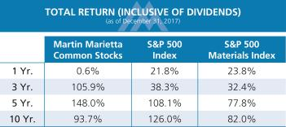

In 2017, we continued to focus on strategically positioning ourselves in high-growth areas. Consistent with our strategic plan and our assessment of the attractiveness of markets, we entered into an agreement to acquire Bluegrass Materials, the largest privately-held, pure-play aggregates business in the United States with locations in Maryland, Georgia, Kentucky, Tennessee and South Carolina.
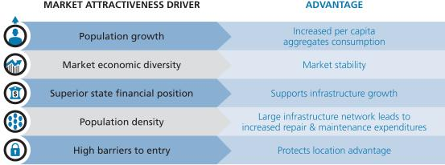

Despite significant precipitation in many of our key markets and shipment volume decreases, we achieved record financial performance in 2017 that led to increased profits versus the prior year. Effective management provided us the ability to prudently reinvest in our business, pursue strategic opportunities, and return cash to our shareholders. Based on our strategy, we have achieved the number 1 or 2 position in 85% of the regions in which we operate, giving us a foundation for durable growth.

In summary, Martin Marietta continued to execute its strategic plan while delivering strong performance in 2017 as compared to 2016:

- Record earnings per diluted share of $11.25 compared with $6.63; 2017 includes $4.07 per share benefit for the impact of the Tax Cuts and Jobs Act of 2017 (2017 Tax Act)

- Record net earnings attributable to Martin Marietta of $713.3 million, an increase of 68%, including a $258.1 million income tax benefit from the remeasurement of deferred tax assets and liabilities following enactment of the 2017 Tax Act

- Record consolidated EBITDA of over $1.00 billion compared with $971.6 million

- Record consolidated total revenues of $3.97 billion compared with $3.82 billion, an increase of 3.8%

- Aggregates product line pricing increase of 4.5% despite aggregates product line volume decline of 0.6%

- Cement product line total revenues of $384.1 million and gross profit of $117.3 million
- Return on shareholders’ equity of 16.2%

- Record Magnesia Specialties’ total revenues of $270.0 million and earnings from operations of $79.4 million
- Effective management of controllable production costs, as evidenced by a 60-basis-point improvement in consolidated gross margin
- Selling, general and administrative (SG&A) expenses representing 6.6% of total revenues
- Operating cash flow of $657.9 million

- 2018 PROXY STATEMENT

Table of Contents

This financial performance allowed us to achieve our additional strategic objectives, including:

- Pursuing aggregates-led expansion through acquisitions that complement existing operations (i.e., bolt-on acquisitions) and acquisitions that provide leadership entry into new markets or similar product lines (i.e., platform acquisitions)

- Returning $209 million to our shareholders in 2017 through share repurchases ($100.0 million) and meaningful dividends ($108.9 million) that were recently increased, and totaling over $1.2 billion since announcing our repurchase authorization in February 2015

Martin Marietta continues to be recognized as the best of the best in our industry. All awards are meaningful, but it is particularly satisfying when we are recognized for achievement against a core value, such as safety. At the 2017 Fall meeting of the National Stone, Sand and Gravel Association (NSSGA), several of our facilities were recognized as NSSGA Safety Excellence Award winners. These awards recognize operations that have gone the longest duration without a reportable injury in their size category, based on data provided by the Mine Safety and Health Administration (MSHA). Our Rio Medina Quarry, located in San Antonio, Texas, earned a gold-level Safety Excellence award in the large quarry category. Silver-level award winners include Helotes Quarry (Texas), Cedarville Quarry (Ohio), 3 Bells Sand & Gravel (Colorado), New Harvey Sand (Iowa), Linn County Sand (Iowa) and Onslow Quarry (North Carolina). In addition, 20 of our operations were recognized as bronze-level award winners.

Stewardship is another of our core values and our operations were well-represented among the NSSGA Environmental Excellence Award winners. These awards provide national recognition for operations actively contributing to the maintenance of the environment in and around their operations as evidenced by a commitment to the exemplary use of environmental controls and systems. This award is based, in part, on the extent to which an operation meets and exceeds technical environmental and regulatory requirements. In addition, in order to be eligible for the award, the operation must certify its compliance with all applicable governmental environmental regulatory requirements and does not have a pattern of violations during the time period of two full years prior to the date of application. Two of our operations, Central Rock (North Carolina) and Mill Creek Limestone (Oklahoma), were recognized as gold-level award winners. Silver-level winners included Kings Mountain Quarry (North Carolina), Maiden Quarry (North Carolina) and North Columbia Quarry

Executive Summary ◆ Compensation Discussion and Analysis

(South Carolina). Eleven of our operations were recognized as bronze-level award winners.

In 2017, Forbes Magazine unveiled two new lists and Martin Marietta was recognized on both: We ranked #146 on the Global 2000 Growth Champions list and #209 on the Global 2000 World’s Best Employers list. Sales are one of four metrics used to rank the companies on the Global 2000 Growth Champions list – the others are profits, assets and market value. Our financial performance put us on this list. Our employees put us on the Global 2000 World’s Best Employers list. Employees were asked to rate their employer and the likelihood they would recommend the company to a friend or family member. We were one of only 9 employers from the Construction Materials sector recognized in the top 500. In addition, we were the highest ranked U.S.-based employer from the Construction Materials sector in the top 500.

Further, for the second year in a row, Martin Marietta was also recognized by Fortune Magazine as one of the World’s 100 Fastest Growing Companies. 2017 marked the 31st edition of Fortune’s Fastest Growing Companies list which reveals the top three-year performers in revenues, profits and stock returns. Martin Marietta was ranked #57 in 2016 and #72 in 2017. None of our industry or sector peers made the Fortune ranking.

Martin Marietta was also identified as North Carolina’s best-run public company for 2017 by the American City Business Journals. Seven performance factors were considered in the ranking: return on equity, profit margin, debt-to-equity ratio, revenue growth, liquidity, shareholder return and employee growth. We bested Bank of America, BB&T, Duke Energy, Lowes, Nucor, Hanes Brands, VF Corporation, Red Hat, and IQVIA (formerly Quintiles), among others, due to our impressive financial performance.

We were also well-represented on the Institutional Investor All-America Executive Team for 2018, where, among other recognitions, the Martin Marietta Analyst Day was ranked second overall.

Finally, our Information Services team was honored at OpenWorld in San Francisco for Digital Innovation. The award recognized the team’s pioneering efforts in installing JD Edwards on Oracle’s SuperCluster technology platform. This project significantly improved application performance, created a robust business continuity and disaster recovery platform, and provides a foundation for growth that will serve the Company for years.

2018 PROXY STATEMENT | 33

Table of Contents

Compensation Discussion and Analysis ◆ Executive Summary

With a primary Martin Marietta strategic objective being value-enhancing growth, it is important that the Mission, Vision, and Values of the Company are unified, aligned, and equally well-known and understood. In 2017, a team of specifically chosen, high-performing employees were tasked with refreshing this message. The team, comprised of nine individuals, met several times as they worked through this important initiative. The message was delivered to all employees in 2017 and will guide our strategic and tactical decisions into the future.
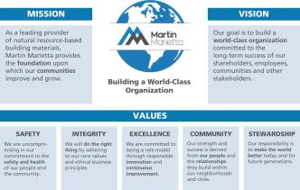

In 2017, we updated our Code of Ethical Business Conduct and provided in-person ethics training to our over 8,000 employees and contractors. The training in 2017 demonstrated how an employee could use the Code in real-life scenarios and provided employees other tools to help in making the right decisions and considering the hard questions of ‘right vs. right.’ Each class opened with an in-depth discussion of the refreshed Mission, Vision, and Values, and continued to cover important and relevant topics. The in-person training, which occurs every three years, is an important component of the Company’s overall ethics program, which includes computer-based training and an ethics hotline.


2017 Say-On-Pay Vote and Shareholder Outreach

Our shareholders expressed their continued support of our executive compensation programs by approving our non-binding advisory vote on executive compensation at our 2017 Annual Meeting of Shareholders. More than 96% of votes cast supported our executive compensation policies and practices. Management and the Committee considered this strong support by our shareholders as indicating that our pay structure aligns our compensation programs with the interests of our shareholders.

The Committee feels strongly that our executive compensation programs should evolve and be adjusted over time to support the achievement of our business goals, to reflect our challenges, and to promote both the near- and long-term profitable growth of Martin Marietta. During 2017, the Committee reviewed and evaluated market trends and best practices in designing and implementing elements of our compensation program. The Committee continues to believe that the goals for our executive compensation programs

are to incentivize and reward achievement that creates value for our shareholders.

We view a continuing, constructive dialogue with our long-term shareholders as critically important to ensuring that we remain aligned with their interests. With that in mind:

- At our 2017 Annual Meeting of Shareholders, more than 96% of shares cast voted in favor of the advisory vote on executive compensation.

- We regularly talk to long-term shareholders and appreciate the opportunity to gain further insight and understanding into their views. In 2017 our investor relations outreach extended to 86 meetings with 296 investment groups in the United States, Canada, and Europe.

- We update the Committee and the Board on our conversations with investors, and this investor input, along

- 2018 PROXY STATEMENT

Table of Contents

 | 2017 Say-On-Pay Vote and Shareholder Outreach ◆ Compensation Discussion and Analysis
with the feedback from its independent compensation consultant, | • Institutional Investor magazine | named | Martin | Marietta to its
assists the Committee as it maintains its focus on aligning pay and | All-America Executive Team 2018. Martin Marietta finished second
performance. | overall (in the Homebuilders & Building Products category) for the
• We speak to almost all of our top 25 shareholders at least annually, | Best Investor Relations Program | and the | Martin | Marietta Analysts

which represents approximately 70% of our outstanding shares. | Day was ranked second overall.

Shareholder Feedback on Proxy Access

At our 2017 Annual Meeting, a nonbinding advisory shareholder proposal to adopt a proxy access Bylaw was supported by a majority of the shares that voted on the proposal. Martin Marietta engaged in discussion with some of our largest shareholders regarding proxy access and, while not unanimous in their view, they generally supported the concept of proxy access. Based on the vote, these discussions, and additional dialogue with the proposal’s proponent, the Board amended our Bylaws in February 2018 to implement proxy access.

Components of Executive Compensation – Performance-Related Compensation

Each NEO receives a mix of fixed and variable components of compensation. A substantial portion of our CEO’s and other executive officers’ compensation is at risk and will vary depending upon our performance. All of the opportunities to achieve long-term equity incentives (LTI) granted to our CEO and other executive officers in 2017 (other than Mr. Nickolas, who did not receive a PSUs award in 2017 as he was hired in August 2017) were performance-related consisting of PSUs that comprised 55% of the long-term equity awards and performance-related RSUs that comprised 45% of the awards. The following charts summarize the various forms of compensation and demonstrate that in 2017 over 87 percent of the CEO’s compensation and 79 percent of other NEO compensation is variable and tied to company performance.
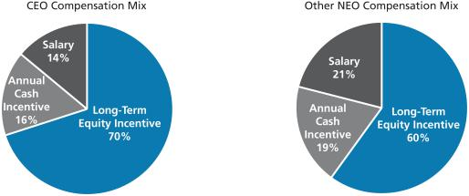

2018 PROXY STATEMENT | 35

Table of Contents

Compensation Discussion and Analysis ◆ Pay Decisions and Compensation Governance Practices

Pay Decisions and Compensation Governance Practices

WHAT WE DO

Pay for performance. Tie pay to performance by ensuring that a significant portion of NEO compensation is performance-based and at-risk.

Median compensation targets. We generally aim to align all compensation elements for our executives with the median of our peer group companies.

PSUs are a substantial portion of LTI. PSU grants, tied to our achievement of specified performance measures, comprised approximately 55% of the total value of annual long-term incentive grants made to our NEOs in 2017. Performance-based RSUs comprised the remaining 45%.

Independent compensation consultant. The Compensation Committee uses an independent compensation consultant.
Robust share ownership requirements. We have robust stock ownership guidelines of 7 times base salary for the CEO, 5 times base salary for our other NEOs, and 5 times annual retainer for Directors. We also have an equity retention requirement of 50% of net shares paid as incentive compensation until ownership guidelines are met.

Clawback policy. We have a compensation recovery (clawback) policy that requires officers to forfeit certain cash-based incentive compensation and/or equity-based incentive compensation if the company restates its financial statements due to the officer’s misconduct.

Regular engagement with shareholders. We engage with shareholders to hear their views on compensation and other issues.

WHAT WE DON’T DO

No employment contracts. None of our NEOs or other executive officers have employment contracts that guarantee continued employment.

No dividends on unvested awards. Our 2017 RSU and PSU awards require three years to fully vest and dividends paid on shares of common stock of Martin Marietta during the vesting period are only paid to award holders if and when an award vests.

No pledging of shares. Our directors and executive officers are not permitted to pledge Martin Marietta shares as collateral for loans or any other purpose.

No hedging. We prohibit directors and executive officers from engaging in short sales of Martin Marietta stock or similar transactions intended to hedge or offset the market value of Martin Marietta stock owned by them.

Minimal executive perquisites. We do not provide NEOs country club reimbursements, personal use of the Company aircraft unrelated to business travel, or other excessive perks.

- 2018 PROXY STATEMENT

Table of Contents

2017 Chairman, President and CEO Compensation ◆ Compensation Discussion and Analysis

A number of key 2017 compensation-related decisions resulted from these significant events and accomplishments, which are discussed more fully below. The Committee believes that our executive compensation program continues to reflect a strong pay-for-performance philosophy and is well-aligned with the interests of shareholders

2017 Chairman, President and CEO Compensation

Base Salary. For 2017, Mr. Nye’s base salary was set at $1,045,000 (effective March 1, 2017).

2017 Annual Incentive. Mr. Nye’s target annual incentive amount for

2017 was $1,143,083 (110% of salary received for the year).

2017-2019 Long-Term Incentives. In 2017, Mr. Nye was granted an LTI award of approximately $4.6 million, which was allocated 55% or $2.53 million in PSUs and 45% or $2.07 million in performance-based RSUs. RSUs will pro rata vest over three years if the performance measure is satisfied, while the vesting of PSUs will be based upon our results relative to the three-year performance goals that were established in the beginning of 2017.

Benefit and Retirement Plans. Mr. Nye is eligible for benefit and retirement programs similar to other employees. None of our executives received additional years of service credits or other forms of formula enhancements under our benefit or retirement plans. Our pension formula is based on years of service and pension eligible compensation, which is a similar formula offered by other companies with defined benefit plans. Mr. Nye is not eligible for retiree health benefits.

Perquisites. Mr. Nye received limited executive perquisites. We provide company-leased cars to the NEOs for their use. Additionally, we pay for the insurance, maintenance and fuel for such vehicles. Executives reimburse our Company for a portion of the expense associated with personal use of these vehicles. In addition, the value of personal mileage is charged to the NEO as imputed income. We make the company-owned aircraft available to the CEO and other senior executives for business travel. We do not provide other perquisites, such as country club memberships, to the NEOs. The Committee reviews our policies and determines whether and to what extent perquisites should be modified or continued.

2017 Target Pay Mix. We believe that, to the maximum extent possible, the compensation opportunities of our CEO should be variable and the variable elements of the compensation package should tie to the Company’s long-term success and the achievement of sustainable long-term total return to our shareholders. As shown in the chart below, a significant portion of our CEO’s target compensation is variable and in the form of LTI, and more than half of total target pay is in the form of equity incentives.

CEO Target Opportunity Mix*
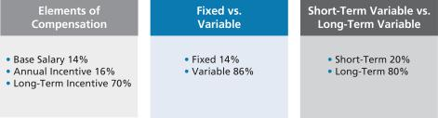

- We consider base salary and annual incentives as short-term pay and PSUs and RSUs as long-term pay. We do not include retirement or other compensation components in the chart.

2018 PROXY STATEMENT | 37

Table of Contents

Compensation Discussion and Analysis ◆ Our Compensation Strategy

Our Compensation Strategy

Our executive compensation program is specifically designed to:

- Attract and retain top-caliber, knowledgeable and experienced senior executives.

- Motivate our executives to achieve superior results and build long-term value for shareholders.

- Reward performance that meets or exceeds established goals consistent with our strategic aims and upholding integrity.

- Align individual objectives with the Company’s objectives without fostering excessive or inappropriate risk-taking.

- Encourage an ownership mentality and align the long-term financial interests of our executives with those of our shareholders.

- Be market competitive with our peers.

- Provide reward systems that are measurable and easily understood by our managers and shareholders.

- Reinforce the succession planning process undertaken on a company-wide basis by building bench strength and by identifying and retaining senior leadership, both capable of achieving the Company’s growth, profitability and other objectives.

In 2017, our executive compensation structure consisted of three primary components: base salary, annual incentives, and long-term incentives. Within the long-term incentive component, we utilized a balanced portfolio of PSUs and performance-based RSUs.
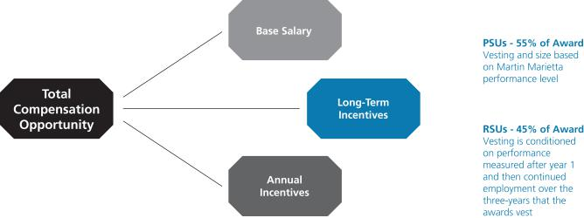

Martin Marietta has a long-standing commitment to pay for performance. We fulfill that aim by providing a majority of compensation through programs in which the amounts

- 2018 PROXY STATEMENT

ultimately received vary in order to best reflect our financial, operational and strategic performance.

Table of Contents

 |  | Our Compensation Strategy ◆ Compensation Discussion and Analysis
The following table summarizes the key elements of our 2017 executive compensation program:
 | Element | Primary Purpose | Key Characteristics
 | Base Salary | To compensate the executive fairly and competitively for | Fixed compensation that is reviewed annually.
 |  | the responsibility level of the position.
 | Annual Performance- | To motivate and reward organizational and individual | Variable compensation component; based on
 | Based Incentive Awards | achievement of annual strategic, financial and individual | pre-established Company and individual performance
 |  | objectives. | goals.
 | Incentive Stock Plan | To ensure executives invest certain levels of their annual | To promote sustainable performance results, a portion of
 |  | incentive compensation into Martin Marietta stock units. | each NEO’s annual cash incentive compensation (35%
 |  |  | for the CEO and 20% for the other NEOs) is automatically
 |  |  | converted into common stock units. NEOs may elect to
 |  |  | convert up to 50% of their annual cash incentive
 |  |  | compensation into common stock units.
 | Long-Term | To align executives with shareholder interests, to | Variable compensation component. Reviewed and
 | Incentive Awards | reinforce long-term value creation, and to provide a | granted annually. New program in 2017 splits long-term
 |  | balanced portfolio of long-term incentive opportunities. | incentives for NEOs at 55% PSUs and 45% RSUs.
 | Performance Share | To motivate executives by tying incentives to our multi- | Grants based on three-year, EBITDA and Sales Growth,
 | Units (PSUs) | year financial goals and relative TSR reinforcing the link | with a modifier based on TSR performance relative to
 |  | between our executive officers and our shareholders. | peers.
 | Restricted Stock Units (RSUs) | To motivate the appropriate behaviors delivering superior | Stock price growth. Awards are subject to achievement of
 |  | long-term total shareholder return. Also promotes a base- | one-year EBITDA.
 |  | level of executive retention.
 | Health/Welfare Plan and | To provide competitive benefits promoting employee | Fixed compensation component.
 | Retirement Benefits | health and productivity and support financial security.
 | Perquisites and Other Benefits | To provide limited business-related benefits, where | Fixed compensation component.
 |  | appropriate, and to assist in attracting and retaining
 |  | executive officers.
 | Change-in-Control Protection | To provide continuity of management and bridge future | Fixed compensation component; only paid in the event
 |  | employment if terminated following a change-in-control. | the executive’s employment is terminated other than “for
 |  |  | cause” or for “good reason”, in either case, in connection
 |  |  | with a change in control

Ongoing Corporate Governance Policies

We endeavor to maintain good corporate governance standards relating to our executive compensation policies and practices, including the following that were in effect during 2017 that directly impacted compensation:

- The Committee is comprised solely of independent Directors who regularly schedule and meet in executive sessions without management present.

- The Committee’s independent compensation consultant is retained directly by the Committee.

2018 PROXY STATEMENT | 39

Table of Contents

Compensation Discussion and Analysis ◆ Ongoing Corporate Governance Policies

- The Committee conducts an annual review and approval of our compensation strategy, including a review of our compensation-related risk profile, to ensure that our compensation-related risks are not reasonably likely to have a material adverse effect on the Company.

- We pay for performance, with approximately 86% of our CEO’s total target pay opportunity being performance-based “at-risk” compensation.

- We cap PSU payments at target if three-year TSR is negative, regardless of our ranking.

- We limit perquisites and other benefits.

Compensation Decision Process

Role of Management and the Committee

The Committee is responsible for carrying out the philosophy and objectives of the Board of Directors related to executive compensation in addition to its responsibilities of overseeing the development and succession of executive management of Martin Marietta. The Committee has the authority to determine compensation and benefits for Martin Marietta’s executive officers. The Committee members are each non-employee, independent Board members pursuant to the New York Stock Exchange rules, and the Committee operates pursuant to a written charter, a copy of which can be viewed on Martin Marietta’s website at www.martinmarietta.com.

The performance of the CEO and each other executive officer is reviewed regularly by the Committee. Based on this review, the Committee sets compensation for all executive officers. Compensation decisions with respect to the executive officers other than the CEO are based in part on recommendations by the CEO, with input from the Senior Vice President– Human Resources, with respect to salary adjustments and annual cash and equity awards. The Committee can accept, reject or modify any recommended adjustments or awards to executive officers. For the CEO, the Committee sets the levels of annual adjustments and awards based on the criteria it deems to be appropriate under the circumstances with input from the independent compensation consultant. There are no employment agreements between Martin Marietta and any executive officer of Martin Marietta, including the CEO.

Role of the Independent Compensation Consultant

The Committee retained an independent compensation consultant in accordance with the Committee’s charter. The consultant reports directly to the Committee. The Committee retains sole authority to hire or terminate the consultant, approve its compensation, determine the nature and scope of services, and evaluate performance. A representative of the compensation consultant attends Committee meetings, either in person or by telephone, as requested, and communicates with the Committee Chair between meetings. The Committee makes all final decisions.

- 2018 PROXY STATEMENT

The compensation consultant’s specific compensation consultation roles include, but are not limited to, the following:
- Advise the Committee on executive compensation trends and regulatory developments.

- Provide a total compensation assessment for executives compared to peer companies and recommendations for executive pay.

- Summarize and report to the Committee on trends, regulatory developments and other factors affecting executive officer compensation, as well as any other areas of concern or risk.

- Serve as a resource to the Committee Chair for meeting agendas and supporting materials in advance of each meeting.

- Review and comment on proxy disclosure items, including this CD&A.

- Advise the Committee on management’s pay recommendations.

Based on these activities, the compensation consultant makes recommendations regarding, and proposes adjustments to, our executive officer compensation program as it deems appropriate. While the consultant works closely with the appropriate members of our executive management team in performing these activities, the consultant reports directly to and is retained by the Committee on all executive compensation matters, and speaks to the Committee and the Chair of the Committee on a regular basis without management present. The compensation consultant periodically attends Committee meetings.

Mercer was paid $150,758 for its compensation advisory services in 2017. During 2017, Mercer and its Marsh & McLennan affiliates were also retained by management to provide services unrelated to executive compensation, including property/casualty insurance brokerage services and administration of a risk management information system. The aggregate fees paid for those other services for 2017 were $312,943. The Committee and the Board did not review or approve the other services provided to us by Mercer and its Marsh & McLennan affiliates as those services are approved by management in the normal course of business.

We have been advised by Mercer that the reporting relationship and compensation of the individual Mercer consultants who perform executive compensation consulting services for our Committee is separate from, and is not determined by reference to, Mercer’s or Marsh & McLennan’s other lines of business or their other work for us. The Committee considered these separate reporting relationships and compensation structures, the provision of other services to the Company by Mercer and Marsh & McLennan, the absence of any business or personal relationship between our officers and Directors and the specific

Table of Contents

Compensation Decision Process ◆ Compensation Discussion and Analysis

Mercer consultants advising the Company (other than the consulting relationship with the Committee), Mercer’s Global Business Standards intended to address potential conflict of interests with respect to their executive compensation consulting services, and the other factors required to be considered by applicable SEC and stock exchange rules, in approving the Committee’s engagement of Mercer for fiscal 2017. Based on this review, the Committee did not identify that Mercer had any conflicts of interest that would prevent Mercer from independently advising the Committee.

The Committee has considered and assessed all relevant factors, including but not limited to those set forth in Rule 10C-1(b)(4)(i) through

- under the Securities Exchange Act of 1934, that could give rise to a potential conflict of interest with respect to the individual independent compensation consultants that provided services in 2017. Based on this review, there are no conflicts of interest raised by the work performed by Mercer.

Role of Peer Companies and Competitive Market Data

The Committee considered peer groups for two elements of the executive compensation program in 2017: the Compensation Peer Group, consisting of 17 companies that the Committee believes compete with us for talent, and the TSR Peer Group,

consisting of a group of 25 companies that the Committee believes compete with us for investors and is used to assess the achievement of TSR measured for the PSU awards.

This section only describes the Compensation Peer Group. The TSR peer group is discussed below in the descriptions of the other elements of our compensation program.

Annually, the Committee studies competitive total compensation market data provided by its independent compensation consultant. To assess competitive pay levels, the Committee reviews and approves the composition of our Compensation Peer Group. The following peer group criteria are considered:

- Company size (approximately 0.4 times to 2.5 times Martin Marietta’s annual revenues);

- Companies in similar industries based on GICS code classifications;

- Direct competitors for business and management talent;

- Companies covered by the investment analysts that track Martin Marietta; and

- Companies that include Martin Marietta in their compensation peer group.

The following companies comprised our Compensation Peer Group for 2017 base salary and long-term incentive pay decisions:

Albermarle Corporation | Granite Construction Inc. | Owens Corning | Vulcan Materials Company
Armstrong World Industries | Louisiana-Pacific Corporation | Peabody Energy Corp. | W. R. Grace & Co.
Compass Minerals International | Masco Corporation | USG Corp. | Westlake Chemical Corporation
CONSOL Energy, Inc. | Nucor Corporation | The Valspar Corporation | Weyerhaeuser Company
FMC Corporation

The Committee studies competitive total compensation data from various sources, including proxy statements of the peer group. Since proxy statements do not provide precise comparisons by position to our executive officers, the Committee also in 2017 took into consideration published independent compensation surveys of companies with revenue in the range of $3.0 billion to $4.0 billion as to median levels for each executive officer as well as private compensation survey data. Where available, size-adjusted market values were developed using regression analysis. This statistical technique accounts for revenue size differences within the peer group and develops an estimated market value for a similar-size company as Martin Marietta. The size-adjusted 50th percentile for total compensation is a key reference point for the Committee. On average, the target for our NEO total compensation opportunities is competitively positioned within a reasonable range of the size-adjusted 50th percentile.

Although the Committee uses the size-adjusted 50th percentile as its starting point in setting compensation levels, the compensation packages for executive officers may vary materially from it based on several factors. Market data, position, tenure, individual and organization performance, retention needs and internal pay equity have been the primary

factors considered in decisions to increase or decrease compensation opportunities. Specifically, the Committee typically sets compensation levels below the size-adjusted 50th percentile for executive officers with relatively less relevant experience, less responsibility, less tenure with Martin Marietta and/or lower performance ratings. Conversely, if an officer consistently receives favorable performance ratings, accumulates years of service and expertise in relevant areas, has more responsibility and/or has significant other achievements, his or her compensation will typically be above the size-adjusted 50th percentile.

Determination of CEO Compensation

At each February Committee meeting, without the CEO present, the Committee reviews and evaluates CEO performance, and determines achievement levels for the prior year. The Committee also reviews competitive compensation data. At this meeting, the Committee discusses salary and annual incentive pay recommendations for the CEO, as well as an evaluation of the CEO’s performance, with the independent members of the Board. The Committee also reviews and discusses an award of RSUs and the target PSU grant size for the CEO at that meeting, which is also discussed with the independent members of the Board.

2018 PROXY STATEMENT | 41

Table of Contents

Compensation Discussion and Analysis ◆ Compensation Program Risk Assessment

Compensation Program Risk Assessment

We perform a thorough annual review of our compensation program structure and all compensation programs, which are also reviewed in detail with the Committee. We believe our executive pay is reasonable and provides appropriate incentives to our executives to achieve our financial and strategic goals without encouraging them to take excessive risks in their business decisions. Our compensation structure does not include features that are reasonably likely to have a material adverse effect on the Company. Compensation program features that mitigate against risks include the following:

- Our annual incentive compensation plan does not provide payment for poor individual or corporate performance, regardless of whether the failure to achieve target was outside management’s control.

- There are caps on the long-term equity awards, even if the required performance-related criteria are exceeded.

- 2018 PROXY STATEMENT

- A majority of the NEOs’ compensation is long-term, with equity grants vesting over three to five years, depending on the award.

- Our compensation is not based on highly-leveraged short-term incentives that encourage high risk investments at the expense of long-term value.

- Long-term compensation to executive officers is based on specific performance measures that balance long-term growth and returns.

- The Committee uses benchmarking data and the advice of its independent compensation consultant to keep compensation in line with typical market practices and appropriate to Martin Marietta’s needs.

- We use a balanced portfolio of long-term incentive programs.

- The Committee’s governance process requires review and approval of all compensation over a certain amount.

Table of Contents

Considerations Regarding 2017 Compensation ◆ Compensation Discussion and Analysis

Considerations Regarding 2017 Compensation

The following chart summarizes the target compensation in our 2017 executive compensation program:

Pay Component | Summary
Base Salary | • At the February 2017 meeting, the Committee reviewed competitive market data and individual performance
 | evaluations.

- The Committee approved base salary increases as follows:

  - Mr. Nye: 3.5% increase, based on his excellent achievements as CEO since 2010 in an economic environment that resulted in muted shipment volume recovery, and specifically his performance in 2017.
  - Other NEOs: approximately 3.0% to 3.3% increases, based on a review of competitive market data and individual performance evaluations.

Target Annual | • NEO target bonuses (as a percentage of base earnings) did not change in 2017 other than Ms. Bar, whose target
Cash Incentives | increased in connection with a promotion in November 2016.
 | • Our shareholders in 2016 approved a new Cash Incentive Plan that fixed the bonus amounts based on certain
 | objective criteria and allowed the Committee to reduce the award based on enumerated factors in the plan. The
 | Committee implemented the Executive Cash Incentive Plan by reference to amounts payable under our Executive
 | Incentive Plan.
 | • Our CEO is required to invest a minimum of 35% of his annual cash bonus into stock units, which are held generally
 | for a period of three years.
 | • Other NEOs are required to invest a minimum of 20% of their annual cash bonus into stock units, which are held
 | generally for a period of three years. Mr. Nickolas and Ms. Lloyd did not participate in this program in 2017.
Long-Term | • Our LTI structure consisted of PSUs and performance-based RSUs.
Incentives | • The LTI awards for NEOs in 2017 were weighted 55% PSUs and 45% RSUs. The LTI grant size is based on
 | competitive market data.
 | • PSU awards in 2017 are earned based on achievement of performance levels, with 33% based on three-year
 | cumulative Sales Growth and 67% based on three-year cumulative EBITDA performance. The Company’s relative
 | TSR ranking compared to major U.S. companies in similar industries provides a modifier to the award up to 20%.
 | • RSU awards to NEOs in 2017 are subject to the achievement of one-year EBITDA performance.
Total Compensation | The Committee uses the size-adjusted 50th percentile of our Compensation Peer Group as a guidepost in setting the
 | target for the total compensation opportunity, but considers a variety of factors in setting compensation. Overall, the
 | Committee believes targeted compensation should be more heavily weighted on variable “at-risk” compensation and
 | longer-term components.

The Committee approved the following actual compensation items in 2017.

Base Salary

The Committee determines base salaries for the NEOs and other executives based on a number of factors, including but not limited to, market data, individual performance, the Company’s performance, and management recommendations (except for the CEO). At the February 2017 meeting (other than for Mr. Nickolas), based on a review of competitive market data and management’s recommendations based on individual performance (except for the CEO), and the Committee’s assessment of Mr. Nye’s performance, the Committee approved the following increases.

 |  |  | 2017 | Effective |  | 2016
 | NEO | Base Salary |  | Date* | Base Salary
 | C. Howard Nye | $ | 1,045,000 | 3/1/17 | $ | 1,010,000
 | James A. J. Nickolas | $ | 470,000 | 8/21/17 |  | —
 | Roselyn R. Bar | $ | 514,200 | 3/1/17 | $ | 497,300
 | Donald A. McCunniff | $ | 384,300 | 3/1/17 | $ | 372,000
 | Daniel L. Grant | $ | 362,300 | 3/1/17 | $ | 351,100
* NEO base salaries were increased on March 1, 2017. Mr. Nickolas commenced employment with the Company in August 2017.
 |  |  |  | 2018 PROXY STATEMENT |  |  | 43

Table of Contents

Compensation Discussion and Analysis ◆ Considerations Regarding 2017 Compensation

Annual Cash Incentive: Executive Cash Incentive Plan

NEOs and other executives are eligible to earn annual incentive compensation under our Executive Cash Incentive Plan based on the achievement of various performance metrics. Individual NEO targets (as a percent of base salary) are approved by the Committee at the beginning of the year based on a review of competitive market data and internal pay equity.

The Committee awards actual annual cash incentive compensation based on achievement against corporate performance objectives and individualized targeted goals. This furthers Martin Marietta’s compensation philosophy to encourage superior performance and reward the achievement of Martin Marietta’s annual goals. In 2017, all of the executive officers participated in the plan. The annual incentive compensation level for 2017 for the NEOs other than Mr. Nye was 100% to 155% of target. The annual incentive compensation level for 2017 for Mr. Nye was 175%.

In determining the incentive payments, the Committee first reviews the achievements of Martin Marietta for the past year as compared to its targeted goals set at the end of the previous
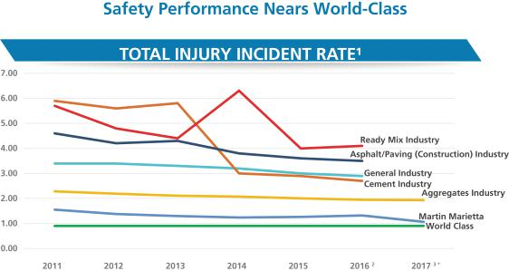

year. The maximum incentive compensation is fixed based on objective criteria as described in the Executive Cash Incentive Plan, and the Committee then determines an appropriate award payout beneath the maximum amount after considering the following:

- A detailed assessment of Martin Marietta’s overall financial performance and each segment’s financial performance.

- Shareholder returns, including the consistent delivery of value to Martin Marietta’s shareholders.

- Our safety performance, which continues to be industry leading even though we increased hourly headcount and trained new employees hired through our acquisitions made during the year.

- Outstanding environmental and regulatory compliance results.

- Continuing achievement of excellent management of working capital.

- The successful organic and inorganic growth of Martin Marietta.

¹ Total Injury Incident Rate per 200,000 hours worked

- General Industry, Asphalt Paving, Cement and Ready Mix reported via BLS through 2016

³ Aggregates Industry reported per MSHA website - Stone, Sand & Gravel * Martin Marietta Year End 2017 performance

These safety metrics are ones that we are proud of:

- More than 90% of our 400+ facilities had no reportable incidents

- 19 sites reached 500,000 hours without any incidents and 11 surpassed one million hours of incident-free work

- 64 sites surpassed 500,000 hours without a lost time incident and 11 exceeded the million-hour mark in that category

- 2018 PROXY STATEMENT

Table of Contents

Considerations Regarding 2017 Compensation ◆ Compensation Discussion and Analysis

The Committee also considered our efforts to tell our sustainability story, which is part of our core strategy. We completed and issued the Company’s third annual sustainability report. “Building. Caring. Growing.” represents our latest publication sharing Martin Marietta’s sustainability story – in 2017 from the perspective of our employees. From our world-class safety programs and performance, to our targeted and intentional support of housing, hunger reduction and healthcare, to environmental programs that ensure operational excellence, we have a solid foundation and an exciting opportunity to build upon.

The Committee also reviewed and considered management’s furtherance of its strategic plan, including a primary objective of value-enhancing growth, and the adoption of Mission, Vision, and Values of the Company to unify management with the same objectives.

The Committee then conducted a comparative review of the individual contributions of each of the executive officers towards achieving these goals. The Committee also considered qualitative measures of performance for the executive officers, such as adherence to and implementation of Martin Marietta’s Code of Ethical Business Conduct, safety, customer satisfaction, and product quality.

Key individual performance criteria are established for each NEO, which are intended to drive strategic and support operational results in the Company and the functional groups. These performance metrics are established at the beginning of each plan year and are based upon Martin Marietta’s Long-Range Operating Plan, which is set at the end of the previous year. For executives in corporate staff positions, 50% of the determination is made with respect to Martin Marietta’s performance and 50% is based on the individual’s performance

against established objectives. Similar to the Committee’s assessment of financial goals, the Committee’s assessment of individual performance goals generally excludes certain non-recurring or extraordinary items. We do not disclose specific individual performance goals due to the potential for competitive harm. Our targeted individual goals are “stretch but reasonable.”

The individualized target goals are tailored for each executive, his or her specific areas of responsibility and the then-current and longer-term goals of Martin Marietta. In addition, achievement of the goals typically is in part dependent on conditions outside the control of each of the named executive officers. For example, our business may be adversely affected by hurricanes or other weather-related conditions, which could have the result of impeding the achievement of certain performance-based goals.

Although there is substantial uncertainty with respect to achieving the target levels at the time the goals are set and communicated, our NEOs have a reasonable expectation of receiving a cash incentive award at a level that is at least near their target level.

2018 PROXY STATEMENT | 45

Table of Contents

Compensation Discussion and Analysis ◆ Considerations Regarding 2017 Compensation

2017 Actual Incentive Cash Earned

The table below summarizes the targets for 2017 and annual incentive award earned by each NEO:

 | Target Annual | 2017 Target |  | 2017 Actual
 | Incentive Bonus |  | Annual |  | Annual
NEO | (% of Salary) | Incentive* |  |  | Incentive
C. Howard Nye | 110% | $ | 1,143,083 | $ | 2,000,000
James A. J. Nickolas | 75% | $ | 129,702 | $ | 162,127
Roselyn R. Bar | 80% | $ | 409,107 | $ | 634,115
Donald A. McCunniff | 70% | $ | 267,575 | $ | 401,363
Daniel L. Grant | 70% | $ | 252,303 | $ | 340,609

* Based on actual base earnings in 2017.

Annual Incentive Feature: Performance-Based Stock Purchase Plan

The Incentive Stock Plan provides an executive the opportunity to invest a portion of his or her annual incentive compensation in Martin Marietta stock. There are both voluntary and mandatory deferrals under the plan.

The voluntary election allows executives to invest up to 50% of their annual cash incentive compensation to purchase units that are subsequently converted into shares of common stock pursuant to the terms of the plan at a 20% discount from the market price of Martin Marietta’s common stock on the date the amount of the incentive compensation is determined. The discount is used to account for the risk of trading current cash compensation for “at-risk” shares which may decline in value.

The mandatory portion requires executives to invest a minimum of 20% of their cash incentive compensation towards the crediting of units under the plan (other than Mr. Nickolas, who was not hired until after the deferral deadline under the Incentive Stock Plan, and Ms. Lloyd, who retired as of December 31, 2017). The CEO is required to invest a minimum of 35% of his cash incentive compensation towards the crediting of such units.

The units generally vest in three years from the date of the award and are distributed in shares of common stock. If an executive officer voluntarily terminates employment before the units vest, the stock units are forfeited and the executive officer receives a cash payment equal to the lesser of the cash that was invested or the fair value of the share units on the day of termination.

The mandatory contribution requirement directly links a portion of executive officer compensation to shareholder returns. The vesting aspect, combined with the yearly stock purchase requirement, creates continuous overlapping three-year cycles, which encourage executive officer retention and provide a continuous link of a significant portion of executive officer compensation with shareholder return over the long term to reward these executive officers in line with our shareholders when our stock price increases.

Long-Term Incentive Compensation

Our Long Term Incentive (LTI) plan’s design reflects the objectives of our compensation program and is in-line with current market approaches, based on the advice of the Committee’s independent compensation consultant. Our plan design objectives are a simplified LTI program, that is transparent and enhances the line of sight between our performance and compensation.

The award in 2017 for all NEOs other than Mr. Nickolas was based on a fixed percentage of base salary with some variation for position and grade, which amount was converted into common stock units based on the average Martin Marietta stock price for the 20-day period ending on March 28, 2017, the day the Martin Marietta Board of Directors confirmed the award, or $212.439. This award value was then divided into PSUs and performance-based RSUs, with 55% of the total award for NEOs consisting of target level for the PSUs and 45% of the total award for NEOs consisting of RSUs. The Committee believes that the incentive mix (PSUs and RSUs) constitutes a simplified pay process and streamlined plan, which more fully reflects the performance of the Company and is better aligned with each manager’s role within Martin Marietta. The RSUs granted to Mr. Nickolas were awarded on August 21, 2017 in connection with his hiring and vest over one-, two- and five-year periods subject to his continued employment. See a further description under Outstanding Equity Awards at Fiscal Year-End and corresponding footnotes on pages 55 to 56.

One of our compensation objectives is to align the potential rewards to senior management with increases in shareholder value. In that regard, the PSUs give the recipient the opportunity to receive Martin Marietta common stock if specific performance goals are achieved, consisting of:

- Earnings before Interest, Income Taxes, Depreciation and Amortization (EBITDA), measuring profitability and comprising 67% of the total award, and

- 2018 PROXY STATEMENT

Table of Contents

- Sales Growth, measuring growth and comprising 33% of the awards.

- In addition, the relative Total Shareholder Return (rTSR) will act as a modifier for the performance such that Martin Marietta’s performance will be measured against the S&P 500, and will modify the total award by a range of -20% to +20% depending on the rTSR.

EBITDA and Sales Growth are two of the drivers of our performance and metrics of significance to our investors. The total payout opportunity for PSUs in 2017 is 0% to 240%: 50% of target if the threshold level is satisfied, 100% of target if the target level is satisfied, and 200% of target if the maximum level is satisfied. The rTSR modifier over the three-year measurement period is then applied to the final award to adjust it up or down up to 20%. The threshold must be satisfied to receive PSUs for each performance measure. If the threshold is not met, none of the PSUs will vest. Performance in each metric is measured independently, so PSUs can be earned as long as the threshold is satisfied for at least one level. The “Target” level is generally viewed as achievable. The “Maximum” level is a stretch that is attainable if we outperform in the area measured.

The performance will be measured in February 2020 for the three-year period beginning January 2017 through December 2019 to determine

- the three-year cumulative EBITDA for Martin Marietta against the target identified in the PSU Award Agreement, and (2) the three-year cumulative Sales Growth against the target identified in the PSU Award Agreement. This amount will be modified by the rTSR for the three-year period as against the peer group of the S&P 500, as set forth in the PSU Award Agreement. The Committee in its discretion may adjust

Considerations Regarding 2017 Compensation ◆ Compensation Discussion and Analysis

the final award values only downwards, either collectively or on an individual basis, in recognition of factors that are unusual or nonrecurring.

A change in the 2017 awards is that participants can “bank” PSUs each year during the three-year measurement period if the Company’s EBITDA and/or Sales Growth for that year equals or exceeds a third of the three-year cumulative target. This gives the participant the ability to earn some level of payout for interim achievements rather than be potentially faced with no award for the entire three-year period. The banked PSUs will vest but will not be distributed until the end of the three-year measurement period, when the cumulative performance is determined and the amount of the rTSR modifier is applied.

The PSUs will convert to unrestricted common stock and be paid conditioned upon and to the extent that the performance goals have been met, which will be determined in February 2020.

These awards are also generally subject to continued employment through the date the PSUs vest. The actual financial performance targets and achievement against those targets will be disclosed at the end of the three-year performance period.

RSUs vest in three equal portions, each on the anniversary of the award date (March 28, 2017) over a period of three years, subject to satisfaction of the performance measure and generally to continued employment through each one of those anniversaries. Once the restricted period ends (each anniversary for one third of the total RSU award), the recipient will be issued unrestricted shares of common stock (minus applicable taxes). The 2017 RSUs awarded to executive officers are also subject to a performance measure for the first year. If the performance measure is satisfied, then the RSUs will continue to vest. If the performance measure is not satisfied, then the RSUs will be forfeited.

2018 PROXY STATEMENT | 47

Table of Contents

Compensation Discussion and Analysis ◆ Considerations Regarding 2017 Compensation

The following table provides a summary of the long-term incentives that each of the NEOs received in 2017.

 | RSUs
 | (3 year annual | PSUs – Target
 | installment vesting | (3 year cliff vesting
 | subject to achievement | subject to achievement
 | of performance | of performance
 | measure) | measures)
NEO | (# of shares) | (# of shares)
C. Howard Nye | 9,755 | 11,355
James A. J. Nickolas | 6,636* | —
Roselyn R. Bar | 2,807 | 3,267
Donald A. McCunniff | 2,122 | 2,470
Daniel L. Grant | 1,898 | 2,210
- The RSUs granted to Mr. Nickolas were awarded on August 21, 2017 in connection with his hiring and vest over one-, two-, and five-year periods subject to his continued employment.

2017 Long-Term Incentive Vesting of Prior Grants

PSUs that were granted in 2015 vested on December 31, 2017, because the applicable performance criteria were satisfied. These PSUs were certified and paid out in February 2018 at 94.75% of the amount of the original grant made in 2015 based on: (1) 3-year average Return on Sales (ROS) of 18.4% as against a target of 19.5%; (2) 3-year cumulative EBITDA of $2.91 billion as against a target of $3.42 billion, and (3) TSR performance of our common stock relative to the TSR Peer Group of 93rd percentile as against a target of the 50th percentile.

 | Payment Calculation for PSUs Granted in 2015
 | Certified on February 22, 2018
 |  | Target
 |  | Units Granted | Percentage | Units
NEO |  | in 2015 | Payable | Payable
C. Howard Nye |  | 3,612 | 95% | 3,423
James A.J. Nickolas* |  | — | — | —
Roselyn R. Bar |  | 1,620 | 95% | 1,535
Donald A. McCunniff |  | 1,328 | 95% | 1,259
Daniel L. Grant |  | 1,253 | 95% | 1,188

* Mr. Nickolas commenced employment with the Company in August 2017.

Stock-Based Awards Generally

The stock purchase awards under our Incentive Stock Plan and the PSUs and RSUs awarded under our LTI program, each as described above, were granted in 2017 at the Committee’s regularly scheduled meetings in February (other than for Mr. Nickolas) following the availability of financial results for the prior year. Newly hired executive officers, such as Mr. Nickolas, may, subject to the discretion of the Committee, receive an award of RSUs as of the date of their hire. The number of RSUs is based on the average New York Stock Exchange closing price of Martin Marietta’s common stock on the date of the grant. The Committee’s schedule is determined several months in advance and the proximity of any awards to earnings announcements or other market events is coincidental.

All of Martin Marietta’s active equity-based award plans have been approved by shareholders.

Stock Ownership Guidelines

In 2018, the Board adopted robust formal Stock Ownership Guidelines for executive officers and members of the Board of Directors. These require the following ownership levels as a multiple of base salary or annual cash retainer, as applicable:

- Chairman, President and CEO – 7 times

- Other Executive Officers – 5 times

- Other Members of the Board of Directors – 5 times

- 2018 PROXY STATEMENT

Table of Contents

Stock Ownership Guidelines ◆ Compensation Discussion and Analysis

The following types of equity instruments count in determining stock ownership for purposes of these guidelines:

- Shares owned separately by the covered person or owned either jointly with, or separately by, his or her immediate family members residing in the same household;

- Shares held in trust for the benefit of the covered person or his or her immediate family members;

- Shares purchased on the open market;

- Shares obtained through stock option exercise (and not thereafter sold);

- Vested shares of RSUs;

- Unvested RSUs;

- Shares held pursuant to deferred stock unit plans for Directors or executive officers; and

- Shares acquired under the Company’s Savings and Investment Plan and similar plans or arrangements

Covered persons who are employees are expected to meet these requirements within five years of the later of becoming a covered person and the date of adoption of the policy. Until such time as such covered person has met these requirements, he or she is expected to retain 50% of any shares of common stock received upon vesting of RSUs, deferred stock unit awards, PSUs, the exercise of stock options, and other similar equity awards, net of amounts withheld to pay taxes and the exercise price of stock options until the applicable Guideline level is met.

Stock ownership does not include vested or unvested stock options, unvested PSUs and vested or unvested stock appreciation rights.

All of the Company’s executive officers and members of the Board of Directors are in compliance with the Stock Ownership Guidelines.

We also require a holding period of annual cash incentive compensation converted to Martin Marietta shares, with vesting generally in three years. There is no additional holding period beyond the vesting date, however a significant portion of the executive compensation program is in the form of equity awards that vest over three years generally.

Our CEO must invest a minimum of 35% of each year’s cash bonus award in common stock units of Martin Marietta. Executive officers must invest a minimum of 20% of their annual bonus. Stock is purchased at a 20% discount to the price on the grant date to account for the additional risk of taking a common

stock unit payment in lieu of a risk-free cash payment. In 2017, Mr. Nye deferred the maximum of 50% of his cash bonus in common stock units.

Perquisites

Martin Marietta provides executives with perquisites that the Committee believes are appropriate, reasonable and consistent with its overall compensation program to better enable Martin Marietta to attract and retain superior employees for key positions. The Committee periodically reviews the types and levels of perquisites provided to the NEOs. The value of each of the NEO’s perquisites is included in the annual compensation set forth in the Summary Compensation Table.

In 2017, we provided personal use of leased automobiles to NEOs. We pay for the insurance, maintenance and fuel for such vehicles, and the value of personal mileage and use is charged to the NEO as imputed income. We make the company-owned aircraft available to the CEO and other senior executives for business travel. When the NEO is accompanied by his or her spouse on such trips, that use is included in the NEO’s taxable income for the year. Martin Marietta also provides to executive officers and other employees certain other fringe benefits such as tuition reimbursement, airline club dues, professional society dues, and food and recreational fees incidental to official company functions. We do not provide other perquisites, such as country club memberships or financial planning services, to the NEOs.

Retirement and Other Benefits

In order to maintain market competitive levels of compensation, we provide retirement and other benefits to the NEOs and other employees, including:

- Medical and dental benefits

- Life, accidental death and disability insurance

- Pension and savings plans

2018 PROXY STATEMENT | 49

Table of Contents

Compensation Discussion and Analysis ◆ Retirement and Other Benefits

The benefits under the defined benefit pension plan are more valuable for employees who remain with Martin Marietta for longer periods, thereby furthering our objectives of retaining individuals with more expertise in relevant areas and who can also participate in management development for purposes of executive succession planning. All of Martin Marietta’s salaried employees in the United States are eligible to participate in our retirement and other plans, and the NEOs participate in the plans on the same terms as Martin Marietta’s other salaried employees.

Additional information regarding these benefits is under the heading Pension Benefits Table on page 58 and the accompanying narrative.

Potential Payments upon Termination or Change of Control

We do not have written employment agreements with executives. Instead, each of our NEOs has a change of control severance agreement (an Employment Protection Agreement) that provides for retention and continuity in order to minimize disruptions during a pending or anticipated change of control. The agreements are triggered only by a qualifying termination of employment following a change of control. Martin Marietta’s equity-based award plans and retirement plans also provide for certain post-termination payments and benefits, as well as the acceleration of time periods for purposes of vesting in, or realizing gain from, any outstanding equity award in the event of a change of control. The Committee believes these payments and benefits are also important to align the interests of the executive officers with the interests of the shareholders because the agreements will reduce or eliminate the reluctance to pursue potential change of control transactions that may ultimately lead to termination of their employment but would otherwise be in the best interests of our shareholders. The Employment

- 2018 PROXY STATEMENT

Protection Agreement is described on pages 59 and 60 of this Proxy Statement.

Tax and Accounting Implications

In administering the compensation program for NEOs, for awards made in 2017 the Committee considered the applicability of Section 162(m) of the Code, the consequences under financial accounting standards, the tax consequences in our analysis of total compensation and the mix of compensation elements, base, bonus and long-term incentives. Prior to amendment as part of the 2017 Tax Act, Section 162(m) prohibited public companies from taking a tax deduction for compensation that is paid to any one of certain employees in excess of $1.0 million, unless the compensation is “qualified performance-based compensation” within the meaning of the Code. To preserve the deductibility of compensation, grants in 2017 of our long-term incentives are intended to qualify as “qualified performance-based compensation.”

The performance-based exception under Section 162(m) was eliminated in the 2017 Tax Act, which was enacted on December 22, 2017. As a result, except to the extent provided in limited transition relief, which is expected to apply to the 2017 grants, compensation that the Committee intended to structure as performance-based compensation under Section 162(m), including LTI awards, will no longer be deductible to the extent that compensation to a covered employee in any year exceeds the $1.0 million limit. While the Committee considers the deductibility of awards as one factor in determining executive compensation, the Committee also looks at other factors in making its decisions, as noted above, and retains the flexibility to award compensation that it determines to be consistent with the goals of our executive compensation program to attract talent, promote retention, or recognize and reward desired performance even if the awards are not deductible for income tax purposes.

Table of Contents

Executive Compensation

Executive Officer Compensation

The following tables show annual and long-term compensation, for services in all capacities to Martin Marietta, earned by the Chief Executive Officer, each individual who served as Chief Financial Officer during 2017, and three other executive officers serving as such on December 31, 2017, which we refer to collectively in this section of this proxy statement as the “named executive officers” or “NEOs.” These tables and the accompanying narratives should be read in conjunction with the Compensation Discussion and Analysis section of this proxy statement, which provides a detailed overview of the methods used by Martin Marietta to compensate its officers, including the named executive officers.

Summary Compensation Table

The table below summarizes the total compensation paid to or earned by each of the named executive officers for the fiscal years set forth below. Martin Marietta has not entered into any employment agreements with any of the named executive officers.

SUMMARY COMPENSATION TABLE

 |  |  |  |  |  |  |  |  | Change in
 |  |  |  |  |  |  |  |  | Pension Value
 |  |  |  |  |  |  |  |  | and Non-
 |  |  |  |  |  |  |  | Non-Equity | Qualified
 |  |  |  |  |  |  |  | Non-Equity | Deferred
 |  |  |  |  |  | Stock | Option | Incentive Plan | Compensation | All Other
Name and |  |  |  | Salary | Bonus | Awards | Awards | Compensation | Earnings | Compensation | Total
Principal Position |  | Year |  | ($) | ($)¹ | ($)² | ($)³ | ($)⁴ | ($)⁵ | ($)⁶ | ($)
(a) |  |  | (b) | (c) | (d) | (e) | (f) | (g) | (h) | (i) | (j)
C. Howard Nye | 2017 |  |  | 1,039,167 | — | 5,431,412 | — | 1,000,000 | 1,414,782 | 103,804 | 8,989,165
Chairman, President | 2016 |  |  | 1,005,000 | 1,300,000 | 4,682,240 | — |  | 687,864 | 364,227 | 8,039,331
and CEO | 2015 |  |  | 977,500 | 603,606 | 1,697,067 | 731,763 |  | 496,430 | 241,027 | 4,747,393
James A.J. Nickolas |  | 2017 |  | 172,936 | — | 1,320,232 | — | 162,127 | 25,995 | 8,534 | 1,689,824
Senior Vice
President and CFO
Roselyn R. Bar | 2017 |  |  | 511,383 | — | 1,433,583 | — | 475,586 | 1,039,249 | 52,062 | 3,511,863
Executive Vice President, | 2016 |  |  | 496,583 | 498,967 | 1,001,335 | — |  | 528,522 | 100,915 | 2,626,322
General Counsel and |  |  |  |  |  |  |  |  | 528,522 | 100,915 | 2,626,322
Corporate Secretary | 2015 |  |  | 445,121 | 241,033 | 491,597 | 190,732 |  | 276,972 | 76,735 | 1,722,190
Donald A. McCunniff |  | 2017 |  | 382,250 | — | 1,044,225 | — | 321,090 | 292,574 | 51,251 | 2,091,390
Donald A. McCunniff |  |  | 2016 | 370,050 | 323,276 | 629,840 |  |  | 160,803 | 71,038 | 1,555,007
Senior Vice President, |  |  |  |  |  |  | — |  | 160,803 | 71,038 | 1,555,007
Human Resources |  |  | 2015 | 359,425 | 191,214 | 397,832 | 153,682 |  | 116,533 | 64,564 | 1,283,250
Daniel L. Grant | 2017 |  |  | 360,433 | — | 947,503 | — | 255,457 | 193,221 | 38,825 | 1,795,439
Senior Vice President, | 2016 |  |  | 349,250 | 303,149 | 525,032 | — |  | 98,052 | 63,434 | 1,338,917
Strategy & Development | 2015 |  |  | 339,083 | 180,392 | 292,075 | 83,853 |  | 130,575 | 56,853 | 1,082,831
Former Executive Officer: |  | 2017 |  | 580,423 | — | 1,353,145 | — | 446,227 | 869,162 | 78,089 | 3,327,046
Anne H. Lloyd |  |  | 2016 | 540,850 | 526,139 | 1,067,845 | — |  | 490,109 | 91,421 | 2,716,364
Executive Vice |  |  |  |  |  |  |  |  | 490,109 | 91,421 | 2,716,364
President and CFO |  |  | 2015 | 525,325 | 319,398 | 603,530 | 233,668 |  | 253,253 | 88,118 | 2,023,292

- The amounts in column (d) for 2016 and 2015 reflect the cash bonuses to the named individuals earned under annual incentive arrangements. The amounts in this column include the amounts of bonus irrevocably deferred in common stock units at the election of each named executive officer pursuant to Martin Marietta’s Incentive Stock Plan, which is discussed in further detail on page 46 under the heading “Annual Incentive Feature: Performance-Based Stock Purchase Plan.” Column (e) includes the amounts mandatorily deferred in 2016 and 2015 under the Incentive Stock Plan.

2018 PROXY STATEMENT | 51

Table of Contents

Executive Compensation ◆ Summary Compensation Table

- The amounts in column (e) reflect the aggregate grant date fair value of awards made in the year reported, determined in accordance with FASB ASC Topic 718 (without any assumption for early forfeiture), of awards of RSUs; and awards of PSUs, which are described in more detail on pages 46 to 48 under the heading “Long-Term Incentive Compensation.” The amounts included in the table reflects the value of the units granted, which is subject to forfeiture if the executive does not remain in the employment of Martin Marietta for the requisite time period (generally three years) and, in the case of the PSUs, if Martin Marietta does not achieve the applicable performance criteria. The amounts reported for 2016 and 2015 include awards related to the amount of cash bonus irrevocably and mandatorily deferred in common stock units by each named executive officer pursuant to Martin Marietta’s Incentive Stock Plan, which is discussed in further detail on page 46 under the heading “Annual Incentive Feature: Performance-Based Stock Purchase Plan”. The amounts in column (e) for 2016 and 2015 do not include the 20% discount on the Incentive Stock Plan units, which is reported in column (i). The amount in column (e) includes PSUs based on the target level of performance. Assuming the maximum payout under the PSUs granted in 2017, which will be determined in January 2020 based on the Company’s performance in 2017-2019, the amounts reported above for 2017 would be as follows: Mr. Nye, $4,767,283; Mr. Nickolas, $0; Ms. Bar, $1,371,617; Mr. McCunniff, $1,037,005; Mr. Grant, $927,846; and Ms. Lloyd, $1,455,585. Assumptions used in the calculation of these amounts are included in Note A to Martin Marietta’s audited financial statements for the fiscal year ended December 31, 2017, included in Martin Marietta’s Annual Report on Form 10-K filed with the SEC on February 24, 2018. The amounts of cash bonus deferred in 2017 for each named executive officer are included in column (e) as follows: Mr. Nye, $1,000,000; Mr. Nickolas, $0; Ms. Bar, $158,529; Mr. McCunniff, $80,273; Mr. Grant, $85,152; and Ms. Lloyd, $0.

- The amounts in column (f) reflect the grant date fair value, determined in accordance with FASB ASC Topic 718 (without any assumption for early forfeiture), of option awards made in the year reported.

- The amounts in column (g) for 2017 reflect the cash paid to the named individuals earned in 2017 and paid in 2018 under annual incentive arrangements discussed in further detail on pages 44 to 48 under the headings “Annual Cash Incentive: Executive Cash Incentive Plan” and “2017 CEO Annual Incentive Award Earned” and not deferred pursuant to Martin Marietta’s Incentive Stock Plan, which is discussed in further detail on page 46 under the heading “Annual Incentive Feature: Performance-Based Stock Purchase Plan.”

- The amounts in column (h) reflect the aggregate increase in the actuarial present value of the named executive officer’s accumulated benefits during 2017, 2016 and 2015, respectively, under all defined benefit retirement plans established by Martin Marietta determined using interest rate and mortality rate assumptions consistent with those used in Martin Marietta’s financial statements and include amounts which the named executive officer may not currently be entitled to receive because such amounts are not vested.

- The amount shown in column (i) for 2017 reflects for each named executive officer: matching contributions allocated by Martin Marietta to each of the named executive officers pursuant to the Savings and Investment Plan, which is more fully described on page 56 under the heading “Retirement and Other Benefits,” the value attributable to life insurance benefits provided to the named executive officers, which is more fully described on page 56 under the heading “Retirement and Other Benefits”; and the value attributable to personal use of leased automobiles provided by Martin Marietta. These values are included as compensation on the W-2 of named executive officers who receive such benefits. Each such named executive officer is responsible for paying income tax on such amount. None of the elements that are perquisites or personal benefits exceed the greater of $25,000 or 10% of the total perquisites for each named executive officer. The amounts in column (i) also reflect the 20% discount from the market price of Martin Marietta’s common stock pursuant to the elective deferrals under the Incentive Stock Plan in each of 2016 and 2015, and the dollar value of dividend equivalents on units credited under the equity awards as computed for financial statement reporting purposes for each fiscal year ended December 31, 2017, 2016 and 2015 in accordance with FASB ASC Topic 718.

- 2018 PROXY STATEMENT

Table of Contents

Grants of Plan-Based Awards ◆ Executive Compensation

Grants of Plan-Based Awards

The table below shows each grant of an award made to a named executive officer in the fiscal year ended December 31, 2017. This includes equity awards made to the named executive officers under the Stock Plan and the Incentive Stock Plan.

GRANTS OF PLAN-BASED AWARDS TABLE

 |  |  |  |  |  |  |  |  |  |  |  | All Other
 |  |  |  |  |  |  |  |  |  |  |  | Stock
 |  |  | Estimated Future Payouts |  |  |  | Estimated Future Payouts |  |  |  |  | Awards: | Grant Date
 |  |  |  |  |  |  |  |  |  |  |  | Number | Fair Value
 |  |  | Under Non-Equity Incentive |  |  |  | Under Equity Incentive |  |  |  |  | of Shares | of Stock
 |  |  |  | Plan Awards |  |  |  | Plan Awards |  |  |  | of Stock | and
Name |  | Grant | Threshold | Target |  | Maximum | Threshold |  | Target |  | Maximum | or Units | Option
Name |  | Date | ($) | ($) |  | ($) | (#) | (#) |  |  | (#) | (#) | Awards4
(a) |  | (b) | (c) | (d) |  | (e) | (f) |  | (g) |  | (h) | (i) | (l)
C. Howard Nye | 2/22/18¹ |  |  | 571,542 |  | 3,750,000 |  |  | 3,233 |  | 21,214 |  | 685,784
 | 3/28/17 |  |  |  |  |  | 5,678 |  | 11,355 |  | 22,710 |  | 2,383,642
 | 3/28/17² |  |  |  |  |  |  |  |  |  |  | 9,755 | 2,047,770
James A. J. Nickolas | 2/22/18¹ |  |  | 129,702 |  | 7,500,000
 | 8/21/17² |  |  |  |  |  |  |  |  |  |  | 6,636 | 1,320,232
Roselyn R. Bar | 2/22/18¹ |  |  | 306,830 |  | 5,625,000 |  |  | 579 |  | 10,607 |  | 122,817
 | 3/28/17³ |  |  |  |  |  | 1,634 |  | 3,267 |  | 6,534 |  | 685,809
 | 3/28/17² |  |  |  |  |  |  |  |  |  |  | 2,807 | 589,245
Donald A. McCunniff | 2/22/18¹ |  |  | 214,060 |  | 6,000,000 |  |  | 303 |  | 8,486 |  | 64,272
 | 3/28/17³ |  |  |  |  |  | 1,235 |  | 2,470 |  | 4,940 |  | 518,502
 | 3/28/17² |  |  |  |  |  |  |  |  |  |  | 2,122 | 445,450
Daniel L. Grant | 2/22/18¹ |  |  | 189,227 |  | 5,625,000 |  |  | 357 |  | 10,607 |  | 75,727
 | 3/28/17³ |  |  |  |  |  | 1,105 |  | 2,210 |  | 4,420 |  | 463,923
 | 3/28/17² |  |  |  |  |  |  |  |  |  |  | 1,898 | 398,428
Former Executive Officer: | 2/22/18¹ |  |  | 446,227 |  | 7,500,000
Anne H. Lloyd |  | 3/28/17³ |  |  |  |  | 1,734 |  | 3,467 |  | 6,934 |  | 727,793
 |  | 3/28/17² |  |  |  |  |  |  |  |  |  | 2,979 | 625,352

- The amounts shown in this row reflect the annual bonus that could have been earned in 2017, payable in 2018, pursuant to the Executive Cash Incentive Plan. For each named executive officer, the amounts shown in columns (d) and (e) reflect the portion of the annual bonus that would have been paid in cash if, respectively, target and maximum performance was achieved for the year (i.e., after reduction for the total portion that would be deferred pursuant to the Incentive Stock Plan pursuant to both mandatory and voluntary deferrals). The amounts shown in columns (g) and (h) reflect the portion of the annual bonus that would have been deferred pursuant to the Incentive Stock Plan if, respectively, target and maximum performance was achieved for the year, inclusive of the 20% discount. Participants in the Incentive Stock Plan for 2017 were approved on May 18, 2017. Therefore, Mr. Nickolas, who commenced employment with the Company in August 2017, did not participate in the Incentive Stock Plan in 2017. These awards are discussed under the heading “Annual Incentive Feature: Performance-Based Stock Purchase Plan” on page 46. The actual amounts paid are reflected in the Summary Compensation Table on page 51.

2018 PROXY STATEMENT | 53

Table of Contents

Executive Compensation ◆ Grants of Plan-Based Awards

- The amounts shown in column (i) reflect the number of RSUs granted in 2017 to each of the named executive officers pursuant to the Stock-Based Award Plan. These awards are discussed under the heading “Long-Term Incentive Compensation” on pages 46 to 48. These awards are also included in column (e) of the Summary Compensation Table on page 51.

- The amounts shown in columns (f), (g) and (h) reflect the threshold, target and maximum, respectively, levels of PSUs payable if the performance measurements are satisfied in the period 2017-2019. These awards are discussed under the heading “Long-Term Incentive Compensation” on pages 46 to 48.

- No options to purchase shares of Martin Marietta’s common stock were granted in 2017. The amounts shown in column (l) reflect the grant date fair value of each equity award computed in accordance with FASB ASC Topic 718.

Stock-based incentive awards have been a significant component of Martin Marietta’s management compensation. In 1998, the Board of Directors adopted and Martin Marietta’s shareholders approved the Stock Plan. In 2016, the Board of Directors and the shareholders approved amendments to the plan increasing the number of shares of Martin Marietta’s common stock available for equity awards. They also approved amendments to the plan designed to more directly tie long-term compensation incentives to Martin Marietta’s performance and enhance flexibility in structuring long-term incentive compensation packages by providing a mix of different types of long-term stock-based incentives. In addition, dividend equivalents that would have been paid in cash during the vesting period will be paid only if and when an award vests.

As amended, the plan authorizes the Management Development and Compensation Committee to award stock options, restricted stock and other stock-based incentive awards to employees of Martin Marietta for the purpose of attracting,

motivating, retaining and rewarding talented and experienced employees. Since 2016, Martin Marietta’s long-term compensation program consists of a mix of RSUs and PSUs for senior level employees and other select employees.

Vesting of the awards granted in 2017 is based on the achievement by Martin Marietta of performance measures described under “Long-Term Incentive Compensation” on pages 46 to 48.

A maximum of 5,800,000 shares of Martin Marietta’s common stock are authorized under the plan for grants to key employees. Each award under the plan is evidenced by an award agreement setting forth the number and type of stock-based incentives subject to the award and such other terms and conditions applicable to the award as determined by the Committee. No employee may receive annual grants for more than 300,000 shares of common stock with respect to (i) full-value awards or (ii) stock options or stock appreciation rights.

- 2018 PROXY STATEMENT

Table of Contents

Outstanding Equity Awards at Fiscal Year-End ◆ Executive Compensation

Outstanding Equity Awards at Fiscal Year-End

The table below shows for each of the named executive officers information with respect to the unexercised stock options (columns (b), (c), (e), and (f)), stock unit awards (columns (g) and (h)) that have not vested, and equity incentive plan awards (columns (d), (i), and (j)) outstanding on December 31, 2017.

OUTSTANDING EQUITY AWARDS AT FISCAL YEAR-END TABLE

 |  |  | OPTION AWARDS |  |  |  | STOCK AWARDS |  | Equity
 |  |  |  |  |  |  |  |  | Incentive
 |  |  |  |  |  |  |  |  | Plan
 |  |  |  |  |  |  |  |  | Awards:
 |  |  |  |  |  |  |  | Equity | Market or
 |  |  |  |  |  |  |  | Equity | Payout
 |  |  |  |  |  |  |  | Incentive Plan | Value or
 |  |  |  |  |  |  | Market | Awards: | Unearned
 |  | Number of | Number of |  |  | Number | Market | Number of | Shares,
 |  | Number of | Number of |  |  | Number | Value of | Unearned | Units or
 |  | Securities | Securities |  |  | of Shares | Shares or | Shares, Units | Other
 |  | Underlying | Underlying | Option |  | or Units of | Units of | or Other | Rights
 |  | Unexercised | Unexercised | Option |  | Stock | Stock | Rights That | That
 |  | Options | Options | Exercise | Option | That Have | That Have | Have | Have Not
Name |  | (#) | (#) | Price | Expiration | Not Vested | Not Vested1 | Not Vested | Vested1
Name |  | Exercisable | Unexercisable | ($) | Date | (#) | ($) | (#) | ($)
(a) |  | (b) | (c) | (e) | (f) | (g) | (h) | (i) | (j)
C. Howard Nye |  | 11,196 | 0 | 95.27 | 5/27/2018 | 22,070⁴ | 4,878,353 | 3,612¹⁰ | 798,396
 | 12,609 |  | 0 | 86.90 | 5/12/2019 | 6,340⁵ | 1,401,394 | 21,339¹¹ | 4,716,773
 | 16,317 |  | 0 | 69.12 | 5/24/2020 | 7,112⁶ | 1,572,036 | 11,355¹² | 2,509,909
 | 14,475 |  | 0 | 108.24 | 5/23/2023 | 9,755⁷ | 2,156,245
 | 3,396 |  | 3,396² | 121.00 | 5/22/2024 | 4,666⁸ | 1,031,373
 | 3,170 |  | 6,340³ | 154.58 | 5/21/2025 | 5,991⁹ | 1,324,251
James A. J. Nickolas |  |  |  |  |  | 6,636¹³ | 1,466,821
Roselyn R. Bar | 3,096 |  | 0 | 95.27 | 5/27/2018 | 9,913⁴ | 2,191,170 | 1,620¹⁰ | 358,085
 | 3,485 |  | 0 | 86.90 | 5/12/2019 | 1,653⁵ | 365,379 | 4,697¹¹ | 1,038,225
 | 4,513 |  | 0 | 69.12 | 5/24/2020 | 1,566⁶ | 346,149 | 3,267¹² | 722,138
 | 4,004 |  | 0 | 108.24 | 5/23/2023 | 2,807⁷ | 620,459
 | 940 |  | 937² | 121.00 | 5/22/2024 | 757⁸ | 167,327
 | 827 |  | 1,651³ | 154.58 | 5/21/2025 | 1,121⁹ | 247,786
Donald A. McCunniff | 1,818 |  | 0 | 69.12 | 5/24/2020 | 8,127⁴ | 1,796,392 | 1,328¹⁰ | 293,541
 | 3,226 |  | 805 | 108.24 | 5/23/2023 | 1,332⁵ | 294,425 | 2,942¹¹ | 650,300
 | 2,271 |  | 756² | 121.00 | 5/22/2024 | 980⁶ | 216,619 | 2,470¹² | 545,969
 | 1,332 |  | 1,331³ | 154.58 | 5/21/2025 | 2,122⁷ | 469,047
 |  |  |  |  |  | 481⁸ | 106,320
 |  |  |  |  |  | 485⁹ | 107,240
Daniel L. Grant | 408 |  | 408² | 121.00 | 5/22/2024 | 7,643⁴ | 1,689,409 | 1,253¹⁰ | 276,963
 | 359 |  | 717³ | 154.58 | 5/21/2025 | 718⁵ | 158,707 | 2,407¹¹ | 532,043
 |  |  |  |  |  | 802⁶ | 177,274 | 2,210¹² | 488,498
 |  |  |  |  |  | 1,833⁷ | 405,166
 |  |  |  |  |  | 680⁸ | 150,307
 |  |  |  |  |  | 568⁹ | 125,551
Former Executive Officer: | 0 |  | 1,151² | 121.00 | 5/22/2024 | 11,878⁴ | 2,625,513 | 1,941¹⁰ | 429,039
Anne H. Lloyd | 0 |  | 2,023³ | 154.58 | 5/21/2025 | 2,025⁵ | 447,606 | 5,017¹¹ | 1,108,958
 |  |  |  |  |  | 1,672⁶ | 369,579 | 3,467¹² | 766,346
 |  |  |  |  |  | 2,979⁷ | 658,478
 |  |  |  |  |  | 1,003⁸ | 221,703
 |  |  |  |  |  | 788⁹ | 174,180
- Based on the closing price of our common stock as of December 29, 2017 ($221.04).

² Options exercisable on May 22, 2018.
³ Options exercisable ratably in installments on May 21, 2018 and 2019.
⁴ RSU restrictions lapse August 21, 2019.
⁵ RSU restrictions lapse on May 21, 2018.
⁶ RSU restrictions lapse ratably in installments on February 4, 2018 and February 4, 2019.

2018 PROXY STATEMENT | 55

Table of Contents

Executive Compensation ◆ Outstanding Equity Awards at Fiscal Year-End

- RSU restrictions lapse ratably in installments on March 28, 2018, March 28, 2019 and March 28, 2020.

⁸ Incentive Stock Plan units restrictions lapse on December 1, 2018.
⁹ Incentive Stock Plan units restrictions lapse on December 1, 2019.
¹⁰ The amount for these outstanding awards of PSUs are presented at the target performance levels. The awards generally vest at December 31, 2017. ¹¹ The amount for these outstanding awards of PSUs are presented at the target performance levels. The awards generally vest at December 31, 2018. ¹² The amount for these outstanding awards of PSUs are presented at the target performance levels. The awards generally vest at December 31, 2019.

- RSU vests as follows subject to continued employment on the dates of vesting: 1,506 units vest on December 31, 2018, 1,083 units vest on December 31, 2019, and 4,047 units vest on August 21, 2022. If Mr. Nickolas’ employment terminates prior to August 21, 2022 as a result of his voluntary termination or the Company’s termination of Mr. Nickolas for cause, all outstanding RSUs expire and he is required to return to the Company the value of any vested shares of common stock that vested in connection with this award.

Option Exercises and Stock Vested

The table below shows on an aggregated basis for each of the named executive officers information on (1) the exercise of options for the purchase of Martin Marietta’s common stock and (2) the vesting of stock, including RSUs, PSUs and Incentive Stock Plan units, during the last completed fiscal year. There are no awards of stock appreciation rights for Martin Marietta’s common stock or other similar instruments.

OPTION EXERCISES AND STOCK VESTED TABLE

 | OPTION AWARDS |  | STOCK AWARDS
 | Number |  | Number of
 | of Shares | Value | Shares | Value
 | Acquired | Realized | Acquired | Realized
 | on Exercise | on Exercise | on Vesting | on Vesting¹
Name | (#) | ($) | (#) | ($)
(a) | (b) | (c) | (d) | (e)
C. Howard Nye | 15,039 | 2,396,740 | 20,108 | 3,854,461
James A. J. Nickolas | 0 | 0 | 0 | 0
Roselyn R. Bar | 0 | 0 | 5,175 | 1,054,936
Donald A. McCunniff | 1,819 | 308,057 | 3,789 | 792,065
Daniel L. Grant | 0 | 0 | 3,085 | 979,118
Former Executive Officer:
Anne H. Lloyd | 29,727 | 3,878,895 | 6,307 | 1,270,720

- The amounts in column (e) include the value of RSUs and PSUs at the time of vesting and the appreciation of both mandatory and voluntary contributions under the Incentive Stock Plan.

Retirement and Other Benefits

In order to maintain market competitive levels of compensation, we provide retirement and other benefits to the named executive officers and other employees. The benefits under the defined benefit pension plan are more valuable for employees who remain with Martin Marietta for longer periods, thereby furthering Martin Marietta’s objectives of retaining individuals with more expertise in relevant areas and who can participate in management development for purposes of executive succession planning. All of Martin Marietta’s salaried employees in the United States are eligible to participate in the following retirement and other plans. The named executive officers participate in the plans on the same terms as Martin Marietta’s other salaried employees.

Pension Plan. We have a tax qualified defined benefit pension plan (“Pension Plan”) under which eligible full-time salaried

employees of Martin Marietta who have completed five continuous years of employment with Martin Marietta, including the named executive officers, earn the right to receive certain benefits upon retirement on a reduced basis at or after age 55 and on an unreduced basis at or after age 62. Retirement benefits are monthly payments for life based on a multiple of the years of service and the final average eligible pay for the five highest consecutive years in the last ten years before retirement, less an offset for social security. The amount is equal to the sum of (A) plus (B) plus (C) below:

- 1.165% of the participant’s final average eligible pay up to social security covered compensation, multiplied by the participant’s credited years of service up to 35 years;

- 1.50% of the participant’s final average eligible pay in excess of social security covered compensation, multiplied by the participant’s credited years of service up to 35 years; and

- 2018 PROXY STATEMENT

Table of Contents

Option Exercises and Stock Vested ◆ Executive Compensation

- 1.50% of the participant’s final average eligible pay multiplied by the participant’s credited years of service in excess of 35 years.

Supplemental Excess Retirement Plan (SERP). We also have a nonqualified restoration plan that covers any employee in the defined benefit pension plan, including the named executive officers, who are highly compensated and whose qualified plan benefit is reduced by Internal Revenue Code benefit or pay limits in Sections 415(b) and 401(a) (17). The plan is based on the same formula as the qualified Pension Plan described above. Benefits under our nonqualified plan are paid from our general assets.

Savings and Investment Plan. The Savings and Investment Plan is a tax-qualified defined contribution retirement savings plan pursuant to which all employees in the United States, including the named executive officers, are eligible to contribute up to 25% or the limit prescribed by the Internal Revenue Service on a ROTH individual retirement account on a before-tax basis and up to an additional 17% of pay on an after-tax basis not to exceed a total of 25% of pay. We match 100% of the first 1% of pay and 50% of the next 5% of pay that is contributed by employees to the Savings and Investment Plan up to Internal Revenue Service limitations. All contributions as well as any matching contributions are fully vested upon contribution. Prior to 2015, the Company sponsored two defined contribution savings plans, the Performance Sharing Plan for salaried employees and the Savings and Investment Plan for hourly employees generally. The two plans were merged in 2014.

Retiree Medical. Eligible salaried employees who commenced employment with Martin Marietta prior to December 1, 1999 and who retire with at least 5 years of service are currently eligible for retiree medical benefits for life. Eligible salaried employees who commenced employment with Martin Marietta

between December 1, 1999 and December 31, 2001 and who retire with at least 15 years of service are currently eligible for retiree medical benefits until age 65. Eligible employees share the cost of retiree medical based on their years of service and a predetermined cap on total payments by Martin Marietta. Employees who commenced employment with Martin Marietta on or after January 1, 2002 are not eligible for retiree medical benefits. Mr. Nye, Mr. Nickolas, Mr. McCunniff and Mr. Grant are not eligible for retiree medical benefits as each commenced employment with Martin Marietta after 2002.

Medical Insurance. Martin Marietta provides an opportunity to all of its salaried employees in the United States and the employees’ immediate family members to select health, dental and vision insurance coverage. Martin Marietta pays a portion of the premiums for this insurance for all employees. All employees in the United States, including the named executive officers, pay a portion of the premiums depending on the coverage they choose.

Life and Disability Insurance. Martin Marietta provides to all of its salaried employees in the United States, including the named executive officers, long-term disability and life insurance that provides up to 1.5 times base salary at no cost to the employee. All employees in the United States, including the named executive officers, can choose additional coverage and pay a portion of the premiums depending on the coverage they choose. In addition, Martin Marietta pays an amount equal to one year of base salary in the event of death of any active salaried employee.

Housing Allowance and Relocation Costs. Martin Marietta provides relocation benefits, including a housing allowance, to certain employees upon their employment with Martin Marietta or in conjunction with a job relocation or promotion.

2018 PROXY STATEMENT | 57

Table of Contents

Executive Compensation ◆ Pension Benefits

Pension Benefits

The table below shows the present value of accumulated benefits payable to each of the named executive officers, including the number of years of service credited to each such named executive officer, under our Pension Plan and SERP, determined using interest rate and mortality rate assumptions consistent with those used in Martin Marietta’s financial statements.

PENSION BENEFITS TABLE

 |  | Numbers of Years | Present Value of | Payments During
 |  | Credited Service | Accumulated Benefit | Last Fiscal Year
Name | Plan Name | (#) | ($)¹ | ($)
(a) | (b) | (c) | (d) | (e)
C. Howard Nye | Pension Plan | 11.417 | 476,596
 | SERP | 11.417 | 4,103,323
James A. J. Nickolas | Pension Plan | .417 | 13,278
 | SERP | .417 | 12,717
Roselyn R. Bar | Pension Plan | 23.500 | 1,235,701
 | SERP | 23.500 | 2,933,371
Donald A. McCunniff | Pension Plan | 6.417 | 331,290
 | SERP | 6.417 | 549,247
Daniel L. Grant | Pension Plan | 4.333 | 224,692
 | SERP | 4.333 | 305,093
Former Executive Officer: | Pension Plan | 19.583 | 915,257
Anne H. Lloyd | SERP | 19.583 | 2,828,200

- Amounts in column (d) reflect the valuation method and use the assumptions that are included in Notes A and J to Martin Marietta’s audited financial statements for the fiscal year ended December 31, 2017, included in Martin Marietta’s Annual Report on Form 10-K filed with the Securities and Exchange Commission on February 23, 2018.

The Pension Plan is a defined benefit plan sponsored by Martin Marietta and covers all of Martin Marietta’s executive officers, including the named executive officers, and substantially all of the salaried employees of Martin Marietta on a non-contributing basis. Compensation covered by the Pension Plan generally includes, but is not limited to, base salary, executive incentive compensation awards, lump sum payments in lieu of a salary increase, and overtime. The normal retirement age under the Pension Plan is 65, but unreduced early retirement benefits are available at age 62 and reduced benefits are available as early as age 55. The calculation of benefits under the Pension Plan is generally based on an annual accrual rate, average compensation for the highest consecutive five years of the ten years preceding retirement, and the participant’s number of years of credited service (1.165% of average compensation up to social security covered compensation for service up to 35 years and 1.50% of average compensation over social security covered compensation for service up to 35 years and 1.50% of average compensation for service over 35 years.) Benefits payable under the Pension Plan are subject to current Internal Revenue Code limitations, including a limitation on the amount of annual compensation for purposes of calculating eligible remuneration for a participant under a qualified retirement plan ($270,000 in 2017). Martin Marietta’s SERP is a restoration plan that generally provides for the payment of benefits in excess of the Internal Revenue Code limits, which benefits vest in the

same manner that benefits vest under the Pension Plan. The SERP provides for a lump sum payment of the vested benefits provided by the SERP subject to the provisions of Section 409A of the Internal Revenue Code. Of the named executive officers, Mr. Nye, Ms. Bar and Mr. McCunniff are each eligible for early retirement, which allows for payment to employees who are age 55 with at least five years of service at a reduced benefit based on the number of years of service and the number of years prior to age 62 at which the benefits began. Mr. Nickolas and Mr. Grant are not yet eligible for early retirement, but would still be eligible for payments at age 55 (age 64.417 for Mr. Grant) at a reduced benefit based on the number of years of service and the number of years prior to age 65 at which the benefits began. The present value of the Pension Plan and SERP benefit, respectively, for Mr. Nye, Mr. Nickolas, Ms. Bar, Mr. McCunniff, and Mr. Grant, if they had terminated on December 31, 2017 and began collecting benefits at age 55 (age 64.417 for Mr. Grant) or current age if older would be as follows: Mr. Nye, $492,626 and $4,412,214, respectively; Mr. Nickolas, $0 and $0, respectively, since he is not vested in the plans; Ms. Bar, $1,307,255 and $3,158,442, respectively; Mr. McCunniff, $335,161 and $559,816 respectively; and Mr. Grant, $0 and $0, respectively, since he is not vested in the plans. The amounts listed in the foregoing table are not subject to any deduction for Social Security benefits or other offset amounts.

- 2018 PROXY STATEMENT

Table of Contents

Potential Payments Upon Termination or Change of Control ◆ Executive Compensation

Potential Payments Upon Termination or Change of Control

The discussion and tables below reflect the amount of potential payments and benefits to each of the named executive officers (other than Ms. Lloyd) at, following, or in connection with any termination of such executive’s employment, including voluntary termination, involuntary not-for-cause termination, for-cause termination, normal retirement, early retirement, in the event of disability or death of the executive, and termination following a change of control. The amounts assume that such termination was effective as of December 31, 2017 and thus includes amounts earned through such time and are estimates of the amounts that would have been paid out to the executives upon their termination at such time. The actual amounts to be paid out can only be determined at the time of such executive’s actual separation from Martin Marietta. Ms. Lloyd’s entitlements upon her resignation are described on pages 60 and 62 of this proxy statement.

Payments Upon Any Termination. Regardless of the manner in which the employment of a named executive officer terminates, he or she is entitled to receive the amounts earned during the term of employment, including cash compensation earned during the fiscal year, amounts contributed by the employee and Martin Marietta’s matching contributions to the Savings and Investment Plan, unused earned vacation pay and amounts accrued and vested through Martin Marietta’s Pension Plan and SERP.

Payments Upon Voluntary Termination. In addition to the amounts described under the heading Payments Upon Any Termination, upon a voluntary termination of employment, the named executive officer would be entitled to receive the lower of the amount of cash contributed to the Incentive Stock Plan or the current market value of the common stock units credited to the employee measured by the NYSE closing price of Martin Marietta’s common stock on the date of termination.

Payments Upon Involuntary Not-For-Cause Termination. In addition to the amounts described under the heading Payments Upon Any Termination , upon an involuntary termination of employment not for cause, the named executive officer would be entitled to receive a prorated share of the common stock units credited to him or her under the Incentive Stock Plan paid out as shares of common stock and the remaining cash contribution invested by the employee in the plan.

Payments Upon Involuntary For-Cause Termination. In the event of involuntary termination for cause, which is defined in the Employment Protection Agreement and the Stock Plan, the named executive officer would be entitled to receive the payments and benefits described under the heading Payments Upon Voluntary Termination.

Payments Upon Retirement. In the event of the retirement at age 62 or above of a named executive officer, in addition to the items described under the heading Payments Upon Any Termination, the executive will receive a portion of the cash

incentive bonus based upon performance and payable under the Executive Cash Incentive Plan that correlates to the percentage of the year in which the employee worked for the Company; will continue to hold all outstanding options unaffected by the retirement and retain such options for the remainder of the outstanding term; will continue to hold all awards of RSUs and PSUs for the remainder of the outstanding term unaffected by the retirement; will vest in all outstanding awards of common stock units under the Incentive Stock Plan; will be eligible to receive health and welfare benefits as described under the heading Retiree Medical on page 57 (except Mr. Nye, Mr. Nickolas, Mr. McCunniff and Mr. Grant, who are not eligible for Retiree Medical); and will continue to receive life insurance coverage until his or her death.

Payments Made Upon Early Retirement. In the event of retirement prior to reaching age 62 but on or after reaching age 55, the named executive officer will receive benefits as described under the heading Payments Upon Voluntary Termination. In addition, the named executive officer will receive reduced benefits of the type described under Pension Benefits on page 58 and may be eligible for benefits described under the heading Retiree Medical beginning on page 57 at a higher cost.

Payments Upon Death or Disability. In the event of the death or disability of a named executive officer, in addition to the payments and benefits under the headings Payments Upon Any Termination, the named executive officer or his or her estate will receive benefits under Martin Marietta’s long-term disability plan or life insurance plan, as appropriate, and a death benefit payment equal to the then-current base salary of such employee paid under the Pension Plan plus one month base salary. In addition, in the event of death, all options will vest and the executor of their estate will have one year to exercise the options. In the event of disability, the executive will receive a portion of the cash incentive compensation based upon performance and payable under the Executive Cash Incentive Plan that correlates to the percentage of the year in which the employee worked for the Company; continue to hold all outstanding options unaffected by the disability and retain such options for the remainder of the outstanding term; will continue to hold all awards of PSUs and RSUs for the remainder of the outstanding term unaffected by the disability; and will vest in all outstanding awards of common stock units under the Incentive Stock Plan.

Payments Upon or in Connection With a Change of Control. Martin Marietta has entered into Employment Protection Agreements, as amended from time to time, with each of the named executive officers. The purpose of these agreements is to provide Martin Marietta’s key executives with payments and benefits upon certain types of terminations within two years and 30 days following a “Change of Control.” For purposes of the agreements, a Change of Control is generally defined as (i) the acquisition by any person, or related group of persons, of 40% or more of either the outstanding common

2018 PROXY STATEMENT | 59

Table of Contents

Executive Compensation ◆ Potential Payments Upon Termination or Change of Control

stock of Martin Marietta or the combined voting power of Martin Marietta’s outstanding securities, (ii) consummation of a reorganization, merger or consolidation or sale or other disposition of all or substantially all of Martin Marietta’s assets following which Martin Marietta’s shareholders before such event fail to own more than 50% of the resulting entity, (iii) a change in the majority membership of the Board, or (iv) a liquidation or dissolution of Martin Marietta.

The agreements provide that if, within the two-year period following a Change of Control, an executive is terminated without “Cause” (as defined in the agreements) or terminates his or her employment with “Good Reason” (as defined in the agreements), or if the executive voluntarily terminates his or her employment for any reason during the thirty-day period following the second anniversary of the Change of Control (except as described below), Martin Marietta is obligated to pay the executive, in a lump sum, an amount equal to three times the sum of the executive’s base salary, annual bonus, perquisites and Martin Marietta’s match to the defined contribution plan; the payment of a pro-rata annual target bonus in the year of termination as determined under the Executive Cash Incentive Plan (for Mr. Nye such target bonus is 110% for purposes of the Employment Protection Agreement) and to provide continuation of health, medical and other insurance benefits for a period of three years following termination. The rationale for selecting these triggers is to encourage the named executive officers to remain focused on Martin Marietta, its performance and matters that are in the best interests of its shareholders rather than be distracted by the personal impact to their employment that the Change of Control may have. The rationale for selecting the latter trigger is to provide an incentive for the executive to remain with Martin Marietta for at least two years following a Change of Control and provide a limited period during which the executive could terminate his or her employment for no reason and obtain payment under his or her Employment Protection Agreement. For purposes of the agreements, “base salary” means the highest annual rate of base salary that the executive received within the twelve-month period ending on the date of the Change of Control, and “annual bonus” means the executive’s highest annual bonus paid during the period beginning five years prior to the Change of Control and ending on the date of the executive’s termination of employment. In addition, for three years following termination of employment, Martin Marietta must provide the executive with welfare benefits that are generally as favorable as those the executive enjoyed prior to the Change of Control. Executives also are credited with an additional three years of service under the Pension Plan and are eligible to retire after age 55 without reduction in benefits and with a lump sum payment based on a 0% discount rate. Martin Marietta must also continue to provide the executive all benefits provided under Martin Marietta’s defined benefit and defined contribution retirement plans and provide the executive with the same retiree medical benefits that were in effect for retirees immediately prior to the Change of Control. Furthermore, the agreements provide for “gross up” payments to compensate the executives for any golden

- 2018 PROXY STATEMENT

parachute excise taxes imposed under the Internal Revenue Code on account of the severance amounts. Gross-up payments are provided to ensure that executives retain the full value of these awards in these termination scenarios. The agreements also have confidentiality requirements to ensure that the executives do not disclose any confidential information relating to Martin Marietta.

The term of the agreements is one year following their effective dates. On each anniversary date of the effective date, the agreements are renewed for one additional year, unless either party gives notice of its intent to cancel the automatic extension. If, prior to termination, a Change of Control occurs or the Board becomes aware of circumstances which in the ordinary course could result in a Change of Control, then under no circumstances will the agreements terminate prior to 31 days after the second anniversary of the Change of Control.

In addition, the Stock Plan, pursuant to which equity-based awards are made to the executive officers, provides that upon the occurrence of a Change of Control of Martin Marietta as provided in the Employment Protection Agreements, all time periods for purposes of vesting in, or realizing gain from, any outstanding award under the plan will automatically accelerate. For purposes of such vesting, any performance criteria will be deemed achieved at the greater of target performance and actual performance, as measured through the date of the Change of Control.

Ms. Lloyd resigned as CFO on August 21, 2017. Following a period in which she remained employed to ensure a smooth transition, her employment ended effective December 31, 2017. Prior to Ms. Lloyd’s resignation, she participated in our executive compensation program on generally the same basis as our other NEOs who were employed for the entire year, including with respect to our annual cash incentive plan and annual LTI grants. In connection with Ms. Lloyd’s resignation, Martin Marietta entered into certain agreements with her that provide, among other things, the following benefits: severance pay equal to $46,717 per month for a period of 36 months, paid in equal semi-monthly installments; continued health and certain other benefit coverage for a period of 36 months; vesting of all of her then outstanding unvested common stock units deferred under the Incentive Stock Plan; continued vesting of all of her outstanding unvested RSUs, PSUs (subject to the achievement of the applicable performance criteria), and options as if she had remained employed; continued eligibility for an annual incentive award for 2017 (at her target of 80% of her base salary) payable in accordance with the terms of the Executive Cash Incentive Plan; and a cash payment in the amount of $671,000 (less applicable withholding tax), payable on January 1, 2021, which is equal to the present value of the additional benefit she would have accrued under the Pension Plan and the SERP over 36 months. All such payments are subject to (1) Ms. Lloyd’s continued compliance with certain post-employment restrictive covenants, including non-compete and confidentiality provisions and (2) clawback provisions in the event of violation of these covenants and in certain other circumstances.

Table of Contents

Potential Payments Upon Termination or Change of Control ◆ Executive Compensation

Value of Payments Upon Termination. The following table shows the potential incremental value of payments to each of our named executive officers upon termination, including in the event of a Change of Control of Martin Marietta, assuming a December 31, 2017 termination date and, where applicable, using the NYSE closing price of our common stock of $221.04 on December 29, 2017 (the last trading day of 2017).

POTENTIAL INCREMENTAL VALUE OF PAYMENTS UPON TERMINATION

OR CHANGE OF CONTROL AT DECEMBER 31, 20171

 |  |  |  |  | Involuntary |  |  | Change-
 |  |  |  |  | Not-for- |  |  | Change-
 |  |  |  |  | Cause |  |  | of-
 |  | Benefit or Payment² | Retirement |  | Termination | Disability | Death | Control
Name |  | Benefit or Payment² | ($) | ($) |  | ($) | ($) | ($)
 | Cash Severance³ |  |  |  |  |  |  | 9,146,391
 | Unvested Restricted Stock Units⁴ |  | 5,129,675 |  | 4,878,353 | 10,008,028 | 10,008,028 | 10,008,028
 | Unexercisable Options⁵ |  | 762,225 |  |  | 762,225 | 762,225 | 762,225
 | Unvested Incentive Stock Plan Units⁶ |  | 891,311 |  | 462,289 | 891,311 | 891,311 | 891,311
C. Howard Nye | Performance Shares⁷ |  | 7,226,682 |  |  | 7,226,682 | 7,226,682 | 7,226,682
 | Retirement Plans⁸ |  |  |  |  | 1,823,680 | 0 | 11,998,395
 | Health and Welfare Benefits⁹ |  |  |  |  |  |  | 80,027
 | Retiree Medical Benefits¹⁰ |  |  |  |  |  |  |  | 0
 | Excise Tax & Gross-up |  |  |  |  |  |  | 15,583,834
 | Cash Severance³ |  |  |  |  |  |  | 1,413,531
 |  | Unvested Restricted Stock Units⁴ | 0 |  | 1,466,821 | 1,466,821 | 1,466,821 | 1,466,821
 |  | Unexercisable Options⁵ |  |  |  |  |  |  | 0
 |  | Unvested Incentive Stock Plan Units⁶ |  |  |  |  |  |  | 0
James A. J. Nickolas |  | Performance Shares⁷ |  |  |  |  |  |  | 0
 |  | Retirement Plans⁸ |  |  |  | 452,374 | 0 | 492,058
 |  | Health and Welfare Benefits⁹ |  |  |  |  |  | 75,983
 |  | Retiree Medical Benefits¹⁰ |  |  |  |  |  |  | 0
 |  | Excise Tax & Gross-up |  |  |  |  |  | 1,269,472
 |  | Cash Severance³ |  |  |  |  |  | 3,442,713
 | Unvested Restricted Stock Units⁴ |  | 1,331,987 |  | 2,191,170 | 3,523,157 | 3,523,157 | 3,523,157
 | Unexercisable Options⁵ |  | 204,102 |  |  | 204,102 | 204,102 | 204,102
 | Unvested Incentive Stock Plan Units⁶ |  | 152,677 |  | 77,377 | 152,677 | 152,677 | 152,677
Roselyn R. Bar | Performance Shares⁷ |  | 1,760,363 |  |  | 1,760,363 | 1,760,363 | 1,760,363
 | Retirement Plans⁸ |  |  |  |  | 0 | 0 | 5,131,360
 | Health and Welfare Benefits⁹ |  |  |  |  |  |  | 47,211
 | Retiree Medical Benefits¹⁰ |  |  |  |  |  |  |  | 0
 | Excise Tax & Gross-up |  |  |  |  |  |  | 5,449,717
 | Cash Severance³ |  |  |  |  |  |  | 2,395,722
 |  | Unvested Restricted Stock Units⁴ | 980,091 |  | 1,796,392 | 2,776,483 | 2,776,483 | 2,776,483
 |  | Unexercisable Options⁵ | 164,254 |  |  | 164,254 | 164,254 | 164,254
 |  | Unvested Incentive Stock Plan Units⁶ | 84,902 |  | 45,624 | 84,902 | 84,902 | 84,902
Donald A. McCunniff |  | Performance Shares⁷ | 1,196,268 |  |  | 1,196,268 | 1,196,268 | 1,196,268
 |  | Retirement Plans⁸ |  |  |  | 185,652 | 0 | 1,382,454
 |  | Health and Welfare Benefits⁹ |  |  |  |  |  | 33,872
 |  | Retiree Medical Benefits¹⁰ |  |  |  |  |  |  | 0
 |  | Excise Tax & Gross-up |  |  |  |  |  | 2,821,040
 |  | Cash Severance³ |  |  |  |  |  | 2,238,580
 | Unvested Restricted Stock Units⁴ |  | 741,147 |  | 1,689,409 | 2,430,556 | 2,430,556 | 2,430,556
 | Unexercisable Options⁵ |  | 88,557 |  |  | 88,557 | 88,557 | 88,557
Daniel L. Grant¹¹ | Unvested Incentive Stock Plan Units⁶ |  | 113,477 |  | 62,550 | 113,477 | 113,477 | 113,477
Daniel L. Grant¹¹ | Performance Shares⁷ |  | 1,020,542 |  |  | 1,020,542 | 1,020,542 | 1,020,542
 | Retirement Plans⁸ |  |  |  |  | 377,648 | 0 | 959,816
 | Health and Welfare Benefits⁹ |  |  |  |  |  |  | 33,035
 | Retiree Medical Benefits¹⁰ |  |  |  |  |  |  |  | 0
 | Excise Tax & Gross-up |  |  |  |  |  |  | 2,390,824
 |  |  |  |  |  |  | 2018 PROXY STATEMENT |  | 61

Table of Contents

Executive Compensation ◆ Potential Payments Upon Termination or Change of Control

- Ms. Lloyd retired from the Company on December 31, 2017. In connection with her separation, she received the following: salary in the amount of $1,962,100; health and welfare benefits in the amount of $94,628; continued vesting of unvested RSUs with a value of $395,883; continued vesting of unexercisable options with a value of $115,447; unvested Incentive Stock Plan units with a value of $301,344; continued vesting of PSUs with a value of $1,541,406; and a severance payment of $671,000 payable on January 1, 2021. In addition, Ms. Lloyd’s Employment Protection Agreement terminated as of September 30, 2017.

- The table does not include information with respect to plans or arrangements that are available generally to all salaried employees and that do not discriminate in favor of executive officers. The table reflects the incremental value over the amounts to which the named executive officer would have been entitled on a voluntary resignation on December 31, 2017.
- Assumes all earned base salary has been paid.
- Reflects the estimated lump-sum intrinsic value of all unvested RSUs.
- Reflects the estimated lump-sum intrinsic value of unvested stock options.

- Reflects the difference between the value of the unvested Incentive Stock Plan share units at year-end and the amount of cash invested by the executive officer in the share units.
- Reflects the estimated lump-sum intrinsic value of all unvested PSUs.

- The table does not include information related to the form and amount of payments or benefits that are not enhanced or accelerated in connection with any termination that would be provided by Martin Marietta’s retirement plans, which is disclosed in the Pension Benefits Table and the accompanying narrative on page 58. Change of Control values include the incremental value of the benefit (including three times Martin Marietta’s match to the defined contribution plan) payable upon a qualifying termination of employment following a Change of Control.

- Reflects the estimated incremental lump-sum present value of all future premiums that would be paid on behalf of the named executive officer under Martin Marietta’s health and welfare plans, including long-term disability and life insurance.

- Reflects the estimated incremental value of the benefit to which the named executive officer would be entitled upon a qualifying termination of employment following a Change of Control. Assumes postretirement medical coverage begins after 3 years of active welfare coverage but no earlier than age 55.

- Mr. Grant was not eligible to retire on December 31, 2017. Reflects the value as if Mr. Grant were retirement eligible.

CEO Pay Ratio Disclosure

Beginning in 2018, the Company is required to disclose in its proxy statement the annual total compensation of the median-compensated employee of, generally, all Company employees (excluding the CEO), the annual total compensation of its CEO, and the ratio of the CEO compensation to the median employee’s compensation.

The Company employs approximately 8,400 employees that are located primarily in the United States, but also represented in Canada and the Bahamas. In determining the median employee we included all employees as of December 31, 2017.

The median employee compensation was identified using a consistently applied compensation measure, encompassing base salary, overtime, incentive compensation with a performance period of one year or less (such as annual incentives and sales or other bonuses), and allowances (such as personal use of company-provided vehicles). As allowed under the SEC rules, base pay was annualized for employees hired during 2017 to reflect a full year of service.

We determined the required ratio by:

- calculating the compensation based on a consistently applied measure as described above of all employees except the CEO, and then sorting those employees from highest to lowest;

- determining the median employee from that list, including evaluating employees situated slightly above and below the

- 2018 PROXY STATEMENT

calculated median to ensure the selected employee reflects our population as a whole; and

- calculating the total annual compensation of our CEO and of the median employee using the same methodology required for the Summary Compensation Table.

The total annual compensation for our CEO for fiscal year 2017 was $8,989,165. The total annual compensation for the median employee (other than our CEO) was $68,778. The resulting ratio of CEO pay to the pay of the Corporation’s median employee for fiscal year 2017 is 131 to one.

This pay ratio is a reasonable estimate calculated in a manner consistent with SEC rules based on our payroll and employment records and the methodology described above. Because the SEC rules for identifying the median-compensated employee and calculating the pay ratio based on that employee’s annual total compensation allow companies to adopt a variety of methodologies, to apply certain exclusions, and to make reasonable estimates and assumptions that reflect their compensation practices, the amount of compensation of the median-compensated employee and the pay ratio reported by other companies may not be comparable to our estimates reported above, as other companies may have different employment and compensation practices and may utilize different methodologies, exclusions, estimates and assumptions in calculating their own pay ratios.

Table of Contents

Proposal 3

Advisory Vote on the Compensation of Our Named Executive Officers

(Item 3 on Proxy Card)

Public companies are required to provide their shareholders with a periodic opportunity to endorse or not endorse our executive officer pay program and policies. The Board of Directors has elected to do so annually and intends to present the following non-binding resolution for approval by shareholders at the Annual Meeting:

“RESOLVED, that the shareholders approve, on an advisory basis, the overall compensation paid to Martin Marietta’s named executive officers, as disclosed pursuant to Item 402 of Regulation S-K in this Proxy Statement in the Compensation Discussion and Analysis and in the narrative and tabular disclosure under the heading “Executive Compensation.”

Shareholders are urged to read the Compensation Discussion and Analysis and consider the various factors regarding compensation that are discussed. We believe that our executive compensation program is reasonable, competitive and strongly focused on pay-for-performance principles. Our executive compensation policies have enabled us to implement our compensation philosophy and achieve its goals. We believe that compensation awarded to our named executive officers in 2017 was appropriate and aligned with 2017 performance and positions us for growth in future years. The results of the vote on this resolution are advisory and will not be binding upon the Board of Directors. However, the Board values our shareholders’ opinions, and consistent with our record of shareholder engagement, will consider the outcome of the vote in making future executive compensation decisions. The next such vote will occur at the 2019 annual meeting of shareholders.

The Board Unanimously

Recommends a Vote “FOR”

This Proposal 3

2018 PROXY STATEMENT | 63

Table of Contents

Securities Authorized for Issuance

Under Equity Compensation Plans

The following table shows information as of December 31, 2017 regarding Martin Marietta’s compensation plans that allow Martin Marietta to issue its equity securities. Martin Marietta’s equity compensation plans consist of the Amended and Restated Martin Marietta Materials, Inc. Common Stock Purchase Plan for Directors (the Directors’ Plan), the Martin Marietta Materials, Inc. Amended and Restated Stock-Based Award Plan (the Stock-Based Award Plan), under which the Martin Marietta Materials, Inc. Incentive Stock Plan (the Incentive Stock Plan) was adopted, the Martin Marietta Materials, Inc. Amended Omnibus Securities Award Plan (the Omnibus Securities Award Plan), and the Martin Marietta Materials, Inc. Shareholder Value Achievement Plan (the Achievement Plan). Martin Marietta’s shareholders have approved all of these plans. Martin Marietta has not entered into any individual compensation arrangements that would allow it to issue its equity securities to employees or non-employees in exchange for goods or services.

EQUITY COMPENSATION PLAN INFORMATION

 |  |  |  | Number of securities
 |  |  |  | remaining available
 | Number of securities |  |  | for future issuance
 | to be issued upon | Weighted-average |  | under equity
 | exercise of | exercise price of |  | compensation plans
 | outstanding | outstanding |  | (excluding securities
 | options, warrants, | options, warrants, |  | reflected in column
 | and rights | and rights |  | (a))
Plan Category | (a) |  | (b)³ | (c)
Equity compensation plans approved by shareholders | 682,619¹ | $ | 114.25 | 1,190,868⁴
Equity compensation plans not approved by shareholders | 112,688² | $ | 51.66 | 0⁵
TOTAL | 795,307 | $ | 96.18 | 1,190,868

- Includes 203,870 stock options that have a weighted-average exercise price of $110.63; 440,461 restricted stock units that have a $0 exercise price; and 38,288 stock units granted in accordance with Martin Marietta’s Incentive Stock Plan that are credited to participants at an average weighted cost of $133.54. The restricted stock units and stock units granted in accordance with Martin Marietta’s Incentive Stock Plan represent Martin Marietta’s obligation to issue shares in the future subject to certain conditions in accordance with Martin Marietta’s Stock-Based Award Plan.

- Represents stock options and restricted stock units granted to legacy Texas Industries, Inc. (“TXI”) employees and employees hired after July 1, 2014.

3The weighted-average exercise price does not take into account the restricted stock units and stock units for which there is no exercise price.

- Includes shares of Martin Marietta’s common stock available for issuance (other than those reported in column (a)) under Martin Marietta’s equity compensation plans as of December 31, 2017 in the following amounts: Directors’ Plan (146,588 shares), Stock-Based Award Plan (836,305 shares), and Shareholder Value Achievement Plan (207,975 shares). Also excludes Texas Industries Inc. stock-based award plans (1,865,240 shares). The Directors’ Plan provides that nonemployee directors may elect to receive all or a portion of their fees in the form of common stock. Under the Achievement Plan, awards can be granted to key senior employees based on certain common stock performance over a long-term period. No awards have been granted under this plan since 2000.

- There are 1,865,240 shares of Martin Marietta’s common stock available for issuance to legacy TXI employees. These shares will be used to settle currently outstanding awards but no further awards will be granted for these shares, as indicated by management in connection with the approval by shareholders of the Amended and Restated Stock-Based Award Plan on May 19, 2017.

On July 1, 2014, in conjunction with the merger of TXI into a wholly-owned subsidiary of Martin Marietta, the Company assumed the TXI 2004 Omnibus Equity Compensation Plan (TXI Legacy Plan) and TXI’s Management Deferred Compensation Plan (the TXI DC Plan) and shares available for future issuance under the TXI Legacy Plan and the TXI DC Plan following the merger.

Description of the TXI Legacy Plan

The TXI Legacy Plan became effective as of July 11, 2012 and will terminate on July 11, 2022 unless sooner terminated. All legacy employees of TXI and its affiliates and subsidiaries are

eligible to receive awards. However, no further awards will be granted under the TXI Legacy Plan, as indicated by management in connection with the approval by shareholders of the Amended and Restated Stock-Based Award Plan on May 19, 2017.

The Company’s Management Development and Compensation Committee (the Committee) may grant incentive stock options and non-qualified stock options and stock appreciation rights (either alone or in tandem with options) under the TXI Legacy Plan. These awards may have terms of up to ten years from the date of grant. The Committee may award restricted stock and restricted stock units, subject to such vesting schedules,

- 2018 PROXY STATEMENT

Table of Contents

Description of the TXI Legacy Plan ◆ Securities Authorized for Issuance Under Equity Compensation Plans

limitations on transfer and other restrictions as the Committee may determine. The Committee may award performance units and performance shares to participants under the TXI Legacy Plan. Performance units have an initial value determined by the Committee, while performance shares will have an initial value based on the fair market value of the stock on the date of grant. Such awards will be earned only if performance goals over performance periods established by or under the direction of the Committee are met.

Subject to the terms of the TXI Legacy Plan, the Committee may grant other equity-based awards on such terms as it may determine. The Committee may establish performance goals in its discretion. Such awards may involve the transfer of actual shares to participants or the payment in cash or otherwise of amounts based on the value of shares.

If Martin Marietta is dissolved or liquidated, or if substantially all of its assets are sold or there is a merger or consolidation and the acquiring or surviving entity does not substitute equivalent awards for the awards then outstanding, each award granted under the TXI Legacy Plan will become fully vested and exercisable and all restrictions on it will lapse. All options and stock appreciation rights not exercised upon the occurrence of such a corporate event will terminate, and the Company may, in its discretion cancel all other awards then outstanding and pay the award holder its then current value as determined by the Committee.

Description of the Deferred Compensation Plan

The TXI DC Plan became effective as of July 11, 2012 and will terminate on July 11, 2022 unless sooner terminated. Key

management legacy employees of TXI, its subsidiaries and its affiliates are eligible to participate in the TXI DC Plan. Under the terms of the TXI DC Plan, participants may elect each year to defer all or a portion of their eligible compensation received during that year. However, no further awards will be granted under the TXI DC Plan, as indicated by management in connection with the approval by shareholders of the Amended and Restated Stock-Based Award Plan on May 19, 2017.

In lieu of receiving the compensation being deferred, participants will be awarded restricted stock units. At the discretion of the Committee, a participant may be entitled to receive dividend equivalents with respect to dividends declared on shares of common stock. The Committee may determine that additional awards of matching restricted stock units will be made to participants and the rate at which matching restricted stock units will be awarded. The matching restricted stock units will have the same deferral period and forfeiture and cancelation provisions as the restricted stock units that are being matched, except that matching restricted stock units may vest in accordance with such schedule as the Committee may determine.

If Martin Marietta is dissolved or liquidated, or if substantially all of its assets are sold (or there is a merger or consolidation) and the acquiring or surviving entity does not substitute equivalent awards for the awards then outstanding, each award granted under the TXI DC Plan will become fully vested and all restrictions on it will lapse.

2018 PROXY STATEMENT | 65

Table of Contents

Annual Meeting and Voting Information

What is the purpose of the annual meeting?

At our annual meeting, shareholders will act on the matters outlined in the accompanying Notice of Annual Meeting of Shareholders. This statement is furnished in connection with the solicitation by Martin Marietta’s Board of Directors of proxies to be used at the meeting and at any and all adjournments or postponements of the meeting.

Whether or not you plan to attend the meeting, we encourage you to date, sign, and return your proxy in the enclosed envelope.

Who is entitled to vote at the meeting?

Only shareholders of record at the close of business on March 9, 2018 are entitled to notice of and to participate in the Annual Meeting. If you were a shareholder of record on that date, you will be entitled to vote all the shares that you held on that date at the meeting, or any adjournments or postponements of the meeting.

What are the voting rights of the holders of Martin Marietta common stock?

Each share of Martin Marietta common stock is entitled to one vote on each matter considered at the meeting.

Who can attend the meeting?

All shareholders as of the record date, or their duly appointed proxies, beneficial owners presenting satisfactory evidence of ownership as of the record date, and invited guests of Martin Marietta may attend the meeting.

What constitutes a quorum?

The presence at the meeting, in person or by proxy, of the holders of a majority of the common stock outstanding on the record date constitutes a quorum, permitting shareholders to take action at the meeting. On March 9, 2018, there were 62,819,920 shares outstanding of Martin Marietta’s common stock, $.01 par value per share.

Who will oversee the voting results?

Votes cast by proxy or in person at the Annual Meeting will be tabulated by an independent inspector of election appointed by Martin Marietta’s Board of Directors for the Annual Meeting from American Stock Transfer & Trust Company, Martin Marietta’s transfer agent. The inspector of election will determine whether a quorum is present. For purposes of determining the presence of a quorum, abstentions and broker non-votes (which are described below) will be counted as shares that are present and entitled to vote.

How do I vote?

Registered shareholders: Registered shareholders have four voting options:

- over the Internet at the internet address shown on the enclosed proxy card;

- by telephone through the number shown on the enclosed proxy card;

- by completing, signing, dating and returning the enclosed proxy card by mail; or

- in person at the meeting.

Even if you plan to attend the meeting, we encourage you to vote your shares by submitting your proxy. If you choose to vote your shares at the meeting, please bring proof of stock ownership and proof of your identity for entrance to the meeting.

Beneficial shareholders: If you hold your Martin Marietta shares in street name, your ability to vote by Internet or telephone depends on the voting process of the bank, broker or other nominee through which you hold the shares. Please follow their directions carefully. If you want to vote at the meeting, you must request a legal proxy from your bank, broker or other nominee and present that proxy, together with proof of your identity, for entrance to the meeting.

If you complete and properly sign the accompanying proxy card and return it to Martin Marietta, it will be voted as you direct. If you are a registered shareholder and attend the meeting, you may deliver your completed proxy card or vote in person. Shareholders whose shares are held by brokers, banks, or other nominees who wish to vote at the meeting will need to obtain a proxy form from the institution that holds its shares.

What can I do if I change my mind after I vote my shares?

Even if you have submitted your vote, you may revoke your proxy and change your vote at any time before voting begins at the annual meeting.

Registered shareholders: Registered shareholders may change their votes in one of two ways:

- by voting on a later date by telephone or over the Internet (only your last dated proxy card or telephone or Internet vote is counted); or

- by delivering a later dated proxy card to our Secretary, either prior to or at the meeting; or by voting your shares in person at the meeting. In order to vote your shares at the meeting, you must specifically revoke a previously submitted proxy.

- 2018 PROXY STATEMENT

Table of Contents

◆ Annual Meeting and Voting Information

Beneficial shareholders: If you hold your shares in street name, you should contact your bank, broker or other nominee to find out how to revoke your proxy.

How do I vote my 401(k) shares?

Each participant in Martin Marietta’s Savings and Investment Plan may direct the trustee as to the manner in which shares of common stock allocated to the plan participant’s account are to be voted. If the plan participant does not return a signed voting instruction card to the trustee in a timely manner or returns a card without indicating any voting instructions, the trustee will vote the shares in the same proportion as shares for which the trustee receives voting instructions for that plan.

Will my broker vote my shares for me if I do not give voting instructions? What are “broker non-votes”?

Brokers holding shares for beneficial owners must vote those shares according to the specific instructions they receive from the beneficial owners. If specific instructions are not received, brokers may generally vote these shares at their discretion. However, the New York Stock Exchange rules preclude brokers from exercising their voting discretion on certain proposals, such as the election of Directors and executive compensation matters. In such cases, absent specific instructions from the beneficial owner, the broker may not vote on those proposals. This results in what is known as a “broker non-vote.” The approval of the ratification of the appointment of independent auditors is not a proposal subject to this rule. Accordingly, if you want your broker to vote your shares on the election of Directors or, the approval on an advisory basis of the compensation of our named executive officers, you must provide specific voting instructions to your broker. Conversely, any broker holding shares for you may vote your shares at their discretion with respect to the ratification of the appointment of independent auditors unless you give them specific instructions on how you wish for them to vote.

What vote is required to approve each item?

Martin Marietta amended its Articles of Incorporation following the 2013 Annual Meeting of Shareholders to provide for majority voting in the election of Directors. As a result, in an uncontested Director election (i.e., an election where the only nominees are those proposed by our Board of Directors, such as at the 2018 Annual Meeting), Directors are elected by a majority of the votes cast by holders of our common stock present in person or by proxy at the meeting. For purposes of uncontested Director elections, a majority of votes cast means that the number of votes cast “for” a nominee’s election exceeds the number of votes cast “against” that nominee’s election. Abstentions and broker non-votes will not be counted as votes cast in the election of Directors and will have no effect on the outcome of the election of Directors.

Under North Carolina law, if an incumbent director is not re-elected at an Annual Meeting of Shareholders, then, even though his or her term has expired, the incumbent director

continues to serve in office as a holdover director until his or her successor is elected or until there is a decrease in the number of directors.

North Carolina law further provides that if the shareholders fail to elect the full authorized number of directors, a board of directors may fill the vacancy by electing a successor. Accordingly, Martin Marietta’s Articles of Incorporation provide that if a nominee is not elected by a vote of the majority of the votes cast with respect to that nominee’s election, the Board of Directors may decrease the number of Directors, fill any vacancy or take other appropriate action.

The ratification of the selection of independent auditors, the advisory vote to approve the compensation of the named executive officers, and any other proposal presented at the meeting, will be approved if more votes are cast by proxy or in person in favor of the proposal than are cast against it.

Abstentions and broker non-votes, if any, will not be counted “for” or “against” any of these proposals.

Where can I find voting results for the Annual Meeting?

We will announce preliminary voting results at the conclusion of the meeting and publish final results in a Current Report on Form 8-K filed with the Securities and Exchange Commission within four business days after the Annual Meeting.

Where can I find out more information about Martin Marietta?

We maintain a website at www.martinmarietta.com where you can find additional information about Martin Marietta. Visitors to the website can view and print copies of Martin Marietta’s SEC filings, including periodic and current reports on Forms 10-K, 10-Q and 8-K, as soon as reasonably practicable after those filings are made with the SEC. Copies of the charters for each of our Audit Committee, Management Development and Compensation Committee, and Nominating and Corporate Governance Committee, Corporate Governance Guidelines, as well as our Code of Ethical Business Conduct are all available through the website. Alternatively, our shareholders and other interested parties may obtain, without charge, copies of all of these documents by writing to the Corporate Secretary, Martin Marietta, 2710 Wycliff Road, Raleigh, NC 27607. Please note that the information contained on Martin Marietta’s website is not incorporated by reference in, or considered to be a part of, this document.

Who is paying for this proxy statement?

The entire cost of preparing, assembling, printing, and mailing the Notice of Meeting, this proxy statement, and proxies, and the cost of soliciting proxies relating to the meeting, if any, has been or will be paid by Martin Marietta. In addition to use of the mail, proxies may be solicited by Directors, officers, and other regular employees of Martin Marietta by telephone, facsimile, or personal solicitation, and no additional compensation will be

2018 PROXY STATEMENT | 67

Table of Contents

Annual Meeting and Voting Information ◆

paid to such individuals. Martin Marietta will use the services of Morrow Sodali LLC, 470 West Avenue, Stamford, CT 06902, a professional soliciting organization, to assist in obtaining in person or by proxy shareholder votes. Martin Marietta estimates its expenses for solicitation services will not exceed $10,000.

Martin Marietta will, if requested, reimburse banks, brokerage houses and other custodians, nominees and certain fiduciaries for their reasonable expenses incurred in mailing proxy materials to their principals.

Incorporation by Reference

The Audit Committee Report beginning on page 29 and the Management Development and Compensation Committee Report beginning on page 30 do not constitute soliciting material and should not be deemed filed or incorporated by reference into any other filing by Martin Marietta under the Securities Act of 1933 or the Securities Exchange Act of 1934, or

subject to Regulation 14A or to the liabilities of Section 18 of the Exchange Act, except to the extent that Martin Marietta specifically requests that the information be treated as soliciting material or specifically incorporates such information by reference.

Shareholders’ Proposals for 2019 Annual Meeting

Proposals by shareholders intended to be presented at the 2019 Annual Meeting of Shareholders of Martin Marietta must be received by the Secretary of Martin Marietta no later than December 19, 2018 in order to be included in the proxy statement and on the proxy card that will be solicited by the Board of Directors in connection with that meeting. The inclusion of any proposal will be subject to applicable rules of the Securities and Exchange Commission. In addition, the Bylaws of Martin Marietta establish an advance notice requirement for any proposal of business to be considered at an Annual Meeting of Shareholders, including the nomination of any person for election as Director. In general, written notice must be received by the Secretary of Martin Marietta at its principal executive office, 2710 Wycliff Road, Raleigh, North Carolina 27607, not less than 60 days nor more than 90 days prior to the first anniversary of the mailing of the preceding year’s proxy statement in connection with the Annual Meeting and must contain specified information concerning the matter to be brought before such meeting and concerning the shareholder proposing such a matter. Accordingly, to be considered at the 2019 Annual Meeting of Shareholders, proposals must be received by the Secretary of Martin Marietta no earlier than January 18, 2019 and no later than February 17, 2019. Any waiver by Martin Marietta of these requirements with respect to the submission of a particular shareholder proposal shall not

constitute a waiver with respect to the submission of any other shareholder proposal nor shall it obligate Martin Marietta to waive these requirements with respect to future submissions of the shareholder proposal or any other shareholder proposal. Our Bylaws provide a proxy access right to permit a shareholder, or a group of up to 20 shareholders, owning at least 3% of our outstanding common stock continuously for at least three years, to nominate and include in our proxy materials director nominees constituting up to 25% of the Board of Directors or two Directors, whichever is greater, provided that the shareholder(s) and the nominee(s) satisfy the requirements specified in our Bylaws. Under our Bylaws, compliant notice of proxy access Director nominations for the 2019 Annual Meeting of Shareholders must be submitted to the Secretary no earlier than November 19, 2018 and no later than December 19, 2018. The notice must contain the information required by the Bylaws. Any shareholder desiring a copy of the Bylaws of Martin Marietta will be furnished one without charge upon written request to the Secretary of Martin Marietta at its principal executive office, 2710 Wycliff Road, Raleigh, North Carolina 27607.

MARTIN MARIETTA MATERIALS, INC.

April 18, 2018

- 2018 PROXY STATEMENT

Table of Contents

Appendix A

MARTIN MARIETTA

GUIDELINES FOR POTENTIAL NEW BOARD MEMBERS

Preamble: The following considerations are one of the tools used to assist the Nominating and Corporate Governance Committee in the exercise of its responsibility to evaluate the suitability of new potential candidates for the Board of Directors, consistent with any criteria set out in Martin Marietta’s Corporate Governance Guidelines. In evaluating a new potential candidate who is not an employee or former employee of Martin Marietta, the Nominating and Corporate Governance Committee would take into consideration the extent to which the candidate has the personal characteristics and core competencies outlined in one or more of the guidelines set out below, and would take into account all other factors it considers appropriate, including the overall composition of the Board. These guidelines are in addition to and are not intended to change or interpret any law or regulation, or Martin Marietta’s Articles of Incorporation or Bylaws. The guidelines are subject to modification from time to time by the Nominating and Corporate Governance Committee.

- Candidates should have a long-term history of the highest integrity and should ascribe fully to the ethics program of Martin Marietta.

- Candidates should be experienced, seasoned and have mature business judgment. It would be desirable if they are still active in their careers.

- Consideration should be given to matching the geographic base of the candidate with the geographic coverage of Martin Marietta.

- Consideration should be given to diversity on the Board. Such diversity may include type of experience, education, skill sets, ethnic origin, gender and other items that will enable the Board to have a broad knowledge base and diverse viewpoints.

- Generally, candidates should not come from firms or companies that are significant sellers or buyers of goods and services to or from Martin Marietta.

  - Candidates who would serve on Martin Marietta’s Audit Committee, Nominating and Corporate Governance Committee, or Management Development and Compensation Committee should be “independent” as defined by the Securities and Exchange Commission, the New York Stock Exchange and Martin Marietta’s Corporate Governance Guidelines.

  - Given the nature of Board governance, the background and expertise of candidates should reflect the skill needs of the Board and Martin Marietta. With the Securities and Exchange Commission requirements with respect to audit committees and the financial nature of much of what the Board is responsible for, a significant number of Board members need to have strong financial knowledge.

  - Candidates should have significant professional experience to make a significant contribution to the Board such that the overall composition of the Board includes expertise in the following areas: audit committee financial experts, legal, human resources, business strategy, marketing, the primary businesses in which Martin Marietta operates, and other areas of importance to Martin Marietta.

  - Public company experience is highly desirable.

  - Candidates from education or nonprofit organizations will be considered where there is a specific priority need identified by the Board and where such a candidate can add value.

- Board candidates ideally would serve on no more than three for-profit boards inclusive of Martin Marietta Materials to assure adequate time to discharge the duties of a Board member.

2018 PROXY STATEMENT A-1

Table of Contents

Appendix B

NON-GAAP MEASURES

Non-GAAP financial measures disclosed by management are provided as additional information to investors in order to provide them with an alternative method for assessing our financial condition and operating results. These measures are not in accordance with, or a substitute for, GAAP, and may be different from or inconsistent with non-GAAP financial measures used by other companies.

EBITDA is a widely accepted financial indicator of a company’s ability to service and/or incur indebtedness. EBITDA is not defined by GAAP and, as such, should not be construed as an alternative to net earnings or operating cash flow.

The following presents a reconciliation of net earnings attributable to Martin Marietta to consolidated EBITDA for the years ended December 31, 2017, 2016, 2015 and 2010

(dollars in thousands)

Consolidated EBITDA for years ended December 31:

 |  |  | 2017 | 2016 |  |  | 2015 |  |  |  |  |  | 2010
Net earnings attributable to Martin Marietta | $ |  | 713,342 |  | $425,386 |  |  | $288,792 |  |  | $ |  | 97,012
Add back:
Interest expense |  |  | 91,487 |  | 81,677 |  |  | 76,287 |  |  |  |  | 68,456
Income tax (benefit) expense for controlling interests |  |  | (94,401) |  | 181,524 |  |  | 124,863 |  |  |  |  | 29,307
Depreciation, depletion and amortization expense |  |  | 293,951 |  |  | 283,003 |  |  | 260,836 |  |  |  | 179,877
Consolidated EBITDA | $ |  | 1,004,379 |  | $971,590 |  |  | $750,778 |  |  | $ |  | 374,652

2018 PROXY STATEMENT B-1

Table of Contents


Table of Contents

ANNUAL MEETING OF SHAREHOLDERS OF

MARTIN MARIETTA MATERIALS, INC.

May 17, 2018

PROXY VOTING INSTRUCTIONS

INTERNET - Access “www.voteproxy.com” and follow the on-screen instructions or scan the QR code with your smartphone. Have your proxy card available when you access the web page.

TELEPHONE - Call toll-free 1-800-PROXIES (1-800-776-9437) in the United States or 1-718-921-8500 from foreign countries from any touch-tone telephone and follow the instructions. Have your proxy card available when you call.

Vote online/phone until 11:59 PM EST the day before the meeting.

MAIL - Sign, date and mail your proxy card in the envelope provided as soon as possible.

IN PERSON - You may vote your shares in person by attending the Annual Meeting.

GO GREEN - e-Consent makes it easy to go paperless. With e-Consent, you can quickly access your proxy material, statements and other eligible documents online, while reducing costs, clutter and paper waste. Enroll today via www.astfinancial.com to enjoy online access.

COMPANY NUMBER
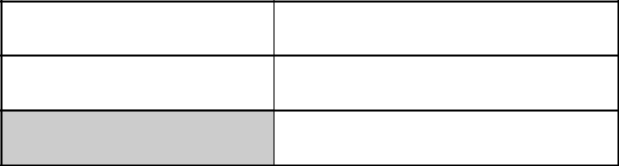


ACCOUNT NUMBER

 |  | The proxy statement, | NOTICE OF INTERNET AVAILABILITY OF PROXY MATERIAL:
 |  | The proxy statement, | form of proxy card and 2017 Annual Report to Shareholders are available for review on the
 |  |  | Internet at http://ir.martinmarietta.com/investor-relations/reports-filings
 | i | Please detach along perforated line and mail in the envelope provided IF you are not voting via telephone or the Internet. i
00033333333300000000 | 8 |  |  |  | 051718

YOU DO NOT NEED TO MARK ANY BOXES IF YOU WISH TO VOTE IN ACCORDANCE WITH THE BOARD OF DIRECTORS’ RECOMMENDATIONS.

THE BOARD OF DIRECTORS RECOMMENDS YOU VOTE “FOR” ITEMS 1, 2 AND 3.
PLEASE SIGN, DATE AND RETURN PROMPTLY IN THE ENCLOSED ENVELOPE. PLEASE MARK YOUR VOTE IN BLUE OR BLACK INK AS SHOWN HERE ☒

This proxy is solicited by the Board of Directors of Martin Marietta Materials, Inc. and when properly executed will be voted as specified herein and, unless otherwise directed, will be voted FOR the election of all nominees as Directors, FOR the ratification of the selection of PricewaterhouseCoopers as independent auditors, and FOR the approval, by a non-binding advisory vote, of the compensation of our named executive officers. The Board of Directors recommends voting FOR each item.

Receipt of Notice of Annual Meeting of Shareholders and accompanying Proxy Statement is hereby acknowledged.

To change the address on your account, please check the box at right and indicate

your new address in the address space above. Please note that changes to the ☐ registered name(s) on the account may not be submitted via this method.

1. | Election of Directors: | FOR | AGAINST | ABSTAIN
 | Sue W. Cole | ☐ | ☐ | ☐
 | Smith W. Davis | ☐ | ☐ | ☐
 | John J. Koraleski | ☐ | ☐ | ☐
 | David G. Maffucci | ☐ | ☐ | ☐
 | Michael J. Quillen | ☐ | ☐ | ☐
 | Donald W. Slager | ☐ | ☐ | ☐
 | Stephen P. Zelnak, Jr. | ☐ | ☐ | ☐
2. | Ratification of selection of PricewaterhouseCoopers as independent | ☐ | ☐ | ☐
 | auditors.
3. | Approval, by a non-binding advisory vote, of the compensation of | ☐ | ☐ | ☐
 | Martin Marietta Materials, Inc.’s named executive officers.

- In their discretion, the proxies are authorized to vote upon such other business as may properly come before the meeting, or any adjournments thereof.


Signature of Shareholder |  | Date: |  | Signature of Shareholder |  | Date:

Note: Please sign exactly as your name or names appear on this Proxy. When shares are held jointly, each holder should sign. When signing as executor, administrator, attorney, trustee or guardian, please give full title as such. If the signer is a corporation, please sign full corporate name by duly authorized officer, giving full title as such. If signer is a partnership, please sign in partnership name by authorized person.

Table of Contents

ANNUAL MEETING OF SHAREHOLDERS OF

MARTIN MARIETTA MATERIALS, INC.

May 17, 2018

GO GREEN
e-Consent makes it easy to go paperless. With e-Consent, you can quickly access your
proxy material, statements and other eligible documents online, while reducing costs,
clutter and paper waste. Enroll today via www.astfinancial.com to enjoy online access.

NOTICE OF INTERNET AVAILABILITY OF PROXY MATERIAL:
The proxy statement, form of proxy card and 2017 Annual Report to Shareholders

are available for review on the Internet at http://ir.martinmarietta.com/investor-relations/reports-filings

 | Please sign, date and mail
 | your proxy card in the
 | envelope provided as soon
 | as possible.
i | Please detach along perforated line and mail in the envelope provided. i
00033333333300000000 8 | 051718


YOU DO NOT NEED TO MARK ANY BOXES IF YOU WISH TO VOTE IN ACCORDANCE WITH THE BOARD OF DIRECTORS’
RECOMMENDATIONS.
THE BOARD OF DIRECTORS RECOMMENDS YOU VOTE “FOR” ITEMS 1, 2 AND 3.

PLEASE SIGN, DATE AND RETURN PROMPTLY IN THE ENCLOSED ENVELOPE. PLEASE MARK YOUR VOTE IN BLUE OR BLACK INK AS SHOWN HERE ☒

This proxy is solicited by the Board of Directors of Martin Marietta Materials, Inc. | 1. Election of Directors: | FOR | AGAINST | ABSTAIN
and when properly executed will be voted as specified herein and, unless otherwise | Sue W. Cole | ☐ | ☐ | ☐
directed, will be voted FOR the election of all nominees as Directors, FOR the
ratification of the selection of PricewaterhouseCoopers as independent auditors, and | Smith W. Davis | ☐ | ☐ | ☐
FOR the approval, by a non-binding advisory vote, of the compensation of our named
executive officers. The Board of Directors recommends voting FOR each item. | John J. Koraleski | ☐ | ☐ | ☐
Receipt of Notice of Annual Meeting of Shareholders and accompanying Proxy | David G. Maffucci | ☐ | ☐ | ☐
Statement is hereby acknowledged. | Michael J. Quillen | ☐ | ☐ | ☐
 | Donald W. Slager | ☐ | ☐ | ☐
 | Stephen P. Zelnak, Jr. | ☐ | ☐ | ☐
 | 2. Ratification of selection of PricewaterhouseCoopers as independent | ☐ | ☐ | ☐
 | auditors.
 | 3. Approval, by a non-binding advisory vote, of the compensation of | ☐ | ☐ | ☐
 | Martin Marietta Materials, Inc.’s named executive officers.

- In their discretion, the proxies are authorized to vote upon such other business as may properly come before the meeting, or any adjournments thereof.

To change the address on your account, please check the box at right and indicate
your new address in the address space above. Please note that changes to the ☐

registered name(s) on the account may not be submitted via this method.

Signature of Shareholder |  | Date: |  | Signature of Shareholder |  | Date:

Note: Please sign exactly as your name or names appear on this Proxy. When shares are held jointly, each holder should sign. When signing as executor, administrator, attorney, trustee or guardian, please give full title as such. If the signer is a corporation, please sign full corporate name by duly authorized officer, giving full title as such. If signer is a partnership, please sign in partnership name by authorized person.

Table of Contents

0

MARTIN MARIETTA MATERIALS, INC.

Proxy solicited by the Board of Directors for the

Annual Meeting to be held May 17, 2018

The undersigned hereby appoints C. Howard Nye and James A. J. Nickolas, and each or either of them, proxies, with full power of substitution, with the powers the undersigned would possess if personally present, to vote, as designated below, all shares of the common stock of the undersigned in Martin Marietta Materials, Inc. at the Annual Meeting of Shareholders to be held on May 17, 2018, and at any adjournment thereof.

(Continued and to be signed on the reverse side)

1.1 14475

