Table of Contents

SCHEDULE 14A

(Rule 14a-101)

INFORMATION REQUIRED IN PROXY STATEMENT

SCHEDULE 14A INFORMATION

Proxy Statement Pursuant to Section 14(a) of the Securities
Exchange Act of 1934 (Amendment No. )

Filed by the Registrant ☒

Filed by a Party other than the Registrant ☐

Check the appropriate box:

- Preliminary Proxy Statement

- Confidential, for Use of the Commission Only (as permitted by Rule 14a-6(e)(2)) ☒ Definitive Proxy Statement
- Definitive Additional Materials

- Soliciting Material pursuant to Rule 14a-12

Martin Marietta Materials, Inc.

(Name of Registrant as Specified In Its Charter)

(Name of Person(s) Filing Proxy Statement, if other than the Registrant)

Payment of Filing Fee (Check the appropriate box):

- No fee required.

- Fee computed on table below per Exchange Act Rules 14a-6(i)(1) and 0-11.

  - Title of each class of securities to which transaction applies:

  - Aggregate number of securities to which transaction applies:

  - Per unit price or other underlying value of transaction computed pursuant to Exchange Act Rule 0-11 (set forth the amount on which the filing fee is calculated and state how it was determined):

  - Proposed maximum aggregate value of transaction:

  - Total fee paid:

- Fee paid previously with preliminary materials.

- Check box if any part of the fee is offset as provided by Exchange Act Rule 0-11(a)(2) and identify the filing for which the offsetting fee was paid previously. Identify the previous filing by registration statement number, or the Form or Schedule and the date of its filing.

  - Amount Previously Paid:

  - Form, Schedule or Registration Statement No.:

  - Filing Party:

  - Date Filed:

Table of Contents
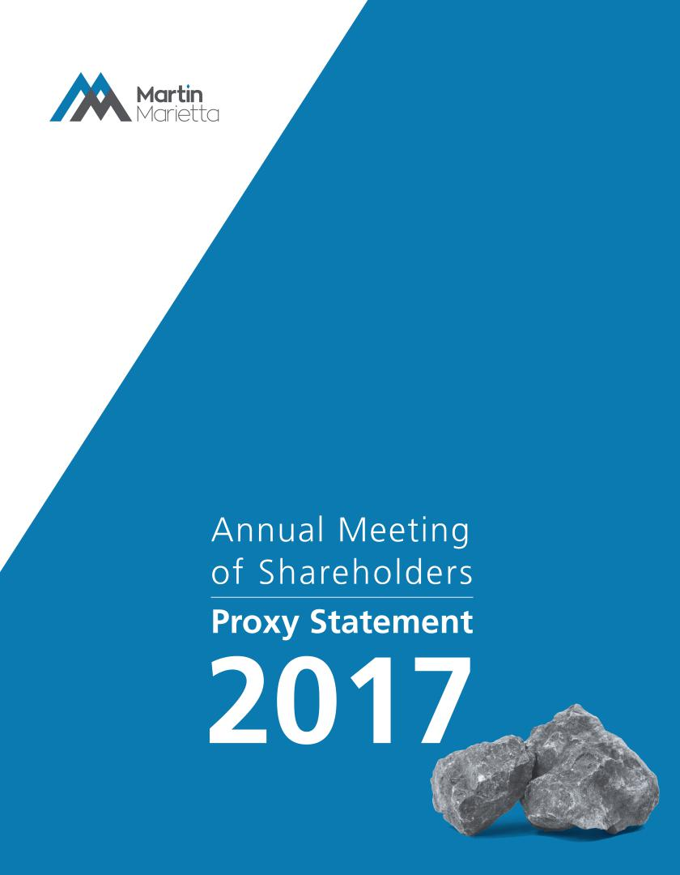

Table of Contents


April 17, 2017

Dear Fellow Shareholder:


On behalf of the Martin Marietta Board of Directors and executive officers, it is my pleasure to invite you to our 2017 Annual Meeting of Shareholders.

Strong Financial Performance

2016 was an exceptional year for Martin Marietta. We established several new financial records and demonstrated the earnings power of our strategically-positioned assets, driven by a more durable, construction-centric recovery. Our record performance and market position yielded strong returns for our shareholders, delivering a 64% total shareholder return, the 9th best in the S&P 500. And, as always, we achieved these results while remaining committed to the safety, ethics, integrity and values that are the hallmark of Martin Marietta.

Shareholder Engagement

We held an Investor Day in Dallas, Texas in 2016. Management provided overviews of our accomplishments relative to our five-year Strategic Operating Analysis and Review (“SOAR 2020”), outlined generally objectives for SOAR 2020 and offered a snapshot of the potential earnings power of the business. However, Texas was, literally, the show’s star. Presentations from our regional management provided insight into the fundamental drivers of the Texas economy. Operations tours were provided at both the Bridgeport/Chico Quarry Complex as well as the Midlothian Cement Plant, including facilities that were added in our recent acquisition of Texas Industries.

Our investor outreach in 2016 extended to 127 meetings with 314 investor groups, and conversations with most of our top 20 shareholders. We visited with our shareholders across the United States and in Toronto, Frankfurt, London, Edinburgh and Paris. We also issued our second Sustainability Report in 2016 - “Building Solid Foundations – Partnering for Stronger Communities” - in response to our shareholders’ request that we share our story on the efforts and improvements we are making in this important aspect. From our world-class safety programs and performance, to our targeted and intentional support of education and health, and environmental programs that ensure operational excellence, we have a solid foundation and an exciting opportunity to build upon.

Governance Developments

There were several important changes to our corporate governance in 2016. First, shareholders approved amendments to our Articles of Incorporation that provide for annual elections of directors. Second, the Board did not renew the shareholder rights plan that expired in October 2016. Our Board continues to review our governance policies to ensure we are able to create appropriate value for our shareholders.

Board Member Changes

At this year’s meeting, William E. McDonald will retire in accordance with the mandatory retirement provision in our bylaws. We wish Bill well in retirement and are extremely grateful for his steady guidance and thoughtful leadership given generously through his 21 years on our Board.

We also added two new Board members in 2016, namely John J. Koraleski, former Chairman and CEO of Union Pacific Railroad, and Donald W. Slager, President and CEO of Republic Services. We are delighted to have both Jack and Don, who each bring strong backgrounds and experience with publicly-traded companies to provide their insights into our Board mix.

Proxy Voting

Because your proxy vote matters, I urge you to cast it promptly — even if you plan to attend the Annual Meeting. We encourage you to vote so that your shares will be represented and voted at the meeting.

Thank you for your continued support of Martin Marietta.

Sincerely,
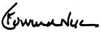

C. Howard Nye

Chairman of the Board, President and Chief Executive Officer

Table of Contents

MARTIN MARIETTA MATERIALS, INC.

2710 Wycliff Road, Raleigh, North Carolina 27607

Notice of Annual Meeting of Shareholders

To Be Held May 18, 2017

To Our Shareholders:

The Annual Meeting of Shareholders of Martin Marietta Materials, Inc. will be held on Thursday, May 18, 2017, at 11:30 a.m. at our principal office located at 2710 Wycliff Road, Raleigh, North Carolina. At the meeting, the holders of our outstanding common stock will act on the following matters:

- Election as Directors the four (4) nominees named in the attached proxy statement, each to serve their respective term as described in the attached proxy statement, and until their successors are duly elected and qualified;

- Ratification of the appointment of PricewaterhouseCoopers LLP as independent auditors for 2017;

- Advisory vote to approve the compensation of our named executive officers;

- Advisory vote to select the frequency of future shareholder votes to approve the compensation of our named executive officers;

- A shareholder proposal described in the accompanying proxy statement, if properly presented at the Annual Meeting; and

- Any other business that may properly come before the meeting.

All holders of record of Martin Marietta common stock (NYSE: MLM) at the close of business on March 10, 2017 are entitled to notice of and to vote at the Annual Meeting and any adjournments or postponements of the meeting.

We have enclosed our 2016 Annual Report to Shareholders. The report is not part of the proxy soliciting materials for the Annual Meeting.

Whether or not you expect to attend the meeting, we hope you will date and sign the enclosed proxy card and mail it promptly in the enclosed stamped envelope. Submitting your proxy now will not prevent you from voting your shares at the meeting, as your proxy is revocable at your option.

Sincerely,
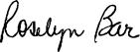

Roselyn R. Bar

Executive Vice President, General

Counsel and Secretary

Raleigh, North Carolina

April 17, 2017

IMPORTANT NOTICE REGARDING THE AVAILABILITY OF PROXY MATERIALS FOR THE

ANNUAL SHAREHOLDER MEETING TO BE HELD ON MAY 18, 2017:

Martin Marietta’s proxy statement, form of proxy card and 2016 Annual Report to Shareholders are also available at ir.martinmarietta.com/reports.cfm.

Table of Contents

Table of Contents

Proxy Summary

The Board of Directors

Proposal 1 – Election of Directors

Director Compensation

Security Ownership of Certain Beneficial Owners and Management

Section 16(a) Beneficial Ownership Reporting Compliance

Corporate Governance Matters

Corporate Governance Philosophy

Board Committees

Proposal 2 – Independent Auditors

Summary of Fees

Audit Fees

Audit-Related Fees

Tax Fees

All Other Fees

Pre-Approval Policies and Procedures

Audit Committee Review

1 | Executive Compensation |  |  |  |  |  |  |  |  | 43
 |  | Executive Officer Compensation |  |  |  |  |  |  |  | 43
6 |  | Summary Compensation Table |  |  |  |  |  |  |  | 43
 |  | Grants of Plan-Based Awards |  |  |  |  |  |  |  | 45
7 |  | Outstanding Equity Awards at Fiscal Year-End |  |  |  |  |  |  |  | 47
11 |  | Option Exercises and Stock Vested |  |  |  |  |  |  |  | 48
11 |  | Pension Benefits |  |  |  |  |  |  |  | 50
 |  | Potential Payments Upon Termination or Change of Control |  |  |  |  |  |  |  | 51

13
- Proposal 3 – Advisory Vote on the Compensation of Our

 | Named Executive Officers |  |  |  |  |  |  |  |  |  | 55
15 | Proposal 4 – Advisory Vote on Frequency of Executive
15
15 | Compensation Vote |  |  |  |  |  |  |  |  |  | 56
19 |  |  |  |  |  |  |  |  |  |  | 56
19 | Proposal 5 – Advisory Vote on Shareholder Proposal
24
24 | Requesting that the Board Amend the Bylaws to Provide
25 |  |  |  |  |  |  |  |  |  |  | 57
25 | for Proxy Access |  |  |  |  |  |  |  |  |  | 57
25
25 | Securities Authorized for Issuance Under Equity
25 |  |  |  |  |  |  |  |  |  |  | 60
25 | Compensation Plans |  |  |  |  |  |  |  |  |  | 60

25 | Description of the TXI Legacy Plan |  |  | 60
25 |  |  |  | 60
25 | Description of the Deferred Compensation Plan |  |  | 61
25 |  |  |  | 61

Audit Committee Report |  |  |  |  |  |  |  |  |  |  |  |  |  |  |  |  |  |  |  |  |  |  | 26 | General Information
 |  |  |  |  |  |  |  |  |  |  |  |  |  |  |  |  |  |  |  |  |  |  | 26 | Incorporation by Reference
Management Development and Compensation
 |  |  |  |  |  |  |  |  |  |  |  |  |  |  |  |  |  |  |  |  |  |  | 27
Committee Report |  |  |  |  |  |  |  |  |  |  |  |  |  |  |  |  |  |  |  |  |  |  | 27 | Shareholders’ Proposals for the 2018 Annual Meeting
Compensation Committee Interlocks and Insider
 |  |  |  |  |  |  |  |  |  |  |  |  |  |  |  |  |  |  |  |  |  |  |  | Appendix A – Martin Marietta Guidelines for Potential
Participation in Compensation Decisions |  |  |  |  |  |  |  |  |  |  |  |  |  |  |  |  |  |  |  |  |  |  | 27
 |  |  |  |  |  |  |  |  |  |  |  |  |  |  |  |  |  |  |  |  |  |  | 27 | New Board Members
Compensation Discussion and Analysis |  |  |  |  |  |  |  |  |  |  |  |  |  |  |  |  |  |  |  |  |  |  | 28
 |  |  |  |  |  |  |  |  |  |  |  |  |  |  |  |  |  |  |  |  |  |  | 28 | Appendix B – Non-GAAP Measures
 | Introduction |  |  |  |  |  |  |  |  |  |  |  |  |  |  |  |  |  |  |  |  |  | 28
 | Executive Summary |  |  |  |  |  |  |  |  |  |  |  |  |  |  |  |  |  |  |  |  |  | 28
 | 2016 Say-On-Pay Vote and Shareholder Outreach |  |  |  |  |  |  |  |  |  |  |  |  |  |  |  |  |  |  |  |  |  | 30
 | Pay Decisions in 2016 Made in Light of Performance |  |  |  |  |  |  |  |  |  |  |  |  |  |  |  |  |  |  |  |  |  | 31
 | Our Compensation Strategy |  |  |  |  |  |  |  |  |  |  |  |  |  |  |  |  |  |  |  |  |  | 31
 | Performance-Related Compensation |  |  |  |  |  |  |  |  |  |  |  |  |  |  |  |  |  |  |  |  |  | 33
 | Ongoing Corporate Governance Policies |  |  |  |  |  |  |  |  |  |  |  |  |  |  |  |  |  |  |  |  |  | 33
 | Compensation Decisions Process |  |  |  |  |  |  |  |  |  |  |  |  |  |  |  |  |  |  |  |  |  | 33
 | Determination of CEO Compensation |  |  |  |  |  |  |  |  |  |  |  |  |  |  |  |  |  |  |  |  |  | 35
 | Compensation Program Risk Assessment |  |  |  |  |  |  |  |  |  |  |  |  |  |  |  |  |  |  |  |  |  | 35
 | Considerations Regarding 2016 Compensation |  |  |  |  |  |  |  |  |  |  |  |  |  |  |  |  |  |  |  |  |  | 36
 | Stock-Based Awards Generally |  |  |  |  |  |  |  |  |  |  |  |  |  |  |  |  |  |  |  |  |  | 41
 | Stock Ownership Guidelines |  |  |  |  |  |  |  |  |  |  |  |  |  |  |  |  |  |  |  |  |  | 41
 | Perquisites |  |  |  |  |  |  |  |  |  |  |  |  |  |  |  |  |  |  |  |  |  | 41
 | Retirement and Other Benefits |  |  |  |  |  |  |  |  |  |  |  |  |  |  |  |  |  |  |  |  |  | 41
 | Potential Payments upon Termination or Change of Control |  |  |  |  |  |  |  |  |  |  |  |  |  |  |  |  |  |  |  |  |  | 42
 | Tax and Accounting Implications |  |  |  |  |  |  |  |  |  |  |  |  |  |  |  |  |  |  |  |  |  | 42

62

64

64

A-1

B-1

Table of Contents


Proxy Summary

This Proxy Summary highlights information about Martin Marietta that can be found elsewhere in this proxy statement. It does not contain all of the information you should consider in voting your shares. We encourage you to read the entire proxy statement for more detailed information on each topic prior to casting your vote. This proxy statement, the proxy card, and the notice of meeting are being sent commencing on approximately April 17, 2017 to shareholders of record on March 10, 2017.

2017 Annual Meeting of Shareholders

Meeting Date: May 18, 2017 Place: 2710 Wycliff Road, Raleigh, NC

Time: 11:30 am ET Record Date: March 10, 2017

Your vote is important. You may vote in person at the Annual Meeting or submit a proxy over the internet. If you have received a paper copy of the proxy card (or if you request a paper copy of the materials), you may submit a proxy by telephone or by mail.

Via the Internet

www.voteproxy.com.

By Telephone

1-800-PROXIES (1-800-776-9437)

in the United States or 1-718-921-8500 from outside the United States.

In Person

Attend the Annual Meeting and vote by ballot.

By Mail

Sign, date and mail your proxy card in the envelope provided.

If you submit your proxy by telephone or over the internet, you do not need to return your proxy card by mail.

PROPOSALS AND VOTING RECOMMENDATIONS

Proposal | Description | Board Voting Recommendation | Page
1 | Election of Four Director Nominees | FOR ALL DIRECTOR NOMINEES | 7
2 | Ratification of the appointment of | FOR | 25
2 | PricewaterhouseCoopers LLP as independent auditors | FOR | 25
3 | Advisory Vote on Company’s Executive Compensation | FOR | 56
4 | Advisory Vote on Frequency of Shareholder Votes on Executive Compensation | EVERY 1 YEAR | 57
5 | Advisory Vote on Shareholder Proposal Requesting that the Board Amend the
 | Bylaws to Provide for Proxy Access | AGAINST | 58

2017 PROXY STATEMENT | 1

Table of Contents
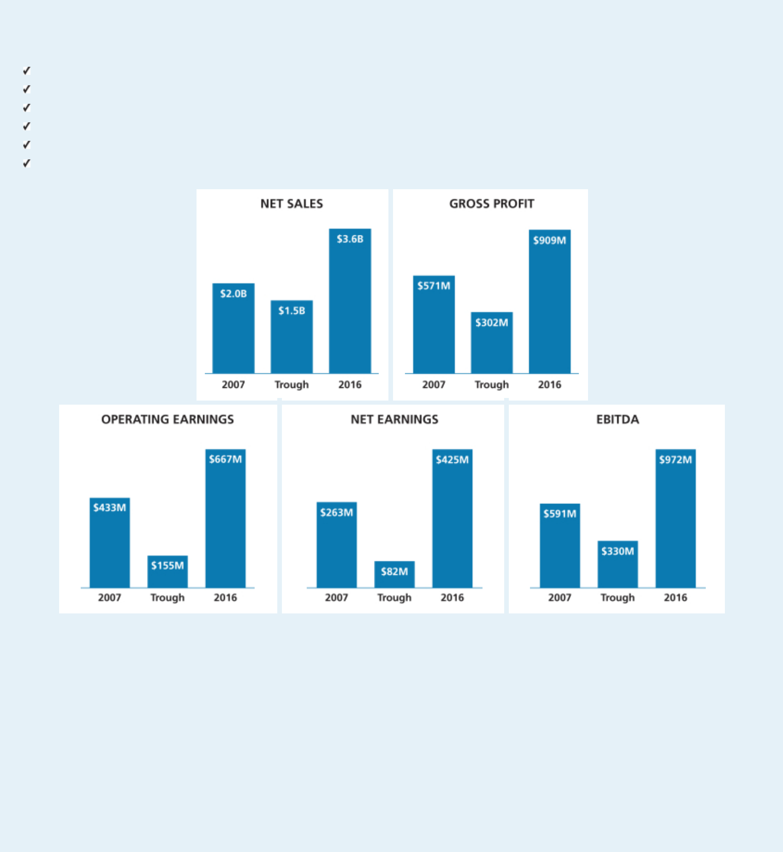

Shareholders Benefit from Martin Marietta’s Strong 2016 Performance

Record net sales of $3.58 billion up 9.4% from 2015

Record gross profit of $909 million up 25.9%

Record operating earnings of $667.3 million up 39.2%

Net earnings attributable to Martin Marietta of $425.4 million, an increase of 47% over 2015

Earnings before interest, taxes, depreciation, depletion and amortization (EBITDA) of $971.6 million up 29.4% from 2015 Earnings attributable to common shareholders per diluted share of $6.63 compared with $4.29, up 54.5%

Notes: Peak and trough years are measured against the reported earnings with no adjustments for unusual or infrequent items. Trough years vary for

each measure as follows: Net Sales – 2009; Gross Profit – 2011; Operating Earnings – 2012; Net Earnings – 2011; EBITDA - 2012

- 2017 PROXY STATEMENT

Table of Contents
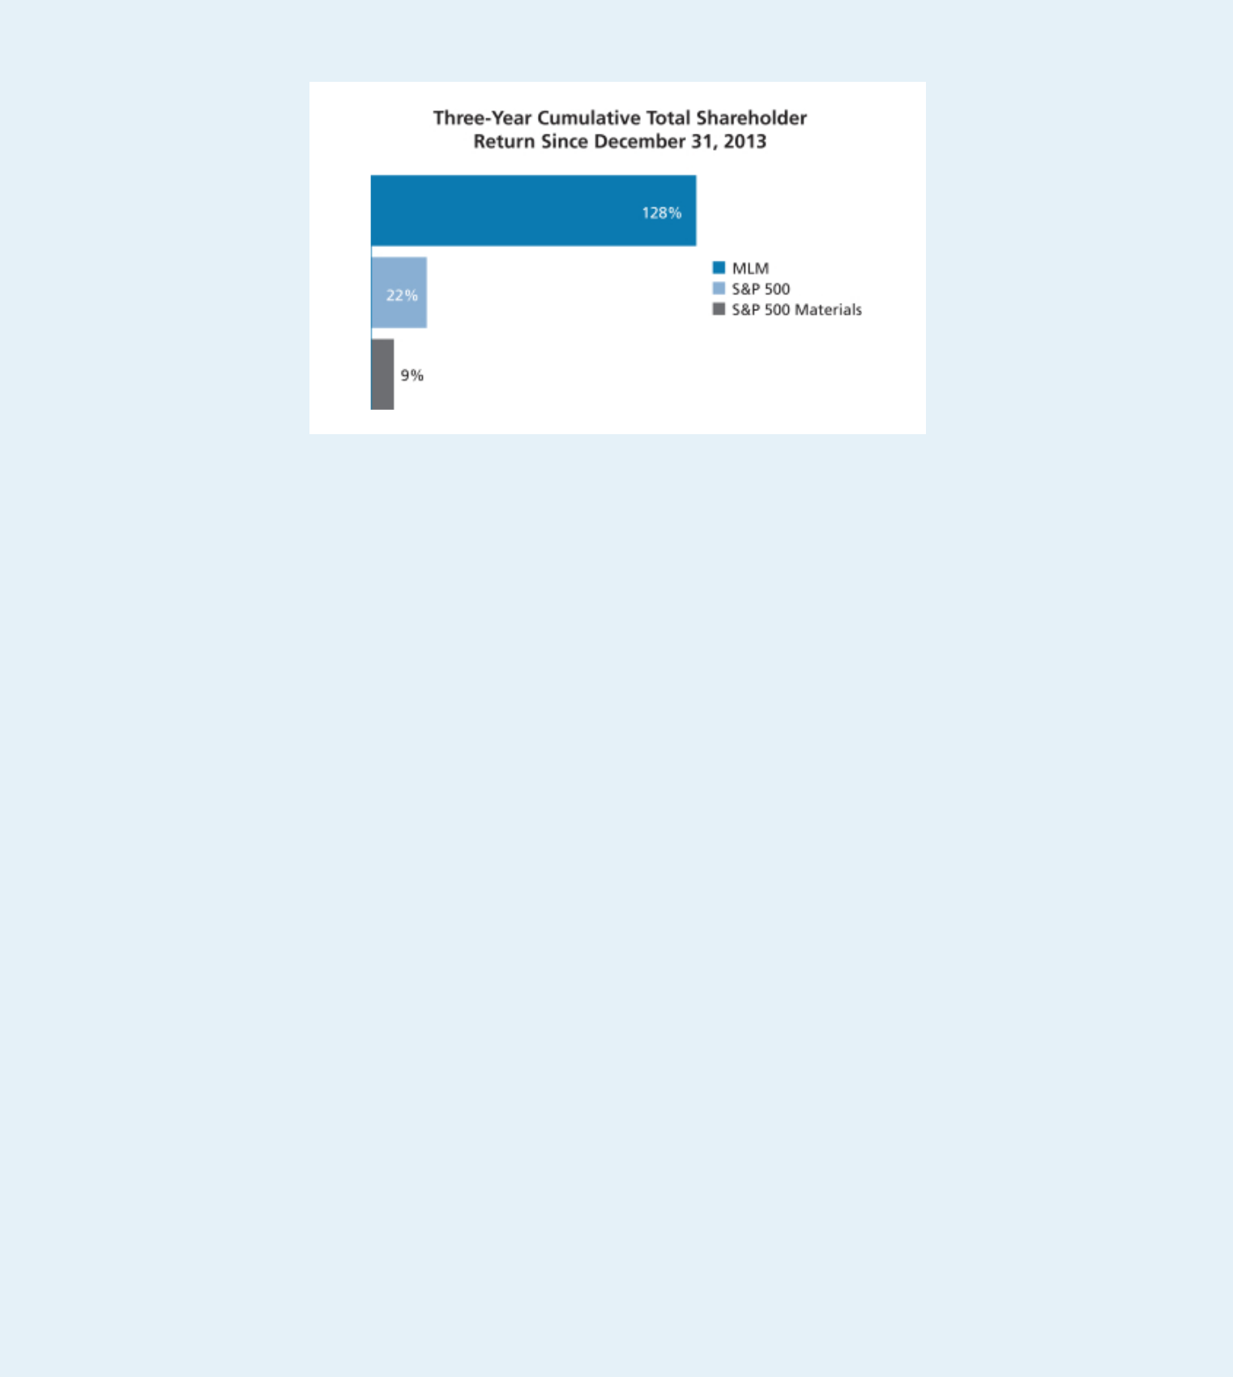

A reconciliation of Net Earnings Attributable to Martin Marietta to EBITDA is included in Annex B.

Corporate Governance Highlights

Recent Updates

- Declassified Board phase-in begins—Directors elected in 2017 to serve one-year terms

- Modifications to our long-term equity compensation and cash incentive programs

Board of Directors

- Lead Independent Director

- 10 Directors; 9 are non-employees; 8 are independent

- Key committee Chairs are independent

- Executive sessions of non-management Directors at each regularly-scheduled meeting

- All Directors attended 100% of all Board and committee meetings in 2016

- Limited membership on other public company boards

- Code of Ethical Business Conduct and ethics program that reports to a Board Committee

- Regular Board self-assessments and Director peer review

- Risk oversight by full Board and Committees

Shareholder Interest

- Majority voting standard for uncontested Director elections

- No shareholder rights plan

- Annual advisory vote to ratify independent auditor

- Annual advisory vote to approve executive compensation

- Longstanding active shareholder engagement

2017 PROXY STATEMENT | 3

Table of Contents
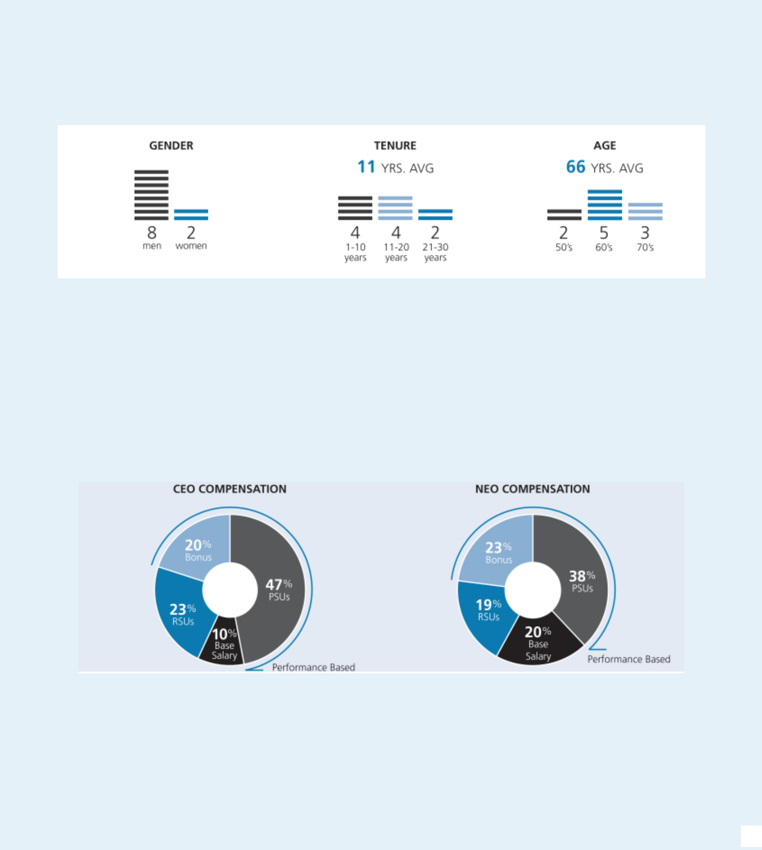

Board Composition

In 2016, we elected two new Directors to the Board, each with extensive experience serving as chief executive officers and members of the board of directors of large publicly-traded companies. We were recognized in 2015 at the Women’s Forum of New York at its Biennial Breakfast of Corporate Champions for our Board diversity.

Board Attendance

In 2016, all directors attended 100% of the total Board and committee meetings to which they were assigned. All incumbent directors attended the May 2016 Annual Meeting, except for Mr. Koraleski who joined the Board in August 2016.

Our Compensation Approach

A substantial portion of compensation paid to our named executive officers (“NEOs”) is variable and performance-based. We use the 50th percentile of our comparator group to set target compensation, but actual pay realized by our NEOs is dependent on our financial, operational and other related performance. Based on our record levels of performance in 2016, variable compensation payable under both our short-term and long-term incentive plans exceeded the target amounts established for each NEO, which is consistent with our pay-for-performance philosophy.

- 2017 PROXY STATEMENT

Table of Contents
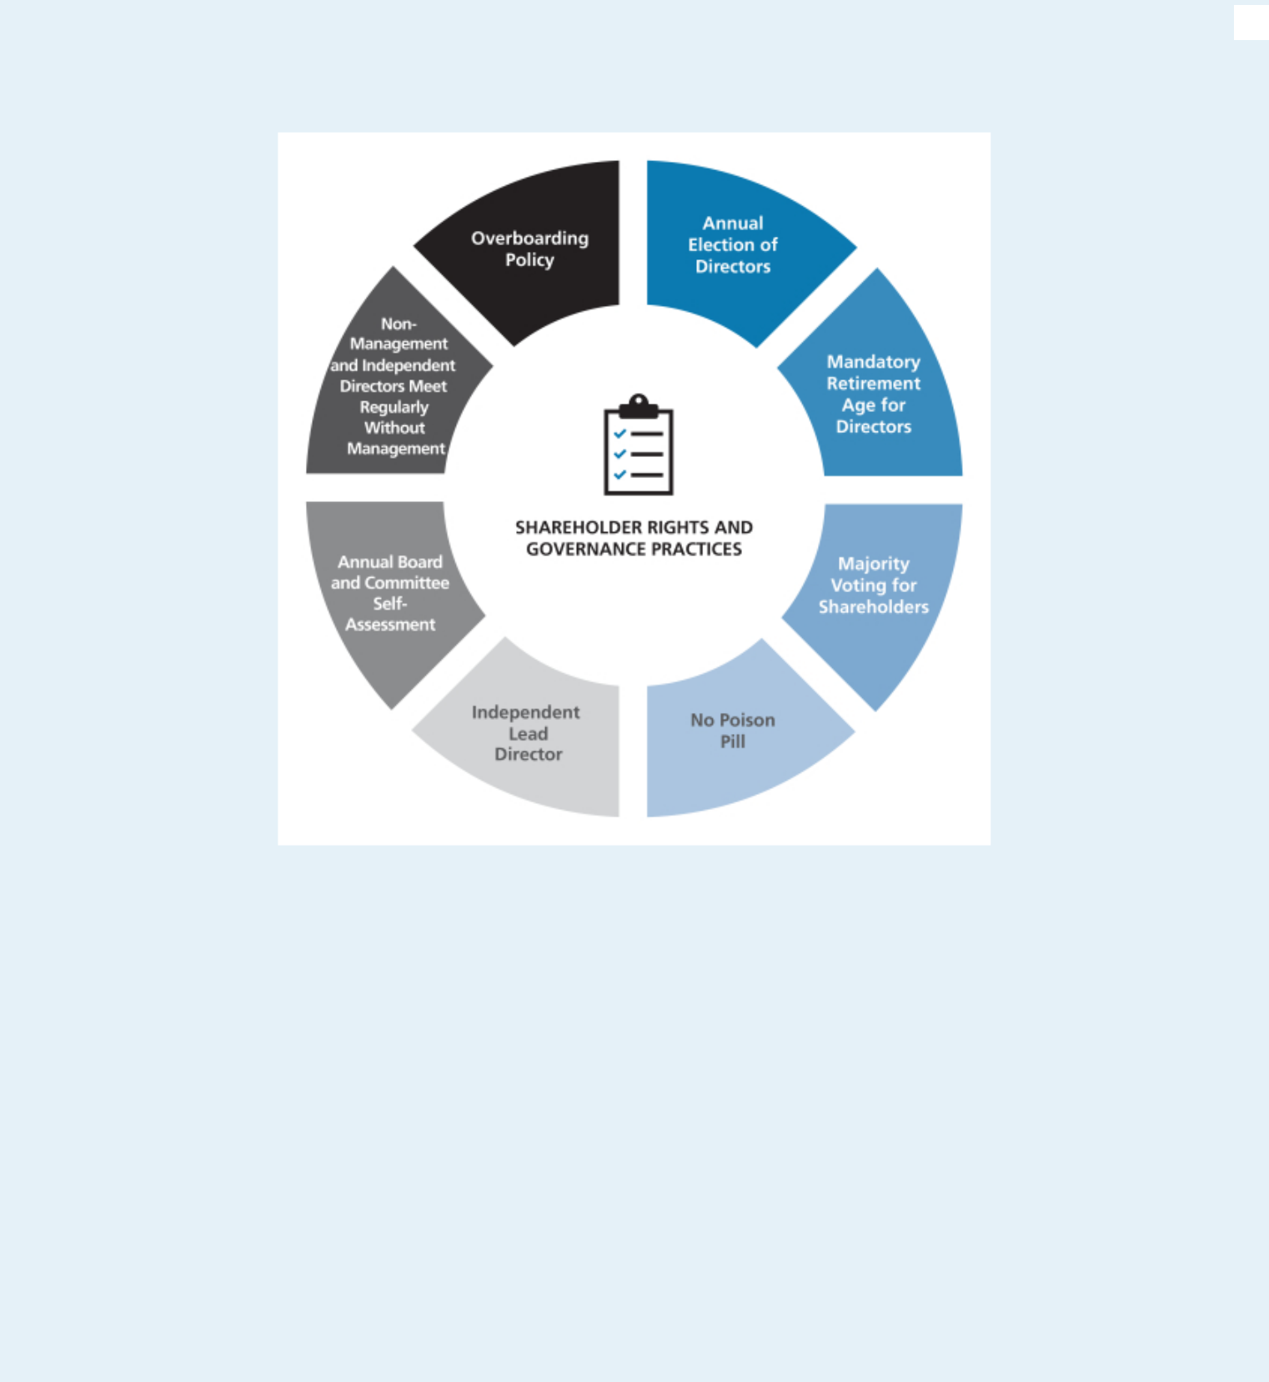

Shareholder Rights and Governance Practices

Will any other matters be presented at the Annual Meeting?

At the time this proxy statement was filed with the Securities and Exchange Commission, the Board of Directors was not aware that any matters not referred to herein would be presented for action at the Annual Meeting. If any other matters properly come before the meeting, it is intended that the persons named in the enclosed proxy will vote the shares represented by proxies on such matters in accordance with the recommendation of the Board of Directors, or, if no recommendation is given, in their own discretion. It is also intended that discretionary authority will be exercised with respect to the vote on any matters incident to the conduct of the meeting.

What are the Board’s recommendations?

Unless you give other instructions on your proxy card, the persons named as proxy holders on the proxy card will vote in accordance with the recommendations of the Board of Directors. The Board’s recommendation, as well as a description of each proposal, is set forth in this proxy statement. The Board recommends a vote:

- FOR the election of the nominated slate of Directors;

- FOR the ratification of the selection of PricewaterhouseCoopers LLP as independent auditors;

- FOR the approval, on a non-binding advisory basis, of the compensation of our named executive officers as described in this proxy statement;

- FOR the selection of “EVERY 1 YEAR” for the frequency of future non-binding advisory votes on the compensation of our named executive officers; and

- AGAINST the advisory vote on the shareholder proposal requesting that the Board amend the Bylaws to provide for proxy access.

2017 PROXY STATEMENT | 5

Table of Contents


CAUTIONARY NOTE REGARDING FORWARD-LOOKING STATEMENTS

This proxy statement contains forward-looking statements as defined in the Securities Exchange Act of 1934 and is subject to the safe harbors created therein. The forward-looking statements contained herein are generally identified by the words “believe,” “project,” “expect,” “anticipate,” “estimate,” “intend,” “strategy,” “future,” “opportunity,” “plan,” “may,” “should,” “will,” “would,” “will be,” “will continue,” “will likely result,” and similar expressions. Forward-looking statements are based on the beliefs and assumptions of our management and on currently available information. A detailed discussion of risks and uncertainties that could cause actual results and events to differ materially from such forward-looking statements is included in our annual report on Form 10-K for the fiscal year ended December 31, 2016. We undertake no responsibility to publicly update or revise any forward-looking statement.

The Board of Directors

The Board of Directors currently consists of ten members, nine of whom are non-employee Directors. At the 2016 Annual Meeting, shareholders approved the Board of Directors’ proposal to amend our Articles of Incorporation to phase out the classification of the terms of our Directors and to provide instead for the annual election of our Directors. Prior to the charter amendment, our Board of Directors was divided into three classes, with each class serving three-year terms. Now, commencing with this 2017 Annual Meeting of Shareholders, our Directors will be elected to one-year terms of office after the current terms of the Directors of each class expire at the 2017, 2018 and 2019 Annual Meetings of Shareholders.

The Board of Directors has nominated four persons for election as Directors to serve a one-year term expiring in 2018. Unless otherwise directed, proxies will be voted in favor of these nominees. Each nominee has agreed to serve if elected. Each of the nominees is currently serving as a Director. Mr. Koraleski was appointed as a Director as of August 15, 2016. Should any nominee become unable to serve as a Director, the persons named in the enclosed form of proxy will, unless otherwise directed, vote for the election of such other person for such position as the present Board of Directors may recommend in place of such nominee.

Under our Bylaws, nominations of persons for election to the Board of Directors may be made at an Annual Meeting of Shareholders by the Board of Directors and by any shareholder who complies with the notice procedures set forth in the Bylaws. As described in the proxy statement for our 2016 Annual Meeting, for a nomination to be properly made by a shareholder at the 2017 Annual Meeting, the shareholder’s notice must have been sent to, and received by, our Secretary at our principal executive offices between January 20, 2017 and February 19, 2017. No such notice was received during this period. Should any of the following nominees be unavailable for election by reason of death or other unexpected occurrence, the proxy, to the extent permitted by applicable law, may be voted with discretionary authority in connection with the nomination by the Board of Directors and the election of any substitute nominee.

The Bylaws of the Corporation provide that a Director will retire at the Annual Meeting of Shareholders following the Director’s 75th birthday. One of our current Directors, William E. McDonald, reached this mandatory retirement age this year and is not eligible for election at the Annual Meeting for a new term. Mr. McDonald has stated that he intends to serve as a Director of the Corporation through the commencement of the 2017 Annual Meeting of Shareholders, after which he will retire from the Board. The Board extends its sincere appreciation to Mr. McDonald for his years of service and thoughtful Board leadership. Mr. McDonald has given generously of his time and has consistently provided the Board with independent insight and advice, which have been invaluable to the Board and to Martin Marietta. In light of the retirement of Mr. McDonald, the Board of Directors has set the size of the Board of Directors at nine effective upon the commencement of the 2017 Annual Meeting.

The recruiting process typically involves either a search firm or a member of the Nominating and Corporate Governance Committee contacting a prospect to gauge his or her interest and availability. A candidate will then meet with several members of the Nominating and Corporate Governance Committee and Board. At the same time, the Nominating and Corporate Governance Committee and the search firm will contact references for the prospect. A background check is completed before a final recommendation is made to the Board to appoint a candidate to the Board. During 2015-2016, the Nominating and Corporate Governance Committee retained a search firm to help identify director prospects, perform candidate outreach, assist in reference checks, and provide other related services. Nominated to the Board in August 2016, Mr. Koraleski was initially identified by the Chairman, President and CEO and was recommended as a Director nominee by the Nominating and Corporate Governance Committee.

Proxies cannot be voted for a greater number of persons than the number of nominees named.

The following sets forth the age and certain other biographical information for each of the nominees for election and for each of the other members of the Board of Directors as of the date of this proxy statement.

- 2017 PROXY STATEMENT

Table of Contents

Proposal No. 1

Election of Directors

Nominees for election to the Board of Directors for a Term Continuing Until 2018:

◆SUE W. COLE


Director Since: 2002

Age: 66

Chair of the Nominating and Corporate Governance Committee and member of the Management Development and Compensation Committee.

Ms. Cole is the managing partner of SAGE Leadership & Strategy, LLC, an advisory firm for businesses, organizations and individuals relating to strategy, governance and leadership development. Ms. Cole was previously a principal of Granville Capital Inc., a registered investment advisor, from 2006 to 2011, and before that she was the Regional CEO, Mid-Atlantic Region, of U.S. Trust Company, N.A., where she was responsible for the overall strategic direction, growth, and leadership of its North Carolina, Philadelphia and Washington, D.C. offices. Ms. Cole previously held various positions in the U.S. Trust Company, N.A. and its predecessors. Ms. Cole has previously served on the public-company board of UNIFI, Inc. She has also been active in community and charitable organizations, including previously serving as Chairman of the North Carolina Chamber, on the Investment Committee of the University of North Carolina at Greensboro and as a member on the North Carolina Economic Development Board. Ms. Cole attended the University of North Carolina at Greensboro where she earned a B.S. in Business Administration and an M.B.A. in Finance.

Key attributes, experience and skills:

- Valuable experience in executive compensation, corporate governance, human resources, finance and financial statements, and customer service

- Chief executive officer of several financial services and investment advisory businesses as well as several non-profit organizations

- Strong leadership skills and familiarity with governmental affairs

◆MICHAEL J.


QUILLEN

Director Since: 2008

Age: 68

Lead Independent Director, Chair of the Management Development and Compensation Committee, Member of the Executive Committee and the Nominating and Corporate Governance Committee.

Mr. Quillen was the founder and served as Chief Executive Officer of Alpha Natural Resources, Inc. (ANR), a leading Appalachian coal supplier, since its formation in 2004 until its merger with Foundation Coal Holdings, Inc. in July 2009, and served as President and Chairman of ANR from 2006 to 2009, and non-Executive Chairman until May 2012. Mr. Quillen held senior executive positions in the coal industry throughout his career at Pittston/Pittston Coal Sales Corp., AMVEST Corporation, NERCO Coal Corporation, Addington, Inc. and Mid-Vol Leasing, Inc. He has also served as Chairman (Rector) of the Board of Visitors of Virginia Polytechnic Institute and State University from July 2012 to June 2014 and was reappointed to an additional four-year term on the Board of Governors in July 2014. He was Chairman of the Audit and Finance Committee of Virginia Polytechnic Institute and State University from July 2010 to June 2012. He also served on the Virginia Port Authority from 2003 to 2012 and as Chairman from July 2011 to December 2012. Mr. Quillen attended Virginia Polytechnic Institute and State University, earning both Bachelor’s and Master’s degrees in Civil Engineering.

Key attributes, experience and skills:

- Valuable business, leadership, management, financial, and mergers and acquisitions experience

- Extensive experience related to mining companies, governmental and regulatory issues, safety, health and environmental matters

- Tremendous insight and expertise with respect to strategic analysis, the natural resources industry, and energy

- Wealth of knowledge related to transportation

2017 PROXY STATEMENT | 7

Table of Contents

Proposal 1: Election of Directors | ◆ Director Nominees
 | Mr. Koraleski served from February 2015 through his retirement in September
 | 2015 as executive Chairman of the Board of the Union Pacific Corporation (UP),
 | which through its subsidiaries operates North America’s premier railroad franchise,
 | covering 23 states across the western two-thirds of the United States. Prior to that,
 | he was named President and Chief Executive Officer of the UP in March 2012,
 | elected as a Director of the UP in July 2012, and appointed Chairman of the Board
 | in 2014. Since joining the Union Pacific Railroad in 1972, Mr. Koraleski held a
 | number of executive positions in the UP and the Railroad, including, Executive
 | Vice President – Marketing and Sales from 1999 to 2012, Executive Vice
 | President – Finance and Information Technology, Chief Financial Officer, and
 | Controller. Mr. Koraleski served as the Chairman of The Bridges Investment Fund,
 | Inc., a general equity fund whose primary investment objective is to seek long-
◆JOHN J. | term capital appreciation, from 2005 through March 2012 and is a past Chairman
◆JOHN J. | of the Association of American Railroads. Mr. Koraleski earned a Bachelor’s and
◆JOHN J. | Master’s degree in business administration from the University of Nebraska at
KORALESKI | Omaha.


Director Since: 2016

Age: 66

Member of the Audit Committee,

Executive Committee and

Management Development and

Compensation Committee.

Key attributes, experience and skills:

- Experience with the demands and challenges associated with managing a large publicly-traded organization from his experience as Chairman and CEO of Union Pacific

- Extensive knowledge of financial system management, public company accounting, disclosure requirements and financial markets

- Valuable expertise in talent management, compensation, governance and succession planning

- Understanding of complex logistic operations, safety and rail operations

- Broad strategic analysis and experience with acquisitions, integration, marketing and information technologies

◆STEPHEN P.


ZELNAK, JR.

Director Since: 1993

Age: 72

Chair of the Finance Committee and Member of the Ethics, Environment, Safety and Health Committee.

Mr. Zelnak currently serves as Chairman of the Board of Beazer Homes USA, Inc., a geographically diversified homebuilder with active operations in 13 states within three geographic regions in the United States. He previously served as Chief Executive Officer of Martin Marietta from 1993 to 2009, President from 1993 to 2006, Chairman of the Board from 1997 through 2009, Executive Chairman from January 2010 to May 2010, and non-Executive Chairman from May 2010 until May 2014. Mr. Zelnak joined Martin Marietta Corporation in 1981 and was responsible for the aggregates operations since 1982. Mr. Zelnak is also Chairman and majority owner of ZP Enterprises, LLC, a private investment firm. In addition to community and charitable organizations, Mr. Zelnak has served as Chairman of the North Carolina Chamber and the National Stone, Sand and Gravel Association. He currently serves on the Advisory Board of the College of Management at North Carolina State University and is a Trustee Emeritus of the Georgia Tech Foundation Board. Mr. Zelnak received a Bachelor’s degree from Georgia Institute of Technology and Master’s degrees in Administrative Science and Business Administration from the University of Alabama system.


Key attributes, experience and skills:

- Former Chairman and CEO of Martin Marietta

- Extensive mentorship, business and operating experience

- Knowledge of all aspects of Martin Marietta and the construction aggregates industry

- Broad strategic and financial experience

- Knowledge of the homebuilding industry and factors that impact construction

- Corporate governance

The Board Unanimously

Recommends a Vote “FOR”

All Nominees for Election to the

Board of Directors

on This Proposal 1

- 2017 PROXY STATEMENT

Table of Contents

Director Nominees ◆ Proposal 1: Election of Directors

Other Directors Whose Terms Continue Until 2018:

◆DAVID G.


MAFFUCCI

Director Since: 2005

Age: 66

Chair of the Audit Committee and member of the Ethics, Environment, Safety and Health Committee.

Mr. Maffucci is a Director of Domtar Corporation, which designs, manufactures, markets and distributes a wide variety of fiber-based products, including communication papers, specialty and packaging papers, market pulp and absorbent hygiene products. He is currently the Chair of its Audit Committee and a member of its Finance Committee and Nominating and Corporate Governance Committee. Mr. Maffucci previously served as Executive Vice President and Chief Financial Officer of Xerium Technologies, Inc., a manufacturer and supplier of consumable products used in paper production, from 2009 to 2010, as well as on its Board of Directors from 2008 until 2010, serving on its Audit and Compensation Committees from 2008 to 2009. On March 30, 2010, Xerium Technologies, Inc. filed a voluntary petition for relief under Chapter 11 of the Federal bankruptcy laws as part of a “pre-arranged” restructuring plan with the support of its lenders. On May 25, 2010, Xerium Technologies, Inc. emerged from Chapter 11 protection. Mr. Maffucci also served as Executive Vice President and Chief Financial Officer of Bowater Incorporated. Mr. Maffucci previously worked at KPMG and is a Certified Public Accountant. He received his Bachelor’s degree from Sacred Heart University.

Key attributes, experience and skills:

- Extensive financial experience with a large public accounting firm

- Accounting principles and practices, auditing, internal control over financial reporting, and risk management processes

◆DONALD W.


SLAGER

Director Since: 2016

Age: 55

Member of the Ethics, Environment, Safety and Health Committee and the Finance Committee.

Donald W. Slager serves as President and Chief Executive Officer of Republic Services, Inc., a service provider in the non-hazardous solid waste industry, holding this position since January 2011. Prior to this, he served as President and Chief Operating Officer of Republic from December 2008 until his promotion to CEO. Prior to that, Mr. Slager served in the same capacity for Allied Waste Industries, Inc. (“Allied Waste”), from 2005 to 2008, prior to its merger with Republic Services. Mr. Slager was Executive Vice President and Chief Operating Officer of Allied Waste between 2003 and 2004. Prior to that, Mr. Slager held varying positions of increasing responsibility with Allied Waste. Mr. Slager also has served as a Director of Republic since 2010. Mr. Slager previously served as an independent Director of UTi Worldwide Inc. (“UTI”) from 2009 to January 2016, where he served as Chairman of the Nominating and Corporate Governance Committee and as a member of both the Compensation and Risk Committees. UTi, a former NYSE listed company, was an international, non-asset-based supply chain services and solutions company providing air and ocean freight forwarding, contract logistics, customs brokerage, distribution, inbound logistics, truckload brokerage and other supply chain management services until it was acquired by DSV A/S a third-party logistics services provider, in January 2016. Mr. Slager has completed the Northwestern University Kellogg School Advanced Executive Program and holds a certificate from the Stanford University Board Consortium Development Program.

Key attributes, experience and skills:

- More than 13 years of C-Suite experience

- More than 26 years of general management experience in a complex, capital intensive and logistics business

- Extensive experience in mergers and acquisitions, integration, and strategic development and analysis

- Valuable experience from his membership on two publicly-traded board of directors

2017 PROXY STATEMENT | 9

Table of Contents

Proposal 1: Election of Directors ◆ Director Nominees

Other Directors Whose Terms Continue Until 2019:

◆C. HOWARD NYE


Director Since: 2010

Age: 54

Chairman of the Board (since 2014) and Chair of

the Executive Committee (since 2014)

Mr. Nye has served as Chairman of the Board since 2014 and as President and Chief Executive Officer of Martin Marietta since January 1, 2010. He previously served as President and Chief Operating Officer of Martin Marietta from August 2006 to 2009. From 2003 to 2006, Mr. Nye served as Executive Vice President of Hanson Aggregates North America, a producer of aggregates for the construction industry, and in other managerial roles since 1993. Mr. Nye is also currently an independent Director of CREE, Inc., a multi-national manufacturer and market-leading innovator of lighting-class LEDs, LED lighting, and semiconductor solutions for wireless and power applications, where he serves as a member on the Compensation Committee and Chair of the Governance and Nominations Committee. Mr. Nye has also been active in a number of various business, civic, and education organizations, including serving as a member of the Executive Committee and past Chairman of the Board of Directors of the National Stone, Sand & Gravel Association, Vice Chairman of the Board of Directors of the American Road & Transportation Builders Association (ARTBA), and a member of the Board of Directors of the United States Chamber of Commerce. Mr. Nye has also been a gubernatorial appointee to the North Carolina Mining Commission. Mr. Nye received an A.B. degree from Duke University and a J.D. degree from Wake Forest University.

Key attributes, experience and skills:

- Extensive knowledge of the construction aggregates industry

- Extensive leadership, business, operating, marketing, mergers and acquisitions, legal, customer-relations, and safety and environmental experience

- Understands the competitive nature of the business and has strong management skills and broad executive experience

- Broad strategic vision for the future growth of Martin Marietta

◆LAREE E. PEREZ


Director Since: 2004

Age: 63

Chair of the Ethics, Environment, Safety and Health Committee and member of the Audit Committee

Ms. Perez has served as Owner and Managing Partner of The Medallion Company, LLC, a consulting firm, since 2003. In 2015, she became employed as an investment consultant with DeRoy & Devereaux, an independent investment adviser, where she provides client consulting services. Ms. Perez was previously a Director of GenOn Energy, Inc., one of the largest power producers in the United States, from 2002 to 2012, and served as the Chairman of the Audit Committee of GenOn Energy, Inc. from 2002 to 2007 and a member of its Audit and Risk and Finance Oversight Committees from 2008 to 2012. Previously, she was Vice President of Loomis, Sayles & Company, L.P. and co-founder, President and Chief Executive Officer of Medallion Investment Company, Inc. In addition to civic and charitable organizations, Ms. Perez recently served as Vice Chairman of the Board of Regents at Baylor University and previously served on the Board of Trustees of New Mexico State University, where she was also Chairman of the Board. Ms. Perez earned a Bachelor’s degree from Baylor University in Finance and Economics.

Key attributes, experience and skills:

- Significant business, financial and private investment experience

- Significant expertise with respect to financial statements, corporate finance, accounting and capital markets, mergers and acquisitions, and strategic analysis

- Insight into auditing best practices

- Familiarity with the southwestern United States

- 2017 PROXY STATEMENT

Table of Contents

Director Nominees ◆ Proposal 1: Election of Directors
Mr. Rediker served as the President and Chief Operating Officer of Utility Composite | Key attributes, experience and
Solutions International (UCSI), a developer and maker of composite materials for | skills:
utility and municipal lighting applications, from 2011 until its sale to Highland | • Significant operating, financial,
Industries in 2016. He is currently providing consulting and transition services to | • Significant operating, financial,
 | leadership, strategic, audit, and
Highland Industries. From 2009 to 2011, Mr. Rediker served as the President and | leadership, strategic, audit, and
 | marketing experience
Chief Operating Officer of B4C, LLC, a developer and maker of ceramic materials for | marketing experience
 | • Extensive experience in mergers
defense and aerospace applications. He previously served as President and Chief | • Extensive experience in mergers
Executive Officer and Director of The Standard Register Company, and as the Chief | and acquisitions, environmental
Executive Officer and a Director of English China Clays, plc. Mr. Rediker received a | and safety, and customer
Bachelor’s degree from the University of California at Santa Barbara in electrical | service
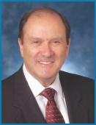
engineering. | • Expertise in corporate strategy

◆DENNIS L.

REDIKER

Director Since: 2003

Age: 73

Member of the Audit Committee

and the Finance Committee.

Director Compensation

Martin Marietta uses a combination of cash and stock-based incentive compensation to attract and retain qualified candidates to serve on the Board of Directors. In setting Director compensation, Martin Marietta considers the significant amount of time that Directors expend in fulfilling their duties to Martin Marietta as well as the skill level required by Martin Marietta of members of the Board. The Board determines reasonable compensation for Directors upon recommendation of the Management Development and Compensation Committee of the Board, which retains independent compensation consultants to assist it.

Cash Compensation Paid to Board Members

For the fiscal year ended December 31, 2016, all the individuals who were then Directors, except Mr. Nye, who was the Chief Executive Officer of Martin Marietta in 2016 and was not and is not compensated separately for his service as a Director, were paid an annual cash retainer, as well as an equity grant of restricted stock units (“RSUs”), which is discussed below. The annual retainer for Board members was $100,000. Members of the Audit Committee received an additional $5,000 in view of their increased responsibilities. Each committee chair received an additional annual fee of $8,000, except the Chair of the Audit Committee, who received an additional annual fee of $15,000 in light of his increased responsibilities. In his role as Lead Independent Director, Mr. Quillen received an additional annual fee of $25,000. The annual cash retainer and supplemental fees are paid in quarterly installments, measured from the end of the month during which the Annual Meeting of Shareholders is held. Directors were also reimbursed for travel and other

expenses related to attendance at Board and committee meetings. Martin Marietta’s plane was used to transport some Directors to and from Board and committee meetings, but no Directors received personal use of Martin Marietta’s plane or other perquisites and personal benefits in 2016.

Equity Compensation Paid to Board Members

Non-employee Directors received an award of RSUs with a value of $100,000 (rounded up to the nearest RSU) based on the closing price as of the date of grant, which was generally immediately following the 2016 Annual Meeting of Shareholders in May 2016. In 2016, this award was 541 RSUs. Mr. Koraleski, who was appointed to the Board on August 15, 2016, received 502 RSUs. The RSUs granted to the Directors in 2016 were fully vested upon award. Directors are required to defer at least 50% of the RSUs until retirement from the Board. Directors may choose to voluntarily defer an additional portion of their RSUs, and any RSUs that are not so deferred will settle in shares of common stock of Martin Marietta as soon as practicable following the grant date. The RSUs were awarded under the Martin Marietta Amended and Restated Stock-Based Award Plan (the “Stock Plan”), which was approved by shareholders on May 19, 2016. The Stock Plan provides that, during any calendar year, no non-employee Director may be granted (i) restricted shares and other full-value stock-based awards, including RSUs, in respect of more than 7,000 shares of common stock of Martin Marietta or

- options or stock appreciation rights in respect of more than 20,000 shares of common stock of Martin Marietta.

The Directors do not have voting or investment power for their respective RSUs.

2017 PROXY STATEMENT | 11

Table of Contents

Proposal 1: Election of Directors ◆ Director Compensation

Deferred Compensation Program for Board Members

The Common Stock Purchase Plan for Directors provides that non-employee Directors may elect to receive all or a portion of their fees earned in 2016 in the form of Martin Marietta’s common stock units. If deferral is elected, there is a mandatory deferral minimum time of three years with, subject to certain restrictions, redeferrals at each Director’s election up to the date the person ceases to be a Director or the date that is one year and one month following the date that the person ceases to be a Director. Directors may elect to receive payment of the deferred amount in a single lump sum or in equal annual installments for a period up to ten years. Directors may also elect to defer their fees paid in cash on the same basis. Amounts

Director Compensation Table

deferred under the plan in cash are credited with interest at the prime rate. Amounts deferred under the plan in common stock are credited toward units of common stock at a 20% discount from the fair market value of the common stock (the closing price of the common stock as reported in the Wall Street Journal) on the date the Director fees would otherwise be paid. There are no matching contributions made by Martin Marietta. The units are converted into common stock of Martin Marietta pursuant to the terms of the plan. Dividend equivalents are paid on the units at the same rate as dividends are paid to all shareholders. The Directors do not have voting or investment power for their respective common stock units.

The table below summarizes the compensation paid by Martin Marietta to each person who served as a non-employee Director during the fiscal year ended December 31, 2016.

 |  |  |  |  | Change in Pension
 |  |  |  |  | Value and
 |  |  |  |  | Nonqualified
 | Fees |  |  | Non-Equity | Deferred
 | Earned or | Stock | Option | Incentive Plan | Compensation | All Other
 | Paid in Cash | Awards | Awards | Compensation | Earnings | Compensation | Total
Name¹ | ($)² | ($)³ | ($)⁴ | ($) | ($)⁵ | ($)⁶ | ($)
(a) | (b) | (c) | (d) | (e) | (f) | (g) | (h)
Sue W. Cole | 108,000 | 100,053 |  |  | 9,982 | 64,603 | 282,638
John J. Koraleski | 52,500 | 100,129 |  |  | 2 | 422 | 153,053
David G. Maffucci | 120,000 | 100,053 |  |  | 5,725 | 32,923 | 258,701
William E. McDonald | 102,000 | 100,053 |  |  | 12,238 | 67,464 | 281,755
Frank H. Menaker, Jr.⁷ | 26,250 | 0 |  |  | 5,201 | 17,712 | 49,163
Laree E. Perez | 113,000 | 100,053 |  |  | 4,361 | 28,366 | 245,780
Michael J. Quillen | 131,000 | 100,053 |  |  | 3,941 | 58,395 | 293,389
Dennis L. Rediker | 105,000 | 100,053 |  |  | 7,669 | 35,071 | 247,793
Richard A. Vinroot⁷ | 27,000 | 0 |  |  | 4,832 | 35,663 | 67,495
Donald W. Slager | 75,000 | 100,053 |  |  | 6 | 671 | 175,730
Stephen P. Zelnak, Jr. | 106,000 | 100,053 |  |  | 3,012 | 34,535 | 243,600

- Mr. Nye, who is the Chief Executive Officer of Martin Marietta and a member of the Board of Directors, is not included in this table because he is not compensated separately for his service as a Director. The compensation received by Mr. Nye as an employee of Martin Marietta is shown in the Summary Compensation Table on page 43.

- The amounts in column (b) reflect fees earned in 2016. Some of these fees were deferred pursuant to the Common Stock Purchase Plan for Directors in the form of common stock units. The number of units of common stock credited in 2016 to each of the Directors under the Common Stock Purchase Plan for Directors and the grant date fair value for these awards determined in accordance with FASB ASC Topic 718, which includes the 20% discount, are as follows: Ms. Cole, 755 units and $108,236 value, respectively; Mr. Koraleski, 0; Mr. Maffucci, 169 units and $24,245 value, respectively; Mr. McDonald, 717 units and $102,289 value, respectively; Mr. Menaker, 231 units and $26,356 value, respectively Ms. Perez, 160 units and $22,956 value, respectively; Mr. Quillen, 912 units and $131,275 value, respectively; Mr. Rediker, 148 units and $21,194 value, respectively; Mr. Vinroot, 237 units and $27,041 value, respectively; Mr. Slager, 0; and Mr. Zelnak, 370 units and $53,297 value, respectively. The number of units credited to each of the Directors as of December 31, 2016, including units accumulated under the plan for all years of service as a Director, is as follows: Ms. Cole, 14,622; Mr. Maffucci, 8,895; Mr. McDonald, 17,223; Mr. Menaker, 0; Ms. Perez, 5,258; Mr. Quillen, 7,359; Mr. Rediker, 9,709; Mr. Vinroot, 15,290; and Mr. Zelnak, 5,881. The 20% discount from the market price of Martin Marietta’s common stock used in converting to common stock is reported in column (g).

- Each Director who was serving immediately following the 2016 Annual Meeting of Shareholder received 541 RSUs in 2016. Mr. Koraleski, who was appointed to the Board on August 15, 2016, received 502 RSUs in 2016. The amounts in column (c) reflect the grant date fair value for these awards determined in accordance with FASB ASC Topic 718. The RSUs fully vested upon award and will be distributed to the Director upon retirement, except Mr. Maffucci received a distribution of 271 unrestricted shares of common stock and deferred the distribution of 270 RSUs until retirement.

- As of December 31, 2016, each Director held options for common stock in the amounts as follows: Ms. Cole, 6,000; Mr. Koraleski, 0; Mr. Maffucci, 0; Mr. McDonald, 6,000; Mr. Menaker, 6,000; Ms. Perez, 6,000; Mr. Quillen, 3,000; Mr. Rediker, 0; Mr. Slager, 0; Mr. Vinroot, 3,000; and Mr. Zelnak, 0.
- The amounts in column (f) reflect interest paid on fees deferred in cash under the Common Stock Purchase Plan for Directors.

- The amounts in column (g) reflect for each Director: (i) an amount equal to the 20% discount from the market price of Martin Marietta’s common stock used in converting fees deferred in 2016 into common stock units pursuant to the Common Stock Purchase Plan for Directors, and (ii) the dollar value of dividend equivalents paid in 2016 on common stock units held under the plan. The Directors did not receive perquisites or other personal benefits in 2016.
- Messrs. Menaker and Vinroot retired at the 2016 Annual Meeting of Shareholders in accordance with the Bylaws that provide for retirement following the Director’s 75th birthday.

- 2017 PROXY STATEMENT

Table of Contents

Security Ownership of Certain

Beneficial Owners and Management

How much stock do Martin Marietta’s Directors and executive officers own?

The following table sets forth information as of March 10, 2017 with respect to the shares of common stock that are beneficially owned by the Directors, the Chief Executive Officer, the Chief Financial Officer, and the three other named executive officers who are listed in the Summary Compensation Table on page 43 of this proxy statement, individually, and by all Directors and executive officers of Martin Marietta as a group.

 | Amount and Nature of | Deferred and
Name of Beneficial Owner | Beneficial Ownership¹ | Restricted Units | Total
Roselyn R. Bar | 41,799² | 17,867 | 59,666
Sue W. Cole | 32,912^{3,4} | — | 32,912
Daniel L. Grant | 971² | 11,959 | 12,930
John J. Koraleski | 502³ | — | 502
Anne H. Lloyd | 63,245² | 20,996 | 84,241
David G. Maffucci | 16,658³ | — | 16,658
Donald A. McCunniff | 10,711² | 13,444 | 24,155
William E. McDonald | 25,875³ | — | 25,875
C. Howard Nye | 124,956² | 59,306 | 184,262
Laree E. Perez | 16,765³ | — | 16,765
Michael J. Quillen | 19,059³ | — | 19,059
Dennis L. Rediker | 18,247³ | — | 18,247
Donald W. Slager | 541³ | — | 541
Stephen P. Zelnak, Jr. | 6,938³ | — | 6,938
All Directors and executive officers as a
group
(15 individuals including those named
above) | 398,104^{3,4} | 134,715⁵ | 532,819⁶

- As to the shares reported, unless indicated otherwise, (i) beneficial ownership is direct, and (ii) the person indicated has sole voting and investment power. None of the Directors or named executive officers individually own in excess of one percent of the shares of common stock outstanding. All Directors and executive officers as a group own 8.45% of the shares of common stock outstanding as of March 10, 2017. None of the shares reported are pledged as security.

- The number of shares owned for each of Mr. Nye, Ms. Lloyd, Ms. Bar, Mr. McCunniff and Mr. Grant assumes that options held by each of them covering shares of common stock in the amounts indicated, which are currently exercisable within 60 days of March 10, 2017, have been exercised: Mr. Nye, 66,018; Ms. Lloyd, 26,339; Ms. Bar, 14,097; Mr. McCunniff, 8,238; and Mr. Grant, 0.

- Amounts reported include (1) compensation paid on an annual basis that Directors have received in common stock units that are deferred pursuant to the Amended and Restated Martin Marietta Materials, Inc. Common Stock Purchase Plan for Directors and (2) RSUs that each Director received in 2016 as part of their compensation. The Directors do not have voting or investment power for their respective common stock units and RSUs. The number of common stock units credited to each of the Directors pursuant to the Common Stock Purchase Plan as of March 10, 2017 is as follows: Ms. Cole, 14,779; Mr. Koraleski, 0; Mr. Maffucci, 8,930; Mr. McDonald, 17,368; Ms. Perez, 5,258; Mr. Quillen, 7,552; Mr. Rediker, 9,740; Mr. Slager, 0; and Mr. Zelnak, 5,960. Amounts reported also include options for common stock for each Director, all of which are currently exercisable, as follows: Ms. Cole, 3,000; Mr. Koraleski, 0; Mr. Maffucci, 0; Mr. McDonald, 0; Ms. Perez, 3,000; Mr. Quillen, 3,000; Mr. Rediker, 0; Mr. Slager, 0; and Mr. Zelnak, 0.

- Includes an approximation of the number of shares in IRA account.

- The amounts reported include common stock units credited to each of the named executives in connection with (i) their deferral of a portion of their cash bonus under the Martin Marietta Materials, Inc. Incentive Stock Plan, and (ii) RSUs (not including any performance-based share units (“PSUs”) granted under the Stock Plan that are subject to forfeiture in accordance with the terms of the plan, each in the following amounts: Mr. Nye, 16,992 and 42,314, respectively; Ms. Lloyd, 3,119 and 17,877, respectively; Ms. Bar, 2,856 and 15,011, respectively; Mr. McCunniff, 1,491 and 11,953, respectively; and Mr. Grant, 1,980 and 9,979, respectively. There are no voting rights associated with the stock units.

2017 PROXY STATEMENT | 13

Table of Contents

Security Ownership of Certain Beneficial Ownership and Management ◆ Section 16(a) Beneficial Ownership Reporting Compliance

- Amounts reported include: (1) 127,216 options held by Directors and executive officers, which are currently exercisable or exercisable within 60 days of March 10, 2017;
(2) 28,086 common stock units credited to executive officers in connection with their deferral of a portion of their cash bonus under the Martin Marietta Materials, Inc. Incentive Stock Plan; (3) 106,629 common stock units credited to executive officers in connection with RSUs granted under the Stock Plan that are subject to forfeiture in accordance with the terms of the Plan; and (4) 58,163 common stock units credited to the Directors in connection with RSUs granted under the Stock Plan. There are no voting rights associated with the stock units.

Section 16(a) Beneficial Ownership Reporting Compliance

Section 16(a) of the Exchange Act requires Directors and officers of Martin Marietta and persons who own more than 10% of the common stock to file with the Securities and Exchange Commission initial reports of ownership and reports in changes in ownership of the common stock. Directors, officers and more than 10% shareholders are required by Securities and Exchange Commission regulations to furnish to Martin Marietta copies of all Section 16(a) reports filed. Based solely on its review of copies of reports furnished to Martin Marietta and written representations of Directors and officers, the company believes that during fiscal year 2016, such filing requirements were satisfied.

Who are the largest owners of Martin Marietta’s stock?

The following table sets forth information with respect to the shares of common stock which are held by persons known to Martin Marietta to be the beneficial owners of more than 5% of such stock as of March 10, 2017. To the best of Martin Marietta’s knowledge, based on filings with the Securities and Exchange Commission as noted below, no person beneficially owned more than 5% of any class of Martin Marietta’s outstanding voting securities at the close of business on March 10, 2017, except for those shown below.

Name and Address | Amount and Nature | Percent
of Beneficial Owner | of Beneficial Ownership | of Class
The Vanguard Group¹
100 Vanguard Boulevard V26
Malvern, PA 19355 | 6,031,329 | 9.5%
BlackRock, Inc.²
55 East 52nd Street
New York, NY 10055 | 3,690,187 | 5.8%

- Rowe Price Associates, Inc.³ 100 East Pratt St.

Baltimore, MD 21202-1009 | 3,628,096 | 5.7%

- As reported in Schedule 13G/A reporting beneficial ownership as of December 31, 2016 filed with the Securities and Exchange Commission on February 10, 2017, indicating sole power to vote 96,957 shares, shared power to vote 10,329 shares, sole power to dispose of 5,925,589 shares, and shared power to dispose of 105,740 shares.

- As reported in Schedule 13G/A reporting beneficial ownership as of December 31, 2016 filed with the Securities and Exchange Commission on January 25, 2017, indicating sole power to vote 3,161,955 shares and sole power to dispose of 3,690,187 shares.

- As reported in Schedule 13G/A reporting beneficial ownership as of December 31, 2016 filed with the Securities and Exchange Commission on February 7, 2017, indicating sole power to vote 1,177,200 shares and sole power to dispose of 3,628,096 shares.

- 2017 PROXY STATEMENT

Table of Contents

Corporate Governance Matters

Corporate Governance Philosophy

Martin Marietta has a culture dedicated to ethical business behavior and responsible corporate activity, which we believe promotes the long-term interests of shareholders. This commitment is reflected in our Corporate Governance Guidelines, posted and available for public viewing on Martin Marietta’s website at www.martinmarietta.com, which set forth a flexible framework within which the Board, assisted by its Committees, directs the affairs of Martin Marietta. The Guidelines address, among other things, the composition and functions of the Board of Directors, director qualifications and independence, Chief Executive Officer performance evaluation and management succession, Board Committees and the selection of new Directors.

Martin Marietta’s Code of Ethical Business Conduct has been in place since the 1980s, and applies to all Board members, officers, and employees, providing our policies and expectations on a number of topics, including our commitment to good

citizenship, promoting a positive and safe work environment, avoiding conflicts of interest, honoring the confidentiality of sensitive information, preservation and use of Company assets, compliance with all laws, and operating with integrity in all that we do. To implement the Code of Ethical Business Conduct, Board members, officers, and employees participate regularly in ethics training. There have been no waivers from any provisions of our Code of Ethical Business Conduct to any Board member or executive officer.

In addition, the Board believes that accountability to shareholders is a mark of good governance and critical to Martin Marietta’s success. To that end, management regularly engages with shareholders on a variety of topics throughout the year to ensure we are addressing their questions and concerns, to seek input and to provide perspective on Company policies and practices.

The chart below provides a snapshot of Martin Marietta’s governance highlights.
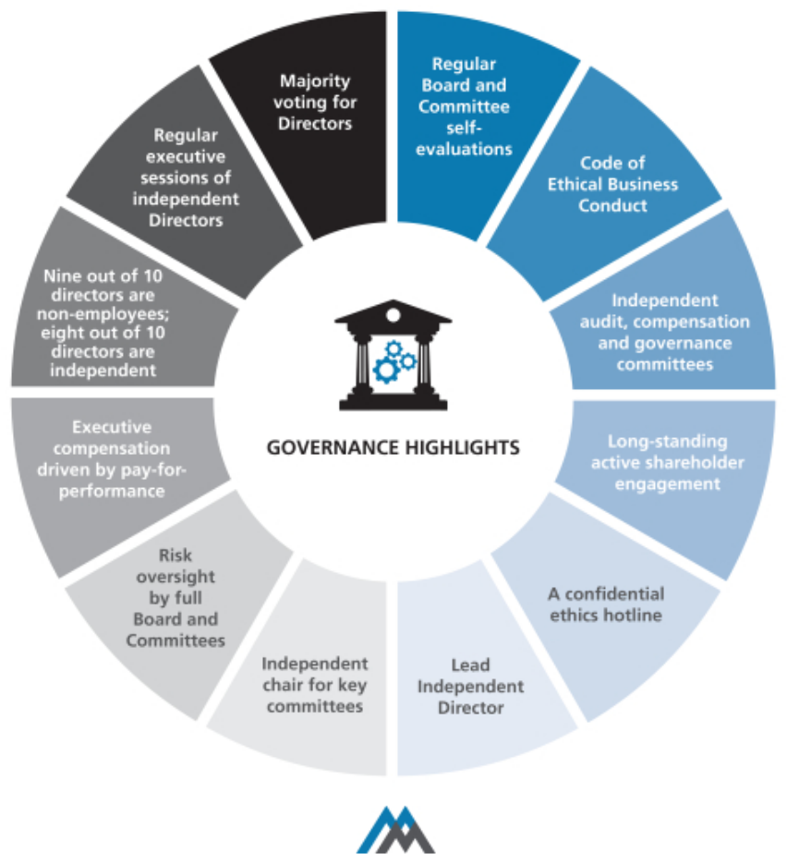

2017 PROXY STATEMENT | 15

Table of Contents

Corporate Governance Matters ◆ Corporate Governance Philosophy

Who are Martin Marietta’s Independent Directors?

All of Martin Marietta’s Directors are non-employee Directors except Mr. Nye. Mr. Nye does not sit in the executive sessions of the independent Directors unless invited to attend for a specific discussion nor does he participate in any action of the Board relating to any executive compensation which he may receive.

In assessing the independence of its members, the Board has adopted for Martin Marietta a set of Guidelines for Director’s Independence. The Guidelines are posted and available for public viewing on Martin Marietta’s website at www.martinmarietta.com. These Guidelines reflect the rules of the New York Stock Exchange, applicable requirements of the SEC, and other standards determined by the Board to be important in assessing the independence of Board members. The Board has determined that all members of the Board, except Mr. Nye and Mr. Zelnak, are “independent” under these Guidelines, resulting in more than two-thirds of the Board being independent. The Board of Directors has determined that no Director (except Mr. Nye and Mr. Zelnak), or any person or organization with which the Director has any affiliation, has a relationship with Martin Marietta that may interfere with his or her independence from Martin Marietta and its management. In making this “independence” determination, the Board considered other entities with which the Directors were affiliated and any business Martin Marietta had done with such entities.

Do the independent Directors ever meet without management?

Martin Marietta’s Corporate Governance Guidelines adopted by the Board provide that at least two Board meetings each year will include an executive session of the non-employee Directors to discuss such topics as they may choose, including a discussion of the performance of Martin Marietta’s Chairman and Chief Executive Officer. In 2016, Martin Marietta’s non-employee Directors met at each regularly scheduled Board meeting, consisting of four times in executive session without management, in addition to executive sessions held by committees of the Board. In addition, at least once a year the independent Directors meet in executive session.

What is the Board’s leadership structure?

Our Corporate Governance Guidelines provide that the Board’s policy as to whether the Chairman and CEO positions should be separate is to adopt the practice that best serves the Company’s needs at any particular time. The Nominating and Governance Committee and the Board discussed board leadership alternatives in connection with combining the Chairman and CEO roles.

The Board believes that, at the present time, the Company is best served by allocating governance responsibilities between a combined Chairman and CEO and a Lead Independent Director with robust responsibilities. This structure allows the Company

- 2017 PROXY STATEMENT

to present a single face to our constituencies through the combined Chairman and CEO position while at the same time providing an active role and voice for the independent directors through the Independent Lead Director.

REASONS FOR COMBINED CHAIR AND CEO


Key highlights:

- The independent Board members believe that Mr. Nye has extensive experience in all facets of the construction materials industry, in both the U.S. and with global competitors.

- Mr. Nye has been effective in creating shareholder value through strategic acquisitions and divestitures, with achievement of expected synergies.

- Mr. Nye has in-depth knowledge of safety, environmental, and regulatory considerations that impact the business and oversight of management.

- Mr. Nye has demonstrated his leadership and vision to guide the Board in its oversight of management with the development of two five-year strategic plans, with the current Strategic Operating Analysis and Review (SOAR 2020) discussed with the Board in August 2015.

- Mr. Nye has engaged in an active investor relations program, including the Company’s Investor Day in 2016, and leads the Board in understanding the perspective of the Company’s shareholders.

- Strong independent directors comprise 80% of the Board, and open communications exist between Mr. Nye and the independent directors.

As a result of Mr. Nye’s long tenure at Martin Marietta and strong performance as a leader since his election as CEO, the Board believes he is uniquely qualified through his experience, education and expertise to be the person who promotes strong and visionary leadership for our Board as well as important recognition as the leader of Martin Marietta by our customers, employees and other constituencies. The Board also believes that Mr. Nye’s serving as both Chairman and CEO is appropriate taking into consideration the size and nature of our business, Mr. Nye’s effective and careful formulation and execution of our strategic plan, his established working relationship and open communication with our other Directors, both during meetings and in the intervals between meetings, the significant board-level experience of our independent Directors as a whole, the strong independent leadership and accountability to shareholders provided by 80% of our Directors being independent, the independent leadership provided by our Committee chairs, and our Board culture in which Mr. Nye and the other Directors are able to thoughtfully debate different points of view and reach consensus in an efficient manner.

Table of Contents

Corporate Governance Philosophy ◆ Corporate Governance Matters

Does the Board have a Lead Independent Director?

In deciding that a combined Chairman and Chief Executive Officer position is the appropriate leadership structure for the Company at this time, the Nominating and Corporate Governance Committee and Board also recognized the benefit of independent leadership to enhance the effectiveness of the Board’s oversight role and communications between the Board and Mr. Nye. Accordingly, in November 2014, our Corporate Governance Guidelines were revised to provide that in the event the Chairman and Chief Executive Officer positions are held by one person, our independent Directors may designate a Lead Independent Director from among the independent Directors. The designation of the Lead Independent Director is to be made annually, although with the expectation of the Board that the Lead Independent Director will be re-appointed for multiple, consecutive one-year terms. Michael J. Quillen currently serves as the Lead Independent Director.

The responsibilities of the Lead Independent Director include:

- Presiding at Board meetings when the Chairman is not present.

- Presiding at executive sessions of the non-management Directors and the independent Directors, with or without the attendance of the Chairman, and meeting separately with the Chairman after executive sessions to review the matters discussed during the executive sessions.

- Acting as a liaison between the Chairman and the independent Directors.

- Suggesting to the Chairman agenda items for Board meetings and consulting with the Chairman regarding Board meeting schedules.

- Calling, where necessary, meetings of independent Directors and executive sessions.

- Being available to meet with shareholders and other key constituents.

- Acting as a resource for, and counsel to, the Chairman.

In addition, the Lead Independent Director attended and met with shareholders at the Company-sponsored Investor Days in 2015 and 2016.

What is the Board’s role in risk oversight?

Our Board currently has eight independent members and only two non-independent members, Mr. Nye and Mr. Zelnak. A number of our independent Board members are serving or have served as members of senior management of other public companies, have served as directors of other public companies, and otherwise have experience and/or educational backgrounds that we believe qualify them to effectively assess risk. Each of our Board Committees, including our key committees of Audit, Management Development and Compensation, and Nominating and Corporate Governance Committees, are comprised solely of independent Directors, each with a different independent

Director serving as Chair of the Committee (other than the Executive Committee, which does not meet on a regular basis).

The Board has overall responsibility for oversight of risk management. The Board believes that an effective risk management system will (1) timely identify the material risks that Martin Marietta faces, (2) communicate necessary information with respect to material risks to senior executives and, as appropriate, to the Board or relevant Board Committee,

- determine whether the risk is excessive or appropriate under the circumstances and designed to achieve a legitimate corporate goal,
- implement risk management responses consistent with Martin Marietta’s risk profile, and (5) integrate risk management into Martin Marietta’s decision-making.

The Board delegates certain responsibilities to Board Committees to assist in fulfilling its risk oversight responsibilities. Each of the Committees reports regularly to the full Board of Directors as to actions taken and topics discussed. In addition, the Board regularly reviews with management the most significant risks facing Martin Marietta, the probabilities of those risks occurring, the steps taken to mitigate any impact of risks, and management’s general risk management strategy. In addition, the Board encourages management to promote a corporate culture that incorporates risk management into Martin Marietta’s day-to-day operations.

The Board has designated the Audit Committee to take the lead in overseeing risks related to financial reporting, financial statements, internal control environment, internal audit, independent audit, and accounting processes. The Finance Committee evaluates risks associated with Martin Marietta’s capital structure, including credit and liquidity risks. The Management Development and Compensation Committee oversees aspects of risk related to the annual performance evaluation of our Chief Executive Officer, succession planning and ensuring that executive compensation is appropriate to meet Martin Marietta’s objectives. That Committee’s assessment of the design features of our executive compensation program that reduce the risk of excessive risk-taking are discussed in the Compensation Discussion and Analysis on page 28. The Nominating and Corporate Governance Committee oversees aspects of risk related to the composition of the Board and its Committees, Board performance and best practices in corporate governance. The Ethics, Environment, Safety and Health Committee monitors risks in the areas of Martin Marietta’s ethics program, health, safety, and the environment.

While the Board oversees Martin Marietta’s risk management, the executive officers are responsible for the day-to-day risk management processes. We believe this division of responsibilities is the most effective approach for addressing the risks facing our Company and is appropriate whether the positions of Chairman and Chief Executive Officer are separate or held by the same individual.

2017 PROXY STATEMENT | 17

Table of Contents

Corporate Governance Matters ◆ Corporate Governance Philosophy

How would interested parties make their concerns known to the independent Directors?

The Board of Directors provides a process for shareholders and other interested parties to send communications to the Board. Shareholders and other interested parties may communicate anonymously and confidentially with the Board through Martin Marietta’s Ethics Hotline at 1-800-209-4508. The Board has also designated the Corporate Secretary to facilitate communications to the Board. Shareholders and other interested parties may communicate directly with the Board of Directors, or directly with non-management Directors, or an individual Director, including the Lead Independent Director, by writing to Martin Marietta, Attn: Corporate Secretary, 2710 Wycliff Road, Raleigh, North Carolina 27607-3033.

All communications by shareholders or other interested parties addressed to the Board will be sent directly to Board members. While Martin Marietta’s Ethics Office and the Corporate Secretary may review, sort, and summarize these communications, all direct communications will be presented to the non-management Directors unless there is instruction from them to filter such communications (and in such event, any communication that has been filtered out will be made available to any non-management Director who wishes to review it).

Martin Marietta and its Board of Directors will continue to review and evaluate the process by which shareholders or other

- 2017 PROXY STATEMENT

interested persons communicate with Martin Marietta and the Board and may adopt other or further processes and procedures in this regard. If so, Martin Marietta will identify those policies and procedures on our website at www.martinmarietta.com.

How often did the Board meet during 2016?

Martin Marietta’s Board of Directors held four meetings during 2016, all of which were regularly scheduled meetings. There were also a total of 25 committee meetings in 2016. In addition, management confers frequently with its Directors on an informal basis to discuss Company affairs.

How many times did Directors attend meetings of the Board and its Committees?

In 2016, all Directors attended 100% of the meetings of the Board of Directors. All Directors attended 100% of the meetings of the committees of the Board on which they served (during the periods that they served).

Will the Directors attend the Annual Meeting?

Martin Marietta’s Directors are expected to attend Martin Marietta’s Annual Meeting of Shareholders. In 2016, all Directors attended the Annual Meeting in May other than Mr. Koraleski, who joined the Board of Directors in August 2016.

Table of Contents

Board Committees ◆ Corporate Governance Matters

Board Committees

Martin Marietta’s Board of Directors has six standing committees: the Audit Committee, the Ethics, Environment, Safety and Health Committee, the Executive Committee, the Finance Committee, the Management Development and Compensation Committee, and the Nominating and Corporate Governance Committee. Each committee has a written charter

that describes its purposes, membership, meeting structure, authority and responsibilities. These charters are reviewed by the respective committee on an annual basis with any recommended changes adopted upon approval by our Board. The charters of our six standing committees are posted on our website.

Below is a summary of our current committee structure and membership information.

 |  | Ethics,
 |  | Environment,
 | Audit | Safety and Health
Director | Committee | Committee
Sue W. Cole
David G. Maffucci | Chair
Financial Expert | Chair
John J. Koraleski
Financial Expert
William E. McDonald
C. Howard Nye
Laree E. Perez |  | Chair
Financial Expert |  | Chair
Michael J. Quillen
Lead Independent Director
Dennis L. Rediker
Financial Expert
Donald W. Slager
Stephen P. Zelnak, Jr.
Number of Meetings | 11 | 2
in 2016 | 11 | 2
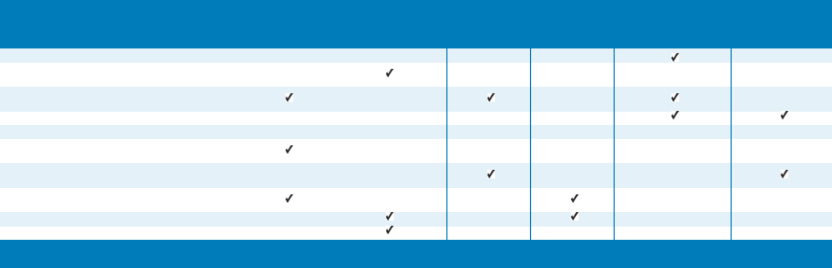

 |  | Management | Nominating
 |  | Development and | and Corporate
Executive | Finance | Compensation | Governance
Committee | Committee | Committee | Committee
 |  |  | Chair

Chair

Chair

Chair

0 5 5 2

The Executive Committee held no meetings during 2016. It has the authority to act during the intervals between the meetings of the Board of Directors and may exercise the powers of the Board in the management of the business and affairs of Martin Marietta as may be authorized by the Board of Directors,

except to the extent such powers are by statute, the Articles of Incorporation or Bylaws reserved to the full Board. The Committee’s current members are Directors Nye (Chair), Koraleski, and Quillen.

2017 PROXY STATEMENT | 19

Table of Contents

Corporate Governance Matters ◆ Board Committees

The primary responsibilities, membership and meeting information for our other standing committees are summarized below.
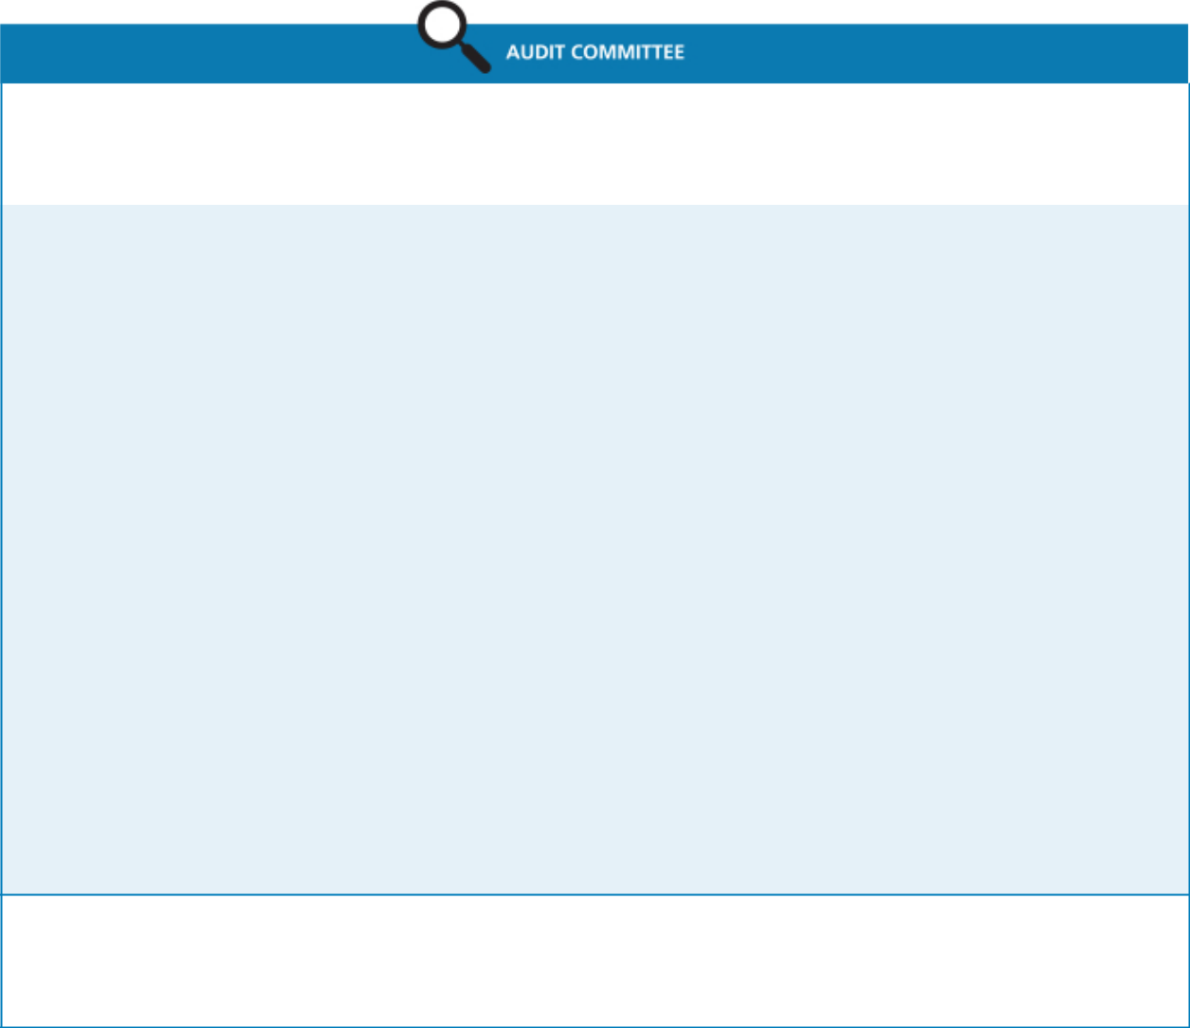

Current Members:
David G. Maffucci (Chair) | Meetings in 2016: | Average Attendance in 2016:
John J. Koraleski | Meetings in 2016: | Average Attendance in 2016:
John J. Koraleski | 11 | 100%
Laree E. Perez | 11 | 100%
Dennis L. Rediker
Primary Responsibilities:

- reviews our significant accounting principles, policies and practices in reporting our financial results under generally accepted accounting principles;

- reviews our annual audited financial statements and related disclosures;

- reviews management letters or internal control reports, and reviews our system of internal control over financial reporting;

- appoints, retains and oversees the work of the independent accountants;

- reviews the effectiveness of the independent audit effort;

- pre-approves audit and permissible non-audit services provided by the independent registered public accounting firm;

- reviews our interim financial results for each of the first three fiscal quarters;

- reviews the qualifications and the plan and scope of work of the corporate internal audit function;

- reviews and discusses the reports of our internal audit group;

- reviews and discusses management’s assessment of the effectiveness of Martin Marietta’s system of internal control over financial reporting;

- discusses Martin Marietta’s earnings press releases, as well as financial information and earnings guidance provided to analysts and rating agencies;

- discusses matters related to risk assessment and risk management and how the process is handled by management;

- reviews and oversees related party transactions;

- reviews complaints regarding accounting, internal controls or auditing matters;

- considers allegations of possible financial fraud or other financial improprieties;

- reviews annually the adequacy of the committee charter and recommends proposed changes to the Board; and

- prepares the annual Audit Committee Report to be included in the proxy statement.

Other Governance Matters:

All members satisfy the audit committee experience and independence standards required by NYSE, and have been determined to be financially literate.

Each member of the Audit Committee has been determined to be an ‘‘audit committee financial expert’’ under applicable SEC regulations.

- 2017 PROXY STATEMENT

Table of Contents

Board Committees ◆ Corporate Governance Matters

Current Members:
Laree E. Perez (Chair) | Meetings in 2016: | Average Attendance in 2016:
David G. Maffucci | Meetings in 2016: | Average Attendance in 2016:
David G. Maffucci | 2 | 100%
Donald W. Slager | 2 | 100%
Stephen P. Zelnak, Jr.
Primary Responsibilities:
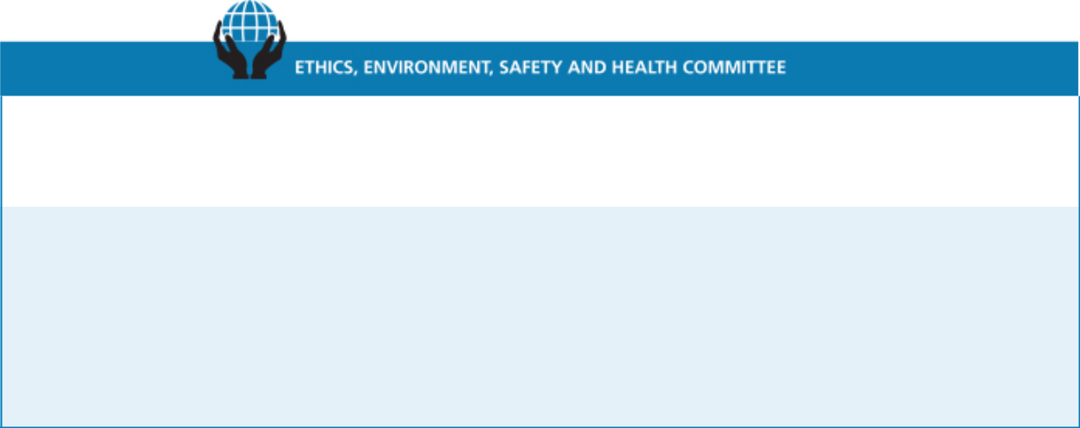

- monitors compliance with our Code of Ethical Business Conduct and reviews all matters presented to it by the Corporate Ethics Officer concerning the ethical practices of Martin Marietta and its Directors, officers, and employees, including conflicts or potential conflicts of interest between Martin Marietta and any of its Directors, officers, and employees;

- reviews and monitors the adequacy of our policies and procedures and organizational structure for ensuring compliance with environmental laws and regulations;

- reviews matters relating to our health and safety programs and performance; and

- reviews annually the adequacy of the committee charter and recommends proposed changes to the Board.

Current Members: | Meetings in 2016: | Average Attendance in 2016:
Stephen P. Zelnak, Jr. (Chair) | Meetings in 2016: | Average Attendance in 2016:
Dennis L. Rediker | 5 | 100%
Donald W. Slager
Primary Responsibilities:
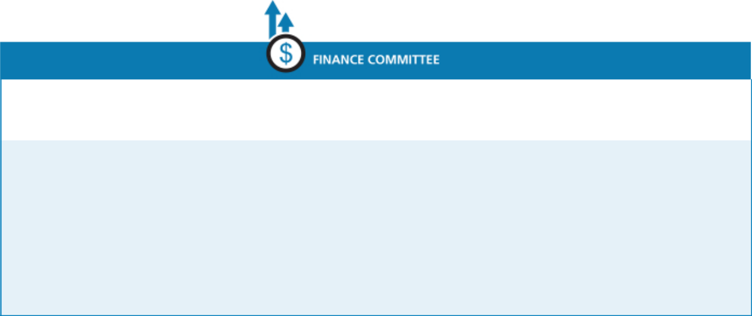

- provides general oversight relating to the management of our financial affairs;

- reviews and approves establishment of lines of credit or other short-term borrowing arrangements and investing excess working capital funds on a short-term basis;

- reviews and makes recommendations to the Board concerning changes to capital structure, including the incurrence of long-term debt, issuance of equity securities, share repurchases, and the payment of dividends, as well as capital expenditures;

- approves our contributions budget; and

- reviews annually the adequacy of the committee charter and recommends proposed changes to the Board.

2017 PROXY STATEMENT | 21

Table of Contents

Corporate Governance Matters ◆ Board Committees
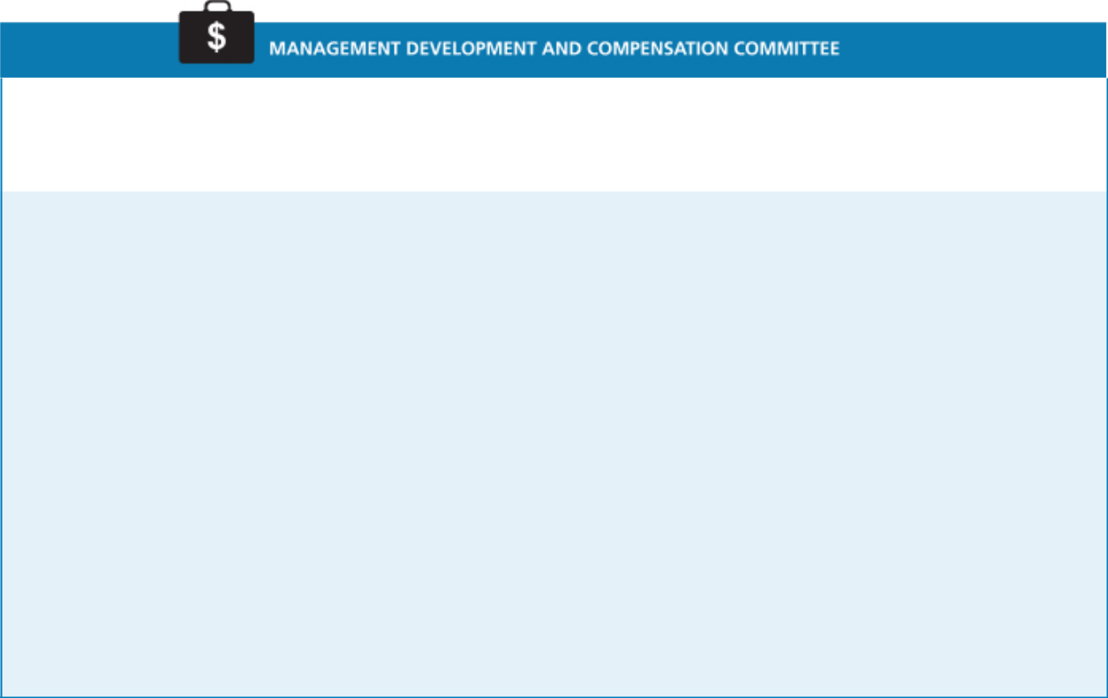

Current Members:
Michael J. Quillen (Chair) | Meetings in 2016: | Average Attendance in 2016:
Sue Cole | Meetings in 2016: | Average Attendance in 2016:
Sue Cole | 5 | 100%
John J. Koraleski | 5 | 100%
William E. McDonald
Primary Responsibilities:

- establishes an overall strategy with respect to compensation for officers and management to enable Martin Marietta to attract and retain qualified employees;

- reviews and oversees executive succession and management development plans;

- reviews and approves management’s assessment of the performance of executive officers, and reviews and approves the salary, bonus, and other compensation of such officers;

- approves and administers our equity and other plans relating to compensation of Martin Marietta’s directors and elected officers;

- reviews and discusses the Compensation Discussion and Analysis and produces a compensation committee report as required by the SEC to be included in this proxy statement;

- provides oversight of our Benefit Plan Committee, which administers Martin Marietta’s defined benefit and contribution plans;

- reviews and approves the goals and objectives for the CEO’s compensation, evaluates the CEO’s performance in light of those goals and objectives, and determines and approves the CEO’s compensation;

- makes recommendations to the Board on changes in the compensation of non-employee directors;

- reviews annually the adequacy of the committee charter and recommends proposed changes to the Board; and

- has the authority, in its sole discretion, to retain, pay, and terminate any consulting firm, if any, used to assist in evaluating director, chief executive officer, or senior executive compensation.
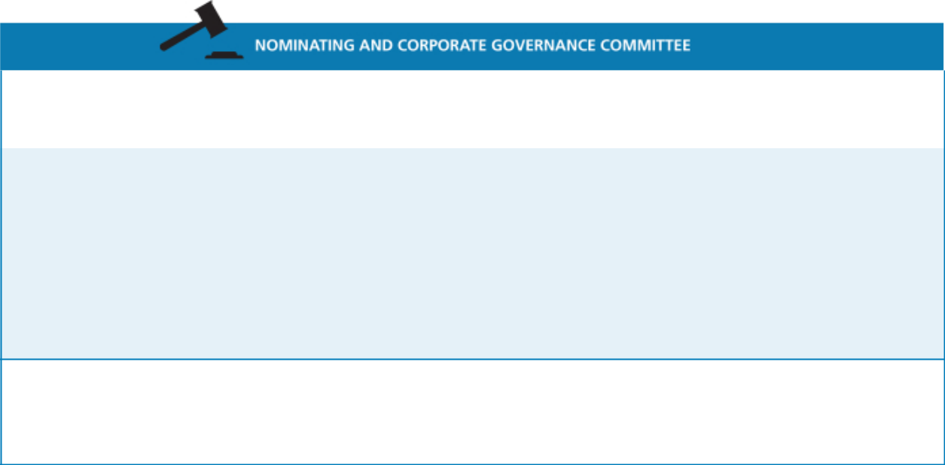

Current Members: | Meetings in 2016: | Average Attendance in 2016:
Sue W. Cole (Chair) | Meetings in 2016: | Average Attendance in 2016:
William E. McDonald | 2 | 100%
Michael J. Quillen
Primary Responsibilities:

- develops criteria for nominating and appointing directors, including Board size and composition, corporate governance policies, and individual director expertise, attributes and skills;

- recommends to the Board the individuals to be nominated as directors;

- recommends to the Board the appointees to be selected for service on the Board committees;

- oversees an annual review of the performance of the Board and each committee;

- reviews annually the adequacy of the committee charter and recommends proposed changes to the Board; and

- oversees the development and implementation of a set of corporate governance principles applicable to Martin Marietta.

Other Governance Matters:

All members are non-employee, independent Directors, as required by the rules of the NYSE.

Upon recommendation of this Committee, the Board of Directors has adopted a set of Corporate Governance Guidelines for Martin Marietta. The Guidelines are posted and available for public viewing on our website at www.martinmarietta.com. A copy may also be obtained upon request from Martin Marietta’s Corporate Secretary.

- 2017 PROXY STATEMENT

Table of Contents

Board Committees ◆ Corporate Governance Matters

Will the Nominating and Corporate Governance Committee consider any Director candidates recommended by shareholders?

The Nominating and Corporate Governance Committee will consider nominees recommended by shareholders for election as a Director at an Annual Meeting of Shareholders of Martin Marietta, if the shareholder making such recommendation complies with the advance notice provisions of the Bylaws of Martin Marietta. The Bylaws of Martin Marietta require advance notice for any proposal for the nomination for election as a Director at an Annual Meeting of Shareholders that is not included in Martin Marietta’s notice of meeting or made by or at the direction of the Board of Directors. In general, nominations must be delivered to the Secretary of Martin Marietta at its principal executive offices, 2710 Wycliff Road, Raleigh, North Carolina 27607, not less than 60 days nor more than 90 days prior to the first anniversary of the mailing of the proxy statement in connection with the preceding year’s Annual Meeting of Shareholders and must contain specified information concerning the nominee and the shareholder proposing the nomination. Any shareholder desiring a copy of the Bylaws of Martin Marietta will be furnished a copy without charge upon written request to the Secretary of Martin Marietta. Since the 2016 Annual Meeting, Martin Marietta has not made any material changes to the procedures by which shareholders may recommend nominees to Martin Marietta’s Board of Directors. Additional information is contained in the section entitled “SHAREHOLDERS’ PROPOSALS FOR 2018 ANNUAL MEETING” below.

How does the Board select nominees for the Board?

The Nominating and Corporate Governance Committee will consider candidates for Board membership suggested by its members and other Board members, as well as management and shareholders. The Committee has also retained a third-party executive search firm to identify potential candidates for its consideration from time to time. The Committee makes an initial determination as to whether to conduct a full evaluation of the candidate, and reviews all information provided to the Committee, including the recommendations for the prospective candidate and the Committee’s own knowledge of the prospective candidate. If the Committee determines that additional consideration is warranted, interviews are conducted by the members of the Committee, as well as the Chief Executive Officer of Martin Marietta; appropriate inquiries are conducted into the background and qualifications of potential candidates; the Committee meets to discuss its evaluation and feedback from the Chief Executive Officer; and, if the Committee determines to do so, it makes a recommendation to the full Board as to the persons who should be nominated by the Board. The Board of Directors determines the nominees after considering the recommendation and report of the Committee.

In evaluating any potential candidate, the Nominating and Corporate Governance Committee considers the extent to which the candidate has the personal characteristics and core competencies outlined in the Guidelines for Potential New Board Members adopted by the Committee, and takes into account all

other factors it considers appropriate. A copy of these Guidelines is attached to this proxy statement as Appendix A.

Do the Board Committees have charters? How can shareholders obtain them?

Martin Marietta’s Board of Directors has adopted written charters meeting the requirements of the NYSE for the Audit Committee, Management Development and Compensation Committee, and Nominating and Corporate Governance Committee. These charters address the purposes and responsibilities of each committee, as described above, and provide for an annual performance evaluation of each committee. Copies of these charters, and the charters of the other committees of the Board, are posted on Martin Marietta’s website at www.martinmarietta.com, along with copies of Martin Marietta’s Corporate Governance Guidelines, Code of Ethical Business Conduct, and Guidelines for Director’s Independence.

How are transactions with persons related to Martin Marietta reviewed?

The SEC requires Martin Marietta to disclose in this proxy statement certain transactions in which Martin Marietta participates and in which certain persons considered “related persons” of Martin Marietta have a direct or indirect material interest. These “related persons” would include the Directors and executive officers of Martin Marietta, nominees for Director, certain control persons, and their immediate family members. Since January 1, 2016, there have been no such transactions.

Each Director, executive officer, and nominee for Director of Martin Marietta receives and agrees to abide by Martin Marietta’s Code of Ethical Business Conduct. Martin Marietta considers that any transaction in which Martin Marietta participates and in which any related person of Martin Marietta has a direct or indirect material interest will be subject to Martin Marietta’s Code of Ethical Business Conduct and subject to review, approval or ratification, as appropriate under the circumstances, by Martin Marietta under the standards enumerated in Martin Marietta’s Code of Ethical Business Conduct. If a proposed transaction is one in which a Director of Martin Marietta has an actual or potential conflict of interest, it will be subject to review by the Chairman of the Board of Directors and the Chairman of the Nominating and Corporate Governance Committee.

Any waivers of the Code of Ethical Business Conduct for Directors and executive officers may be made only by Martin Marietta’s Board of Directors or any committee to which it delegates that authority. Any waivers for Directors and executive officers and any amendments to the Code of Ethical Business Conduct will be promptly disclosed to Martin Marietta’s shareholders by posting on our website, www.martinmarietta.com.

In assessing the independence of its members, the Board considers any interests a director may have in any transactions in which Martin Marietta participates. The Board also considers other entities with which the Directors are affiliated and any business Martin Marietta has done with such entities.

2017 PROXY STATEMENT | 23

Table of Contents

Proposal 2

Independent Auditors

(Item 2 on Proxy Card)

The Board of Directors recommends that the shareholders ratify the appointment of PricewaterhouseCoopers LLP (“PwC”), an independent registered public accounting firm, to audit the consolidated financial statements of Martin Marietta and the effectiveness of Martin Marietta’s internal control over financial reporting for the 2017 fiscal year. The ratification of the appointment of PricewaterhouseCoopers LLP is being submitted to the shareholders because management believes this to be good corporate practice. Should the shareholders fail to ratify this appointment, the Audit Committee will review the matter and determine, in its sole discretion, whether PwC or another independent registered public accounting firm should be retained.

PwC served as Martin Marietta’s independent auditors for 2016 and audited the consolidated financial statements of Martin Marietta for the year ended December 31, 2016 and the effectiveness of Martin Marietta’s internal control over financial reporting as of December 31, 2016. In connection with the audit of Martin Marietta’s 2016 consolidated financial statements, Martin Marietta entered into an engagement letter with PwC that sets forth the terms by which PwC would perform audit services for Martin Marietta in 2016.

The Audit Committee conducted a competitive process with multiple firms to determine the Company’s independent registered public accounting firm for the fiscal year ending December 31, 2016. The Audit Committee invited several firms to participate in this process, including its then-incumbent independent auditor, Ernst & Young LLP (“EY”). As a result of this process, on March 14, 2016, the Audit Committee dismissed EY as its independent registered public accounting firm for the fiscal year ending December 31, 2016. During the fiscal years ended December 31, 2015 and 2014 and in the subsequent interim period through March 14, 2016, there were no “disagreements” (as that term is described in Item 304(a)(1)(iv) of Regulation S-K of the rules and regulations of the SEC and the related instructions) with EY on any matters of accounting principles or practices, financial statement disclosure, or auditing scope or procedure which, if not resolved to the satisfaction of EY, would have caused EY to make reference to the subject matter of such disagreements in their reports on the consolidated financial statements.

The audit reports of EY on the Company’s consolidated financial statements as of and for the fiscal years ended December 31, 2015 and 2014 did not contain an adverse opinion or a disclaimer of opinion, and were not qualified or modified as to uncertainty, audit scope or accounting principles. During the fiscal years ended December 31, 2015 and 2014 and in the subsequent interim period through March 14, 2016 there were no “reportable events” as that term is described in Item 304(a)(1)(v) of Regulation S-K of the rules and regulations of the SEC.

On March 14, 2016, the Audit Committee approved the appointment of PwC as the Company’s new independent registered public accounting firm for the year ending December 31, 2016. During the fiscal years ended December 31, 2015 and 2014 and in the subsequent interim period through March 14, 2016, neither the Company nor anyone acting on its behalf consulted with PwC regarding (i) the application of accounting principles to a specific transaction, either completed or proposed, or the type of audit opinion that might be rendered on the Company’s consolidated financial statements, and neither a written report nor oral advice was provided to the Company that PwC concluded was an important factor considered by the Company in reaching a decision as to any accounting, auditing, or financial reporting issue, (ii) any matter that was the subject of a disagreement as defined in Item 304(a)(1)(iv) of Regulation S-K, or (iii) any reportable event as defined in Item 304(a)(1)(v) of Regulation S-K of the rules and regulations of the SEC.

The Audit Committee is solely responsible for retaining or terminating Martin Marietta’s independent auditors. Representatives of PwC are expected to attend the Annual Meeting, will have the opportunity to make a statement if they so desire, and will be available to respond to questions from shareholders.

The Board Unanimously
Recommends a Vote “FOR”

on this Proposal 2

- 2017 PROXY STATEMENT

Table of Contents

Summary of Fees ◆ Proposal 2: Independent Auditors

Summary of Fees

The following table summarizes the aggregate fees billed for professional services rendered to Martin Marietta by PwC in 2016 and EY in 2015. A description of these various fees and services follows the table.

 | 2016 | 2015
Audit Fees | $2,473,000 | $2,825,000
Audit-Related Fees | 103,000 | 90,000
Tax Fees | 40,000 | 853,000
All Other Fees | 0 | 0
TOTAL | $2,616,000 | $3,768,000
Percentage of Audit & Audit-Related Fees to Total Fees | 98.5% | 77.4%

Audit Fees

The aggregate fees billed for professional services rendered by PwC to Martin Marietta for 2016 in connection with the annual consolidated financial statement audit, the annual internal controls audit, and reviews of Martin Marietta’s consolidated financial consolidated statements included in the quarterly reports on Form 10-Q was $2,473,000.

The aggregate fees billed for professional services rendered by EY to Martin Marietta for 2015 in connection with the annual consolidated financial statement audit, the annual internal controls audit, and reviews of Martin Marietta’s consolidated financial consolidated statements included in the quarterly reports on Form 10-Q was $2,825,000.

Audit-Related Fees

The aggregate fees billed for professional services rendered by PwC to Martin Marietta for 2016 in connection with audit-related services, including agreed-upon procedures reports, subsidiary audits and continuing education, was $103,000.

The aggregate fees billed for professional services rendered by EY to Martin Marietta for 2015 in connection with audit-related services, including agreed-upon procedures reports, subsidiary audits and continuing education, was $90,000.

Tax Fees

The aggregate fees billed for professional services rendered by PwC to Martin Marietta for 2016 in connection with tax advice related to transfer pricing issues was $40,000.

The aggregate fees billed for professional services rendered by EY to Martin Marietta for 2015 in connection with tax advice, including consultation on tax audits, transaction issues, transfer

pricing issues and other tax-related activities and tax compliance was $853,000.

All Other Fees

There were no other fees billed for other professional services rendered or products provided by PwC to Martin Marietta for 2016.

There were no other fees billed for other professional services rendered or products provided by EY to Martin Marietta for 2015.

Pre-Approval Policies and Procedures

The Audit Committee has adopted a policy that requires advance approval of all audit, audit-related, tax services, and other services performed by its independent auditor. The policy provides for pre-approval by the Audit Committee of specifically defined audit and non-audit services. Unless the specific service has been previously pre-approved with respect to that year, the Audit Committee must approve the permitted service before the independent auditor is engaged to perform it. The Audit Committee has delegated to the Chair of the Audit Committee authority to approve permitted services, provided that the Chair reports any decision to the Committee at its next scheduled meeting.

Audit Committee Review

In connection with the Audit Committee’s review of services rendered and fees billed by the independent auditor, the Audit Committee has considered whether the provision of the non-audit related services described above is compatible with maintaining the independent auditors’ independence and has concluded that the provision of these services did not compromise such independence.

2017 PROXY STATEMENT | 25

Table of Contents

Audit Committee Report

The Audit Committee operates under a written charter adopted by the Board of Directors, which is reassessed at least annually for adequacy by the Audit Committee. The Directors who serve on the Audit Committee have no financial or personal ties to Martin Marietta (other than Director compensation and equity ownership as described in this proxy statement) and are all “independent” for purposes of the Securities and Exchange Commission’s regulations, the New York Stock Exchange listing standards, and the Guidelines for Director’s Independence adopted by the Board of Directors. The Board of Directors has determined that none of the Audit Committee members has a relationship with Martin Marietta that may interfere with the Director’s independence from Martin Marietta and its management. Copies of the Audit Committee’s charter and Martin Marietta’s Guidelines for Director’s Independence can be viewed on Martin Marietta’s website at www.martinmarietta.com.

The Board of Directors has charged the Audit Committee with a number of responsibilities, including review of the adequacy of Martin Marietta’s financial reporting, accounting systems, and internal controls. Martin Marietta’s independent auditors and the vice president of the internal audit function report directly and are ultimately accountable to the Audit Committee.

In the discharge of its responsibilities, the Audit Committee has reviewed and discussed with management and the independent auditors Martin Marietta’s audited consolidated financial statements for fiscal year 2016. In addition, the Committee has discussed with the independent auditors matters such as the quality (in addition to acceptability), clarity, consistency, and completeness of Martin Marietta’s financial reporting, as required by Auditing Standard No. 1301, Communications with Audit Committees, as adopted by the Public Company Accounting Oversight Board.

The Audit Committee has received from the independent auditors written disclosures and a letter concerning the independent auditors’ independence from Martin Marietta, as required by the Public Company Accounting Oversight Board in Rule 3526, Communication with Audit Committees Concerning Independence, and has discussed with the independent auditors the independent auditors’ independence. These disclosures have been reviewed by the Committee and discussed with the independent auditors.

Based on these reviews and discussions, the Audit Committee has recommended to the Board of Directors that the audited financial statements be included in Martin Marietta’s 2016 Annual Report on Form 10-K for filing with the Securities and Exchange Commission.

February 22, 2017

AUDIT COMMITTEE

David G. Maffucci, Chair

John J. Koraleski
Laree E. Perez
Dennis L. Rediker

- 2017 PROXY STATEMENT

Table of Contents

Management Development and Compensation Committee Report

The Management Development and Compensation Committee has reviewed and discussed with management the Compensation Discussion and Analysis beginning on page 28 of this Proxy Statement. Based on this review and discussion, the Management Development and Compensation Committee recommended to the Board of Directors that the Compensation Discussion and Analysis be included in Martin Marietta’s Annual Report on Form 10-K and this Proxy Statement.

February 23, 2017

MANAGEMENT DEVELOPMENT AND

COMPENSATION COMMITTEE

Michael J. Quillen, Chair

Sue W. Cole
John J. Koraleski
William E. McDonald

Compensation Committee Interlocks and Insider Participation in Compensation Decisions

The members of Martin Marietta’s Management Development and Compensation Committee are Directors Cole, Koraleski, McDonald and Quillen, none of whom has ever been an officer or employee of Martin Marietta or any of its subsidiaries, or had any relationship requiring disclosure by Martin Marietta under Item 404 of Regulation S-K. There are no executive officer-Director interlocks where an executive of Martin Marietta serves on the compensation committee of another corporation that has an executive officer serving on Martin Marietta’s Board of Directors.

2017 PROXY STATEMENT | 27

Table of Contents

Compensation Discussion and Analysis

Introduction

This Compensation Discussion and Analysis, or CD&A, describes our 2016 executive compensation program and the attendant oversight provided by the Management Development and Compensation Committee of the Board of Directors (the “Committee”). It also summarizes our executive compensation

structure and discusses the compensation earned by Martin Marietta’s named executive officers (the CEO, the CFO, and the three other most highly compensated executive officers in 2016) as presented below in the tables under “Executive Compensation” following this CD&A, which contain detailed compensation information quantifying and further explaining our named executive officers’ compensation.

For 2016, our named executive officers (“NEOs”) were:
 | NEO |  | Title
 | C. Howard Nye |  | Chairman of the Board, President and Chief Executive Officer
 | Anne H. Lloyd |  | Executive Vice President and Chief Financial Officer
 | Roselyn R. Bar |  | Executive Vice President, General Counsel and Corporate Secretary
 | Donald A. McCunniff |  | Senior Vice President – Human Resources
 | Daniel L. Grant |  | Senior Vice President – Strategy & Development

Executive Summary

By almost any meaningful measure, 2016 was a remarkable year. Record financial performance delivered a 64 percent total shareholder return (“TSR”), the 9th best in the S&P 500. We continue to focus not only on the operations of the Company, but on the best practices needed to make Martin

Marietta not just the best aggregates company, but rather one of the world’s best companies. Our Company performance, coupled with the achievement of key strategic goals, delivered excellent results in 2016, and established an enhanced solid foundation for continued performance and delivery of shareholder value.

Another Record Year: Performance Through Transformation

- Record net sales of $3.6 billion

- Record gross profit of $908.9 million

- Record net sales and gross margin with 80% of peak shipment volumes
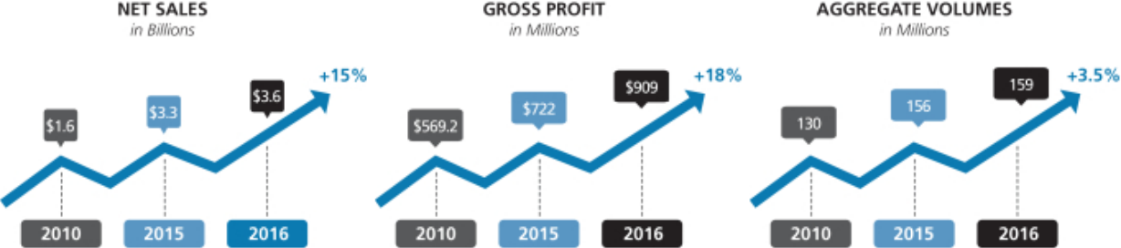

Our performance earned us recognition, including being ranked #57 in Fortune’s 100 fastest growing companies in the world and ranked #9 in the S&P 500 in 2016. During the period January 1, 2006 to December 31, 2016, our TSR of

- 2017 PROXY STATEMENT

107.37% represented a 72% premium relative to the performance of the S&P 500 TSR of 20.79%.

Table of Contents

Executive Summary ◆ Compensation Discussion and Analysis

In 2016, we continued to execute on our strategic plan, following the $2.8 billion acquisition of Texas Industries, Inc. in 2014, and focused on strategically positioning ourselves in high-growth areas.
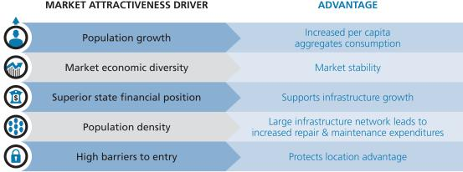

Despite significant precipitation in many of our key markets and modest shipment volume increases, we achieved record growth in 2016 that led to increased profits versus the prior year. Effective management provided us the ability to prudently reinvest in our business, pursue strategic opportunities, and return cash to our shareholders. Based on our strategy, we have achieved the number 1 or 2 position in 85% of the regions in which we operate, giving us a foundation for durable growth.
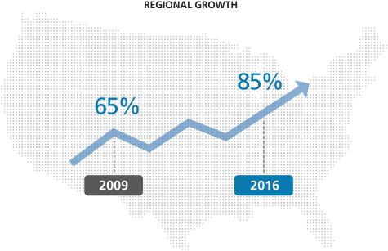

In summary, Martin Marietta continued to execute its strategic plan while delivering strong performance in 2016:

- Record net sales of $3.6 billion (compared with $3.3 billion), an increase of 9.4% from 2015

- Record gross profit of $909 million, an increase of 25.9% from $721.8 million in 2015

- Record operating earnings of $667.3 million, an increase of 39.2% from 2015

- Consolidated gross margin expanded by 340 basis points to 23.8%

- Consolidated gross margin (excluding freight and delivery revenues) expanded by 330 basis points to 25.4%

- Net earnings attributable to Martin Marietta of $425.4 million, an increase of 47% from 2015

2017 PROXY STATEMENT | 29

Table of Contents

Compensation Discussion and Analysis ◆ 2016 Say-On-Pay Vote and Shareholder Outreach

- Earnings before interest, taxes, depreciation and amortization (“EBITDA”) of $971.6 million increased 29.4% over 2015 EBITDA

- Earnings attributable to Martin Marietta per diluted share (“EPS”) of $6.63 increased 54.5% from $4.29 in 2015

- Aggregates product line pricing up 7.3% with shipment volume growth of 1.4%

- Our Return on Invested Capital (“ROIC”) of 8.42% increased 254 basis points from 5.88% in the prior year. For the first time since 2008, ROIC exceeded the Weighted Average Cost of Capital (WACC) of 7.87%. Our ROIC and invested capital growth also drove shareholder value in 2016.

This financial performance allowed us to achieve our additional strategic objectives, including:

- Pursuing aggregates-led expansion through acquisitions that complement existing operations (i.e., bolt-on acquisitions) and acquisitions that provide leadership entry into new markets or similar product lines (i.e., platform acquisitions)

- Returning nearly $365 million to our shareholders in 2016 through share repurchases and meaningful dividends that were recently increased, and almost $1 billion since announcing our repurchase authorization in February 2015

- Increasing market capitalization 54% to $14.1 billion in 2016.
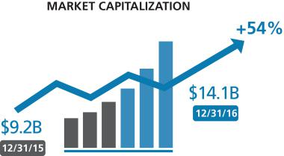

2016 Say-On-Pay Vote and Shareholder Outreach

Our shareholders expressed their continued support of our executive compensation programs by approving our non-binding advisory vote on executive compensation at our 2016 Annual Meeting of Shareholders. More than 96% of votes cast supported our executive compensation policies and practices. Management and the Committee considered this strong support by our shareholders that our pay structure aligns our compensation programs with the interests of our shareholders.

The Committee feels strongly that our executive compensation programs should evolve and be adjusted over time to support the achievement of our business goals, to reflect our challenges, and to promote both the near- and long-term profitable growth of Martin Marietta. During 2016, the Committee reviewed and evaluated market trends and best practices in designing and implementing elements to our compensation program. The Committee continues to believe that the goals for our executive compensation programs are to incentivize and reward achievement that creates value for our shareholders.

We view a continuing, constructive dialogue with our long-term shareholders as critically important to ensuring that we remain aligned with their interests. With that in mind:

- We regularly talk to long-term shareholders and appreciate the opportunity to gain further insight and understanding into their views. In 2016 our investor relations outreach extended to 127 meetings with 314 investment firms in the United States and Europe.

- We held an Investor Day in May 2016 at which shareholders were invited to meet with the entire leadership team of Martin Marietta, including our Lead Independent Director, and visit two of our facilities in the Dallas metroplex, including a quarry and a cement plant.

- We speak to almost all of our top 25 shareholders at least annually, which represents approximately 70% of our outstanding shares.

- Institutional Investor magazine named Martin Marietta to its 2017 All-America Executive Team. Martin Marietta finished second overall (in the Homebuilders & Building Products category) for the Best Investor Relations Program and Best Analyst Days.

- 2017 PROXY STATEMENT

Table of Contents

 | Pay Decisions in 2016 Made in Light of Performance ◆ Compensation Discussion and Analysis
Pay Decisions in 2016 Made in Light of Performance
WHAT WE DO | WHAT WE DON’T DO
Pay for performance. Tie pay to performance by ensuring that a | No employment contracts. None of our NEOs or other executive
significant portion of NEO compensation is performance-based and | officers have employment contracts that guarantee continued
at-risk. | employment.
Median compensation targets. All compensation elements of our | No dividends on unvested awards. Our 2016 RSU and PSU
executives are generally targeted at the median of our peer group | awards require three years to fully vest and dividends paid on
companies. | shares of common stock of Martin Marietta during the vesting period
PSUs are a substantial portion of LTI. PSU grants, tied to our | are only paid to award holders if and when an award vests.
achievement of specified performance measures, comprised
approximately 67% of the total value of annual long-term incentive
grants made to our NEOs in 2016. RSUs comprised the remaining

33%.

Independent compensation consultant. The Compensation

Committee uses an independent compensation consultant.

Minimal executive perquisites.

A number of key 2016 compensation-related decisions resulted from these significant events and accomplishments, which are discussed more fully below. The Committee believes that our executive compensation program continues to reflect a strong pay-for-performance philosophy and is well-aligned with the interests of shareholders

Our Compensation Strategy

Our executive compensation program is specifically designed to:

- Attract and retain top-caliber, knowledgeable and experienced senior executives.

- Motivate our executives to achieve superior results and build long-term value for shareholders.

- Reward performance that meets or exceeds established goals consistent with our strategic aims and upholding integrity.

- Align individual objectives with the Company’s objectives without fostering excessive or inappropriate risk-taking.

- Encourage an ownership mentality and align the long-term financial interests of our executives with those of our shareholders.

- Be market competitive with our peers.

- Provide reward systems that are measurable and easily understood by our managers and shareholders.

- Reinforce the succession planning process undertaken on a company-wide basis by building bench strength and by identifying and retaining senior leadership, both capable of achieving the Company’s growth, profitability and other objectives.

In 2016, our executive compensation structure consisted of three primary components: base salary, annual incentives, and long-term incentives. Within the long-term incentive component, we changed our program in 2016 to eliminate options and utilized a balanced portfolio of performance-based share units (“PSUs”) and restricted stock units (“RSUs”).
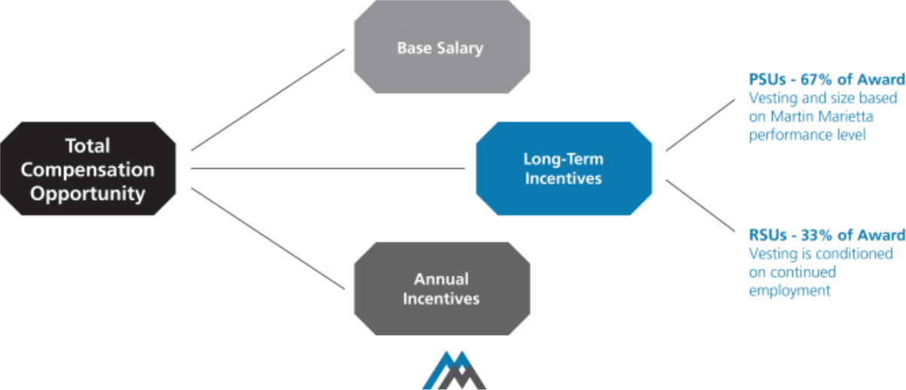

2017 PROXY STATEMENT | 31

Table of Contents

Compensation Discussion and Analysis ◆ Our Compensation Strategy

Martin Marietta has a long-standing commitment to pay for performance. We fulfill that aim by providing a majority of compensation through programs in which the amounts

ultimately received vary in order to best reflect our financial, operational and strategic performance.

The following table summarizes the key elements of our 2016 executive compensation program:

Element | Primary Purpose
Base Salary | To compensate the executive fairly and competitively for the
 | responsibility level of the position.
Annual Performance- | To motivate and reward organizational and individual
Based Incentive Awards | achievement of annual strategic, financial and individual
Incentive Stock Plan | objectives.
Incentive Stock Plan | To ensure executives invest certain levels of their annual
 | bonus into Martin Marietta stock units.
 | To align executives with shareholder interests, to reinforce
Long-Term Incentive Awards | To align executives with shareholder interests, to reinforce
 | long-term value creation, and to provide a balanced
Performance Share Units | portfolio of long-term incentive opportunity.
Performance Share Units | To motivate executives by tying incentives to our multi-year
(PSU) | financial goals and relative TSR reinforcing the link between
Restricted Stock Units (RSUs) | our executive officers and our shareholders.
Restricted Stock Units (RSUs) | To motivate the appropriate behaviors delivering superior
 | long-term total shareholder return. Also promotes a base-
Health/Welfare Plan and | level of executive retention.
Health/Welfare Plan and | To provide competitive benefits promoting employee health
Retirement Benefits | and productivity and support financial security.
Perquisites and Other Benefits | To provide limited business-related benefits, where
 | appropriate, and to assist in attracting and retaining
Change-in-Control Protection | executive officers.
Change-in-Control Protection | To provide continuity of management and bridge future
 | employment if terminated following a change-in-control.
Severance Protection | To bridge future employment if terminated other than “for
 | cause.”


Key Characteristics

Fixed compensation that is reviewed annually.

Variable compensation component; based on pre-established Company and individual performance goals.

Executives may invest up to 50% of their annual bonus into stock units, with a mandatory minimum of 35% for our CEO and 20% for other NEOs to be invested in common stock units.

Variable compensation component. Reviewed and granted annually. New program in 2016 splits long-term incentives for NEOs at 67% PSUs and 33% RSUs.

Grants based on three-year Return on Sales (ROS), EBITDA and TSR performance relative to peers.

Stock price growth.

Fixed compensation component.

Fixed compensation component.

Fixed compensation component; only paid in the event the executive’s employment is terminated following a change-in-control.

Fixed compensation component; only paid in the event the executive’s employment is terminated other than “for cause.”

- 2017 PROXY STATEMENT

Table of Contents

Performance-Related Compensation ◆ Compensation Discussion and Analysis

Performance-Related Compensation

A substantial portion of our CEO’s and executive officers’ compensation is at risk and will vary depending upon our performance. Most of the opportunities to achieve long-term equity incentives granted to our CEO and other executive officers in 2016 were performance-related consisting of PSUs that comprised 67% of the long-term equity awards.

Approximately 67% of our CEO’s total pay opportunity at target levels is performance-based “at risk” compensation.
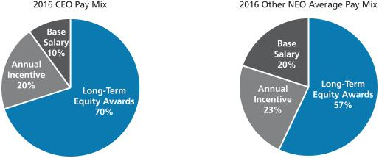

Ongoing Corporate Governance Policies

We endeavor to maintain good corporate governance standards relating to our executive compensation policies and practices, including the following that were in effect during 2016 that directly impacted compensation:

- The Committee is composed solely of independent Directors who regularly schedule and meet in executive sessions without management present.

- The Committee’s independent compensation consultant is retained directly by the Committee.

- The Committee conducts an annual review and approval of our compensation strategy, including a review of our compensation-related risk profile, to ensure that our compensation-related risks are not reasonably likely to have a material adverse effect on the Company.

- We pay for performance, with approximately 67% of our CEO’s total target pay opportunity being performance-based “at risk” compensation.

- We cap PSU payments at target if three-year TSR is negative, regardless of our ranking.

- We limit perquisites and other benefits.

Compensation Decision Process

Role of Management and the Committee

The Committee is responsible for carrying out the philosophy and objectives of the Board of Directors related to executive compensation in addition to its responsibilities of overseeing the development and succession of executive management of Martin Marietta. The Committee has the authority to determine

compensation and benefits for Martin Marietta’s executive officers. The Committee members are each non-employee, independent Board members pursuant to the New York Stock Exchange rules, and the Committee operates pursuant to a written charter, a copy of which can be viewed on Martin Marietta’s website at www.martinmarietta.com.

The performance of the CEO and each other executive officer is reviewed regularly by the Committee. Based on this review, the Committee sets compensation for all executive officers. Compensation decisions with respect to the executive officers other than the CEO are based in part on recommendations by the CEO, with input from the Senior Vice President— Human Resources, with respect to salary adjustments and annual cash and equity awards. The Committee can accept, reject or modify any recommended adjustments or awards to executive officers. For the CEO, the Committee sets the levels of annual adjustments and awards based on the criteria it deems to be appropriate under the circumstances with input from the independent compensation consultant. There are no employment agreements between Martin Marietta and any executive officer of Martin Marietta, including the CEO.

Role of the Independent Compensation Consultant

The Committee retained an independent compensation consultant in accordance with the Committee’s charter. The consultant reports directly to the Committee. The Committee retains sole authority to hire or terminate the consultant, approve its compensation, determine the nature and scope of services, and evaluate performance. A representative of the compensation consultant attends Committee meetings, either in person or by telephone, as requested, and communicates with the Committee Chair between meetings. The Committee makes all final decisions.

2017 PROXY STATEMENT | 33

Table of Contents

Compensation Discussion and Analysis ◆ Compensation Decision Process

The compensation consultant’s specific compensation consultation roles include, but are not limited to, the following:

- Advise the Committee on executive compensation trends and regulatory developments.

- Provide a total compensation assessment for executives compared to peer companies and recommendations for executive pay.

- Summarize and report to the Committee on trends, regulatory developments and other factors affecting executive officer compensation, as well as any other areas of concern or risk.

- Serve as a resource to the Committee Chair for meeting agendas and supporting materials in advance of each meeting.

- Review and comment on proxy disclosure items, including this CD&A.

- Advise the Committee on management’s pay recommendations.

Based on these activities, the compensation consultant makes recommendations regarding, and proposes adjustments to, our executive officer compensation program as it deems appropriate. While the consultant works closely with the appropriate members of our executive management team in performing these activities, the consultant reports directly to and is retained by the Committee on all executive compensation matters, and speaks to the Committee and the Chair of the Committee on a regular basis without management present. The compensation consultant periodically attends Committee meetings.

Mercer was paid $204,345 for its compensation advisory services in 2016. Also during 2016, Mercer and its Marsh & McLennan affiliates were also retained by management to provide services unrelated to executive compensation, including property/casualty insurance brokerage services and administration of a risk management information system. The aggregate fees paid for those other services for 2016 were $277,095. The Committee and the Board did not review or approve the other services provided to us by Mercer and its Marsh & McLennan affiliates, as those services were approved by management in the normal course of business prior to the Committee’s engagement of Mercer to work on its behalf.

We have been advised by Mercer that the reporting relationship and compensation of the individual Mercer consultants who perform executive compensation consulting services for our Committee is separate from, and is not determined by reference to, Mercer’s or Marsh & McLennan’s other lines of business or their other work for us. The Committee considered these separate reporting relationships and compensation structures,

- 2017 PROXY STATEMENT

the provision of other services to the Company by Mercer and Marsh & McLennan, the absence of any business or personal relationship between our officers and Directors and the specific Mercer consultants advising the Company (other than the consulting relationship with the Committee), Mercer’s Global Business Standards intended to address potential conflict of interests with respect to their executive compensation consulting services, and the other factors required to be considered by applicable SEC and stock exchange rules, in approving the Committee’s engagement of Mercer for fiscal 2016. Based on this review, the Committee did not identify that Mercer had any conflicts of interest that would prevent Mercer from independently advising the Committee.

The Committee has considered and assessed all relevant factors, including but not limited to those set forth in Rule 10C-1(b)(4)(i) through (vi) under the Securities Exchange Act of 1934, that could give rise to a potential conflict of interest with respect to the individual independent compensation consultants that provided services in 2016. Based on this review, there are no conflicts of interest raised by the work performed by Mercer.

Role of Peer Companies and Competitive Market Data

The Committee considered peer groups for two elements of the executive compensation program in 2016: the Compensation Peer Group, consisting of 17 companies that the Committee believes compete with us for talent, and the TSR Peer Group, consisting of a group of 25 companies that the Committee believes compete with us for investors and is used to assess the achievement of TSR measured for the PSU awards.

This section only describes the Compensation Peer Group. The TSR peer group is discussed below in the descriptions of the other elements of our compensation program.

Annually, the Committee studies competitive total compensation market data provided by its independent compensation consultant. To assess competitive pay levels, the Committee reviews and approves the composition of our Compensation Peer Group. The following peer group criteria are considered:

- Company size (approximately 0.4x to 2.5x Martin Marietta’s annual revenues);

- Companies in similar industries based on GICS code classifications;

- Direct competitors for business and management talent;

- Companies covered by the investment analysts that track Martin Marietta; and

- Companies that include Martin Marietta in their compensation peer group.

Table of Contents

Compensation Decision Process ◆ Compensation Discussion and Analysis

The following companies comprised our Compensation Peer Group for 2016 base salary, bonus, and long-term incentive pay decisions:

Albermarle Corporation Granite Construction Inc.

Armstrong World Industries Louisiana-Pacific Corporation

Compass Minerals International Masco Corporation

CONSOL Energy, Inc. Nucor Corporation

FMC Corporation

The Committee studies competitive total compensation data from various sources, including proxy statements of the peer group. Since proxy statements do not provide precise comparisons by position to our executive officers, the Committee also in 2016 took into consideration published independent compensation surveys of companies with revenue in the range of $3.0 billion to $4.0 billion as to median levels for each executive officer as well as private compensation survey data. Where available, size-adjusted market values were developed using regression analysis. This statistical technique accounts for revenue size differences within the peer group and develops an estimated market value for a similar-size company as Martin Marietta. The size-adjusted 50th percentile for total compensation is a key reference point for the Committee. On average, the target for our NEO total compensation opportunities is competitively positioned within a reasonable range of the size-adjusted 50th percentile.

Although the Committee uses the benchmark standards as its starting point in setting compensation levels, the compensation packages for executive officers may vary materially from the Compensation Peer Group benchmarks based on several factors. Market data, position, tenure, individual and organization performance, retention needs and internal pay equity have been the primary factors considered in decisions to increase or decrease compensation opportunities. Specifically, the Committee sets compensation levels below the benchmark levels for executive officers with relatively less relevant experience, less responsibility, less tenure with Martin Marietta and/or lower performance ratings. Conversely, if an officer consistently receives favorable performance ratings, accumulates years of service and expertise in relevant areas, has more responsibility and/or has significant other achievements, his or her compensation will typically be above the peer group median. In 2016, long-term compensation in the form of PSUs to executive officers was based on specific performance measurements as discussed below.

Determination of CEO Compensation

At each February Committee meeting, without the CEO present, the Committee reviews and evaluates CEO performance, and determines achievement level for the prior year. The Committee also reviews competitive compensation data. At this meeting,

Owens Corning Vulcan Materials Company

Peabody Energy Corp. W. R. Grace & Co.

USG Corp. Westlake Chemical Corporation

The Valspar Corporation Weyerhaeuser Company

the Committee discusses salary and annual incentive pay recommendations for the CEO, as well as an evaluation of the CEO’s performance, with the independent members of the Board. The Committee also reviews and discusses an award of RSUs and the target PSU grant size for the CEO at that meeting, which is also discussed with the full Board.

Compensation Program Risk Assessment

We perform a thorough annual review of our compensation program structure, which is reviewed in detail with the Committee. We believe our executive pay is reasonable and provides appropriate incentives to our executives to achieve our financial and strategic goals without encouraging them to take excessive risks in their business decisions. Our compensation structure does not include features that are reasonably likely to have a material adverse effect on the Company. Compensation program features that mitigate against risks include the following:

- Our annual bonus plan does not provide payment for poor individual or corporate performance, regardless of whether the failure to achieve target was outside management’s control.

- There are caps on the long-term equity awards, even if the required performance-related criteria are exceeded.

- A majority of the NEOs’ compensation is long-term, with equity grants vesting over three to five years, depending on the plan.

- Our compensation is not based on highly-leveraged short-term incentives that encourage high risk investments at the expense of long-term value.

- Long-term compensation to executive officers is based on specific performance measures that balance long-term growth and returns.

- The Committee uses benchmarking data and the advice of its independent compensation consultant to keep compensation in line with typical market practices and appropriate to Martin Marietta’s needs.

- We use a balanced portfolio of long-term incentive programs.

2017 PROXY STATEMENT | 35

Table of Contents

Compensation Discussion and Analysis ◆ Considerations Regarding 2016 Compensation

Considerations Regarding 2016 Compensation

The following chart summarizes the target compensation in our 2016 executive compensation program:

Pay Component | Summary
Base Salary | • At the February 2016 meeting, the Committee reviewed competitive market data and individual performance evaluations.

- The Committee approved base salary increases as follows:

- Mr. Nye: 3.1% increase, based on his excellent achievements as CEO since 2010 in an economic environment that resulted in muted shipment volume recovery, and specifically his performance in 2016.
- Other NEOs: approximately 3.0% increases, based on a review of competitive market data and individual performance evaluations.
Target Annual | • Mr. Nye’s target bonus was increased in 2016 to 110% of his base earnings.
Cash Incentives | • Other NEO target bonuses (as a % of base earnings) did not change in 2016.
 | • Our 2016 Executive Incentive Plan design did not change.
 | • Our CEO is required to invest a minimum of 35% of his annual cash bonus into stock units, which are held generally for a
 | period of three years.
 | • Other NEOs are required to invest a minimum of 20% of their annual cash bonus into stock units, which are held generally
 | for a period of three years.
Long-Term | • Our structure changed in 2016 to include PSUs and RSUs, and eliminate stock options.
Incentives | • The LTI awards for NEOs in 2016 were weighted 2/3 PSUs and 1/3 RSUs. The LTI grant size is based on competitive
 | market data.
 | • PSU awards in 2016 are earned based on achievement of performance levels, with 75% based on three-year return on
 | sales and cumulative EBITDA performance, and 25% based on TSR ranking compared to major U.S. companies in similar
 | industries.
Total Compensation | Targeted total compensation opportunity is the size-adjusted 50th percentile of our Compensation Peer Group. Overall, the
 | Committee believes targeted compensation should be more heavily weighted on variable “at-risk” compensation and longer-
 | term components.

The Committee approved the following actual compensation items in 2016.

Base Salary

The Committee determines base salaries for the NEOs and other executives based on a number of factors, including but not limited to, market data, individual performance, the Company’s performance, and management recommendations (except for the CEO). At the February 2016 meeting, based on a review of competitive market data and management’s recommendations based on individual performance (except for the CEO), and the Committee’s assessment of Mr. Nye’s performance, the Committee approved the following increases.

 | 2015 | Percentage |  | Effective |  | 2016
NEO | Base Salary | Increase* | Reason | Date | Base Salary
C. Howard Nye | $980,000 | 3.1% | Merit Increase | 3/1/16 | $ | 1,010,000
Anne H. Lloyd | $526,600 | 3.0% | Merit Increase | 3/1/16 | $ | 543,700
Roselyn R. Bar | $493,000 | 3.0% | Merit Increase | 3/1/16 | $ | 497,300
Donald A. McCunniff | $360,300 | 3.0% | Merit Increase | 3/1/16 | $ | 372,000
Daniel L. Grant | $340,000 | 3.3% | Merit Increase | 3/1/16 | $ | 351,100

* NEO base salaries were increased on March 1, 2016. The percentage increase reflects the annualized amount; actual increases were pro-rated from the last increase date.

Annual Cash Incentive: Executive Incentive Plan

NEOs and other executives are eligible to earn annual bonuses under our Executive Incentive Plan based on the achievement of various performance metrics. Individual NEO targets (as a percent of base salary) are approved by the Committee at the beginning of the year based on a review of competitive market data.

Actual cash bonuses are determined based on compensation peer data and internal pay equity. The Committee awards annual cash bonuses based on corporate performance objectives and the achievement of individualized targeted goals. This furthers Martin Marietta’s compensation philosophy to encourage superior performance and reward the achievement of

- 2017 PROXY STATEMENT

Table of Contents

Martin Marietta’s annual goals. In 2016, all of the executive officers participated in the plan, except for Mr. Nye, for whom bonus compensation was awarded outside of the plan. The annual bonus level for 2016 for the NEOs was 152% to 157% of target.

In determining the incentive payments, the Committee first reviews the achievements of Martin Marietta for the past year as compared to its targeted goals set at the end of the previous year. The factors that the Committee took into account in determining Martin Marietta’s performance in 2016 include those listed above under Executive Summary on pages 28 to 30. The Committee also considered:

- A detailed assessment of Martin Marietta’s overall financial performance and each segment’s financial performance.

Considerations Regarding 2016 Compensation ◆ Compensation Discussion and Analysis

- Shareholder returns, including the consistent delivery of value to Martin Marietta’s shareholders.

- Our safety performance, which continues to be industry leading even though we increased hourly headcount and trained new employees hired through our acquisitions made during the year.

- Outstanding environmental and regulatory compliance results.

- Continuing achievement of excellent management of working capital.

- The successful organic and inorganic growth of Martin Marietta.
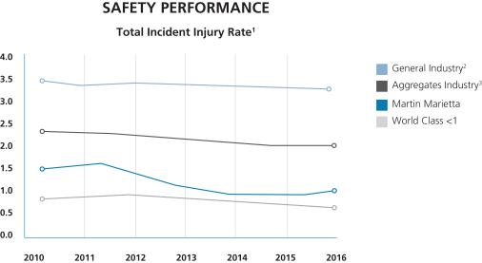

- Total Incident Injury Rate per 200,000 man hours worked.
- Reported as of 12.31.14 by Bureau of Labor Statistics. Latest available data.

- Reported by Mine Safety and Health Administration for 2010 – 2015 and by National Stone, Sand and Gravel Association for year to date as of 06.30.16 (latest data available) for the Aggregates Industry.

The Committee also considered our efforts to tell our sustainability story, which is part of our core strategy. We completed and issued the Company’s second annual sustainability report. “Building Solid Foundations – Partnering for Stronger Communities” represents our latest publication sharing Martin Marietta’s sustainability story – in 2016 from the perspective of our employees. From our world-class safety programs and performance, to our targeted and intentional support of housing, hunger reduction and healthcare, to environmental programs that ensure operational excellence, we have a solid foundation and an exciting opportunity to build upon.


2017 PROXY STATEMENT | 37

Table of Contents

Compensation Discussion and Analysis ◆ Considerations Regarding 2016 Compensation

The Committee then conducts a comparative review of the individual contributions of each of the executive officers towards achieving these goals. The Committee also considers qualitative measures of performance for the executive officers, such as adherence to and implementation of Martin Marietta’s Code of Ethical Business Conduct, safety, customer satisfaction, and product quality.

Key individual performance criteria are established for each NEO, which are intended to drive strategic and support operational results in the Company and the functional groups. These performance metrics are established at the beginning of each plan year and are based upon Martin Marietta’s Long-Range Operating Plan, which is set at the end of the previous year. For executives in corporate staff positions, 50% of the determination is made with respect to Martin Marietta’s performance and 50% is based on the individual’s performance against established objectives. Similar to the Committee’s assessment of financial goals, the Committee’s assessment of individual performance goals generally excludes certain non-recurring or extraordinary items. We do not disclose specific individual performance goals due to the potential for competitive harm. Our targeted individual goals are “stretch but reasonable.”

The individualized target goals are tailored for each executive, his or her specific areas of responsibility and the then-current and longer-term goals of Martin Marietta. In addition, achievement of the goals typically is in part dependent on conditions outside the control of each of the named executive officers. For example, our business may be adversely affected by hurricanes or other weather-related conditions, which could have the result of impeding the achievement of certain performance-based goals.

Although there is substantial uncertainty with respect to achieving the target levels at the time the goals are set and communicated, our NEOs have a reasonable expectation of receiving a cash incentive award at a level that is near their target level.

2016 CEO Annual Incentive Award Earned

The CEO does not participate in Martin Marietta’s Executive Incentive Plan and his bonus, if any, is determined at the discretion of the Committee, based on the performance factors discussed above for 2016, including:

- Revenue growth

- Gross profit margin expansion

- EBITDA growth

- EPS growth

- Effective cost management

- Safety and regulatory compliance record

Generally, Mr. Nye’s target bonus level is approximately 110% of his base salary although there is no specific target for the CEO’s bonus. The Committee did not attempt to set Mr. Nye’s 2016 bonus in any particular relationship to peer compensation survey data but did consider those factors. The Committee awarded him an annual incentive bonus of $2,000,000 for 2016, which was approximately 181% of his target annual incentive, after considering many diverse factors, including performance, peer group compensation and the advice of the Committee’s independent compensation consultant. Consistent with its compensation philosophy that focuses on long-term performance, the Committee considers whether there are factors in addition to quantitative ones that should be taken into account in establishing the overall level of Mr. Nye’s compensation. In this regard, the Committee considered accomplishments that benefit shareholders in the longer term. In subjectively determining the amount of Mr. Nye’s bonus for 2016, the Committee took into account the same type of objective performance measures and qualitative measures, such as the effectiveness and quality of Mr. Nye’s leadership of Martin Marietta, as it considered for executive officers who receive awards under the plan.

2016 Actual Incentive Cash Earned

The table below summarizes the targets for 2016 and annual incentive award earned by each NEO:

 | Target Annual | 2016 Target |  | 2016 Actual
 | Incentive Bonus |  | Annual |  | Annual
NEO | (% of Salary) | Incentive** |  |  | Incentive
C. Howard Nye* | 110%* | $ | 1,105,500 | $ | 2,000,000
Anne H. Lloyd | 80% | $ | 432,680 | $ | 657,674
Roselyn R. Bar | 80% | $ | 397,267 | $ | 623,709
Donald A. McCunniff | 70% | $ | 259,035 | $ | 404,095
Daniel L. Grant | 70% | $ | 244,475 | $ | 378,936

- Mr. Nye has no target bonus under the Executive Incentive Plan, but the Committee in 2016 generally considered an appropriate target for Mr. Nye to be 110% of base salary earnings in evaluating his bonus level.

- Based on actual base earnings in 2016.

- 2017 PROXY STATEMENT

Table of Contents

Annual Incentive Feature: Performance-Based Stock Purchase Plan

The Incentive Stock Plan provides an executive the opportunity to invest a portion of his or her annual bonus in Martin Marietta stock. There are both voluntary and mandatory deferrals under the plan.

The voluntary election allows executives to invest up to 50% of their annual cash bonus to purchase units that are subsequently converted into shares of common stock pursuant to the terms of the plan at a 20% discount from the market price of Martin Marietta’s common stock on the date the amount of the bonus is determined. The discount is used to account for the risk of trading current cash compensation for “at-risk” shares which may decline in value.

The mandatory portion requires executives to invest a minimum of 20% of their cash bonus towards the crediting of units under the plan. The CEO is required to invest a minimum of 35% of his cash bonus towards the crediting of such units.

The units generally vest in three years from the date of the award and are distributed in shares of common stock. If an executive officer voluntarily terminates employment before the units vest, the stock units are forfeited and the executive officer receives a cash payment equal to the lesser of the cash that was invested or the fair value of the share units on the day of termination.

The mandatory contribution requirement directly links a portion of executive officer compensation to shareholder returns. The vesting aspect, combined with the yearly stock purchase requirement, creates continuous overlapping three-year cycles, which encourage executive officer retention and provide a continuous link of a significant portion of executive officer compensation with shareholder return over the long term to reward these executive officers in line with our shareholders when our stock price increases.

Long-Term Incentive Compensation

For 2016, we made changes to the Long-Term Incentive (“LTI”) awards that included adding PSUs and eliminating stock options. The new plan’s design reflects the objectives of our compensation program and is in-line with current market approaches, based on the advice of the Committee’s independent compensation consultant. The guiding principles in making these changes were to simplify the LTI program, make it more transparent, and enhance the line of sight between our performance and compensation.

The award in 2016 was based on a fixed percentage of base salary with some variation for position and grade, which amount was converted into common stock units based on the average Martin Marietta stock price for the 20-day period ending on February 4, 2016, the day the Martin Marietta Board of Directors

Considerations Regarding 2016 Compensation ◆ Compensation Discussion and Analysis

confirmed the award, or $122.469. This award value was then divided into PSUs and RSUs, with 2/3 of the total award for NEOs consisting of target level for the PSUs and 1/3 of the total award for NEOs consisting of RSUs. The Committee believes that the incentive mix (PSUs and RSUs) constitutes a simplified pay process and streamlined plan, which more fully reflects the performance of the Company and is better aligned with each manager’s role within Martin Marietta.

One of our compensation objectives is to align the potential rewards to senior management with shareholder value. In that regard, the PSUs give the recipient the opportunity to receive Martin Marietta common stock if specific performance goals are achieved, consisting of:

- Return on Sales (“ROS”), measuring cost management and comprising 37.5% of the total award,

- Earnings before Interest, Taxes, Depreciation, Depletion and Amortization (“EBITDA”), measuring profitability and comprising 37.5% of the total award, and

- Relative Total Shareholder Return (“rTSR”), measuring Martin Marietta’s performance against a specified group of peers and comprising 25% of the total award.

ROS and EBITDA are two of the drivers of our performance and metrics that interest our investors. The total payout opportunity for PSUs is 50% of target if the threshold level is satisfied, 100% of target if the target level is satisfied, and 200% of target if the maximum level is satisfied. The threshold must be satisfied to receive PSUs for each performance measure. If the threshold is not met for any of the metrics, none of the PSUs will vest. Performance in each metric is measured independently, so PSUs can be earned as long as the threshold is satisfied for at least one level. The “Target” level is generally viewed as achievable. The “Maximum” level is a stretch that is attainable if we outperform in the area measured.

The performance will be measured in January 2019 for the three-year period beginning January 2016 through December 2018 to determine (1) the three-year average ROS for Martin Marietta against the target identified in the PSU Award Agreement, (2) the three-year cumulative EBITDA against the target identified in the PSU Award Agreement, and (3) the rTSR for the three-year period as against the rTSR Peer Group, each as set forth in the PSU Award Agreement. Again, these targets reflect a stretch effort at the maximum levels. The Committee in its discretion may adjust the final award values, either collectively or on an individual basis, in recognition of factors that are unusual or nonrecurring.

The PSUs will convert to unrestricted common stock and be paid to the recipient conditioned upon and to the extent that the performance goals have been met, which will be determined in January 2019. These awards are also generally subject to continued employment through the date the PSUs vest.

2017 PROXY STATEMENT | 39

Table of Contents

Compensation Discussion and Analysis ◆ Considerations Regarding 2016 Compensation

RSUs vest in three equal portions, each on the anniversary of the award date (February 4, 2016) over a period of three years, subject generally to continued employment through each one of those anniversaries. Once the restricted period ends (each anniversary for one third of the total RSU award), the recipient will be issued unrestricted shares of common stock (minus applicable taxes).

For the measurement period 2016-2018, the Committee utilized a peer group consisting of the following companies with which to compare the element of the PSU awards requiring achievement of TSR at the end of the three-year period, ending December 31, 2018. These companies were chosen with a focus on companies in similar industries as Martin Marietta with annual revenue and market values in a range that is between .2

AECOM Technology Eagle Materials

Alcoa Emcor Group

Allegheny Technologies Fluor Corporation

Carpenter Technology Freeport-McMoran

Century Aluminum Granite Construction

Commercial Metals Jacobs Engineering

Compass Minerals International

and 1.5 times that of Martin Marietta. A governance feature of the PSU award is that this portion of the payments is capped at target if the Company’s three-year TSR return is negative, regardless of the rTSR ranking.

The 2016-2018 TSR Peer Group of 23 companies were identified according to the following criteria and consisted of the following:

- S&P 1500 Materials companies in the Construction Materials, Metals & Mining, and Forest Products industries

- S&P 1500 Capital Goods companies in the Construction & Engineering industries

- Market capitalization and annual revenues of at least 20% of Martin Marietta at December 31, 2015

KBR Inc. Steel Dynamics

Louisiana Pacific Stillwater Mining

Newmont Mining TimkenSteel Corporation

Nucor Corporation U.S. Steel

Quanta Services Vulcan Materials

Reliance Steel & Aluminum Worthington Industries

The actual financial performance targets and achievement against those targets will be disclosed at the end of the three-year performance period.

The following table provides a summary of the long-term incentives that each of the NEOs received in 2016.

 |  | PSUs – Target
 |  | (3 year cliff vesting
 | RSUs | subject to achievement
 | (1-year | of performance
 | pro rata vesting) | measures)
NEO | (# of shares) | (# of shares)
C. Howard Nye | 10,670 | 21,339
Anne H. Lloyd | 2,509 | 5,017
Roselyn R. Bar | 2,349 | 4,697
Donald A. McCunniff | 1,471 | 2,942
Daniel L. Grant | 1,204 | 2,407

- 2017 PROXY STATEMENT

Table of Contents

Considerations Regarding 2016 Compensation ◆ Compensation Discussion and Analysis

2016 Long-Term Incentive Vesting of Prior Grants

PSUs that were granted in 2014 vested on December 31, 2016, because the applicable performance criteria were satisfied. These PSUs were certified and paid out in February 2017 at 107.91% of the amount of the original grant made in 2014. The PSU payment percentage of 107.91% was based on: (1) 3-year average ROS of 17.3% as against a target of 19.5%; (2) 3-year cumulative EBITDA of $2.34 billion as against a target of $2.64 billion, and (3) TSR performance of our common stock relative to the TSR Peer Group of 96th percentile as against a target of the 50th percentile.

 | Payment Calculation for PSUs Granted in 2014
 | Certified on February 23, 2017
 |  | Target
 |  | Units Granted | Percentage | Units
NEO |  | in 2014 | Payable | Payable
C. Howard Nye |  | 2,799 | 107.91% | 3,021
Anne H. Lloyd |  | 1,584 | 107.91% | 1,710
Roselyn R. Bar |  | 1,322 | 107.91% | 1,427
Donald A. McCunniff |  | 1,084 | 107.91% | 1,170
Daniel L. Grant |  | 1,029 | 107.91% | 1,111

Stock-Based Awards Generally

The stock purchase awards under our Incentive Stock Plan and the PSUs and RSUs awarded under our LTI program, each as described above, were granted in 2016 at the Committee’s regularly scheduled meetings in February following the availability of financial results for the prior year. Newly hired executive officers may, subject to the discretion of the Committee, receive an award of RSUs as of the date of their hire. The number of RSUs is based on the average New York Stock Exchange closing price of Martin Marietta’s common stock for the 20-day period ending on the date of the grant. The Committee’s schedule is determined several months in advance and the proximity of any awards to earnings announcements or other market events is coincidental.

All of Martin Marietta’s active equity-based award plans have been approved by shareholders.

Stock Ownership Guidelines

The stock ownership levels of our NEOs are consistent with typical tiered stock ownership guidelines employed by major U.S. companies. We employ stock ownership guidelines in the form of a required holding period of annual cash bonuses converted to Martin Marietta shares, with vesting generally in three years rather than stock ownership guidelines expressed as a multiple of salary. There is no additional holding period beyond the vesting date, however a significant portion of the executive compensation program is in the form of equity awards that vest over three-, four- or five-year periods.

Our CEO must invest a minimum of 35% of each year’s cash bonus award in common stock units of Martin Marietta. Executive officers must invest a minimum of 20% of their annual bonus. Stock is purchased at a 20% discount to the price on the grant date to account for the additional risk of taking a

common stock unit payment in lieu of a risk-free cash payment. In 2016, Mr. Nye deferred the maximum of 50% of his cash bonus in common stock units.

Perquisites

Martin Marietta provides executives with perquisites that the Committee believes are appropriate, reasonable and consistent with its overall compensation program to better enable Martin Marietta to attract and retain superior employees for key positions. The Committee periodically reviews the types and levels of perquisites provided to the NEOs. The value of each of the NEO’s perquisites is included in the annual compensation set forth in the Summary Compensation Table.

In 2016, we provided personal use of leased automobiles to NEOs. We pay for the insurance, maintenance and fuel for such vehicles, and the value of personal mileage and use is charged to the NEO as imputed income. Martin Marietta also provides to executive officers and other employees certain other fringe benefits such as tuition reimbursement, airline club dues, professional society dues, and food and recreational fees incidental to official company functions. We do not provide other perquisites, such as country club memberships or financial planning services, to the NEOs.

Retirement and Other Benefits

In order to maintain market competitive levels of compensation, we provide retirement and other benefits to the NEOs and other employees, including:

- Medical and dental benefits

- Life, accidental death and disability insurance

- Pension and savings plans

The benefits under the defined benefit pension plan are more valuable for employees who remain with Martin Marietta for

2017 PROXY STATEMENT | 41

Table of Contents

Compensation Discussion and Analysis ◆ Potential Payments upon Termination or Change of Control

longer periods, thereby furthering our objectives of retaining individuals with more expertise in relevant areas and who can also participate in management development for purposes of executive succession planning. All of Martin Marietta’s salaried employees in the United States are eligible to participate in our retirement and other plans, and the NEOs participate in the plans on the same terms as Martin Marietta’s other salaried employees.

Additional information regarding these benefits is under the heading Pension Benefits Table on page 50 and the accompanying narrative.

Potential Payments upon Termination or Change of Control

We do not have written employment agreements with executives. Instead, each of our NEOs has a change of control severance agreement (an “Employment Protection Agreement”) that provides for retention and continuity in order to minimize disruptions during a pending or anticipated change of control. The agreements are triggered only by a qualifying termination of employment following a change of control. Martin Marietta’s equity-based award plans and retirement plans also provide for certain post-termination payments and benefits, as well as the acceleration of time periods for purposes of vesting in, or realizing gain from, any outstanding equity award in the event of a change of control. The Committee believes these payments and benefits are also important to align the interests of the executive officers with the interests of the shareholders because the agreements will reduce or eliminate the reluctance to pursue potential change of control transactions that may ultimately lead

to termination of their employment but would otherwise be in the best interests of our shareholders. The Employment Protection Agreement is described on pages 51 and 52 of this Proxy Statement.

Tax and Accounting Implications

In administering the compensation program for NEOs, the Committee considers the applicability of Section 162(m) of the Code, the consequences under financial accounting standards, the tax consequences in our analysis of total compensation and the mix of compensation elements, base, bonus and long-term incentives. For example, we do not issue incentive stock options, which would provide potential tax savings to the recipient, because of the negative tax and accounting consequences to the Company. Section 162(m) prohibits public companies from taking a tax deduction for compensation that is paid to any one of certain employees in excess of one million dollars, unless the compensation is “qualified performance-based compensation” within the meaning of the Code.

To preserve the deductibility of compensation, grants in 2016 of some of our long-term incentives are intended to qualify as “qualified performance-based compensation.” The Committee has the discretion to design and implement compensation elements that may not be deductible under Section 162(m) if the Committee determines that, despite the tax consequences, those elements are in our Company’s best interest to adopt. The Committee believes that Martin Marietta’s general compensation policies and objectives that are currently in place best serves shareholder interests.

- 2017 PROXY STATEMENT

Table of Contents

Executive Compensation

Executive Officer Compensation

The following tables show annual and long-term compensation, for services in all capacities to Martin Marietta, earned by the Chief Executive Officer, the Chief Financial Officer, and three other executive officers serving as such on December 31, 2016, which we refer to collectively as the “named executive officers” or “NEOs.” These tables and the accompanying narratives should be read in conjunction with the Compensation Discussion and Analysis section of this proxy statement, which provides a detailed overview of the methods used by Martin Marietta to compensate its officers, including the named executive officers.

Summary Compensation Table

The table below summarizes the total compensation paid to or earned by each of the named executive officers for the fiscal years set forth below. Martin Marietta has not entered into any employment agreements with any of the named executive officers.

SUMMARY COMPENSATION TABLE

 |  |  |  |  |  |  | Change in
 |  |  |  |  |  |  | Pension Value
 |  |  |  |  |  |  | and Non-
 |  |  |  |  |  |  | Qualified
 |  |  |  |  |  | Non-Equity | Deferred
 |  |  |  | Stock | Option | Incentive Plan | Compensation | All Other
Name and |  | Salary | Bonus | Awards | Awards | Compensation | Earnings | Compensation | Total
Principal Position | Year | ($) | ($)¹ | ($)² | ($)³ | ($) | ($)⁴ | ($)⁵ | ($)
(a) | (b) | (c) | (d) | (e) | (f) | (g) | (h) | (i) | (j)
C. Howard Nye | 2016 | 1,005,000 | 1,300,000 | 4,682,240 |  |  | 687,864 | 364,227 | 8,039,331
Chairman, President | 2015 | 977,500 | 603,606 | 1,697,067 | 731,763 |  | 496,430 | 241,027 | 4,747,393
and CEO | 2014 | 928,755 | 715,000 | 4,418,415 | 589,817 |  | 710,125 | 241,092 | 7,603,204
Anne H. Lloyd | 2016 | 540,850 | 526,139 | 1,067,845 |  |  | 490,109 | 91,421 | 2,716,364
Executive Vice | 2015 | 525,325 | 319,398 | 603,530 | 233,668 |  | 253,253 | 88,118 | 2,023,292
President and CFO | 2014 | 510,775 | 407,280 | 2,093,845 | 199,906 |  | 604,298 | 79,879 | 3,895,983
Roselyn R. Bar | 2016 | 496,583 | 498,967 | 1,001,335 |  |  | 528,522 | 100,915 | 2,626,322
Executive Vice President, |  |  |  |  |  |  | 528,522 | 100,915 | 2,626,322
Executive Vice President, | 2015 | 445,121 | 241,033 | 491,597 | 190,732 |  | 276,972 | 76,735 | 1,722,190
General Counsel and |  |  |  |  |  |  | 276,972 | 76,735 | 1,722,190
Corporate Secretary | 2014 | 425,496 | 346,400 | 1,734,847 | 163,129 |  | 591,148 | 69,356 | 3,330,376
Donald A. McCunniff | 2016 | 370,050 | 323,276 | 629,840 |  |  | 160,803 | 71,038 | 1,555,007
Senior Vice President, | 2015 | 359,425 | 191,214 | 397,832 | 153,682 |  | 116,533 | 64,564 | 1,283,250
Human Resources | 2014 | 349,442 | 282,000 | 1,418,203 | 131,432 |  | 141,894 | 54,572 | 2,377,543
Daniel L. Grant | 2016 | 349,250 | 303,149 | 525,032 |  |  | 98,052 | 63,434 | 1,338,917
Senior Vice President – | 2015 | 339,083 | 180,392 | 292,075 | 83,853 |  | 130,575 | 56,853 | 1,082,831
Strategy & Development | 2014 | 328,667 | 234,360 | 1,260,978 | 70,861 |  | 107,937 | 42,373 | 2,045,176

- The amounts in column (d) for 2016 reflect the cash bonuses to the named individuals earned in 2016 and paid in 2017 under annual incentive arrangements discussed in further detail on pages 36 to 38 under the headings “Annual Cash Incentive: Executive Incentive Plan” and “2016 CEO Annual Incentive Award Earned.” The amounts in this column include the amounts of bonus irrevocably deferred in common stock units at the election of each named executive officer pursuant to Martin Marietta’s Incentive Stock Plan, which is discussed in further detail on page 39 under the heading “Annual Incentive Feature: Performance-Based Stock Purchase Plan.” The amounts deferred in 2016 for each of the named executive officers at his or her election are as follows: Mr. Nye, $300,000; Ms. Lloyd, $0; Ms. Bar, $62,371; Mr. McCunniff, $0; and Mr. Grant, $18,947. The number of stock units and the related grant date fair value attributable to the amounts of bonus so deferred by the named executive officers appear in columns (i) and (l), respectively, of the Grants of Plan-Based Awards Table on page 45. Column (e) includes the amounts mandatorily deferred in 2016 under the Incentive Stock Plan.

- The amounts in column (e) reflect the aggregate grant date fair value of awards made in the year reported, determined in accordance with FASB ASC Topic 718 (without any assumption for early forfeiture), of awards of RSUs; awards related to the amount of cash bonus irrevocably and mandatorily deferred in common stock units by each named executive officer pursuant to Martin Marietta’s Incentive Stock Plan, which is discussed in further detail on page 39 under the heading “Annual Incentive Feature: Performance-Based Stock Purchase Plan”; and awards of PSUs, which are described in more

2017 PROXY STATEMENT | 43

Table of Contents

Executive Compensation ◆ Summary Compensation Table

detail on pages 39 to 40 under the heading “Long-Term Incentive Compensation.” The amounts included in the table reflects the value of the units granted, which is subject to forfeiture if the executive does not remain in the employment of Martin Marietta for the requisite time period (generally three or four years) and, in the case of the PSUs, if Martin Marietta does not achieve the applicable performance criteria. The amounts in column (e) do not include the 20% discount on the Incentive Stock Plan units, which is reported in column (i). The amount in column (e) also includes PSUs, which were first awarded in 2014, and assumes the number of shares based on the target level of performance. Assuming the maximum payout under the PSUs granted in 2015, which will be determined in January 2018 based on the Company’s performance in 2015-2017 for awards granted in 2015, the amounts reported above for 2015 would be as follows: Mr. Nye, $784,021; Ms. Lloyd, $421,313; Ms. Bar, $351,637; Mr. McCunniff, $288,256; and Mr. Grant, $271,976. Assuming the maximum payout under the PSUs granted in 2016, which will be determined in January 2019 based on the Company’s performance in 2016-2018 for awards granted in 2016, the amounts reported above for 2016 would be as follows: Mr. Nye, $5,309,570; Ms. Lloyd, $1,248,330; Ms. Bar, $1,168,708; Mr. McCunniff, $732,028; and Mr. Grant, $598,910. Assumptions used in the calculation of these amounts are included in Note A to Martin Marietta’s audited financial statements for the fiscal year ended December 31, 2016, included in Martin Marietta’s Annual Report on Form 10-K filed with the SEC on February 24, 2017. The amounts of cash bonus deferred in 2016 at the election of each named executive officer are included in column (d). The amounts of cash bonus mandatorily deferred in 2016 for each of the named executive officers are as follows: Mr. Nye, $700,000; Ms. Lloyd, $131,535; Ms. Bar, $124,742; Mr. McCunniff, $80,819; and Mr. Grant, $75,787.

- The amounts in column (f) reflect the grant date fair value, determined in accordance with FASB ASC Topic 718 (without any assumption for early forfeiture), of option awards made in the year reported.

- The amounts in column (h) reflect the aggregate increase in the actuarial present value of the named executive officer’s accumulated benefits during 2016, 2015 and 2014, respectively, under all defined benefit retirement plans established by Martin Marietta determined using interest rate and mortality rate assumptions consistent with those used in Martin Marietta’s financial statements and include amounts which the named executive officer may not currently be entitled to receive because such amounts are not vested.

- The amount shown in column (i) for 2016 reflects for each named executive officer: matching contributions allocated by Martin Marietta to each of the named executive officers pursuant to the Savings and Investment Plan, which is more fully described on page 49 under the heading “Retirement and Other Benefits,” the value attributable to life insurance benefits provided to the named executive officers, which is more fully described on page 49 under the heading “Retirement and Other Benefits”; the value attributable to personal use of leased automobiles provided by Martin Marietta; and personal use of the corporate plane in 2016. These values are included as compensation on the W-2 of named executive officers who receive such benefits. Each such named executive officer is responsible for paying income tax on such amount. None of the elements that are perquisites or personal benefits exceed the greater of $25,000 or 10% of the total perquisites for each named executive officer. The amounts in column (i) also reflect the 20% discount from the market price of Martin Marietta’s common stock pursuant to the elective deferrals under the Incentive Stock Plan in each of 2016, 2015 and 2014, and the dollar value of dividend equivalents on units credited under the equity awards as computed for financial statement reporting purposes for each fiscal year ended December 31, 2016, 2015 and 2014 in accordance with FASB ASC Topic 718.

- 2017 PROXY STATEMENT

Table of Contents

Grants of Plan-Based Awards ◆ Executive Compensation

Grants of Plan-Based Awards

The table below shows each grant of an award made to a named executive officer in the fiscal year ended December 31, 2016. This includes equity awards made to the named executive officers under the Stock Plan and the Incentive Stock Plan.

GRANTS OF PLAN-BASED AWARDS TABLE

 |  |  |  |  |  |  |  |  |  |  |  |  |  | All Other | All Other
 |  |  |  |  |  |  |  |  |  |  |  |  |  | Stock | Option
 |  |  | Estimated Future Payouts |  |  |  |  | Estimated Future Payouts |  |  |  |  |  | Awards: | Awards: | Exercise | Grant Date
 |  |  |  |  |  |  |  |  |  |  |  |  |  | Number | Number of | or Base | Fair Value
 |  |  | Under Non-Equity Incentive |  |  |  |  | Under Equity Incentive |  |  |  |  |  | of Shares | Securities | Price of | of Stock
 |  |  |  | Plan Awards1 |  |  |  |  | Plan Awards |  |  |  |  | of Stock | Underlying | Option | and
 | Grant |  | Threshold |  | Target |  | Maximum | Threshold |  | Target |  | Maximum |  | or Units | Options | Awards | Option
Name | Date |  | ($) | ($) |  |  | ($) | (#) | (#) |  |  | (#) |  | (#) | (#) | ($/Sh) | Awards6
(a) | (b) |  | (c) |  | (d) |  | (e) | (f) |  | (g) |  | (h) |  | (i) | (j)5 | (k) | (l)
C. Howard Nye | 2/23/17² |  |  |  |  |  |  |  |  |  |  |  |  | 5,991 |  |  | 1,250,202
 | 2/4/16 |  |  |  |  |  |  | 10,670 |  | 21,339 |  | 42,678 |  |  |  |  | 2,654,785
 | 2/4/16³ |  |  |  |  |  |  |  |  |  |  |  |  | 10,670 |  |  | 1,327,455
Anne H. Lloyd | 2/23/17² |  |  |  | 432,680 |  |  |  |  |  |  |  |  | 788 |  |  | 164,440
 | 2/23/17² |  |  |  |  |  |  |  |  |  |  |  |  | 788 |  |  | 164,440
 | 2/4/16⁴ |  |  |  |  |  |  | 2,509 |  | 5,017 |  | 10,034 |  |  |  |  | 624,165
 | 2/4/16³ |  |  |  |  |  |  |  |  |  |  |  |  | 2,509 |  |  | 312,145
Roselyn R. Bar | 2/23/17² |  |  |  | 397,267
 | 2/23/17² |  |  |  |  |  |  |  |  |  |  |  |  | 1,121 |  |  | 233,930
 | 2/4/16⁴ |  |  |  |  |  |  | 2,349 |  | 4,697 |  | 9,394 |  |  |  |  | 584,354
 | 2/4/16³ |  |  |  |  |  |  |  |  |  |  |  |  | 2,349 |  |  | 292,240
Donald A. McCunniff | 2/23/17² |  |  |  | 259,035 |  |  |  |  |  |  |  |  | 485 |  |  | 101,210
 | 2/23/17² |  |  |  |  |  |  |  |  |  |  |  |  | 485 |  |  | 101,210
 | 2/4/16 | 4 |  |  |  |  |  | 1,471 |  | 2,942 |  | 5,884 |  |  |  |  | 366,014
 | 2/4/16 | 3 |  |  |  |  |  |  |  |  |  |  |  | 1,471 |  |  | 183,007
Daniel L. Grant | 2/23/17 | 2 |  |  | 244,475
 | 2/23/17² |  |  |  |  |  |  |  |  |  |  |  |  | 568 |  |  | 118,530
 | 2/4/16⁴ |  |  |  |  |  |  | 1,204 |  | 2,407 |  | 4,814 |  |  |  |  | 299,455
 | 2/4/16³ |  |  |  |  |  |  |  |  |  |  |  |  | 1,204 |  |  | 149,790

- The amounts shown in column (d) reflect the target level of annual bonus that could have been earned in 2016, payable in 2017 pursuant to the Executive Incentive Plan. There is no threshold amount since the program does not provide for an amount to be paid if performance falls below the performance goals and in 2016 there was no maximum level of annual bonus that could have been earned. These amounts shown in column (d) have not been reduced by the amounts that were mandatorily and voluntarily invested pursuant to the Incentive Stock Plan, which are also reported in column (i) of this table corresponding to footnote 2. The amount earned in cash and voluntarily deferred is also included in column (d) of the Summary Compensation Table. Mandatory deferrals of payments under the Incentive Stock Plan into common stock units are included in column

(e) of the Summary Compensation Table on page 43. Mr. Nye does not participate in the Executive Incentive Plan.

- The amounts shown in column (i) include the amount of cash bonus earned in 2016 but paid in 2017 that was deferred in units of common stock under the Incentive Stock Plan. Participants in this program for 2016 were approved on May 19, 2016. These awards are discussed under the heading “Annual Incentive Feature: Performance-Based Stock Purchase Plan” on page 39. These awards are also included in part, for NEOs other than Mr. Nye, in column (d) of this table and in full, for all NEOs, in columns (d), (e) and (i) of the Summary Compensation Table on page 43.

- The amounts shown in column (i) reflect the number of RSUs granted in 2016 to each of the named executive officers pursuant to the Stock-Based Award Plan. These awards are discussed under the heading “Long-Term Incentive Compensation” on pages 39 to 40. These awards are also included in column (e) of the Summary Compensation Table on page 43.

- The amounts shown in columns (f), (g) and (h) reflect the threshold, target and maximum, respectively, levels of PSUs payable if the performance measurements are satisfied in the period 2016-2018. These awards are discussed under the heading “Long-Term Incentive Compensation” on pages 39 to 40.
- No options to purchase shares of Martin Marietta’s common stock were granted in 2016.

- The amounts shown in column (l) reflect the grant date fair value of each equity award computed in accordance with FASB ASC Topic 718. The components of these amounts are included in columns (d), (e) and (i) of the Summary Compensation Table on page 43.

2017 PROXY STATEMENT | 45

Table of Contents

Executive Compensation ◆ Grants of Plan-Based Awards

Stock-based incentive awards have been a significant component of Martin Marietta’s management compensation. In 1998, the Board of Directors adopted and Martin Marietta’s shareholders approved the Stock Plan. In 2016, the Board of Directors and the shareholders approved amendments to the plan increasing the number of shares of Martin Marietta’s common stock available for equity awards. They also approved amendments to the plan designed to more directly tie long-term compensation incentives to Martin Marietta’s performance and enhance flexibility in structuring long-term incentive compensation packages by providing a mix of different types of long-term stock-based incentives. In addition, dividend equivalents that would have been paid in cash during the vesting period will be paid only if and when an award vests.

As amended, the plan authorizes the Management Development and Compensation Committee to award stock options, restricted stock and other stock-based incentive awards to

- 2017 PROXY STATEMENT

employees of Martin Marietta for the purpose of attracting, motivating, retaining and rewarding talented and experienced employees. Since 2016, Martin Marietta’s long-term compensation program consists of a mix of RSUs and PSUs for senior level employees and other select employees.

The awards granted in 2016 were based on the achievement by Martin Marietta of performance measures described under “Long-Term Incentive Compensation” on pages 39 to 40.

A maximum of 5,800,000 shares of Martin Marietta’s common stock are authorized under the plan for grants to key employees. Each award under the plan is evidenced by an award agreement setting forth the number and type of stock-based incentives subject to the award and such other terms and conditions applicable to the award as determined by the Committee. No employee may receive annual grants for more than 300,000 shares of common stock with respect to (i) full-value awards or (ii) stock options or stock appreciation rights.

Table of Contents

Outstanding Equity Awards at Fiscal Year-End ◆ Executive Compensation

Outstanding Equity Awards at Fiscal Year-End

The table below shows for each of the named executive officers information with respect to the unexercised stock options (columns (b), (c), (e), and (f)), stock unit awards (columns (g) and (h)) that have not vested, and equity incentive plan awards (columns (d), (i), and (j)) outstanding on December 31, 2016.

OUTSTANDING EQUITY AWARDS AT FISCAL YEAR-END TABLE

 |  | OPTION AWARDS |  |  |  |  | STOCK AWARDS |  | Equity
 |  |  |  |  |  |  |  |  | Incentive
 |  |  |  |  |  |  |  |  | Plan
 |  |  |  |  |  |  |  |  | Awards:
 |  |  |  |  |  |  |  |  | Market or
 |  |  | Equity |  |  |  |  | Equity | Payout
 |  |  | Incentive |  |  |  |  | Incentive Plan | Value or
 |  |  | Plan |  |  |  |  | Awards: | Unearned
 |  |  | Awards: |  |  |  | Market | Number of | Shares,
 | Number of | Number of | Number of |  |  | Number | Value of | Unearned | Units or
 | Securities | Securities | Securities |  |  | of Shares | Shares or | Shares, Units | Other
 | Underlying | Underlying | Underlying |  |  | or Units of | Units of | or Other | Rights
 | Unexercised | Unexercised | Unexercised | Option |  | Stock | Stock | Rights That | That
 | Options | Options | Unearned | Exercise | Option | That Have | That Have | Have | Have Not
 | (#) | (#) | Options | Price | Expiration | Not Vested | Not Vested1 | Not Vested | Vested1
Name | Exercisable | Unexercisable | (#) | ($) | Date | (#) | ($) | (#) | ($)
(a) | (b) | (c) | (d) | (e) | (f) | (g) | (h) | (i) | (j)
C. Howard Nye | 15,039 | 0 |  | 79.79 | 5/27/2017 | 6,792⁵ | 1,504,632 | 5598¹¹ | 1,240,125
 | 11,196 | 0² |  | 95.27 | 5/27/2018 | 22,070⁶ | 4,889,167 | 7224¹² | 1,600,333
 | 12,609 | 0³ |  | 86.90 | 5/12/2019 | 6,340⁷ | 1,404,500 | 42,678¹³ | 9,454,457
 | 16,317 | 0⁴ |  | 69.12 | 5/24/2020 | 10,670⁸ | 2,363,725
 | 10,857 | 3,618 |  | 108.24 | 5/23/2023 | 6,335⁹ | 1,403,393
 | 0 | 6,792 |  | 121.00 | 5/22/2024 | 4,666¹⁰ | 1,033,659
 | 0 | 9,510 |  | 154.58 | 5/21/2025
Anne H. Lloyd | 9,060 | 0 |  | 79.79 | 5/27/2017 | 2,302⁵ | 509,962 | 3168¹¹ | 701,807
 | 3,794 | 0² |  | 95.27 | 5/27/2018 | 11,878⁶ | 2,631,333 | 3882¹² | 859,979
 | 4,274 | 0³ |  | 86.90 | 5/12/2019 | 2,025⁷ | 448,598 | 10,034¹³ | 2,222,832
 | 5,530 | ₀4 |  | 69.12 | 5/24/2020 | 2,509⁸ | 555,819
 | 3,681 | 1,224 |  | 108.24 | 5/23/2023 | 1,328⁹ | 294,192
 | 0 | 2,302 |  | 121.00 | 5/22/2024 | 1,003¹⁰ | 222,195
 | 0 | 3,036 |  | 154.58 | 5/21/2025
Roselyn R. Bar | 3,096 | 0 |  | 95.27 | 5/27/2018 | 1,879⁵ | 416,255 | 2644¹¹ | 585,725
 | 3,485 | 0² |  | 86.90 | 5/12/2019 | 9,913⁶ | 2,196,027 | 3240¹² | 717,757
 | 4,513 | 0³ |  | 69.12 | 5/24/2020 | 1,653⁷ | 366,189 | 9394¹³ | 2,081,053
 | 3,003 | 1,001⁴ |  | 108.24 | 5/23/2023 | 2,349⁸ | 520,374
 | 0 | 1,877 |  | 121.00 | 5/22/2024 | 978⁹ | 216,656
 | 0 | 2,478 |  | 154.58 | 5/21/2025 | 757¹⁰ | 167,698
Donald A. McCunniff | 3,637 | 0 |  | 69.12 | 5/24/2020 | 1,514⁵ | 335,396 | 2168¹¹ | 480,277
 | 2,421 | 805² |  | 108.24 | 5/23/2023 | 8,127⁶ | 1,800,374 | 2656¹² | 588,384
 | 1,514 | 1,513³ |  | 121.00 | 5/22/2024 | 1,332⁷ | 295,078 | 5884¹³ | 1,303,483
 | 666 | 1,997⁴ |  | 154.58 | 5/21/2025 | 1,471⁸ | 325,871
 |  |  |  |  |  | 525⁹ | 116,303
 |  |  |  |  |  | 481¹⁰ | 106,556
Daniel L. Grant | 0 | 816³ |  | 121.00 | 5/22/2024 | 816⁵ | 180,768 | 2058¹¹ | 455,909
 | 0 | 1,076⁴ |  | 154.58 | 5/21/2025 | 7,643⁶ | 1,693,154 | 2506¹² | 555,154
 |  |  |  |  |  | 718⁷ | 159,059 | 4814¹³ | 1,066,445
 |  |  |  |  |  | 1,163⁸ | 257,639
 |  |  |  |  |  | 732⁹ | 162,160
 |  |  |  |  |  | 680¹⁰ | 150,640
- Based on the closing price of our common stock as of December 30, 2016 ($221.53).

² Options exercisable on May 23, 2017.
³ Options exercisable ratably in installments on May 24, 2017 and 2018.
⁴ Options exercisable ratably in installments on May 21, 2017, 2018 and 2019. ⁵ RSU restrictions lapse on May 22, 2017.
⁶ RSU restrictions lapse August 21, 2019.

2017 PROXY STATEMENT | 47

Table of Contents

Executive Compensation ◆ Option Exercises and Stock Vested

- RSU restrictions lapse on May 21, 2018.
- RSU restrictions lapse ratably in installments on February 4, 2017, February 4, 2018 and February 4, 2019.

⁹ Incentive Stock Plan units restrictions lapse on December 1, 2017.
¹⁰ Incentive Stock Plan units restrictions lapse on December 1, 2018.
¹¹ The amount for these outstanding awards of PSUs are presented at the maximum performance levels. The awards generally vest at December 31, 2016. ¹² The amount for these outstanding awards of PSUs are presented at the maximum performance levels. The awards generally vest at December 31, 2017. ¹³ The amount for these outstanding awards of PSUs are presented at the maximum performance levels. The awards generally vest at December 31, 2018.
Option Exercises and Stock Vested

The table below shows on an aggregated basis for each of the named executive officers information on (1) the exercise of options for the purchase of Martin Marietta’s common stock and (2) the vesting of stock, including RSUs and Incentive Stock Plan units, during the last completed fiscal year. There are no awards of stock appreciation rights for Martin Marietta’s common stock or other similar instruments.

OPTION EXERCISES AND STOCK VESTED TABLE

 | OPTION AWARDS |  | STOCK AWARDS
 | Number |  | Number of
 | of Shares | Value | Shares | Value
 | Acquired | Realized | Acquired | Realized
 | on Exercise | on Exercise | on Vesting | on Vesting¹
Name | (#) | ($) | (#) | ($)
(a) | (b) | (c) | (d) | (e)
C. Howard Nye | 25,669 | 1,783,571 | 11,246 | 1,901,829
Anne H. Lloyd | 13,578 | 921,947 | 3,390 | 588,335
Roselyn R. Bar | 18,478 | 1,755,893 | 2,817 | 486,892
Donald A. McCunniff |  |  | 2,060 | 364,260
Daniel L. Grant | 1,175 | 83,132 | 41 | 9,057
- The amounts in column (e) include the value of RSUs at the time of vesting and the appreciation of both mandatory and voluntary contributions under the Incentive Stock Plan.

Retirement and Other Benefits

In order to maintain market competitive levels of compensation, we provide retirement and other benefits to the named executive officers and other employees. The benefits under the defined benefit pension plan are more valuable for employees who remain with Martin Marietta for longer periods, thereby furthering Martin Marietta’s objectives of retaining individuals with more expertise in relevant areas and who can participate in management development for purposes of executive succession planning. All of Martin Marietta’s salaried employees in the United States are eligible to participate in the following retirement and other plans. The named executive officers participate in the plans on the same terms as Martin Marietta’s other salaried employees.

Pension Plan. We have a tax qualified defined benefit pension plan (“Pension Plan”) under which eligible full-time salaried employees of Martin Marietta who have completed five continuous years of employment with Martin Marietta, including the named executive officers, earn the right to receive certain benefits upon retirement on a reduced basis at or after age 55

and on an unreduced basis at or after age 62. Retirement benefits are monthly payments for life based on a multiple of the years of service and the final average eligible pay for the five highest consecutive years in the last ten years before retirement, less an offset for social security. The amount is equal to the sum of (A) plus (B) plus (C) below:

- 1.165% of the participant’s final average eligible pay up to social security covered compensation, multiplied by the participant’s credited years of service up to 35 years;

- 1.50% of the participant’s final average eligible pay in excess of social security covered compensation, multiplied by the participant’s credited years of service up to 35 years;

- 1.50% of the participant’s final average eligible pay multiplied by the participant’s credited years of service in excess of 35 years.

Supplemental Excess Retirement Plan (“SERP”). We also have a nonqualified restoration plan that covers any employee in the defined benefit pension plan, including the named executive officers, who are highly compensated and whose qualified plan

- 2017 PROXY STATEMENT

Table of Contents

Option Exercises and Stock Vested ◆ Executive Compensation

benefit is reduced by Internal Revenue Code benefit or pay limits in Sections 415(b) and 401(a)(17). The plan is based on the same formula as the qualified Pension Plan described above. Benefits under our nonqualified plan are paid from our general assets.

Savings and Investment Plan. The Savings and Investment Plan is a tax-qualified defined contribution retirement savings plan pursuant to which all employees in the United States, including the named executive officers, are eligible to contribute up to 25% or the limit prescribed by the Internal Revenue Service on a ROTH individual retirement account on a before-tax basis and up to an additional 17% of pay on an after-tax basis not to exceed a total of 25% of pay. We match 100% of the first 1% of pay and 50% of the next 5% of pay that is contributed by employees to the Savings and Investment Plan up to Internal Revenue Service limitations. All contributions as well as any matching contributions are fully vested upon contribution. Prior to 2015, the Company sponsored two defined contribution savings plans, the Performance Sharing Plan for salaried employees and the Savings and Investment Plan for hourly employees generally. The two plans were merged in 2014.

Retiree Medical. Eligible salaried employees who commenced employment with Martin Marietta prior to December 1, 1999 and who retire with at least 5 years of service are currently eligible for retiree medical benefits for life. Eligible salaried employees who commenced employment with Martin Marietta between December 1, 1999 and December 31, 2001 and who retire with at least 15 years of service are currently eligible for retiree medical benefits until age 65. Eligible employees share the cost of retiree medical based on their years of service and a

predetermined cap on total payments by Martin Marietta. Employees who commenced employment with Martin Marietta on or after January 1, 2002 are not eligible for retiree medical benefits. Mr. Nye, Mr. McCunniff and Mr. Grant are not eligible for retiree medical benefits as each commenced employment with Martin Marietta after 2002.

Medical Insurance. Martin Marietta provides an opportunity to all of its salaried employees in the United States and the employees’ immediate family to select health, dental and vision insurance coverage. Martin Marietta pays a portion of the premiums for this insurance for all employees. All employees in the United States, including the named executive officers, pay a portion of the premiums depending on the coverage they choose.

Life and Disability Insurance. Martin Marietta provides to all of its salaried employees in the United States, including the named executive officers, long-term disability and life insurance that provides up to 1.5 times base salary at no cost to the employee. All employees in the United States, including the named executive officers, can choose additional coverage and pay a portion of the premiums depending on the coverage they choose. In addition, Martin Marietta pays an amount equal to one year of base salary in the event of death of any active salaried employee.

Housing Allowance and Relocation Costs. Martin Marietta provides relocation benefits, including a housing allowance, to certain employees upon their employment with Martin Marietta or in conjunction with a job relocation or promotion.

2017 PROXY STATEMENT | 49

Table of Contents

Executive Compensation ◆ Pension Benefits

Pension Benefits

The table below shows the present value of accumulated benefits payable to each of the named executive officers, including the number of years of service credited to each such named executive officer, under our Pension Plan and SERP, determined using interest rate and mortality rate assumptions consistent with those used in Martin Marietta’s financial statements.

PENSION BENEFITS TABLE

 |  | Numbers of Years | Present Value of | Payments During
 |  | Credited Service | Accumulated Benefit | Last Fiscal Year
Name | Plan Name | (#) | ($)¹ | ($)
(a) | (b) | (c) | (d) | (e)
C. Howard Nye | Pension Plan | 10.417 | 372,213
 | SERP | 10.417 | 2,792,924
Anne H. Lloyd | Pension Plan | 18.583 | 746,658
 | SERP | 18.583 | 2,127,637
Roselyn R. Bar | Pension Plan | 22.500 | 1,035,383
 | SERP | 22.500 | 2,094,440
Donald A. McCunniff | Pension Plan | 5.417 | 247,210
 | SERP | 5.417 | 340,753
Daniel L. Grant | Pension Plan | 3.333 | 155,684
 | SERP | 3.333 | 180,880

- Amounts in column (d) reflect the valuation method and use the assumptions that are included in Notes A and J to Martin Marietta’s audited financial statements for the fiscal year ended December 31, 2016, included in Martin Marietta’s Annual Report on Form 10-K filed with the Securities and Exchange Commission on February 24, 2017.

The Pension Plan is a defined benefit plan sponsored by Martin Marietta and covers all of Martin Marietta’s executive officers, including the named executive officers, and substantially all of the salaried employees of Martin Marietta on a non-contributing basis. Compensation covered by the Pension Plan generally includes, but is not limited to, base salary, executive incentive compensation awards, lump sum payments in lieu of a salary increase, and overtime. The normal retirement age under the Pension Plan is 65, but unreduced early retirement benefits are available at age 62 and reduced benefits are available as early as age 55. The calculation of benefits under the Pension Plan is generally based on an annual accrual rate, average compensation for the highest consecutive five years of the ten years preceding retirement, and the participant’s number of years of credited service (1.165% of average compensation up to social security covered compensation for service up to 35 years and 1.50% of average compensation over social security covered compensation for service up to 35 years and 1.50% of average compensation for service over 35 years.) Benefits payable under the Pension Plan are subject to current Internal Revenue Code limitations, including a limitation on the amount of annual compensation for purposes of calculating eligible remuneration for a participant under a qualified retirement plan ($265,000 in 2016). Martin Marietta’s SERP is a restoration plan that generally provides for the payment of benefits in excess of

the Internal Revenue Code limits, which benefits vest in the same manner that benefits vest under the Pension Plan. The SERP provides for a lump sum payment of the vested benefits provided by the SERP subject to the provisions of Section 409A of the Internal Revenue Code. Of the named executive officers, Ms. Lloyd, Ms. Bar and Mr. McCunniff are each eligible for early retirement, which allows for payment to employees who are age 55 with at least five years of service at a reduced benefit based on the number of years of service and the number of years prior to age 62 at which the benefits began. Mr. Nye and Mr. Grant are not yet eligible for early retirement, but would still be eligible for payments at age 55 (age 64.417 for Mr. Grant) at a reduced benefit based on the number of years of service and the number of years prior to age 65 at which the benefits began. The present value of the Pension Plan and SERP benefit, respectively, for Mr. Nye, Ms. Lloyd, Ms. Bar, Mr. McCunniff, and Mr. Grant, if they had terminated on December 31, 2016 and began collecting benefits at age 55 (age 64.417 for Mr. Grant) would be as follows: Mr. Nye, $314,339 and $2,486,400, respectively; Ms. Lloyd, $837,523 and $2,528,351, respectively; Ms. Bar, $1,130,139 and $2,357,550, respectively; Mr. McCunniff, $253,095 and $354,997 respectively; and Mr. Grant, $0 and $0, respectively, since he is not vested in the plans. The amounts listed in the foregoing table are not subject to any deduction for Social Security benefits or other offset amounts.

- 2017 PROXY STATEMENT

Table of Contents

Potential Payments Upon Termination or Change of Control ◆ Executive Compensation

Potential Payments Upon Termination or Change of Control

The discussion and tables below reflect the amount of potential payments and benefits to each of the named executive officers at, following, or in connection with any termination of such executive’s employment, including voluntary termination, involuntary not-for-cause termination, for-cause termination, normal retirement, early retirement, in the event of disability or death of the executive, and termination following a change of control. The amounts assume that such termination was effective as of December 31, 2016 and thus includes amounts earned through such time and are estimates of the amounts that would have been paid out to the executives upon their termination at such time. The actual amounts to be paid out can only be determined at the time of such executive’s actual separation from Martin Marietta.

Payments Upon Any Termination. Regardless of the manner in which the employment of a named executive officer terminates, he or she is entitled to receive the amounts earned during the term of employment, including cash compensation earned during the fiscal year, amounts contributed by the employee and Martin Marietta’s matching contributions to the Savings and Investment Plan, unused earned vacation pay and amounts accrued and vested through Martin Marietta’s Pension Plan and SERP.

Payments Upon Voluntary Termination. In addition to the amounts described under the heading Payments Upon Any Termination, upon a voluntary termination of employment, the named executive officer would be entitled to receive the lower of the amount of cash contributed to the Incentive Stock Plan or the current market value of the common stock units credited to the employee measured by the NYSE closing price of Martin Marietta’s common stock on the date of termination.

Payments Upon Involuntary Not-For-Cause Termination. In addition to the amounts described under the heading Payments Upon Any Termination, upon an involuntary termination of employment not for cause, the named executive officer would be entitled to receive a prorated share of the common stock units credited to him or her under the Incentive Stock Plan paid out as shares of common stock and the remaining cash contribution invested by the employee in the plan.

Payments Upon Involuntary For-Cause Termination. In the event of involuntary termination for cause, which is defined in the Employment Protection Agreement and the Stock Plan, the named executive officer would be entitled to receive the payments and benefits described under the heading Payments Upon Voluntary Termination.

Payments Upon Retirement. In the event of the retirement at age 62 or above of a named executive officer, in addition to the items described under the heading Payments Upon Any Termination, the executive will receive a portion of the cash incentive bonus based upon performance and payable under the

Executive Incentive Plan that correlates to the percentage of the year in which the employee worked for the Company; continue to hold all outstanding options unaffected by the retirement and retain such options for the remainder of the outstanding term; will continue to hold all awards of RSUs and PSUs for the remainder of the outstanding term unaffected by the retirement; will vest in all outstanding awards of common stock units under the Incentive Stock Plan; will be eligible to receive health and welfare benefits as described under the heading Retiree Medical on page 49 (except Mr. Nye, Mr. McCunniff and Mr. Grant, who are not eligible for Retiree Medical); and will continue to receive life insurance coverage until his or her death.

Payments Made Upon Early Retirement. In the event of the retirement prior to reaching age 62 but on or after reaching age 55, the named executive officer will receive benefits as described under the heading Payments Upon Voluntary Termination. In addition, the named executive officer will receive reduced benefits of the type described under Pension Benefits on page 50 and may be eligible for benefits described under the heading Retiree Medical on page 49 at a higher cost.

Payments Upon Death or Disability. In the event of the death or disability of a named executive officer, in addition to the payments and benefits under the headings Payments Upon Any Termination, the named executive officer or their estate will receive benefits under Martin Marietta’s long-term disability plan or life insurance plan, as appropriate, and a death benefit payment equal to the then-current base salary of such employee paid under the Pension Plan plus one month base salary. In addition, in the event of death, all awards of RSUs and options will vest and the executor of their estate will have one year to exercise the options. In the event of disability, the executive will receive a portion of the cash incentive bonus based upon performance and payable under the Executive Incentive Plan that correlates to the percentage of the year in which the employee worked for the Company; continue to hold all outstanding options unaffected by the disability and retain such options for the remainder of the outstanding term; will continue to hold all awards of PSUs for the remainder of the outstanding term unaffected by the disability; and will vest in all outstanding awards of common stock units under the Incentive Stock Plan.

Payments Upon or in Connection With a Change of Control. Martin Marietta has entered into Employment Protection Agreements, as amended from time to time, with each of the named executive officers. The purpose of these agreements is to provide Martin Marietta’s key executives with payments and benefits upon certain types of terminations within two years and 30 days following a “Change of Control.” For purposes of the agreements, a Change of Control is generally defined as (i) the acquisition by any person, or related group of persons, of 40% or more of either the outstanding common stock of Martin Marietta or the combined voting power of Martin Marietta’s outstanding securities, (ii) consummation of a

2017 PROXY STATEMENT | 51

Table of Contents

Executive Compensation ◆ Potential Payments Upon Termination or Change of Control

reorganization, merger or consolidation or sale or other disposition of all or substantially all of Martin Marietta’s assets following which Martin Marietta’s shareholders before such event fail to own more than 50% of the resulting entity, (iii) a change in the majority membership of the Board, or (iv) a liquidation or dissolution of Martin Marietta.

The agreements provide that if, within the two-year period following a Change of Control, an executive is terminated without “Cause” (as defined in the agreements) or terminates his employment with “Good Reason” (as defined in the agreements), or if the executive voluntarily terminates his or her employment for any reason during the thirty-day period following the second anniversary of the Change of Control (except as described below), Martin Marietta is obligated to pay the executive, in a lump sum, an amount equal to three times the sum of the executive’s base salary, annual bonus, perquisites and Martin Marietta’s match to the defined contribution plan; the payment of a pro-rata annual target bonus in the year of termination as determined under the Executive Incentive Plan (for Mr. Nye such target bonus is 110% for purposes of the Employment Protection Agreement) and to provide continuation of health, medical and other insurance benefits for a period of three years following termination. The rationale for selecting these triggers is to encourage the named executive officers to remain focused on Martin Marietta, its performance and matters that are in the best interests of its shareholders rather than be distracted by the personal impact to their employment that the Change of Control may have. The rationale for selecting the latter trigger is to provide an incentive for the executive to remain with Martin Marietta for at least two years following a Change of Control and provide a limited period during which the executive could terminate his or her employment for no reason and obtain payment under his or her Employment Protection Agreement. For purposes of the agreements, “base salary” means the highest annual rate of base salary that the executive received within the twelve-month period ending on the date of the Change of Control, and “annual bonus” means the executive’s highest annual bonus paid during the period beginning five years prior to the Change of Control and ending

- 2017 PROXY STATEMENT

on the date of the executive’s termination of employment. In addition, for three years following termination of employment, Martin Marietta must provide the executive with welfare benefits that are generally as favorable as those the executive enjoyed prior to the Change of Control. Executives also are credited with an additional three years of service under the defined benefit plan and are eligible to retire after age 55 without reduction in benefits and with a lump sum payment based on a 0% discount rate. Martin Marietta must also continue to provide the executive all benefits provided under Martin Marietta’s defined benefit and defined contribution retirement plans and provide the executive with the same retiree medical benefits that were in effect for retirees immediately prior to the Change of Control. Furthermore, the agreements provide for “gross up” payments to compensate the executives for any golden parachute excise taxes imposed under the Internal Revenue Code on account of the severance amounts. Gross-up payments are provided to ensure that executives retain the full value of these awards in these termination scenarios. The agreements also have confidentiality requirements to ensure that the executives do not disclose any confidential information relating to Martin Marietta.

The term of the agreements is one year following their effective dates. On each anniversary date of the effective date, the agreements are renewed for one additional year, unless either party gives notice of its intent to cancel the automatic extension. If, prior to termination, a Change of Control occurs or the Board becomes aware of circumstances which in the ordinary course could result in a Change of Control, then under no circumstances will the agreements terminate prior to 31 days after the second anniversary of the Change of Control.

In addition, the Stock Plan, pursuant to which equity-based awards are made to the executive officers, provides that upon the occurrence of a Change of Control of Martin Marietta as provided in the Employment Protection Agreements, all time periods for purposes of vesting in, or realizing gain from, any outstanding award under the plan will automatically accelerate.

Table of Contents

Potential Payments Upon Termination or Change of Control ◆ Executive Compensation

Value of Payments Upon Termination. The following tables show the potential incremental value of payments to each of our named executive officers upon termination, including in the event of a Change of Control of Martin Marietta, assuming a December 31, 2016 termination date and, where applicable, using the NYSE closing price of our common stock of $221.53 on December 30, 2016 (the last trading day of 2016).

POTENTIAL INCREMENTAL VALUE OF PAYMENTS UPON TERMINATION

OR CHANGE OF CONTROL AT DECEMBER 31, 2016

 |  |  |  | Involuntary |  |  | Change-
 |  |  |  | Not-for- |  |  | Change-
 |  |  | Retirement¹⁰ | Cause |  |  | of-
 |  |  | Retirement¹⁰ | Termination | Disability | Death | Control
Name | Benefit or Payment1 | ($) |  | ($) | ($) | ($) | ($)
 | Cash Severance² |  |  |  |  |  | 9,048,795
 | Unvested Restricted Stock Units³ | 5,272,857 |  | 4,889,167 | 10,162,024 | 10,162,024 | 10,162,024
 | Unexercisable Options⁴ | 341,048 |  |  | 341,048 | 341,048 | 341,048
C. Howard Nye | Unvested Incentive Stock Plan Units⁵ | 1,422,740 |  | 744,750 | 1,422,740 | 1,422,740 | 1,422,740
C. Howard Nye | Performance Shares⁶ | 5,527,395 |  |  | 5,527,395 | 5,527,395 | 5,527,395
 | Retirement Plans⁷ |  |  |  | 2,084,680 | 563,404 | 7,964,021
 | Health and Welfare Benefits⁸ |  |  |  |  |  | 80,196
 | Retiree Medical Benefits⁹
 | Excise Tax & Gross-up |  |  |  |  |  | 12,912,210
 | Cash Severance² |  |  |  |  |  | 3,625,839
 | Unvested Restricted Stock Units³ | 1,514,379 |  | 2,631,333 | 4,145,712 | 4,145,712 | 4,145,712
 | Unexercisable Options⁴ | 115,447 |  |  | 115,447 | 115,447 | 115,447
Anne H. Lloyd | Unvested Incentive Stock Plan Units⁵ |  | 301,344 | 157,057 | 301,344 | 301,344 | 301,344
Anne H. Lloyd | Performance Shares⁶ |  | 1,541,406 |  | 1,541,406 | 1,541,406 | 1,541,406
 | Retirement Plans⁷ |  |  |  | 43,721 |  | 4,072,579
 | Health and Welfare Benefits⁸ |  |  |  |  |  | 8,993
 | Retiree Medical Benefits⁹
 | Excise Tax & Gross-up |  |  |  |  |  | 5,041,826
 | Cash Severance² |  |  |  |  |  | 3,392,745
 | Unvested Restricted Stock Units³ | 1,302,818 |  | 2,196,027 | 3,498,845 | 3,498,845 | 3,498,845
 | Unexercisable Options⁴ | 94,270 |  |  | 94,270 | 94,270 | 94,270
Roselyn R. Bar | Unvested Incentive Stock Plan Units⁵ | 224,132 |  | 116,298 | 224,132 | 224,132 | 224,132
Roselyn R. Bar | Performance Shares⁶ | 1,399,405 |  |  | 1,399,405 | 1,399,405 | 1,399,405
 | Retirement Plans⁷ |  |  |  |  |  | 3,124,077
 | Health and Welfare Benefits⁸ |  |  |  |  |  | 57,841
 | Retiree Medical Benefits⁹ |  |  |  |  |  | 48,243
 | Excise Tax & Gross-up |  |  |  |  |  | 4,405,031
 | Cash Severance² |  |  |  |  |  | 2,357,589
 | Unvested Restricted Stock Units³ | 956,345 |  | 1,800,374 | 2,756,719 | 2,756,719 | 2,756,719
 | Unexercisable Options⁴ | 75,901 |  |  | 75,901 | 75,901 | 75,901
Donald A. McCunniff | Unvested Incentive Stock Plan Units⁵ |  | 129,555 | 65,176 | 129,555 | 129,555 | 129,555
Donald A. McCunniff | Performance Shares⁶ |  | 945,933 |  | 945,933 | 945,933 | 945,933
 | Retirement Plans⁷ |  |  |  | 183,345 | 4,790 | 1,010,569
 | Health and Welfare Benefits⁸ |  |  |  |  |  | 34,136
 | Retiree Medical Benefits⁹
 | Excise Tax & Gross-up |  |  |  |  |  | 2,637,736
 | Cash Severance² |  |  |  |  |  | 2,204,137
 | Unvested Restricted Stock Units³ | 597,466 |  | 1,693,154 | 2,290,620 | 2,290,620 | 2,290,620
 | Unexercisable Options⁴ | 21,027 |  |  | 21,027 | 21,027 | 21,027
Daniel L. Grant | Unvested Incentive Stock Plan Units⁵ | 181,643 |  | 91,144 | 181,643 | 181,643 | 181,643
Daniel L. Grant | Performance Shares⁶ | 810,800 |  |  | 810,800 | 810,800 | 810,800
 | Retirement Plans⁷ |  |  |  | 290,072 |  | 662,208
 | Health and Welfare Benefits⁸ |  |  |  |  |  | 33,369
 | Retiree Medical Benefits⁹
 | Excise Tax & Gross-up |  |  |  |  |  | 2,246,733

- The table does not include information with respect to plans or arrangements that are available generally to all salaried employees and that do not discriminate in favor of executive officers. The table reflects the incremental value over the amounts to which the named executive officer would have been entitled on a voluntary resignation on December 31, 2016.

- Assumes all earned base salary has been paid.
- Reflects the estimated lump-sum intrinsic value of all unvested RSUs.
- Reflects the estimated lump-sum intrinsic value of unvested stock options.

2017 PROXY STATEMENT | 53

Table of Contents

Executive Compensation ◆ Potential Payments Upon Termination or Change of Control

- Reflects the difference between the value of the unvested Incentive Stock Plan share units at year-end and the amount of cash invested by the executive officer in the share units.

- Reflects the estimated lump-sum intrinsic value of all unvested PSUs.

- The table does not include information related to the form and amount of payments or benefits that are not enhanced or accelerated in connection with any termination that would be provided by Martin Marietta’s retirement plans, which is disclosed in the Pension Benefits Table and the accompanying narrative on page 50. Change of Control values include the incremental value of the benefit (including three times Martin Marietta’s match to the defined contribution plan) payable upon a qualifying termination of employment following a Change of Control.

- Reflects the estimated incremental lump-sum present value of all future premiums that would be paid on behalf of the named executive officer under Martin Marietta’s health and welfare plans, including long-term disability and life insurance.

- Reflects the estimated incremental value of the benefit to which the named executive officer would be entitled upon a qualifying termination of employment following a Change of Control. Assumes postretirement medical coverage begins after 3 years of active welfare coverage but no earlier than age 55.
- Mr. Nye and Mr. Grant were not eligible to retire on December 31, 2016. Reflects the value as if Mr. Nye and Mr. Grant were retirement eligible.

- 2017 PROXY STATEMENT

Table of Contents

Proposal 3

Advisory Vote on the Compensation of Our Named Executive Officers

(Item 3 on Proxy Card)

Public companies are required to provide their shareholders with a periodic opportunity to endorse or not endorse our executive officer pay program and policies. The Board of Directors has elected to do so annually and intends to present through the following non-binding resolution for approval by shareholders at the Annual Meeting:

“RESOLVED, that the shareholders approve, on an advisory basis, the overall compensation paid to Martin Marietta’s named executive officers, as disclosed pursuant to Item 402 of Regulation S-K in this Proxy Statement in the Compensation Discussion and Analysis and in the narrative and tabular disclosure under the heading “Executive Compensation.”

Shareholders are urged to read the Compensation Discussion and Analysis and consider the various factors regarding compensation that are discussed. We believe that our executive compensation program is reasonable, competitive and strongly focused on pay-for-performance principles. Our executive compensation policies have enabled us to implement our compensation philosophy and achieve its goals. We believe that compensation awarded to our named executive officers in 2016 was appropriate and aligned with 2016 performance and positions us for growth in future years. The results of the vote on this resolution are advisory and will not be binding upon the Board of Directors. However, the Board values our shareholders’ opinions, and consistent with our record of shareholder engagement, will consider the outcome of the vote in making future executive compensation decisions.

The Board Unanimously
Recommends a Vote “FOR”

This Proposal 3

2017 PROXY STATEMENT | 55

Table of Contents

Proposal 4

Advisory Vote on Frequency of Executive Compensation Vote

(Item 4 on Proxy Card)

The Dodd-Frank Act and Section 14A of the Exchange Act enable our shareholders, at least once every six years, to indicate their preference regarding how frequently we should solicit a ‘‘Say on Pay’’ advisory vote such as Proposal 3 described on the preceding page. Specifically, shareholders must be given the opportunity to vote on our executive compensation programs either every 1 year, every 2 years or every 3 years. Although this vote is advisory and nonbinding, our Board of Directors will review voting results and give serious consideration to the outcome of such voting.

Our Board of Directors recognizes the importance of receiving regular input from our shareholders on important issues such as our compensation programs. Our Board also believes that a well-structured compensation program should include plans that drive creation of shareholder value over the long-term, and that it should receive advisory input from our shareholders each year. Accordingly, as indicated below, the Board recommends that you vote in favor of an advisory vote on our compensation programs every 1 year.

Shareholders may cast their vote on their preferred voting frequency by choosing the option of every 1 year, every 2 years, every 3 years or abstain from voting. You are not voting to approve or disapprove the Board’s recommendation on this item. The frequency option that receives the highest number of votes cast on the proposal will be considered the frequency preferred by our shareholders. However, as indicated above, the shareholder vote on the frequency of nonbinding shareholder votes to approve executive compensation will not be binding on us or the Board, and will not be construed as overruling any decision by us or the Board. The vote will not be construed to create or imply any change to our fiduciary duties or those of the Board, or to create or imply any additional fiduciary duties for us or the Board. However, the Board values our shareholders’ opinions, and consistent with our record of shareholder engagement, will consider the outcome of the vote in making a determination concerning the frequency of advisory votes on executive compensation.

The Board Unanimously Recommends a Vote “FOR” Every 1 Year on This Proposal 4

- 2017 PROXY STATEMENT

Table of Contents

Proposal 5

Advisory Vote on Shareholder Proposal Requesting that the Board Amend the Bylaws to Provide for Proxy Access

(Item 5 on Proxy Card)

The shareholder identified below has submitted the following proposal to be voted upon at the Annual Meeting. In accordance with SEC rules, we are reprinting the proposal and supporting statements as they were submitted to us. Martin Marietta is not responsible for the contents thereof or any inaccuracies the proposal may contain.

The City of New York, Office of the Comptroller, One Centre Street, 8th Floor, New York, New York 10007-2341, the beneficial owner of no less than 100 shares of common stock of the Corporation having a market value greater than $2,000, has notified Martin Marietta that he intends to present the following proposal at this year’s Annual Meeting:

The Shareholder’s Proposal

RESOLVED: Shareholders of Martin Marietta Materials, Inc. (the “Company”) ask the board of directors (the “Board”) to take the steps necessary to adopt a “proxy access” bylaw. Such a bylaw shall require the Company to include in proxy materials prepared for a shareholder meeting at which directors are to be elected the name, Disclosure and Statement (as defined herein) of any person nominated for election to the board by a shareholder or group (the “Nominator”) that meets the criteria established below. The Company shall allow shareholders to vote on such nominee on the Company’s proxy card.

The number of shareholder-nominated candidates appearing in proxy materials shall not exceed the larger of two or one quarter of the directors then serving. This bylaw, which shall supplement existing rights under Company bylaws, should provide that a Nominator must:

- have beneficially owned 3% or more of the Company’s outstanding common stock continuously for at least three years before submitting the nomination;

- give the Company, within the time period identified in its bylaws, written notice of the information required by the bylaws and any Securities and Exchange Commission rules about (i) the nominee, including consent to being named in the proxy materials and to serving as director if elected; and (ii) the Nominator, including proof it owns the required shares (the “Disclosure”); and

- certify that (i) it will assume liability stemming from any legal or regulatory violation arising out of the Nominator’s communications with the Company shareholders, including the Disclosure and Statement;

  - it will comply with all applicable laws and regulations if it uses soliciting material other than the Company’s proxy materials; and (iii) to the best of its knowledge, the required shares were acquired in the ordinary course of business and not to change or influence control at the Company.

The Nominator may submit with the Disclosure a statement not exceeding 500 words in support of each nominee (the “Statement”). The Board shall adopt procedures for promptly resolving disputes over whether notice of a nomination was timely, whether the Disclosure and Statement satisfy the bylaw and applicable federal regulations, and the priority to be given to multiple nominations exceeding the one-quarter limit.

SUPPORTING STATEMENT

We believe proxy access will make directors more accountable and enhance shareholder value. A 2014 study by the CFA Institute concluded that proxy access could raise overall US market capitalization by up to $140.3 billion if adopted market-wide, “with little cost or disruption.” (http://www.cfapubs.org/doi/pdf1/10.2469/ccb.v’.2014.n9. l)

The proposed terms are similar to those in vacated SEC Rule 14a-11 (https://ww w.sec.gov/ rules/ final/1 0 l 0/33-9136.pdt). The SEC, following extensive analysis and input from market participants, determined that those terms struck the proper balance of providing shareholders with viable proxy access while containing appropriate safeguards.

The proposed terms enjoy strong investor support and company acceptance. Between January 2015 and December 2016, 95 similar shareholder proposals received majority votes and more than 300 companies of various sizes across industries enacted bylaws with similar terms.

We urge shareholders to vote FOR this proposal.

Board of Directors’ Statement in Opposition to Proposal 5

The Board recommends a vote “AGAINST” this proposal.

The Board has carefully considered the proposal and determined that it is not in the best interests of Martin Marietta and its shareholders. Martin Marietta regularly monitors and responds to corporate governance developments, including evolving issues such as proxy access. While the Board recognizes that proxy access is a topic of growing interest to investors and continues to evaluate it, the Board believes that this proposal fails to include safeguards that should be incorporated into proxy

2017 PROXY STATEMENT | 57

Table of Contents

Proposal 5: Advisory Vote on Shareholder Proposal ◆ Board of Directors’ Statement in Opposition to Proposal 5

access, and also fails to recognize that Martin Marietta’s existing governance structure already provides shareholders with meaningful input and opportunity regarding the nomination and election of directors and corporate strategies as a whole.

The Board believes that the appropriate process for implementing new proxy access rights as a permanent feature of Martin Marietta’s corporate governance should be a deliberate and measured one, involving consultation with shareholders and a review of marketplace developments. The Board is committed to engaging with shareholders to determine a tailored and appropriate approach for Martin Marietta.

Adoption of the proposal’s specific proxy access framework may have significant adverse consequences.

This proposal would allow an unlimited group of shareholders that together own 3% of our outstanding shares continuously for a period of three years to nominate the greater of 2 members or 25% of the Board.

The Board recognizes that a 3% ownership threshold has become the consensus standard for an appropriate proxy access threshold. The Board believes, however, that this proposal’s lack of an aggregation limit would allow shareholders with very low ownership stakes in Martin Marietta to use the proxy access process to advance special interests that fail to represent the overall interests of the Company and its shareholders. Shareholders and shareholder groups invoking the proposed proxy access framework would have no fiduciary obligations to other shareholders and may cause Martin Marietta considerable expense and distraction, while only serving such shareholders’ own short-term special interests. In contrast, the independent members of the Nominating and Corporate Governance Committee owe fiduciary duties to all of our shareholders when recommending director candidates and carefully consider candidate independence and qualifications based on Company guidelines to ensure optimal Board composition. The Nominating and Corporate Governance Committee is always open to and appreciates recommendations from shareholders for high quality director nominees.

In addition, the Board believes that allowing the greater of two members or 25% of the Board to be elected through proxy access every year may be highly disruptive and could adversely affect the continuity and effectiveness of the Board’s operations. The concept of proxy access is meant to provide a company’s significant long-term shareholders a greater voice in its direction and management, reflected in representation on the Board. However, the proposed number and percentage of proxy access candidates, coupled with our annual elections, has the potential to thrust the Company into perpetual proxy contests, potentially causing dissension among Board members and delay in Board action. The Board and management may be required to divert their time and attention to frequent contested elections instead

of the operation of the Company, which could lead to adverse effects on Martin Marietta’s financial and operational performance.

The proposal’s specific proxy access framework has the potential to provide undue influence for special interest groups and disrupt Board continuity and effectiveness. The prospect of routinely standing for a contested election could deter highly qualified director candidates from serving. The Board believes the absence of a specified cap on aggregation and the high permissible number or percentage of proxy access candidates contemplated by this proposal do not adequately protect Martin Marietta and its shareholders from these significant risks of disruption and expense.

However, the Board will continue to consider the appropriateness of proxy access in light of ongoing shareholder concerns and developing market practices.

We are committed to active shareholder engagement. Shareholders may already communicate with the Board to express dissatisfaction with any matter and have meaningful rights in the nomination of director candidates.

The Board believes that accountability to shareholders is a mark of good governance and critical to Martin Marietta’s success. To that end, management regularly engages with shareholders to ensure the Board is addressing their concerns and to seek input and to provide perspective on Company policies and practices.

The Board provides a process for shareholders to communicate directly with the Board, non-management directors or an individual Director, including the Lead Independent Director, by writing to Martin Marietta’s Corporate Secretary.

In addition, Martin Marietta shareholders have several ways to bring potential director candidates to the attention of our Nominating and Corporate Governance Committee, including the following:

- Our bylaws allow shareholders to directly nominate candidates for election to our Board if advance notice provisions are satisfied; and

- The Nominating and Corporate Governance Committee carefully considers any potential director candidates recommended by shareholders.

We are committed to strong corporate governance practices that ensure Board accountability and shareholder input.

The proposal does not recognize Martin Marietta’s actions to develop a strong corporate governance profile. The Board regularly assesses and refines Martin Marietta’s governance policies to address evolving best practices and to respond to shareholder feedback. Martin Marietta has adopted the

- 2017 PROXY STATEMENT

Table of Contents

Board of Directors’ Statement in Opposition to Proposal 5 ◆ Proposal 5: Advisory Vote on Shareholder Proposal

following governance policies that illustrate the Company’s commitment to

Board accountability and responsiveness to shareholders:

- Annual, non-staggered director elections commencing with director candidates standing for election at the 2017 Annual Meeting as a result of a recent management proposal to declassify the Board;

- Nine out of ten directors are non-employees;

- Eight out of ten directors are independent, with an empowered Lead Independent Director and regular executive sessions held among the independent directors;

- Audit, Management Development and Compensation, and Nominating and Corporate Governance Committees are compromised solely of independent directors, and each with independent chairs;

- Regular Board and Committee performance evaluations;

- Publicly available guidelines used by the Nominating and Corporate Governance Committee to evaluate director candidate qualifications and their independence;

- Majority vote to elect directors in uncontested elections;

- No poison pill;

- Executive compensation driven by pay-for-performance;

- Long-standing active shareholder engagement;

- Established mechanism for shareholders to directly communicate with the Board; and

- Process for shareholders to nominate director candidates at annual meetings, subject to conditions set forth in the bylaws.

The proposal does not recognize Martin Marietta’s existing corporate governance structure and other policies that reflect a significant and continuing commitment to strong governance practices and a willingness to be accountable to shareholders.

The Board believes the best course of action for Martin Marietta at this time is to continue discussion with shareholders and review developing market practices in order to ensure that any significant change to the current governance framework involving proxy access is appropriately tailored and in the best interests of Martin Marietta and all shareholders.

The Board Unanimously Recommends a Vote “AGAINST” This Proposal 5


2017 PROXY STATEMENT | 59

Table of Contents

Securities Authorized for Issuance

Under Equity Compensation Plans

The following table shows information as of December 31, 2016 regarding Martin Marietta’s compensation plans that allow Martin Marietta to issue its equity securities. Martin Marietta’s equity compensation plans consist of the Amended and Restated Martin Marietta Materials, Inc. Common Stock Purchase Plan for Directors (the “Directors’ Plan”), the Martin Marietta Materials, Inc. Amended and Restated Stock-Based Award Plan (the “Stock-Based Award Plan”), under which the Martin Marietta Materials, Inc. Incentive Stock Plan (the “Incentive Stock Plan”) was adopted, the Martin Marietta Materials, Inc. Amended Omnibus Securities Award Plan (the “Omnibus Securities Award Plan”), and the Martin Marietta Materials, Inc. Shareholder Value Achievement Plan (the “Achievement Plan”). Martin Marietta’s shareholders have approved all of these plans. Martin Marietta has not entered into any individual compensation arrangements that would allow it to issue its equity securities to employees or non-employees in exchange for goods or services.

EQUITY COMPENSATION PLAN INFORMATION

 |  |  |  | Number of securities
 |  |  |  | remaining available
 | Number of securities |  |  | for future issuance
 | to be issued upon | Weighted-average |  | under equity
 | exercise of | exercise price of |  | compensation plans
 | outstanding |  | outstanding | (excluding securities
 | options, warrants, | options, warrants, |  | reflected in column
 | and rights |  | and rights | (a))
Plan Category | (a) |  | (b)³ | (c)
Equity compensation plans approved by | 735,592¹ |  |  | 911,345⁴
shareholders | 735,592¹ | $ | 106.03 | 911,345⁴
Equity compensation plans not approved by | 141,374² |  |  | 0⁵
shareholders | 141,374² | $ | 57.63 | 0⁵
TOTAL | 876,966 | $ | 93.11 | 911,345

- Includes 287,678 stock options that have a weighted-average exercise price of $108.07; 407,586 restricted stock units that have a $0 exercise price; and 40,328 stock units granted in accordance with Martin Marietta’s Incentive Stock Plan that are credited to participants at an average weighted cost of $91.51. The restricted stock units and stock units granted in accordance with Martin Marietta’s Incentive Stock Plan represent Martin Marietta’s obligation to issue shares in the future subject to certain conditions in accordance with Martin Marietta’s Stock-Based Award Plan.

- Represents stock options and restricted stock units granted to legacy Texas Industries, Inc. (“TXI”) employees and employees hired after July 1, 2014.

3The weighted-average exercise price does not take into account the restricted stock units and stock units for which there is no exercise price.

- Includes shares of Martin Marietta’s common stock available for issuance (other than those reported in column (a)) under Martin Marietta’s equity compensation plans as of December 31, 2016 in the following amounts: Directors’ Plan (148,720 shares), Stock-Based Award Plan (911,345 shares), and Shareholder Value Achievement Plan (207,975 shares). Also excludes Texas Industries Inc. stock-based award plans (1,861,288 shares). The Directors’ Plan provides that nonemployee directors may elect to receive all or a portion of their fees in the form of common stock. Under the Achievement Plan, awards can be granted to key senior employees based on certain common stock performance over a long-term period. No awards have been granted under this plan since 2000.

- There are 1,842,476 shares of Martin Marietta’s common stock available for issuance to legacy TXI employees. These shares will be used to settle currently outstanding awards but no further awards will be granted for these shares, as indicated by management in connection with the approval by shareholders of the Amended and Restated Stock-Based Award Plan on May 19, 2016.

On July 1, 2014, in conjunction with the merger of TXI into a wholly-owned subsidiary of Martin Marietta, the Company assumed the TXI 2004 Omnibus Equity Compensation Plan (“TXI Legacy Plan”) and TXI’s Management Deferred Compensation Plan (the “TXI DC Plan”) and shares available for future issuance under the TXI Legacy Plan and the TXI DC Plan following the merger.

Description of the TXI Legacy Plan

The TXI Legacy Plan became effective as of July 11, 2012 and will terminate on July 11, 2022 unless sooner terminated. All legacy employees of TXI and its affiliates and subsidiaries are

eligible to receive awards. However, no further awards will be granted under the TXI Legacy Plan, as indicated by management in connection with the approval by shareholders of the Amended and Restated Stock-Based Award Plan on May 19, 2016.

The Company’s Management Development and Compensation Committee (the Committee) may grant incentive stock options and non-qualified stock options and stock appreciation rights (either alone or in tandem with options) under the TXI Legacy Plan. These awards may have terms of up to ten years from the date of grant. The Committee may award restricted stock and restricted stock units, subject to such vesting schedules,

- 2017 PROXY STATEMENT

Table of Contents

Description of the Deferred Compensation Plan ◆ Securities Authorized for Issuance Under Equity Compensation Plans

limitations on transfer and other restrictions as the Committee may determine. The Committee may award performance units and performance shares to participants under the TXI Legacy Plan. Performance units have an initial value determined by the Committee, while performance shares will have an initial value based on the fair market value of the stock on the date of grant. Such awards will be earned only if performance goals over performance periods established by or under the direction of the Committee are met.

Subject to the terms of the TXI Legacy Plan, the Committee may grant other equity-based awards on such terms as it may determine. The Committee may establish performance goals in its discretion. Such awards may involve the transfer of actual shares to participants or the payment in cash or otherwise of amounts based on the value of shares.

If Martin Marietta is dissolved or liquidated, or if substantially all of its assets are sold or there is a merger or consolidation and the acquiring or surviving entity does not substitute equivalent awards for the awards then outstanding, each award granted under the TXI Legacy Plan will become fully vested and exercisable and all restrictions on it will lapse. All options and stock appreciation rights not exercised upon the occurrence of such a corporate event will terminate, and the Company may, in its discretion cancel all other awards then outstanding and pay the award holder its then current value as determined by the Committee.

Description of the Deferred Compensation Plan

The TXI DC Plan became effective as of July 11, 2012 and will terminate on July 11, 2022 unless sooner terminated. Key

management legacy employees of TXI, its subsidiaries and its affiliates are eligible to participate in the TXI DC Plan. Under the terms of the TXI DC Plan, participants may elect each year to defer all or a portion of their eligible compensation received during that year. However, no further awards will be granted under the TXI DC Plan, as indicated by management in connection with the approval by shareholders of the Amended and Restated Stock-Based Award Plan on May 19, 2016.

In lieu of receiving the compensation being deferred, participants will be awarded restricted stock units. At the discretion of the Committee, a participant may be entitled to receive dividend equivalents with respect to dividends declared on shares of common stock. The Committee may determine that additional awards of matching restricted stock units will be made to participants and the rate at which matching restricted stock units will be awarded. The matching restricted stock units will have the same deferral period and forfeiture and cancelation provisions as the restricted stock units that are being matched, except that matching restricted stock units may vest in accordance with such schedule as the Committee may determine.

If Martin Marietta is dissolved or liquidated, or if substantially all of its assets are sold (or there is a merger or consolidation) and the acquiring or surviving entity does not substitute equivalent awards for the awards then outstanding, each award granted under the TXI DC Plan will become fully vested and all restrictions on it will lapse.

2017 PROXY STATEMENT | 61

Table of Contents

Annual Meeting and Voting Information

What is the purpose of the annual meeting?

At our annual meeting, shareholders will act on the matters outlined in the accompanying Notice of Annual Meeting of Shareholders. This statement is furnished in connection with the solicitation by Martin Marietta’s Board of Directors of proxies to be used at the meeting and at any and all adjournments or postponements of the meeting.

Whether or not you plan to attend the meeting, we encourage you to date, sign, and return your proxy in the enclosed envelope.

Who is entitled to vote at the meeting?

Only shareholders of record at the close of business on March 10, 2017 are entitled to notice of and to participate in the Annual Meeting. If you were a shareholder of record on that date, you will be entitled to vote all the shares that you held on that date at the meeting, or any adjournments or postponements of the meeting.

What are the voting rights of the holders of Martin Marietta common stock?

Each share of Martin Marietta common stock is entitled to one vote on each matter considered at the meeting.

Who can attend the meeting?

All shareholders as of the record date, or their duly appointed proxies, beneficial owners presenting satisfactory evidence of ownership as of the record date, and invited guests of Martin Marietta may attend the meeting.

What constitutes a quorum?

The presence at the meeting, in person or by proxy, of the holders of a majority of the common stock outstanding on the record date constitutes a quorum, permitting shareholders to take action at the meeting. On March 10, 2017, there were 62,631,458 shares outstanding of Martin Marietta’s common stock, $.01 par value per share.

Who will oversee the voting results?

Votes cast by proxy or in person at the Annual Meeting will be tabulated by an independent inspector of election appointed by Martin Marietta’s Board of Directors for the Annual Meeting from American Stock Transfer & Trust Company, Martin Marietta’s transfer agent. The inspector of election will determine whether a quorum is present. For purposes of determining the presence of a quorum, abstentions and broker non-votes (which are described below) will be counted as shares that are present and entitled to vote.

How do I vote?

Registered shareholders: Registered shareholders have four voting options:

- over the Internet at the internet address shown on the enclosed proxy card;

- by telephone through the number shown on the enclosed proxy card;

- by completing, signing, dating and returning the enclosed proxy card by mail; or

- in person at the meeting.

Even if you plan to attend the meeting, we encourage you to vote your shares by submitting your proxy. If you choose to vote your shares at the meeting, please bring proof of stock ownership and proof of your identity for entrance to the meeting.

Beneficial shareholders: If you hold your Martin Marietta shares in street name, your ability to vote by Internet or telephone depends on the voting process of the bank, broker or other nominee through which you hold the shares. Please follow their directions carefully. If you want to vote at the meeting, you must request a legal proxy from your bank, broker or other nominee and present that proxy, together with proof of your identity, for entrance to the meeting.

If you complete and properly sign the accompanying proxy card and return it to Martin Marietta, it will be voted as you direct. If you are a registered shareholder and attend the meeting, you may deliver your completed proxy card or vote in person. Shareholders whose shares are held by brokers, banks, or other nominees who wish to vote at the meeting will need to obtain a proxy form from the institution that holds its shares.

What can I do if I change my mind after I vote my shares?

Even if you have submitted your vote, you may revoke your proxy and change your vote at any time before voting begins at the annual meeting.

Registered shareholders: Registered shareholders may change their votes in one of two ways:

- by voting on a later date by telephone or over the Internet (only your last dated proxy card or telephone or Internet vote is counted); or

- by delivering a later dated proxy card to our Secretary, either prior to or at the meeting; or by voting your shares in person at the meeting. In order to vote your shares at the meeting, you must specifically revoke a previously submitted proxy.

- 2017 PROXY STATEMENT

Table of Contents

◆ Annual Meeting and Voting Information

Beneficial shareholders: If you hold your shares in street name, you should contact your bank, broker or other nominee to find out how to revoke your proxy.

How do I vote my 401(k) shares?

Each participant in Martin Marietta’s Savings and Investment Plan may direct the trustee as to the manner in which shares of common stock allocated to the plan participant’s account are to be voted. If the plan participant does not return a signed voting instruction card to the trustee in a timely manner or returns a card without indicating any voting instructions, the trustee will vote the shares in the same proportion as shares for which the trustee receives voting instructions for that plan.

Will my broker vote my shares for me if I do not give voting instructions? What are “broker non-votes”?

Brokers holding shares for beneficial owners must vote those shares according to the specific instructions they receive from the beneficial owners. If specific instructions are not received, brokers may generally vote these shares at their discretion. However, the New York Stock Exchange rules preclude brokers from exercising their voting discretion on certain proposals, such as the election of Directors, executive compensation matters and the shareholder proposal requesting proxy access. In such cases, absent specific instructions from the beneficial owner, the broker may not vote on those proposals. This results in what is known as a “broker non-vote.” The approval of the ratification of the appointment of independent auditors is not a proposal subject to this rule. Accordingly, if you want your broker to vote your shares on the election of Directors, the approval on an advisory basis of the compensation of our named executive officers, the approval on an advisory basis of the frequency of voting on our executive compensation, and the shareholder proposal, you must provide specific voting instructions to your broker. Conversely, any broker holding shares for you may vote your shares at their discretion with respect to the ratification of the appointment of independent auditors unless you give them specific instructions on how you wish for them to vote.

What vote is required to approve each item?

Martin Marietta amended its Articles of Incorporation following the 2013 Annual Meeting of Shareholders to provide for majority voting in the election of Directors. As a result, in an uncontested Director election (i.e., an election where the only nominees are those proposed by our Board of Directors, such as at the 2017 Annual Meeting), Directors are elected by a majority of the votes cast by holders of our common stock present in person or by proxy at the meeting. For purposes of uncontested Director elections, a majority of votes cast means that the number of votes cast “for” a nominee’s election exceeds the number of votes cast “against” that nominee’s election. Abstentions and broker non-votes will not be counted as votes cast in the election of Directors and will have no effect on the outcome of the election of Directors.

Under North Carolina law, if an incumbent director is not re-elected at an Annual Meeting of Shareholders, then, even

though his or her term has expired, the incumbent director continues to serve in office as a holdover director until his or her successor is elected or until there is a decrease in the number of directors. North Carolina law further provides that if the shareholders fail to elect the full authorized number of directors, a board of directors may fill the vacancy by electing a successor. Accordingly, Martin Marietta’s Articles of Incorporation provide that if a nominee is not elected by a vote of the majority of the votes cast with respect to that nominee’s election, the Board of Directors may decrease the number of Directors, fill any vacancy or take other appropriate action.

The ratification of the selection of independent auditors, the shareholder proposal requesting proxy access, and any other proposal presented at the meeting, will be approved if more votes are cast by proxy or in person in favor of the proposal than are cast against it. With respect to the advisory vote on the frequency of future advisory votes on executive compensation the period receiving the greatest number of votes (every 1 year, every 2 years or every 3 years) will be considered the preference selected by the shareholders.

Abstentions and broker non-votes, if any, will not be counted “for” or “against” any of these proposals.

Where can I find voting results for the Annual Meeting?

We will announce preliminary voting results at the conclusion of the meeting and publish final results in a Current Report on Form 8-K filed with the Securities and Exchange Commission within four business days after the Annual Meeting.

Where can I find out more information about Martin Marietta?

We maintain a website at www.martinmarietta.com where you can find additional information about Martin Marietta. Visitors to the website can view and print copies of Martin Marietta’s SEC filings, including periodic and current reports on Forms 10-K, 10-Q and 8-K, as soon as reasonably practicable after those filings are made with the SEC. Copies of the charters for each of our Audit Committee, Management Development and Compensation Committee, and Nominating and Corporate Governance Committee, Corporate Governance Guidelines, as well as our Code of Ethical Business Conduct are all available through the website. Alternatively, our shareholders and other interested parties may obtain, without charge, copies of all of these documents by writing to the Corporate Secretary, Martin Marietta, 2710 Wycliff Road, Raleigh, NC 27607. Please note that the information contained on Martin Marietta’s website is not incorporated by reference in, or considered to be a part of, this document.

Who is paying for this proxy statement?

The entire cost of preparing, assembling, printing, and mailing the Notice of Meeting, this proxy statement, and proxies, and the cost of soliciting proxies relating to the meeting, if any, has been or will be paid by Martin Marietta. In addition to use of the

2017 PROXY STATEMENT | 63

Table of Contents

Annual Meeting and Voting Information ◆

mail, proxies may be solicited by Directors, officers, and other regular employees of Martin Marietta by telephone, facsimile, or personal solicitation, and no additional compensation will be paid to such individuals. Martin Marietta will use the services of Morrow Sodali LLC, 470 West Avenue, Stamford, CT 06902, a professional soliciting organization, to assist in obtaining in

person or by proxy shareholder votes. Martin Marietta estimates its expenses for solicitation services will not exceed $10,000. Martin Marietta will, if requested, reimburse banks, brokerage houses and other custodians, nominees and certain fiduciaries for their reasonable expenses incurred in mailing proxy materials to their principals.

Incorporation by Reference

The Audit Committee Report beginning on page 26 and the Management Development and Compensation Committee Report beginning on page 27 do not constitute soliciting material and should not be deemed filed or incorporated by reference into any other filing by Martin Marietta under the Securities Act of 1933 or the Securities Exchange Act of 1934, or

subject to Regulation 14A or to the liabilities of Section 18 of the Exchange Act, except to the extent that Martin Marietta specifically requests that the information be treated as soliciting material or specifically incorporates such information by reference.

Shareholders’ Proposals for 2018 Annual Meeting

Proposals by shareholders intended to be presented at the 2018 Annual Meeting of Shareholders of Martin Marietta must be received by the Secretary of Martin Marietta no later than December 18, 2017 in order to be included in the proxy statement and on the proxy card that will be solicited by the Board of Directors in connection with that meeting. The inclusion of any proposal will be subject to applicable rules of the Securities and Exchange Commission. In addition, the Bylaws of Martin Marietta establish an advance notice requirement for any proposal of business to be considered at an Annual Meeting of Shareholders, including the nomination of any person for election as Director. In general, written notice must be received by the Secretary of Martin Marietta at its principal executive office, 2710 Wycliff Road, Raleigh, North Carolina 27607, not less than 60 days nor more than 90 days prior to the first anniversary of the mailing of the preceding year’s proxy statement in connection with the Annual Meeting and must contain specified information concerning the matter to be brought before such meeting and concerning the shareholder

proposing such a matter. Accordingly, to be considered at the 2018 Annual Meeting of Shareholders, proposals must be received by the Secretary of Martin Marietta no earlier than January 17, 2018 and no later than February 16, 2018. Any waiver by Martin Marietta of these requirements with respect to the submission of a particular shareholder proposal shall not constitute a waiver with respect to the submission of any other shareholder proposal nor shall it obligate Martin Marietta to waive these requirements with respect to future submissions of the shareholder proposal or any other shareholder proposal. Any shareholder desiring a copy of the Bylaws of Martin Marietta will be furnished one without charge upon written request to the Secretary of Martin Marietta at its principal executive office, 2710 Wycliff Road, Raleigh, North Carolina 27607.

MARTIN MARIETTA MATERIALS, INC.

April 17, 2017

- 2017 PROXY STATEMENT

Table of Contents

Appendix A

MARTIN MARIETTA

GUIDELINES FOR POTENTIAL NEW BOARD MEMBERS

Preamble: The following considerations are one of the tools used to assist the Nominating and Corporate Governance Committee in the exercise of its responsibility to evaluate the suitability of new potential candidates for the Board of Directors, consistent with any criteria set out in Martin Marietta’s Corporate Governance Guidelines. In evaluating a new potential candidate who is not an employee or former employee of Martin Marietta, the Nominating and Corporate Governance Committee would take into consideration the extent to which the candidate has the personal characteristics and core competencies outlined in one or more of the guidelines set out below, and would take into account all other factors it considers appropriate, including the overall composition of the Board. These guidelines are in addition to and are not intended to change or interpret any law or regulation, or Martin Marietta’s Articles of Incorporation or Bylaws. The guidelines are subject to modification from time to time by the Nominating and Corporate Governance Committee.

- Candidates should have a long-term history of the highest integrity and should ascribe fully to the ethics program of Martin Marietta.

- Candidates should be experienced, seasoned and have mature business judgment. It would be desirable if they are still active in their careers.

- Consideration should be given to matching the geographic base of the candidate with the geographic coverage of Martin Marietta.

- Consideration should be given to diversity on the Board. Such diversity may include type of experience, education, skill sets, ethnic origin, gender and other items that will enable the Board to have a broad knowledge base and diverse viewpoints.

- Generally, candidates should not come from firms or companies that are significant sellers or buyers of goods and services to or from Martin Marietta.

- Candidates who would serve on Martin Marietta’s Audit Committee, Nominating and Corporate Governance Committee, or Management Development and Compensation Committee should be “independent” as defined by the Securities and Exchange Commission, the New York Stock Exchange and Martin Marietta’s Corporate Governance Guidelines.

- Given the nature of Board governance, the background and expertise of candidates should reflect the skill needs of the Board and Martin Marietta. With the Securities and Exchange Commission requirements with respect to audit committees and the financial nature of much of what the Board is responsible for, a significant number of Board members need to have strong financial knowledge.

- Candidates should have significant professional experience to make a significant contribution to the Board such that the overall composition of the Board includes expertise in the following areas: audit committee financial experts, legal, human resources, business strategy, marketing, the primary businesses in which Martin Marietta operates, and other areas of importance to Martin Marietta.

- Public company experience is highly desirable.

- Candidates from education or nonprofit organizations will be considered where there is a specific priority need identified by the Board and where such a candidate can add value.

- Board candidates ideally would serve on no more than three for-profit boards inclusive of Martin Marietta Materials to assure adequate time to discharge the duties of a Board member.

2017 PROXY STATEMENT A-1

Table of Contents

Appendix B

NON-GAAP MEASURES

Non-GAAP financial measures disclosed by management are provided as additional information to investors in order to provide them with an alternative method for assessing our financial condition and operating results. These measures are not in accordance with, or a substitute for, GAAP, and may be different from or inconsistent with non-GAAP financial measures used by other companies.

Gross margin as a percentage of net sales represents a non-GAAP measure. The Company presents this ratio based on net sales, as it is consistent with the basis by which management reviews the Company’s operating results. Management believes it is consistent with the basis by which investors analyze the Company’s operating results given that freight and delivery revenues and costs represent pass-throughs and have no profit mark-up. Gross margin calculated as percentages of total revenues represents the most directly comparable financial measure calculated in accordance with generally accepted accounting principles (GAAP).

EBITDA is a widely accepted financial indicator of a company’s ability to service and/or incur indebtedness. EBITDA is not defined by GAAP and, as such, should not be construed as an alternative to net earnings or operating cash flow.

The following presents (i) the calculations of consolidated gross margin for the years ended December 31, 2016 and 2015 in accordance with GAAP and reconciliations of the ratios as percentages of total revenues to percentages of net sales; and (ii) a reconciliation of net earnings attributable to Martin Marietta to consolidated EBITDA for the years ended December 31, 2016 and 2015.

(in all tables, dollars in thousands)

Consolidated Gross Margin in Accordance with GAAP for years ended December 31:

 |  |  |  | 2016 |  |  |  |  |  |  |  | 2015
Gross profit |  | $ |  | 908,966 |  |  |  |  | $ |  |  | 721,767
Total revenues |  | $ |  | 3,818,749 |  |  |  |  | $3,539,570
Gross margin |  |  |  | 23.8% |  |  |  |  |  |  |  | 20.4%
Consolidated Gross Margin (Excluding Freight and Delivery Revenues) for years ended December 31:
 |  |  |  | 2016 |  |  |  |  |  |  |  | 2015
Gross profit |  | $ |  | 908,966 |  |  |  |  | $ |  |  | 721,767
Total revenues |  | $ |  | 3,818,749 |  |  |  |  | $3,539,570
Less: Freight and delivery revenues |  |  |  | (241,982) |  |  |  |  |  |  |  | (271,454)
Net sales |  | $ |  | 3,576,767 |  |  |  |  | $3,268,116
Gross margin (excluding freight and delivery revenues) |  |  |  | 25.4% |  |  |  |  |  |  |  | 22.1%
Consolidated EBITDA for years ended December 31:
 |  |  |  | 2016 |  |  |  |  |  |  |  | 2015
Net earnings attributable to Martin Marietta |  | $ |  | 425,386 |  |  |  | $ 288,792
Add back: |  |  |  | 81,677 |  |  |  |  |  |  |  | 76,287
Interest expense |  |  |  | 181,524 |  |  |  | 124,793
Income tax expense for controlling interests |  |  |  | 283,003 |  |  |  |  |  | 260,836
Depreciation, depletion and amortization expense |  | $ |  | 971,590 |  |  |  | $ 750,708
Consolidated EBITDA
 |  |  |  |  |  |  |  | 2017 PROXY STATEMENTB-1

Table of Contents


Table of Contents
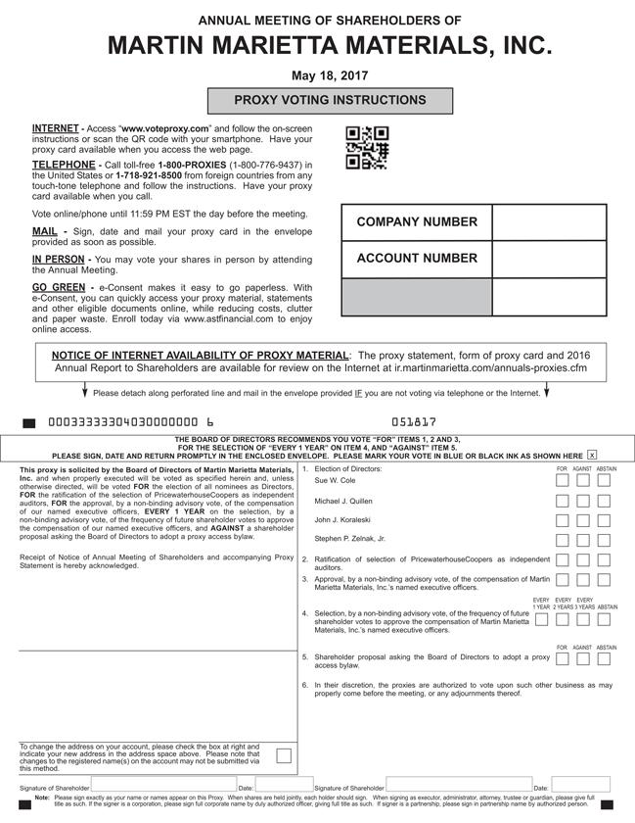

Table of Contents
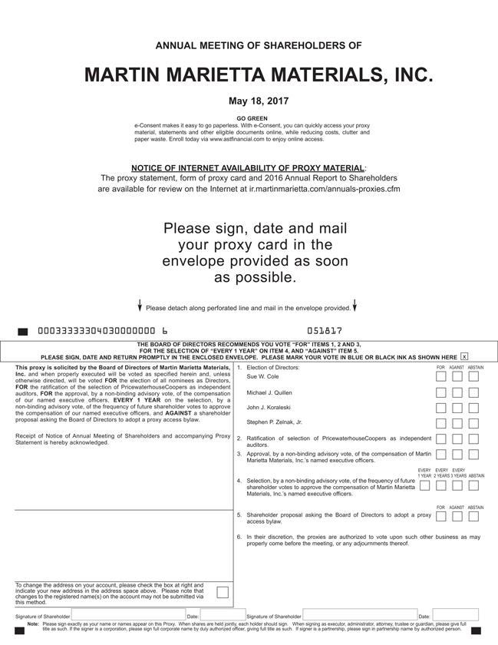

Table of Contents


